​
​
​
UNITED STATES
SECURITIES AND EXCHANGE COMMISSION
Washington, D.C. 20549
​
FORM 8-K
​
CURRENT REPORT
​
Pursuant to Section 13 or 15(d) of the Securities Exchange Act of 1934
​
Date of Report (date of earliest event reported): February 24, 2026
​

​
Merit Medical Systems, Inc.
(Exact name of registrant as specified in its charter)
​

​ | ​ | ​ | ​ | ​
Utah | ​ ​ ​ | 0-18592 | ​ ​ ​ | 87-0447695
(State or other jurisdiction of | ​ | (Commission | ​ | (I.R.S. Employer
incorporation or organization) | ​ | File Number) | ​ | Identification No.)
​

​ | ​ | ​
1600 West Merit Parkway | ​ ​ ​ | ​
South Jordan, Utah | ​ | 84095
(Address of principal executive offices) | ​ | (Zip Code)
​
(801) 253-1600
(Registrant's telephone number, including area code)
​
N/A
(Former name or former address, if changed since last report)
​
Check the appropriate box below if the Form 8-K filing is intended to simultaneously satisfy the filing obligation of the registrant under any of the following provisions:
​
☐ Written communications pursuant to Rule 425 under the Securities Act (17 CFR 230.425)
​
☐ Soliciting material pursuant to Rule 14a-12 under the Exchange Act (17 CFR 240.14a-12)
​
☐ Pre-commencement communications pursuant to Rule 14d-2(b) under the Exchange Act (17 CFR 240.14d-2(b))
​
☐ Pre-commencement communications pursuant to Rule 13e-4(c) under the Exchange Act (17 CFR 240.13e-4(c))
​
Securities registered pursuant to Section 12(b) of the Act:
​

Title of each class | ​ ​ ​ | Trading Symbol(s) | ​ ​ ​ | Name of each exchange on which registered
Common Stock, no par value | ​ | MMSI | ​ | NASDAQ Global Select Market System
​
Indicate by check mark whether the registrant is an emerging growth company as defined in Rule 405 of the Securities Act of 1933 (§230.405 of this chapter) or Rule 12b-2 of the Securities Exchange Act of 1934 (§240.12b-2 of this chapter).
​
Emerging growth company ☐
​
If an emerging growth company, indicate by check mark if the registrant has elected not to use the extended transition period for complying with any new or revised financial accounting standards provided pursuant to Section 13(a) of the Exchange Act. ☐
​
​
​
​
​
Item 2.02. Results of Operations and Financial Condition.
On February 24, 2026, Merit Medical Systems, Inc. (“Merit”) issued a press release announcing its operating and financial results for the quarter and year ended December 31, 2025. A copy of the press release is furnished as Exhibit 99.1 to this report and incorporated herein by reference.
Item 7.01. Regulation FD Disclosure.
On February 24, 2026, Merit is conducting a conference call to discuss its operating and financial results for the quarter and year ended December 31, 2025. A live webcast and slide presentation will also be available for the conference call on the Merit’s website. A copy of the slide presentation is furnished as Exhibit 99.2 to this report and incorporated herein by reference.
The information contained in Item 2.02 and Item 7.01 of this Current Report on Form 8-K (including the exhibits attached hereto) is furnished pursuant to General Instruction B.2. of Form 8-K and shall not be deemed to be “filed” for purposes of Section 18 of the Securities Exchange Act of 1934, as amended (the “Exchange Act”), or otherwise subject to the liabilities of that section, nor shall it be deemed incorporated by reference in any filing made by Merit under the Securities Act of 1933, as amended, or the Exchange Act.
In addition to disclosing results that are determined in accordance with Generally Accepted Accounting Principles (“GAAP”), Merit is disclosing non-GAAP financial information in both the press release announcing its operating and financial results and the conference call presentation. Reconciliations of certain of these non-GAAP financial measures to the comparable GAAP financial measures are included in the press release and conference call presentation attached as Exhibit 99.1 and 99.2, respectively, to this report. Merit does not provide guidance for GAAP reported financial measures (other than revenue) or a reconciliation of forward-looking non-GAAP financial measures to the most directly comparable GAAP reported financial measures (other than revenue) because Merit is unable to predict with reasonable certainty the financial impact of items such as expenses related to acquisitions or other extraordinary transactions, non-cash expenses related to amortization or write-off of previously acquired tangible and intangible assets, certain severance expenses, performance-based stock compensation expenses, expenses resulting from non-ordinary course litigation or administrative proceedings and resulting settlements, governmental proceedings, and changes in governmental or industry regulations. These items are uncertain, depend on various factors, and could have a material impact on GAAP reported results for the guidance period. For the same reasons, Merit is unable to address the significance of the unavailable information, which could be material to future results. Specifically, Merit is not, without unreasonable effort, able to reliably predict the impact of these items and Merit believes inclusion of a reconciliation of these forward-looking non-GAAP figures to their GAAP counterparts could be confusing to investors or cause undue reliance.
Item 9.01. Financial Statements and Exhibits.
​
(d) Exhibits
​ | ​ | ​
EXHIBIT NUMBER |  | DESCRIPTION
​ | ​ | ​
99.1 | ​ | Press Release, dated February 24, 2026, entitled “Merit Medical Reports Fourth Quarter and Full Year 2025 Results and Issues Fiscal Year 2026 Guidance” including unaudited financial information.
99.2 | ​ | Conference Call Presentation
104 | ​ | The cover page from this Current Report on Form 8-K, formatted in Inline XBRL
​
​
​
2
​
​
​
SIGNATURES
​
Pursuant to the requirements of the Securities Exchange Act of 1934, as amended, the registrant has duly caused this report to be signed on its behalf by the undersigned hereunto duly authorized.
​
​ | MERIT MEDICAL SYSTEMS, INC.
​ | ​ | ​
​ | ​ | ​
Date: February 24, 2026 | By: | /s/ Brian G. Lloyd
​ | ​ | Brian G. Lloyd
​ | ​ | Chief Legal Officer and Corporate Secretary
​
​
​
​
3
Exhibit 99.1
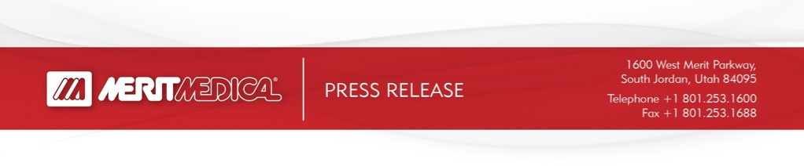
​
​
​  ​  ​ | ​ | ​ | ​
​ | Contacts:  ​ | ​ | ​
​ | PR/Media Inquiries:  Sarah Comstock  Merit Medical | Investor Inquiries:  Mike Piccinino, CFA, IRC  ICR Healthcare | ​
​ | +1-801-432-2864 | +1-443-213-0509 | ​
​ | sarah.comstock@merit.com | mike.piccinino@icrhealthcare.com | ​
​ | ​ | ​ | ​
​
FOR IMMEDIATE RELEASE
MERIT MEDICAL REPORTS FOURTH QUARTER AND FULL YEAR 2025 RESULTS AND ISSUES FISCAL YEAR 2026 GUIDANCE
​
Fourth Quarter Highlights†
 | ● | Reported revenue of $393.9 million, up 11%
 | ● | Constant currency revenue* and constant currency revenue, organic* up 10% and up 7%, respectively
 | ● | GAAP operating margin of 13.8%, compared to 10.3% in prior year period
 | ● | Non-GAAP operating margin* of 21.0%, compared to 19.6% in prior year period
 | ● | GAAP EPS $0.63, up 37%
 | ● | Non-GAAP EPS* $1.04, up 12%
 | ● | Free cash flow* generation of $74.0 million, up 13%
Fiscal Year 2025 Highlights†
 | ● | Reported revenue of $1.516 billion, up 12%
 | ● | Constant currency revenue* and constant currency revenue, organic* up 11% and up 7%, respectively
 | ● | GAAP operating margin of 12.2%, compared to 11.5% in prior year
 | ● | Non-GAAP operating margin* of 20.3%, compared to 19.0% in prior year
 | ● | GAAP EPS $2.13, up 5%
 | ● | Non-GAAP EPS* $3.83, up 11%
 | ● | Free cash flow* generation of $215.7 million, up 16%
1

Fiscal Year 2026 Guidance
 | ● | Total revenue of $1.610 billion to $1.630 billion, up 6% - 8% year-over-year on a reported basis and up 5% - 7% year-over-year on a constant currency* basis.
 | ● | Non-GAAP EPS of $4.01 to $4.15, up 5% – 8% year-over-year.
† Comparisons above are calculated for the current quarter compared with the fourth quarter of 2024 or for the current year compared with fiscal year 2024, as applicable, unless otherwise specified. Amounts stated in this release are rounded, while percentages are calculated from the underlying amounts.
* Constant currency revenue; constant currency revenue, organic; non-GAAP gross profit and margin; non-GAAP operating income and margin; non-GAAP net income; non-GAAP EPS; and free cash flow figures (used here and below) are non-GAAP financial measures. A reconciliation of these financial measures to their most directly comparable GAAP financial measures is included under the heading “Non-GAAP Financial Measures” below.
​
SOUTH JORDAN, Utah, February 24, 2026 -- Merit Medical Systems, Inc. (NASDAQ: MMSI), a leading global manufacturer and marketer of healthcare technology, today announced financial results for the three and twelve-month periods ended December 31, 2025.
“Merit delivered better-than-expected revenue and financial results in the fourth quarter,” said Martha G. Aronson, Merit’s President and CEO. “Our fourth quarter capped off an impressive year of operating and financial performance in 2025; we delivered 6.8% organic, constant currency revenue growth, a 130 basis-point improvement year-over-year in our non-GAAP operating margin and generated strong free cash flow of more than $215 million, a 16% increase year-over-year. We are introducing 2026 revenue and non-GAAP earnings per share guidance which reflects confidence in our team’s ability to deliver continued strong execution, stable constant currency growth, improving profitability and solid free cash flow generation again this year. Importantly, the team remains laser focused on delivering the final year of our Continued Growth Initiatives Program and the related financial targets for the three-year period ending December 31, 2026.”
Merit’s revenue by operating segment and product category for the three and twelve-month periods ended December 31, 2025 and 2024 was as follows (unaudited; in thousands, except for percentages):
​
​ | ​ | ​ | ​ | ​ | ​ | ​ | ​ | ​ | ​ | ​ | ​ | ​ | ​ | ​ | ​ | ​ | ​ | ​
​ | ​ ​ ​ | Three Months Ended
​ | ​ | Reported |  |  |  |  |  |  |  | ​ | ​ | ​ | ​ | Constant Currency*
​ | ​ ​ ​ | December 31, |  |  |  |  | ​ | ​ | ​ | ​ | Impact of foreign |  | ​ | December 31, |  | ​ | ​ | ​
​ | ​ ​ ​ | 2025 |  | ​ ​ ​ | 2024(1) |  | ​ | % Change |  | ​ | exchange |  | ​ | 2025 |  | ​ | % Change
Cardiovascular | ​ | ​ | ​ | ​ | ​ | ​ | ​ | ​ | ​ | ​ | ​ | ​ | ​ | ​ | ​ | ​ | ​ | ​
Peripheral Intervention |  | $ | 154,933 | ​ | $ | 135,235 | ​ | 15 | % | ​ | $ | (1,635) | ​ | $ | 153,298 | ​ | 13 | %
Cardiac Intervention |  |  | 117,240 | ​ |  | 95,228 | ​ | 23 | % | ​ | ​ | (1,883) | ​ | ​ | 115,357 | ​ | 21 | %
Custom Procedural Solutions |  |  | 53,621 | ​ |  | 50,923 | ​ | 5 | % | ​ | ​ | (562) | ​ | ​ | 53,059 | ​ | 4 | %
OEM |  |  | 48,085 | ​ |  | 56,314 | ​ | (15) | % | ​ | ​ | (300) | ​ | ​ | 47,785 | ​ | (15) | %
Total |  |  | 373,879 | ​ |  | 337,700 | ​ | 11 | % | ​ | ​ | (4,380) | ​ | ​ | 369,499 | ​ | 9 | %
​ | ​ | ​ | ​ | ​ | ​ | ​ | ​ | ​ | ​ | ​ | ​ | ​ | ​ | ​ | ​ | ​ | ​ | ​
Endoscopy | ​ | ​ | ​ | ​ | ​ | ​ | ​ | ​ | ​ | ​ | ​ | ​ | ​ | ​ | ​ | ​ | ​ | ​
Endoscopy Devices |  |  | 20,057 | ​ |  | 17,458 | ​ | 15 | % | ​ | ​ | (15) | ​ | ​ | 20,042 | ​ | 15 | %
​ | ​ | ​ | ​ | ​ | ​ | ​ | ​ | ​ | ​ | ​ | ​ | ​ | ​ | ​ | ​ | ​ | ​ | ​
Total |  | $ | 393,936 | ​ | $ | 355,158 | ​ | 11 | % | ​ | $ | (4,395) | ​ | $ | 389,541 | ​ | 10 | %
2

​
​ | ​ | ​ | ​ | ​ | ​ | ​ | ​ | ​ | ​ | ​ | ​ | ​ | ​ | ​ | ​ | ​ | ​ | ​
​ | ​ ​ ​ | Year Ended
​ | ​ | Reported |  |  |  |  |  |  |  | ​ | ​ | ​ | ​ | Constant Currency *
​ | ​ ​ ​ | December 31, |  |  |  |  | ​ | ​ | ​ | ​ | Impact of foreign |  | ​ | December 31, |  | ​ | ​ | ​
​ | ​ ​ ​ | 2025 |  | ​ ​ ​ | 2024(1) |  | ​ | % Change |  | ​ | exchange |  | ​ | 2025 |  | ​ | % Change
Cardiovascular | ​ | ​ | ​ | ​ | ​ | ​ | ​ | ​ | ​ | ​ | ​ | ​ | ​ | ​ | ​ | ​ | ​ | ​
Peripheral Intervention |  | $ | 579,840 | ​ | $ | 532,770 | ​ | 9 | % | ​ | $ | (1,191) | ​ | $ | 578,649 | ​ | 9 | %
Cardiac Intervention |  |  | 448,914 | ​ |  | 368,951 | ​ | 22 | % | ​ | ​ | (2,213) | ​ | ​ | 446,701 | ​ | 21 | %
Custom Procedural Solutions |  |  | 209,333 | ​ |  | 200,033 | ​ | 5 | % | ​ | ​ | (1,228) | ​ | ​ | 208,105 | ​ | 4 | %
OEM |  |  | 204,955 | ​ |  | 199,990 | ​ | 2 | % | ​ | ​ | (521) | ​ | ​ | 204,434 | ​ | 2 | %
Total |  |  | 1,443,042 | ​ |  | 1,301,744 | ​ | 11 | % | ​ | ​ | (5,153) | ​ | ​ | 1,437,889 | ​ | 10 | %
​ | ​ | ​ | ​ | ​ | ​ | ​ | ​ | ​ | ​ | ​ | ​ | ​ | ​ | ​ | ​ | ​ | ​ | ​
Endoscopy | ​ | ​ | ​ | ​ | ​ | ​ | ​ | ​ | ​ | ​ | ​ | ​ | ​ | ​ | ​ | ​ | ​ | ​
Endoscopy Devices |  |  | 72,864 | ​ |  | 54,770 | ​ | 33 | % | ​ | ​ | (20) | ​ | ​ | 72,844 | ​ | 33 | %
​ | ​ | ​ | ​ | ​ | ​ | ​ | ​ | ​ | ​ | ​ | ​ | ​ | ​ | ​ | ​ | ​ | ​ | ​
Total |  | $ | 1,515,906 | ​ | $ | 1,356,514 | ​ | 12 | % | ​ | $ | (5,173) | ​ | $ | 1,510,733 | ​ | 11 | %
​
(1) | Commencing January 1, 2025, Merit reorganized its sales teams and product categories to include revenues from the sale of its spine devices under its OEM product category. Revenue figures for 2024 have been recast to reflect this realignment of its portfolio of spine products, representing approximately $5.9 million and $22.6 million in revenue for the three and twelve-month periods ended December 31, 2024, respectively, within the OEM product category to provide comparability between the reporting periods.
Fourth Quarter 2025 Financial Summary:
GAAP gross margin was 49.6%, compared to 48.7% for the fourth quarter of 2024. Non-GAAP gross margin* was 54.5%, compared to 53.5% for the fourth quarter of 2024.
GAAP operating margin was 13.8%, compared to 10.3% for the fourth quarter of 2024. Non-GAAP operating margin* was 21.0%, compared to 19.6% for the fourth quarter of 2024.
GAAP net income was $38.0 million, or $0.63 per share, compared to $27.9 million, or $0.46 per share, for the fourth quarter of 2024. Non-GAAP net income* was $62.5 million, or $1.04 per share, compared to $56.3 million, or $0.93 per share, for the fourth quarter of 2024.
Fiscal Year 2025 Financial Summary:
GAAP gross margin was 48.7%, compared to 47.4% for fiscal year 2024. Non-GAAP gross margin* was 53.7%, compared to 51.7% for fiscal year 2024.
GAAP operating margin was 12.2%, compared to 11.5% for fiscal year 2024. Non-GAAP operating margin* was 20.3%, compared to 19.0% for fiscal year 2024.
GAAP net income was $128.5 million, or $2.13 per share, compared to $120.4 million, or $2.03 per share, for fiscal year 2024. Non-GAAP net income* was $231.4 million, or $3.83 per share, compared to $205.4 million, or $3.46 per share, for fiscal year 2024.
As of December 31, 2025, Merit had cash and cash equivalents of $446.4 million and total debt obligations of $747.5 million, compared to cash and cash equivalents of $376.7 million and total debt obligations of $747.5 million as of December 31, 2024. Merit had available borrowing capacity of approximately $697 million as of December 31, 2025.
3

Fiscal Year 2026 Financial Guidance
Based upon the information currently available to Merit’s management, for the twelve-months ending December 31, 2026, absent the potential impact of trade policies and related actions implemented by the U.S. and other countries subsequent to today’s date, material acquisitions, non-recurring transactions or other factors beyond Merit’s current expectations, Merit anticipates the following financial results:
​
Revenue and Earnings Guidance*
​ | ​ | ​ | ​ | ​
​ | ​ | Year Ended | Year Ending | % Change
Financial Measure | ​ | December 31, 2025 | December 31, 2026 | Y/Y
Total Revenue | ​ | $1.516 billion | $1.610 - $1.630 billion | 6% - 8%
​ | ​ | ​ | ​ | ​
Non-GAAP Earnings Per Share(1) | ​ | $3.83 | $4.01 - $4.15 | 5% - 8%
​
*Percentage figures approximated; dollar figures may not foot due to rounding.
(1) Merit’s non-GAAP earnings per share reflect the dilutive impact of its 3.00% Convertible Senior Notes due 2029 (the “Convertible Notes”) calculated using the if-converted method of approximately $0.07 per share for the year ending December 31, 2026. Any offsetting impacts of the capped call associated with the Convertible Notes are not considered.
Merit does not provide guidance for GAAP reported financial measures (other than revenue) or a reconciliation of forward-looking non-GAAP financial measures to the most directly comparable GAAP reported financial measures (other than revenue) because Merit is unable to predict with reasonable certainty the financial impact of various items which could impact Merit’s future financial results, such as expenses attributable to acquisitions or other extraordinary transactions, non-cash expenses related to amortization or write-off of previously acquired tangible and intangible assets, certain employee termination benefits, performance-based stock compensation expenses, expenses resulting from non-ordinary course litigation or administrative proceedings and resulting settlements, governmental proceedings, and changes in governmental or industry regulations. These items are uncertain, depend on various factors, and could have a material impact on GAAP reported results for the guidance period. For the same reasons, Merit is unable to address the significance of the unavailable information, which could be material to future results. Specifically, Merit is not, without unreasonable effort, able to reliably predict the impact of these items and Merit believes inclusion of a reconciliation of these forward-looking non-GAAP measures to their GAAP counterparts could be confusing to investors or cause undue reliance.
Merit’s financial guidance for the year ending December 31, 2026 is subject to risks and uncertainties identified in this release and Merit’s filings with the U.S. Securities and Exchange Commission (the “SEC”). This guidance is based on information and estimates available to Merit as of February 24, 2026. Should known or unknown risks or uncertainties materialize or should underlying assumptions prove inaccurate, actual results will likely vary, and could vary materially, from past results and those anticipated, estimated or projected.
​
CONFERENCE CALL
As previously announced, Merit will hold its investor conference call today, Tuesday, February 24, 2026, at 4:30 p.m., Eastern Time, to discuss its results for the fourth quarter and year ended December 31, 2025 and provide an operational update. To access the conference call, please pre-register using the following link. Registrants will receive confirmation with dial-in details. A live webcast and slide deck will also be available at merit.com.
4

CONSOLIDATED BALANCE SHEETS
(in thousands)
​
​ | ​ | ​ | ​ | ​ | ​ | ​
​ | ​ ​ ​ | December 31, |  | ​ ​ ​ | ​ | ​
​ | ​ | 2025 |  | ​ | December 31,
​ | ​ | (Unaudited) |  | ​ | 2024
ASSETS |  | ​ | ​ |  | ​ | ​
Current Assets |  | ​ | ​ |  | ​ | ​
Cash and cash equivalents | ​ | $ | 446,404 | ​ | $ | 376,715
Trade receivables, net | ​ |  | 203,710 | ​ |  | 190,243
Other receivables | ​ |  | 17,773 | ​ |  | 16,588
Inventories | ​ |  | 333,705 | ​ |  | 306,063
Prepaid expenses and other assets | ​ |  | 31,493 | ​ |  | 28,544
Prepaid income taxes | ​ |  | 4,941 | ​ |  | 3,286
Income tax refund receivables | ​ |  | 2,128 | ​ |  | 2,335
Total current assets | ​ |  | 1,040,154 | ​ |  | 923,774
​ | ​ | ​ | ​ | ​ | ​ | ​
Property and equipment, net | ​ |  | 428,401 | ​ |  | 386,165
Intangible assets, net | ​ |  | 537,654 | ​ |  | 498,265
Goodwill | ​ |  | 506,837 | ​ |  | 463,511
Deferred income tax assets | ​ |  | 7,049 | ​ |  | 16,044
Operating lease right-of-use assets | ​ |  | 87,600 | ​ |  | 65,508
Other assets | ​ |  | 78,227 | ​ |  | 65,336
Total Assets | ​ | $ | 2,685,922 | ​ | $ | 2,418,603
​ | ​ | ​ | ​ | ​ | ​ | ​
LIABILITIES AND STOCKHOLDERS' EQUITY | ​ |  | ​ | ​ |  | ​
Current Liabilities | ​ |  | ​ | ​ |  | ​
Trade payables | ​ | $ | 60,551 | ​ | $ | 68,502
Accrued expenses | ​ |  | 159,486 | ​ |  | 134,077
Current operating lease liabilities | ​ |  | 10,876 | ​ |  | 10,331
Income taxes payable | ​ |  | 8,851 | ​ |  | 3,492
Total current liabilities | ​ |  | 239,764 | ​ |  | 216,402
​ | ​ | ​ | ​ | ​ | ​ | ​
Long-term debt | ​ |  | 734,038 | ​ |  | 729,551
Deferred income tax liabilities | ​ |  | 19,665 | ​ |  | 240
Liabilities related to unrecognized tax benefits | ​ |  | 2,248 | ​ |  | 2,118
Deferred compensation payable | ​ |  | 17,542 | ​ |  | 19,197
Deferred credits | ​ |  | 1,398 | ​ |  | 1,502
Long-term operating lease liabilities | ​ |  | 76,658 | ​ |  | 54,783
Other long-term obligations | ​ |  | 10,306 | ​ |  | 15,451
Total liabilities | ​ |  | 1,101,619 | ​ |  | 1,039,244
​ | ​ | ​ | ​ | ​ | ​ | ​
Stockholders' Equity | ​ |  | ​ | ​ |  | ​
Common stock | ​ |  | 763,909 | ​ |  | 703,219
Retained earnings | ​ |  | 824,030 | ​ |  | 695,541
Accumulated other comprehensive loss | ​ |  | (3,636) | ​ |  | (19,401)
Total stockholders' equity | ​ |  | 1,584,303 | ​ |  | 1,379,359
Total Liabilities and Stockholders' Equity | ​ | $ | 2,685,922 | ​ | $ | 2,418,603
​
​
​
​
​
5

CONSOLIDATED STATEMENTS OF INCOME
(Unaudited, in thousands except per share amounts)
​
​ | ​ | ​ | ​ | ​ | ​ | ​ | ​ | ​ | ​ | ​ | ​ | ​
​ | ​ ​ ​ | Three Months Ended |  |  |  |  | ​ ​ ​ | Year Ended
​ | ​ | December 31, |  |  |  |  | ​ | December 31,
​ | ​ ​ ​ | 2025 |  | ​ ​ ​ | 2024 |  | ​ ​ ​ | 2025 |  | ​ ​ ​ | 2024
Net sales | ​ | $ | 393,936 | ​ | $ | 355,158 | ​ | $ | 1,515,906 | ​ | $ | 1,356,514
Cost of sales | ​ |  | 198,584 | ​ |  | 182,175 | ​ |  | 777,636 | ​ |  | 713,181
Gross profit | ​ |  | 195,352 | ​ |  | 172,983 | ​ |  | 738,270 | ​ |  | 643,333
​ | ​ | ​ | ​ | ​ | ​ | ​ | ​ | ​ | ​ | ​ | ​ | ​
Operating expenses: | ​ |  | ​ | ​ |  | ​ | ​ |  | ​ | ​ |  | ​
Selling, general and administrative | ​ |  | 114,830 | ​ |  | 111,074 | ​ |  | 455,214 | ​ |  | 399,731
Research and development | ​ |  | 26,541 | ​ |  | 25,194 | ​ |  | 97,352 | ​ |  | 87,466
Contingent consideration (benefit) expense | ​ |  | (214) | ​ |  | 151 | ​ |  | 984 | ​ |  | 443
Total operating expenses | ​ |  | 141,157 | ​ |  | 136,419 | ​ |  | 553,550 | ​ |  | 487,640
​ | ​ | ​ | ​ | ​ | ​ | ​ | ​ | ​ | ​ | ​ | ​ | ​
Income from operations | ​ |  | 54,195 | ​ |  | 36,564 | ​ |  | 184,720 | ​ |  | 155,693
​ | ​ | ​ | ​ | ​ | ​ | ​ | ​ | ​ | ​ | ​ | ​ | ​
Other income (expense): | ​ |  | ​ | ​ |  | ​ | ​ |  | ​ | ​ |  | ​
Interest income | ​ |  | 3,904 | ​ |  | 4,741 | ​ |  | 15,070 | ​ |  | 26,230
Interest expense | ​ |  | (6,364) | ​ |  | (7,993) | ​ |  | (26,461) | ​ |  | (31,219)
Other expense — net | ​ |  | (675) | ​ |  | (167) | ​ |  | (2,392) | ​ |  | (711)
Total other expense — net | ​ |  | (3,135) | ​ |  | (3,419) | ​ |  | (13,783) | ​ |  | (5,700)
​ | ​ | ​ | ​ | ​ | ​ | ​ | ​ | ​ | ​ | ​ | ​ | ​
Income before income taxes | ​ |  | 51,060 | ​ |  | 33,145 | ​ |  | 170,937 | ​ |  | 149,993
​ | ​ | ​ | ​ | ​ | ​ | ​ | ​ | ​ | ​ | ​ | ​ | ​
Income tax expense | ​ |  | 13,054 | ​ |  | 5,198 | ​ |  | 42,448 | ​ |  | 29,636
​ | ​ | ​ | ​ | ​ | ​ | ​ | ​ | ​ | ​ | ​ | ​ | ​
Net income | ​ | $ | 38,006 | ​ | $ | 27,947 | ​ | $ | 128,489 | ​ | $ | 120,357
​ | ​ | ​ | ​ | ​ | ​ | ​ | ​ | ​ | ​ | ​ | ​ | ​
Earnings per common share | ​ |  | ​ | ​ |  | ​ | ​ |  | ​ | ​ |  | ​
Basic | ​ | $ | 0.64 | ​ | $ | 0.48 | ​ | $ | 2.17 | ​ | $ | 2.07
Diluted | ​ | $ | 0.63 | ​ | $ | 0.46 | ​ | $ | 2.13 | ​ | $ | 2.03
​ | ​ | ​ | ​ | ​ | ​ | ​ | ​ | ​ | ​ | ​ | ​ | ​
Weighted average shares outstanding | ​ |  | ​ | ​ |  | ​ | ​ |  | ​ | ​ |  | ​
Basic | ​ |  | 59,343 | ​ |  | 58,541 | ​ |  | 59,158 | ​ |  | 58,218
Diluted | ​ |  | 60,026 | ​ |  | 60,613 | ​ |  | 60,460 | ​ |  | 59,365
​
​
​
6

​
CONSOLIDATED STATEMENTS OF CASH FLOWS
(Unaudited, in thousands)
​
​ | ​ | ​ | ​ | ​ | ​ | ​
​ | ​ | Year Ended
​ | ​ | December 31,
​ | ​ ​ ​ | 2025 |  | ​ ​ ​ | 2024
CASH FLOWS FROM OPERATING ACTIVITIES: |  | ​ |  | ​ | ​
Net income | ​ | $ | 128,489 | ​ | $ | 120,357
Adjustments to reconcile net income to net cash provided by operating activities: | ​ |  | ​ | ​ |  | ​
Depreciation and amortization | ​ |  | 123,168 | ​ |  | 102,709
Gain on disposition of a business | ​ | ​ | (249) | ​ |  | —
Write-off of certain intangible assets and other long-term assets | ​ |  | 313 | ​ |  | 456
Amortization of right-of-use operating lease assets | ​ | ​ | 11,481 | ​ |  | 12,023
Fair value adjustments related to contingent consideration liabilities | ​ | ​ | 984 | ​ |  | 443
Deferred income taxes | ​ | ​ | 5,214 | ​ | ​ | (14,873)
Stock-based compensation expense | ​ |  | 43,460 | ​ |  | 28,473
Other adjustments | ​ | ​ | 7,855 | ​ | ​ | 8,156
Changes in operating assets and liabilities, net of acquisitions | ​ |  | (23,344) | ​ |  | (36,945)
Total adjustments | ​ |  | 168,882 | ​ |  | 100,442
Net cash, cash equivalents, and restricted cash provided by operating activities | ​ |  | 297,371 | ​ |  | 220,799
​ | ​ | ​ | ​ | ​ | ​ | ​
CASH FLOWS FROM INVESTING ACTIVITIES: | ​ |  | ​ | ​ |  | ​
Capital expenditures for property and equipment | ​ |  | (81,716) | ​ |  | (35,140)
Cash paid for notes receivable and other investments | ​ | ​ | (18,084) | ​ | ​ | (10,433)
Cash paid in acquisitions, net of cash acquired | ​ | ​ | (144,769) | ​ | ​ | (320,182)
Other investing, net | ​ | ​ | (2,817) | ​ | ​ | (2,898)
Net cash, cash equivalents, and restricted cash used in investing activities | ​ | ​ | (247,386) | ​ | ​ | (368,653)
​ | ​ | ​ | ​ | ​ | ​ | ​
CASH FLOWS FROM FINANCING ACTIVITIES: |  | ​ |  | ​ | ​
Proceeds from issuance of common stock | ​ | ​ | 28,213 | ​ | ​ | 40,908
Proceeds from (payments on) long-term debt | ​ | ​ | — | ​ | ​ | (99,063)
Contingent payments related to acquisitions | ​ |  | (2,685) | ​ |  | (261)
Payment of taxes related to an exchange of common stock | ​ |  | (9,529) | ​ |  | (1,592)
Net cash, cash equivalents, and restricted cash provided by (used in) financing activities | ​ |  | 15,999 | ​ |  | (60,008)
Effect of exchange rates on cash | ​ |  | 3,798 | ​ |  | (2,515)
Net increase (decrease) in cash, cash equivalents and restricted cash | ​ |  | 69,782 | ​ |  | (210,377)
​ | ​ | ​ | ​ | ​ | ​ | ​
CASH, CASH EQUIVALENTS AND RESTRICTED CASH: | ​ |  | ​ | ​ |  | ​
Beginning of period | ​ |  | 378,767 | ​ |  | 589,144
End of period | ​ | $ | 448,549 | ​ | $ | 378,767
​ | ​ | ​ | ​ | ​ | ​ | ​
RECONCILIATION OF CASH, CASH EQUIVALENTS AND RESTRICTED CASH TO THE CONSOLIDATED BALANCE SHEETS: | ​ | ​ | ​ | ​ | ​ | ​
Cash and cash equivalents | ​ | ​ | 446,404 | ​ | ​ | 376,715
Restricted cash reported in prepaid expenses and other current assets | ​ | ​ | 2,145 | ​ | ​ | 2,052
Total cash, cash equivalents and restricted cash | ​ | $ | 448,549 | ​ | $ | 378,767
​
​
​
​
7

Non-GAAP Financial Measures
Although Merit’s financial statements are prepared in accordance with accounting principles generally accepted in the United States of America (“GAAP”), Merit’s management believes that the non-GAAP financial measures referenced in this release may provide investors with useful information regarding the underlying business trends and performance of Merit’s ongoing operations and can be useful for period-over-period comparisons of such operations. Non-GAAP financial measures used in this release include:
 | ● | constant currency revenue;
 | ● | constant currency revenue, organic;
 | ● | non-GAAP gross profit and margin;
 | ● | non-GAAP operating income and margin;
 | ● | non-GAAP net income;
 | ● | non-GAAP earnings per share; and
 | ● | free cash flow.
Merit’s management team uses these non-GAAP financial measures to evaluate Merit’s profitability and efficiency, to compare operating and financial results to prior periods, to evaluate changes in the results of its operating segments, and to measure and allocate financial resources internally. However, Merit’s management does not consider such non-GAAP measures in isolation or as an alternative to measures determined in accordance with GAAP.
Readers should consider non-GAAP measures used in this release in addition to, not as a substitute for, financial reporting measures prepared in accordance with GAAP. These non-GAAP financial measures generally exclude some, but not all, items that may affect Merit’s net income. In addition, they are subject to inherent limitations as they reflect the exercise of judgment by management about which items are excluded. Merit believes it is useful to exclude such items in the calculation of non-GAAP gross profit and margin, non-GAAP operating income and margin, non-GAAP net income, and non-GAAP earnings per share (in each case, as further illustrated in the reconciliation tables below) because such amounts in any specific period may not directly correlate to the underlying performance of Merit’s business operations and can vary significantly between periods as a result of factors such as acquisition or other extraordinary transactions, non-cash expenses related to amortization or write-off of previously acquired tangible and intangible assets, certain employee termination benefits, expenses resulting from non-ordinary course litigation or administrative proceedings and resulting settlements, governmental proceedings or changes in tax or industry regulations, gains or losses on disposal of certain assets, equity method investment loss (income) from equity investees, and debt issuance costs. Merit may incur similar types of expenses in the future, and the non-GAAP financial information included in this release should not be viewed as a statement or indication that these types of expenses will not recur. Additionally, the non-GAAP financial measures used in this release may not be comparable with similarly titled measures of other companies. Merit urges readers to review the reconciliations of its non-GAAP financial measures to their most directly comparable GAAP financial measures included herein, and not to rely on any single financial measure to evaluate Merit’s business or results of operations.
Constant Currency Revenue
Merit’s constant currency revenue is prepared by converting the current-period reported revenue of subsidiaries whose functional currency is a currency other than the U.S. dollar at the applicable foreign exchange rates in effect during the comparable prior-year period and adjusting for the effects of hedging transactions on reported revenue, which are recorded in the U.S. dollar. The constant currency revenue adjustments of $(4.4) million and $(5.2) million to reported revenue for the three and twelve-month periods ended December 31, 2025, respectively, were calculated using the applicable average foreign exchange rates for the three and twelve-month periods ended December 31, 2024.
8

Constant Currency Revenue, Organic
Merit’s constant currency revenue, organic, is defined, with respect to prior fiscal year periods, as GAAP revenue. With respect to current fiscal year periods, constant currency revenue, organic, is defined as constant currency revenue (as defined above), less revenue from certain acquisitions. For the three-month period ended December 31, 2025, Merit’s constant currency revenue, organic, excludes revenues attributable to products acquired in connection with (i) the assets acquired from Pentax of America, Inc. related to the C2 CryoBalloon™ device in November 2025 (the “C2 Acquisition”), (ii) Merit’s merger transaction with Biolife Delaware, L.L.C. (“Biolife”) in May 2025 (the “Biolife Merger”) and (iii) the assets acquired from Cook Medical Holdings LLC in November 2024 (the “Cook Transaction”). For the twelve-month period ended December 31, 2025, Merit’s constant currency revenue, organic, excludes revenues attributable to products acquired in connection with (i) the C2 Acquisition, (ii) the Biolife Merger, (iii) the Cook Transaction and (iv) the assets acquired from EndoGastric Solutions, Inc. in July 2024 (the “EGS Transaction”).
Non-GAAP Gross Profit and Margin
Non-GAAP gross profit is calculated by reducing GAAP cost of sales by amounts recorded for amortization of intangible assets and inventory mark-up related to acquisitions. Non-GAAP gross margin is calculated by dividing non-GAAP gross profit by reported net sales.
Non-GAAP Operating Income and Margin
Non-GAAP operating income is calculated by adjusting GAAP operating income for certain items which are deemed by Merit’s management to be outside of core operations and vary in amount and frequency among periods, such as expenses related to acquisitions or other extraordinary transactions, non-cash expenses related to amortization or write-off of previously acquired tangible and intangible assets, certain employee termination benefits, performance-based stock compensation expenses, expenses resulting from non-ordinary course litigation or administrative proceedings and resulting settlements, governmental proceedings, and changes in governmental or industry regulations, as well as other items referenced in the tables below. Non-GAAP operating margin is calculated by dividing non-GAAP operating income by reported net sales.
Non-GAAP Net Income
Non-GAAP net income is calculated by adjusting GAAP net income for the items set forth in the definition of non-GAAP operating income above, as well as for expenses related to debt issuance costs, gains or losses on disposal of certain assets, equity method investment loss (income) from equity investees, and other items set forth in the tables below.
Non-GAAP EPS
Non-GAAP EPS is defined as non-GAAP net income divided by the diluted shares outstanding for the corresponding period.
Free Cash Flow
Free cash flow is defined as cash flow from operations calculated in accordance with GAAP, less capital expenditures for property and equipment calculated in accordance with GAAP, as set forth in the consolidated statement of cash flows.
Other Non-GAAP Financial Measure Reconciliations
The following tables set forth supplemental financial data and corresponding reconciliations of non-GAAP financial measures to Merit’s corresponding financial measures prepared in accordance with GAAP, in each case, for the three and twelve-month periods ended December 31, 2025 and 2024. The non-GAAP income adjustments referenced in the following tables do not reflect non-performance-based stock compensation expense of $4.4 million and $3.7 million for the three-month periods ended December 31, 2025 and 2024, respectively, and $18.2 million and $13.2 million for the twelve-month periods ended December 31, 2025 and 2024, respectively.
​
9

Reconciliation of GAAP Net Income to Non-GAAP Net Income
(Unaudited, in thousands except per share amounts)
​
​ | ​ | ​ | ​ | ​ | ​ | ​ | ​ | ​ | ​ | ​ | ​ | ​
​ | ​ | Three Months Ended
​ | ​ | December 31, 2025
​ | ​ ​ ​ | Pre-Tax |  | ​ ​ ​ | Tax Impact |  | ​ ​ ​ | After-Tax |  | ​ ​ ​ | Per Share Impact
GAAP net income | ​ | $ | 51,060 | ​ | $ | (13,054) | ​ | $ | 38,006 | ​ | $ | 0.63
​ | ​ | ​ | ​ | ​ | ​ | ​ | ​ | ​ | ​ | ​ | ​ | ​
Non-GAAP adjustments: |  | ​ | ​ |  | ​ | ​ |  | ​ | ​ |  | ​ | ​
Cost of Sales | ​ | ​ | ​ | ​ | ​ | ​ | ​ | ​ | ​ | ​ | ​ | ​
Amortization of intangibles | ​ | ​ | 19,237 | ​ | ​ | (4,541) | ​ | ​ | 14,696 | ​ | ​ | 0.24
Inventory mark-up related to acquisitions | ​ | ​ | 97 | ​ | ​ | (23) | ​ | ​ | 74 | ​ | ​ | 0.00
Operating Expenses | ​ | ​ | ​ | ​ | ​ | ​ | ​ | ​ | ​ | ​ | ​ | ​
Contingent consideration benefit | ​ | ​ | (214) | ​ | ​ | (3) | ​ | ​ | (217) | ​ | ​ | (0.00)
Amortization of intangibles | ​ | ​ | 2,586 | ​ | ​ | (611) | ​ | ​ | 1,975 | ​ | ​ | 0.03
Performance-based share-based compensation (a) | ​ | ​ | 5,543 | ​ | ​ | 155 | ​ | ​ | 5,698 | ​ | ​ | 0.09
Corporate restructuring (b) | ​ | ​ | (346) | ​ | ​ | 82 | ​ | ​ | (264) | ​ | ​ | (0.00)
Acquisition-related | ​ | ​ | 602 | ​ | ​ | (174) | ​ | ​ | 428 | ​ | ​ | 0.01
Medical Device Regulation expenses (c) | ​ | ​ | 929 | ​ | ​ | (219) | ​ | ​ | 710 | ​ | ​ | 0.01
Other (d) | ​ | ​ | 50 | ​ | ​ | (12) | ​ | ​ | 38 | ​ | ​ | 0.00
Other (Income) Expense | ​ | ​ | ​ | ​ | ​ | ​ | ​ | ​ | ​ | ​ | ​ | ​
Amortization of long-term debt issuance costs | ​ | ​ | 1,414 | ​ | ​ | (334) | ​ | ​ | 1,080 | ​ | ​ | 0.02
Other non-operating loss (e) | ​ | ​ | 415 | ​ | ​ | (98) | ​ | ​ | 317 | ​ | ​ | 0.01
​ | ​ | ​ | ​ | ​ | ​ | ​ | ​ | ​ | ​ | ​ | ​ | ​
Non-GAAP net income | ​ | $ | 81,373 | ​ | $ | (18,832) | ​ | $ | 62,541 | ​ | $ | 1.04
​ | ​ | ​ | ​ | ​ | ​ | ​ | ​ | ​ | ​ | ​ | ​ | ​
Diluted shares | ​ |  | ​ | ​ |  | ​ | ​ |  | ​ | ​ |  | 60,026
​
​ | ​ | ​ | ​ | ​ | ​ | ​ | ​ | ​ | ​ | ​ | ​ | ​
​ | ​ | Three Months Ended
​ | ​ | December 31, 2024
​ | ​ | Pre-Tax |  | ​ | Tax Impact |  | ​ | After-Tax |  | ​ | Per Share Impact
GAAP net income | ​ ​ ​ | $ | 33,145 | ​ ​ ​ | $ | (5,198) | ​ ​ ​ | $ | 27,947 | ​ ​ ​ | $ | 0.46
​ | ​ | ​ | ​ | ​ | ​ | ​ | ​ | ​ | ​ | ​ | ​ | ​
Non-GAAP adjustments: | ​ |  | ​ | ​ |  | ​ | ​ |  | ​ | ​ |  | ​
Cost of Sales | ​ | ​ | ​ | ​ | ​ | ​ | ​ | ​ | ​ | ​ | ​ | ​
Amortization of intangibles | ​ | ​ | 16,832 | ​ | ​ | (3,978) | ​ | ​ | 12,854 | ​ | ​ | 0.21
Inventory mark-up related to acquisitions | ​ | ​ | 75 | ​ | ​ | (17) | ​ | ​ | 58 | ​ | ​ | 0.00
Operating Expenses | ​ | ​ | ​ | ​ | ​ | ​ | ​ | ​ | ​ | ​ | ​ | ​
Contingent consideration expense | ​ | ​ | 151 | ​ | ​ | 48 | ​ | ​ | 199 | ​ | ​ | 0.00
Amortization of intangibles | ​ | ​ | 2,385 | ​ | ​ | (564) | ​ | ​ | 1,821 | ​ | ​ | 0.03
Performance-based share-based compensation (a) | ​ | ​ | 5,841 | ​ | ​ | (141) | ​ | ​ | 5,700 | ​ | ​ | 0.09
Corporate restructuring (b) | ​ | ​ | 1,098 | ​ | ​ | (260) | ​ | ​ | 838 | ​ | ​ | 0.01
Acquisition-related | ​ | ​ | 5,239 | ​ | ​ | (1,237) | ​ | ​ | 4,002 | ​ | ​ | 0.07
Medical Device Regulation expenses (c) | ​ | ​ | 1,395 | ​ | ​ | (329) | ​ | ​ | 1,066 | ​ | ​ | 0.02
Other (d) | ​ | ​ | 71 | ​ | ​ | (16) | ​ | ​ | 55 | ​ | ​ | 0.00
Other (Income) Expense | ​ | ​ | ​ | ​ | ​ | ​ | ​ | ​ | ​ | ​ | ​ | ​
Amortization of long-term debt issuance costs | ​ | ​ | 2,338 | ​ | ​ | (552) | ​ | ​ | 1,786 | ​ | ​ | 0.03
​ | ​ | ​ | ​ | ​ | ​ | ​ | ​ | ​ | ​ | ​ | ​ | ​
Non-GAAP net income | ​ | $ | 68,570 | ​ | $ | (12,244) | ​ | $ | 56,326 | ​ | $ | 0.93
​ | ​ | ​ | ​ | ​ | ​ | ​ | ​ | ​ | ​ | ​ | ​ | ​
Diluted shares | ​ |  | ​ | ​ |  | ​ | ​ |  | ​ | ​ |  | 60,613

Note: Certain per-share impacts may not sum to totals due to rounding.
​
10

Reconciliation of GAAP Net Income to Non-GAAP Net Income
(Unaudited, in thousands except per share amounts)
​
​ | ​ | ​ | ​ | ​ | ​ | ​ | ​ | ​ | ​ | ​ | ​ | ​
​ | ​ | Year Ended
​ | ​ | December 31, 2025
​ | ​ ​ ​ | Pre-Tax |  | ​ ​ ​ | Tax Impact |  | ​ ​ ​ | After-Tax |  | ​ ​ ​ | Per Share Impact
GAAP net income | ​ | $ | 170,937 | ​ | $ | (42,448) | ​ | $ | 128,489 | ​ | $ | 2.13
​ | ​ | ​ | ​ | ​ | ​ | ​ | ​ | ​ | ​ | ​ | ​ | ​
Non-GAAP adjustments: | ​ |  | ​ | ​ |  | ​ | ​ |  | ​ | ​ |  | ​
Cost of Sales | ​ | ​ | ​ | ​ | ​ | ​ | ​ | ​ | ​ | ​ | ​ | ​
Amortization of intangibles | ​ | ​ | 75,035 | ​ | ​ | (17,725) | ​ | ​ | 57,310 | ​ |  | 0.95
Inventory mark-up related to acquisitions | ​ | ​ | 347 | ​ | ​ | (82) | ​ | ​ | 265 | ​ | ​ | 0.00
Operating Expenses | ​ | ​ | ​ | ​ | ​ | ​ | ​ | ​ | ​ | ​ | ​ | ​
Contingent consideration expense | ​ | ​ | 984 | ​ | ​ | 26 | ​ | ​ | 1,010 | ​ |  | 0.02
Amortization of intangibles | ​ | ​ | 10,083 | ​ | ​ | (2,382) | ​ | ​ | 7,701 | ​ |  | 0.13
Performance-based share-based compensation (a) | ​ | ​ | 25,224 | ​ | ​ | (2,189) | ​ | ​ | 23,035 | ​ | ​ | 0.38
Corporate restructuring (b) | ​ | ​ | 2,527 | ​ | ​ | (596) | ​ | ​ | 1,931 | ​ |  | 0.03
Acquisition-related | ​ | ​ | 2,690 | ​ | ​ | (176) | ​ | ​ | 2,514 | ​ |  | 0.04
Medical Device Regulation expenses (c) | ​ | ​ | 5,812 | ​ | ​ | (1,372) | ​ | ​ | 4,440 | ​ |  | 0.07
Other (d) | ​ | ​ | 153 | ​ | ​ | (36) | ​ | ​ | 117 | ​ | ​ | 0.00
Other (Income) Expense | ​ | ​ | ​ | ​ | ​ | ​ | ​ | ​ | ​ | ​ |  | ​
Amortization of long-term debt issuance costs | ​ | ​ | 5,656 | ​ | ​ | (1,336) | ​ | ​ | 4,320 | ​ |  | 0.07
Other non-operating loss (e) | ​ | ​ | 426 | ​ | ​ | (159) | ​ | ​ | 267 | ​ | ​ | 0.00
​ | ​ | ​ | ​ | ​ | ​ | ​ | ​ | ​ | ​ | ​ | ​ | ​
Non-GAAP net income | ​ | $ | 299,874 | ​ | $ | (68,475) | ​ | $ | 231,399 | ​ | $ | 3.83
​ | ​ | ​ | ​ | ​ | ​ | ​ | ​ | ​ | ​ | ​ | ​ | ​
Diluted shares | ​ |  | ​ | ​ |  | ​ | ​ |  | ​ | ​ |  | 60,460
​
​ | ​ | ​ | ​ | ​ | ​ | ​ | ​ | ​ | ​ | ​ | ​ | ​
​ | ​ | Year Ended
​ | ​ | December 31, 2024
​ | ​ ​ ​ | Pre-Tax |  | ​ ​ ​ | Tax Impact |  | ​ ​ ​ | After-Tax |  | ​ ​ ​ | Per Share Impact
GAAP net income | ​ | $ | 149,993 | ​ | $ | (29,636) | ​ | $ | 120,357 | ​ | $ | 2.03
​ | ​ | ​ | ​ | ​ | ​ | ​ | ​ | ​ | ​ | ​ | ​ | ​
Non-GAAP adjustments: | ​ |  | ​ | ​ |  | ​ | ​ |  | ​ | ​ |  | ​
Cost of Sales | ​ |  | ​ | ​ |  | ​ | ​ |  | ​ | ​ |  | ​
Amortization of intangibles | ​ |  | 57,659 | ​ | ​ | (13,632) | ​ |  | 44,027 | ​ |  | 0.74
Inventory mark-up related to acquisitions | ​ |  | 634 | ​ | ​ | (149) | ​ |  | 485 | ​ |  | 0.01
Operating Expenses | ​ |  | ​ | ​ | ​ | ​ | ​ |  | ​ | ​ |  | ​
Contingent consideration expense | ​ |  | 443 | ​ | ​ | 17 | ​ |  | 460 | ​ |  | 0.01
Amortization of intangibles | ​ |  | 7,931 | ​ | ​ | (1,876) | ​ |  | 6,055 | ​ |  | 0.10
Performance-based share-based compensation (a) | ​ | ​ | 15,237 | ​ | ​ | (1,607) | ​ | ​ | 13,630 | ​ | ​ | 0.23
Corporate restructuring (b) | ​ |  | 3,128 | ​ | ​ | (739) | ​ |  | 2,389 | ​ |  | 0.04
Acquisition-related | ​ |  | 8,849 | ​ | ​ | (2,089) | ​ |  | 6,760 | ​ |  | 0.11
Medical Device Regulation expenses (c) | ​ | ​ | 7,515 | ​ | ​ | (1,774) | ​ | ​ | 5,741 | ​ | ​ | 0.10
Other (d) | ​ | ​ | 373 | ​ | ​ | (88) | ​ | ​ | 285 | ​ | ​ | 0.00
Other (Income) Expense | ​ |  | ​ | ​ | ​ | ​ | ​ |  | ​ | ​ |  | ​
Amortization of long-term debt issuance costs | ​ |  | 6,769 | ​ | ​ | (1,598) | ​ |  | 5,171 | ​ |  | 0.09
​ | ​ | ​ | ​ | ​ | ​ | ​ | ​ | ​ | ​ | ​ | ​ | ​
Non-GAAP net income | ​ | $ | 258,531 | ​ | $ | (53,171) | ​ | $ | 205,360 | ​ | $ | 3.46
​ | ​ | ​ | ​ | ​ | ​ | ​ | ​ | ​ | ​ | ​ | ​ | ​
Diluted shares | ​ |  | ​ | ​ |  | ​ | ​ |  | ​ | ​ |  | 59,365

Note: Certain per-share impacts may not sum to totals due to rounding.
​
​
11

​
​
Reconciliation of Reported Operating Income to Non-GAAP Operating Income
(Unaudited, in thousands except percentages)
​
​ | ​ | ​ | ​ | ​ | ​ | ​ | ​ | ​ | ​ | ​ | ​ | ​ | ​ | ​ | ​ | ​ | ​ | ​ | ​ | ​ | ​ | ​ | ​ | ​
​ | ​ | Three Months Ended |  |  |  |  | ​ | Three Months Ended |  |  |  |  | ​ | Year Ended |  |  |  |  | ​ | Year Ended
​ | ​ | December 31, 2025 |  |  |  |  | ​ | December 31, 2024 |  |  |  |  | ​ | December 31, 2025 |  |  |  |  | ​ | December 31, 2024
​ | ​ ​ ​ | Amounts |  | ​ ​ ​ | % Sales |  | ​ ​ ​ | Amounts |  | ​ ​ ​ | % Sales |  | ​ ​ ​ | Amounts |  | ​ ​ ​ | % Sales |  | ​ ​ ​ | Amounts |  | ​ ​ ​ | % Sales
Net Sales as Reported | ​ | $ | 393,936 | ​ | ​ | ​ | ​ | $ | 355,158 | ​ | ​ | ​ | ​ | $ | 1,515,906 | ​ | ​ | ​ | ​ | $ | 1,356,514 | ​ | ​ | ​
​ | ​ | ​ | ​ | ​ | ​ | ​ | ​ | ​ | ​ | ​ | ​ | ​ | ​ | ​ | ​ | ​ | ​ | ​ | ​ | ​ | ​ | ​ | ​ | ​
GAAP Operating Income | ​ | ​ | 54,195 | ​ | 13.8 | % | ​ | ​ | 36,564 | ​ | 10.3 | % | ​ | ​ | 184,720 | ​ | 12.2 | % | ​ | ​ | 155,693 | ​ | 11.5 | %
Cost of Sales | ​ | ​ | ​ | ​ | ​ | ​ | ​ | ​ | ​ | ​ | ​ | ​ | ​ | ​ | ​ | ​ | ​ | ​ | ​ | ​ | ​ | ​ | ​ | ​
Amortization of intangibles | ​ | ​ | 19,237 | ​ | 4.9 | % | ​ | ​ | 16,832 | ​ | 4.7 | % | ​ | ​ | 75,035 | ​ | 4.9 | % | ​ | ​ | 57,659 | ​ | 4.3 | %
Inventory mark-up related to acquisitions | ​ | ​ | 97 | ​ | 0.0 | % | ​ | ​ | 75 | ​ | 0.0 | % | ​ | ​ | 347 | ​ | 0.0 | % | ​ | ​ | 634 | ​ | 0.0 | %
Operating Expenses | ​ | ​ | ​ | ​ | ​ | ​ | ​ | ​ | ​ | ​ | ​ | ​ | ​ | ​ | ​ | ​ | ​ | ​ | ​ | ​ | ​ | ​ | ​ | ​
Contingent consideration (benefit) expense | ​ | ​ | (214) | ​ | (0.1) | % | ​ | ​ | 151 | ​ | 0.0 | % | ​ | ​ | 984 | ​ | 0.1 | % | ​ | ​ | 443 | ​ | 0.0 | %
Amortization of intangibles | ​ | ​ | 2,586 | ​ | 0.7 | % | ​ | ​ | 2,385 | ​ | 0.7 | % | ​ | ​ | 10,083 | ​ | 0.7 | % | ​ | ​ | 7,931 | ​ | 0.6 | %
Performance-based share-based compensation (a) | ​ | ​ | 5,543 | ​ | 1.4 | % | ​ | ​ | 5,841 | ​ | 1.6 | % | ​ | ​ | 25,224 | ​ | 1.7 | % | ​ | ​ | 15,237 | ​ | 1.1 | %
Corporate restructuring (b) | ​ | ​ | (346) | ​ | (0.1) | % | ​ | ​ | 1,098 | ​ | 0.3 | % | ​ | ​ | 2,527 | ​ | 0.2 | % | ​ | ​ | 3,128 | ​ | 0.2 | %
Acquisition-related | ​ | ​ | 602 | ​ | 0.2 | % | ​ | ​ | 5,239 | ​ | 1.5 | % | ​ | ​ | 2,690 | ​ | 0.2 | % | ​ | ​ | 8,849 | ​ | 0.7 | %
Medical Device Regulation expenses (c) | ​ | ​ | 929 | ​ | 0.2 | % | ​ | ​ | 1,395 | ​ | 0.4 | % | ​ | ​ | 5,812 | ​ | 0.4 | % | ​ | ​ | 7,515 | ​ | 0.6 | %
Other (d) | ​ | ​ | 50 | ​ | 0.0 | % | ​ | ​ | 71 | ​ | 0.0 | % | ​ | ​ | 153 | ​ | 0.0 | % | ​ | ​ | 373 | ​ | 0.0 | %
​ | ​ | ​ | ​ | ​ | ​ | ​ | ​ | ​ | ​ | ​ | ​ | ​ | ​ | ​ | ​ | ​ | ​ | ​ | ​ | ​ | ​ | ​ | ​ | ​
Non-GAAP Operating Income | ​ | $ | 82,679 | ​ | 21.0 | % | ​ | $ | 69,651 | ​ | 19.6 | % | ​ | $ | 307,575 | ​ | 20.3 | % | ​ | $ | 257,462 | ​ | 19.0 | %

Note: Certain percentages may not sum to totals due to rounding.
​
​
(a) | Represents performance-based share-based compensation expense, including stock-settled and cash-settled awards.
(b) | Includes employee termination benefits associated with activities related to corporate restructuring initiatives and costs to terminate certain distribution contracts from the Biolife Merger.
(c) | Represents incremental expenses incurred to comply with the E.U. Medical Device Regulation.
(d) | Represents costs to comply with Merit’s corporate integrity agreement with the U.S. Department of Justice.
(e) | Includes gains and losses associated with the disposal of business units and equity method investment loss (income) from equity investees.
12

Reconciliation of Reported Revenue to Constant Currency Revenue (Non-GAAP), and Constant Currency Revenue, Organic (Non-GAAP)
(Unaudited, in thousands except percentages)
​
​ | ​ | ​ | ​ | ​ | ​ | ​ | ​ | ​ | ​ | ​ | ​ | ​ | ​ | ​ | ​ | ​
​ | ​ | ​ | ​ | Three Months Ended |  |  |  |  | ​ | ​ | ​ | Year Ended
​ | ​ | ​ | ​ | December 31, |  |  |  |  | ​ | ​ | ​ | December 31,
​ | ​ ​ ​ | % Change | ​ ​ ​ | 2025 |  | ​ ​ ​ | 2024 |  | ​ ​ ​ | % Change | ​ ​ ​ | 2025 |  | ​ ​ ​ | 2024
Reported Revenue |  | 10.9 | % | $ | 393,936 | ​ | $ | 355,158 |  | 11.8 | % | $ | 1,515,906 | ​ | $ | 1,356,514
​ | ​ | ​ | ​ | ​ | ​ | ​ | ​ | ​ | ​ | ​ | ​ | ​ | ​ | ​ | ​ | ​
Add: Impact of foreign exchange |  | ​ | ​ |  | (4,395) | ​ |  | — |  | ​ | ​ |  | (5,173) | ​ |  | —
​ | ​ | ​ | ​ | ​ | ​ | ​ | ​ | ​ | ​ | ​ | ​ | ​ | ​ | ​ | ​ | ​
Constant Currency Revenue (a) |  | 9.7 | % | $ | 389,541 | ​ | $ | 355,158 |  | 11.4 | % | $ | 1,510,733 | ​ | $ | 1,356,514
​ | ​ | ​ | ​ | ​ | ​ | ​ | ​ | ​ | ​ | ​ | ​ | ​ | ​ | ​ | ​ | ​
Less: Revenue from certain acquisitions | ​ | ​ | ​ | ​ | (10,840) | ​ | ​ | — | ​ | ​ | ​ | ​ | (62,285) | ​ | ​ | —
​ | ​ | ​ | ​ | ​ | ​ | ​ | ​ | ​ | ​ | ​ | ​ | ​ | ​ | ​ | ​ | ​
Constant Currency Revenue, Organic (a) | ​ | 6.6 | % | $ | 378,701 | ​ | $ | 355,158 | ​ | 6.8 | % | $ | 1,448,448 | ​ | $ | 1,356,514

​
(a) | A non-GAAP financial measure. For a definition of this and other non-GAAP financial measures, see the section of this release entitled “Non-GAAP Financial Measures.”
13

Reconciliation of Reported Gross Margin to Non-GAAP Gross Margin (Non-GAAP)
(Unaudited, as a percentage of reported revenue)
​ | ​ | ​ | ​ | ​ | ​ | ​ | ​ | ​ | ​ | ​ | ​ | ​
​ | ​ | Three Months Ended |  |  |  |  | ​ | Year Ended
​ | ​ | December 31, |  |  |  |  | ​ | December 31,
​ | ​ ​ ​ | 2025 | ​ ​ ​ | ​ | 2024 | ​ ​ ​ | ​ | 2025 | ​ ​ ​ | ​ | 2024
Reported Gross Margin |  | 49.6 | % | ​ | 48.7 | % | ​ | 48.7 | % | ​ | 47.4 | %
​ | ​ | ​ | ​ | ​ | ​ | ​ | ​ | ​ | ​ | ​ | ​ | ​
Add back impact of: |  | ​ |  | ​ | ​ |  | ​ | ​ |  | ​ | ​ | ​
Amortization of intangibles |  | 4.9 | % | ​ | 4.7 | % | ​ | 4.9 | % | ​ | 4.3 | %
Inventory mark-up related to acquisitions |  | 0.0 | % | ​ | 0.0 | % | ​ | 0.0 | % | ​ | 0.0 | %
​ | ​ | ​ | ​ | ​ | ​ | ​ | ​ | ​ | ​ | ​ | ​ | ​
Non-GAAP Gross Margin | ​ | 54.5 | % | ​ | 53.5 | % | ​ | 53.7 | % | ​ | 51.7 | %
​

Note: Certain percentages may not sum to totals due to rounding.
​
​
​
​
​
​
​
14

​ | ​
Reconciliation of Reported Cash Flow from Operations to Free Cash Flow (Non-GAAP)
(Unaudited, in thousands)
​ | ​ | ​ | ​ | ​ | ​ | ​ | ​ | ​ | ​ | ​ | ​ | ​
​ | ​ | Three Months Ended |  |  |  |  | ​ | Year Ended
​ | ​ | December 31, |  |  |  |  | ​ | December 31,
​ | ​ ​ ​ | 2025 |  | ​ ​ ​ | 2024 |  | ​ | 2025 |  | ​ ​ ​ | 2024
Reported Cash Flow from Operations |  | $ | 98,510 | ​ | $ | 68,745 | ​ | $ | 297,371 | ​ | $ | 220,799
​ | ​ | ​ | ​ | ​ | ​ | ​ | ​ | ​ | ​ | ​ | ​ | ​
Less: Capital Expenditures |  | ​ | (24,464) | ​ | ​ | (3,472) | ​ | ​ | (81,716) | ​ | ​ | (35,140)
​ | ​ | ​ | ​ | ​ | ​ | ​ | ​ | ​ | ​ | ​ | ​ | ​
Free Cash Flow | ​ | $ | 74,046 | ​ | $ | 65,273 | ​ | $ | 215,655 | ​ | $ | 185,659
​
​
​
​
​
15

​
Reconciliation of 2026 Net Sales Guidance - % Change from Prior Year (Constant Currency)
​
​ | ​ | ​ | ​ | ​
​ | ​ | Low | ​ | High
2026 Net Sales Guidance - % Change from Prior Year (GAAP) | ​ | 6.2% | ​ | 7.5%
Estimated impact of foreign currency exchange rate fluctuations | ​ | (0.8%) | ​ | (0.8%)
2026 Net Sales Guidance - % Change from Prior Year (Constant Currency) | ​ | 5.4% | ​ | 6.7%
​

Note: Certain percentages may not sum to totals due to rounding.
​
16

ABOUT MERIT
Founded in 1987, Merit is engaged in the development, manufacture, and distribution of proprietary medical devices used in interventional, diagnostic, and therapeutic procedures, particularly in cardiology, radiology, oncology, critical care, and endoscopy. Merit serves customers worldwide with a domestic and international sales force and clinical support team totaling more than 800 individuals. Merit employs approximately 7,500 people worldwide.
CAUTIONARY STATEMENT REGARDING FORWARD-LOOKING STATEMENTS
This release contains forward-looking statements within the meaning of Section 27A of the Securities Act of 1933, as amended, and Section 21E of the Securities Exchange Act of 1934, as amended. Forward-looking statements include, among others:
 | ● | statements preceded or followed by, or that include the words, “may,” “will,” “should,” “expects,” “plans,” “anticipates,” “intends,” “seeks,” “believes,” “estimates,” “projects,” “forecasts,” “potential,” “target,” “continue,” “upcoming,” “optimistic” or other forms of these words or similar words or expressions, or the negative thereof or other comparable terminology;
 | ● | statements that address Merit’s future operating performance or events or developments that Merit’s management expects or anticipates will occur, including, without limitation, any statements regarding Merit’s projected revenues, earnings or other financial measures, Merit’s plans and objectives for future operations, Merit’s proposed new products or services, the integration, development or commercialization of the business or any assets acquired from other parties, future economic conditions or performance, the implementation of, and results which may be achieved through, Merit’s Continued Growth Initiatives Program or other business optimization initiatives, and any statements of assumptions underlying any of the foregoing; and
 | ● | statements regarding Merit’s past performance, efforts, or results about which inferences or assumptions may be made, including statements proceeded or followed by the words "preliminary," "initial," "potential," "possible," "diligence," "industry-leading," "compliant," "indications" or "early feedback" or other forms of these words or similar words or expressions, or the negative thereof or other comparable terminology.
The forward-looking statements contained in this release are based on Merit management’s current expectations and assumptions regarding future events or outcomes. If underlying expectations or assumptions prove inaccurate, or risks or uncertainties materialize, actual results will likely differ, and may differ materially, from Merit’s expectations reflected in any forward-looking statements. Financial estimates are subject to change and are not intended to be relied upon as predictions of future operating results. Investors are cautioned not to unduly rely on any such forward-looking statements.
The following are some of the important risks and uncertainties that could cause Merit’s actual results to differ from management’s expectations in any forward-looking statements: risks and uncertainties associated with Merit’s executive succession planning activities and leadership transition; risks and uncertainties regarding trade policies or related actions implemented by the U.S. or other countries, including existing, proposed, prospective or invalidated tariffs, duties or other measures; risks and uncertainties associated with Merit’s integration of businesses or products acquired from third parties, including the acquisitions of the businesses and products in connection with the C2 Acquisition and the Biolife Merger in 2025 and the Cook Transaction and the EGS Transaction in 2024, and Merit’s ability to achieve the anticipated financial results, product development and other anticipated benefits of such acquisitions; effects of Merit’s 3.00% Senior Convertible Notes on Merit’s net income and earnings per share performance; disruptions in Merit’s supply chain, manufacturing or sterilization processes; U.S. and global political, economic, competitive, reimbursement and regulatory conditions; modification or limitation of, or policies and procedures associated with, governmental or private insurance reimbursement policies; reduced availability of, and price increases associated with, components and other raw materials; increases in transportation expenses; risks relating to Merit’s potential inability to successfully manage growth through acquisitions generally, including the inability to effectively integrate acquired operations or products or commercialize technology developed internally or acquired through completed, proposed or future transactions; fluctuations in interest or foreign currency exchange rates and inflation; cybersecurity events; government scrutiny and regulation of the medical device industry; difficulties relating to development, testing and regulatory approval, clearance and maintenance of Merit’s products; the safety, efficacy and patient and physician adoption of Merit’s products; the ability to fully enroll and the outcomes of ongoing and future clinical trials and market studies relating to Merit’s products; litigation and other legal proceedings affecting Merit; failure to comply with U.S. and foreign laws and regulations; restrictions on Merit’s liquidity or business operations resulting from its debt agreements; infringement of Merit’s technology or the assertion that Merit’s technology infringes the rights of other parties; product recalls and product liability claims; potential for significant adverse changes in governing regulations; Merit’s divestiture of its
17

DualCap® anti-microbial cap product line in February 2026, changes in tax laws and regulations in the United States or other jurisdictions or exposure to additional tax liabilities which may adversely affect Merit’s effective tax rate; termination of relationships with Merit’s suppliers, or failure of such suppliers to perform; development of new products and technology that could render Merit’s existing or future products obsolete; market acceptance of new products; failure to comply with applicable environmental laws; changes in key personnel; labor shortages and increases in labor costs; price and product competition; extreme weather events; and geopolitical events. For a further discussion of the risks and uncertainties which may affect Merit’s business, operations and financial condition, see Part I, Item 1A. “Risk Factors” in Merit’s Annual Report on Form 10-K for the year ended December 31, 2025 filed with the SEC.
All subsequent forward-looking statements attributable to Merit or persons acting on its behalf are expressly qualified in their entirety by these cautionary statements. Actual results will likely differ, and may differ materially, from anticipated results. Financial estimates are subject to change and are not intended to be relied upon as predictions of future operating results. Those estimates and all other forward-looking statements included in this release are made only as of the date of this release, and except as otherwise required by applicable law, Merit assumes no obligation to update or disclose revisions to estimates and all other forward-looking statements.
TRADEMARKS
Unless noted otherwise, trademarks and registered trademarks used in this release are the property of Merit Medical Systems, Inc., its subsidiaries, or its licensors.
​
​
# # #
18

Exhibit 99.2
 |  | 1 Merit Medical Investor Call February 24, 2026 Fourth Quarter 2025 Results Martha Aronson President and CEO Raul Parra CFO
 | 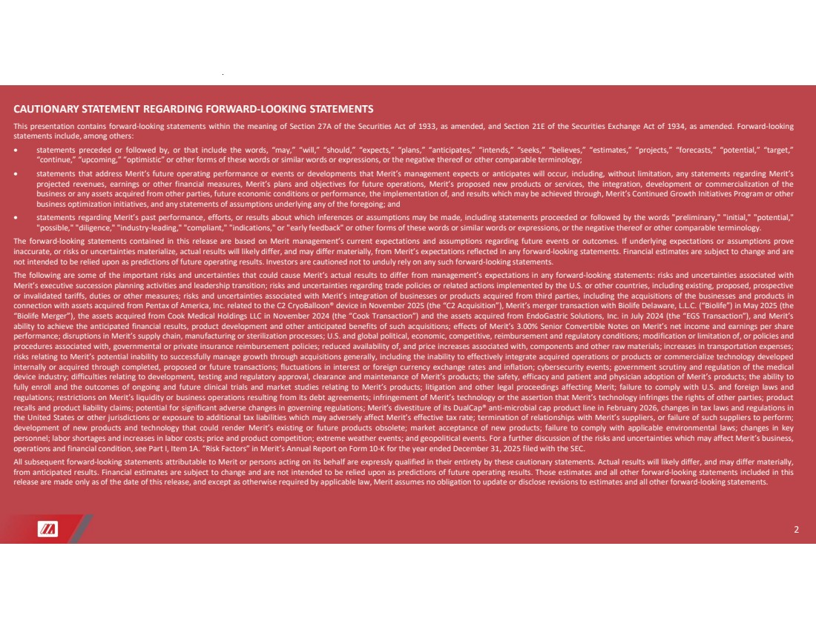 | 2 CAUTIONARY STATEMENT REGARDING FORWARD-LOOKING STATEMENTS This presentation contains forward-looking statements within the meaning of Section 27A of the Securities Act of 1933, as amended, and Section 21E of the Securities Exchange Act of 1934, as amended. Forward-looking statements include, among others: • statements preceded or followed by, or that include the words, “may,” “will,” “should,” “expects,” “plans,” “anticipates,” “intends,” “seeks,” “believes,” “estimates,” “projects,” “forecasts,” “potential,” “target,” “continue,” “upcoming,” “optimistic” or other forms of these words or similar words or expressions, or the negative thereof or other comparable terminology; • statements that address Merit’s future operating performance or events or developments that Merit’s management expects or anticipates will occur, including, without limitation, any statements regarding Merit’s projected revenues, earnings or other financial measures, Merit’s plans and objectives for future operations, Merit’s proposed new products or services, the integration, development or commercialization of the business or any assets acquired from other parties, future economic conditions or performance, the implementation of, and results which may be achieved through, Merit’s Continued Growth Initiatives Program or other business optimization initiatives, and any statements of assumptions underlying any of the foregoing; and • statements regarding Merit’s past performance, efforts, or results about which inferences or assumptions may be made, including statements proceeded or followed by the words "preliminary," "initial," "potential," "possible," "diligence," "industry-leading," "compliant," "indications," or "early feedback" or other forms of these words or similar words or expressions, or the negative thereof or other comparable terminology. The forward-looking statements contained in this release are based on Merit management’s current expectations and assumptions regarding future events or outcomes. If underlying expectations or assumptions prove inaccurate, or risks or uncertainties materialize, actual results will likely differ, and may differ materially, from Merit’s expectations reflected in any forward-looking statements. Financial estimates are subject to change and are not intended to be relied upon as predictions of future operating results. Investors are cautioned not to unduly rely on any such forward-looking statements. The following are some of the important risks and uncertainties that could cause Merit’s actual results to differ from management’s expectations in any forward-looking statements: risks and uncertainties associated with Merit’s executive succession planning activities and leadership transition; risks and uncertainties regarding trade policies or related actions implemented by the U.S. or other countries, including existing, proposed, prospective or invalidated tariffs, duties or other measures; risks and uncertainties associated with Merit’s integration of businesses or products acquired from third parties, including the acquisitions of the businesses and products in connection with assets acquired from Pentax of America, Inc. related to the C2 CryoBalloon® device in November 2025 (the “C2 Acquisition”), Merit’s merger transaction with Biolife Delaware, L.L.C. (“Biolife”) in May 2025 (the “Biolife Merger”), the assets acquired from Cook Medical Holdings LLC in November 2024 (the “Cook Transaction”) and the assets acquired from EndoGastric Solutions, Inc. in July 2024 (the “EGS Transaction”), and Merit’s ability to achieve the anticipated financial results, product development and other anticipated benefits of such acquisitions; effects of Merit’s 3.00% Senior Convertible Notes on Merit’s net income and earnings per share performance; disruptions in Merit’s supply chain, manufacturing or sterilization processes; U.S. and global political, economic, competitive, reimbursement and regulatory conditions; modification or limitation of, or policies and procedures associated with, governmental or private insurance reimbursement policies; reduced availability of, and price increases associated with, components and other raw materials; increases in transportation expenses; risks relating to Merit’s potential inability to successfully manage growth through acquisitions generally, including the inability to effectively integrate acquired operations or products or commercialize technology developed internally or acquired through completed, proposed or future transactions; fluctuations in interest or foreign currency exchange rates and inflation; cybersecurity events; government scrutiny and regulation of the medical device industry; difficulties relating to development, testing and regulatory approval, clearance and maintenance of Merit’s products; the safety, efficacy and patient and physician adoption of Merit’s products; the ability to fully enroll and the outcomes of ongoing and future clinical trials and market studies relating to Merit’s products; litigation and other legal proceedings affecting Merit; failure to comply with U.S. and foreign laws and regulations; restrictions on Merit’s liquidity or business operations resulting from its debt agreements; infringement of Merit’s technology or the assertion that Merit’s technology infringes the rights of other parties; product recalls and product liability claims; potential for significant adverse changes in governing regulations; Merit’s divestiture of its DualCap® anti-microbial cap product line in February 2026, changes in tax laws and regulations in the United States or other jurisdictions or exposure to additional tax liabilities which may adversely affect Merit’s effective tax rate; termination of relationships with Merit’s suppliers, or failure of such suppliers to perform; development of new products and technology that could render Merit’s existing or future products obsolete; market acceptance of new products; failure to comply with applicable environmental laws; changes in key personnel; labor shortages and increases in labor costs; price and product competition; extreme weather events; and geopolitical events. For a further discussion of the risks and uncertainties which may affect Merit’s business, operations and financial condition, see Part I, Item 1A. “Risk Factors” in Merit’s Annual Report on Form 10-K for the year ended December 31, 2025 filed with the SEC. All subsequent forward-looking statements attributable to Merit or persons acting on its behalf are expressly qualified in their entirety by these cautionary statements. Actual results will likely differ, and may differ materially, from anticipated results. Financial estimates are subject to change and are not intended to be relied upon as predictions of future operating results. Those estimates and all other forward-looking statements included in this release are made only as of the date of this release, and except as otherwise required by applicable law, Merit assumes no obligation to update or disclose revisions to estimates and all other forward-looking statements.
 | 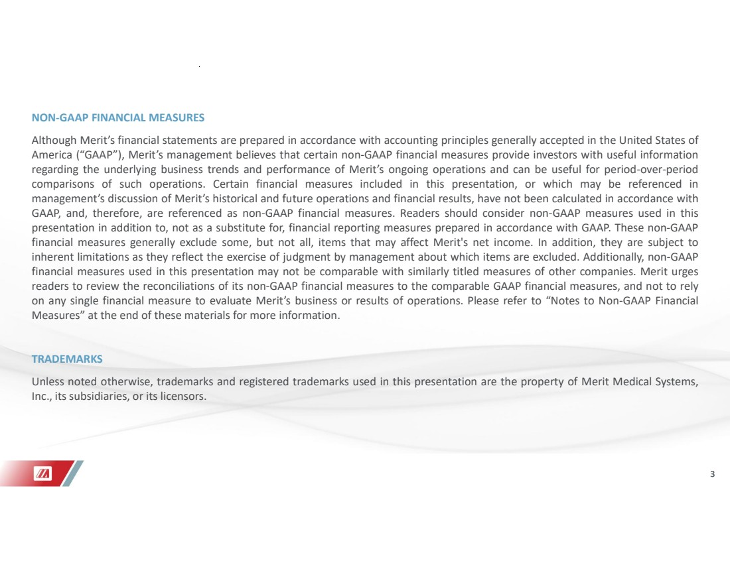 | 3 NON-GAAP FINANCIAL MEASURES Although Merit’s financial statements are prepared in accordance with accounting principles generally accepted in the United States of America (“GAAP”), Merit’s management believes that certain non-GAAP financial measures provide investors with useful information regarding the underlying business trends and performance of Merit’s ongoing operations and can be useful for period-over-period comparisons of such operations. Certain financial measures included in this presentation, or which may be referenced in management’s discussion of Merit’s historical and future operations and financial results, have not been calculated in accordance with GAAP, and, therefore, are referenced as non-GAAP financial measures. Readers should consider non-GAAP measures used in this presentation in addition to, not as a substitute for, financial reporting measures prepared in accordance with GAAP. These non-GAAP financial measures generally exclude some, but not all, items that may affect Merit's net income. In addition, they are subject to inherent limitations as they reflect the exercise of judgment by management about which items are excluded. Additionally, non-GAAP financial measures used in this presentation may not be comparable with similarly titled measures of other companies. Merit urges readers to review the reconciliations of its non-GAAP financial measures to the comparable GAAP financial measures, and not to rely on any single financial measure to evaluate Merit’s business or results of operations. Please refer to “Notes to Non-GAAP Financial Measures” at the end of these materials for more information. TRADEMARKS Unless noted otherwise, trademarks and registered trademarks used in this presentation are the property of Merit Medical Systems, Inc., its subsidiaries, or its licensors.
 | 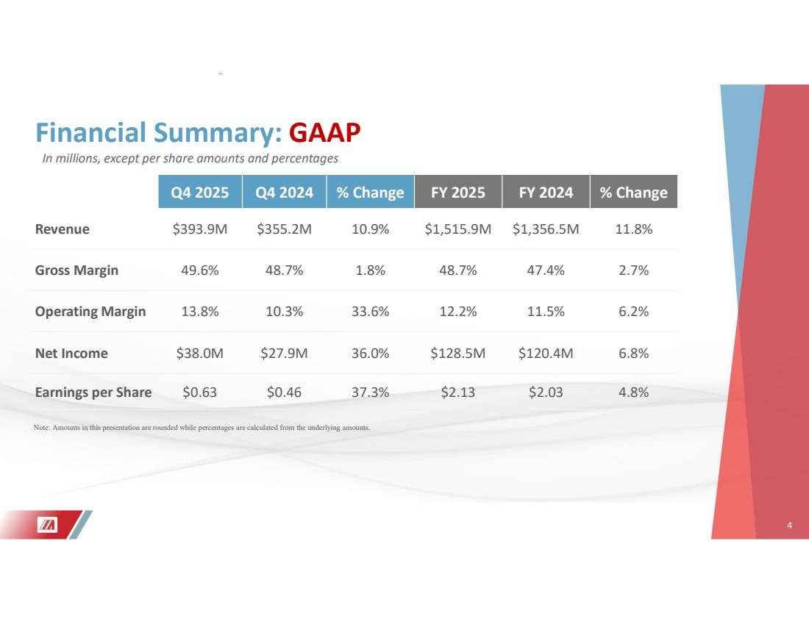 | 4 Q4 2025 Q4 2024 % Change FY 2025 FY 2024 % Change Revenue $393.9M $355.2M 10.9% $1,515.9M $1,356.5M 11.8% Gross Margin 49.6% 48.7% 1.8% 48.7% 47.4% 2.7% Operating Margin 13.8% 10.3% 33.6% 12.2% 11.5% 6.2% Net Income $38.0M $27.9M 36.0% $128.5M $120.4M 6.8% Earnings per Share $0.63 $0.46 37.3% $2.13 $2.03 4.8% Financial Summary: GAAP 4 Note: Amounts in this presentation are rounded while percentages are calculated from the underlying amounts. In millions, except per share amounts and percentages
 | 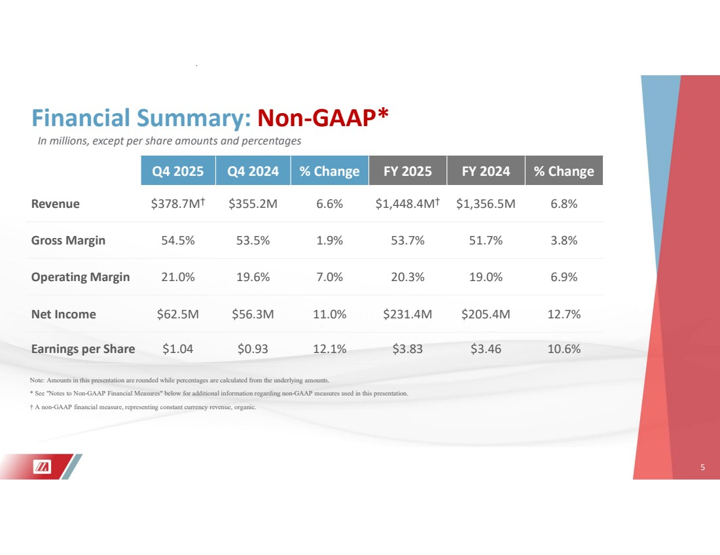 | 5 Q4 2025 Q4 2024 % Change FY 2025 FY 2024 % Change Revenue $378.7M† $355.2M 6.6% $1,448.4M† $1,356.5M 6.8% Gross Margin 54.5% 53.5% 1.9% 53.7% 51.7% 3.8% Operating Margin 21.0% 19.6% 7.0% 20.3% 19.0% 6.9% Net Income $62.5M $56.3M 11.0% $231.4M $205.4M 12.7% Earnings per Share $1.04 $0.93 12.1% $3.83 $3.46 10.6% Financial Summary: Non-GAAP* 5 Note: Amounts in this presentation are rounded while percentages are calculated from the underlying amounts. * See "Notes to Non-GAAP Financial Measures" below for additional information regarding non-GAAP measures used in this presentation. † A non-GAAP financial measure, representing constant currency revenue, organic. In millions, except per share amounts and percentages
 | 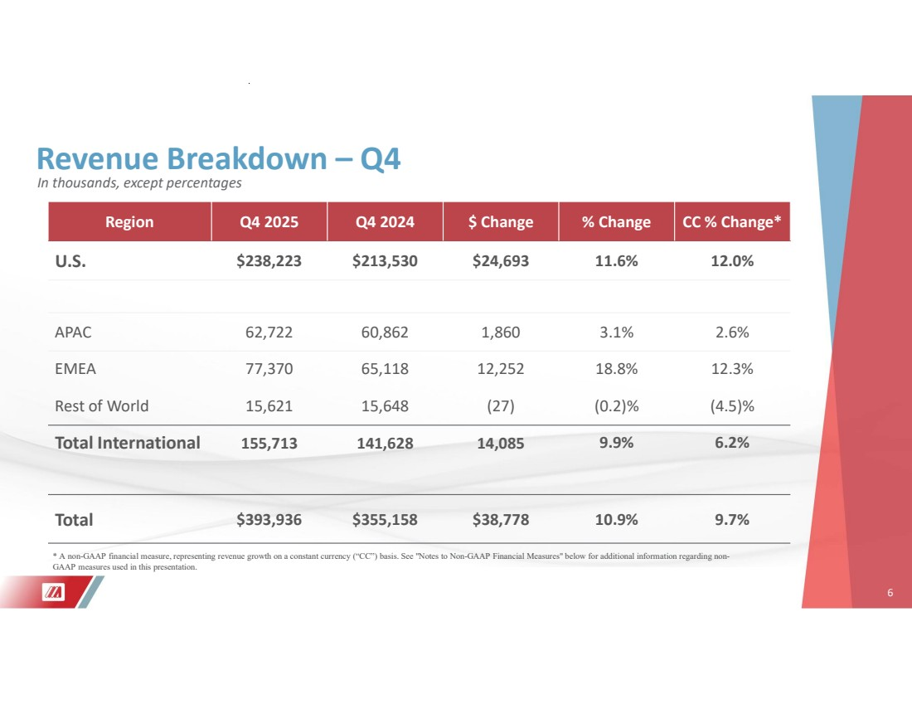 | 6 Revenue Breakdown – Q4 Region Q4 2025 Q4 2024 $ Change % Change CC % Change* U.S. $238,223 $213,530 $24,693 11.6% 12.0% APAC 62,722 60,862 1,860 3.1% 2.6% EMEA 77,370 65,118 12,252 18.8% 12.3% Rest of World 15,621 15,648 (27) (0.2)% (4.5)% Total International 155,713 141,628 14,085 9.9% 6.2% Total $393,936 $355,158 $38,778 10.9% 9.7% 6 * A non-GAAP financial measure, representing revenue growth on a constant currency (“CC”) basis. See "Notes to Non-GAAP Financial Measures" below for additional information regarding non-GAAP measures used in this presentation. In thousands, except percentages
 | 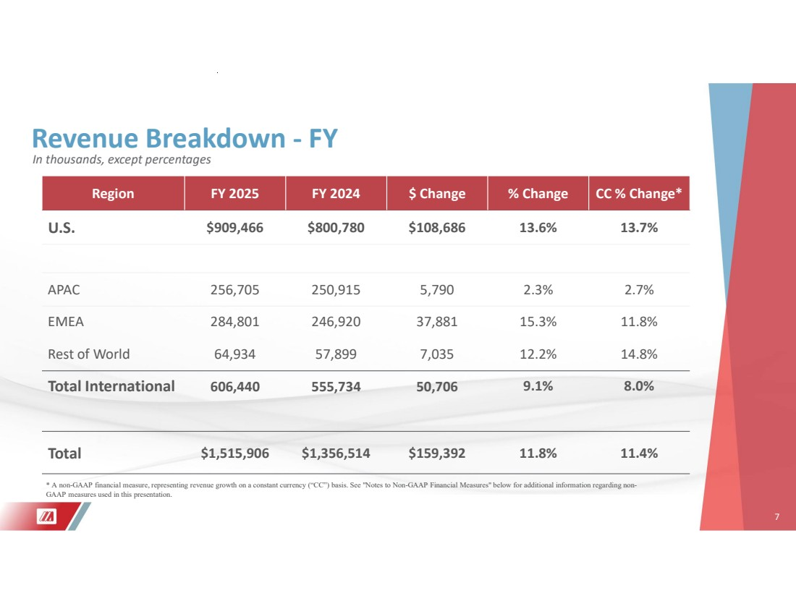 | 7 Revenue Breakdown - FY Region FY 2025 FY 2024 $ Change % Change CC % Change* U.S. $909,466 $800,780 $108,686 13.6% 13.7% APAC 256,705 250,915 5,790 2.3% 2.7% EMEA 284,801 246,920 37,881 15.3% 11.8% Rest of World 64,934 57,899 7,035 12.2% 14.8% Total International 606,440 555,734 50,706 9.1% 8.0% Total $1,515,906 $1,356,514 $159,392 11.8% 11.4% 7 * A non-GAAP financial measure, representing revenue growth on a constant currency (“CC”) basis. See "Notes to Non-GAAP Financial Measures" below for additional information regarding non-GAAP measures used in this presentation. In thousands, except percentages
 | 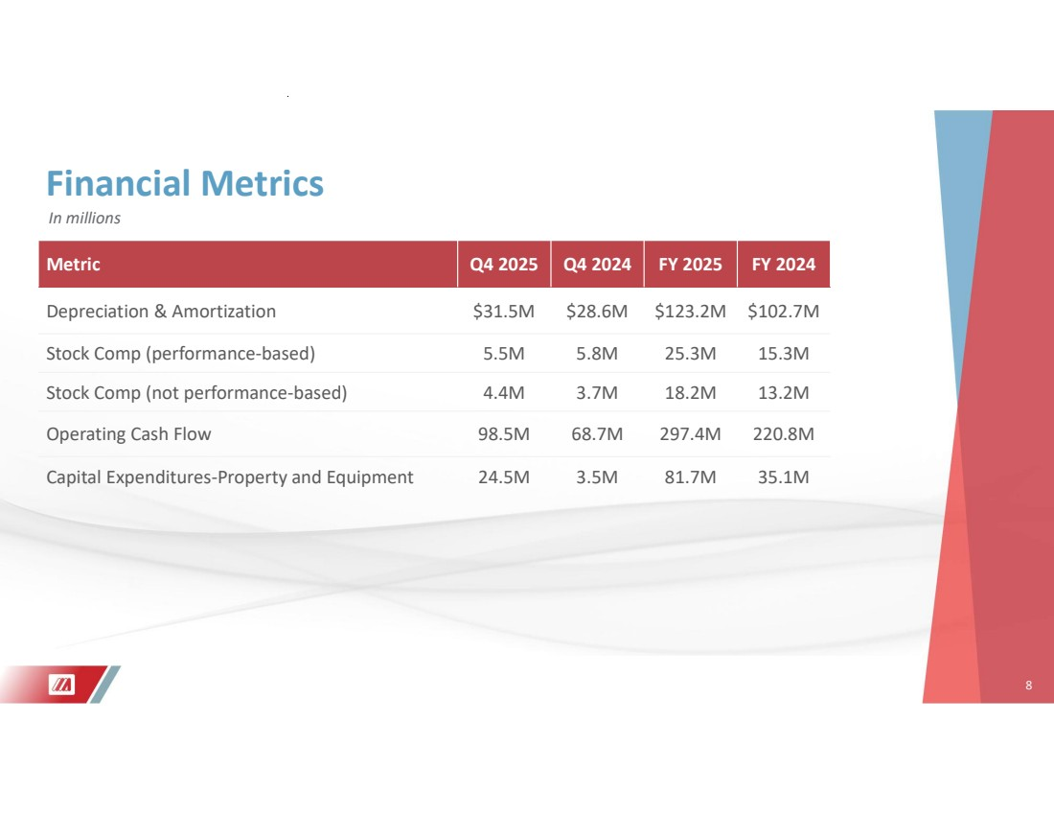 | 8 Financial Metrics Metric Q4 2025 Q4 2024 FY 2025 FY 2024 Depreciation & Amortization $31.5M $28.6M $123.2M $102.7M Stock Comp (performance-based) 5.5M 5.8M 25.3M 15.3M Stock Comp (not performance-based) 4.4M 3.7M 18.2M 13.2M Operating Cash Flow 98.5M 68.7M 297.4M 220.8M Capital Expenditures-Property and Equipment 24.5M 3.5M 81.7M 35.1M 8 In millions
 | 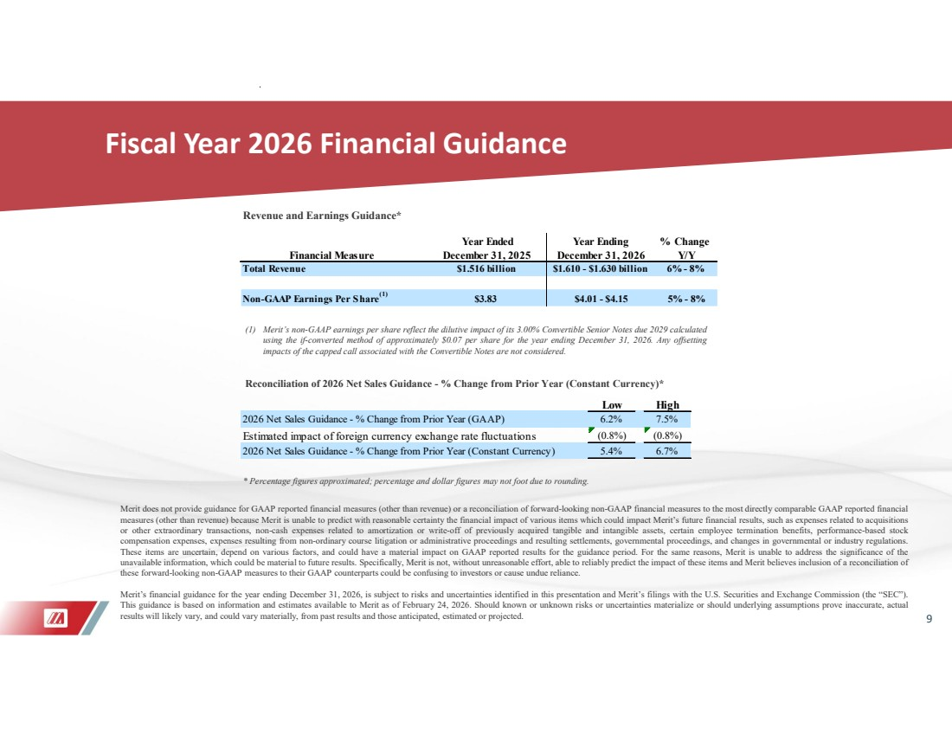 | 9 Fiscal Year 2026 Financial Guidance Merit does not provide guidance for GAAP reported financial measures (other than revenue) or a reconciliation of forward-looking non-GAAP financial measures to the most directly comparable GAAP reported financial measures (other than revenue) because Merit is unable to predict with reasonable certainty the financial impact of various items which could impact Merit’s future financial results, such as expenses related to acquisitions or other extraordinary transactions, non-cash expenses related to amortization or write-off of previously acquired tangible and intangible assets, certain employee termination benefits, performance-based stock compensation expenses, expenses resulting from non-ordinary course litigation or administrative proceedings and resulting settlements, governmental proceedings, and changes in governmental or industry regulations. These items are uncertain, depend on various factors, and could have a material impact on GAAP reported results for the guidance period. For the same reasons, Merit is unable to address the significance of the unavailable information, which could be material to future results. Specifically, Merit is not, without unreasonable effort, able to reliably predict the impact of these items and Merit believes inclusion of a reconciliation of these forward-looking non-GAAP measures to their GAAP counterparts could be confusing to investors or cause undue reliance. Merit’s financial guidance for the year ending December 31, 2026, is subject to risks and uncertainties identified in this presentation and Merit’s filings with the U.S. Securities and Exchange Commission (the “SEC”). This guidance is based on information and estimates available to Merit as of February 24, 2026. Should known or unknown risks or uncertainties materialize or should underlying assumptions prove inaccurate, actual results will likely vary, and could vary materially, from past results and those anticipated, estimated or projected. * Percentage figures approximated; percentage and dollar figures may not foot due to rounding. Reconciliation of 2026 Net Sales Guidance - % Change from Prior Year (Constant Currency)* Revenue and Earnings Guidance* (1) Merit’s non-GAAP earnings per share reflect the dilutive impact of its 3.00% Convertible Senior Notes due 2029 calculated using the if-converted method of approximately $0.07 per share for the year ending December 31, 2026. Any offsetting impacts of the capped call associated with the Convertible Notes are not considered. Low High 2026 Net Sales Guidance - % Change from Prior Year (GAAP) 6.2% 7.5% Estimated impact of foreign currency exchange rate fluctuations (0.8%) (0.8%) 2026 Net Sales Guidance - % Change from Prior Year (Constant Currency) 5.4% 6.7% Year Ended Year Ending % Change Financial Measure December 31, 2025 December 31, 2026 Y/Y Total Revenue $1.516 billion $1.610 - $1.630 billion 6% - 8% Non-GAAP Earnings Per Share(1) $3.83 $4.01 - $4.15 5% - 8%
 | 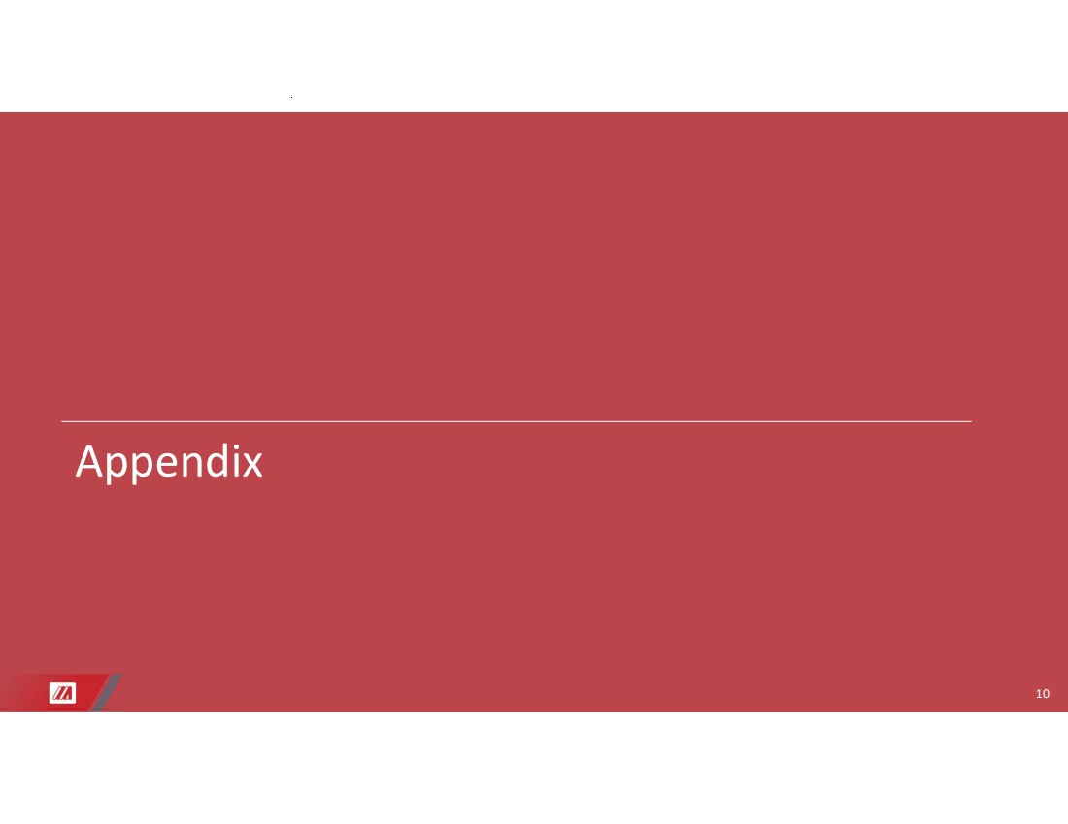 | 10 Appendix
 | 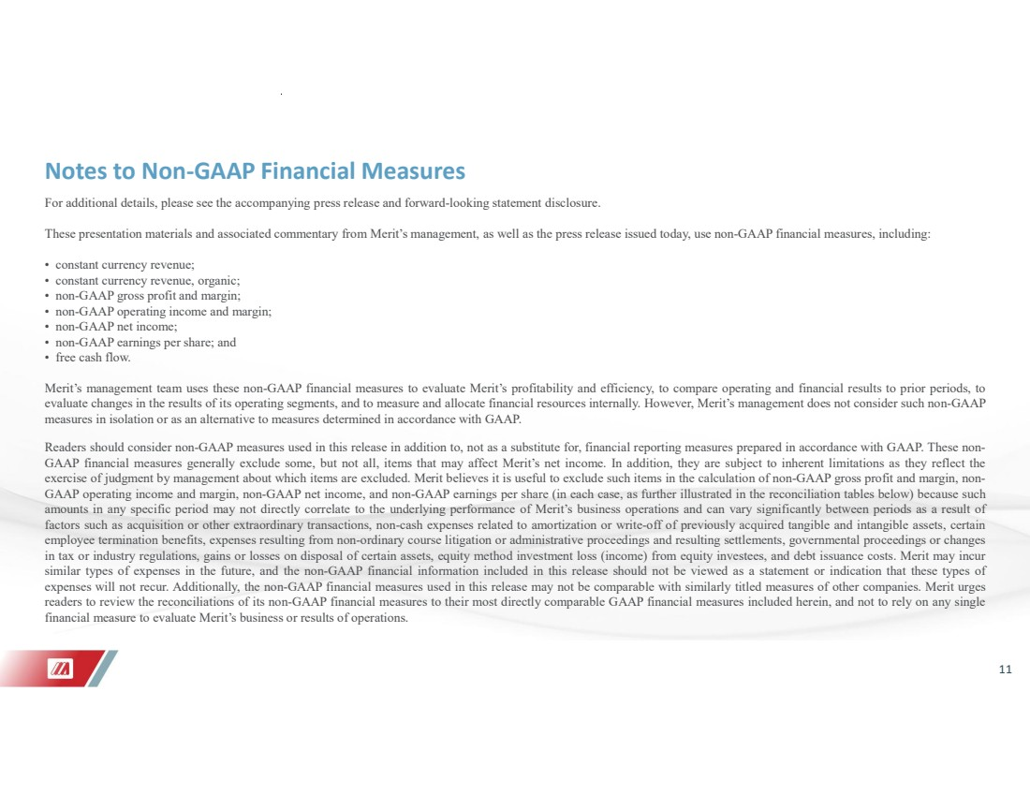 | 11 Notes to Non-GAAP Financial Measures For additional details, please see the accompanying press release and forward-looking statement disclosure. These presentation materials and associated commentary from Merit’s management, as well as the press release issued today, use non-GAAP financial measures, including: • constant currency revenue; • constant currency revenue, organic; • non-GAAP gross profit and margin; • non-GAAP operating income and margin; • non-GAAP net income; • non-GAAP earnings per share; and • free cash flow. Merit’s management team uses these non-GAAP financial measures to evaluate Merit’s profitability and efficiency, to compare operating and financial results to prior periods, to evaluate changes in the results of its operating segments, and to measure and allocate financial resources internally. However, Merit’s management does not consider such non-GAAP measures in isolation or as an alternative to measures determined in accordance with GAAP. Readers should consider non-GAAP measures used in this release in addition to, not as a substitute for, financial reporting measures prepared in accordance with GAAP. These non-GAAP financial measures generally exclude some, but not all, items that may affect Merit’s net income. In addition, they are subject to inherent limitations as they reflect the exercise of judgment by management about which items are excluded. Merit believes it is useful to exclude such items in the calculation of non-GAAP gross profit and margin, non-GAAP operating income and margin, non-GAAP net income, and non-GAAP earnings per share (in each case, as further illustrated in the reconciliation tables below) because such amounts in any specific period may not directly correlate to the underlying performance of Merit’s business operations and can vary significantly between periods as a result of factors such as acquisition or other extraordinary transactions, non-cash expenses related to amortization or write-off of previously acquired tangible and intangible assets, certain employee termination benefits, expenses resulting from non-ordinary course litigation or administrative proceedings and resulting settlements, governmental proceedings or changes in tax or industry regulations, gains or losses on disposal of certain assets, equity method investment loss (income) from equity investees, and debt issuance costs. Merit may incur similar types of expenses in the future, and the non-GAAP financial information included in this release should not be viewed as a statement or indication that these types of expenses will not recur. Additionally, the non-GAAP financial measures used in this release may not be comparable with similarly titled measures of other companies. Merit urges readers to review the reconciliations of its non-GAAP financial measures to their most directly comparable GAAP financial measures included herein, and not to rely on any single financial measure to evaluate Merit’s business or results of operations.
 | 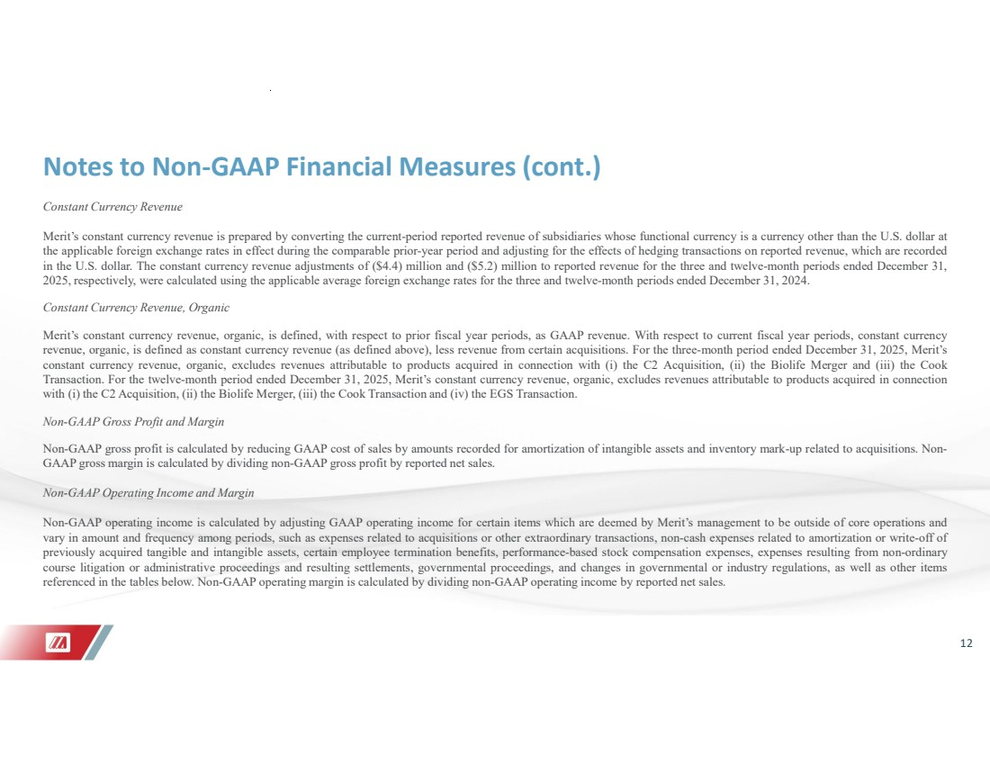 | 12 Notes to Non-GAAP Financial Measures (cont.) Constant Currency Revenue Merit’s constant currency revenue is prepared by converting the current-period reported revenue of subsidiaries whose functional currency is a currency other than the U.S. dollar at the applicable foreign exchange rates in effect during the comparable prior-year period and adjusting for the effects of hedging transactions on reported revenue, which are recorded in the U.S. dollar. The constant currency revenue adjustments of ($4.4) million and ($5.2) million to reported revenue for the three and twelve-month periods ended December 31, 2025, respectively, were calculated using the applicable average foreign exchange rates for the three and twelve-month periods ended December 31, 2024. Constant Currency Revenue, Organic Merit’s constant currency revenue, organic, is defined, with respect to prior fiscal year periods, as GAAP revenue. With respect to current fiscal year periods, constant currency revenue, organic, is defined as constant currency revenue (as defined above), less revenue from certain acquisitions. For the three-month period ended December 31, 2025, Merit’s constant currency revenue, organic, excludes revenues attributable to products acquired in connection with (i) the C2 Acquisition, (ii) the Biolife Merger and (iii) the Cook Transaction. For the twelve-month period ended December 31, 2025, Merit’s constant currency revenue, organic, excludes revenues attributable to products acquired in connection with (i) the C2 Acquisition, (ii) the Biolife Merger, (iii) the Cook Transaction and (iv) the EGS Transaction. Non-GAAP Gross Profit and Margin Non-GAAP gross profit is calculated by reducing GAAP cost of sales by amounts recorded for amortization of intangible assets and inventory mark-up related to acquisitions. Non-GAAP gross margin is calculated by dividing non-GAAP gross profit by reported net sales. Non-GAAP Operating Income and Margin Non-GAAP operating income is calculated by adjusting GAAP operating income for certain items which are deemed by Merit’s management to be outside of core operations and vary in amount and frequency among periods, such as expenses related to acquisitions or other extraordinary transactions, non-cash expenses related to amortization or write-off of previously acquired tangible and intangible assets, certain employee termination benefits, performance-based stock compensation expenses, expenses resulting from non-ordinary course litigation or administrative proceedings and resulting settlements, governmental proceedings, and changes in governmental or industry regulations, as well as other items referenced in the tables below. Non-GAAP operating margin is calculated by dividing non-GAAP operating income by reported net sales.
 | 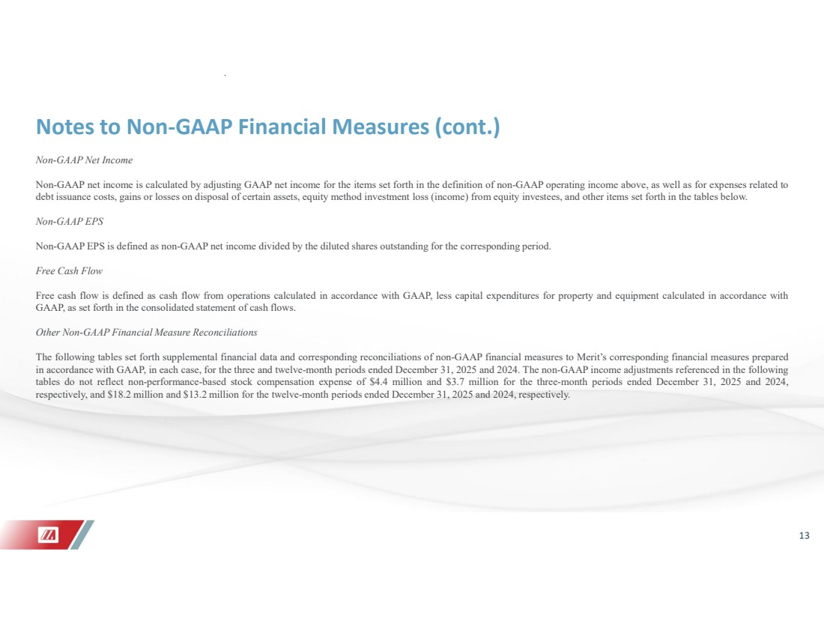 | 13 Notes to Non-GAAP Financial Measures (cont.) Non-GAAP Net Income Non-GAAP net income is calculated by adjusting GAAP net income for the items set forth in the definition of non-GAAP operating income above, as well as for expenses related to debt issuance costs, gains or losses on disposal of certain assets, equity method investment loss (income) from equity investees, and other items set forth in the tables below. Non-GAAP EPS Non-GAAP EPS is defined as non-GAAP net income divided by the diluted shares outstanding for the corresponding period. Free Cash Flow Free cash flow is defined as cash flow from operations calculated in accordance with GAAP, less capital expenditures for property and equipment calculated in accordance with GAAP, as set forth in the consolidated statement of cash flows. Other Non-GAAP Financial Measure Reconciliations The following tables set forth supplemental financial data and corresponding reconciliations of non-GAAP financial measures to Merit’s corresponding financial measures prepared in accordance with GAAP, in each case, for the three and twelve-month periods ended December 31, 2025 and 2024. The non-GAAP income adjustments referenced in the following tables do not reflect non-performance-based stock compensation expense of $4.4 million and $3.7 million for the three-month periods ended December 31, 2025 and 2024, respectively, and $18.2 million and $13.2 million for the twelve-month periods ended December 31, 2025 and 2024, respectively.
 | 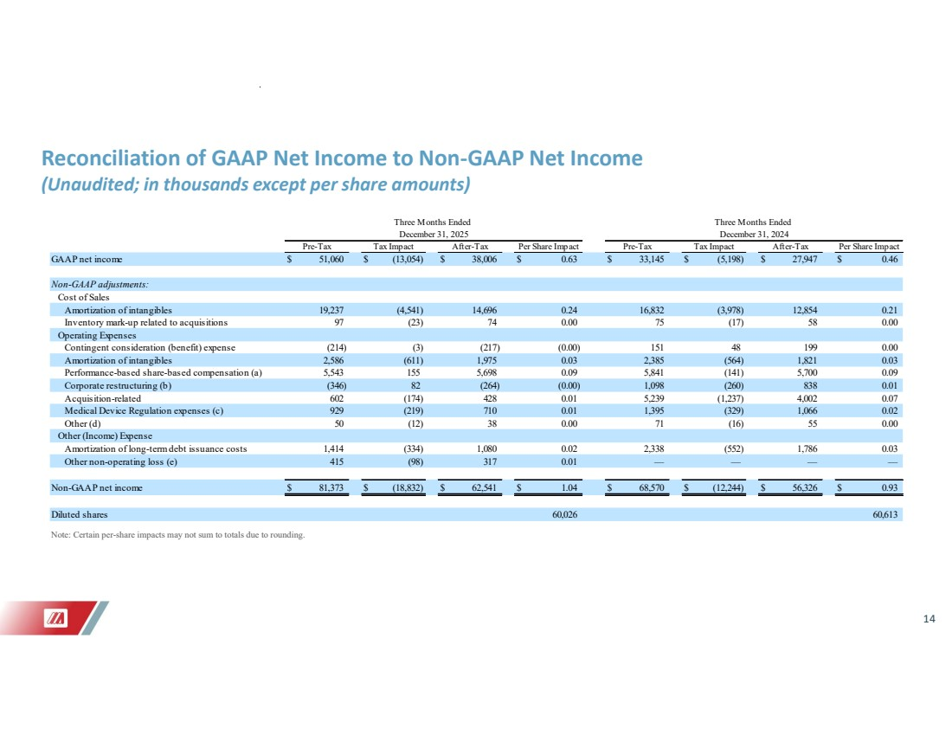 | 14 Reconciliation of GAAP Net Income to Non-GAAP Net Income (Unaudited; in thousands except per share amounts) Note: Certain per-share impacts may not sum to totals due to rounding. GAAP net income $ 51,060 $ (13,054) $ 38,006 $ 0.63 $ 33,145 $ (5,198) $ 27,947 $ 0.46 Non-GAAP adjustments: Cost of Sales Amortization of intangibles 19,237 (4,541) 14,696 0.24 16,832 (3,978) 12,854 0.21 Inventory mark-up related to acquisitions 97 (23) 74 0.00 75 (17) 58 0.00 Operating Expenses Contingent consideration (benefit) expense (214) (3) (217) (0.00) 151 48 199 0.00 Amortization of intangibles 2,586 (611) 1,975 0.03 2,385 (564) 1,821 0.03 Performance-based share-based compensation (a) 5,543 155 5,698 0.09 5,841 (141) 5,700 0.09 Corporate restructuring (b) (346) 82 (264) (0.00) 1,098 (260) 838 0.01 Acquisition-related 602 (174) 428 0.01 5,239 (1,237) 4,002 0.07 Medical Device Regulation expenses (c) 929 (219) 710 0.01 1,395 (329) 1,066 0.02 Other (d) 50 (12) 38 0.00 71 (16) 55 0.00 Other (Income) Expense Amortization of long-term debt issuance costs 1,414 (334) 1,080 0.02 2,338 (552) 1,786 0.03 Other non-operating loss (e) 415 (98) 317 0.01 — — — — Non-GAAP net income $ 81,373 $ (18,832) $ 62,541 $ 1.04 $ 68,570 $ (12,244) $ 56,326 $ 0.93 Diluted shares 60,026 60,613 Three Months Ended Three Months Ended December 31, 2025 December 31, 2024 Pre-Tax Tax Impact After-Tax Per Share Impact Pre-Tax Tax Impact After-Tax Per Share Impact
 | 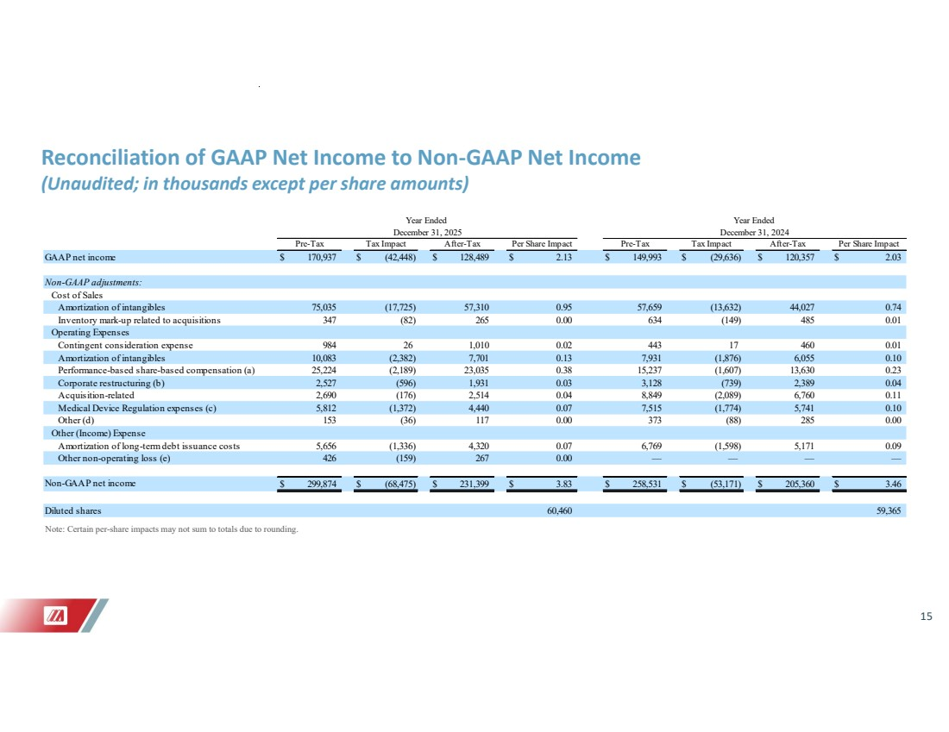 | 15 Reconciliation of GAAP Net Income to Non-GAAP Net Income (Unaudited; in thousands except per share amounts) Note: Certain per-share impacts may not sum to totals due to rounding. GAAP net income $ 170,937 $ (42,448) $ 128,489 $ 2.13 $ 149,993 $ (29,636) $ 120,357 $ 2.03 Non-GAAP adjustments: Cost of Sales Amortization of intangibles 75,035 (17,725) 57,310 0.95 57,659 (13,632) 44,027 0.74 Inventory mark-up related to acquisitions 347 (82) 265 0.00 634 (149) 485 0.01 Operating Expenses Contingent consideration expense 984 26 1,010 0.02 443 17 460 0.01 Amortization of intangibles 10,083 (2,382) 7,701 0.13 7,931 (1,876) 6,055 0.10 Performance-based share-based compensation (a) 25,224 (2,189) 23,035 0.38 15,237 (1,607) 13,630 0.23 Corporate restructuring (b) 2,527 (596) 1,931 0.03 3,128 (739) 2,389 0.04 Acquisition-related 2,690 (176) 2,514 0.04 8,849 (2,089) 6,760 0.11 Medical Device Regulation expenses (c) 5,812 (1,372) 4,440 0.07 7,515 (1,774) 5,741 0.10 Other (d) 153 (36) 117 0.00 373 (88) 285 0.00 Other (Income) Expense Amortization of long-term debt issuance costs 5,656 (1,336) 4,320 0.07 6,769 (1,598) 5,171 0.09 Other non-operating loss (e) 426 (159) 267 0.00 — — — — Non-GAAP net income $ 299,874 $ (68,475) $ 231,399 $ 3.83 $ 258,531 $ (53,171) $ 205,360 $ 3.46 Diluted shares 60,460 59,365 Year Ended Year Ended December 31, 2025 December 31, 2024 Pre-Tax Tax Impact After-Tax Per Share Impact Pre-Tax Tax Impact After-Tax Per Share Impact
 | 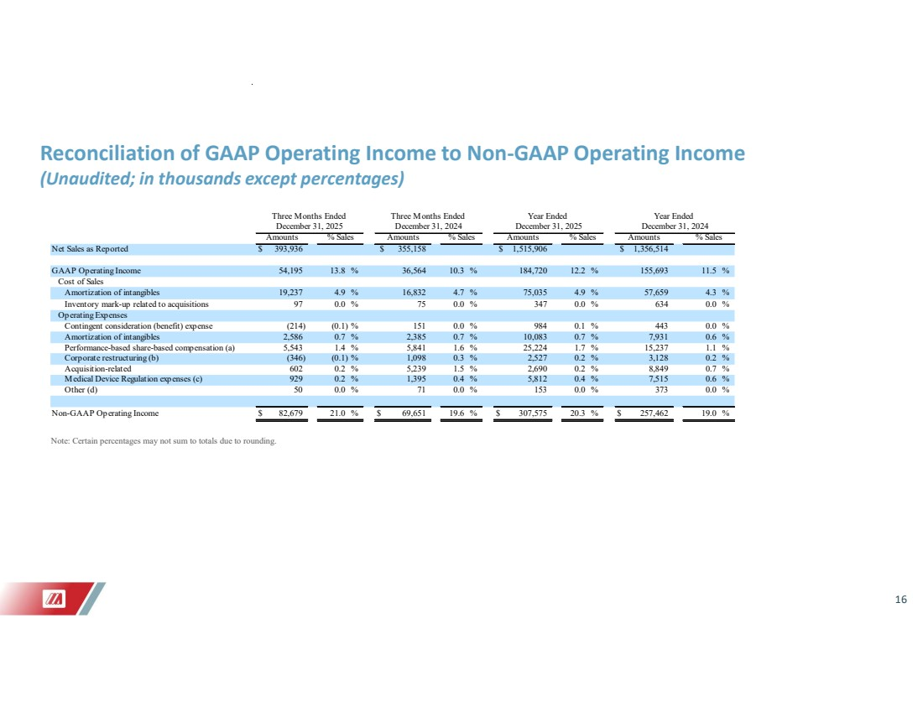 | 16 Reconciliation of GAAP Operating Income to Non-GAAP Operating Income (Unaudited; in thousands except percentages) Note: Certain percentages may not sum to totals due to rounding. Net Sales as Reported $ 393,936 $ 355,158 $ 1,515,906 $ 1,356,514 GAAP Operating Income 54,195 13.8 % 36,564 10.3 % 184,720 12.2 % 155,693 11.5 % Cost of Sales Amortization of intangibles 19,237 4.9 % 16,832 4.7 % 75,035 4.9 % 57,659 4.3 % Inventory mark-up related to acquisitions 97 0.0 % 75 0.0 % 347 0.0 % 634 0.0 % Operating Expenses Contingent consideration (benefit) expense (214) (0.1) % 151 0.0 % 984 0.1 % 443 0.0 % Amortization of intangibles 2,586 0.7 % 2,385 0.7 % 10,083 0.7 % 7,931 0.6 % Performance-based share-based compensation (a) 5,543 1.4 % 5,841 1.6 % 25,224 1.7 % 15,237 1.1 % Corporate restructuring (b) (346) (0.1) % 1,098 0.3 % 2,527 0.2 % 3,128 0.2 % Acquisition-related 602 0.2 % 5,239 1.5 % 2,690 0.2 % 8,849 0.7 % Medical Device Regulation expenses (c) 929 0.2 % 1,395 0.4 % 5,812 0.4 % 7,515 0.6 % Other (d) 50 0.0 % 71 0.0 % 153 0.0 % 373 0.0 % Non-GAAP Operating Income $ 82,679 21.0 % $ 69,651 19.6 % $ 307,575 20.3 % $ 257,462 19.0 % Three Months Ended Three Months Ended Year Ended Year Ended December 31, 2025 December 31, 2024 December 31, 2025 December 31, 2024 Amounts % Sales Amounts % Sales Amounts % Sales Amounts % Sales
 | 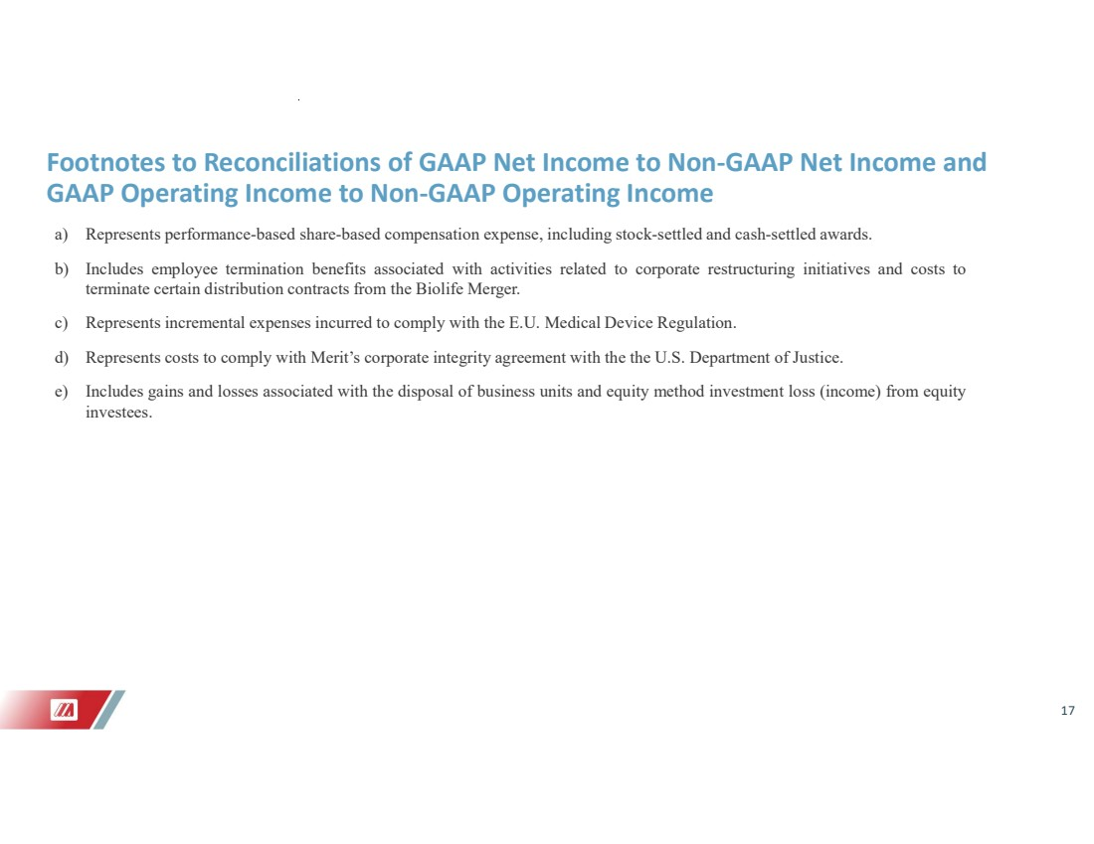 | 17 Footnotes to Reconciliations of GAAP Net Income to Non-GAAP Net Income and GAAP Operating Income to Non-GAAP Operating Income a) Represents performance-based share-based compensation expense, including stock-settled and cash-settled awards. b) Includes employee termination benefits associated with activities related to corporate restructuring initiatives and costs to terminate certain distribution contracts from the Biolife Merger. c) Represents incremental expenses incurred to comply with the E.U. Medical Device Regulation. d) Represents costs to comply with Merit’s corporate integrity agreement with the the U.S. Department of Justice. e) Includes gains and losses associated with the disposal of business units and equity method investment loss (income) from equity investees.
 | 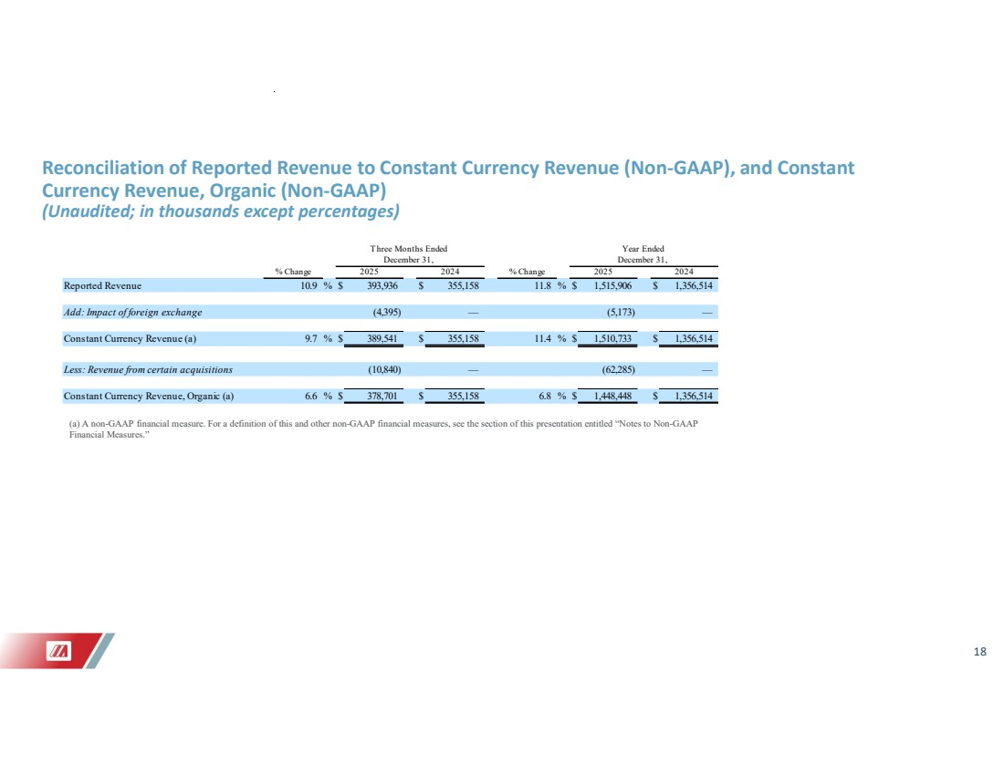 | 18 Reconciliation of Reported Revenue to Constant Currency Revenue (Non-GAAP), and Constant Currency Revenue, Organic (Non-GAAP) (Unaudited; in thousands except percentages) (a) A non-GAAP financial measure. For a definition of this and other non-GAAP financial measures, see the section of this presentation entitled “Notes to Non-GAAP Financial Measures.” % Change % Change Reported Revenue 10.9 % $ 393,936 $ 355,158 11.8 % $ 1,515,906 $ 1,356,514 Add: Impact of foreign exchange (4,395) — (5,173) — Constant Currency Revenue (a) 9.7 % $ 389,541 $ 355,158 11.4 % $ 1,510,733 $ 1,356,514 Less: Revenue from certain acquisitions — (10,840) (62,285) — Constant Currency Revenue, Organic (a) 6.6 % $ 378,701 $ 355,158 6.8 % $ 1,448,448 $ 1,356,514 T hree Months Ended Year Ended December 31, December 31, 2025 2024 2025 2024
 | 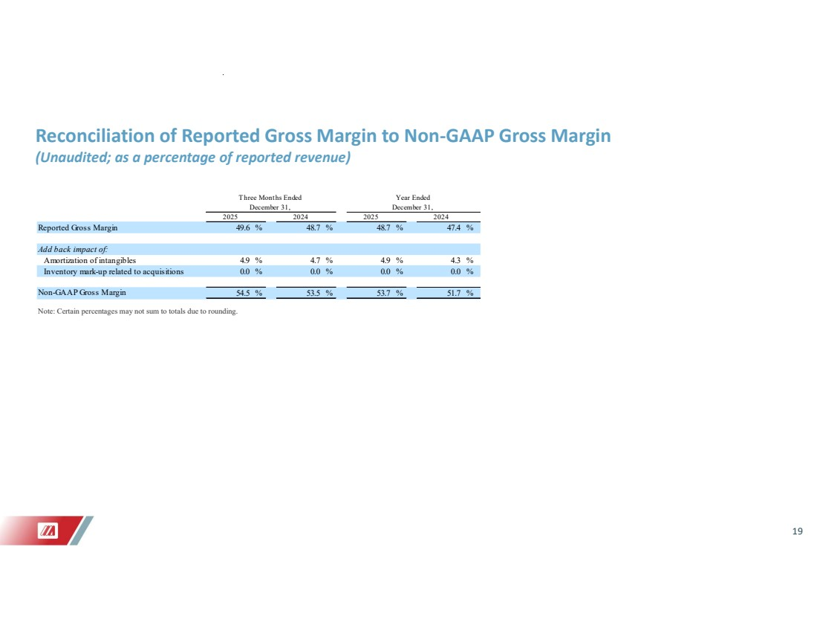 | 19 Reconciliation of Reported Gross Margin to Non-GAAP Gross Margin (Unaudited; as a percentage of reported revenue) Note: Certain percentages may not sum to totals due to rounding. 2025 2024 2025 2024 Reported Gross Margin 49.6 % 48.7 % 48.7 % 47.4 % Add back impact of: Amortization of intangibles 4.9 % 4.7 % 4.9 % 4.3 % Inventory mark-up related to acquisitions 0.0 % 0.0 % 0.0 % 0.0 % Non-GAAP Gross Margin % 53.5 54.5 % 53.7 % 51.7 % December 31, Three Months Ended Year Ended December 31,
 | 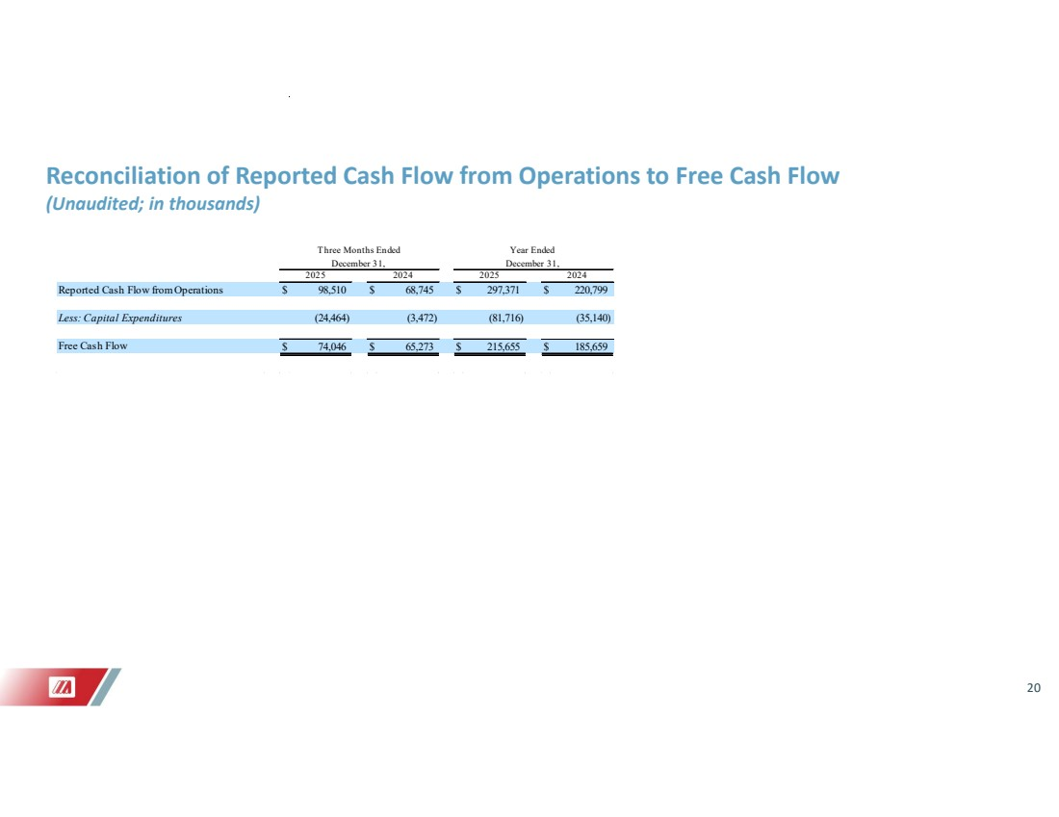 | 20 Reconciliation of Reported Cash Flow from Operations to Free Cash Flow (Unaudited; in thousands) Reported Cash Flow from Operations $ 98,510 $ 68,745 $ 297,371 $ 220,799 Less: Capital Expenditures (3,472) (24,464) (81,716) (35,140) Free Cash Flow $ 74,046 $ 65,273 $ 215,655 $ 185,659 Three Months Ended Year Ended December 31, December 31, 2025 2024 2025 2024


