UNITED STATES

SECURITIES AND EXCHANGE COMMISSION

Washington, D.C. 20549

FORM 8-K

CURRENT REPORT

Pursuant to Section 13 or 15(d) of the Securities Exchange Act of 1934

Date of Report (date of earliest event reported): October 29, 2026


Merit Medical Systems, Inc.

(Exact name of registrant as specified in its charter)

Utah

(State or other jurisdiction of

incorporation or organization)

​​​

0-18592

(Commission

File Number)

​​​

87-0447695

(I.R.S. Employer

Identification No.)

1600 West Merit Parkway

​​​

South Jordan, Utah

(Address of principal executive offices)

84095

(Zip Code)

(801) 253-1600

(Registrant's telephone number, including area code)

N/A

(Former name or former address, if changed since last report)

Check the appropriate box below if the Form 8-K filing is intended to simultaneously satisfy the filing obligation of the registrant under any of the following provisions:

- Written communications pursuant to Rule 425 under the Securities Act (17 CFR 230.425)

- Soliciting material pursuant to Rule 14a-12 under the Exchange Act (17 CFR 240.14a-12)

- Pre-commencement communications pursuant to Rule 14d-2(b) under the Exchange Act (17 CFR 240.14d-2(b))

- Pre-commencement communications pursuant to Rule 13e-4(c) under the Exchange Act (17 CFR 240.13e-4(c)) Securities registered pursuant to Section 12(b) of the Act:

Title of each class | ​​​ | Trading Symbol(s) | ​​​ | Name of each exchange on which registered
Common Stock, no par value |  | MMSI |  | NASDAQ Global Select Market System

Indicate by check mark whether the registrant is an emerging growth company as defined in Rule 405 of the Securities Act of 1933 (§230.405 of this chapter) or Rule 12b-2 of the Securities Exchange Act of 1934 (§240.12b-2 of this chapter).

Emerging growth company ☐

If an emerging growth company, indicate by check mark if the registrant has elected not to use the extended transition period for complying with any new or revised financial accounting standards provided pursuant to Section 13(a) of the Exchange Act. ☐

Item 2.02. Results of Operations and Financial Condition.

On October 29, 2026, Merit Medical Systems, Inc. (“Merit”) issued a press release (the “Earnings Press Release”) announcing its operating and financial results for the quarter ended September 30, 2026. A copy of the Earnings Press Release is furnished as Exhibit 99.1 to this report and incorporated herein by reference.

Item 7.01. Regulation FD Disclosure.

On October 29, 2026, Merit is conducting a conference call to discuss its operating and financial results for the quarter ended September 30, 2026. A live webcast and conference call presentation will also be available for the conference call at merit.com. A copy of the conference call presentation is furnished as Exhibit 99.2 to this report and incorporated herein by reference.

Additionally, on October 29, 2026, Merit issued a press release (the “Acquisition Press Release”) announcing its acquisition of Solo Pace, Inc. (“Solo Pace”) on October 13, 2026 pursuant to a Stock Purchase Agreement wherein Merit paid cash of approximately $45 million to acquire the outstanding equity interests of Solo Pace. A copy of the Acquisition Press Release is furnished as Exhibit 99.3 to this report and incorporated herein by reference.

The information contained in Item 2.02 and Item 7.01 of this report (including the exhibits attached hereto) is furnished pursuant to General Instruction B.2. of Form 8-K and shall not be deemed to be “filed” for purposes of Section 18 of the Securities Exchange Act of 1934, as amended (the “Exchange Act”), or otherwise subject to the liabilities of that section, nor shall it be deemed incorporated by reference in any filing made by Merit under the Securities Act of 1933, as amended, or the Exchange Act.

In addition to disclosing results that are determined in accordance with Generally Accepted Accounting Principles (“GAAP”), Merit is disclosing non-GAAP financial information in both the press release announcing its operating and financial results and the conference call presentation. Reconciliations of certain of these non-GAAP financial measures to the comparable GAAP financial measures are included in the press release and conference call presentation attached as Exhibit 99.1 and 99.2 to this report, respectively. Merit does not provide guidance for GAAP reported financial measures (other than revenue) or a reconciliation of forward-looking non-GAAP financial measures to the most directly comparable GAAP reported financial measures (other than revenue) because Merit is unable to predict with reasonable certainty the financial impact of items such as expenses related to acquisitions or other extraordinary transactions, non-cash expenses related to amortization or write-off of previously acquired tangible and intangible assets, certain severance expenses, performance-based stock compensation expenses, expenses resulting from non-ordinary course litigation or administrative proceedings and resulting settlements, governmental proceedings, and changes in governmental or industry regulations. These items are uncertain, depend on various factors, and could have a material impact on GAAP reported results for the guidance period. For the same reasons, Merit is unable to address the significance of the unavailable information, which could be material to future results. Specifically, Merit is not, without unreasonable effort, able to reasonably predict the amount and impact of these items, and Merit believes inclusion of the most directly comparable GAAP financial measure, and a reconciliation of these forward-looking non-GAAP figures to their GAAP counterparts, could be confusing to investors or cause undue reliance.

2

Item 9.01. Financial Statements and Exhibits.

(d) | Exhibits
EXHIBIT NUMBER |  |  |  |  | DESCRIPTION
 | 99.1 |  | Press Release, dated October 29, 2026, entitled “Merit Medical Reports Third Quarter 2026 Results: Delivers 9% Organic Constant
 |  |  | Currency Revenue Growth and Raises Full-Year 2026 Guidance” including unaudited financial information
 | 99.2 |  | Conference Call Presentation
 | 99.3 |  | Press Release, dated October 29, 2026, entitled “Merit Medical Acquires Solo Pace, Inc., Expanding Its Cardiac Therapies Platform
 |  |  | with Innovative TAVR Pacing Technology”
 | 104 |  | The cover page from this Current Report on Form 8-K, formatted in Inline XBRL

SIGNATURES

Pursuant to the requirements of the Securities Exchange Act of 1934, as amended, the registrant has duly caused this report to be signed on its behalf by the undersigned hereunto duly authorized.

 | MERIT MEDICAL SYSTEMS, INC.
Date: October 29, 2026 | By: /s/ Brian G. Lloyd
 |  | Brian G. Lloyd
 |  | Chief Legal Officer and Corporate Secretary
 | 3

Exhibit 99.1
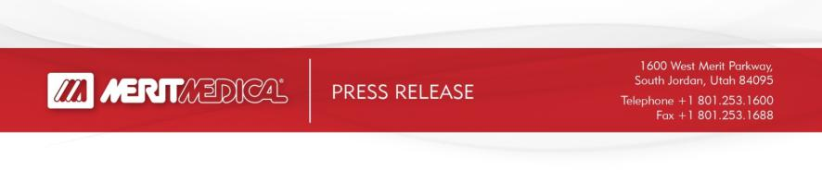

Contacts:
PR/Media Inquiries: |  |  | Investor Inquiries:
Sarah Comstock |  |  | Mike Piccinino, CFA, IRC
Merit Medical |  |  | ICR Healthcare
+1-801-432-2864 |  | +1-443-213-0509
sarah.comstock@merit.com |  |  | mike.piccinino@icrhealthcare.com

FOR IMMEDIATE RELEASE

MERIT MEDICAL REPORTS THIRD QUARTER 2026 RESULTS: DELIVERS 9% ORGANIC CONSTANT CURRENCY REVENUE GROWTH AND RAISES FULL-YEAR 2026 GUIDANCE

Financial Highlights†

  - Reported revenue of $416.2 million, up 8.4%

  - Constant currency revenue* and constant currency revenue, organic* up 8% and up 9%, respectively

  - GAAP operating margin of 14.1%, compared to 11.1% in prior year period

  - Non-GAAP operating margin* of 21.3%, compared to 19.7% in prior year period

  - GAAP EPS $0.70, up 51%

  - Non-GAAP EPS* $1.12, up 22%

  - Cash flow from operations of $175.2 million year-to-date

  - Free cash flow* generation of $129.5 million year-to-date

- Comparisons above are calculated for the current quarter compared with the third quarter of 2025, unless otherwise specified. Amounts stated in this release are rounded, while percentages are calculated from the underlying amounts.

- Constant currency revenue; constant currency revenue, organic; non-GAAP gross profit and margin; non-GAAP operating income and margin; non-GAAP net income; non-GAAP EPS; and free cash flow figures (used here and below) are non-GAAP financial measures. A reconciliation of these financial measures to their most directly comparable GAAP financial measures is included under the heading “Non-GAAP Financial Measures” below.

SOUTH JORDAN, Utah, October 29, 2026 -- Merit Medical Systems, Inc. (NASDAQ: MMSI), a leading global manufacturer and marketer of healthcare technology, today announced financial results for the three and nine-month periods ended September 30, 2026.

“Merit delivered third quarter financial results that exceeded the high end of our expectations, driven primarily by 9% organic, constant currency revenue growth, excluding the impact of a strategic divestiture,” said Martha G. Aronson, Merit’s President and CEO. “We experienced strong revenue growth trends in the U.S. and better-than-expected demand for Merit’s products across both our Foundational and our Therapeutic platforms. We also delivered strong growth in both our non-GAAP operating profit and our non-GAAP earnings per share, which increased 17% and 22%, respectively, year-over-year.” Ms. Aronson

1

continued: “We have raised our 2026 revenue and non-GAAP earnings per share guidance to reflect the stronger-than-expected results over the first nine months of 2026 and remain confident in our team’s ability to execute, with attractive constant currency growth, improving profitability, and solid cash flow generation this year. Our team remains focused on delivering our Continued Growth Initiative financial targets for the three-year period ending December 31, 2026, and, in parallel, we are finalizing our longer-term strategic plan focused on identifying opportunities to better position the company for sustainable growth, enhanced profitability and value creation for our shareholders.”

Merit’s revenue by product category for the three and nine-month periods ended September 30, 2026 and 2025 was as follows (unaudited; in thousands, except for percentages):

 | ​​​ |  |  |  |  |  |  |  |  |  | Three Months Ended
 | ​​​ |  |  |  |  |  |  |  | Reported |  |  |  |  |  |  | Impact of foreign |  |  |  |  |  | Constant Currency*
 | ​​​ |  |  | September 30, |  |  |  |  |  |  |  |  |  |  |  |  |  |  |  |  |  | September 30,
 | ​​​ |  |  | 2026 |  | ​​​ |  |  | 2025 |  | % Change |  |  |  |  | exchange |  |  |  |  |  | 2026 |  |  |  | % Change
 | Foundational
 | Access | $ |  | 157,922 |  | $ |  |  | 151,508 |  | 4 % |  | $ |  |  | (1,018) |  |  | $ |  |  | 156,904 |  |  | 4 %
 | OEM |  |  | 46,278 |  |  |  |  | 41,499 |  | 12 % |  |  |  |  | 47 |  |  |  |  |  | 46,325 |  |  | 12 %
 | Procedural Solutions |  |  | 27,162 |  |  |  |  | 32,287 |  | (16)% |  |  |  |  | 184 |  |  |  |  |  | 27,346 |  |  | (15)%
 | Vascular Intervention |  |  | 42,367 |  |  |  |  | 35,391 |  | 20 % |  |  |  |  | (166) |  |  |  |  |  | 42,201 |  |  | 19 %
 | Other |  |  | 2,006 |  |  |  |  | 221 |  | 808 % |  |  |  |  | 547 |  |  |  |  |  | 2,553 |  |  | 1,055 %
 | Total Foundational |  |  | 275,735 |  |  |  |  | 260,906 |  | 6 | % |  |  |  | (406) |  |  |  |  |  | 275,329 |  |  | 6 |  | %
 | Therapeutic
 | Cardiac Therapies |  |  | 27,547 |  |  |  |  | 25,530 |  | 8 % |  |  |  |  | (53) |  |  |  |  |  | 27,494 |  |  | 8 %
 | Endoscopy |  |  | 23,428 |  |  |  |  | 17,631 |  | 33 % |  |  |  |  | 36 |  |  |  |  |  | 23,464 |  |  | 33 %
 | OEM |  |  | 13,089 |  |  |  |  | 9,953 |  | 32 % |  |  |  |  | (16) |  |  |  |  |  | 13,073 |  |  | 31 %
 | Oncology |  |  | 27,085 |  |  |  |  | 23,263 |  | 16 % |  |  |  |  | (24) |  |  |  |  |  | 27,061 |  |  | 16 %
 | Renal Therapies |  |  | 13,550 |  |  |  |  | 13,808 |  | (2)% |  |  |  |  | (123) |  |  |  |  |  | 13,427 |  |  | (3)%
 | Vascular Intervention |  |  | 35,810 |  |  |  |  | 33,066 |  | 8 % |  |  |  |  | (496) |  |  |  |  |  | 35,314 |  |  | 7 %
 | Total Therapeutic |  |  | 140,509 |  |  |  |  | 123,251 |  | 14 | % |  |  |  | (676) |  |  |  |  |  | 139,833 |  |  | 13 |  | %
Total |  |  | $ | 416,244 |  |  |  | $ | 384,157 |  | 8 | % |  | $ |  | (1,082) |  |  |  | $ |  | 415,162 |  |  | 8 |  | %
 | ​​​ |  |  |  |  |  |  |  |  |  | Nine Months Ended
 | ​​​ |  |  |  |  |  |  |  | Reported |  |  |  |  |  |  | Impact of foreign |  |  |  |  |  | Constant Currency *
 | ​​​ |  |  | September 30, |  |  |  |  |  |  |  |  |  |  |  |  |  |  |  |  |  | September 30,
 | ​​​ |  |  | 2026 |  | ​​​ |  |  | 2025 |  | % Change |  |  |  |  | exchange |  |  |  |  |  | 2026 |  |  |  | % Change
Foundational
 | Access | $ |  | 470,832 |  | $ |  |  | 438,028 |  | 7 % |  | $ |  |  | (8,538) |  |  | $ |  |  | 462,294 |  |  | 6 %
 | OEM |  |  | 134,156 |  |  |  |  | 128,140 |  | 5 % |  |  |  |  | (217) |  |  |  |  |  | 133,939 |  |  | 5 %
 | Procedural Solutions |  |  | 81,599 |  |  |  |  | 92,597 |  | (12)% |  |  |  |  | 166 |  |  |  |  |  | 81,765 |  |  | (12)%
 | Vascular Intervention |  |  | 123,057 |  |  |  |  | 103,195 |  | 19 % |  |  |  |  | (1,638) |  |  |  |  |  | 121,419 |  |  | 18 %
 | Other |  |  | 2,531 |  |  |  |  | 1,710 |  | 48 % |  |  |  |  | 3,296 |  |  |  |  |  | 5,827 |  |  | 241 %
Total Foundational |  |  |  | 812,175 |  |  |  |  | 763,670 |  | 6 | % |  |  |  | (6,931) |  |  |  |  |  | 805,244 |  |  |  | 5 | %
Therapeutic
 | Cardiac Therapies |  |  | 83,461 |  |  |  |  | 69,019 |  | 21 % |  |  |  |  | (1,747) |  |  |  |  |  | 81,714 |  |  | 18 %
 | Endoscopy |  |  | 68,767 |  |  |  |  | 52,582 |  | 31 % |  |  |  |  | 56 |  |  |  |  |  | 68,823 |  |  | 31 %
 | OEM |  |  | 33,365 |  |  |  |  | 30,830 |  | 8 % |  |  |  |  | (66) |  |  |  |  |  | 33,299 |  |  | 8 %
 | Oncology |  |  | 76,367 |  |  |  |  | 69,257 |  | 10 % |  |  |  |  | (550) |  |  |  |  |  | 75,817 |  |  | 9 %
 | Renal Therapies |  |  | 37,775 |  |  |  |  | 40,014 |  | (6)% |  |  |  |  | (515) |  |  |  |  |  | 37,260 |  |  | (7)%
 | Vascular Intervention |  |  | 105,054 |  |  |  |  | 96,598 |  | 9 % |  |  |  |  | (2,252) |  |  |  |  |  | 102,802 |  |  | 6 %
Total Therapeutic |  |  |  | 404,789 |  |  |  |  | 358,300 |  | 13 | % |  |  |  | (5,074) |  |  |  |  |  | 399,715 |  |  |  | 12 | %
Total |  | $ |  | 1,216,964 |  |  | $ |  | 1,121,970 |  | 8 | % |  |  | $ | (12,005) |  |  |  |  | $ | 1,204,959 |  |  |  | 7 | %
 |  |  |  |  |  |  |  |  | 2

Financial Summary:

GAAP gross margin was 48.2%, compared to 48.5% for the third quarter of 2025. Non-GAAP gross margin* was 52.8%, compared to 53.6% for the third quarter of 2025.

GAAP operating margin was 14.1%, compared to 11.1% for the third quarter of 2025. Non-GAAP operating margin* was 21.3%, compared to 19.7% for the third quarter of 2025.

GAAP net income was $42.3 million, or $0.70 per share, compared to $27.8 million, or $0.46 per share, for the third quarter of 2025. Non-GAAP net income* was $67.4 million, or $1.12 per share, compared to $54.9 million, or $0.92 per share, for the third quarter of 2025.

As of September 30, 2026, Merit had cash and cash equivalents of $503.6 million and total debt obligations of $747.5 million, compared to cash and cash equivalents of $446.4 million and total debt obligations of $747.5 million as of December 31, 2025. Merit had available borrowing capacity of approximately $697 million as of September 30, 2026.

Fiscal Year 2026 Financial Guidance

Based upon the information currently available to Merit’s management, for the twelve-month period ending December 31, 2026, absent the potential impact of trade policies and related actions implemented by the U.S. and other countries subsequent to today’s date, material acquisitions, non-recurring transactions or other factors beyond Merit’s current expectations, Merit anticipates the following financial results:

Revenue and Earnings Guidance*
 | ​​​ |  | Updated Guidance |  |  | Prior Guidance⁽²⁾
 |  |  | Year Ending | % Change |  | Year Ending | % Change
 | Financial Measure |  | December 31, 2026 | Y/Y |  | December 31, 2026 | Y/Y
 | Total Revenue |  | $1.635 - $1.642 billion | 8% | - 8% | $1.631 - $1.643 billion | 8% | - 8%
 | Non-GAAP Earnings Per Share⁽¹⁾ |  | $4.33 - $4.37 | 13% | - 14% | $4.25 - $4.35 | 11% | - 14%

*Percentage figures approximated; dollar figures may not foot due to rounding.

- Merit’s non-GAAP earnings per share reflect the dilutive impact of its 3.00% Convertible Senior Notes due 2029 (the “Convertible Notes”) calculated using the if-converted method of approximately $0.01 per share for the year ending December 31, 2026. Any offsetting impacts of the capped call associated with the Convertible Notes are not considered.

- “Prior Guidance” reflects Merit’s full-year 2026 financial guidance, previously introduced on July 30, 2026.

Merit does not provide guidance for GAAP reported financial measures (other than revenue) or a reconciliation of forward-looking non-GAAP financial measures to the most directly comparable GAAP reported financial measures (other than revenue) because Merit is unable to predict with reasonable certainty the financial impact of various items which could impact Merit’s future financial results, such as expenses attributable to acquisitions or other extraordinary transactions, non-cash expenses related to amortization or write-off of previously acquired tangible and intangible assets, certain employee termination benefits, performance-based stock compensation expenses, expenses resulting from non-ordinary course litigation or administrative proceedings and resulting settlements, governmental proceedings, and changes in governmental or industry regulations. These items are uncertain, depend on various factors, and could have a material impact on GAAP reported results for the guidance period. For the same reasons, Merit is unable to address the significance of the unavailable information, which could be material to future results. Specifically, Merit is not, without unreasonable effort, able to reasonably predict the amount and impact of these items and Merit believes inclusion of the most comparable GAAP financial measure, and a reconciliation of these forward-looking non-GAAP measures to their GAAP counterparts could be confusing to investors or cause undue reliance.

Merit’s financial guidance for the year ending December 31, 2026 is subject to risks and uncertainties identified in this release and Merit’s filings with the SEC. This guidance is based on information and estimates available to Merit as of October 29, 2026. Should known or unknown risks or uncertainties materialize or should underlying assumptions prove inaccurate, actual results will likely vary, and could vary materially, from past results and those anticipated, estimated or projected.

3

CONFERENCE CALL

As previously announced, Merit will hold its investor conference call today, Thursday, October 29, 2026, at 4:30 p.m., Eastern Time, to discuss its results for the third quarter and provide an operational update. To access the conference call, please pre-register using the following link. Registrants will receive confirmation with dial-in details. A live webcast and slide deck will also be available at merit.com.

4

CONSOLIDATED BALANCE SHEETS

(in thousands)

 |  |  |  | September 30, |  |  |  | December 31,
 |  |  |  | 2026 |  |  |  | 2025 | ​
 | ASSETS |  |  | (Unaudited) |  |  |  |  | ​
 | Current Assets |  |  |  | ​ |  |  |  | ​
 | Cash and cash equivalents | $ |  | 503,551 | $ |  |  | 446,404
 | Trade receivables, net |  |  | 221,866 |  |  |  | 203,710
 | Other receivables |  |  | 37,875 |  |  |  | 17,773
 | Inventories |  |  | 391,022 |  |  |  | 333,705
 | Prepaid expenses and other current assets |  |  | 35,188 |  |  |  | 31,493
 | Prepaid income taxes |  |  | 5,030 |  |  |  | 4,941
 | Income tax refund receivables |  |  | 4,283 |  |  |  | 2,128
 | Total current assets |  |  | 1,198,815 |  |  |  | 1,040,154
 | Property and equipment, net |  |  | 437,347 |  |  |  | 428,401
 | Intangible assets, net |  |  | 591,204 |  |  |  | 537,654
 | Goodwill |  |  | 537,135 |  |  |  | 506,837
 | Deferred income tax assets |  |  | 7,273 |  |  |  | 7,049
 | Right-of-use operating lease assets |  |  | 84,379 |  |  |  | 87,600
 | Other assets |  |  | 68,753 |  |  |  | 78,227
Total Assets |  |  | $ | 2,924,906 |  |  | $ | 2,685,922
 |  |  |  |  |  |  |  |  | ​
 | LIABILITIES AND STOCKHOLDERS' EQUITY |  |  |  | ​ |  |  |  | ​
 | Current Liabilities |  |  |  | ​ |  |  |  | ​
 | Trade payables | $ |  | 66,286 | $ |  |  | 60,551
 | Accrued expenses |  |  | 174,024 |  |  |  | 159,486
 | Short-term operating lease liabilities |  |  | 10,382 |  |  |  | 10,876
 | Income taxes payable |  |  | 14,391 |  |  |  | 8,851
 | Total current liabilities |  |  | 265,083 |  |  |  | 239,764
 | Long-term debt |  |  | 737,404 |  |  |  | 734,038
 | Deferred income tax liabilities |  |  | 37,216 |  |  |  | 19,665
 | Liabilities related to unrecognized tax benefits |  |  | 2,248 |  |  |  | 2,248
 | Deferred compensation payable |  |  | 19,373 |  |  |  | 17,542
 | Deferred credits |  |  | 1,321 |  |  |  | 1,398
 | Long-term operating lease liabilities |  |  | 74,273 |  |  |  | 76,658
 | Other long-term obligations |  |  | 43,437 |  |  |  | 10,306
 | Total liabilities |  |  | 1,180,355 |  |  |  | 1,101,619
 |  |  |  |  |  |  |  |  | ​
 | Stockholders' Equity |  |  |  | ​ |  |  |  | ​
 | Common stock |  |  | 808,930 |  |  |  | 763,909
 | Retained earnings |  |  | 946,139 |  |  |  | 824,030
 | Accumulated other comprehensive loss |  |  | (10,518) |  |  |  | (3,636)
 | Total stockholders' equity |  |  | 1,744,551 |  |  |  | 1,584,303
Total Liabilities and Stockholders' Equity |  |  | $ | 2,924,906 |  |  | $ | 2,685,922

5

CONSOLIDATED STATEMENTS OF INCOME

(Unaudited, in thousands except per share amounts)

 | ​​​ |  |  | Three Months Ended |  |  |  | ​​​ |  | Nine Months Ended
 | ​​​ |  |  | September 30, |  |  |  | ​​​ |  | September 30,
 | ​​​ |  |  | 2026 | ​​​ |  | 2025 | ​​​ |  | 2026 | ​​​ |  | 2025
 | Net sales |  | $ | 416,244 |  | $ | 384,157 |  | $ | 1,216,964 |  | $ | 1,121,970
 | Cost of sales |  |  | 215,613 |  |  | 197,746 |  |  | 616,370 |  |  | 579,052
 | Gross profit |  |  | 200,631 |  |  | 186,411 |  |  | 600,594 |  |  | 542,918
 |  |  |  |  |  |  |  |  |  |  |  |  |  | ​
 | Operating expenses: |  |  |  | ​ |  |  | ​ |  |  | ​ |  |  | ​
 | Selling, general and administrative |  |  | 119,511 |  |  | 119,801 |  |  | 366,950 |  |  | 340,384
 | Research and development |  |  | 22,393 |  |  | 23,966 |  |  | 70,391 |  |  | 70,811
 | Contingent consideration (benefit) expense |  |  | (36) |  |  | 32 |  |  | (70) |  |  | 1,198
 | Total operating expenses |  |  | 141,868 |  |  | 143,799 |  |  | 437,271 |  |  | 412,393
 | Income from operations |  |  | 58,763 |  |  | 42,612 |  |  | 163,323 |  |  | 130,525
 |  |  |  |  |  |  |  |  |  |  |  |  |  | ​
 | Other income (expense): |  |  |  | ​ |  |  | ​ |  |  | ​ |  |  | ​
 | Interest income |  |  | 4,128 |  |  | 3,615 |  |  | 11,780 |  |  | 11,166
 | Interest expense |  |  | (7,333) |  |  | (6,754) |  |  | (25,977) |  |  | (20,097)
 | Other income (expense) — net |  |  | 227 |  |  | (933) |  |  | 11,519 |  |  | (1,717)
 | Total other expense — net |  |  | (2,978) |  |  | (4,072) |  |  | (2,678) |  |  | (10,648)
 | Income before income taxes |  |  | 55,785 |  |  | 38,540 |  |  | 160,645 |  |  | 119,877
 | Income tax expense |  |  | 13,474 |  |  | 10,785 |  |  | 38,536 |  |  | 29,394
 | Net income | $ |  | 42,311 | $ |  | 27,755 | $ |  | 122,109 | $ |  | 90,483
 |  |  |  |  |  |  |  |  |  |  |  |  |  | ​
 | Earnings per common share |  |  |  | ​ |  |  | ​ |  |  | ​ |  |  | ​
 | Basic | $ |  | 0.71 | $ |  | 0.47 | $ |  | 2.05 | $ |  | 1.53
 | Diluted | $ |  | 0.70 | $ |  | 0.46 | $ |  | 2.03 | $ |  | 1.49
 |  |  |  |  |  |  |  |  |  |  |  |  |  | ​
 | Weighted average shares outstanding |  |  |  | ​ |  |  | ​ |  |  | ​ |  |  | ​
 | Basic |  |  | 59,806 |  |  | 59,245 |  |  | 59,666 |  |  | 59,095
 | Diluted |  |  | 60,379 |  |  | 59,919 |  |  | 60,134 |  |  | 60,604

6

CONSOLIDATED STATEMENTS OF CASH FLOWS

(Unaudited, in thousands)

 |  |  |  | Nine Months Ended
 | ​​​ |  |  | September 30,
 | ​​​ |  |  | 2026 | ​​​ |  | 2025
 | CASH FLOWS FROM OPERATING ACTIVITIES:
 | Net income | $ |  | 122,109 | $ |  | 90,483 | ​
 | Adjustments to reconcile net income to net cash provided by operating activities: |  |  |  | ​ |  |  | ​
 | Depreciation and amortization |  |  | 93,383 |  |  | 91,629
 | Gain on disposition of a business |  |  | (12,557) |  |  | (249)
 | Amortization of right-of-use operating lease assets |  |  | 8,771 |  |  | 8,693
 | Fair value adjustments related to contingent consideration liabilities |  |  | (70) |  |  | 1,198
 | Stock-based compensation expense |  |  | 35,497 |  |  | 33,563
 | Other adjustments |  |  | 6,950 |  |  | 5,123
 | Changes in operating assets and liabilities, net of acquisitions and divestitures |  |  | (78,853) |  |  | (31,579)
 | Total adjustments |  |  | 53,121 |  |  | 108,378
 | Net cash, cash equivalents, and restricted cash provided by operating activities |  |  | 175,230 |  |  | 198,861
 |  |  |  |  |  |  |  | ​
 | CASH FLOWS FROM INVESTING ACTIVITIES: |  |  |  | ​ |  |  | ​
 | Capital expenditures for property and equipment |  |  | (45,686) |  |  | (57,252)
 | Proceeds from asset and business dispositions |  |  | 25,555 |  |  | 298
 | Cash paid for notes receivable and other investments |  |  | (9,242) |  |  | (14,936)
 | Cash paid in acquisitions, net of cash acquired |  |  | (93,049) |  |  | (122,834)
 | Other investing, net |  |  | (2,293) |  |  | (2,327)
 | Net cash, cash equivalents, and restricted cash used in investing activities |  |  | (124,715) |  |  | (197,051)
 | CASH FLOWS FROM FINANCING ACTIVITIES:
 | Proceeds from issuance of common stock |  |  | 16,272 |  |  | 22,179
 | Contingent payments related to acquisitions |  |  | (3,030) |  |  | (2,645)
 | Payment of taxes related to an exchange of common stock |  |  | (6,973) |  |  | (8,597)
 | Net cash, cash equivalents, and restricted cash provided by financing activities |  |  | 6,269 |  |  | 10,937
 | Effect of exchange rates on cash |  |  | 454 |  |  | 3,047
 | Net increase in cash, cash equivalents and restricted cash |  |  | 57,238 |  |  | 15,794
 |  |  |  |  |  |  |  | ​
 | CASH, CASH EQUIVALENTS AND RESTRICTED CASH: |  |  |  | ​ |  |  | ​
 | Beginning of period |  |  | 448,549 |  |  | 378,767
 | End of period |  | $ | 505,787 |  | $ | 394,561
 | RECONCILIATION OF CASH, CASH EQUIVALENTS AND RESTRICTED CASH TO THE CONSOLIDATED BALANCE
SHEETS:
 | Cash and cash equivalents |  |  | 503,551 |  |  | 392,457
 | Restricted cash reported in prepaid expenses and other current assets |  |  | 2,236 |  |  | 2,104
 | Total cash, cash equivalents and restricted cash |  | $ | 505,787 |  | $ | 394,561
7

Non-GAAP Financial Measures

Although Merit’s financial statements are prepared in accordance with accounting principles generally accepted in the United States of America (“GAAP”), Merit’s management believes that the non-GAAP financial measures referenced in this release may provide investors with useful information regarding the underlying business trends and performance of Merit’s ongoing operations and can be useful for period-over-period comparisons of such operations. Non-GAAP financial measures used in this release include:

- constant currency revenue;

- constant currency revenue, organic;

- non-GAAP gross profit and margin;

- non-GAAP operating income and margin;

- non-GAAP net income;

- non-GAAP earnings per share; and

- free cash flow.

Merit’s management team uses these non-GAAP financial measures to evaluate Merit’s profitability and efficiency, to compare operating and financial results to prior periods, to evaluate changes in the results of its operating segment, and to measure and allocate financial resources internally. However, Merit’s management does not consider such non-GAAP measures in isolation or as an alternative to measures determined in accordance with GAAP.

Readers should consider non-GAAP measures used in this release in addition to, not as a substitute for, financial reporting measures prepared in accordance with GAAP. These non-GAAP financial measures generally exclude some, but not all, items that may affect Merit’s net income. In addition, they are subject to inherent limitations as they reflect the exercise of judgment by management about which items are excluded. Merit believes it is useful to exclude such items in the calculation of non-GAAP gross profit and margin, non-GAAP operating income and margin, non-GAAP net income, and non-GAAP earnings per share (in each case, as further illustrated in the reconciliation tables below) because such amounts in any specific period may not directly correlate to the underlying performance of Merit’s business operations and can vary significantly between periods as a result of factors such as acquisition or other extraordinary transactions, non-cash expenses related to amortization or write-off of previously acquired tangible and intangible assets, certain employee termination benefits, expenses resulting from non-ordinary course litigation or administrative proceedings and resulting settlements, governmental proceedings or changes in tax or industry regulations, gains or losses on disposal of certain assets, equity method investment loss (income) from equity investees, and debt issuance costs. Merit may incur similar types of expenses in the future, and the non-GAAP financial information included in this release should not be viewed as a statement or indication that these types of expenses will not recur. Additionally, the non-GAAP financial measures used in this release may not be comparable with similarly titled measures of other companies. Merit urges readers to review the reconciliations of its non-GAAP financial measures to their most directly comparable GAAP financial measures included herein, and not to rely on any single financial measure to evaluate Merit’s business or results of operations.

Constant Currency Revenue

Merit’s constant currency revenue is prepared by converting the current-period reported revenue of subsidiaries whose functional currency is a currency other than the U.S. dollar at the applicable foreign exchange rates in effect during the comparable prior-year period and adjusting for the effects of hedging transactions on reported revenue, which are recorded in the U.S. dollar. The constant currency revenue adjustment of $(1.1) million and $(12.0) million to reported revenue for the three and nine-month periods ended September 30, 2026 was calculated using the applicable average foreign exchange rates for the three and nine-month periods ended September 30, 2025.

8

Constant Currency Revenue, Organic

Merit’s constant currency revenue, organic, is defined, with respect to prior fiscal year periods, as GAAP revenue less revenue from certain divestitures. For the three and nine-month periods ended September 30, 2025, Merit’s constant currency revenue, organic, excludes revenues attributable to the DualCap® product line which Merit sold to Health Line International Corporation (“Health Line”) on February 17, 2026 (the “DualCap Divestiture”).

With respect to current fiscal year periods, constant currency revenue, organic, is defined as constant currency revenue (as defined above), less revenue from certain acquisitions and divestitures. For the three-month period ended September 30, 2026, Merit’s constant currency revenue, organic, excludes revenues attributable to products acquired in connection with (i) Merit’s acquisition of View Point Medical, Inc. (“View Point”) in April 2026 (the “View Point Merger”) and (ii) the assets acquired from Pentax of America, Inc. related to the C2 CryoBalloon™ device in November 2025 (the “C2 Acquisition”). For the nine-month period ended September 30, 2026, Merit’s constant currency revenue, organic, excludes revenues attributable to products acquired in connection with (i) the View Point Merger, (ii) the C2 Acquisition and (iii) Merit’s acquisition of Biolife Delaware, L.L.C. (“Biolife”) in May 2025 (the “Biolife Merger”) and excludes revenues attributable to the DualCap Divestiture.

Non-GAAP Gross Profit and Margin

Non-GAAP gross profit is calculated by reducing GAAP cost of sales by amounts recorded for amortization of intangible assets and inventory mark-up related to acquisitions.

Non-GAAP gross margin is calculated by dividing non-GAAP gross profit by reported net sales.

Non-GAAP Operating Income and Margin

Non-GAAP operating income is calculated by adjusting GAAP operating income for certain items which are deemed by Merit’s management to be outside of core operations and vary in amount and frequency among periods, such as expenses related to acquisitions or other extraordinary transactions, non-cash expenses related to amortization or write-off of previously acquired tangible and intangible assets, certain employee termination benefits, performance-based stock compensation expenses, expenses resulting from non-ordinary course litigation or administrative proceedings and resulting settlements, governmental proceedings, and changes in governmental or industry regulations, as well as other items referenced in the tables below. Non-GAAP operating margin is calculated by dividing non-GAAP operating income by reported net sales.

Non-GAAP Net Income

Non-GAAP net income is calculated by adjusting GAAP net income for the items set forth in the definition of non-GAAP operating income above, as well as for expenses related to Merit’s long-term debt, gains or losses on disposal of certain assets, equity method investment loss (income) from equity investees, and other items set forth in the tables below.

Non-GAAP EPS

Non-GAAP EPS is defined as non-GAAP net income divided by the diluted shares outstanding for the corresponding period.

Free Cash Flow

Free cash flow is defined as cash flow from operations calculated in accordance with GAAP, less capital expenditures for property and equipment calculated in accordance with GAAP, as set forth in the consolidated statement of cash flows.

Other Non-GAAP Financial Measure Reconciliations

The following tables set forth supplemental financial data and corresponding reconciliations of non-GAAP financial measures to Merit’s corresponding financial measures prepared in accordance with GAAP, in each case, for the three and nine-month periods ended September 30, 2026 and 2025. The non-GAAP income adjustments referenced in the following tables do not reflect non-performance-based stock compensation expense of $6.4 million and $4.6 million for the three-month periods ended September 30, 2026 and 2025, respectively, and $15.9 million and $13.9 million for the nine-month periods ended September 30, 2026 and 2025, respectively.

9

Reconciliation of GAAP Net Income to Non-GAAP Net Income

(Unaudited, in thousands except per share amounts)

 |  |  |  |  |  | Three Months Ended
 | ​​​ | Pre-Tax |  | ​​​ |  | September 30, 2026 |  |  |  |  |  | ​​​ |  | Per Share Impact
 | ​​​ | Pre-Tax |  | ​​​ |  | Tax Impact |  | ​​​ |  | After-Tax
GAAP net income |  | $ | 55,785 |  | $ | (13,474) |  |  | $ | 42,311 |  |  | $ | 0.70
 |  |  |  |  |  |  |  |  |  |  |  |  |  |  | ​
Non-GAAP adjustments: |  |  |  | ​ |  |  |  | ​ |  |  |  | ​ |  |  | ​
Cost of Sales |  |  |  | ​ |  |  |  | ​ |  |  |  | ​ |  |  | ​
Amortization of intangibles |  |  | 18,996 |  |  | (4,484) |  |  |  | 14,512 |  |  |  | 0.24 | ​
Operating Expenses |  |  |  |  |  |  |  |  |  |  |  | ​ |  |  | ​
Contingent consideration benefit |  |  | (36) |  |  | (14) |  |  |  | (50) |  |  |  | (0.00)
Amortization of intangibles |  |  | 2,540 |  |  | (600) |  |  |  | 1,940 |  |  |  | 0.03
Performance-based share-based compensation (a) |  |  | 7,173 |  |  | (665) |  |  |  | 6,508 |  |  |  | 0.11
Corporate restructuring (b) |  |  | 301 |  |  | (71) |  |  |  | 230 |  |  |  | 0.00
Acquisition-related |  |  | 280 |  |  | (11) |  |  |  | 269 |  |  |  | 0.00
Medical Device Regulation expenses (c) |  |  | 519 |  |  | (123) |  |  |  | 396 |  |  |  | 0.01
Other (Income) Expense
Long-term debt costs (e) |  |  | 1,414 |  |  | (334) |  |  |  | 1,080 |  |  |  | 0.02
Other non-operating loss (f) |  |  | 254 |  |  | (60) |  |  |  | 194 |  |  |  | 0.00
Non-GAAP net income |  | $ | 87,226 |  | $ | (19,836) |  |  | $ | 67,390 |  |  | $ | 1.12
Diluted shares |  |  |  | ​ |  |  |  | ​ |  |  |  | ​ |  | 60,379
 |  |  |  |  |  | Three Months Ended
 |  | Pre-Tax |  |  |  | September 30, 2025 |  |  |  |  |  |  |  | Per Share Impact
 |  | Pre-Tax |  |  |  | Tax Impact |  |  |  | After-Tax
GAAP net income | ​​​ | $ | 38,540 | ​​​ | $ | (10,785) |  | ​​​ | $ | 27,755 |  | ​​​ | $ | 0.46
 |  |  |  |  |  |  |  |  |  |  |  |  |  |  | ​
Non-GAAP adjustments: |  |  |  | ​ |  |  |  | ​ |  |  |  | ​ |  |  | ​
Cost of Sales |  | ​ |  |  |  | ​ |  |  |  | ​ |  |  |  |  | ​
Amortization of intangibles |  |  | 19,212 |  |  | (4,539) |  |  |  | 14,673 |  |  |  | 0.24
Inventory mark-up related to acquisitions |  |  | 183 |  |  | (43) |  |  |  | 140 |  |  |  | 0.00 | ​
Operating Expenses |  |  |  |  |  |  |  |  |  |  |  | ​ |  |  | ​
Contingent consideration expense |  |  | 32 |  |  | (5) |  |  |  | 27 |  |  |  | 0.00
Amortization of intangibles |  |  | 2,560 |  |  | (604) |  |  |  | 1,956 |  |  |  | 0.03
Performance-based share-based compensation (a) |  |  | 9,028 |  |  | (1,413) |  |  |  | 7,615 |  |  |  | 0.13
Corporate restructuring (b) |  |  | 286 |  |  | (67) |  |  |  | 219 |  |  |  | 0.00
Acquisition-related |  |  | (68) |  |  | 16 |  |  |  | (52) |  |  |  | (0.00)
Medical Device Regulation expenses (c) |  |  | 1,655 |  |  | (391) |  |  |  | 1,264 |  |  |  | 0.02
Other (d) |  |  | 74 |  |  | (17) |  |  |  | 57 |  |  |  | 0.00
Other (Income) Expense |  |  |  |  |  |  |  |  |  |  |  | ​
Long-term debt costs (e) |  |  | 1,414 |  |  | (334) |  |  |  | 1,080 |  |  |  | 0.02
Other non-operating loss (f) |  |  | 260 |  |  | (61) |  |  |  | 199 |  |  |  | 0.00
Non-GAAP net income |  | $ | 73,176 |  | $ | (18,243) |  |  | $ | 54,933 |  |  | $ | 0.92
Diluted shares |  |  |  | ​ |  |  |  | ​ |  |  |  | ​ |  | 59,919

Note: Certain per-share impacts may not sum to totals due to rounding.

10

Reconciliation of GAAP Net Income to Non-GAAP Net Income

(Unaudited, in thousands except per share amounts)

 |  |  |  |  |  | Nine Months Ended
 | ​​​ |  | Pre-Tax | ​​​ |  | September 30, 2026 |  |  |  | ​​​ |  | Per Share Impact
 | ​​​ |  | Pre-Tax |  |  | Tax Impact | ​​​ |  | After-Tax
GAAP net income |  | $ | 160,645 |  | $ | (38,536) |  | $ | 122,109 |  | $ | 2.03
 |  |  |  |  |  |  |  |  |  |  |  |  | ​
Non-GAAP adjustments: |  |  |  | ​ |  |  | ​ |  |  | ​ |  |  | ​
Cost of Sales |  |  |  | ​ |  |  | ​ |  |  | ​
Amortization of intangibles |  |  | 55,941 |  |  | (13,206) |  |  | 42,735 |  |  | 0.71 | ​
Operating Expenses |  |  |  |  |  |  |  |  |  | ​ |  |  | ​
Contingent consideration benefit |  |  | (70) |  |  | (9) |  |  | (79) |  |  | (0.00)
Amortization of intangibles |  |  | 7,490 |  |  | (1,768) |  |  | 5,722 |  |  | 0.10
Performance-based share-based compensation (a) |  |  | 19,602 |  |  | (1,727) |  |  | 17,875 |  |  | 0.30
Corporate restructuring (b) |  |  | 2,460 |  |  | (581) |  |  | 1,879 |  |  | 0.03
Acquisition-related |  |  | 7,091 |  |  | (916) |  |  | 6,175 |  |  | 0.10
Medical Device Regulation expenses (c) |  |  | 2,589 |  |  | (611) |  |  | 1,978 |  |  | 0.03
Other (Income) Expense
Long-term debt costs (e) |  |  | 9,305 |  |  | (2,197) |  |  | 7,108 |  |  | 0.12
Gain on disposal of business unit |  |  | (12,502) |  |  | 1,520 |  |  | (10,982) |  |  | (0.18)
Other non-operating loss (f) |  |  | 1,079 |  |  | (267) |  |  | 812 |  |  | 0.01
Non-GAAP net income |  | $ | 253,630 |  | $ | (58,298) |  | $ | 195,332 |  | $ | 3.25
Diluted shares |  |  |  |  |  |  | ​ |  |  | ​ |  | 60,134
 |  |  |  |  |  | Nine Months Ended
 | ​​​ |  | Pre-Tax | ​​​ |  | September 30, 2025 |  |  |  | ​​​ |  | Per Share Impact
 | ​​​ |  | Pre-Tax |  |  | Tax Impact | ​​​ |  | After-Tax
GAAP net income |  | $ | 119,877 |  | $ | (29,394) |  | $ | 90,483 |  | $ | 1.49
 |  |  |  |  |  |  |  |  |  |  |  |  | ​
Non-GAAP adjustments: |  |  |  | ​ |  |  | ​ |  |  | ​ |  |  | ​
Cost of Sales |  |  |  | ​ |  |  | ​ |  |  | ​ |  |  | ​
Amortization of intangibles |  |  | 55,798 |  |  | (13,184) |  |  | 42,614 |  |  | 0.70
Inventory mark-up related to acquisitions |  |  | 250 |  |  | (59) |  |  | 191 |  |  | 0.00
Operating Expenses |  |  |  |  |  |  |  |  |  | ​
Contingent consideration expense |  |  | 1,198 |  |  | 29 |  |  | 1,227 |  |  | 0.02
Amortization of intangibles |  |  | 7,497 |  |  | (1,771) |  |  | 5,726 |  |  | 0.09
Performance-based share-based compensation (a) |  |  | 19,681 |  |  | (2,344) |  |  | 17,337 |  |  | 0.29
Corporate restructuring (b) |  |  | 2,873 |  |  | (678) |  |  | 2,195 |  |  | 0.04
Acquisition-related |  |  | 2,088 |  |  | (2) |  |  | 2,086 |  |  | 0.03
Medical Device Regulation expenses (c) |  |  | 4,883 |  |  | (1,153) |  |  | 3,730 |  |  | 0.06
Other (d) |  |  | 103 |  |  | (24) |  |  | 79 |  |  | 0.00
Other (Income) Expense |  |  |  |  |  |  |  |  |  | ​
Long-term debt costs (e) |  |  | 4,242 |  |  | (1,002) |  |  | 3,240 |  |  | 0.05
Other non-operating loss (f) |  |  | 11 |  |  | (61) |  |  | (50) |  |  | (0.00)
Non-GAAP net income |  | $ | 218,501 |  | $ | (49,643) |  | $ | 168,858 |  | $ | 2.79
Diluted shares |  |  |  |  |  |  | ​ |  |  | ​ |  | 60,604

Note: Certain per-share impacts may not sum to totals due to rounding.

11

Reconciliation of Reported Operating Income to Non-GAAP Operating Income

(Unaudited, in thousands except percentages)

 |  |  |  | Three Months Ended |  |  |  |  |  | Three Months Ended |  |  |  |  |  | Nine Months Ended |  |  |  |  |  | Nine Months Ended
 |  | ​​​ |  | September 30, 2026 |  |  |  | ​​​ |  | September 30, 2025 |  |  |  | ​​​ |  | September 30, 2026 |  |  |  | ​​​ |  | September 30, 2025
 |  | ​​​ |  | Amounts | ​​​ | % Sales |  | ​​​ |  | Amounts | ​​​ % Sales |  |  | ​​​ |  | Amounts | ​​​ % Sales |  |  | ​​​ |  | Amounts | ​​​ % Sales
 | Net Sales as Reported |  | $ | 416,244 |  |  |  |  | $ | 384,157 |  |  |  |  | $ | 1,216,964 |  |  |  |  | $ | 1,121,970
 | GAAP Operating Income |  |  | 58,763 |  | 14.1 | % |  |  | 42,612 | 11.1 |  | % |  |  | 163,323 | 13.4 |  | % |  |  | 130,525 | 11.6 |  | %
 | Cost of Sales
 | Amortization of intangibles |  |  | 18,996 |  | 4.6 | % |  |  | 19,212 | 5.0 |  | % |  |  | 55,941 | 4.6 |  | % |  |  | 55,798 | 5.0 |  | %
 | Inventory mark-up related to acquisitions |  |  | — |  | — |  |  |  | 183 | 0.0 |  | % |  |  | — |  | — |  |  |  | 250 | 0.0 |  | %
 | Operating Expenses
 | Contingent consideration (benefit) expense |  |  | (36) |  | (0.0) | % |  |  | 32 | 0.0 |  | % |  |  | (70) | (0.0) |  | % |  |  | 1,198 | 0.1 |  | %
 | Amortization of intangibles |  |  | 2,540 |  | 0.6 | % |  |  | 2,560 | 0.7 |  | % |  |  | 7,490 | 0.6 |  | % |  |  | 7,497 | 0.7 |  | %
 | Performance-based share-based compensation (a) |  |  | 7,173 |  | 1.7 | % |  |  | 9,028 | 2.4 |  | % |  |  | 19,602 | 1.6 |  | % |  |  | 19,681 | 1.8 |  | %
 | Corporate restructuring (b) |  |  | 301 |  | 0.1 | % |  |  | 286 | 0.1 |  | % |  |  | 2,460 | 0.2 |  | % |  |  | 2,873 | 0.3 |  | %
 | Acquisition-related |  |  | 280 |  | 0.1 | % |  |  | (68) | (0.0) |  | % |  |  | 7,091 | 0.6 |  | % |  |  | 2,088 | 0.2 |  | %
 | Medical Device Regulation expenses (c) |  |  | 519 |  | 0.1 | % |  |  | 1,655 | 0.4 |  | % |  |  | 2,589 | 0.2 |  | % |  |  | 4,883 | 0.4 |  | %
 | Other (d) |  |  | — |  | — |  |  |  | 74 | 0.0 |  | % |  |  | — |  | — |  |  |  | 103 | 0.0 |  | %
Non-GAAP Operating Income |  |  | $ | 88,536 |  | 21.3 | % |  | $ | 75,574 |  | 19.7 | % |  | $ | 258,426 |  | 21.2 | % |  | $ | 224,896 |  | 20.0 | %

Note: Certain percentages may not sum to totals due to rounding.

- Represents performance-based share-based compensation expense, including stock-settled and cash-settled awards.

- Includes employee termination benefits associated with activities related to corporate restructuring initiatives and costs to terminate certain distribution contracts from the Biolife Merger.

- Represents incremental expenses incurred to comply with the E.U. Medical Device Regulation.

- Represents costs to comply with Merit’s corporate integrity agreement with the U.S. Department of Justice.

- Represents costs associated with the Convertible Notes including the amortization of debt issuance costs and, for the nine-months ended September 30, 2026, a one-time charge for additional interest incurred pursuant to Merit's obligation to remove restrictive legends.

- Includes equity method investment loss from equity investees.

12

Reconciliation of Reported Revenue to Constant Currency Revenue (Non-GAAP), and Constant Currency Revenue, Organic (Non-GAAP)

(Unaudited, in thousands except percentages)

 |  |  |  |  |  | Three Months Ended |  |  |  |  |  |  |  |  |  |  | Nine Months Ended
 |  | ​​​ | % Change | ​​​ |  | September 30, |  |  |  |  |  |  | ​​​ % Change |  | ​​​ |  | September 30,
 |  | ​​​ | % Change | ​​​ |  | 2026 |  | ​​​ |  |  | 2025 |  |  |  | ​​​ |  | 2026 |  | ​​​ |  |  | 2025
Reported Revenue |  |  | 8.4 | % | $ | 416,244 |  |  | $ |  | 384,157 |  |  | 8.5 | % | $ | 1,216,964 |  |  | $ |  | 1,121,970
Add: Impact of foreign exchange |  |  |  |  |  | (1,082) |  |  |  |  | — |  |  |  |  |  | (12,005) |  |  |  |  | —
Constant Currency Revenue (a) |  |  | 8.1 % |  | $ | 415,162 |  | $ |  |  | 384,157 |  | 7.4 % |  |  | $ | 1,204,959 |  | $ |  |  | 1,121,970
Less: Revenue from certain acquisitions |  |  |  |  |  | (2,634) |  |  |  |  | — |  |  |  |  |  | (16,338) |  |  |  |  | —
Less: Revenue from divestitures (b) |  |  |  |  |  | — |  |  |  |  | (5,228) |  |  |  |  |  | (1,644) |  |  |  |  | (15,440)
Constant Currency Revenue, Organic (a) |  |  | 8.9 % |  | $ | 412,528 |  | $ |  |  | 378,929 |  | 7.3 % |  |  | $ | 1,186,977 |  | $ |  |  | 1,106,530

- A non-GAAP financial measure. For a definition of this and other non-GAAP financial measures, see the section of this release entitled “Non-GAAP Financial Measures.”

- On February 17, 2026, Merit consummated the DualCap Divestiture for consideration of $28 million, of which $25.5 million was paid to Merit at closing.

13

Reconciliation of Reported Gross Margin to Non-GAAP Gross Margin (Non-GAAP)

(Unaudited, as a percentage of reported revenue)

 |  |  |  | Three Months Ended |  |  |  |  |  |  | Nine Months Ended
 |  | ​​​ |  | September 30, |  |  |  |  |  |  | September 30,
 |  | ​​​ | 2026 | ​​​ |  |  | 2025 | ​​​ |  | 2026 | ​​​ |  |  | 2025
 | Reported Gross Margin |  |  | 48.2 % |  |  |  | 48.5 % |  |  | 49.4 % |  |  | 48.4 %
 | Add back impact of: |  |  | ​ |  |  |  | ​ |  |  | ​ |  |  | ​
 | Amortization of intangibles |  |  | 4.6 % |  |  |  | 5.0 % |  |  | 4.6 % |  |  | 5.0 %
 | Inventory mark-up related to acquisitions |  |  | — % |  |  |  | 0.0 % |  |  | — % |  |  | 0.0 %
 | Non-GAAP Gross Margin |  |  | 52.8 % |  |  |  | 53.6 % |  |  | 53.9 % |  |  | 53.4 %

Note: Certain percentages may not sum to totals due to rounding.

14

Reconciliation of Reported Cash Flow from Operations to Free Cash Flow (Non-GAAP)

(Unaudited, in thousands)

 |  | Nine Months Ended
​​​ |  | September 30,
​​​ | 2026 |  |  | ​​​ |  | 2025
Reported Cash Flow from Operations | $ | 175,230 |  |  | $ | 198,861
Less: Capital Expenditures | ​ | (45,686) |  |  | ​ | (57,252)
Free Cash Flow | $ | 129,544 |  |  | $ | 141,609

15

Reconciliation of 2026 Net Sales Guidance - % Change from Prior Year (Constant Currency)
 |  | Updated Guidance |  |  |  | Prior Guidance⁽¹⁾
 |  | Low |  | High |  | Low |  | High
2026 Net Sales Guidance - % Change from Prior Year (GAAP) |  | 7.9% |  | 8.4% |  | 7.6% |  | 8.4%
Estimated impact of foreign currency exchange rate fluctuations |  | (0.8%) |  | (0.8%) |  | (0.8%) |  | (0.8%)
2026 Net Sales Guidance - % Change from Prior Year (Constant Currency) |  | 7.0% |  | 7.5% |  | 6.8% |  | 7.6%

Note: Certain percentages may not sum to totals due to rounding.

(1) “Prior Guidance” reflects Merit’s full-year 2026 financial guidance, previously introduced on July 30, 2026.

16

ABOUT MERIT

Founded in 1987, Merit is engaged in the development, manufacture, and distribution of proprietary medical devices used in interventional, diagnostic, and therapeutic procedures, particularly in cardiology, radiology, oncology, critical care, and endoscopy. Merit serves customers worldwide with a domestic and international sales force and clinical support team totaling approximately 900 individuals. Merit employs approximately 7,500 people worldwide.

CAUTIONARY STATEMENT REGARDING FORWARD-LOOKING STATEMENTS

This release contains forward-looking statements within the meaning of Section 27A of the Securities Act of 1933, as amended, and Section 21E of the Securities Exchange Act of 1934, as amended. Forward-looking statements include, among others:

- statements preceded or followed by, or that include the words, “may,” “will,” “should,” “expects,” “plans,” “anticipates,” “intends,” “seeks,” “believes,” “estimates,” “projects,” “forecasts,” “potential,” “target,” “continue,” “upcoming,” “optimistic” or other forms of these words or similar words or expressions, or the negative thereof or other comparable terminology;

- statements that address Merit’s future operating performance or events or developments that Merit’s management expects or anticipates will occur, including, without limitation, any statements regarding Merit’s projected revenues, earnings or other future financial measures, Merit’s plans and objectives for future operations, Merit’s proposed new products or services, the integration, development or commercialization of the business or any assets acquired from other parties, future economic conditions or performance, the implementation of, and results which may be achieved through, Merit’s Continued Growth Initiatives Program or other business optimization initiatives, and any statements of assumptions underlying any of the foregoing; and

- statements regarding Merit’s past performance, efforts, or results about which inferences or assumptions may be made, including statements preceded or followed by the words "preliminary," "initial," "potential," "possible," "diligence," "industry-leading," "compliant," "indications" or "early feedback" or other forms of these words or similar words or expressions, or the negative thereof or other comparable terminology.

The forward-looking statements contained in this release are based on Merit management’s current expectations and assumptions regarding future events or outcomes. If underlying expectations or assumptions prove inaccurate, or risks or uncertainties materialize, actual results will likely differ, and may differ materially, from Merit’s expectations reflected in any forward-looking statements. Financial estimates are subject to change and are not intended to be relied upon as predictions of future operating results. Investors are cautioned not to unduly rely on any such forward-looking statements.

The following are some of the important risks and uncertainties that could cause Merit’s actual results to differ from management’s expectations in any forward-looking statements: risks and uncertainties arising from the conflict among the United States, Israel and Iran and related geopolitical instability; risks and uncertainties associated with Merit’s acquisition of Solo Pace, Inc. (“Solo Pace”) and SOLO PACE CONTROL and FUSION systems and related technology in October 2026; risks and uncertainties associated with Merit’s integration of the Solo Pace business, assets and operations into its operations and its ability to achieve anticipated financial results, product development and other anticipated benefits of the acquisition; uncertainties as to whether Merit will achieve revenue or other financial performance consistent with its forecasts projected for the Solo Pace acquisition; risks and uncertainties regarding trade policies or related actions implemented by the United States or other countries, including existing, proposed, prospective or invalidated tariffs, duties or other measures; risks and uncertainties associated with Merit’s integration of businesses or assets acquired from third parties, including the View Point Merger in April 2026, the C2 Acquisition in November 2025 and the Biolife Merger in May 2025, and Merit’s ability to achieve the anticipated operating and financial results, product development and other anticipated benefits of such acquisitions; effects of Merit’s 3.00% Convertible Senior Notes due 2029 on Merit’s net income and earnings per share performance; disruptions in Merit’s supply chain, manufacturing or sterilization processes; U.S. and global political, economic, competitive, reimbursement and regulatory conditions; risks and uncertainties associated with Merit’s executive succession and leadership transition; modification or limitation of, or policies and procedures associated with, governmental or private insurance reimbursement policies; reduced availability of, and price increases associated with, components and other raw materials; increases in transportation expenses; risks relating to Merit’s potential inability to successfully manage growth through acquisitions generally, including the inability to effectively integrate acquired operations or products or commercialize technology developed internally or acquired through completed, proposed or future transactions; prospective financial obligations or other uncertainties associated with Merit’s divestiture of its DualCap® anti-microbial cap product line in February 2026; fluctuations in interest or foreign currency exchange rates and inflation; cybersecurity events; government

17

scrutiny and regulation of the medical device industry; difficulties relating to development, testing and regulatory approval, clearance and maintenance of Merit’s products; the safety, efficacy and patient and physician adoption of Merit’s products; the ability to fully enroll and the outcomes of ongoing and future clinical trials and market studies relating to Merit’s products; litigation and other legal proceedings affecting Merit; risks and possible effects of any failure to comply with U.S. and foreign laws and regulations; restrictions on Merit’s liquidity or business operations resulting from its debt agreements; infringement of Merit’s technology or the assertion that Merit’s technology infringes the rights of other parties; product recalls and product liability claims; potential for significant adverse changes in governing regulations;, changes in tax laws and regulations in the United States or other jurisdictions or exposure to additional tax liabilities which may adversely affect Merit’s effective tax rate; termination of relationships with Merit’s suppliers, or failure of such suppliers to perform; development of new products and technology that could render Merit’s existing or future products obsolete; market acceptance of new products; failure to comply with applicable environmental laws; changes in key personnel; labor shortages and increases in labor costs; price and product competition; extreme weather events; and geopolitical events. For a further discussion of the risks and uncertainties and other factors that may affect Merit’s business, operations and financial condition, see Part I, Item 1A. “Risk Factors” in Merit’s Annual Report on Form 10-K for the year ended December 31, 2025 filed with the SEC, which Merit updated in Part II, Item 1A. “Risk Factors” in Merit’s Quarterly Reports on Form 10-Q for each of the quarters ended March 31, 2026, June 30, 2026 and September 30, 2026.

All subsequent forward-looking statements attributable to Merit or persons acting on its behalf are expressly qualified in their entirety by these cautionary statements. Actual results will likely differ, and may differ materially, from anticipated results. Financial estimates are subject to change and are not intended to be relied upon as predictions of future operating results. Those estimates and all other forward-looking statements included in this release are made only as of the date of this release, and except as otherwise required by applicable law, Merit assumes no obligation to update or disclose revisions to estimates and all other forward-looking statements.

TRADEMARKS

Unless noted otherwise, trademarks and registered trademarks used in this release are the property of Merit Medical Systems, Inc., its subsidiaries, or its licensors.

# # #

18

Exhibit 99.2
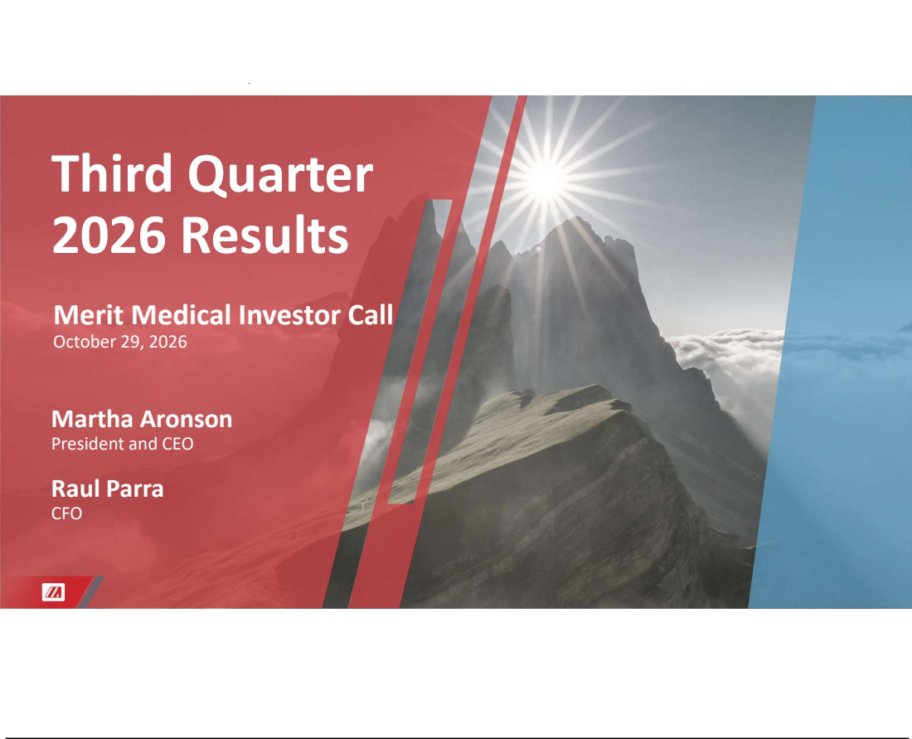

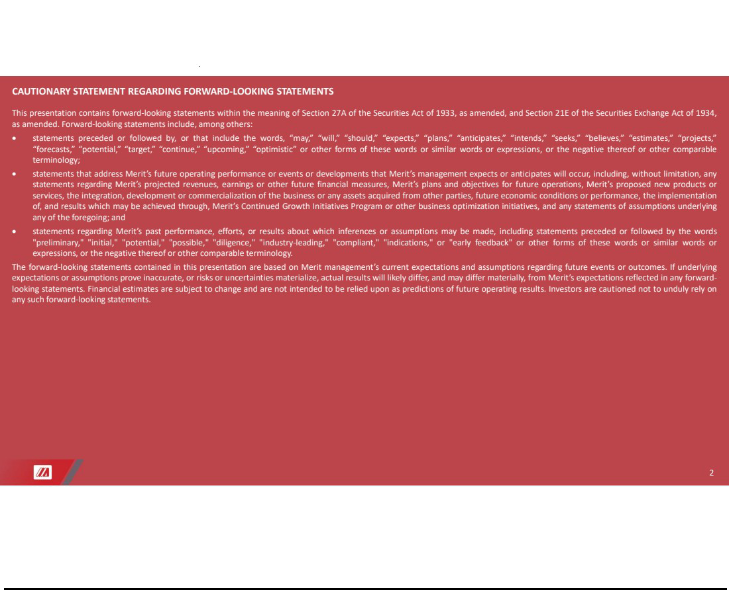

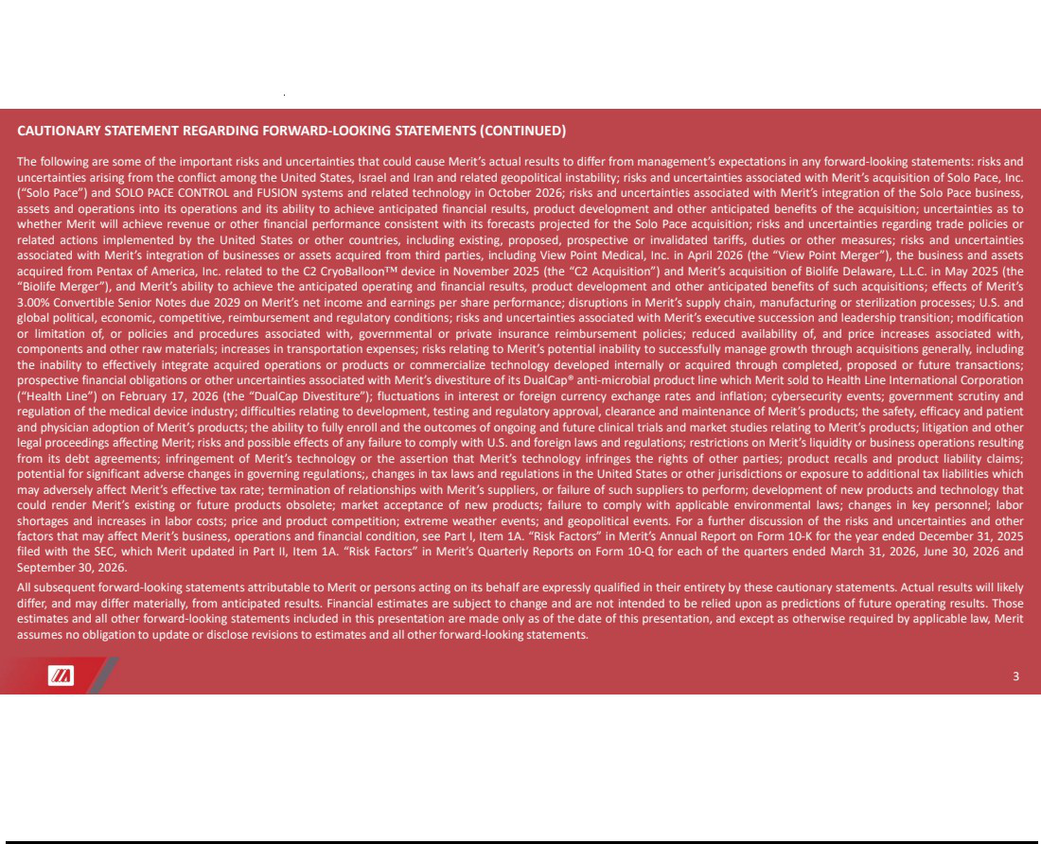

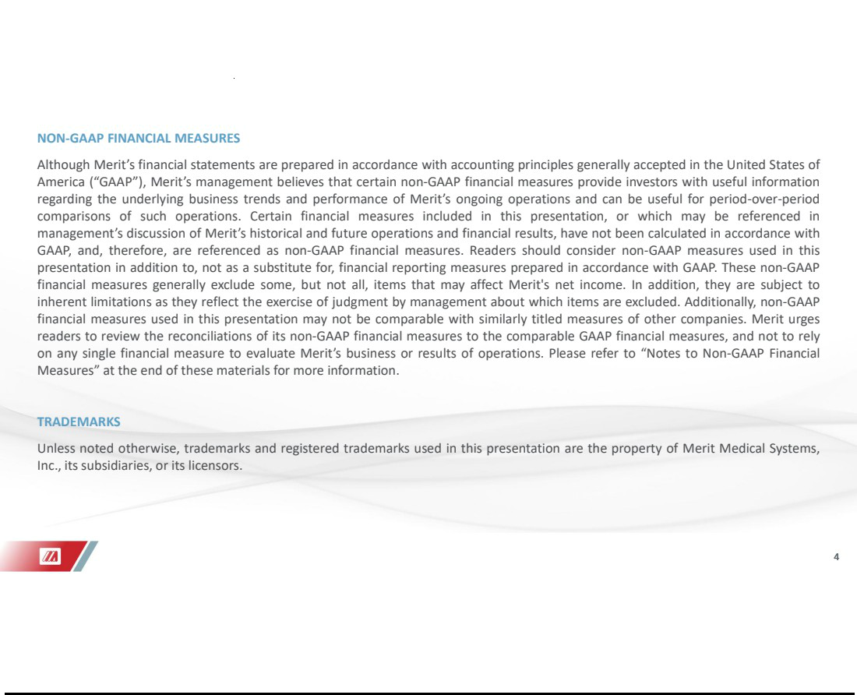

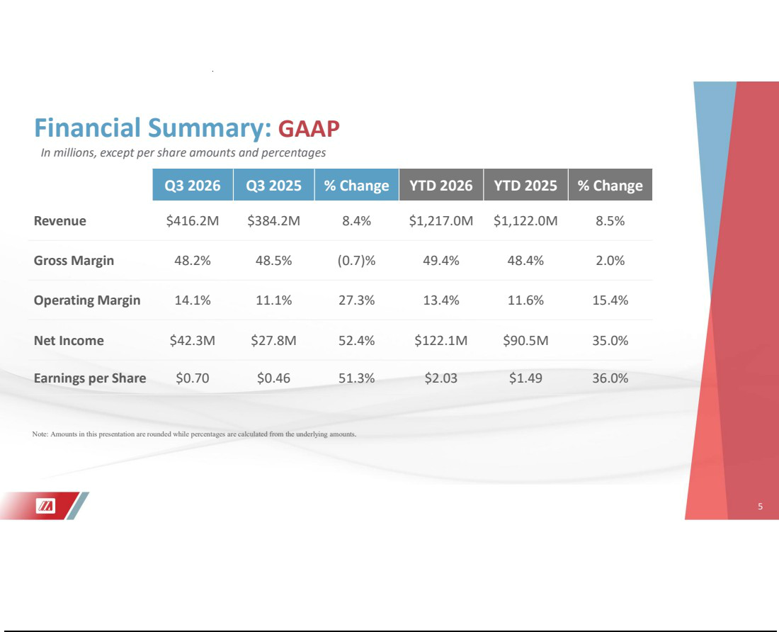

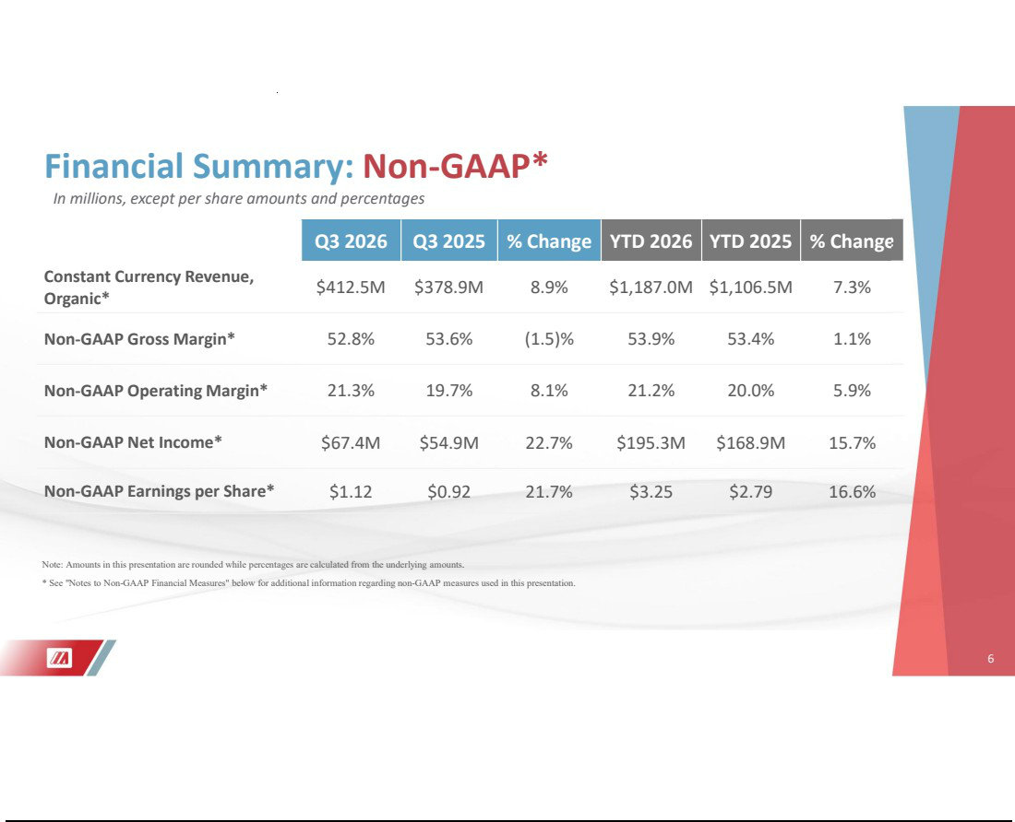

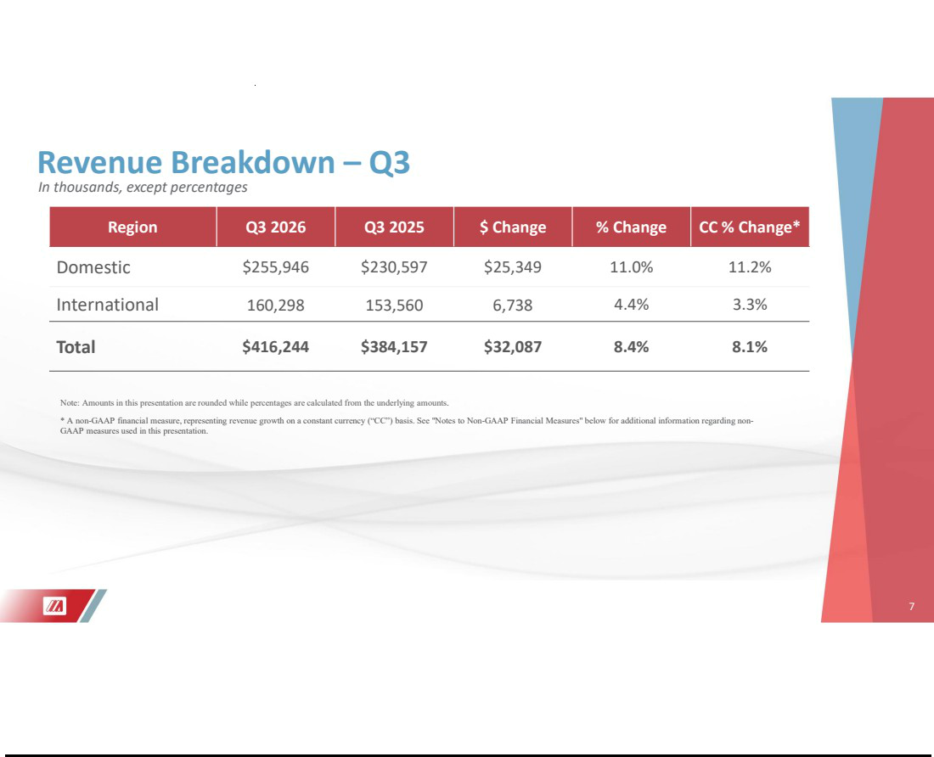

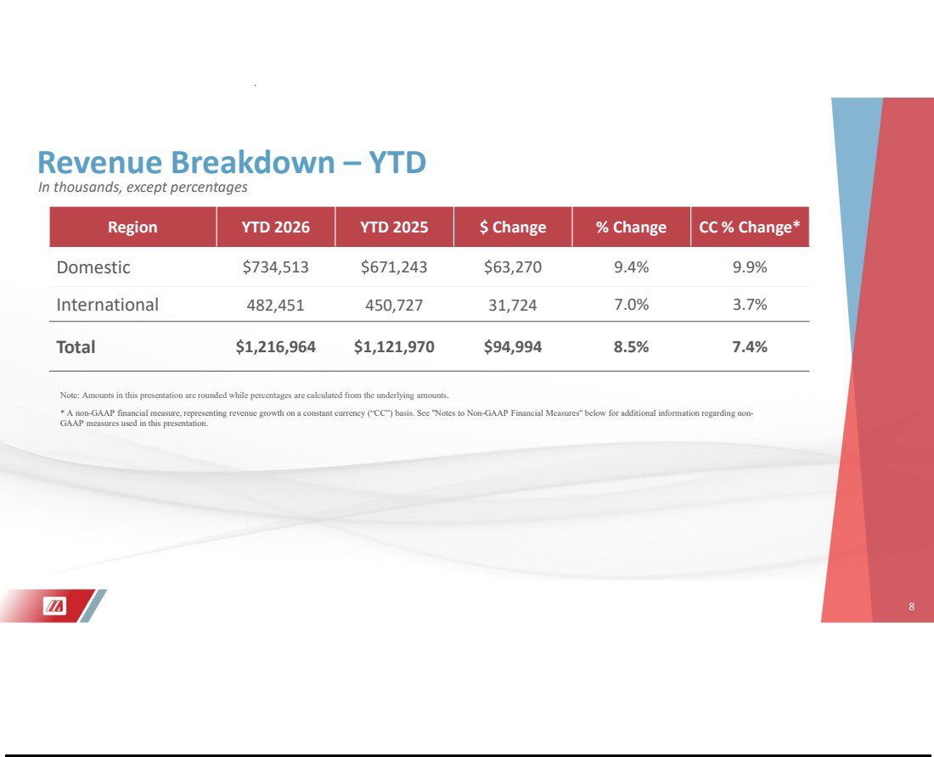

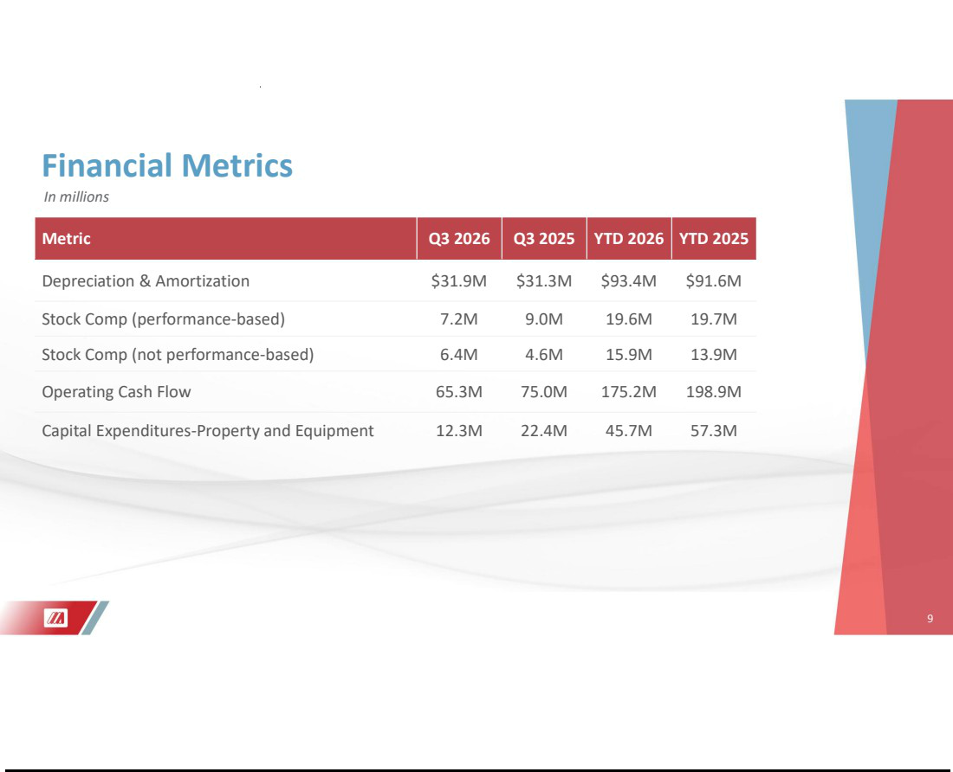

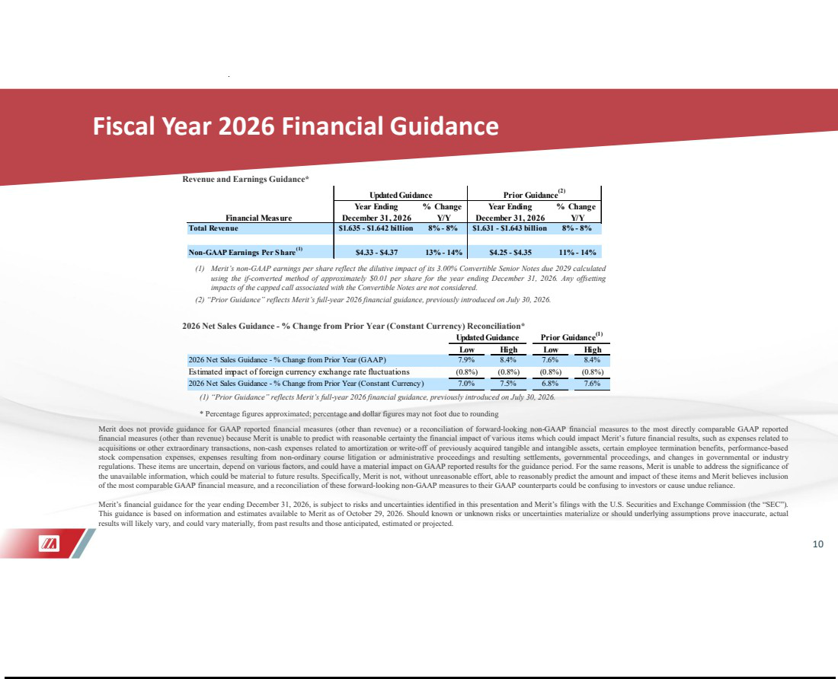



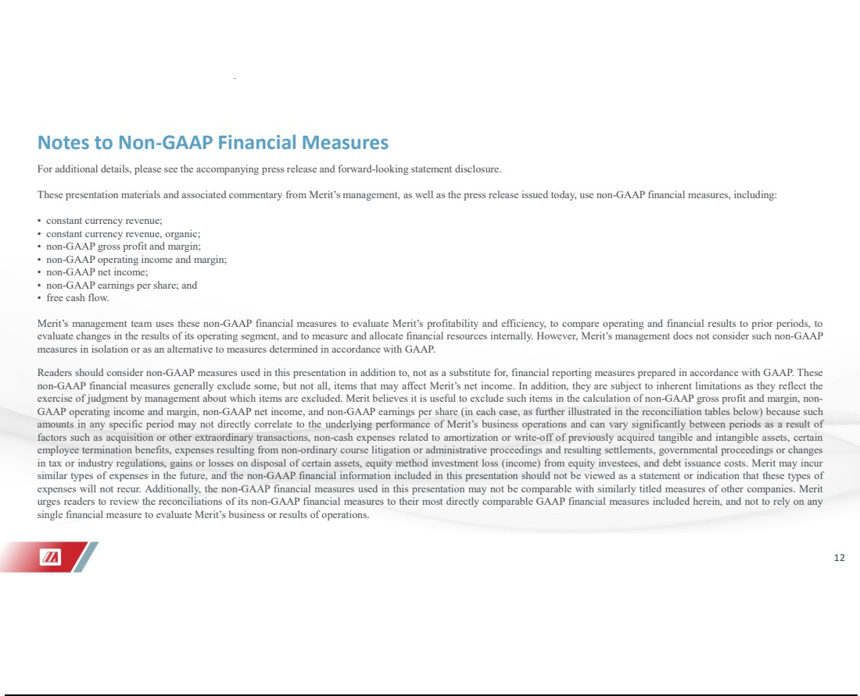

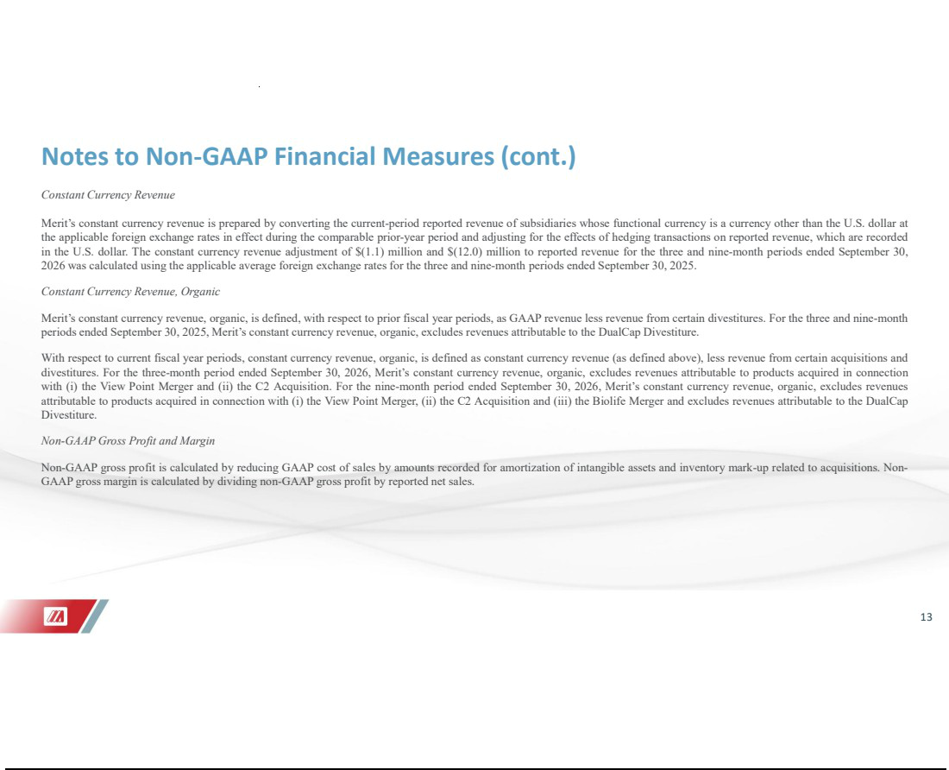

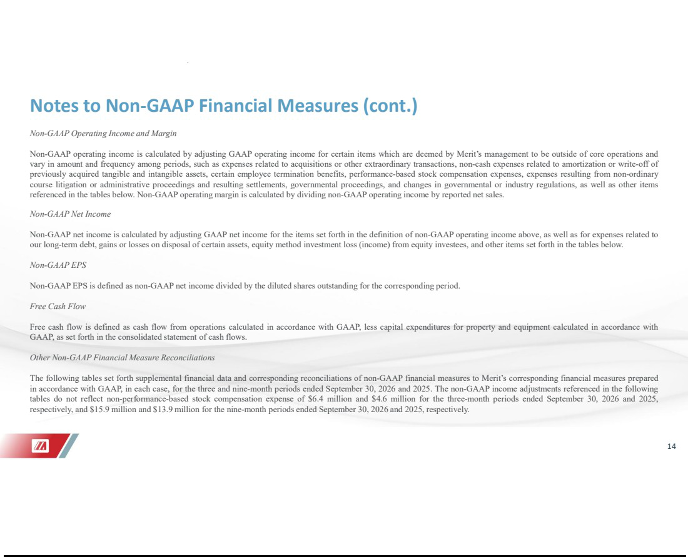

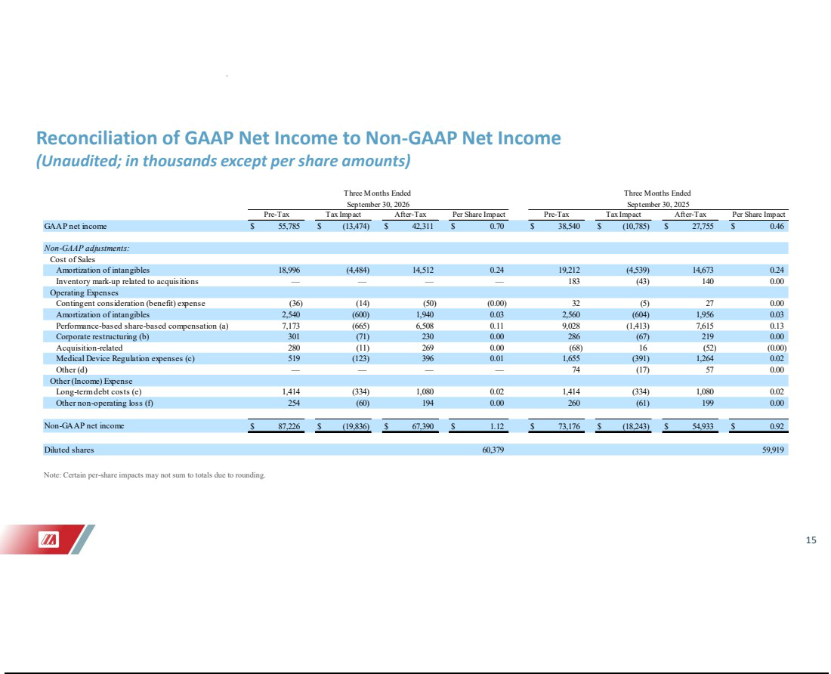

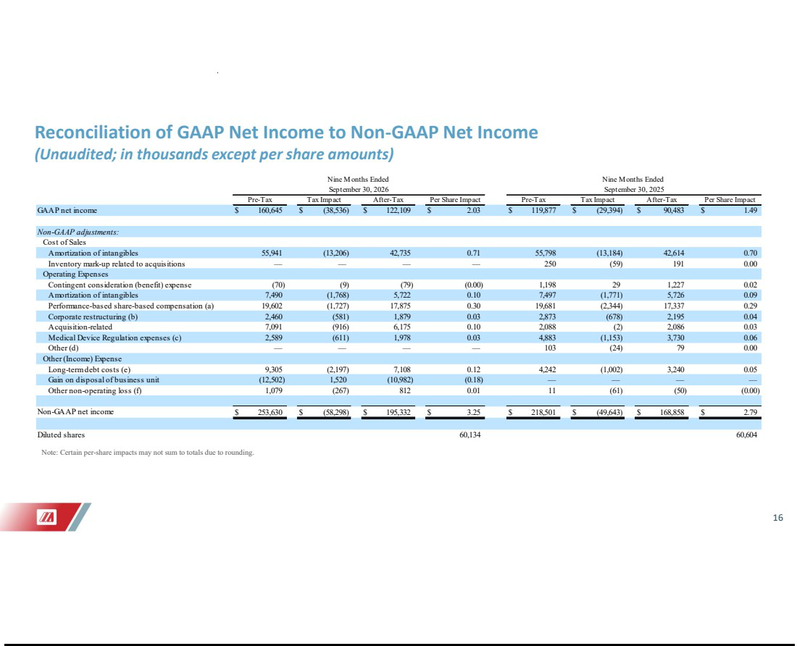

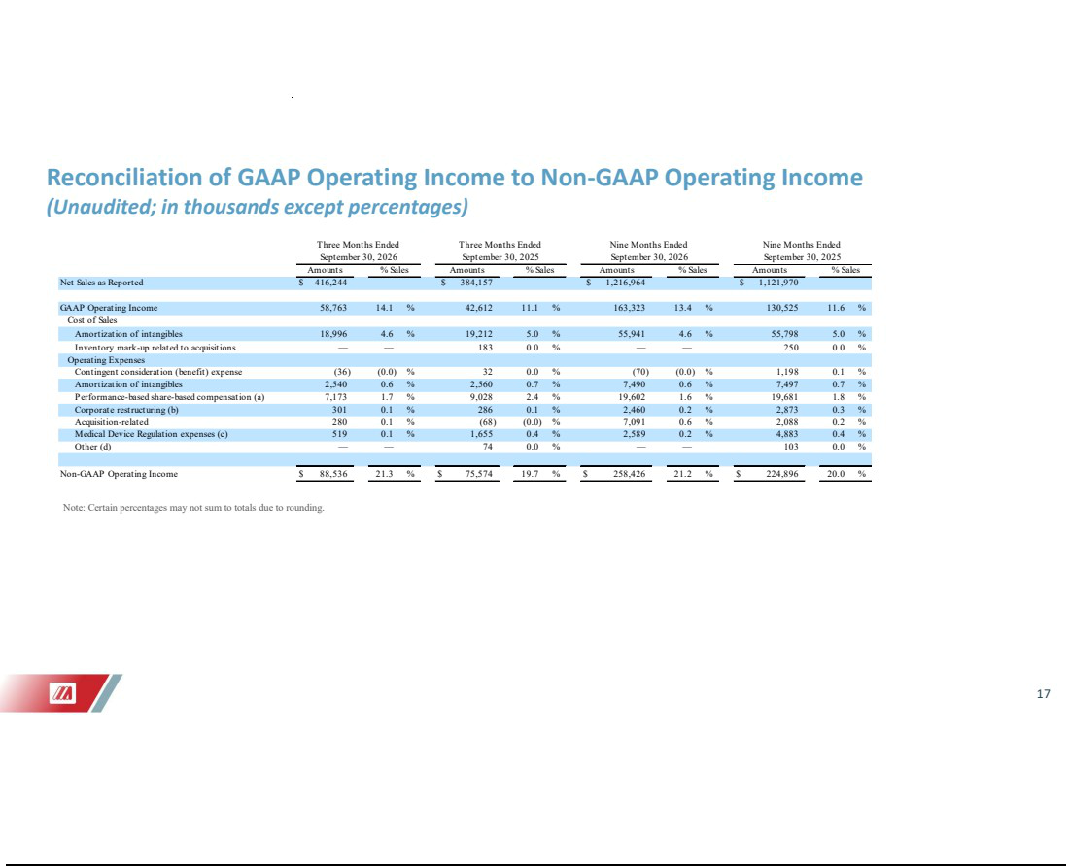

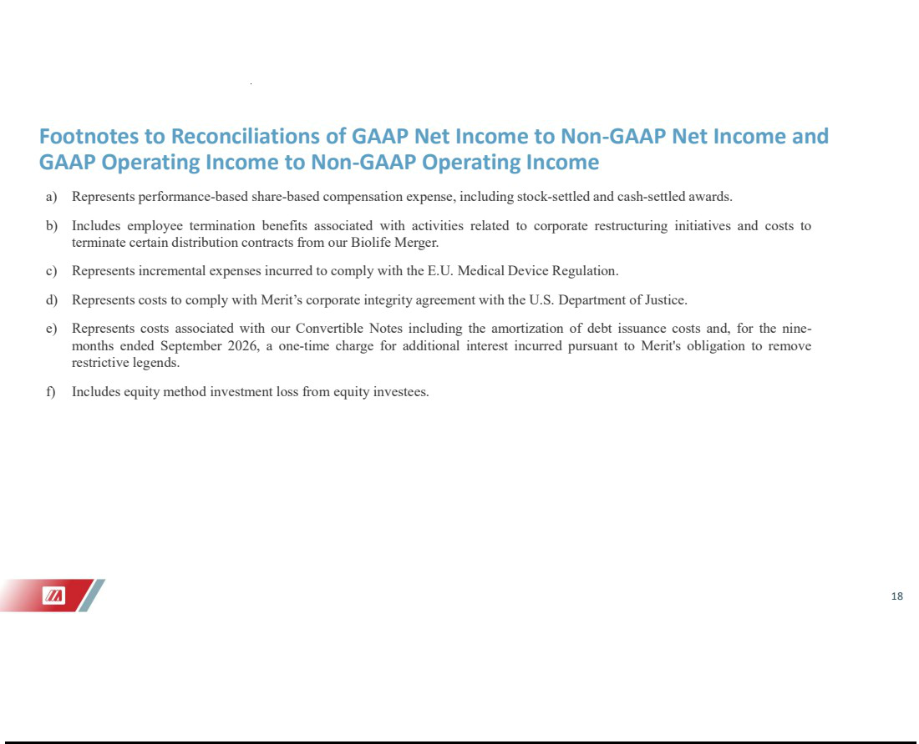

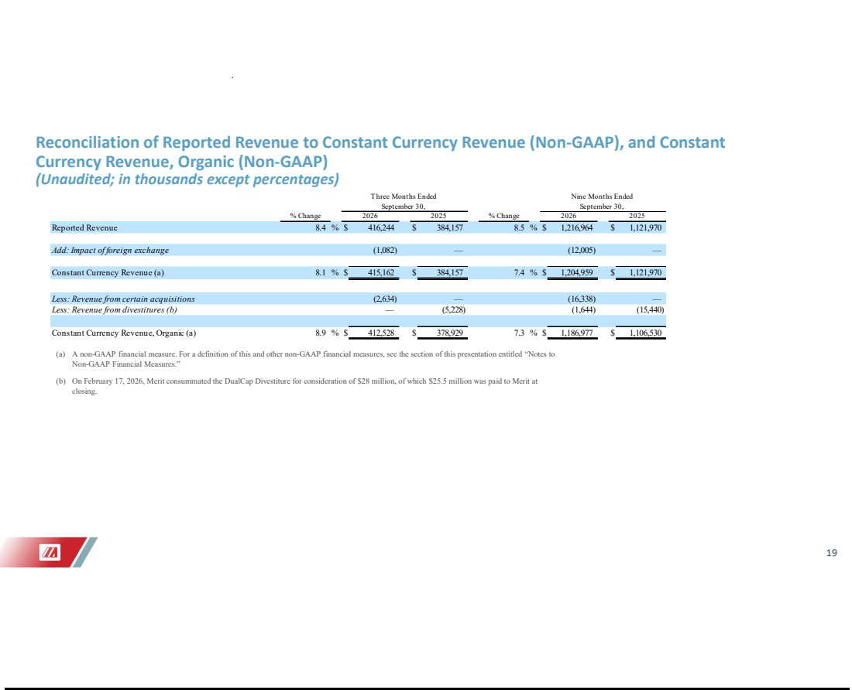

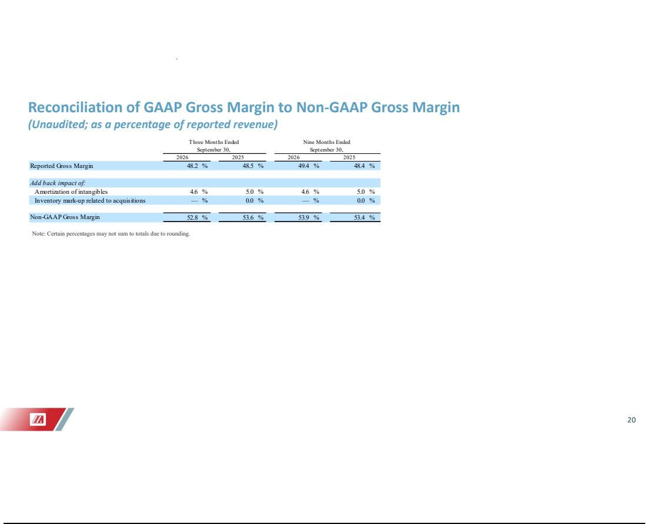

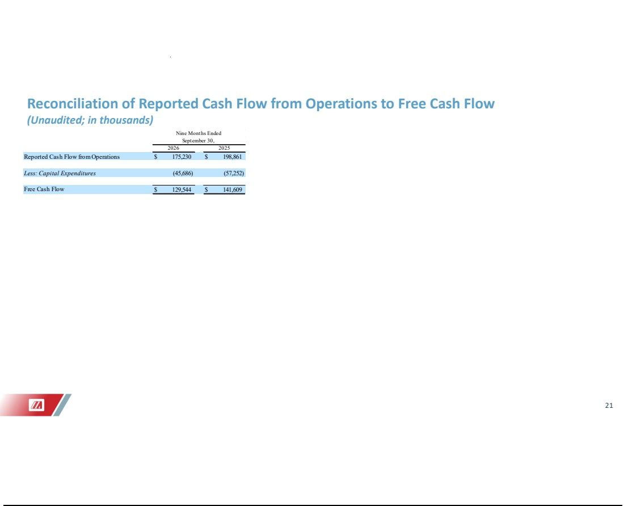

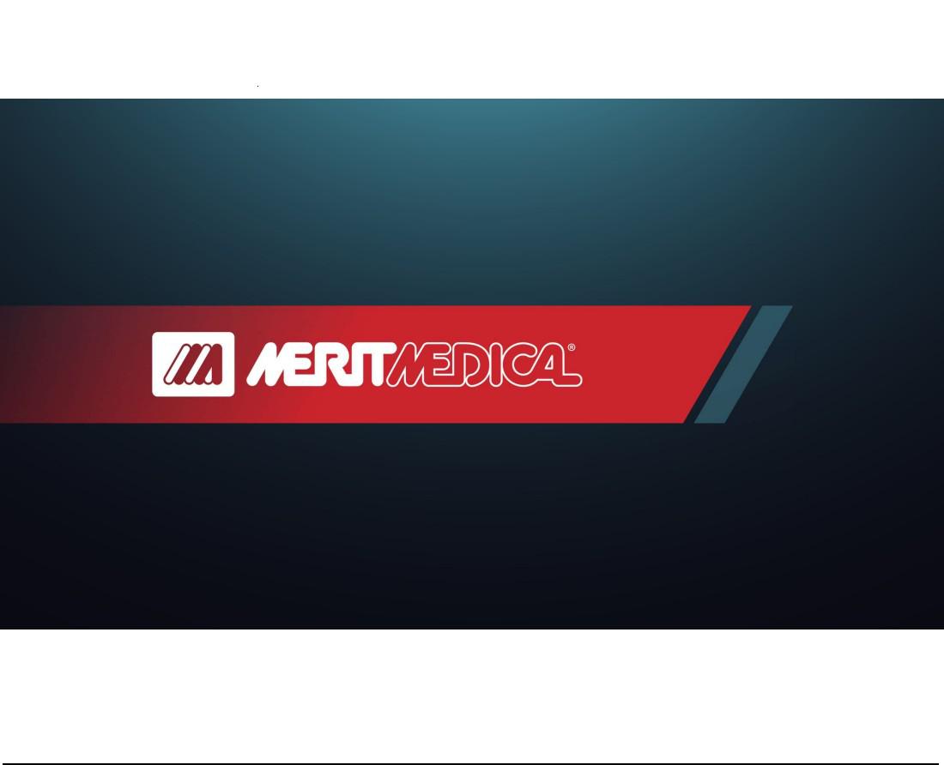

Exhibit 99.3


Merit Medical Acquires Solo Pace, Inc., Expanding Its Cardiac Therapies Platform with Innovative TAVR Pacing Technology

- Solo Pace, Inc. specializes in temporary pacing solutions and systems designed for transcatheter heart valve procedures, including transcatheter aortic valve replacement procedures.

SOUTH JORDAN, Utah, October 29, 2026 (GLOBE NEWSWIRE) -- Merit Medical Systems, Inc. (NASDAQ: MMSI), a global leader of healthcare technology, today announced its acquisition of Solo Pace, Inc. (Solo Pace). Located in Minneapolis, Minnesota, Solo Pace manufactures temporary pacing technology designed to help physicians treat patients with aortic stenosis. Merit had previously invested in Solo Pace and on October 13, 2026, Merit acquired all remaining outstanding equity of Solo Pace for purchase consideration of approximately $45 million.

The acquisition expands Merit’s Cardiac Therapies platform with differentiated technologies, including SOLO PACE CONTROL™ and SOLO PACE FUSION™ systems, exclusively engineered for transcatheter aortic valve replacement (TAVR) and other transcatheter heart valve (THV) procedures. Prior to the acquisition, Merit served as the exclusive distributor of Solo Pace’s precision intraprocedural pacing technology. The acquisition builds on this existing commercial relationship and supports Merit’s strategy to expand its structural heart portfolio, with a focus on technologies designed to simplify procedural workflows and support physicians performing transcatheter heart valve procedures.

TAVR is a minimally invasive THV procedure that replaces the aortic valve in the heart. A treatment for aortic stenosis, or narrowing of the valve opening, TAVR is a rapidly growing procedure, with more than 100,000 performed annually in the United States alone.¹ Temporary pacing is a critical component of TAVR procedures, supporting accurate valve deployment and helping physicians perform the procedure safely and efficiently.

SOLO PACE CONTROL and FUSION systems are designed to help physicians treat patients by simplifying pacing setup,² reducing workflow variability,^{2,3} and standardizing pacing strategies for TAVR procedures.^{2–4} The systems can help physicians minimize communication-related pacing errors^{2–4} and decrease the risk of vascular complications.^{2,4,5–7}

SOLO PACE FUSION is a single-use, sterile kit designed for temporary intracardiac pacing for TAVR and other THV procedures. Combining guide wire functionality, left ventricular pacing, and patient grounding in one device, SOLO PACE FUSION is designed to provide stable, reliable temporary pacing throughout pacing setup and delivery.^{2,8}

Designed for use with the existing SOLO PACE CONTROL external pulse generator, SOLO PACE FUSION is engineered to improve procedural efficiency during TAVR procedures.⁸ In addition, it supports temporary pacing with operator-specific protocols, automated pace capture checks, sterile remote-control operation, and simple visual indicators.

“SOLO PACE CONTROL and FUSION systems have the potential to redefine pacing in transcatheter valve procedures,” said David V. Daniels, MD, Interventional Cardiologist and Founder of Solo Pace. “Seeing the technology embraced by physicians and having a meaningful impact on procedural efficiency has been incredibly gratifying. With Merit taking the lead, I’m excited for the difference the Solo Pace products can make in advancing patient care and market adoption.”

Solo Pace announced U.S. Food and Drug Administration (FDA) 510(k) clearance and commercial release of the SOLO PACE FUSION system on April 17, 2025, and March 31, 2026, respectively.

“This acquisition expands our Cardiac Therapies platform and further strengthens our position in the structural heart market,” said Martha G. Aronson, Merit’s President and Chief Executive Officer. “Through our exclusive distribution relationship, we have seen a favorable response from clinicians. That experience reinforces our confidence in the technology and the opportunity to support its next phase of growth. We look forward to leveraging our commercial, clinical, and physician education capabilities to expand adoption in the United States and, over time, bring these solutions to more physicians and patients worldwide.”

Learn more about SOLO PACE CONTROL and SOLO PACE FUSION.

- Cleveland Clinic. 2025. “How and Why Volumes Matter In Aortic Valve Replacement.” Last modified January 22, 2025.

- Data on file.

- Blusztein et al. 2023. Struct Heart. doi: 10.1016/j.shj.2023.100213.

- Berman et al. 2024. Struct Heart. doi: 10.1016/j.shj.2024.100306.
- Faurie et al. 2019. JACC Cardiovasc Interv. doi: 10.1016/j.jcin.2019.09.029.

- Regueiro et al. 2023. JACC Cardiovasc Interv. doi: 10.1016/j.jcin.2023.10.035.

- Arnold et al. 2014. Circ Cardiovasc Interv. doi: 10.1161/CIRCINTERVENTIONS.114.001395.
- Pasupati. “First-in-Human Experience with LV Guidewire Pacing.” TCT, October 2025.

FINANCIAL SUMMARY

On October 13, 2026, Merit paid purchase consideration of approximately $45 million to acquire all remaining outstanding equity of Solo Pace. Merit previously owned approximately 18% of Solo Pace pursuant to various agreements executed between January 2023 and December 2025 under which Merit paid a total of $5 million to acquire

shares of Solo Pace, an option to acquire all remaining outstanding equity of Solo Pace based on certain commercialization milestones, and exclusive rights to distribute the Solo Pace products upon commercialization.

From the acquisition effective date of October 13, 2026, through December 31, 2026, the acquisition is projected to be immaterial to Merit’s previously forecasted full-year 2026 total revenue, non-GAAP net income and non-GAAP earnings per share. The acquisition is expected to be immaterial to Merit’s previously forecasted full-year 2026 GAAP net income and GAAP earnings per share.

For the twelve months ending December 31, 2027, the acquisition is projected to be slightly accretive to non-GAAP net income and non-GAAP earnings per share, inclusive of approximately $1.5 million of lower interest income on cash balances used for the total purchase consideration and excluding approximately $3.2 million of non-cash and non-recurring transaction-related expenses. The acquisition is projected to be slightly dilutive to Merit’s GAAP net income and GAAP earnings per share in 2027 and accretive thereafter.

NON-GAAP FINANCIAL MEASURES

Merit generally does not provide guidance for GAAP reported financial measures (other than revenue) or a reconciliation of forward-looking non-GAAP financial measures to the most directly comparable GAAP reported financial measures (other than revenue) because Merit is unable to predict with reasonable certainty the financial impact of various items which could impact Merit’s future financial results, such as expenses attributable to acquisitions or other extraordinary transactions, non-cash expenses related to amortization or write-off of previously acquired tangible and intangible assets, certain employee termination benefits, performance-based stock compensation expenses, expenses resulting from non-ordinary course litigation or administrative proceedings and resulting settlements, governmental proceedings, and changes in governmental or industry regulations. These items are uncertain, depend on various factors, and could have a material impact on GAAP reported results for the guidance period. For the same reasons, Merit is unable to address the significance of the unavailable information, which could be material to future results. Specifically, Merit is not, without unreasonable effort, able to reliably predict the impact of these items, and Merit believes inclusion of a reconciliation of these forward-looking non-GAAP measures to their GAAP counterparts could be confusing to investors or cause undue reliance. Only information on the impacts to such measures from the proposed acquisition is included in this release. A reconciliation of the impacts on such financial measures to the impacts on their GAAP counterparts is not available without unreasonable effort.

ADVISORS

Parr Brown Gee & Loveless served as legal advisor to Merit in connection with the transaction.

ABOUT MERIT MEDICAL

Founded in 1987, Merit Medical Systems, Inc. is engaged in the development, manufacture, and distribution of proprietary medical devices used in interventional, diagnostic, and therapeutic procedures, particularly in cardiology, radiology, oncology, critical care, and endoscopy. Merit serves customers worldwide with a domestic and international sales force and clinical support team totaling approximately 900 individuals. Merit employs approximately 7,500 people worldwide.

CAUTIONARY STATEMENT REGARDING FORWARD-LOOKING STATEMENTS

This release contains forward-looking statements within the meaning of Section 27A of the Securities Act of 1933, as amended, and

Section 21E of the Securities Exchange Act of 1934, as amended. Forward-looking statements include, among others:

- Statements proceeded or followed by, or that include the words, “may,” “will,” “should,” “expects,” “plans,” “anticipates,” “intends,” “seeks,” “believes,” “estimates,” “projects,” “forecasts,” “potential,” “target,” “continue,” “upcoming,” “optimistic” or other forms of these words or similar words or expressions, or the negative thereof or other comparable terminology;
- Statements that address Merit’s future operating performance or events or developments that Merit’s management expects or anticipates will occur, including, without limitation, any statements regarding Merit’s projected revenues, revenue growth or other financial measures, Merit’s plans and objectives for future operations, Merit’s proposed new products or services, the integration, development or commercialization of the business or any assets acquired from other parties, future economic conditions or performance, the implementation of, and results which may be achieved through, Merit’s Continued Growth Initiatives Program or other business optimization initiatives, and any statements of assumptions underlying any of the foregoing; and

- Statements regarding Merit’s past performance, efforts, or results about which inferences or assumptions may be made, including statements proceeded or followed by the words "preliminary," "initial," "potential," "possible," "diligence," "industry-leading," "compliant," "indications," or "early feedback" or other forms of these words or similar words or expressions, or the negative thereof or other comparable terminology.

The forward-looking statements contained in this release are based on Merit management’s current expectations and assumptions regarding future events or outcomes. If underlying expectations or assumptions prove inaccurate, or risks or uncertainties materialize, actual results will likely differ, and could differ materially, from Merit’s expectations reflected in any forward-looking statements. Financial estimates are subject to change and are not intended to be relied upon as predictions of future operating results. Investors are cautioned not to unduly rely on any such forward-looking statements.

The following are some of the important risks and uncertainties that could cause Merit’s actual results to differ from Merit’s expectations in any forward-looking statements: risks and uncertainties associated with Merit’s acquisition of Solo Pace and SOLO PACE CONTROL and FUSION systems and related technology; risks and uncertainties associated with Merit’s integration of the Solo Pace business, assets and operations into its operations and its ability to achieve anticipated financial results, product development and other anticipated benefits of the acquisition; uncertainties as to whether Merit will achieve revenue or other financial performance consistent with its forecasts projected for the Solo Pace acquisition; risks and uncertainties regarding trade policies or related actions implemented by the United States or other countries, including existing, proposed, prospective or invalidated tariffs, duties or other measures; risks and uncertainties associated with Merit’s integration of businesses or assets acquired from third parties, including View Point Medical, Inc. in April 2026, the business and assets related to the C2 CryoBalloon™ device acquired from Pentax of America, Inc. in November 2025 and Biolife Delaware, L.L.C. in May 2025, and Merit’s ability to achieve the anticipated operating and financial results, product development and other anticipated benefits of such acquisitions; effects of Merit’s 3.00% Convertible Senior Notes due 2029 on Merit’s net income and earnings per share performance; disruptions in Merit’s supply chain, manufacturing or sterilization processes; U.S. and global political, economic, competitive, reimbursement and regulatory conditions; risks and uncertainties associated with Merit’s executive succession and leadership transition; modification or limitation of, or policies and procedures associated with, governmental or private insurance reimbursement policies; reduced availability of, and price increases associated with, components and other raw materials; increases in transportation expenses; risks relating to Merit’s potential inability to successfully manage growth through acquisitions generally, including the inability to effectively integrate acquired operations or products or commercialize technology developed internally or acquired through completed, proposed or future transactions; prospective financial obligations or other uncertainties associated with Merit’s divestiture of its DualCap® anti-microbial cap product line in February 2026; fluctuations in interest or foreign currency exchange rates and inflation; cybersecurity events; government scrutiny and regulation of the medical device industry; difficulties relating to development, testing and regulatory approval, clearance and maintenance of Merit’s products; the safety, efficacy and patient and physician adoption of Merit’s products; the ability to fully enroll and the outcomes of ongoing and future clinical trials and market studies relating to Merit’s products; litigation and other legal proceedings affecting Merit; the risk and possible effects of any failure to comply with U.S. and foreign laws and regulations; restrictions on Merit’s liquidity or business operations resulting from its debt agreements; infringement of Merit’s technology or the assertion that Merit’s technology infringes the rights of other parties; product recalls and product liability claims; potential for significant adverse changes in governing regulations;, changes in tax laws and regulations in the United States or other jurisdictions or exposure to additional tax liabilities which may adversely affect Merit’s effective tax rate; termination of relationships with Merit’s suppliers, or failure of such suppliers to perform; development of new products and technology that could render Merit’s existing or future products obsolete;

market acceptance of new products; failure to comply with applicable environmental laws; changes in key personnel; labor shortages and increases in labor costs; price and product competition; extreme weather events; and geopolitical events. For a further discussion of the risks and uncertainties that may affect Merit’s business, operations and financial condition, see Part I, Item 1A. “Risk Factors” in Merit’s Annual Report on Form 10-K for the year ended December 31, 2025, filed with the U.S. Securities and Exchange Commission (SEC), Part II, Item 1A, “Risk Factors” in Merit’s Quarterly Report on Form 10-Q for the quarter ended June 30, 2026 filed with the SEC and Merit’s other filings with the SEC.

All subsequent forward-looking statements attributable to Merit or persons acting on its behalf are expressly qualified in their entirety by these cautionary statements. Financial estimates are subject to change and are not intended to be relied upon as predictions of future operating results. Those estimates and all other forward-looking statements included in this release are made only as of the date of this release, and except as otherwise required by applicable law, Merit assumes no obligation to update or disclose revisions to estimates and all other forward-looking statements.

TRADEMARKS

Unless noted otherwise, trademarks and registered trademarks used in this release are the property of Merit Medical Systems, Inc., its subsidiaries, or its licensors.

CONTACTS

PR/Media Inquiries

Sarah Comstock

Merit Medical

+1-801-432-2864 | sarah.comstock@merit.com

Investor Inquiries

Mike Piccinino, CFA, IRC

ICR Healthcare

+1-443-213-0509 | mike.piccinino@icrhealthcare.com

