Table of Contents
​
​
UNITED STATES SECURITIES AND EXCHANGE COMMISSION
Washington, D.C. 20549
​
FORM 10-K
​
 | ☒ | Annual report pursuant to Section 13 or 15(d) of the Securities Exchange Act of 1934
For the fiscal year ended December 31, 2025
or
 | ☐ | Transition report pursuant to Section 13 or 15(d) of the Securities Exchange Act of 1934.
For the transition period from to .
Commission File Number 0-18592
​

MERIT MEDICAL SYSTEMS, INC.
(Exact name of registrant as specified in its charter)

Utah | ​ ​ ​ | 87-0447695
(State or other jurisdiction of incorporation or organization) | ​ | (IRS Employer Identification No.)
​
1600 West Merit Parkway, South Jordan, Utah 84095
(Address of principal executive offices, including zip code)
​
Registrant’s telephone number, including area code: (801) 253-1600
Securities registered pursuant to Section 12(b) of the Act:
​

Title of each class | Trading Symbol | Name of exchange on which registered
Common Stock, no par value | MMSI | NASDAQ Global Select Market
​
Securities registered pursuant to Section 12(g) of the Act: None
Indicate by check mark if the registrant is a well-known seasoned issuer, as defined in Rule 405 of the Securities Act. Yes ☐ No ☒
Indicate by check mark if the registrant is not required to file reports pursuant to Section 13 or Section 15(d) of the Act. Yes ☐ No ☒
Indicate by check mark whether the registrant (1) has filed all reports required to be filed by Section 13 or 15(d) of the Securities Exchange Act of 1934 during the preceding 12 months (or for such shorter period that the registrant was required to file such reports), and (2) has been subject to such filing requirements for the past 90 days. Yes ☒ No ☐
Indicate by check mark whether the registrant has submitted electronically every Interactive Data File required to be submitted and posted pursuant to Rule 405 of Regulation S-T (§ 232.405 of this chapter) during the preceding 12 months (or for such shorter period that the registrant was required to submit such files). Yes ☒ No ☐
Indicate by check mark whether the registrant is a large accelerated filer, an accelerated filer, a non-accelerated filer, a smaller reporting company or an emerging growth company. See the definitions of “large accelerated filer,” “accelerated filer,” “smaller reporting company” and "emerging growth company" in Rule 12b-2 of the Exchange Act.
Large Accelerated Filer ☒ | Accelerated Filer ☐ | Non-Accelerated Filer ☐ | Smaller Reporting Company ☐ | Emerging Growth Company ☐
If an emerging growth company, indicate by check mark if the registrant has elected not to use the extended transition period for complying with any new or revised financial accounting standards provided pursuant to Section 13(a) of the Exchange Act. ☐
Indicate by check mark whether the registrant has filed a report on and attestation to its management’s assessment of the effectiveness of its internal control over financial reporting under Section 404(b) of the Sarbanes-Oxley Act (15 U.S.C. 7262(b)) by the registered public accounting firm that prepared or issued its audit report. ☒
If securities are registered pursuant to Section 12(b) of the Act, indicate by check mark whether the financial statements of the registrant included in the filing reflect the correction of an error to previously issued financial statements. ☐
Indicate by check mark whether any of those error corrections are restatements that required a recovery analysis of incentive-based compensation received by any of the registrant’s executive officers during the relevant recovery period pursuant to §240.10D-1(b). ☐
Indicate by check mark whether the registrant is a shell company (as defined in Rule 12b-2 of the Exchange Act). Yes ☐ No ☒
The aggregate market value of the registrant’s common stock held by non-affiliates of the registrant on June 30, 2025, based upon the closing price of the common stock as reported by the NASDAQ Global Select Market on such date, was approximately $5.4 billion. As of February 20, 2026, the registrant had 59,431,931 shares of common stock outstanding.
DOCUMENTS INCORPORATED BY REFERENCE
Portions of the following document are incorporated by reference in Part III of this Report: the registrant’s definitive proxy statement relating to its 2026 Annual Meeting of Shareholders.
​
​
TABLE OF CONTENTS
​
​ | ​ | ​ | ​
PART I | ​ | ​ | ​
​ | ​ | ​ | ​
Item 1. | Business | ​ | 3
​ | ​ | ​ | ​
Item 1A. | Risk Factors | ​ | 20
​ | ​ | ​ | ​
Item 1B. | Unresolved Staff Comments | ​ | 35
​ | ​ | ​ | ​
Item 1C. | Cybersecurity | ​ | 35
​ | ​ | ​ | ​
Item 2. | Properties | ​ | 36
​ | ​ | ​ | ​
Item 3. | Legal Proceedings | ​ | 36
​ | ​ | ​ | ​
Item 4. | Mine Safety Disclosures | ​ | 36
​ | ​ | ​ | ​
PART II | ​ | ​ | ​
​ | ​ | ​ | ​
Item 5. | Market for Registrant’s Common Equity, Related Stockholder Matters and Issuer Purchases of Equity Securities | ​ | 37
​ | ​ | ​ | ​
Item 6. | Reserved | ​ | 38
​ | ​ | ​ | ​
Item 7. | Management’s Discussion and Analysis of Financial Condition and Results of Operations | ​ | 39
​ | ​ | ​ | ​
Item 7A. | Quantitative and Qualitative Disclosures About Market Risk | ​ | 46
​ | ​ | ​ | ​
Item 8. | Financial Statements and Supplementary Data | ​ | 47
​ | ​ | ​ | ​
Item 9. | Changes in and Disagreements with Accountants on Accounting and Financial Disclosure | ​ | 92
​ | ​ | ​ | ​
Item 9A. | Controls and Procedures | ​ | 92
​ | ​ | ​ | ​
Item 9B. | Other Information | ​ | 94
​ | ​ | ​ | ​
PART III | ​ | ​ | ​
​ | ​ | ​ | ​
Item 10. | Directors, Executive Officers and Corporate Governance | ​ | 94
​ | ​ | ​ | ​
Item 11. | Executive Compensation | ​ | 94
​ | ​ | ​ | ​
Item 12. | Security Ownership of Certain Beneficial Owners and Management and Related Stockholder Matters | ​ | 94
​ | ​ | ​ | ​
Item 13. | Certain Relationships and Related Transactions and Director Independence | ​ | 94
​ | ​ | ​ | ​
Item 14. | Principal Accountant Fees and Services | ​ | 94
​ | ​ | ​ | ​
PART IV | ​ | ​ | ​
​ | ​ | ​ | ​
Item 15. | Exhibits and Financial Statement Schedules | ​ | 94
​ | ​ | ​ | ​
Item 16. | Form 10-K Summary | ​ | 102
​ | ​ | ​ | ​
SIGNATURES |  | ​ | 103
​
​
​
​
Table of Contents
PART I
Unless otherwise indicated in this report, “Merit,” “we,” “us,” “our,” and similar terms refer to Merit Medical Systems, Inc. and our consolidated subsidiaries.
DISCLOSURE REGARDING FORWARD-LOOKING STATEMENTS
This report contains “forward-looking statements” within the meaning of Section 27A of the Securities Act of 1933, as amended (the “Securities Act”), and Section 21E of the Securities Exchange Act of 1934, as amended (the “Exchange Act”). Forward-looking statements include, among others:
 | ● | statements preceded or followed by, or that include the words, “may,” “will,” “should,” “expects,” “plans,” “anticipates,” “intends,” “seeks,” “believes,” “estimates,” “projects,” “forecasts,” “potential,” “target,” “continue,” “upcoming,” “optimistic” or other forms of these words or similar words or expressions, or the negative thereof or other comparable terminology;
 | ● | statements that address our future operating performance or events or developments that we expect or anticipate will occur, including, without limitation, any statements regarding our projected earnings, revenues or other financial measures, our plans and objectives for future operations, our proposed new products or services, the integration, development or commercialization of the business or any assets acquired from other parties, future economic conditions or performance, the implementation of, and results which may be achieved through, Merit’s Continued Growth Initiatives Program or other business optimization initiatives, and any statements of assumptions underlying any of the foregoing; and
 | ● | statements regarding our past performance, efforts, or results about which inferences or assumptions may be made, including statements proceeded or followed by the words "preliminary," "initial," "potential," "possible," "diligence," "industry-leading," "compliant," "indications" or "early feedback" or other forms of these words or similar words or expressions, or the negative thereof or other comparable terminology.
The forward-looking statements contained in this report are based on our management’s current expectations and assumptions regarding future events or outcomes. If underlying expectations or assumptions prove inaccurate, or risks or uncertainties materialize, actual results will likely differ, and could differ materially, from our expectations reflected in any forward-looking statements. Investors are cautioned not to unduly rely on any such forward-looking statements.
The following are some of the important risks and uncertainties that could cause our actual results to differ from our expectations in any forward-looking statements: inherent risks and uncertainties associated with consequences of Merit’s executive succession planning activities and leadership transition; risks and uncertainties regarding trade policies or related actions implemented by the U.S. or other countries, including existing, proposed or prospective tariffs, duties or other measures; risk and uncertainties relating to Merit’s integration of businesses or products acquired from third parties, including the acquisitions of the businesses and products from Pentax of America, Inc. and Biolife, L.L.C. in 2025 and from Cook Medical Holdings LLC and EndoGastric Solutions, Inc. in 2024, and Merit’s ability to achieve the anticipated financial results, product development and other anticipated benefits of such acquisitions; disruptions in Merit’s supply chain, manufacturing or sterilization processes; U.S. and global political, economic, competitive, reimbursement and regulatory conditions; reduced availability of, and price increases associated with, components and other raw materials; increases in transportation expenses; risks relating to Merit’s potential inability to successfully manage growth through acquisitions generally, including the inability to effectively integrate acquired operations or products or commercialize technology developed internally or acquired through completed, proposed or future transactions; fluctuations in interest or foreign currency exchange rates and inflation; cybersecurity events; difficulties relating to development, testing and regulatory approval, clearance and maintenance of Merit’s products; the ability to fully enroll and the outcomes of ongoing and future clinical trials and market studies relating to Merit’s products; litigation and other judicial proceedings affecting Merit; failure to comply with U.S. and foreign laws and regulations; restrictions on Merit’s liquidity or business operations resulting from its debt agreements; infringement of Merit’s technology or the assertion that Merit’s technology infringes the rights of other parties; product recalls and product liability claims; potential for significant adverse changes in governing regulations; changes in tax laws and regulations in the United States or other jurisdictions or exposure to additional tax liabilities which may adversely affect our effective tax rate; termination of relationships with Merit’s suppliers, or failure of such suppliers to perform; development of new products and technology that could render Merit’s
1
Table of Contents
existing or future products obsolete; market acceptance of new products; failure to comply with applicable environmental laws; changes in key personnel; labor shortages and increases in labor costs; price and product competition; extreme weather events; and geopolitical events. For a further discussion of the risks and uncertainties and other factors affecting our business, see Item 1A. Risk Factors in this report and our subsequent Quarterly Reports on Form 10-Q.
All subsequent forward-looking statements attributable to us or persons acting on our behalf are expressly qualified in their entirety by these cautionary statements. All forward-looking statements included in this report are made as of the date hereof and are based on information available to us as of such date. We assume no obligation to update any forward-looking statement. If we do update or correct one or more forward-looking statements, investors and others should not conclude that we will make additional updates or corrections.
DISCLOSURE REGARDING TRADEMARKS
This report includes trademarks, tradenames and service marks that are our property or the property of other third parties. Solely for convenience, such trademarks and tradenames sometimes appear without any “™” or “®” symbol. However, failure to include such symbols is not intended to suggest, in any way, that we will not assert our rights or the rights of any applicable licensor, to these trademarks and tradenames.
DISCLOSURE REGARDING WEBSITE REFERENCES
In this report, we make reference to our website at www.merit.com. References to our website in this report are provided for convenience only. The content of our website does not constitute part of, and shall not be deemed incorporated by reference into, this report.
​
2
Table of Contents
Item 1.Business.
Our Company
Merit Medical Systems, Inc. is a leading manufacturer and marketer of proprietary medical devices used in interventional, diagnostic and therapeutic procedures, particularly in cardiology, radiology, oncology, critical care and endoscopy. We strive to be the most customer-focused company in healthcare. Each day we are determined to make a difference by understanding our customers’ needs and innovating and delivering a diverse range of products that improve the lives of people and communities throughout the world. We believe that long-term value is created for our customers, employees, shareholders, and communities when we focus outward and are determined to deliver an exceptional customer experience.
Merit Medical Systems, Inc. was founded in 1987 by Fred P. Lampropoulos, Kent W. Stanger, Darla Gill and William Padilla. Initially, we focused our operations on injection and insert molding of plastics. Our first product was a specialized control syringe used to inject contrast solution into a patient’s arteries for a diagnostic cardiac procedure called an angiogram. Since that time, our products and product lines have expanded substantially, both through internal research and development projects and through strategic acquisitions.
Business Strategy
Our business strategy focuses on five target areas as follows:
 | ● | enhancing global growth and profitability through research and development, sales model optimization, cost discipline and operational focus;
 | ● | optimizing our operational capability through lean processes, cost effective environments and asset utilization;
 | ● | targeting high-growth, high-return opportunities by understanding, innovating and delivering in our core divisions;
 | ● | maintaining a highly disciplined, customer-focused enterprise guided by strong core values to globally address unmet or underserved healthcare needs; and
 | ● | creating a sustainable business for our employees, shareholders and community.
We conduct our operations through a number of domestic and foreign subsidiaries and representative offices. Our principal offices are located at 1600 West Merit Parkway, South Jordan, Utah, 84095, and our telephone number is (801) 253-1600. We maintain an internet website at www.merit.com.
Products
We design, develop, market and manufacture, through our own operations and contract manufacturers, medical products that offer a high level of quality, value and safety to our customers, as well as the patients they serve. Our products are used in the following clinical areas: radiology; diagnostic and interventional cardiology; interventional radiology; neurointerventional radiology; vascular, general and thoracic surgery; electrophysiology; cardiac rhythm management; interventional pulmonology; interventional nephrology; orthopedic spine surgery; interventional oncology; pain management; breast cancer surgery, outpatient access centers; intensive care; imaging; and interventional gastroenterology.
The success of our products is enhanced by the extensive experience of our management team in the healthcare industry, our experienced direct sales force and distributors, our ability to provide custom procedural solutions such as kits, trays and procedural packs at the request of our customers, and our dedication to offering facility-unique solutions in the markets we serve worldwide.
We conduct our business through two operating segments: cardiovascular and endoscopy. For information relating to our operating segments and product categories, see Note 13 Segment Reporting and Foreign Operations to our consolidated financial statements set forth in Item 8 of this report and Management’s Discussion and Analysis set forth in Item 7 of this report.
The following sections describe our principal product offerings by reporting segment and product category.
3
Table of Contents
Cardiovascular
We offer a broad line of medical devices used to gain and maintain vascular access. These products include our micropuncture kits, angiographic needles, family of Prelude® Introducer Sheaths and wide range of guide wires and safety products. Our cardiovascular segment includes the following product categories: peripheral intervention, cardiac intervention, custom procedural solutions, and original equipment manufacturer (“OEM”).
Peripheral Intervention
Our peripheral intervention products support the minimally invasive diagnosis and treatment of diseases in peripheral vessels and organs throughout the body, excluding the heart. Products in our peripheral intervention product category are organized into the following product groups: peripheral intervention, and oncology.
Merit Vascular – Peripheral
Our peripheral intervention products include product offerings in the following product portfolios: access (peripheral), angiography, drainage, delivery systems, embolotherapy, and intervention (peripheral). The renal therapies portion of our access (peripheral) portfolio includes the following key products:
 | ● | Merit Wrapsody® Cell-Impermeable Endoprosthesis (the “Wrapsody Device”), a cell-impermeable endoprosthesis which is designed to maintain long-term vessel patency in patients with obstructions in the dialysis outflow circuit;
 | ● | HeRO® (Hemodialysis Reliable Outflow) Graft, a fully subcutaneous vascular access system, which is intended for use in maintaining long-term vascular access for chronic hemodialysis patients;
 | ● | CentrosFLO® Long-Term Hemodialysis Catheter and ProGuide® Chronic Dialysis Catheter, which are designed to maintain optimal blood flow;
 | ● | BioFlo DuraMax® Catheter, which provides optimal ease of insertion and high flow rates at modest arterial pressure;
 | ● | Broad offering of peritoneal dialysis catheters, accessories and implantation kits for home dialysis therapy; and
 | ● | Surfacer® Inside-Out® Access Catheter System that restores and preserves access in chronically occluded veins.
The products in our angiography portfolio are used to identify blockages and other disease states in blood vessels. The principal product offerings in our angiography portfolio include our:
 | ● | Merit SplashWire® hydrophilic Steerable Guide Wires, combining optimum lubricity, exceptional torque response and enhanced visibility;
 | ● | Performa® and Impress® Diagnostic Catheters, a catheter offering designed for traversing difficult to access peripheral blood vessels; and
 | ● | Performa Vessel Sizing Catheters for vessel measurement.
We offer a broad line of drainage products. The principal product offerings in our drainage portfolio include our:
 | ● | Aspira® Pleural Effusion Drainage and Aspira® Peritoneal Drainage Systems, a compassionate treatment option for end-stage cancer, allowing patients to spend more time at home by reducing the need for frequent hospital visits to treat their drainage needs;
 | ● | Family of ReSolve® Drainage Catheters, including our ReSolve ConvertX® Stent System and ReSolve Mini™ Locking Drainage Catheter, and our related tubing sets and drainage bag;
 | ● | One-Step® and Valved One-Step® Drainage Catheters, sold individually and in kits, for quickly removing unwanted fluid accumulation; and
 | ● | Revolution™ Catheter Securement Device and StayFIX® Fixation Device, used to stop migration, movement and accidental removal of percutaneous catheters.
4
Table of Contents
The principal product offerings in our delivery systems portfolio include our:
 | ● | SwiftNINJA® Steerable Microcatheter, an advanced microcatheter with a 180-degree articulating tip;
 | ● | Merit Maestro® and Merit Pursue™ Microcatheters, small microcatheters designed for pushability and trackability through small and tortuous vessels; and
 | ● | True Form® Reshapable Guide Wire, designed to be reshaped multiple times, reducing the need for multiple guide wires.
Our embolotherapy products treat disease by blocking or slowing the flow of blood into the arteries or delivering chemotherapy drugs in the treatment of primary and metastatic liver cancer. The principal product offerings in our embolotherapy portfolio include our:
 | ● | Embosphere® Microspheres, a highly-studied, round embolic for consistent and predictable results;
 | ● | HepaSphere® Microspheres, soft embolics with a consistent cross-sectional diameter for predictable, flow-directed targeting; and
 | ● | Siege® Vascular Plug, a self-expanding vascular implant designed for peripheral arterial embolization in vessels measuring 1.5mm to 6.0mm in diameter.
The products in our intervention (peripheral) portfolio are chiefly used to remove blood clots, retrieve foreign bodies in blood vessels and assist with placing balloons and stents to treat arterial disease. The principal product offerings in our intervention (peripheral) portfolio include our:
 | ● | ClariVein® Specialty Infusion Catheter which is designed for controlled 360-degree dispersion of physician specified agents to the peripheral vasculature;
 | ● | Dynamis AV™ PTA Dilatation Catheter, a line of balloon catheters that facilitates the opening of blockages located in the arteriovenous system of dialysis patients;
 | ● | Q50X™ and Q50® Stent Graft Balloon Catheters, a line of catheters that treat abdominal and thoracic endovascular aortic repair procedures and reinterventions;
 | ● | Fountain® Infusion System and Mistique® Infusion Catheters, a line of catheters that treat arterial and hemodialysis graft occlusions and deep vein thrombosis; and
 | ● | EN Snare® and One Snare® Endovascular Snare Systems, a complete line of snares designed to manipulate, capture and retrieve foreign material in the body.
Merit Oncology
Our oncology products are dedicated to the accurate diagnosis and localization of breast and soft tissue tumors and the innovative treatment of early-stage breast cancer. We also offer an extensive line of soft tissue biopsy products and accessories. Our primary product offerings in our oncology portfolio include our:
 | ● | SCOUT® Radar Localization System, a nonradioactive, wire-free tumor localization system that facilitates successful surgical removal of marked lesions and lymph nodes, improving workflow and the patient experience;
 | ● | CorVocet® Biopsy System, one of our innovative soft tissue core needle biopsy and accessory products, designed to cut a full core of tissue and provide large specimens for pathological examination;
 | ● | Achieve®, Temno® and Tru-Cut® Soft Tissue Biopsy Devices which are designed to produce superior soft tisuue biopsy samples;
 | ● | BioSentry® biopsy tract sealant system designed to address the issues of biopsy-related pneumothorax; and
 | ● | SAVI® Brachytherapy, a precise, targeted approach to accelerated partial breast irradiation with lower toxicities and reduced treatment duration.
5
Table of Contents
Cardiac Intervention
We manufacture and sell a variety of products designed to treat various heart conditions. Products in our cardiac intervention product category are organized into the following product portfolios: access (cardiac), angiography, electrophysiology and CRM, fluid management, hemodynamic monitoring, hemostasis, and intervention (cardiac).
Merit Vascular – Cardiac
The principal product offerings in our access portfolio (cardiac) include our family of Prelude Introducer Sheaths, for both radial and femoral access, featuring our recently-launched Prelude Wave™ Hydrophilic Sheath Introducer with SnapFix™ technology and our Prelude IDeal™ Hydrophilic Sheath Introducer, an ultra-thin wall introducer sheath that provides more room for the insertion of catheters and other devices in the radial artery.
The principal product offerings in our angiography portfolio include our InQwire® Guide Wires and Performa Diagnostic and Ultimate™ catheters for femoral and radial procedures.
Electrophysiology is the study of diagnosing and treating abnormal electrical activities of the heart. Cardiac rhythm management (“CRM”) is the field of cardiac disease therapy that relates to the diagnosis and treatment of cardiac arrhythmias or the improper beating of the heart. The principal product offerings in our electrophysiology and CRM portfolio include our:
 | ● | Evolution® system for lead removal procedures relating to pacemakers and implantable cardioverter defibrillators;
 | ● | Worley™ Advanced LV Delivery System, used to aid in the insertion and implantation of left ventricular pacing leads;
 | ● | HeartSpan® Transseptal Needle, for left-heart access procedures;
 | ● | HeartSpan® Steerable and Fixed Curve Sheath Introducer, featuring a neutral position indicator and tactile click to help physicians identify curve orientation with an expanded product line that includes fixed curve shapes; and
 | ● | SafeGuard Focus® and Focus CoolTM compression devices, used to protect closed surgical sites in the immediate postoperative period.
The product offerings in our fluid management portfolio include manifolds, control syringes and tubing.
The principal products we offer in our hemodynamic monitoring portfolio include the Meritrans DTXPLUS® disposable transducer, SAFEDRAW® closed arterial blood sampling system and related accessories.
The principal product offerings in our hemostasis portfolio include our Prelude SYNC EVO®, PreludeSYNC Distal™, PreludeSYNC EZTM Radial Compression devices (designed to reduce and stop blood flow after radial access procedures), and the SafeGuard® Pressure Assisted Device which provides hemostasis after femoral procedures.
The principal product offerings in our intervention (cardiac) portfolio include a full line of inflation devices and hemostasis valves, including the BasixSKY®, BasixCompak®, basixTOUCH®, Blue Diamond® and DiamondTouch™ inflation devices, the PhD™ Hemostasis Valve, and the 10Fore™ Hemostasis Valve, the latest addition to our hemostasis valve portfolio.
6
Table of Contents
Custom Procedural Solutions
Our custom procedural solutions product category is comprised of standard and custom kit and pack solutions that include items needed for peripheral procedures, safety and waste management products, and hemostasis accessories. Our kit and pack solutions can optimize efficiency and reduce cost and waste. The principal product offerings in this product category include:
 | ● | Critical care products;
 | ● | Medallion® syringes;
 | ● | Manifold kits; and
 | ● | Trays and packs.
OEM
Our global OEM Division sells components and finished devices, including molded components, sub-assembled goods, custom kits and bulk non-sterile goods, to other medical device manufacturers. Additionally, we provide coating services for medical tubes and wires under OEM brands in addition to many of the products identified above. We offer coated tubes and wires to customers on a spool or as further manufactured components, including guide wire components, coated mandrels/stylets and coated needles.
We also manufacture and sell sensor components for microelectromechanical systems. These components consist of piezoresistive pressure sensors in various forms, including bare silicon die, die mounted on ceramic substrates, and fully calibrated components for numerous applications both inside and outside the healthcare industry.
Merit Spine
In 2025, we reorganized our sales teams and product categories to include our spine products under our OEM product category. Our spine products are used in the treatment of vertebral compression fractures and metastatic spinal tumors and in musculoskeletal biopsy procedures. Our spine product line includes the following product portfolios: vertebral augmentation, radiofrequency ablation, and bone biopsy systems. Our primary product offerings in the vertebral augmentation and radiofrequency ablation portfolios include our:
 | ● | STAR™ Tumor Ablation System, designed to provide palliative treatment of painful metastatic spinal tumors in cancer patients by targeted radiofrequency ablation;
 | ● | Arcadia® Steerable and straight balloons, designed to achieve controlled, precise, targeted cavity creation in vertebral augmentation procedures; and
 | ● | StabiliT® MX Vertebral Augmentation System, which uses our inflation devices to deliver bone cement.
The bone biopsy systems portfolio comprises a full offering of manual bone biopsy products, including our Madison™, Huntington™, Kensington™, Preston™ and Westbrook™ biopsy products.
Endoscopy
The products in our endoscopy operating segment, Merit Medical Endotek®, are organized in two product portfolios: gastroenterology and pulmonary.
Our gastroenterology products include a complete range of innovative, gastrointestinal solutions. Our primary product offerings in our gastroenterology portfolio include our:
 | ● | Recently-launched Resilience Through-the-Scope Esophageal Stent which provides luminal patency in the esophagus;
 | ● | Recently-acquired C2 CryoBalloon® device and related technology intended to treat patients suffering from Barretts esophagus and other gastrointestinal disorders;
 | ● | EsophyX® Z+ system for minimally invasive non-pharmacological treatment of gastroesophageal reflux disease;
7
Table of Contents
 | ● | Alimaxx-ES™ and EndoMAXX® Fully Covered Esophageal Stents for maintaining esophageal luminal patency in certain esophageal strictures;
 | ● | BIG60® and BIG60 ALPHA® Inflation Devices, 60-mL syringes and gauges designed to inflate and deflate non-vascular balloon dilators while monitoring and displaying inflation pressures up to 12 atmospheres; and
 | ● | Elation® Fixed Wire, Wire Guided and new 5-stage Balloon Dilators, intended for use in the alimentary tract.
Our pulmonary products consist of laser-cut tracheobronchial stents, advanced over-the-wire and direct visualization delivery systems and dilation balloons to endoscopically dilate strictures. Our primary product offerings in our pulmonary portfolio include our:
 | ● | AERO®, AEROmini® and AERO DV® Fully Covered Tracheobronchial Stents, for the treatment of tracheobronchial strictures produced by malignant neoplasms; and
 | ● | Elation® Pulmonary™ Balloon Dilator, for the dilation of strictures of the trachea and bronchi.
We also offer a variety of kits and accessories for endoscopy and bronchoscopy procedures.
Marketing and Sales
Target Market/Industry. Our principal target markets are peripheral intervention (including, renal therapies), cardiac intervention, interventional oncology, critical care and endoscopy. Within these markets our products are used in the following clinical areas: diagnostic and interventional cardiology; interventional radiology; neurointerventional radiology; vascular, general and thoracic surgery; electrophysiology; cardiac rhythm management; interventional pulmonology; interventional nephrology; orthopedic spine surgery; interventional oncology; pain management; breast cancer surgery; outpatient access centers; intensive care; imaging; and interventional gastroenterology.
According to statistics published by the World Health Organization, cardiovascular disease continues to be a leading cause of death and a significant global health problem. Treatment options range from dietary changes to surgery, depending on the nature of the specific disease or disorder. Endovascular techniques, including angioplasty, stenting and endoluminal stent grafts, continue to represent important therapeutic options for the treatment of vascular disease. We derive a large percentage of our revenues from sales of products used during percutaneous diagnostic and interventional procedures such as angiography, angioplasty and stent placement, and we intend to pursue additional sales growth by building on our existing market position in both core technology and accessory products.
Marketing Strategy. Traditionally, as part of our product sales and marketing efforts, we attend major medical conventions throughout the world pertaining to our target markets and invest in market development including physician training, peer-to-peer education, and patient outreach. Additionally, we are developing digital and direct-to-customer programs to increase awareness of our products, and we work closely with major healthcare facilities and physicians involving our primary target markets in the areas of training, therapy awareness programs, clinical studies and ongoing product research and development. In general, our target markets are characterized by rapid change resulting from technological advances and scientific discoveries. We plan to continue to develop and launch innovative products to support clinical trends and to address the increasing demands of these markets.
Product Development Strategy. Our product development is focused on identifying and introducing a regular flow of profitable products that meet customer needs. To stay abreast of customer needs, we work closely with health care professionals working in the fields of medicine in which we offer or develop products. Suggestions for new products and product improvements may also come from engineers, marketing and sales personnel, and physicians and technicians who perform clinical procedures.
When we believe that a product suggestion demonstrates a sustainable competitive advantage, meets customer needs, fits strategically and technologically with our business and has a good potential financial return, we generally assemble a “project team” comprised of individuals from our sales, marketing, engineering, manufacturing, legal, regulatory and quality assurance departments. This team works to identify the customer requirements, develop the design, compile necessary documentation and testing, and prepare the product for market introduction. We believe that one of our competitive strengths is our capacity to rapidly conceive, design, develop and introduce new products that meet customer needs.
8
Table of Contents
U.S. and International Sales. Sales of our products in the U.S. accounted for 60%, 59% and 58% of our net sales for the years ended December 31, 2025, 2024 and 2023, respectively. In the U.S., we have dedicated, direct sales organizations primarily focused on selling to end-user physicians, hospitals and alternate site facilities (e.g., office-based labs), major buying groups and integrated healthcare networks.
Internationally, we employ sales representatives and contract with independent distributor organizations and custom procedure tray manufacturers to distribute our products worldwide, including territories in Europe, the Middle East, Africa, Asia, Oceania, Central and South America, Mexico and Canada. In 2025, our international sales grew 9.1% over our 2024 international sales and accounted for 40% of our net sales. Our largest non-U.S. market is China where we maintain a distribution center and administrative office in Beijing and sales offices in other major cities. We sell our products through more than 500 distributors in mainland China, who are responsible for reselling our products, primarily to hospitals. We use the “modified direct” sales approach in China, employing sales personnel throughout China who work with our distributors to promote the clinical advantages of our products to clinicians and other decision makers at hospitals.
In 2019, China announced a volume-based procurement (“VBP”) policy applicable to medical device manufacturers that is designed to reduce the price of medical devices sold in China. We began experiencing the impact of the VBP policy in 2022 in the form of decreased sales prices and revenue. The negative impacts of the VBP policy have persisted since 2022 and we expect to continue to experience these negative impacts in 2026. For further discussion of the risks and uncertainties associated with the VBP policy, please refer to disclosure under the heading “Consolidation in the healthcare industry, group purchasing organizations and public cost-containment measures have led to demands for price concessions, which may reduce our revenues and harm our ability to sell our products at prices necessary to support our current business strategies.” set forth in Item 1A “Risk Factors.”
In Europe, the Middle East and Africa (“EMEA”), we have direct, modified direct and distributor sales operations. Such sales operations are active throughout the region, including the largest markets in Western, Southern, Central and Eastern Europe and the emerging markets within EMEA.
Our direct sales personnel are principally engaged in each of our divisions. Marketing teams responsible for each division operate clinical education programs, often directed by leading subject matter personnel, who provide technical instruction on techniques and therapies to physicians, nurses and technologists. We are currently conducting education programs specific to radial access, spinal intervention, surgical grafts, wire-free tumor localization, electrophysiology, endoscopy, dialysis and embolism.
We require our international distributors to store products and sell directly to customers within defined sales territories. Each of our products must be approved for sale under the laws of the country in which it is sold. International distributors are responsible for compliance with applicable anti-corruption laws, such as the U.S. Foreign Corrupt Practices Act, as well as all applicable laws and regulations in their respective countries.
We consider training to be a critical factor in the success of our sales force. Members of our sales force are trained by our clinical marketers, our staff professionals, consulting physicians, and senior field trainers in their respective territories.
OEM Sales. Our global OEM Division sells components and finished devices, including molded components, sub-assembled goods, custom kits and bulk non-sterile goods, to medical device manufacturers. These products may be combined with other components and products from other companies and sold under a Merit or customer label. Products sold by our OEM Division can be customized and enhanced to customer specifications, including packaging, labeling and a variety of physical modifications. Our OEM Division serves customers with a staff of regional sales representatives based in the U.S., Europe and Asia, and a dedicated OEM engineering and customer service group.
Customers
We provide products to hospitals and alternate site-based physicians, technicians and nurses. Hospitals and acute care facilities in the U.S. purchase our products through our direct sales force, distributors, OEM partners, or custom procedure tray manufacturers who assemble and combine our products in custom kits and packs. Outside the U.S., hospitals and acute care facilities generally purchase our products through our direct sales force, or, in the absence of a sales force, through independent distributors or OEM partners.
Research and Development
Our research and development operations have been central to our historical growth, and we believe they will be critical to our continued growth. In recent years, our commitment to innovation has led to the introduction of several new products,
9
Table of Contents
improvements to our existing products and expansion of our product lines, as well as enhancements in our research and development facilities.
We continue to develop new products and make improvements to our existing products utilizing many different sources. In 2025, we endeavored to facilitiate cross-functional collaboration by aligning our research and development and marketing teams with our sales organization to enhance the integration of physician feedback into new product development and project prioritization. This alignment strengthens our ability to execute on product development strategies and accelerate new product introductions. By more effectively incorporating customer feedback into our innovation process, we are better positioned to deliver solutions that meet clinical needs and improve patient outcomes. This approach supports disciplined resource allocation, fosters operational efficiency, and reinforces our commitment to delivering differentiated products that drive long-term growth.
In 2025, we completed projects that resulted in the newest additions to our product lineup: the 10FoRe™ hemostasis valve, Ventrax® Delivery System, MAK™ Gold Mini Access Kits, and Prelude Wave™ Hydrophilic Sheath Introducer with SnapFix™ technology. Other products added to our new product portfolio include simplified connections to our Centesis and Aspira® drainage systems to facilitate compatibility with a broader range of drainage tools.
Currently, we have research and development facilities in California, Minnesota, Texas, Utah, Ireland and France.
Manufacturing
We manufacture many of our products using our proprietary technology and our expertise in plastic injection molding, insert molding and extrusion and in embolotherapy products production, along with many other technologically advanced manufacturing processes. We generally contract with third parties for the tooling of our molds, but we design and own most of our molds. We have also received various International Organization of Standardization (“ISO”) certifications for many of our facilities; for further details, please refer to Item 1. “Business - Sustainability” below. Merit Sensor Systems, Inc. (“Merit Sensors”) develops and markets silicon pressure sensors to a range of enterprises and presently supplies the sensors we use in our digital inflation devices and blood pressure sensors.
We have specialized manufacturing personnel at most of our eleven global manufacturing facilities. Consequently, we possess the capability to flexibly locate or shift the manufacture of products to the facilities providing the most strategic advantages. The determination of manufacturing location is based upon multiple factors, including facility technological capabilities, market demand, acquisition and integration activities and economic and competitive conditions.
We have packaging and manufacturing facilities located in Texas, Florida, Virginia, Utah, Minnesota, Mexico, Brazil, Ireland, France, The Netherlands, and Singapore. See Item 2. “Properties.”
We ship our products through distribution centers located in Virginia, Utah, Canada, Brazil, The Netherlands, United Kingdom (“UK”), South Africa, South Korea, India, New Zealand, Japan, China, Hong Kong, Thailand, Mexico, Colombia and Australia.
Competition
Merit operates in the complex, highly competitive and challenging global medical technology marketplace, specifically in the areas of cardiology, radiology, oncology, critical care and endoscopy. This marketplace is characterized by rapid technological advancement, industry and customer consolidation, customer demands for price reductions, regulatory reform, and evolving patient needs. We compete with companies of varying sizes. Many of our competitors are much larger than we are and have access to greater resources. We also compete with smaller companies that sell single or limited numbers of products in specific product lines or geographies. In certain countries, and particularly in China and Japan, we also face competition from domestic medical device companies that may benefit from their status as local suppliers. We also face competition from non-medical device companies offering alternative therapies for disease states that could also be treated using our products.
The principal competitive factors in the markets in which our products are sold are quality, price, product features, customer service, breadth of line, and customer relationships. We believe our products are attractive to customers due to their innovative designs, the quality of materials and workmanship, clinical performance, our strong focus on customer needs, and our prompt attention to customer requests. As a company, some of our primary competitive strengths are our relative stability in the marketplace; comprehensive, broad line of ancillary products; manufacturing integration to secure our supply chain; commitment to innovation and strong cadence of new products and product line extensions that enhance our portfolio.
10
Table of Contents
Our primary competitors in our peripheral intervention market are Teleflex Incorporated (“Teleflex”), Cook Medical Incorporated (“Cook Medical”), Medtronic plc (“Medtronic”), Boston Scientific Corporation (“Boston Scientific”), and Becton, Dickinson and Company (“BD”). Our primary competitors in our cardiac intervention market are BD, Teleflex, Medtronic, Abbott Laboratories, Terumo Corporation, Edwards Lifesciences Corporation, Cook Medical, and Boston Scientific. Our primary competitors in our spine market are Medtronic, Stryker Corporation, and Johnson & Johnson. Our primary competitors in our oncology market are BD, Hologic, Inc., Argon Medical Devices, Inc. and Cook Medical. Our primary competitors in our endoscopy market are Getinge AB, Boston Scientific, Cook Medical, and Olympus Corporation.
Based on available industry data, with respect to the number of procedures performed, we believe we are a leading provider of digital inflation technology in the world. In addition, we believe we are one of the market leaders in the U.S. for analog inflation devices. We believe we are a market leader in the U.S. for control syringes, radar localization, waste-disposal systems, embolic beads, tubing and manifolds. Although we believe our recent and planned additions to these product lines will help us compete even more effectively in both the U.S. and international markets, we cannot give any assurance that we will be able to maintain our existing competitive advantages or compete successfully in the future.
Sources and Availability of Raw Materials
Raw materials essential to our business are generally purchased worldwide and are normally available in quantities adequate to meet the needs of our business. Where there are exceptions, the temporary unavailability of those raw materials has not historically had a material adverse effect on our financial results; however, fluctuations and uncertainties in supply chain, transportation logistics, and freight expenses that we have experienced during the past several years have challenged our operating capabilities and could result in disruptions in our operations and materially impact our financial results. For further discussion of the risks and uncertainties associated with recent disruptions in supply chain and logistics, please refer to disclosure under the heading “Disruptions in the supply from third-party vendors of the materials and components used in manufacturing or sterilizing our products could adversely affect our business, operations or financial condition.” set forth in Item 1A “Risk Factors.”
Proprietary Rights and Litigation
We rely on a combination of patents, trade secrets, trademarks, copyrights and confidentiality agreements to protect our intellectual property. We have a number of U.S. and foreign-issued patents and pending patent applications, including rights to patents and patent applications acquired through strategic transactions, which relate to various aspects of our products and technology. The duration of our patents is determined by the laws of the country of issuance and, for the U.S., is typically 20 years from the date of filing of the patent application. As of December 31, 2025, we owned approximately 2,200 U.S. and international patents and patent applications.
Additionally, we hold exclusive and non-exclusive licenses to a variety of third-party technologies covered by patents and patent applications. In the aggregate, our intellectual property assets are critical to our business, but no single patent, trademark or other intellectual property asset is of material importance to our business.
The Merit® name and logo are trademarks in the U.S. and other countries. In addition to the Merit name and logo, we have used, registered or applied for registration of other specific trademarks and service marks to help distinguish our products, technologies and services from those of our competitors in the U.S. and foreign countries. See Item 1. “Business - Products” above. The duration of our trademark registrations varies from country to country; in the U.S. we can generally maintain our trademark rights and renew any trademark registrations for as long as the trademarks are in use. As of December 31, 2025, we owned approximately 840 U.S. and foreign trademark registrations and trademark applications.
There is substantial litigation regarding patents and other intellectual property rights in the medical device industry. At any given time, we may be involved as either a plaintiff or a defendant, as well as a counter-claimant or counter-defendant, in patent, trademark, and other intellectual property infringement actions. If a court rules against us in any intellectual property litigation we could be subject to significant liabilities, be forced to seek licenses from third parties, or be prevented from marketing certain products. In addition, intellectual property litigation is costly and may consume significant time of employees and management.
11
Table of Contents
Regulation
Corporate Integrity Agreement. In October 2020, we entered into a Corporate Integrity Agreement (“CIA”) with the Office of Inspector General (“OIG”), a five-year agreement that was a condition of our settlement with the United States Department of Justice (“DOJ”). The CIA, which expired in October 2025, subjected us to certain compliance, monitoring, reporting, certification, oversight and training obligations. On January 23, 2026, we received a letter from OIG that signaled formal completion of the CIA. We intend to continue our compliance program with continual improvements tailored to the nature of our medical device business.
Regulatory Approvals. Our products and operations are global and are subject to regulations by the FDA and various other federal and state agencies, as well as by foreign governmental agencies. These agencies enforce laws and regulations that control the design, development, testing, clinical trials, manufacturing, labeling, storage, advertising, marketing, distribution, import and export, and post-market surveillance of our medical products. Further, approval by one governmental agency does not assure approval by another governmental agency, although sometimes test results from one country can be used in applications for regulatory approval in another country. Finally, changes in government administrations may result in changed administrative or legislative priorities and could also prevent or delay approval of our current or future products, restrict or regulate post-approval activities and affect our ability to profitably sell our current or future products for which we obtain marketing approval.
The time required to obtain approval by the FDA and foreign governmental agencies can be lengthy and complicated given that the regulatory requirements may differ in each jurisdiction. For example, in May 2017, the European Union (E.U.) adopted Regulation (EU) 2017/745 (“MDR”), which replaced Council Directive 93/92/EEC (“MDD”) as of May 26, 2021. Under transitional provisions, medical devices with notified body certificates issued under the MDD prior to May 26, 2021, for which we intend to seek approval under the MDR and which meet certain other requirements, may continue to be placed on the E.U. market until December 31, 2027 or December 31, 2028 depending on risk classification. After the expiry of the applicable transitional period, only devices that have been CE marked under the MDR may be placed on the market in the E.U.
We are preparing to comply with these new regulations under the MDR before the transitional period expires. However, there will be products that we will instead choose to discontinue or postpone introduction in the E.U. This decision will depend on a number of factors, including, without limitation, changing business strategies, timing and cost of obtaining MDR certification, availability of necessary data and the capacity of notified bodies. The MDR includes increasingly stringent requirements in multiple areas, such as pre-market clinical evidence, review of high-risk devices, labeling, post-market surveillance and post-market clinical follow-up. Under the MDR, pre-market clinical data will now be required to obtain CE mark approval for high-risk, new and modified medical devices.
U.S. and foreign counter-part regulatory approval processes for medical devices are expensive, uncertain and lengthy. In certain circumstances, human clinical trials are required for regulatory clearance or approval for devices, which can be expensive, time-consuming and produce uncertain results. There can be no assurance that we will be able to obtain necessary regulatory approvals for any product on a timely basis or at all. Delays in, or failure to receive, such approvals, the loss of previously received approvals, or the failure to comply with existing or future regulatory requirements could have a material adverse effect on our business, financial condition, results of operations or prospects. Further, even if a regulatory approval or clearance is issued by the FDA, the FDA may impose post-clearance or post-approval marketing restrictions or other regulatory requirements regarding a medical product that could have a material adverse effect on our business, financial conditions, operations or prospects. Finally, even after regulatory approval or clearance, Merit is subject to several laws, rules and regulations, and the failure to comply with any applicable laws, rules or regulations at any time during the lifecycle of a product, including without limitation, after approval or clearance, may subject us to a variety of administrative or judicial proceedings, penalties or sanctions, including refusal by the applicable regulatory authority to approve pending applications, withdrawal of an approval, imposition of a clinical hold, issuance of warning letters and other types of letters, product recalls, product seizures, total or partial suspension of production or distribution, injunctions, fines, refusals of government contracts, restitution, disgorgement of profits, or civil or criminal investigations and penalties brought by the FDA and the Department of Justice or other governmental entities.
Quality System Requirements. The Federal Food, Drug and Cosmetic Act (“FDCA”) and its counterpart non-U.S. laws require us to comply with quality system regulations (“QSR”) pertaining to all aspects of our product design, purchasing and supplier controls, manufacturing, distribution, servicing, complaint handling, corrective and preventive action and internal quality system audits. The FDA, Notified Bodies, and foreign regulators enforce these requirements through
12
Table of Contents
periodic inspections of medical device manufacturers. These requirements are complex, technical and require substantial resources to remain compliant. Our failure or the failure of our distributors or suppliers to maintain compliance with these requirements could result in the shutdown of our manufacturing operations or the recall of our products, or could restrict our ability to obtain new product approvals or certificates from regulatory authorities, such as the FDA, that are necessary for import and export of our products. Any of these results could have a material adverse effect on our business. If one of our suppliers fails to maintain compliance with our quality requirements, we may have to qualify a new supplier and could experience manufacturing delays as a result. We also could be subject to injunctions, product seizures, or civil or criminal penalties.
Labeling and Promotion. Our labeling and promotional activities are also subject to scrutiny by the FDA and foreign regulators. Labeling includes not only the label on a device, but also includes any descriptive or informational literature that accompanies or is used to promote the device. Among other things, labeling violates the law if it is false or misleading in any respect or it fails to contain adequate directions for use. Moreover, product claims that are outside the approved or cleared labeling (for example, an uncleared or unapproved use) violate the FDCA and other applicable laws. If the FDA determines that our promotional materials constitute promotion of an uncleared or unapproved use, or otherwise violate the FDCA, it could request that we modify our promotional materials or subject us to regulatory or enforcement actions, including the issuance of an untitled letter, a notice of violation, a warning letter, injunction, seizure, civil fines or criminal penalties. Allegations of off-label promotion can also result in enforcement action by federal, state, or foreign enforcement authorities and trigger significant civil or criminal penalties, including exclusion from the Medicare and Medicaid programs and liability under the False Claims Act, discussed further below.
Our product promotion is also subject to regulation by the Federal Trade Commission (the “FTC”), which has primary oversight of the advertising of unrestricted devices, including FDA-cleared devices. The Federal Trade Commission Act prohibits unfair methods of competition and unfair or deceptive acts or practices in or affecting commerce, as well as unfair or deceptive practices such as the dissemination of any false or misleading advertisement pertaining to medical devices. FTC enforcement can result in orders requiring, among other things, limits on advertising, corrective advertising, consumer redress, rescission of contracts and such other relief as the FTC may deem necessary.
In addition, under the federal Lanham Act and similar state laws, competitors and others can initiate litigation relating to advertising claims.
Import and Export Requirements. Our operations are global and are subject to complex federal and foreign laws relating to the import and export of medical devices. Among other requirements, the laws of the U.S. require imported articles to have their labels accurately marked with the appropriate country of origin, the violation of which may result in confiscation, fines and penalties. Products for export are subject to foreign countries’ import requirements and the exporting requirements of the exporting countries’ regulating bodies, as applicable.
Additionally, the export of our products is subject to restrictions due to trade and economic sanctions imposed by the U.S., the E.U. and other governments and organizations. The U.S. Departments of Justice, Commerce, State and Treasury and other federal agencies and authorities have a broad range of civil and criminal penalties they may seek to impose against corporations and individuals for violations of economic sanctions laws, export control laws, and other federal statutes and regulations, including those established by the Office of Foreign Assets Control. With the U.S. and other countries imposing export sanctions on certain countries and actors in response to escalating tensions in certain parts of the world, any such export restrictions may affect the company’s business in certain regions of the world, including the requirement to obtain specific export licenses to enable the continuation of Merit’s business in those regions.
Additional Post-Market Requirements. As a medical device manufacturer, we are subject to other post-market requirements in multiple jurisdictions, including (i) product listing, (ii) establishment registration, (iii) Unique Device Identification (“UDI”), and (iv) reports of corrections and removals. We are also subject to regulations that require manufacturers to report to the FDA, or an equivalent foreign regulatory body, any incident in which their device may have caused or contributed to a death or serious injury, or has malfunctioned in a way that would likely cause or contribute to a death or serious injury if the malfunction of the device or a similar device were to recur. The FDA also regularly inspects companies to determine compliance with the QSRs and other post-market requirements. Please refer to our discussion of the risks and uncertainties associated with these post-market requirements under the heading “The FDA regulatory clearance process is extensive and dynamic, and the failure to obtain and maintain required regulatory clearances and approvals could prevent us from commercializing our products.” set forth in Item 1A “Risk Factors.”
13
Table of Contents
Reimbursement. Our products are generally used in medical procedures that are covered and reimbursed by governmental payers, such as Medicare, and/or private health plans. In general, these third-party payers cover a medical device and/or related procedure in which the device is used only when the payer determines that healthcare outcomes are supported by medical evidence and the device and procedure is medically necessary for the diagnosis or treatment of the patient’s illness or injury. Even if a device has received clearance or approval for marketing by the FDA or, for uses outside of the U.S., a similar foreign regulatory agency, there is no certainty that third-party payers will cover and reimburse for the cost of the device and/or related procedures involving the use of the device. Because of increasing cost-containment pressures, some private payers in the U.S. and government payers in foreign countries may also condition payment on the cost-effectiveness of the device and/or procedure. Even if coverage is available, third-party payers may place restrictions on the circumstances in which they provide coverage or may offer reimbursement that is not sufficient to cover the cost of our products. If healthcare providers such as hospitals and physicians cannot obtain adequate coverage and reimbursement for our products or the procedures in which they are used, this may affect demand for our products and our business, financial condition, results of operations, or cash flows could suffer a material adverse impact.
Anti-Corruption Laws. Our international operations are subject to the Foreign Corrupt Practices Act (the “FCPA”), the U.K. Bribery Act and other foreign anti-corruption laws. The FCPA prohibits offering, paying, or promising to pay anything of value to foreign officials for the purpose of obtaining or maintaining an improper business advantage. The FCPA also requires that we maintain fair and accurate books and records and devise and maintain an adequate system of internal accounting controls. In certain countries, the individuals and entities that we regularly interact with may meet the definition of a foreign government official for purposes of the FCPA. As part of our compliance program, we train our U.S. and international employees, and we also train and monitor foreign third parties with whom we contract (e.g., distributors), to comply with the FCPA and other anti-corruption laws. Failing to comply with the FCPA or any other anti-corruption law could result in fines, penalties or other adverse consequences.
As we expand our international operations, we continue to increase the scope of our compliance programs to match the risks relating to the potential for violations of the FCPA and other anti-corruption laws. Our compliance program includes (i) policies addressing not only the FCPA, but also the provisions of a variety of anti-corruption laws in multiple foreign jurisdictions, (ii) provisions relating to books and records that apply to us as a public company, and (iii) effective training for our personnel and relevant third parties.
Transparency Laws. The U.S. Physician Payment Sunshine Act, and similar state laws, include annual reporting and disclosure requirements for device manufacturers aimed at increasing the transparency of the interactions between device manufacturers and healthcare providers. Reports submitted under these requirements are placed in a public database. A number of other jurisdictions outside the U.S. have also adopted or begun adopting similar transparency laws. In addition to the burden of establishing processes for compliance, if we fail to provide these reports, or if the reports we provide are not accurate, we could be subject to significant penalties.
Anti-Kickback Statutes. The federal Anti-Kickback Statute prohibits persons and entities from, among other things, knowingly and willfully offering or paying remuneration, directly or indirectly, to induce the purchase, order, lease, or recommendation of a good or service for which payment may be made in whole or part under a federal healthcare program, such as Medicare or Medicaid, unless the arrangement fits within one of several statutory exemptions or regulatory “safe harbors.” The definition of remuneration has been broadly interpreted to include anything of value, including, for example, gifts, discounts, the furnishing of supplies or equipment, credit arrangements, payments of cash and waivers of payments. Violations can result in significant penalties, imprisonment and exclusion from Medicare, Medicaid and other federal healthcare programs. Exclusion of a manufacturer would preclude any federal healthcare program from paying for the manufacturer’s products. Under the Affordable Care Act, a violation of the Anti-Kickback Statute is deemed to be a violation of the False Claims Act, which is discussed in more detail below. A party’s failure to fully satisfy the obligations of a regulatory “safe harbor” provision may result in increased scrutiny by government enforcement authorities.
In addition to the federal Anti-Kickback Statute, many states have their own anti-kickback laws. Often, these laws closely follow the language of the federal law, although they do not always have the same exceptions or safe harbors. In some states, these anti-kickback laws apply with respect to all payers, including commercial health insurance companies.
Government officials continue their vigorous enforcement efforts on the sales and marketing activities of pharmaceutical, medical device and other healthcare companies, including the pursuit of cases against individuals or entities that allegedly offered unlawful inducements to potential or existing customers to procure their business. Settlements of these government cases have involved significant fines and penalties and, in some instances, criminal proceedings.
14
Table of Contents
False Claims Laws. The False Claims Acts prohibit any person from knowingly presenting, or causing to be presented, a false claim for payment to the federal government or knowingly making, or causing to be made, a false statement to get a claim paid. The Civil False Claims Act can be violated without actual knowledge and only requires reckless disregard or deliberate ignorance, while the Criminal False Claims Act requires a higher knowledge standard of actual knowledge and intent to violate. Manufacturers can be held liable under the False Claims Acts, even if they do not submit claims to the government, if they are found to have caused the submission of false claims (e.g., by third parties such as healthcare providers). The Civil False Claims Act also includes whistleblower provisions that allow private citizens to bring suit against an entity or individual on behalf of the U.S. and to recover a portion of any monetary recovery. Many of the recent, highly publicized settlements in the healthcare industry relating to sales and marketing practices have been cases brought under the Civil False Claims Act. Most states also have adopted statutes or regulations similar to the federal laws, which apply to items and services reimbursed under Medicaid and other state programs. Sanctions under the federal False Claims Acts and similar state laws may include civil monetary penalties, treble damages, criminal fines and/or imprisonment.
Labor Standards Laws. We are also subject to corporate social responsibility (“CSR”) laws and regulations which require us to monitor the labor standards in our supply chain, including the California Transparency in Supply Chains Act, the UK Modern Slavery Act, and U.S. Federal Acquisition Regulations regarding Combating Trafficking in Persons. These CSR laws and regulations may impose additional processes and supplier management systems and have led certain key customers to impose additional requirements on medical device companies, including audits, as a prerequisite to selling products to such customers, which could result in increased costs for our products, the termination or suspension of certain suppliers, and reductions in our margins and profitability.
Environmental Regulation. We are subject to various environmental laws, directives and regulations both in the U.S. and internationally. Our operations involve the use of substances regulated under environmental laws, primarily in the manufacturing and sterilization process. We believe our policies and practices comply, in all material respects, with applicable environmental laws and regulations. We strive to continuously improve our environmental management system with a goal of reducing pollution, minimizing depletion of natural resources and reducing our overall environmental footprint. Specifically, we are working to optimize energy and resource usage, ultimately reducing greenhouse gas emissions, water use and waste.
Privacy and Security. Due to Merit’s global presence, we are impacted by the privacy and data security requirements of U.S. and foreign governments, those of various regional, provincial, state and local governments, as well those targeted towards our specific industry. More privacy and data security laws and regulations are being adopted and enforced, with increasingly significant fines and financial penalties for violations in the jurisdictions in which we conduct our operations. Compliance with these evolving and complex data privacy and cybersecurity laws and regulations has resulted and will likely continue to result in new compliance challenges and increased costs. Our business relies on the secure electronic transmission, storage and hosting of personal and sensitive personal information, including protected health information, financial information, intellectual property and other sensitive information related to our customers and workforce.
Internationally, Merit is impacted by a number of stringent privacy regimes, such as the General Data Protection Regulation (“GDPR”) in the E.U. and the Personal Information Protection Law (“PIPL”) in China. Non-compliance could result in the imposition of significant fines, penalties, and/or orders to stop non-compliant activities.
In the U.S., data privacy is regulated at the federal and state levels. U.S. federal and state laws protect the confidentiality of certain patient health information, including patient medical records (“PHI”), and restrict the use and disclosure of patient health information by healthcare providers. “Privacy” and “Security” Rules under the Health Insurance Portability and Accountability Act of 1996 (“HIPAA”), as amended, and the Health Information Technology for Economic and Clinical Health Act (the “HITECH Act”), govern the use, disclosure, and security of protected health information. Merit may be subject to these laws in certain instances.
Additionally, several U.S. states have enacted comprehensive data privacy laws. In general, these laws give residents the right to obtain their personal information from companies, request to have their personal information deleted, and opt out of having that information sold to third parties. The state laws also compel companies to post clear privacy policies that detail the types of personal information they collect about consumers, with whom they share this data, and how consumers can control their personal data.
15
Table of Contents
We post on our websites our privacy notices, policies and practices regarding the collection, use and disclosure of user data, as well as providing our privacy policies to our employees (including job applicants) by linking to the Merit privacy policy (posted on the Merit website) from our Employee Handbook and our job application board. Any failure, or perceived failure, by us to comply with our posted privacy notices or policies or with any applicable regulatory requirements or orders, or privacy, data protection, information security or consumer protection-related privacy laws and regulations in one or more jurisdictions could result in proceedings or actions against us by governmental entities or, in some jurisdictions, individuals, including class action privacy litigation, subject us to significant fines, penalties, judgments and negative publicity, require us to change our business practices, increase the costs and complexity of compliance, and adversely affect our business.
Because privacy and data security laws and regulations continue to expand, differ from jurisdiction to jurisdiction, and are subject to evolving (and at times inconsistent) governmental interpretation, compliance with these laws and regulations may require significant additional cost expenditures or changes in products or business that increase competition or reduce revenue. Noncompliance with such laws or regulations could result in the imposition of fines, penalties, or orders to stop noncompliant activities, as well as harm to reputation, or other consequences. If our customers were to reduce their use of our products and services as a result of these concerns, our business could be materially harmed. We are also subject to the possibility of security and privacy breaches, which themselves may result in a violation of these privacy laws.
Seasonality
Our worldwide sales have not historically reflected a significant degree of seasonality; however, customer purchases have historically been lower during the third quarter of the year, as compared to other quarters. This reflects, among other factors, lower demand during summer months in countries in the northern hemisphere.
Sustainability
Under the oversight of our Board of Directors and management team, we continue to make sustainability a key focus of our business. We have a cross-functional Corporate Sustainability Council that is driving long-term environment, social and governance goals across our enterprise. These efforts have included proactive actions to address both risks and opportunities related to our sustainability program, as we strive for continued growth and profitability.
The majority of our products are disposable medical devices and are generally disposed of after a single use due primarily to the risks of exposing patients to bloodborne pathogens capable of transmitting disease or other potentially infectious materials. Additionally, repeated sterilization to address such risks is not possible because it may adversely affect the quality of the materials used in many of our products and result in the failure of our product to function properly if used in multiple medical procedures. Consequently, many of our used products will likely end up in regulated medical waste disposal facilities at the end of their usefulness. We continually look for opportunities to deliver sustainable, long-term growth of our business. Our sustainability practices are an integral component of our business strategy.
We have identified sustainability opportunities, and have developed areas of focus where we are positioned to make a positive impact. These include programs designed to reduce waste, improve efficiencies, reduce greenhouse gas emissions, and protect the environment. Our sustainability values in action include:
 | ● | achievement of the ISO 14001 certification (international standard that specifies requirements for an effective environmental management system) at nine facilities including eight manufacturing facilities (eight in scope) and one large distribution facility (one in scope). A key part of our ISO 14001 program is energy management which includes yearly energy reviews and procurement controls for energy efficient purchasing;
 | ● | establishment and support of employee gardens that promote pollination and provide farm-to-table nutrition for our employees at our headquarters in South Jordan, Utah;
 | ● | use of re-usable pallets where possible and methods to move products in reusable bulk containers, reducing intra-company shipping materials;
 | ● | reduction in water consumption at our water-stressed location in South Jordan, Utah by investing in campus-wide xeriscaping and water recirculation systems within our most water intensive operations;
 | ● | reduction in packaging materials by implementing product family packaging reviews to consolidate shipments by better understanding our customers' purchasing practices-these reviews often allow us to increase quantities
16
Table of Contents
per box, eliminate the usage of intermediate packaging, reduce film thickness and re-use original product packaging where possible;
 | ● | transition from paper work orders to electronic work orders through our internally designed eWorq program. Currently, 84% of our global work orders are managed by eWorq, with a goal to be at 93% by the end of 2026. This project saves millions of pieces of paper and thousands of plastic sleeves annually. Currently, our eWorq program is in place at five of our largest manufacturing sites. We estimate that we eliminated 4,931,000 pages of paper during 2025. We plan to continue implementing this program at our manufacturing facilities globally to eliminate as much paper as we can within our operations;
 | ● | recycling programs where we recycle materials, including food waste, paper, plastic, cardboard, beverage containers, scrap metal, and pallets;
 | ● | Waste to energy (WtE) programs where we divert hard-to-recycle items from the landfill to certified WtE plants that utilize advanced pollution controls to burn the waste and create steam to drive turbines, resulting in the production of electricity and heat for homes and businesses;
 | ● | placement of free car charging stations for employees who have transitioned to electric vehicles;
 | ● | installation of efficient heating and cooling systems that operate on variable efficiency drives, increasing our energy efficiency at our headquarters in South Jordan, Utah and our transition to Light Emitting Diode ("LED") lighting in our global facilities;
 | ● | operation of an environmental tracking system at our world-wide facilities to facilitate monthly reporting and accountability for energy, water, waste, recycling, and scope 1 and 2 greenhouse gas emissions metrics—this system supports our 2030 operational sustainability goals; and
 | ● | engaged in a comprehensive materiality assessment to better align environmental, social and governance expectations from our internal and external stakeholders.
To learn more about our sustainability programs and accomplishments, you may visit www.merit.com/about/corporate-sustainability/.
Our People
As of December 31, 2025, we had approximately 7,500 employees located in approximately 43 countries performing a variety of roles. In the highly competitive medical device industry, we consider attracting, developing, and retaining talented people in technical, operational, marketing, sales, research, management, and other positions to be critical to our overall long-term growth strategy. Our ability to recruit and retain such talent depends on several factors, including our work environment, employee engagement, compensation and benefits, talent and career development, and employee wellness. We invest in our people and cultivate a company culture committed to supporting an inclusive workforce.
Work Environment. We strive to create a global work environment where employees feel welcomed, respected, and valued. With this goal in mind, our Chief Human Resources Officer has been charged with working with our leadership team to strengthen and enhance our inclusion efforts company wide. We are committed to providing equal opportunity in all aspects of employment. In the U.S., we are an equal opportunity/affirmative action employer committed to making employment decisions without regard to race, religion, ethnicity or national origin, gender, sexual orientation, gender identity or expression, age, disability, protected veteran status or any other characteristics protected by law. To further promote a culture of inclusion, during 2021 we started the Women’s Leadership Initiative (“WLI”), our first ever affinity group led by women and open to all Merit employees. The WLI contributes to our long-term strategies by promoting a culture of inclusion through (i) sponsoring professional development activities focused on overcoming barriers and restraints to the advancement of women’s careers, (ii) facilitating external interactions with organizations and thought leaders, and (iii) providing resources focused on improving inclusion. Through the WLI, the first global Strategic Leadership Program was launched in 2025 in partnership with the University of Utah and an external leadership development partner.
Employee Engagement. The engagement of our workforce is critical to delivering on our competitive strategy, and we place high importance on informed and engaged employees. We communicate frequently with our employees through a variety of communication methods, including video and written communications, town hall meetings, and our company intranet, and we acknowledge individual contributions to Merit by celebrating milestones of service in five-year
17
Table of Contents
increments. Since 2021, we have substantially strengthened our employee communication capabilities through the addition of dedicated internal resources and programs aimed at doing even more to communicate with and engage our workforce. In partnership with the Gallup organization, in 2022 we launched our first ever global employee engagement survey and have continued this survey in each subsequent year, with increasing participation and engagement results. This survey provides us with many insights into the engagement of our employees from which we have been able to develop action plans at the team and company level in order to further strengthen employee engagement. The employee participation rate in the engagement survey reached a high of 93% in 2025.
Additionally, for five consecutive years, our subsidiary in China has been recognized as a “China Top Employer” by the Top Employers Institute. This award reflects our unwavering commitment to excellence in human resources practices. In selecting recipients of the award, the Top Employers Institute considers a variety of factors, including people strategy, work environment, talent acquisition, learning and development, employee well-being, and diversity and inclusion.
The Merit Way—Our Core Values. In July 2025, Merit celebrated the one-year anniversary of the launch of our values program known as “The Merit Way,” which is an employee initiative designed to create a single global culture united by common values that honors Merit’s past and future. The Merit Way values are described with the acronym H.E.A.R.T. as follows:
 | ● | Health – Committed to employee and patient well-being
 | ● | Excellence – Deliver your best with the highest of standards
 | ● | Agility – Decide, act, and adapt to change
 | ● | Responsibility – Own your decisions, actions and results
 | ● | Teamwork – Collaborate and communicate to achieve a common goal.
In 2025, the Merit Way values were embedded in performance management recognition programs in addition to global and local communications.
Compensation and Benefits. Because our mission is to create innovative medical devices that improve lives, we aim to hire and develop employees who want to build something special through hard work, team effort, and commitment. That is why we provide our employees with competitive total rewards packages and strive to provide the most cost-effective medical benefits and wellness programs. As a result of our focus on competitive health and wellness benefits, we have achieved our tenth consecutive year of zero health care plan cost increases for our U.S. employees who participate in our group healthcare plans. Our total rewards package includes competitive pay, annual incentive awards and bonus opportunities, healthcare and retirement benefits, an Employee Stock Purchase Plan, paid time off and sick leave, paid parental leave, flexible work schedules, remote working opportunities, and a wellness program.
Talent Development. Since 2021, we have been building and strengthening global programs around strategic talent management, employee performance, development, succession planning and engagement. In 2025, we launched an automated global performance management program with a focus on The Merit Way values using our global HR information system. Employee development programs are also being executed at different global and local levels with a focus on management and leadership development. For example, we deployed Gallup’s “Conversations That Matter” training to more than 500 managers worldwide in our operations, quality assurance and research and development departments.
Community. Our employees are actively involved in their communities and supporting causes. At our headquarters, we provide an onsite garden where employees take part in growing and distributing produce to employees and to the local community. Employees also actively support causes by raising awareness and funds for non-profit organizations. Areas that our employees have supported in recent years include Breast Cancer Awareness Month, Heart Health Month, children’s charities and supporting those in need. In 2025, we continued our support of humanitarian missions through Merit product donations in Belize, Honduras, Ethiopia, Peru, Tanzania, Haiti, Mauritius, Nicaragua, and Syria. Merit also conducts and/or participates in medical education conferences around the globe.
Wellness. Wellness is at the foundation of creating a positive employee experience and is the reason for “Health” being the first of the Merit Way values. At both our company headquarters in Utah and at our largest manufacturing location in Tijuana, Mexico, we have an onsite medical clinic available for our employees and their families where we provide preventative and general medical care. We have a monthly wellness committee meeting and create a “Get Healthy”
18
Table of Contents
wellness program available to all sites across the globe. Programs include providing health information from medical and nutrition experts, newsletters with wellness and dietary tips, and activities promoting health and wellbeing such as walking groups and fitness challenges. Some programs include suicide prevention awareness, on-site diabetes screenings, mental health awareness, lifestyle modification to prevent diseases, tobacco cessation and breast cancer awareness. Additionally, we continue to offer our Smart Choice meal program designed by our onsite dietician and culinary team to provide a free healthy meal option to employees at our Utah headquarters.
Additionally, Merit Medical Ireland has held the KeepWell Mark™ accreditation since 2021, recognizing our commitment to employee wellbeing. This year, our Ireland subsidiary was honored with the “Best in Class - Mental Health” award, reflecting our strong focus on mental health and wellness culture. Retaining the KeepWell Mark™ demonstrates our ongoing dedication to workplace health, safety, and wellbeing, with senior management playing an active role in promoting these values.
Health and Safety. Ensuring our employees’ safety is a top priority. We strive to foster a safety-oriented culture, and we maintain an occupational health and safety management system that covers all our employees and contractors. By minimizing risks at our production facilities and implementing training to enhance awareness of hazards, we are able to promote safe practices that can preserve the health of our employees. We maintain high standards for workplace safety, and our orientation for employees includes training about safe procedures. Our programs and policies are in compliance with applicable local, regional, and federal laws, including U.S. Occupational Safety and Health Administration requirements. We have obtained ISO 45001 certification at eight manufacturing facilities (eight in scope) and one distribution facility (one in scope). This is a globally recognized standard for employee occupational health and safety, established by the International Organization for Standardization, which provides a voluntary framework to identify key occupational health and safety aspects associated with our business helping to deliver continuous improvement.
We also have formal plans in place to protect our employee’s safety in the event of an emergency and maintain emergency action plans that employees receive training on annually. Our emergency action plans describe procedures that employees should follow when faced with a variety of unexpected health and safety events. As part of this initiative, we train certain employees to use automated external defibrillators, provide first aid, and perform cardiopulmonary resuscitation (CPR). In addition, we conduct periodic health and safety audits of our facilities to monitor the effectiveness of our programs and drive continual improvement in our overall safety performance.
Recent Developments
None.
Available Information
We file annual, quarterly and current reports and other information with the SEC. The SEC maintains an Internet site that contains reports, proxy and information statements, and other information regarding issuers that file electronically with the SEC. The address of the SEC’s internet website is www.sec.gov.
Our internet address is www.merit.com. On our Investor Relations website, www.merit.com/investors, we make available, free of charge, a variety of information for investors. Our goal is to maintain the Investor Relations website as a portal through which investors can easily find or navigate to pertinent information about us, including:
 | ● | Our annual report on Form 10-K, quarterly reports on Form 10-Q, current reports on Form 8-K, and any amendments to those reports, as soon as reasonably practicable after we electronically file that material with or furnish it to the SEC.
 | ● | Press releases on our quarterly earnings and other pertinent information, including product launches, corporate initiatives, and participation in upcoming investor conferences.
 | ● | Corporate governance information including our corporate governance guidelines, committee charters, and codes of business conduct and ethics.
Additionally, we provide electronic and paper copies of such filings free of charge upon request.
Financial Information About Foreign and Domestic Sales
For financial information relating to our foreign and domestic sales see Note 2 Revenues and Note 13 Segment Reporting and Foreign Operations to our consolidated financial statements set forth in Item 8 of this report.
19
Table of Contents
Item 1A.Risk Factors.
Our business, operations and financial condition are subject to risks and uncertainties. Should one or more of these risks or uncertainties materialize, or should any underlying assumptions prove incorrect, our actual results will vary, and may vary materially, from those anticipated, estimated, projected or expected. Among the key factors that may have a direct bearing on our business, operations or financial condition are the factors identified below:
Business, Economic, Industry and Operational Risks
Disruptions in the supply from third-party vendors of the materials and components used in manufacturing or sterilizing our products could adversely affect our business, operations or financial condition.
We rely on third-party vendors to supply raw materials, component parts, finished products and services in connection with our business. Our reliance on these third-party vendors exposes us to product or service shortages and unanticipated price increases, whether due to inflationary pressure, regulatory changes, tariffs and related measures, geopolitical tensions, the discretion of such vendors or otherwise. For example, we rely on a relatively small number of service providers to sterilize our products. If any of these service providers ceases operations, ceases to provide services to us or fails to comply with quality or regulatory requirements, we may be unable to find a suitable service provider to replace them. This could significantly delay or stop production and adversely affect sales of such products. Additionally, many of our products have components that are manufactured using resins, plastics and other petroleum-based materials which are available from a limited number of suppliers. There is no assurance that crude oil supplies will be uninterrupted or that petroleum-based manufacturing materials will be available for purchase in the future. Tensions in the Middle East and Venezuela and the military conflict in Ukraine may increase the likelihood of supply interruptions and hinder our ability to obtain the materials we need to make our products. Supply disruptions are making it harder for us to obtain the materials we need, putting upward pressure on our costs and increasing the risk that we may be unable to acquire the materials we need to continue to manufacture certain products. If we are unable to manage the challenges associated with supply disruptions or delays, our business, operations or financial condition could be adversely impacted.
Cost volatility could adversely affect our operations.
The cost of the raw materials, components and services required to operate our business are affected by a variety of factors beyond our control, including existing and potential tariffs and related counter-measures, changes in supply and demand, general economic conditions, labor and transportation costs, climate change, competition, import duties, currency exchange rates, regulatory changes and political uncertainty around the world. In particular, we purchase large quantities of resins, which are oil-based components used to manufacture certain products. Any significant increase in resin costs could adversely impact future operating results. In addition to increased resin costs, increases in oil prices could also increase our packaging and transportation costs.
The overall costs of raw materials, transportation, construction, services and energy necessary for the production and distribution of our products continue to increase and be volatile. During 2025, we experienced significantly elevated commodity and supply chain costs, including the costs of labor, raw materials, energy, packaging materials and other inputs necessary for the production and distribution of our products. Those elevated costs may continue in 2026, which could adversely affect our business, operations or financial condition.
Our ability to recover increased costs may depend upon our ability to raise prices on our products. Due to the highly competitive nature of the healthcare industry and the cost-containment efforts of our customers and third-party payers, we may be unable to pass along cost increases through higher prices. If we are unable to recover these costs through price increases or offset these increases through cost reductions, we could experience lower margins and profitability, and our business, operations or financial condition could be materially harmed.
Changes in economic and geopolitical conditions, domestic and foreign trade policies, monetary policies and other factors beyond our control may adversely impact our business, operations or financial condition.
Our operations and performance are significantly impacted by global, regional and U.S. economic and geopolitical conditions. The global macroeconomic environment continues to be challenging due to the effects of inflation, instability in global credit markets, uncertainty regarding global monetary policies, instability in the geopolitical environment in many parts of the world and other factors. Periods of diplomatic or armed conflict, such as the ongoing conflict in Ukraine, tensions in the Middle East and in Venezuela and China-Taiwan relations, may result in (i) new or evolving sanctions and trade restrictions, which may impair trade with sanctioned individuals and countries, and (ii) negative impacts to regional
20
Table of Contents
trade ecosystems among our customers, partners, and us. Non-compliance with sanctions, as well as general ecosystem disruptions, could result in reputational harm, operational delays, monetary fines, lost revenues, increased costs, lost export privileges or criminal sanctions.
During 2025 and 2026, the U.S. government announced changes to its trade policies, including increasing tariffs on imports, in some cases significantly, and potentially negotiating or terminating existing trade agreements. Many of the announced tariffs apply to countries from which we import our raw materials, component parts and finished products, including Mexico, Ireland and China, and have increased our manufacturing costs. The current tariff environment is dynamic and uncertain, as the U.S. government has imposed, modified and paused tariffs multiple times since the beginning of 2025. Changes to tariffs and other trade policies can be announced at any time with little or no notice, and recent judicial action and executive response in the U.S. have added to the uncertainty of the situation. We cannot predict with certainty the future trade policy of the United States or other countries. We continue to evaluate the potential impact of trade policies on our business and financial condition in 2026. However, the ultimate impact of any announced or future tariffs will depend on various factors, including (i) whether such tariffs are ultimately implemented or suspended, (ii) the timing and duration of implementation or suspension and the amount, scope and nature of such tariffs and (iii) potential exclusions from the application of those tariffs.
Additionally, potential tariffs or other U.S. trade policy measures could trigger retaliatory actions by other countries, including by countries that are significant markets for our products, such as China. The escalation of trade tensions could impact us in a variety of ways, including (i) increases in manufacturing costs, (ii) disruptions or delays to our global supply chain, (iii) limitations on our ability to sell our products, and (iv) reductions in sales volumes and gross margins for our products, any of which could negatively affect our business, operations and financial condition.
Furthermore, tariffs or other trade restrictions may lead to continuing uncertainty and volatility in U.S. and global financial and economic conditions and commodity markets, significant inflation, and reduced demand for our products. Also, disruptions and volatility in the financial markets may lead to adverse changes in the availability, terms and cost of capital. Such adverse changes could increase our costs of capital and limit our access to external financing sources to fund acquisitions, capital expenditures, or refinance debt maturities on similar terms, which could in turn reduce our cash flows and limit our ability to pursue growth opportunities.
The above factors, as well as other economic and geopolitical factors in the U.S. and abroad, could have a material adverse effect on our business, operations and financial condition, including:

 | ● | changes in economic, monetary and fiscal policies in the U.S. and abroad;
 | ● | a global or regional economic slowdown in any of our market segments;
 | ● | public health crises, and government and social responses;
 | ● | government cost-reduction initiatives;
 | ● | policies in various countries that favor domestic industries or restrict foreign companies;
 | ● | postponement of spending, in response to tighter credit, financial market volatility and other factors;
 | ● | rapid escalation of the cost of regulatory compliance and litigation; and
 | ● | credit risks, longer payment cycles and other challenges in collecting accounts receivable.
Volatile geopolitical turmoil, including popular uprisings, regional conflicts, terrorism and war could result in market instability, which could negatively impact our financial results.
We are a global company with international operations, and we sell our products in countries throughout the world. Regional conflicts, including the ongoing conflict in Ukraine, tensions in the Middle East and Venezuela, and the risk of increased tensions between China and Taiwan, could negatively impact our ability to sell our products in or source materials from sanctioned countries. In addition, international conflicts could further result in global or regional market instability, insurrections and civil unrest, increased energy costs, and increased risk of cybersecurity attacks, any of which could adversely impact our financial results.
Any damage or interruption to our operations, facilities, manufacturing processes or information technology systems, or those of our suppliers, could have an adverse effect on our business, operations or financial condition.
Damage or interruption to our facilities or systems, or those of our suppliers, because of extreme weather conditions, natural disaster, power loss, communications failure, geopolitical disruption, labor strikes, civil unrest, cyber-attack, public health crises, unauthorized entry or other events could significantly disrupt our operations, the operations of suppliers or
21
Table of Contents
critical infrastructure. These events may delay or prevent product manufacturing and shipment during the time required to repair, rebuild or replace the damaged facilities or systems. Climate change may increase both the frequency and severity of natural disasters and, consequently, risks to our operations and growth. In the event of any such delay or interruption of our operations, facilities or systems, or those of our suppliers, we may experience a loss of market share and harm to our reputation, which could adversely affect our business, operations or financial condition.
Consolidation in the healthcare industry, group purchasing organizations and public cost-containment measures have led to demands for price concessions with respect to our products, which may reduce our revenues and harm our ability to sell our products at prices necessary to support our current business strategies.
Healthcare costs have risen significantly over the past decade, which has led to numerous cost containment measures and other healthcare reforms by legislators, regulators and third-party payers. Cost reform has triggered a consolidation trend in the healthcare industry to aggregate purchasing power, which has created more requests for pricing concessions and is expected to continue. Additionally, many of our customers belong to group purchasing organizations or integrated delivery networks that aggregate their market power to consolidate purchasing decisions for these customers. These customers are often able to obtain lower prices and more favorable terms, which has led to lower revenues and required us to take on additional liability.
Furthermore, we may find limited demand for otherwise promising new products unless reimbursement approval is obtained from private and governmental third-party payers. Legislative or administrative reforms to the reimbursement systems in the U.S., Japan, China, or other countries in a manner that significantly reduces or eliminates reimbursement for procedures using our medical devices, including price regulation, competitive bidding and tendering, coverage and payment policies, comparative effectiveness of therapies, and heightened clinical data requirements, could have a material adverse effect on our business, financial condition or results of operations.
The global trend toward limiting growth of healthcare costs has impacted us in international markets, including China, our largest international market in terms of revenue. China has implemented the VBP policy, which has the specific aim of decreasing prices for medical devices. China’s VBP policy has negatively impacted our product pricing and revenue in China since 2022. Due to uncertainties with the application of the VBP tender process, we are unable to reliably forecast the impact of the VBP policy on our China revenues in 2026. However, we expect that the VBP tender process in China will continue to negatively impact our revenue from China in 2026, and there can be no assurance that the VBP policy will not have a materially adverse effect on our business, operations or financial condition.
We may be unable to compete in our markets, particularly if there is a significant change in practices or technology.
We are a global company that faces significant competition from a wide range of existing competitors and new market entrants. These include large medical device companies with extensive product lines, many of which may have greater financial and other resources than we do, as well as firms which are more specialized than we are with respect to particular markets or product lines. Nontraditional entrants, such as technology companies, are also entering into the healthcare industry and some may have greater financial or other resources than we do.
The medical device industry is also subject to rapid technological change and frequent product introductions. Our ability to compete successfully is dependent, in part, upon our response to changes in technology and our efforts to develop and market new products which achieve significant market acceptance. Companies with substantially greater resources than us are actively engaged in research and development of new methods, treatments, drugs, and procedures that could limit the market for our products and eventually make our products obsolete. Furthermore, our existing competitors and new market entrants may respond more quickly to or integrate new or emerging technologies such as artificial intelligence (“AI”) and machine learning in their product offerings, which could also limit the market for our products. A reduction in demand for our products could have a material adverse effect on our business, operations or financial condition.
The development, deployment and use of AI in our business operations could result in regulatory action, legal liability, operational challenges or reputational harm and our failure to adapt to developments related to AI in a timely manner (or at all) could adversely affect our business, financial condition or results of operations.
We have integrated AI into our some of our product development activities and into our business operations generally. We expect to continue to utilize AI in our operations, as well as pursue new AI technology partnerships with third parties. The development, deployment and use of AI (particularly generative AI) is rapidly evolving and presents various risks, including from confidentiality, privacy, data protection, cybersecurity and compliance perspectives, and raises intellectual property, legal, regulatory, reputational, ethical, operational, technological and other concerns. AI systems may fail,
22
Table of Contents
underperform or disrupt our business operations. If we do not effectively adopt and integrate AI into our business in a timely manner and manage the associated risks, our competitive position could be adversely affected, which could negatively impact our business, financial condition or results of operation.
Strategic, Business Development and Employee Attraction and Retention Risks
We may incur substantial costs when evaluating, negotiating and closing acquisitions, and our failure to integrate acquired businesses may adversely impact our business and financial results.
We seek to supplement our internal growth through strategic acquisitions and transactions. We regularly evaluate potential acquisitions and transactions, certain of which may be significant. We have incurred, and will likely continue to incur, significant expenses in connection with evaluating, negotiating and consummating acquisition and other transactions.
Our integration of acquired businesses requires considerable efforts, which may include corporate restructuring and the coordination of information technologies, research and development, sales and marketing, operations, regulatory, supply chain, manufacturing, quality systems and finance. These efforts result in additional expenses and require significant management time. Some of the factors that could affect the success of our acquisitions include the effectiveness of our due diligence process, our ability to execute our business plan for the acquired operations, the strength of the acquired technology, results of clinical trials, regulatory approvals and reimbursement levels of the acquired products and related procedures, the performance of critical transition services, our ability to adequately fund acquired research and development projects and retain key employees and our ability to achieve synergies with the acquired businesses. Foreign acquisitions involve unique risks, including those related to integration of operations across different geographies, cultures and languages, currency risks and risks associated with the economic, political, legal and regulatory environment in specific countries. In addition, we have and may in the future acquire less than full ownership interests in other businesses, which involve unique challenges for effective collaboration. Our failure to effectively integrate acquired businesses could have an adverse impact on our business and our future growth. In addition, we cannot be certain that the businesses we acquire or invest in will become profitable or remain so, and if our acquisitions or investments are not successful, we may record related asset impairment charges in the future or experience other negative consequences on our operating results.
Past and future acquisitions and transactions may increase the risks of competition we face by, among other things, extending our operations into industry segments and product lines where we have few existing customers or experienced sales personnel and limited expertise. Further, as a result of certain acquisitions, we are selling capital equipment, in addition to our historical sales of disposable medical devices. The sale of capital equipment may create additional risks and potential liability, which may negatively affect our business, operations or financial condition.
In addition, we may not realize competitive advantages, synergies or other benefits anticipated in connection with any acquisition or other transaction. If we do not adequately identify and value targets for, or manage issues related to, acquisitions and other transactions, such transactions may not produce the anticipated benefits and could have an adverse effect on our business, operations or financial condition.
Failure to realize the benefits expected from recent acquisitions could adversely affect our business, operating results or financial condition.
We have completed a series of strategic acquisitions and transactions in recent years, some of which have been significant, such as the acquisitions of assets or businesses from each of the following companies: AngioDynamics, Inc. on June 8, 2023; EndoGastric Solutions, Inc. on July 1, 2024; Cook Medical Holdings, LLC on November 1, 2024; Biolife, L.L.C. on May 20, 2025; and Pentax of America, Inc. on November 3, 2025 (collectively, the “Recent Acquisitions”). The benefits we expect from the Recent Acquisitions are based on projections and assumptions about the performance of the acquired assets under our ownership, which may not materialize as expected. Our business, operating results or financial condition could be adversely affected if we are unable to realize the anticipated benefits from the Recent Acquisitions on a timely basis, if at all. Achieving the benefits of the Recent Acquisitions will depend, in part, on our ability to integrate the acquired
23
Table of Contents
businesses and operations successfully and efficiently with our business. The challenges involved in these integrations include:
 | ● | integrating operations and production lines;
 | ● | limiting business disruptions, preserving customer and other important relationships of the acquired businesses, and attracting new business and operational relationships;
 | ● | coordinating and integrating research and development and engineering teams across technologies and product lines to enhance product development while reducing costs;
 | ● | consolidating and integrating corporate, IT, cybersecurity, finance and administrative infrastructures;
 | ● | coordinating branding, sales and marketing efforts to effectively position acquired products; and
 | ● | integrating employees and human resource systems and benefits, maintaining employee productivity and retaining key employees.
If we do not successfully manage the challenges inherent in integrating an acquired business, we may not achieve the anticipated benefits of the Recent Acquisitions on our anticipated timeframe, if at all, and our business, operations or financial condition could be materially adversely affected.
If we fail to achieve projected benefits from business acquisitions or strategic investments or identify underperforming products, we may dispose of the acquired or underperforming assets, which could adversely affect our results of operations.
We may acquire businesses or assets which do not produce the benefits projected at the time of acquisition or we may identify legacy operations and products that are underperforming, do not fit with our longer-term business strategy or become subject to unforeseen operating difficulties. We may divest these underperforming businesses, operations or products. The resulting divestiture may be financially disadvantageous to us, which could adversely affect our results of operations. If we cannot divest an underperforming business, operation or asset on acceptable terms, we may voluntarily cease operations related to that business, operation or asset. In such event, we may be required to take impairment charges or write-downs in connection with acquisitions and divestitures, which could adversely affect our results of operations.
Our future growth is dependent in part upon the development of new products and the enhancement of existing products, and there can be no assurance that such products be developed or enhanced.
An important component of our business strategy is to increase revenue growth through innovation and new product development. The development of new products and enhancement of existing products requires significant investment in research and development, clinical trials and regulatory approvals. Our product development efforts may be affected by a number of factors, including our ability to anticipate customer needs, innovate and develop new products, efficiently complete clinical trials, obtain regulatory approvals and reimbursement approvals in the U.S. and abroad, efficiently manufacture products, obtain and enforce intellectual property rights and gain and maintain market approval of our products. There can be no assurance that any product we have recently launched, are preparing for launch, are now developing or that we may seek to develop in the future, will achieve technological feasibility, obtain regulatory or reimbursement approval, gain market acceptance or command prices consistent with expectations or profitability. If we are unable to develop and launch new and enhanced products, our ability to maintain or expand our market position in the markets in which we participate may be adversely impacted.
Additionally, the development or enhancement of certain products or groups of products, for example the Wrapsody Device, may have a disproportionate impact on our business, financial condition or results of operations. We have devoted and currently devote significant research and development resources to certain products and groups of products. In light of the significant investment of financial and personnel resources to the development of these products, failure to meet development timelines or growth projections, poor clinical outcomes, increasing regulatory requirements, failure to obtain reimbursement approvals, launch delays and inability to effectively scale manufacturing and achieve targeted margins with respect to any of these products or groups of products in particular may adversely impact our business, operations or financial condition.
We may be unable to accurately forecast customer demand for our products and manage our inventory.
To ensure adequate supply, we must forecast our inventory needs and place orders with our suppliers based on estimates of future demand for particular products. Our ability to accurately forecast demand for our products could be negatively affected by many factors, including product introductions by our competitors, an increase or decrease in customer demand
24
Table of Contents
for our products or for products of our competitors, unanticipated changes in general market conditions or regulatory matters and weakening of economic conditions, or decreased consumer confidence. Inventory levels in excess of customer demand may result in inventory write-downs or write-offs, which would impact our results of operation. Conversely, if we underestimate customer demand, our manufacturing facilities may not be able to deliver products to meet our order requirements, which could damage our reputation and customer relationships.
Our reliance on third-party distributors could negatively impact the commercialization of our products.
In many countries, we rely on third-party distributors to market, distribute and sell our products, which exposes us to multiple risks. These distributors are often the main point of contact for the healthcare professionals and customers who buy and use our products. If we are unable to enter into or maintain distribution agreements with these distributors on acceptable terms, we may not be able to successfully commercialize our products in certain countries. The sales of our products in these countries may be at risk if third-party distributors become insolvent, cease selling our products or choose to sell competing products. In addition, although our contract terms require our distributors to comply with applicable laws regarding the sale of our products, including anti-competition, anti-corruption, anti-money laundering and sanctions laws, we may not be able to ensure proper compliance. Our reliance on third-party distributors exposes us to various risks, including commercial, legal, compliance and reputational risks, the realization of any of which could harm our results of operations and business.
If we are unable to effectively execute our leadership succession plans and attract, develop and retain key employees, our business or results of operations could be harmed.
Effective succession planning is critical to our long-term success. Failure to ensure the transfer of knowledge and smooth transitions involving executives and other key employees could hinder our strategic planning and execution. Changes in our management team may be disruptive to our business, and any failure to successfully integrate key new hires or promote employees could adversely affect our operations.
Effective October 3, 2025, Fred Lampropoulos resigned as Chief Executive Officer and President of Merit and Merit’s Board of Directors appointed Martha G. Aronson as a Director and as Merit’s new Chief Executive Officer and President. Additionally, effective January 4, 2026, Mr. Lampropoulos resigned as a Director and Chair of the Board of Merit. While we have endeavored to manage this leadership transition carefully, changes in leadership are inherently difficult and may negatively impact relationships with key customers, suppliers, investors and employees, cause operational or administrative inefficiencies or disruptions, distract from the achievement of our strategic business objectives, harm our workplace culture, result in loss of institutional knowledge, cause additional volatility in our stock price, or other adverse consequences resulting from the anticipated transition, the occurrence of any of which could have a materially adverse effect on our business.
We do not maintain key man life insurance on Ms. Aronson. The loss of Ms. Aronson or of certain other key management personnel could have a materially adverse effect on our business, operations and financial condition.
Our ability to compete effectively depends on our ability to attract, develop and retain executives and key employees. The market for experienced and talented employees, particularly for persons with certain technical competencies, is highly competitive. Inflationary pressures, labor demand and shortages and other macroeconomic factors have increased and could further increase the cost of labor, particularly in Mexico, and could harm our ability to recruit, hire and retain talented employees. If we are unable to maintain (i) competitive and equitable compensation and benefit programs, and (ii) an inclusive work culture that aligns our workforce with our mission and values, our ability to recruit, hire, develop, engage, motivate and retain talented and experienced employees could be negatively affected, which could adversely impact our business or results of operation.
25
Table of Contents
Regulatory, Litigation, Tax and Legal Compliance Risks
The FDA regulatory clearance process is extensive and dynamic, and the failure to obtain and maintain required regulatory clearances and approvals could prevent us from commercializing our products.
Before we can introduce a new device or a new claim for an existing medical device in the U.S., we must generally obtain clearance or approval from the FDA, unless an exemption from premarket review or an alternative clearance or approval procedure applies. The process of obtaining and maintaining FDA clearances and approvals for our devices could require a significant period of time, require the expenditure of substantial resources, involve rigorous clinical testing and post-market surveillance, require changes to our products or result in limitations on the indicated uses of our products.
We may make changes to our cleared or approved devices without seeking additional clearances or approvals if we determine such clearances or approvals are not necessary and document the basis for that conclusion. However, the FDA may disagree with our determination or may require additional information, including clinical data, to be submitted before a determination is made, in which case we may be required to delay the introduction and marketing of our modified products, redesign our products, conduct clinical trials to support any modifications or pay significant regulatory fines or penalties. In addition, the FDA may not approve or clear our products for the indications that are necessary or desirable for successful commercialization.
Further, the FDA may change its clearance and approval policies, adopt additional regulations or revise existing regulations, or take other actions which may prevent or delay approval or clearance of our products or impact our ability to modify our currently cleared products on a timely basis. Delays in receipt of, or failure to obtain, regulatory clearances or approvals for any product enhancements or new products we develop could result in delayed or no realization of revenue from such product enhancements or new products and in substantial additional costs, which could decrease our profitability.
In addition, we are required to continue to comply with applicable FDA and other regulatory requirements once we have obtained clearance or approval for a product, including good manufacturing practices, timely adverse event reporting, completion of required post-market studies, timely annual and other periodic reports and other requirements. We cannot provide assurance that we will comply with all of these requirements or successfully maintain the clearances or approvals we have received or may receive in the future. The loss of previously received clearances or approvals, or the failure to comply with existing or future regulatory requirements, could have a material adverse effect on our business.
Our products are subject to regulation in foreign countries in which we sell them. We have expended significant resources and experienced delays in obtaining foreign approvals and clearances and we will likely continue to incur significant expense, and experience delays, as we seek to obtain further approvals or clearances.
In order to sell our products in foreign countries, generally we must obtain regulatory approvals and comply with applicable regulations of those countries. These regulations, including the requirements for approvals or clearances and the time required for regulatory review, vary from country to country. See our related discussion under Item 1. “Business – Regulation – Regulatory Approvals.”
In general, we intend to obtain MDR approvals for our principal products sold in the E.U. ahead of transition deadlines; however for multiple reasons, including but not limited to changing business strategies, limited labor pool and contract resources, administrative delays, increased costs of obtaining MDR certification, availability of necessary data and notified body capacity, there will be some products that will not be fully compliant by the transition deadline. The additional time and resources required to obtain MDR certification has been a significant factor in, and will likely continue to influence, our decisions to discontinue sales and distribution of certain products in the E.U.
The global regulatory environment is becoming increasingly stringent and unpredictable. Complying with and obtaining regulatory approval in foreign countries, including our efforts to comply with changing requirements and with the requirements of the MDR, have caused and will likely continue to cause us to experience more uncertainty, risk, expense and delay in commercializing products in certain foreign jurisdictions, which could have a material adverse impact on our net sales, market share and financial results from our international operations.
26
Table of Contents
Unsuccessful pre- and post-market clinical trials relating to our products could have a material adverse effect on our prospects.
As a part of the process of obtaining regulatory clearance or approval for new products and new indications for existing products, we conduct and participate in clinical trials with a variety of study designs and patient populations. We are developing and expect to continue to develop products that are increasingly therapeutic in nature. Pursuit of our business strategy for therapeutic products will likely increase our need for, and dependance on, clinical trials. Such clinical trials are inherently uncertain and there can be no assurance that these trials will be completed in a timely or cost-effective manner or result in a commercially viable product or indication. Unfavorable, unexpected or inconsistent clinical data from existing or future clinical trials conducted by us, by our competitors or by third parties, or the FDA's, foreign regulatory authorities’ or the market's perception of this clinical data, may adversely impact our ability to obtain and maintain product clearances and approvals, our position in, and share of, the markets in which we participate and our prospects.
The medical device industry is subject to extensive scrutiny and regulation by governmental and other authorities. If governmental authorities determine that we have violated laws or regulations, our company or our employees may be subject to various penalties, including civil or criminal penalties.
Our products and business activities are subject to rigorous regulation by the FDA and other federal, state and foreign governmental authorities. These authorities and domestic and foreign legislators continue to scrutinize the medical device industry. In recent years, the U.S. Congress and multiple federal agencies, as well as foreign counterparts, have issued subpoenas and other requests for information to medical device manufacturers.
We anticipate that governmental authorities will continue to scrutinize our industry closely, and that additional regulation by governmental authorities may increase compliance costs, exposure to litigation and other adverse effects on our operations. If we fail to comply with applicable regulatory requirements, we may be subjected to a wide variety of sanctions, including warning letters that require corrective action, injunctions, product recalls, suspension of product manufacturing, revocation of approvals, import or export prohibitions, exclusion from participation in government healthcare programs, civil fines and/or criminal penalties, which in turn may have a negative impact on our business, results of operations or financial condition.
We are subject to laws targeting fraud and abuse in the healthcare industry, the violation of which could adversely affect our business, operations or financial condition.
Our operations are subject to state and federal laws targeting fraud and abuse in the healthcare industry, including the U.S. federal Anti-Kickback Statute, which prohibit knowingly and willfully offering, paying, soliciting or receiving remuneration, directly or indirectly, to induce or reward either the referral of an individual, or the furnishing or arranging for an item or service, for which payment may be made under federal healthcare programs, such as the Medicare and Medicaid programs. Violations of these laws are punishable by criminal or civil sanctions, including substantial fines, imprisonment and exclusion from participation in such programs, any of which could harm our business or negatively impact our financial results. Allegations of such violations could lead to expensive and time-consuming investigations by government authorities and result in settlement costs and additional restrictions.
Furthermore, our contracts with government-sponsored healthcare entities are subject to specific procurement requirements. Failure to comply with applicable rules or regulations or with contractual or other requirements may result in monetary damages and criminal or civil penalties, as well as termination of our government contracts or our suspension or debarment from government contract work.
We are subject to the U.S. Foreign Corrupt Practices Act and similar anti-bribery laws in non-U.S. jurisdictions, and our failure, or the failure of our distributors or agents, to comply with these laws could subject us to civil and criminal penalties and adversely affect our business, operations or financial condition.
We currently conduct our business in various foreign countries, and we expect to continue to expand our foreign operations. As a result, we are subject to the FCPA, the U.K. Bribery Act, and similar anti-corruption laws in non-U.S. jurisdictions. These laws generally prohibit companies and their intermediaries from illegally offering things of value to any individual for the purpose of obtaining or retaining business.
Compliance with the FCPA and other anti-bribery laws presents challenges to our operations. Our policies mandate compliance with the FCPA and all other applicable anti-bribery laws. Further, we expect our employees, distributors,
27
Table of Contents
agents and others who work for us or on our behalf to comply with these anti-bribery laws. Despite our training and compliance programs, our internal control policies and procedures may not always protect us from negligent, reckless or criminal acts or other violations committed by our employees, distributors or agents. If our employees, distributors or agents violate the provisions of the FCPA or other anti-bribery laws, or even if there are allegations of such violations, we could be subject to investigations or civil and criminal penalties or other sanctions, which could have a material, adverse effect on our reputation, business, operations or financial condition.
Limits on reimbursement imposed by governmental and other programs may adversely affect our business and results of operation.
We sell our products to hospitals and other healthcare providers around the world that typically receive reimbursement for the services provided to patients from third-party payers such as government programs (e.g., Medicare and Medicaid in the U.S.) and private insurance programs. The ability of our customers to obtain adequate reimbursement for the health care procedures that use our products, such that the cost of our products is covered, is critical to our business. Limits on reimbursement imposed by such third-party payers may adversely affect our customers’ decisions to purchase our products, which could adversely affect our business and results of operations.
Third-party payers, whether foreign, domestic, governmental or commercial, are developing increasingly sophisticated methods of controlling healthcare costs. In general, a third-party payer covers a medical procedure only when the plan administrator is satisfied that the product or procedure is reasonable and necessary to the patient’s treatment; however, for certain payers the cost-effectiveness of the treatment may also be a condition. In addition, in the U.S., no uniform policy of coverage and reimbursement for procedures using our products exists among payers. Therefore, coverage and reimbursement for procedures using our products can differ significantly from payer to payer and, in some cases, jurisdiction to jurisdiction. In addition, payers regularly review new and existing technologies for possible coverage and can, without notice, deny, change or reverse coverage decisions or alter prior authorization requirements for new or existing products and procedures. If we are not successful in reversing non-coverage or unfavorable coverage policies, or if third-party payers that currently cover or reimburse certain procedures involving the use of our products reverse, change or limit their coverage of such procedures in the future, our business and results of operation could be adversely impacted.
Our business is subject to evolving domestic and foreign laws and regulations regarding privacy and data protection. Many of these laws and regulations are subject to change and uncertain interpretation and could result in claims, changes to our business practices, penalties, increased cost of operations, or declines in user growth or engagement, or otherwise harm our business.
The U.S. and other countries in which we operate have adopted laws and regulations protecting certain data, including medical and personal data (including HIPAA and the HITECH Act), and requiring data holders and controllers to implement administrative, logical and technical controls and procedures in order to protect the privacy of such data. Individual states have also enacted data privacy laws giving consumers the right to demand certain information and actions from companies who collect personal information. A significant number of countries where we operate have enacted privacy or data protection laws and regulations, many of which restrict outbound data transfers, creating significant compliance challenges as we seek to maintain our global reach, with significant penalties for non-compliance. These domestic and international laws and regulations have been, and may continue to be, inconsistent with each other, requiring different approaches in different jurisdictions. In addition, the interpretation and application of privacy and data protection laws and regulations in the U.S., Europe, Asia and elsewhere are often uncertain and in flux. Further, we have incurred, and will likely continue to incur, significant expense in connection with our efforts to comply with those laws and regulations. It is possible that those laws and regulations may be interpreted and applied in a manner that is inconsistent with our privacy and data protection practices, may result in significant liability, fines or orders requiring that we change our data practices, which could, in turn, harm our business.
Use of our products in unapproved circumstances could expose us to liabilities.
The marketing clearances and approvals from the FDA and other authorities of certain of our products are, or are expected to be, limited to specific uses. We are prohibited from marketing or promoting any uncleared or unapproved use of our products. However, physicians may use these products in ways or circumstances other than those strictly within the scope of the regulatory approval or clearance. The use of our products for unauthorized purposes could arise from our sales personnel or third-party distributors violating our policies by providing information or recommendations about such unauthorized uses. Consequently, claims may be asserted by the FDA or other authorities that we are not in compliance with applicable laws or regulations or have improperly promoted our products for uncleared or unapproved uses. The FDA
28
Table of Contents
or such other authorities could require a recall of products or allege that our promotional activities misbrand or adulterate our products or violate other legal requirements, which could result in investigations, prosecutions, fines or other civil or criminal actions.
Our products may be subject to product liability claims and warranty claims.
The design, manufacture and marketing of medical devices involve various risks. Frequently, our products are used in connection with invasive procedures, surgical and intensive care settings and in other contexts that entail an inherent risk of product liability claims. If medical personnel or their patients suffer injury or death in connection with the use of our products, whether as a result of a failure of our products to function as designed, an inappropriate design, inadequate disclosure of product-related risks or information, improper use, or for any other reason, we could be subject to lawsuits seeking significant compensatory and punitive damages, safety alerts or product recalls. We have faced, and currently face, claims by patients claiming injuries from our products. To date, these claims have not had a material adverse effect on our business, operations or financial condition. The outcome of this type of personal injury litigation is difficult to assess or quantify. We maintain product liability insurance; however, there is no assurance that this coverage will be sufficient to satisfy any claim made against us. Moreover, any product liability claim brought against us could result in significant costs, divert our management’s attention from other business matters or operations, increase our product liability insurance rates, or prevent us from securing insurance coverage in the future.
We generally offer a limited warranty for the return of products due to defects in quality and workmanship. We attempt to estimate our potential liability for future product returns and establish reserves on our financial statements in amounts that we believe will be sufficient to address our warranty obligations; however, our actual liability for product returns may significantly exceed the amount of our reserves. If we underestimate our potential liability for future product returns, or if unanticipated events result in returns that exceed our historical experience, our financial condition and operating results could be materially harmed.
In addition, the occurrence of such an event or claim could result in a recall of products from the market or a safety alert relating to such products. Such a recall could result in significant costs, reduce our revenue, divert management’s attention from our business, and harm our reputation.
Our employees, independent contractors, consultants, manufacturers and distributors may engage in misconduct or other improper activities, including noncompliance with regulatory standards and requirements.
We are exposed to the risk that our employees, independent contractors, consultants, manufacturers and distributors may engage in misconduct or illegal activity. Misconduct by these parties could include intentional, reckless or negligent conduct, or unauthorized activities that violate the laws and regulations of the FDA and other federal, state and international authorities. We have adopted a code of business conduct and ethics, and a global anti-corruption policy, but it is not possible to identify and deter all misconduct, and the precautions we take to detect and prevent this activity may not be effective in controlling unknown or unmanaged risks or losses or in protecting us from governmental investigations or other actions or lawsuits. If any such actions are instituted against us, and we are not successful in defending ourselves or asserting our rights, those actions could have a significant impact on our business, including the imposition of significant civil, criminal and administrative penalties.
We are routinely a party to litigation, which could affect our financial condition and results of operations.
We are routinely a party, including as a defendant, to or otherwise involved in legal proceedings, claims or other legal matters. Although we endeavor to mitigate our legal risk, we are potentially subject to a wide variety of claims in the conduct of our business, including claims relating to products liability, labor matters, securities laws, regulatory compliance and breach of contract. Legal proceedings can be complex, expensive, time-consuming and disruptive to our operations, with the final outcome depending on a number of variables, many of which are beyond our control. The ultimate resolution and potential financial impact of any such proceedings on us are uncertain. If a legal proceeding is resolved against us, it could result in significant compensatory damages or injunctive relief that could materially and adversely affect our financial condition and results of operations.
29
Table of Contents
We are subject to changes in tax laws, fluctuations in tax rates, the adoption of new tax legislation or exposure to additional tax liabilities, which may adversely affect our effective tax rate, business, financial condition, or results of operations.
We are subject to taxation in numerous countries, states and other jurisdictions. Our effective tax rate is derived from a combination of applicable tax rates in the various countries, states and other jurisdictions in which we operate. In preparing our financial statements, we estimate the amount of tax that will become payable in each of these jurisdictions. Our effective tax rate may, however, differ from the estimated amount due to numerous factors, including a change in the mix of our profitability from country to country and changes in tax laws. Any of these factors could cause us to experience an effective tax rate significantly different from previous periods or our current expectations, which could have an adverse effect on our business, financial condition or results of operation.
In many countries, including the United States, we are subject to transfer pricing and other tax regulations designed to ensure that appropriate levels of income are reported as earned by our U.S. or local entities and are taxed accordingly. Although we believe we are in substantial compliance with applicable regulations and restrictions, we are subject to the risk that governmental authorities could assert that we owe additional taxes. In the event that audits, assessments, or other determinations by governmental authorities are concluded adversely to us, they could have an adverse effect on our business, financial condition or results of operation.
Changes in the tax laws and regulations of the jurisdictions in which we operate could increase our tax expense or tax payments, increase tax uncertainty and have a material adverse impact on our results of operations. For example, the Organization for Economic Cooperation and Development published Pillar Two Model Rules which impose a 15% minimum tax on income of large multinational enterprises in the jurisdictions in which they operate. In 2025, Pillar Two legislation became effective in some of the jurisdictions in which we operate. We continue to evaluate the impacts of the enacted Pillar Two legislation. Tax laws in the U.S. and in other countries in which we and our affiliates operate could change on a prospective or retroactive basis, and any such changes could have a material impact on our effective tax rate and on our business, results of operations, financial condition, and cash flows.
Environmental, Health and Safety and Corporate Social Responsibility Risks
Our failure to comply with applicable environmental, health and safety laws and regulations could negatively affect our business, operations or financial condition.
We manufacture and assemble certain products that require the use of materials that are subject to domestic and foreign laws and regulations governing the protection of the environment, health and safety. Existing and prospective environmental, health and safety laws and regulations could lead to business interruption, increased costs and other adverse consequences. Compliance with future regulations may also require additional capital investments or other expenses. Additionally, we are subject to certain risks of future liabilities, lawsuits and claims resulting from substances we manufacture, dispose of or release. Certain environmental laws and regulations may impose “strict liability” for the conduct of, or conditions caused by, others, or for acts that were in non-compliance with applicable laws at the time the acts were performed, rendering us liable without regard to our negligence or fault. Our failure to comply with these laws and regulations may have an adverse effect on our business, operations or financial condition.
Some of our products are composed of materials that contain per- and polyfluoroalkyl substances (“PFAS”). Regulations are being considered in the European Union and other countries that would limit or ban the use of PFAS in consumer and medical products. If these regulations were to restrict our use of PFAS in the production of our products, our business, operations and financial condition could be materially harmed.
Environmental laws and regulations could also impact the way in which our products are sterilized. Most of our products are sterilized using Ethylene Oxide (“EtO”). Regulations are being considered in the U.S., EU and other countries that would limit the use of EtO for the sterilization of medical products. The impact of these regulations could have a material adverse effect on our business.
Our operations are also subject to various laws and regulations relating to occupational health and safety. We maintain safety, training and maintenance programs as part of our ongoing efforts to ensure compliance with applicable laws and regulations. Compliance with applicable health and safety laws and regulations has required and continues to require significant expenditures.
30
Table of Contents
We could be negatively impacted by corporate social responsibility laws, regulations, practices and expectations.
We are subject to CSR laws and regulations which require us to monitor the labor standards in our supply chain, including the California Transparency in Supply Chains Act, the UK Modern Slavery Act, and U.S. Federal Acquisition Regulations regarding Combating Trafficking in Persons. These laws and regulations may impose additional processes and supplier management systems and have led certain key customers to impose additional requirements on medical device companies as a prerequisite to selling products to such customers, which could result in increased costs for our products, the termination or suspension of certain suppliers or customers, and reductions in our margins and profitability.
Governments, investors, customers, employees and other stakeholders have focused on CSR practices and disclosures, and expectations in this area are rapidly evolving. The criteria by which our CSR practices are assessed may change due to evolving social and regulatory landscape, which could result in greater regulatory requirements or expectations of us and cause us to undertake costly initiatives to satisfy such new criteria. If we are unable to satisfy evolving criteria, investors may conclude that our policies and actions with respect to CSR matters are inadequate and our reputation, business, financial condition and results of operations could be adversely impacted.
Our business and operations are subject to risks related to climate change.
Risks associated with climate change are subject to increasing societal, regulatory and political focus in the United States and globally. Shifts in weather patterns caused by climate change are projected to increase the frequency, severity or duration of certain adverse weather conditions and natural disasters, such as hurricanes, tornadoes, earthquakes, wildfires, droughts or flooding, which could cause significant business and supply chain interruptions, damage to our products and facilities as well as the infrastructure of hospitals, medical care facilities and other customers, reduced workforce availability, increased costs of raw materials and components and increased liabilities. In addition, increased public concern over climate change could result in new legal or regulatory requirements designed to mitigate the effects of climate change. Such developments could result in increased compliance costs and adverse impacts on raw material sourcing, manufacturing operations and the distribution of our products, which could adversely affect our business and operations.
Intellectual Property
We may not be able to protect our intellectual property, which could harm our business and financial condition.
Our ability to remain competitive is dependent, in part, upon our ability to protect our intellectual property rights. We seek to protect our intellectual property through a combination of confidentiality and license agreements, maintaining trade secrets, and through registrations under patent, trademark, and copyright laws. However, these measures afford only limited protection and may be challenged, invalidated, or circumvented by third parties. Additionally, these measures may not prevent competitors from duplicating our products or gaining access to our proprietary information and technology. Third parties may copy all or portions of our products or otherwise use our intellectual property without authorization, and we may not be able to prevent the unauthorized disclosure or use of our intellectual property by consultants, vendors and former and current employees. Despite our efforts to restrict such unauthorized disclosure or use through nondisclosure agreements and other contractual restrictions, we may not be able to enforce these contractual provisions or we may incur substantial costs enforcing our legal rights.
Third parties may also develop similar or superior technology independently or by designing around our patents. In addition, the laws of some foreign countries do not offer the same level of protection for our intellectual property as U.S. laws. No assurances can be given that any patent application we have filed or may file will result in a patent being issued, or that any existing or future patents will afford adequate or meaningful protection against competitors or against similar technologies. All of our patents and copyrights will eventually expire and some of our patents, including patents protecting significant elements of our technology, will expire within the next several years.
Filing, prosecuting and defending our intellectual property in countries throughout the world may be impractical and expensive. Litigation may be necessary to enforce our intellectual property rights, protect our trade secrets or to determine the validity and scope of proprietary rights claimed by others. Any such litigation could be expensive, time-consuming and divert management’s attention from our business. Litigation also puts our patents at risk of being invalidated or interpreted narrowly. Moreover, the legal systems of certain countries, particularly certain developing countries, do not favor the enforcement of patents and other intellectual property protections, which makes it difficult to stop infringement. We may not prevail in any lawsuits that we initiate, and the damages or other remedies awarded, if any, may not be commercially valuable.
31
Table of Contents
Third parties claiming that we infringe their intellectual property rights could cause us to incur significant legal or licensing expenses and prevent us from selling our products.
Our commercial success will depend in part on not infringing or violating the intellectual property rights of others. From time to time, third parties may claim that we have infringed their intellectual property rights, including claims regarding patents, copyrights, trademarks, trade secrets, and confidential information. Because of constant technological change in the medical device industry in which we compete, the extensive patent coverage of existing technologies, and the rapid rate of issuance of new patents, it is possible that the number of these claims may grow. Any such claim, with or without merit, could result in costly litigation, distract management from day-to-day operations and harm our reputation, which in turn could harm our business or results of operations. If we are not successful in defending such claims, we could be required to (i) stop selling our products, (ii) redesign our products, (iii) discontinue the use of related trademarks, technologies or designs, (iv) pay damages or indemnification obligations, or (v) enter into royalty or licensing arrangements. Royalty or licensing arrangements that we may seek in such circumstances may not be available to us on commercially reasonable terms or at all and we may not be able to redesign applicable products in a way to avoid infringing the intellectual property rights of others.
Information Technology and Cybersecurity Risks
We rely on the proper function, availability and security of information technology systems to operate our business, and a material disruption of critical information systems or a material breach in the security of our systems may adversely affect our business, reputation or financial condition.
We rely on information technology (including technology from third-party providers) to process, transmit, and store electronic information in our operations, including sensitive personal information and proprietary or confidential information. We also rely on our technology infrastructure to interact with customers and suppliers, fulfill orders, collect and make payments, ship products, support customers and otherwise conduct business. Our internal information technology systems, as well as those systems maintained by third-party providers, may be subjected to leaks, computer viruses or other malicious code, unauthorized access attempts, and ransom or other cyber-attacks (including through phishing emails, attempts to induce employees to disclose information, and the exploitation of software and operating vulnerabilities), any of which could compromise our confidential or proprietary information and disrupt our operations. Cyber-attacks continue to increase in frequency, sophistication (including the use of AI) and intensity, and are becoming increasingly difficult to detect. Such attacks are often carried out by highly-skilled actors, who are increasingly well-resourced. AI is increasingly being used by malicious actors to create more targeted cyberattacks and spread misinformation. Geopolitical events have also increased cybersecurity risks. Additionally, the continuing evolution of technology we use, including cloud-based computing, data hosting and AI, create additional exposure to security breaches and loss of access to our confidential or proprietary information. There can be no assurance that our protective measures have prevented or will prevent security breaches, any of which could have a significant impact on our business, reputation or financial condition.
We rely on third-party vendors to supply and support certain aspects of our information technology systems. These vendors could become vulnerable to cyber-attacks, malicious intrusions, breakdowns, interference or other significant disruptions, and their systems may contain defects in design or manufacture or other problems that could result in system disruption or compromise the information security of our own systems. In addition, we continue to grow in part through business and product acquisitions and may face risks associated with defects and vulnerabilities in the systems operated by the other parties to those transactions, or difficulties or other breakdowns or disruptions in connection with the integration of the acquired businesses and products into our information technology systems.
Cyber-attacks could also result in unauthorized access to our systems and products, including personal information of individuals, which could trigger notification requirements, encourage actions by regulatory bodies, result in adverse publicity, prompt us to offer credit support products or services and lead to litigation. If we fail to maintain or protect our information technology systems and data integrity or fail to anticipate, plan for or manage significant disruptions to these systems, we could lose customers, be subject to fraud, breach our agreements with or duties toward customers, physicians or other parties, be subjected to regulatory sanctions or penalties, incur expenses or lose revenues, sustain damage to our reputation, or suffer other adverse consequences. Unauthorized tampering, adulteration or interference with our products may also create issues with product functionality that could result in a loss of data, risk to patient safety, and product recalls or field actions. Any of these events could have a material adverse effect on our business, reputation or financial condition.
32
Table of Contents
The SEC has adopted rules that require us to provide disclosure regarding cybersecurity risk management, strategy and governance, as well as material cybersecurity incidents. We cannot predict or estimate the amount of additional costs we will incur in order to comply with these rules or the timing of such costs. These rules may also require us to report a cybersecurity incident before we have been able to fully assess its impact or remediate the underlying issue. Efforts to comply with such reporting requirements could divert management's attention from our incident response and could potentially reveal system vulnerabilities to threat actors. Failure to timely report incidents under these or other similar rules could also result in monetary fines, sanctions or subject us to other forms of liability.
Market, Liquidity and Credit Risks
The agreements and instruments governing our debt contain restrictions and limitations that could significantly affect our ability to operate our business, as well as significantly affect our liquidity.
On June 6, 2023, we entered into a Fourth Amended and Restated Credit Agreement (“Fourth A&R Credit Agreement”), with Wells Fargo Bank, National Association, and other financial institutions named therein. On December 5, 2023, we executed an amendment to the Fourth A&R Credit Agreement (as amended, the "Amended Fourth A&R Credit Agreement”) to facilitate the issuance of our Convertible Notes described below.
We have pledged substantially all of our assets as collateral for the Amended Fourth A&R Credit Agreement. Our breach of any covenant in the Amended Fourth A&R Credit Agreement could result in a default under that agreement and could trigger acceleration of the underlying obligations. Any default under the Amended Fourth A&R Credit Agreement could adversely affect our ability to service our debt and to fund capital expenditures and ongoing operations. The administrative agent, joint lead arrangers, joint bookrunners and lenders under the Amended Fourth A&R Credit Agreement have available to them the remedies typically available to lenders and secured parties, including the ability to foreclose on the collateral we have pledged.
On December 8, 2023, we issued $747.5 million aggregate principal amount of 3.00% Convertible Senior Notes due 2029 (the “Convertible Notes”) pursuant to Rule 144A of the Securities Act of 1933, as amended. The Convertible Notes are unsecured and bear interest at 3.00% per year, payable semi-annually in arrears on February 1 and August 1 of each year, beginning on August 1, 2024. The Convertible Notes will mature on February 1, 2029, unless earlier repurchased, redeemed or converted in accordance with their terms prior to such date.
The Amended Fourth A&R Credit Agreement and the Indenture which governs the Convertible Notes (the “Note Indenture”) contain restrictive covenants that could adversely affect our ability to operate our business, our liquidity or our results of operations. These covenants restrict, among other things, our incurrence of indebtedness, creation of liens or pledges on our assets, mergers or similar combinations or liquidations, asset dispositions, repurchases or redemptions of equity interests or debt, issuances of equity and payment of dividends and certain distributions.
The Amended Fourth A&R Credit Agreement provides for potential borrowings of up to $850 million. Increased borrowing pursuant to the Amended Fourth A&R Credit Agreement may make it more difficult for us to comply with leverage ratios and other restrictive covenants in that agreement. We may also have less cash available for operations and investments in our business, as we will be required to use additional cash to satisfy the minimum payment obligations associated with the increased indebtedness.
Our management has broad discretion regarding the use of proceeds of the Convertible Notes and other borrowed funds.
Our management has broad discretion with respect to the use of the proceeds from the sale of the Convertible Notes and borrowed funds under the Amended Fourth A&R Credit Agreement. Some of these uses could prove to be ineffective or unproductive and could negatively impact our business. We used a portion of the proceeds from the sale of the Convertible Notes and borrowed funds under the Amended Fourth A&R Credit Agreement to finance the Recent Acquisitions. Our failure to utilize borrowed funds effectively and productively or find suitable investments or assets to acquire in a timely manner or on acceptable terms could result in financial losses, violation of financial covenants, limitations on our ability to access additional liquidity resources or have other negative consequences, any of which could result in a material adverse effect on our business, operations or financial condition.
We may not be able to service all of our indebtedness.
As of December 31, 2025, our total outstanding indebtedness under the Convertible Notes and the Amended Fourth A&R Credit Agreement was $747.5 million. Under the terms of the Amended Fourth A&R Credit Agreement, we are potentially
33
Table of Contents
able to borrow up to $697 million in additional funds, which could result in total indebtedness under the Convertible Notes and Amended Fourth A&R Credit Agreement of up to $1,444.5 million.
We depend on our cash on hand and free cash flow from operations to fund our debt obligations, capital expenditures and ongoing operations. Our ability to service our debt and to fund our planned capital expenditures and ongoing operations will depend on our ability to continue to generate cash flow which, in turn, is dependent on a range of economic, competitive, and business factors, many of which are outside our control. If we are unable to generate sufficient cash flow or we are unable to access additional liquidity sources, we may not be able to service or repay our debt, operate our business, respond to competitive challenges, or fund our other liquidity and capital needs, any of which could have a material adverse effect on our business, financial condition or results of operations.
The fundamental change repurchase feature of the Convertible Notes may delay or prevent an otherwise beneficial attempt to acquire us.
Certain provisions in the Note Indenture may make it more difficult or expensive for a third party to acquire us. For example, the Note Indenture requires us, in certain circumstances, to repurchase the Convertible Notes for cash upon the occurrence of a fundamental change and, in certain circumstances, to increase the conversion rate for a holder that converts its Convertible Notes in connection with a make-whole fundamental change. A takeover of Merit may trigger the requirement that we repurchase the Convertible Notes and/or increase the conversion rate, which could make it more costly for a potential acquirer to engage in such takeover. Such additional costs may have the effect of delaying or preventing a takeover of Merit that would otherwise be beneficial to investors.
The market price of our common stock has been and may continue to be volatile.
The market price of our common stock has at times, been, and may in the future be, volatile for various reasons, including those discussed in these risk factors. Other events that could cause volatility in our stock include variances in our financial results; analysts’ and other projections or recommendations regarding our common stock specifically or medical technology stocks generally; any restatement of our financial statements; governmental or regulatory investigations; actions taken by activist investors or other shareholders; significant litigation or a decline, or rise, of stock prices in capital markets generally.
In connection with the sale of the Convertible Notes, we entered into capped call transactions with certain of the initial purchasers of the Convertible Notes and/or their affiliates (the “Option Counterparties”). The capped call transactions are expected generally to reduce potential dilution to our common stock upon conversion of any Convertible Notes and/or offset any cash payments we are required to make in excess of the principal amount of converted Convertible Notes, as the case may be, with such reduction and/or offset subject to a cap. Certain actions taken by the Option Counterparties, including modifying their hedge positions, purchasing or selling our common stock, or defaulting on their obligations, could negatively impact the market price of our common stock.
Fluctuations in foreign currency exchange rates may negatively impact our financial results.
We report our financial results in United States Dollars. However, a substantial amount of our revenue is derived from sales in foreign currencies. Thus, the revenues we report with respect to our operations outside the U.S. have been and may continue to be adversely affected by fluctuations in foreign currency exchange rates. These exchange rate fluctuations are caused by a number of factors, including changes in a country's political and economic policies and inflationary conditions. Currency exchange rates have been especially volatile in recent years, and these currency fluctuations have affected, and may continue to affect, the reported value of our assets and liabilities, as well as our cash flows. Those fluctuations could have a negative impact on our margins and financial results. During 2025, 2024 and 2023, the exchange rate between all applicable foreign currencies and the U.S. Dollar resulted in increases/(decreases) in our net sales of $5.2 million, $(7.2) million and $(6.4) million, respectively.
For the year ended December 31, 2025, $510.3 million, or 34%, of our net sales, were denominated in foreign currencies, with our Chinese Yuan- and Euro-denominated sales representing our largest currency risks. If the rate of exchange between foreign currencies declines against the U.S. Dollar, we may not be able to increase the prices we charge our customers for products whose prices are denominated in those currencies. Furthermore, we may be unable or elect not to enter into hedging transactions which could mitigate the effect of declining exchange rates. As a result, if the rate of exchange between foreign currencies declines against the U.S. Dollar, our financial results may be negatively impacted.
34
Table of Contents
Item 1B. Unresolved Staff Comments.
None.
​
Item 1C. Cybersecurity.
We maintain strong cybersecurity systems to guard against unauthorized access, malicious software, corruption of data, disruption of our networks and systems and unauthorized release of confidential information. We employ an experienced and dedicated information security team, strive to follow industry best practices, and work with our employees globally to create awareness and mitigate cyber risk. On an ongoing basis, we assess risks (including our exposure from significant information technology suppliers, significant software as a service providers and major vendors with access to our data and information technology systems) and implement procedures and practices designed to improve the security, confidentiality, integrity and availability of our systems. We voluntarily engage third-party security auditors to test our systems and controls at least annually against the most widely recognized security standards and regulations. We have developed and continue to implement a continuing cyber awareness training program which is designed to increase awareness of cybersecurity threats throughout our company and reduce the risk of human error. We conduct periodic phishing testing on all our employees with e-mail access and emphasize information security in training events and programs we host throughout the year.
We have established controls and procedures to escalate enterprise-level issues, including cybersecurity matters, to the appropriate management levels within our organization and our Board of Directors, or members or committees thereof, as appropriate. Our Board of Directors provides oversight of our enterprise risk management, including our approach to managing cybersecurity risk, and has delegated responsibility for review of information security risks to its Audit Committee. The Audit Committee regularly reviews information security risks and receives reports from our Chief Information Officer and other members of the Company’s management regarding those risks. Our cybersecurity program is managed by a dedicated Chief Information Officer whose global team, including the Vice President, Information Security, is responsible for leading enterprise-wide cybersecurity strategy, policy, standards, architecture and processes. Our Chief Information Officer has over 30 years of relevant industry experience, including 19 years with Merit. Our Vice President, Information Security, functions as our senior information security officer and has over 19 years of relevant industry experience. Further, team members who support our cybersecurity program have relevant educational and industry experience through various roles involving information technology, security, auditing, compliance, systems and programming, as well as cybersecurity certifications such as Certified Information Systems Security Professional.
Under our framework, cybersecurity issues are analyzed by subject matter experts for potential financial, operational, and reputational risks, based on, among other factors, the nature of the matter and breadth of impact. Matters determined to present potential material impacts to the Company’s financial results, operations, and/or reputation are immediately reported by management to our Board of Directors or the Audit Committee, as appropriate, in accordance with our escalation framework. In addition, we have established procedures to ensure that management responsible for overseeing the effectiveness of disclosure controls is informed in a timely manner of known cybersecurity risks and incidents that may materially impact our operations and that timely public disclosure is made as appropriate.
We maintain cyber insurance coverage that may, subject to policy terms, conditions and limitations, cover certain aspects of cybersecurity risks; however, such insurance coverage may be unavailable or insufficient to cover all losses or all types of claims that may arise in the continually evolving area of cyber risk.
During the last three years, we have not experienced a material security breach and, as a result, we have not incurred any material expenses from such a breach. Furthermore, during such time, we have not been penalized or paid any amount under any information security breach settlement.
​
35
Table of Contents
Item 2.Properties.
Our world headquarters is located in South Jordan, Utah, with our principal office for European operations located in Galway, Ireland and our principal office for Asian distribution located in Beijing, China. We also support our European operations from a distribution and customer service facility located in Maastricht, The Netherlands. In addition, we lease commercial space in India, Hong Kong, Italy, Dubai, Australia, Canada, Brazil, Malaysia, South Korea, Japan, South Africa, Singapore, Great Britain, Vietnam, Taiwan, New Zealand, Indonesia, and France, as well as in California and Texas. Our principal manufacturing and packaging facilities are located in Utah, Virginia, Texas, Florida, Ireland, Brazil, Singapore, Mexico, France and The Netherlands. Our research and development activities are conducted principally at facilities located in Utah, California, Texas, Ireland and France.
Our total manufacturing, commercial, distribution, and research space is approximately 2.2 million square feet, of which approximately 1.2 million square feet is owned, and 1.0 million square feet is leased.
The following is a summary of the approximate square footage of our key facilities:
​ | ​ | ​ | ​ | ​
Location | ​ ​ ​ | Main Purpose | ​ ​ ​ | Area (sq. ft.)
Utah |  | HQ, Manufacturing, Distribution, Research |  | 932,735
Mexico | ​ | Manufacturing | ​ | 262,020
Virginia | ​ | Manufacturing, Distribution | ​ | 187,659
The Netherlands |  | Manufacturing, Distribution |  | 162,646
Ireland | ​ | Manufacturing, Research | ​ | 139,680
Texas | ​ | Manufacturing, Research | ​ | 98,995
Singapore | ​ | Manufacturing | ​ | 68,000
China | ​ | Distribution | ​ | 58,521
​
Operations associated with our cardiovascular segment utilize all of our facilities, while operations associated with our endoscopy segment are conducted primarily from our facilities located in Utah and Texas.
We believe our existing and proposed facilities will generally be adequate for our present and future anticipated levels of operations.
​
Item 3.Legal Proceedings.
See Note 10 Commitments and Contingencies to our consolidated financial statements set forth in Item 8 of this report and incorporated herein by reference.
​
Item 4.Mine Safety Disclosures.
The disclosure required by this item is not applicable.
​
36
Table of Contents
PART II

Item 5. | Market for Registrant’s Common Equity, Related Stockholder Matters and Issuer Purchases of Equity Securities.
Market Information
Our common stock is traded on the NASDAQ Global Select Market under the symbol “MMSI.” As of February 20, 2026, the number of shares of our common stock outstanding was 59,431,931 held by approximately 87 shareholders of record, not including shareholders whose shares are held in securities position listings. We did not repurchase any shares during the years ended December 31, 2025, 2024 and 2023.
Dividends
We have never declared or paid cash dividends on shares of our common stock. We presently intend to retain any future earnings for use in our business and, therefore, do not anticipate paying any dividends on shares of our common stock in the foreseeable future. In addition, (i) cash held by our subsidiary in China is subject to local laws and regulations that require government approval for the transfer of such funds to entities located outside of China (which may prevent such funds from being used to pay dividends) and (ii) our Amended Fourth A&R Credit Agreement contains covenants prohibiting the declaration and distribution of a cash dividend at any time prior to the termination of the Amended Fourth A&R Credit Agreement.
37
Table of Contents
Performance
The following graph compares the performance of our common stock with the performance of the NASDAQ US Benchmark TR Index and NASDAQ Stocks (SIC 3840-3849 U.S. Companies - Surgical, Medical and Dental Instruments and Supplies) for a five-year period by measuring the changes in common stock prices from December 31, 2020 to December 31, 2025.
​
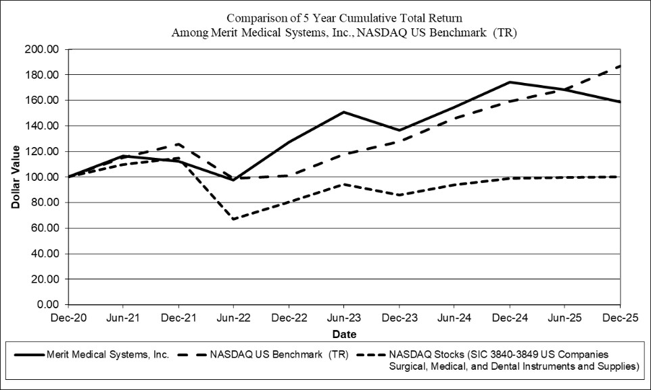
​
​
​ | ​ | ​ | ​ | ​ | ​ | ​ | ​ | ​ | ​ | ​ | ​ | ​ | ​ | ​ | ​ | ​ | ​ | ​
​ | ​ ​ ​ | 12/2020 |  | ​ ​ ​ | 12/2021 |  | ​ ​ ​ | 12/2022 |  | ​ ​ ​ | 12/2023 |  | ​ ​ ​ | 12/2024 |  | ​ ​ ​ | 12/2025
Merit Medical Systems, Inc. | ​ | $ | 100.00 | ​ | $ | 112.23 | ​ | $ | 127.20 | ​ | $ | 136.81 | ​ | $ | 174.17 | ​ | $ | 158.70
NASDAQ US Benchmark (TR) | ​ | ​ | 100.00 | ​ | ​ | 125.89 | ​ | ​ | 101.05 | ​ | ​ | 127.76 | ​ | ​ | 159.03 | ​ | ​ | 186.96
NASDAQ Stocks (SIC 3840-3849 U.S. Companies) | ​ |  | 100.00 | ​ | ​ | 114.90 | ​ | ​ | 80.42 | ​ | ​ | 85.77 | ​ | ​ | 98.74 | ​ | ​ | 100.10
The stock performance graph assumes for comparison that the value of our common stock and of each index was $100 on December 31, 2020 and that all dividends were reinvested. Past performance is not necessarily an indicator of future results.
NOTE: Performance graph data is complete through last fiscal year. Corporate Performance Graph with peer group uses peer group only performance (excludes only Merit). Peer group indices use beginning of period market capitalization weighting. Prepared by Zacks Investment Research, Inc. Used with permission. All rights reserved. Copyright 1980-2026. Index Data: Copyright NASDAQ OMX, Inc. Used with permission. All rights reserved.
​
Item 6.Reserved.
​
38
Table of Contents
Item 7.Management’s Discussion and Analysis of Financial Condition and Results of Operations.
The following discussion and analysis of our financial condition and results of operations should be read in conjunction with the Consolidated Financial Statements and related Notes thereto set forth in Item 8 of this report.
Discussion of the year ended December 31, 2024, compared to the year ended December 31, 2023 is included in Part II, Item 7 “Management’s Discussion and Analysis of Financial Condition and Results of Operations” of our Annual Report on Form 10-K for the year ended December 31, 2024, and is incorporated by reference into this Form 10-K.
Overview
We design, develop, manufacture, market and sell medical products for interventional and diagnostic procedures. For financial reporting purposes, we report our operations in two operating segments: cardiovascular and endoscopy. Our cardiovascular segment consists of four product categories: peripheral intervention, cardiac intervention, custom procedural solutions, and OEM. Within these product categories, we sell a variety of products, including cardiology and radiology devices (which assist in diagnosing and treating coronary arterial disease, peripheral vascular disease and other nonvascular diseases), as well as embolotherapeutic, cardiac rhythm management, electrophysiology, critical care, breast cancer localization and guidance, biopsy, and interventional oncology and spine devices. Our endoscopy segment consists of gastroenterology and pulmonology devices which assist in the palliative treatment of expanding esophageal, tracheobronchial and biliary strictures caused by malignant tumors.
For the year ended December 31, 2025, we reported sales of $1.516 billion, up $159.4 million or 11.8%, compared to 2024 sales of $1.357 billion. Our revenue results for the year ended December 31, 2025 were driven primarily by demand in the U.S. and favorable international sales trends, particularly in Europe, the Middle East and Africa (“EMEA”) region.
Gross profit as a percentage of sales was 48.7% for the year ended December 31, 2025 as compared to 47.4% for the year ended December 31, 2024.
Net income for the year ended December 31, 2025 was $128.5 million, or $2.13 per share, as compared to $120.4 million, or $2.03 per share, for the year ended December 31, 2024.
In May 2025, we completed a merger transaction with Biolife Delaware, L.L.C. (“Biolife”), a manufacturer of unique patented hemostatic devices under the brand names StatSeal® and WoundSeal®. In November 2025, pursuant to the terms of an asset purchase agreement between Merit and Pentax of America, Inc., we acquired the C2 CryoBalloon® device and related technology.
In February 2024, we introduced our “Continued Growth initiatives” Program with muti-year financial targets for the three-year period ending December 31, 2026, which reflects our commitment to better-position Merit for long-term, sustainable growth and enhanced profitability.
Results of Operations
The following table sets forth certain operational data as a percentage of sales for the years indicated:
​ | ​ | ​ | ​ | ​ | ​ | ​
​ | 2025 | ​ ​ ​ | 2024 | ​ ​ ​ | 2023
Net sales | 100 | % | 100 | % | 100 | %
Gross profit | 48.7 |  | 47.4 |  | 46.4 | ​
Selling, general and administrative expenses | 30.0 |  | 29.5 |  | 29.7 | ​
Research and development expenses | 6.4 |  | 6.4 |  | 6.6 | ​
Contingent consideration expense | 0.1 |  | 0.0 |  | 0.1 | ​
Acquired in-process research and development expense | — |  | — |  | 0.1 | ​
Income from operations | 12.2 |  | 11.5 |  | 9.9 | ​
Other expense — net | (0.9) |  | (0.4) |  | (0.9) | ​
Income before income taxes | 11.3 |  | 11.1 |  | 8.9 | ​
Net income | 8.5 |  | 8.9 |  | 7.5 | ​
​
39
Table of Contents
Sales
Listed below are the sales by product category within each operating segment for the years ended December 31, 2025, 2024 and 2023 (in thousands, other than percentage changes):
​ | ​ | ​ | ​ | ​ | ​ | ​ | ​ | ​ | ​ | ​ | ​ | ​
​ | % Change | ​ ​ ​ | 2025 |  | ​ ​ ​ | % Change | ​ ​ ​ | 2024* |  | ​ ​ ​ | 2023*
Cardiovascular | ​ | ​ | ​ | ​ | ​ | ​ | ​ | ​ | ​ | ​ | ​ | ​
Peripheral Intervention | 8.8 | % | $ | 579,840 |  | 10.2 | % | $ | 532,770 |  | $ | 483,265
Cardiac Intervention | 21.7 | % |  | 448,914 |  | 3.4 | % |  | 368,951 |  |  | 356,650
Custom Procedural Solutions | 4.6 | % |  | 209,333 |  | 3.3 | % |  | 200,033 |  |  | 193,717
OEM | 2.5 | % |  | 204,955 |  | 7.0 | % |  | 199,990 |  |  | 186,928
Total | 10.9 | % |  | 1,443,042 |  | 6.7 | % |  | 1,301,744 |  |  | 1,220,560
​ | ​ | ​ | ​ | ​ | ​ | ​ | ​ | ​ | ​ | ​ | ​ | ​
Endoscopy | ​ | ​ | ​ | ​ | ​ | ​ | ​ | ​ | ​ | ​ | ​ | ​
Endoscopy Devices | 33.0 | % |  | 72,864 |  | 48.8 | % |  | 54,770 |  |  | 36,806
​ | ​ | ​ | ​ | ​ | ​ | ​ | ​ | ​ | ​ | ​ | ​ | ​
Total | 11.8 | % | $ | 1,515,906 |  | 7.9 | % | $ | 1,356,514 |  | $ | 1,257,366
*Commencing January 1, 2025, we reorganized our sales teams and product categories to include revenues from the sale of our spine devices under our OEM product category. Revenue figures for 2024 and 2023 have been recast to reflect this realignment of our portfolio of spine products, representing approximately $22.6 million and $22.4 million in revenue, respectively, within the OEM product category to provide comparability between the reported periods.
​
Cardiovascular Sales. Our cardiovascular sales for the year ended December 31, 2025 were $1.443 billion, up 10.9%, when compared to the year ended December 31, 2024 of $1.302 billion. Sales for the year ended December 31, 2025 were favorably affected by increased sales of:
 | (a) | Cardiac intervention products, which increased by $80.0 million, or 21.7%, from the corresponding period of 2024. This increase was driven primarily by $35.3 million in incremental sales associated with products acquired from Cook in November 2024, $11.9 million in sales associated with products acquired in connection with the Biolife Merger in May 2025 and increased sales of our intervention, cardiac rhythm management/electrophysiology (“CRM/EP”), angiography, access and fluid management products.
 | (b) | Peripheral intervention products, which increased by $47.1 million, or 8.8%, from the corresponding period of 2024. This increase was driven primarily by increased sales of our embolotherapy, radar localization, access, delivery systems and drainage products.
 | (c) | Custom procedural solutions products, which increased by $9.3 million, or 4.6% from the corresponding period of 2024. This increase was driven primarily by increased sales of our kits, trays and critical care products.
 | (d) | OEM products, which increased by $5.0 million, or 2.5% from the corresponding period of 2024. This increase was driven primarily by increased sales of our intervention, CRM/EP, kits and peripheral intervention products, offset partially by decreased sales of our access and coated tube and wire products.
Endoscopy Sales. Our endoscopy sales for the year ended December 31, 2025 were $72.9 million, up 33.0%, when compared to sales for the year ended December 31, 2024 of $54.8 million. Sales for the year ended December 31, 2025 were favorably affected by increased sales of our EsophyX® Z+ device acquired from Endogastric Solutions, Inc. in July 2024.
Geographic Sales
Listed below are sales by geography for the years ended December 31, 2025, 2024 and 2023 (in thousands, other than percentage changes):
​ | ​ | ​ | ​ | ​ | ​ | ​ | ​ | ​ | ​ | ​ | ​ | ​
​ | % Change | ​ ​ ​ | 2025 |  | ​ ​ ​ | % Change | ​ ​ ​ | 2024 |  | ​ ​ ​ | 2023
United States | 13.6 | % | $ | 909,466 | ​ | 10.2 | % | $ | 800,780 | ​ | $ | 726,989
International | 9.1 | % | ​ | 606,440 | ​ | 4.8 | % | ​ | 555,734 | ​ | ​ | 530,377
Total | 11.8 | % | $ | 1,515,906 |  | 7.9 | % | $ | 1,356,514 |  | $ | 1,257,366
​
40
Table of Contents
United States Sales: U.S. sales for the year ended December 31, 2025 were $909.5 million, or 60.0% of net sales, up 13.6% when compared to 2024. The increase in our domestic sales in 2025 was driven primarily by our U.S. direct, endoscopy, and OEM businesses.
International Sales. International sales for the year ended December 31, 2025 were $606.4 million, or 40.0% of net sales, up 9.1% when compared to 2024. The increase in our international sales during 2025 was primarily a result of higher sales in EMEA, which increased $37.9 million or 15.3%, higher Rest of World (“ROW”) sales which increased $7.0 million or 12.2%, and higher sales in our Asia Pacific region, which increased $5.8 million or 2.3%, compared to the corresponding period of 2024.
Our international sales are subject to foreign currency exchange rate fluctuations between the natural currency of a foreign country and the U.S. Dollar. Foreign currency exchange rate fluctuations, calculated by using the applicable average foreign exchange rates for the prior year increased sales 0.3% for the year ended December 31, 2025 compared to 2024.
Gross Profit
Our gross profit as a percentage of sales was 48.7%, 47.4%, and 46.4% for the years ended December 31, 2025, 2024 and 2023, respectively. The increase in gross profit as a percentage of sales for 2025, as compared to 2024, was primarily due to favorable changes in pricing and product mix, partially offset by higher intangible amortization expense as a percentage of sales associated with acquisitions and unfavorable manufacturing variances.
Operating Expenses
Selling, General and Administrative Expenses. Our selling, general and administrative (“SG&A”) expenses as a percentage of sales were 30.0%, 29.5% and 29.7% for the years ended December 31, 2025, 2024 and 2023, respectively. SG&A expenses increased $55.5 million, or 13.9%, for the year ended December 31, 2025 compared to 2024. The increase in SG&A expenses for the year ended December 31, 2025 compared to the year ended December 31, 2024 was primarily due to an increase in labor-related costs including (i) variable compensation associated with performance-based bonus programs, commissions associated with sales growth, as well as an increase in expense associated with both performance and non-performance based equity awards; and (ii) headcount additions to support investment in the business and growth from acquisitions, including those in connection with the Cook Transaction and the Biolife Merger. In addition, higher marketing, advertising, and travel expenditures contributed to the year-over-year increase in 2025.
Research and Development Expenses. Our research and development (“R&D”) expenses as a percentage of sales were 6.4%, 6.4% and 6.6% for the years ended December 31 2025, 2024, and 2023, respectively. R&D expenses increased by $9.9 million or 11.3% to $97.4 million for the year ended December 31, 2025, compared to $87.5 million in 2024. The increase in R&D expenses for the year ended December 31, 2025 compared to the year ended December 31, 2024 was primarily related to increased labor-related costs including variable compensation associated with bonus and equity award programs and increased consulting services and clinical trials.
Contingent Consideration Expense. For the years ended December 31, 2025, 2024 and 2023, we recorded $1.0 million, $0.4 million and $1.7 million, respectively, of net contingent consideration expense from changes in the estimated fair value of our contingent consideration obligations stemming from our previously disclosed business acquisitions. The expense in each fiscal year relates to changes in the probability and timing of achieving certain revenue and operational milestones, as well as expense for the passage of time.
41
Table of Contents
Operating Income
Our operating profit by operating segment for the years ended December 31, 2025, 2024 and 2023 was as follows (in thousands):
​ | ​ | ​ | ​ | ​ | ​ | ​ | ​ | ​
Operating Income | 2025 |  | ​ ​ ​ | 2024 |  | ​ ​ ​ | 2023
Cardiovascular | $ | 166,133 | ​ | $ | 150,150 | ​ | $ | 114,440
Endoscopy |  | 18,587 | ​ |  | 5,543 | ​ |  | 9,504
Total operating income | $ | 184,720 | ​ | $ | 155,693 | ​ | $ | 123,944
​
Cardiovascular Operating Income. Our cardiovascular operating income for the year ended December 31, 2025 was $166.1 million, compared to cardiovascular operating income of $150.2 million for the year ended December 31, 2024. This increase in cardiovascular operating income was primarily related to increased sales and gross profit, partially offset by increased SG&A and R&D expenses.
Endoscopy Operating Income. Our endoscopy operating income for the year ended December 31, 2025 was $18.6 million, compared to operating income of $5.5 million for the year ended December 31, 2024. This increase in endoscopy operating income relative to 2024 was primarily due to increased sales and gross profit.
Other Income (Expense)
Our other expense for the years ended December 31, 2025, 2024 and 2023 was $13.8 million, $5.7 million, and $11.9 million, respectively. The increase in other expense for 2025 compared to 2024 was principally the result of a decrease in interest income associated with decreased average cash and cash equivalents during the period, partially offset by reduced interest expense associated with borrowings under the Amended Fourth A&R Credit Agreement.
Effective Tax Rate
Our provision for income taxes for the years ended December 31, 2025, 2024 and 2023 was a tax expense of $42.4 million, $29.6 million and $17.7 million, respectively, which resulted in an effective income tax rate of 24.8%, 19.8%, and 15.8%, respectively. The increase in the effective income tax rate for 2025 compared to 2024 was primarily the result of decreased benefit from discrete items such as share-based compensation and contingent liabilities and increased permanent tax differences in various jurisdictions and items related to the budget reconciliation package enacted during the period and retroactive to the beginning of the year.
Net Income
Our net income for the years ended December 31, 2025, 2024 and 2023 was $128.5 million, $120.4 million, and $94.4 million, respectively. The increase in net income for 2025, when compared to 2024, was primarily related to higher sales and higher gross margin as a percentage of sales; partially offset by higher SG&A, R&D, other expense and income tax expense.
Liquidity and Capital Resources
Capital Commitments and Contractual Obligations
Our most significant contractual obligations as of December 31, 2025 included total long-term debt obligations of $747.5 million, interest payments on this debt, contingent consideration liabilities of $4.5 million, of which $3.2 million is recorded in current liabilities, and operating lease liabilities of $87.5 million, of which $10.9 million is recorded in current liabilities. Additional information about these obligations is contained in Notes 8, 15 and 17 to our consolidated financial statements set forth in Item 8 of this report.
42
Table of Contents
Cash Flows
At December 31, 2025 and 2024, we had cash, cash equivalents and restricted cash of $448.5 million and $378.8 million respectively, of which $66.0 million and $50.6 million, respectively, were held by foreign subsidiaries. We do not consider our foreign earnings to be permanently reinvested. As of December 31, 2025 and 2024, approximately $2.1 million and $2.1 million respectively, of our cash and cash equivalents represents restricted cash for the payment of certain import and other taxes for our subsidiary in China. Cash held by our subsidiary in China is subject to local laws and regulations that require government approval for the transfer of such funds to entities located outside of China. As of December 31, 2025 and 2024, cash and cash equivalents, including restricted cash, held by our subsidiary in China was $20.0 million and $18.1 million, respectively.
Cash flows provided by operating activities. We generated cash from operating activities of $297.4 million, $220.8 million and $145.2 million during the years ended December 31, 2025, 2024 and 2023, respectively. Net cash provided by operating activities increased $76.6 million for the year ended December 31, 2025 compared to the year ended December 31, 2024. Significant changes in operating assets and liabilities affecting cash flows during these years included:
 | ● | Net income was $128.5 million and $120.4 million for the years ended December 31, 2025 and 2024, respectively.
 | ● | Depreciation and amortization was $123.2 million and $102.7 million for the years ended December 31, 2025 and 2024, respectively, primarily due to an increase in intangible assets as a result of acquisitions.
 | ● | Cash paid for income taxes was $31.4 million and $45.0 million for the years ended December 31, 2025 and 2024, respectively, primarily as the result of increased taxes payable and an increased portion of our total tax expense relating to deferred tax expense.
 | ● | Stock-based compensation expense was $43.5 million and $28.5 million for the years ended December 31, 2025 and 2024, respectively. The increase in stock-based compensation expense during 2025 is primarily associated with the increase in the Company’s stock price and grants of restricted stock units.
 | ● | Cash used for inventories was $21.6 million and $2.3 million for the years ended December 31, 2025 and 2024, respectively. The increase in inventories during 2025 was principally associated with our strategy to proactively invest in our inventory balances to encourage high customer service levels, as well as to build bridge inventory for production line transfers and increases in safety stock due to vendor supply delays.
Cash flows used in investing activities. We used cash in investing activities of $247.4 million, $368.7 million, and $175.3 million for the years ended December 31, 2025, 2024 and 2023, respectively. We invested in capital expenditures for property and equipment of $81.7 million, $35.1 million, and $34.3 million for the years ended December 31, 2025, 2024 and 2023, respectively. Capital expenditures in each period were primarily related to investment in property and equipment to support development and production of our products and in 2025 includes costs for the construction of a new distribution facility in South Jordan, Utah. Historically, we have incurred significant expenses in connection with facility construction, production automation, product development and the introduction of new products. We anticipate that we will spend approximately $80 to $100 million in 2026 for property and equipment.
Cash outflows invested in acquisitions for the year ended December 31, 2025 were $144.8 million and were primarily related to payments required by our merger agreement with Biolife LLC ($120.0 million) and our asset purchase agreement with Pentax of America, Inc. ($19 million). Cash outlfows invested in acquisitions for the year ended December 31, 2024 were $320.2 million and were primarily related to payments required by our asset purchase agreements with Cook Medical Holdings LLC ($210.0 million), Endogastric Solutions, Inc. ($105.0 million) and Scholten Surgical Instruments, Inc. ($3.0 million). Cash outflows invested in acquisitions for the year ended December 31, 2023 were $134.5 million and were primarily related to payments required by our asset purchase agreements with AngioDynamics, Inc. ($100 million), Bluegrass Vascular Technologies, Inc. ($32.7 million) and ART ($1.5 million).
43
Table of Contents
Cash flows provided by (used in) financing activities. Cash provided by (used in) financing activities for the years ended December 31, 2025, 2024 and 2023 was $16.0 million, $(60.0) million, and $559.3 million, respectively. In 2025 we had cash proceeds from the issuance of common stock of $28.2 million. In 2024 we decreased our net borrowings under our Amended Fourth A&R Credit Agreement by $99.1 million and had cash proceeds from the issuance of common stock of $40.9 million. In 2023 we issued convertible debt of $747.5 million, paid $66.5 million for the purchase of capped call options, and decreased our net borrowings under our Amended Fourth A&R Credit Agreement by $99.1 million.
As of December 31, 2025, we had outstanding borrowings of $747.5 million and issued letter of credit guarantees of $2.8 million, with additional available borrowings of approximately $697 million under the Amended Fourth A&R Credit Agreement, based on the leverage ratio required pursuant to the Amended Fourth A&R Credit Agreement. Our interest rate as of December 31, 2025 and 2024 was a fixed rate of 3.0% on our Convertible Notes. See Note 8 Debt to our consolidated financial statements set forth in Item 8 of this report for additional details regarding the Amended Fourth A&R Credit Agreement and our Convertible Notes.
We currently believe that our existing cash balances, anticipated future cash flows from operations and borrowings under our long-term debt agreements will be adequate to fund our current and currently planned future operations for the next twelve months and the foreseeable future. In the event we pursue and complete significant transactions or acquisitions in the future, additional funds may be required to meet our strategic needs, which may require us to raise additional funds in the debt or equity markets.
Critical Accounting Policies and Estimates
Our significant accounting policies are summarized in Note 1 Organization and Summary of Significant Accounting Policies to our consolidated financial statements set forth in Item 8 of this report. While these significant accounting policies affect the reporting of our financial condition and results of operations, the SEC has requested that all registrants address their most critical accounting policies. The SEC has indicated that a “critical accounting policy” is one which is both important to the representation of the registrant’s financial condition and results and requires management’s most difficult, subjective or complex judgments, often as a result of the need to make estimates about the effect of matters that are inherently uncertain. We base our estimates on past experience and on various other assumptions our management believes to be reasonable under the circumstances, the results of which form the basis for making judgments about carrying values of assets and liabilities that are not readily apparent from other sources. Actual results will differ and may differ materially from these estimates under different assumptions or conditions. Additionally, changes in accounting estimates could occur in the future from period to period. The following paragraphs identify our most critical accounting policies:
Inventory Obsolescence. Our management reviews inventory quantities on hand and records provisions for estimated excess, slow moving and obsolete inventory. Based on this review, we provide adjustments for any slow-moving finished good products or raw materials that we believe will expire prior to being sold or used to produce a finished good and any products that are unmarketable. This review of inventory quantities for unmarketable and/or slow moving products is based on forecasted product demand derived from our historical experience of product sales and production raw material usage. If market conditions become less favorable than those projected by our management, additional inventory write-downs may be required. During the years ended December 31, 2025, 2024 and 2023, we recorded obsolescence expense of approximately $11.2 million, $10.6 million, and $11.5 million, respectively, and wrote off approximately $9.0 million, $12.0 million, and $11.9 million, respectively. Based on this historical trend, we believe that our inventory balances as of December 31, 2025 have been accurately adjusted for any unmarketable and/or slow moving products that may expire prior to being sold.
Valuation of Goodwill and Intangible Assets. We allocate any excess purchase price over the fair value of the net tangible and identifiable intangible assets acquired in a business combination to goodwill. We base the fair value of identifiable intangible assets acquired in a business combination on valuations that use information and assumptions that a market participant would use, including assumptions for estimated revenue projections, growth rates, cash flows, discount rates, useful life, and other relevant assumptions.
44
Table of Contents
We test our goodwill balances for impairment annually as of July 1, or whenever impairment indicators arise. When impairment indicators are identified, we may elect to perform an optional qualitative assessment to determine whether it is more likely than not that the fair value of our reporting units has fallen below their carrying value. Our election to perform a qualitative impairment assessment for an individual reporting unit in a given year is influenced by a number of factors, including, but not limited to, the size of the reporting unit's goodwill, the significance of the excess of the reporting unit's estimated fair value over carrying value at the last quantitative assessment date, the amount of time since the last quantitative analysis was performed, and other performance and market indicators. During a qualitative assessment, if we determine that it is not more likely than not that the implied fair value of the goodwill is less than its carrying amount, no further testing is necessary. If we do not perform a qualitative assesment, or we determine that it is more likely than not that the implied fair value of the goodwill is less than its carrying amount, we perform a quantitative assessment, which uses a combination of a guideline public company market-based approach and a discounted cash flow income-based approach. The quantitative assessment considers whether the carrying amount of a reporting unit exceeds its fair value, in which case an impairment charge is recorded to the extent the reporting unit’s carrying value exceeds its fair value. This analysis requires significant judgment, including estimation of the amount, timing and duration of future cash flows, which is based on internal forecasts, and a determination of a discount rate based on our weighted average cost of capital. During our annual impairment test performed during the third quarter of 2025, we evaluated each of our four reporting units using a qualitative assessment. As a result of the assessment, we determined that it was not more likely than not that the implied fair value was less than its carrying amount for each of our four reporting units, and no detailed quantitative assessment was necessary.
We evaluate long-lived assets, including amortizing intangible assets, for impairment whenever events or changes in circumstances indicate that their carrying amounts may not be recoverable. We perform the impairment analysis at the asset group for which the lowest level of identifiable cash flows is largely independent of the cash flows of other assets and liabilities. We first compare undiscounted cash flows to the carrying amount of the asset group to determine if impairment exists, and then determine the fair value of our amortizing assets based on estimated future cash flows discounted back to their present value using a discount rate that reflects the risk profiles of the underlying activities. This analysis requires similar significant judgments as those discussed above regarding goodwill. In-process technology intangible assets, which are not subject to amortization until projects reach commercialization, are assessed for impairment at least annually and more frequently if events occur that would indicate a potential reduction in the fair value of the assets below their carrying value.
We did not have any goodwill or intangible asset impairments for the years ended December 31, 2025, 2024 and 2023. See Note 5 Goodwill and Intangible Assets to our consolidated financial statements set forth in Item 8 of this report for additional details regarding goodwill and intangible asset balances.
​
45
Table of Contents
Item 7A.Quantitative and Qualitative Disclosures About Market Risk.
Currency Exchange Rate Risk
Our consolidated financial statements are denominated in, and our principal currency is, the U.S. Dollar. For the year ended December 31, 2025, a portion of our net sales ($510.3 million, representing 33.7% of our aggregate net sales), was attributable to sales that were denominated in foreign currencies. All other international sales were denominated in U.S. Dollars. Our principal market risk relates to changes in the value of the Chinese Yuan Renminbi (CNY) and Euro (EUR) relative to the U.S. Dollar (USD), with limited market risk relating to various other currencies. In general, a strengthening of the U.S. Dollar against CNY has a negative effect on our operating income. Our Euro-denominated expenses associated with our European operations (manufacturing sites, a distribution facility and sales representatives) provide a natural hedge for Euro-denominated revenues. Accordingly, a strengthening of the U.S. Dollar against the Euro will generally have a positive effect on our operating income.
We forecast our net exposure related to sales and expenses denominated in foreign currencies. As of December 31, 2025 and 2024, we had entered into foreign currency forward contracts, which qualified as cash flow hedges, with aggregate notional amounts of $138.6 million and $117.5 million, respectively. We also forecast our net exposure in various receivables and payables to fluctuations in the value of various currencies, and we enter into foreign currency forward contracts to mitigate that exposure. As of December 31, 2025 and 2024, we had entered into foreign currency forward contracts, which were not designated as hedging instruments, related to those balance sheet accounts with aggregate notional amounts of $107.6 million and $95.7 million, respectively.
A sensitivity analysis of changes in the fair value of all currency exchange rate derivative contracts at December 31, 2025 and 2024 indicates that, if the U.S. Dollar strengthened or weakened by 10% against all currencies, it would have the following impact on the fair value of these contracts (in thousands):
​ | ​ | ​ | ​ | ​ | ​ | ​
​ | ​ ​ ​ | 2025 |  | ​ ​ ​ | 2024
10% Strengthening | ​ | $ | 13,569 | ​ | $ | 5,545
10% Weakening | ​ | $ | (13,569) | ​ | $ | (5,545)
​
Gains or losses on the fair value of derivative contracts would generally be offset by gains and losses on the underlying hedged transaction or net exposure. These offsetting gains and losses are not reflected above. See Note 9 Derivatives to our consolidated financial statements set forth in Item 8 of this report for additional discussion of our foreign currency forward contracts.
Interest Rate Risk
As discussed in Note 8 Debt to our consolidated financial statements set forth in Item 8 of this report, as of December 31, 2025, we had no outstanding borrowings under the Amended Fourth A&R Credit Agreement. Our exposure to market risk for changes in interest rates relates primarily to variable interest earned on cash balances. Accordingly, our earnings and after-tax cash flow are affected by changes in interest rates. Assuming the current level of cash balances remained the same and no additional borrowings are withdrawn, it is estimated that our interest income before income taxes would change by approximately $4.5 million annually for each one percentage point change in the average interest rate associated with these cash holdings.
​
46
Table of Contents
Item 8.Financial Statements and Supplementary Data.
REPORT OF INDEPENDENT REGISTERED PUBLIC ACCOUNTING FIRM
To the stockholders and the Board of Directors of Merit Medical Systems, Inc.
Opinion on the Financial Statements
We have audited the accompanying consolidated balance sheets of Merit Medical Systems, Inc. and subsidiaries (the "Company") as of December 31, 2025 and 2024, the related consolidated statements of income, comprehensive income, stockholders' equity, and cash flows, for each of the three years in the period ended December 31, 2025, and the related notes and the schedules⁠ listed in the Index at Item 15 (collectively referred to as the "financial statements"). In our opinion, the financial statements present fairly, in all material respects, the financial position of the Company as of December 31, 2025 and 2024, and the results of its operations and its cash flows for each of the three years in the period ended December 31, 2025, in conformity with accounting principles generally accepted in the United States of America.
We have also audited, in accordance with the standards of the Public Company Accounting Oversight Board (United States) (PCAOB), the Company's internal control over financial reporting as of December 31, 2025, based on criteria established in Internal Control — Integrated Framework (2013) issued by the Committee of Sponsoring Organizations of the Treadway Commission and our report dated February 24, 2026, expressed an unqualified opinion on the Company's internal control over financial reporting.
Basis for Opinion
These financial statements are the responsibility of the Company's management. Our responsibility is to express an opinion on the Company's financial statements based on our audits. We are a public accounting firm registered with the PCAOB and are required to be independent with respect to the Company in accordance with the U.S. federal securities laws and the applicable rules and regulations of the Securities and Exchange Commission and the PCAOB.
We conducted our audits in accordance with the standards of the PCAOB. Those standards require that we plan and perform the audit to obtain reasonable assurance about whether the financial statements are free of material misstatement, whether due to error or fraud. Our audits included performing procedures to assess the risks of material misstatement of the financial statements, whether due to error or fraud, and performing procedures that respond to those risks. Such procedures included examining, on a test basis, evidence regarding the amounts and disclosures in the financial statements. Our audits also included evaluating the accounting principles used and significant estimates made by management, as well as evaluating the overall presentation of the financial statements. We believe that our audits provide a reasonable basis for our opinion.
Critical Audit Matters
The critical audit matters communicated below are matters arising from the current-period audit of the financial statements that were communicated or required to be communicated to the audit committee and that (1) relate to accounts or disclosures that are material to the financial statements and (2) involved our especially challenging, subjective, or complex judgments. The communication of critical audit matters does not alter in any way our opinion on the financial statements, taken as a whole, and we are not, by communicating the critical audit matters below, providing separate opinions on the critical audit matters or on the accounts or disclosures to which they relate.
​
47
Table of Contents
Inventories - Provision for estimated excess, slow moving and obsolete inventories – Refer to Note 1 to the financial statements
Critical Audit Matter Description
Inventories are valued at the lower of cost, at approximate costs determined on a first-in, first-out method, or net realizable value. The Company reviews inventories on hand and records provisions based on estimated excess, slow moving and obsolete inventories. The valuation of inventories includes an assessment of future product demand based on historical sales and raw material usage and product expiration.
We identified the provision for estimated excess, slow moving and obsolete inventories as a critical audit matter because of management’s significant judgment and estimates in determining the provision for estimated excess, slow moving and obsolete inventories primarily around forecasted product demand derived from historical experience of product sales and production raw material usage. This required a high degree of auditor judgment and an increased extent of effort.
How the Critical Audit Matter Was Addressed in the Audit
Our audit procedures related to management’s estimate of the valuation of excess, slow moving and obsolete inventories included the following, among others:
​
 | ● | We tested the effectiveness of internal controls over the provision for estimated excess, slow moving and obsolete inventories.
 | ● | We evaluated management’s ability to accurately estimate the provision for estimated excess, slow moving and obsolete inventories by comparing actual write-downs of inventories to management’s historical estimates.
 | ● | We tested the calculation of the estimated excess, slow moving and obsolete inventories, on a sample basis, including the completeness and accuracy of the data used in the calculation, such as future product demand based on historical sales and raw material usage and product expiration.
 | ● | We assessed the reasonableness of the assumptions used in the calculations of the provision for estimated excess, slow moving and obsolete inventories by developing an independent expectation and comparing our independent expectation to the results of the Company’s calculation.
 | ● | We tested the mathematical accuracy of the Company’s calculation of excess, slow moving and obsolete inventories.
Intangible Assets – Biolife Developed Technology – Refer to Note 3 to the financial statements
Critical Audit Matter Description
On May 16, 2025, the Company entered into a merger agreement with Biolife Delaware, L.L.C. (“Biolife”), to become a wholly-owned subsidiary of the Company. The Company accounted for this transaction under the acquisition method of accounting for business combinations. Accordingly, the purchase price was allocate⁠d to the tangible and intangible assets acquired based on their respective fair values, including developed technology intangible assets of $90.5 million.
The determination of the fair value of the developed technology intangible assets required management to make significant estimates and assumptions related to future cash flows and the discount rate.
We identified the valuation of the acquired developed technology intangible assets from Biolife as a critical audit matter because of the significant estimates and assumptions management made to determine the fair value of the acquired developed technology. This required a high degree of auditor judgment and an increased extent of effort, including the involvement of our fair value specialists, when performing audit procedures to evaluate the reasonableness of management’s forecasts of future cash flows and the discount rate.
48
Table of Contents
How the Critical Audit Matter Was Addressed in the Audit
Our audit procedures related to the estimates of future cash flows and discount rate for the acquired Biolife developed technology intangible assets included the following, among others:
​
 | ● | We tested the effectiveness of internal controls over the valuation of the developed technology intangible assets, including those over estimates of future cash flows and the selection of the discount rate.
 | ● | We assessed the reasonableness of management’s estimated cash flows by inquiring of management regarding its processes for developing estimated cash flows and comparing the estimates to historical results achieved by the predecessor, historical results of the Company and other transactions completed in recent years, and comparable peer companies.
 | ● | We performed sensitivity analyses of the significant assumptions used in the developed technology valuation model to evaluate the change in fair value resulting from changes in the significant assumptions.
 | ● | With the assistance of our fair value specialists, we (1) evaluated the reasonableness of the valuation methodology; (2) evaluated the reasonableness of the discount rate through comparing the data underlying the determination of the discount rate to independent sources and developed a range of independent estimates and compared it to the discount rate selected by management; and (3) tested the mathematical accuracy of the discounted cash flow calculations.
 | ● | We evaluated whether the estimated revenue growth rates and cash flows were consistent with evidence obtained as part of a retrospective review of actual post-transaction financial results.

​  /s/ DELOITTE & TOUCHE LLP | ​
​ | ​
Salt Lake City, Utah | ​
February 24, 2026 | ​
We have served as the Company’s auditor since 1988. | ​
​
​
49
Table of Contents
​
MERIT MEDICAL SYSTEMS, INC. AND SUBSIDIARIES
CONSOLIDATED BALANCE SHEETS
(In thousands)
​

​ | ​ | ​ | ​ | ​ | ​ | ​
​ | ​ ​ ​ | December 31, |  | ​ ​ ​ | December 31,
ASSETS | ​ ​ ​ | 2025 |  | ​ ​ ​ | 2024
​ | ​ | ​ | ​ | ​ | ​ | ​
Current assets: |  | ​ | ​ |  | ​ | ​
Cash and cash equivalents | ​ | $ | 446,404 | ​ | $ | 376,715
Trade receivables — net of allowance for credit losses — 2025 — $10,136 and 2024 — $9,729 | ​ |  | 203,710 | ​ |  | 190,243
Other receivables | ​ |  | 17,773 | ​ |  | 16,588
Inventories | ​ |  | 333,705 | ​ |  | 306,063
Prepaid expenses and other current assets | ​ |  | 31,493 | ​ |  | 28,544
Prepaid income taxes | ​ |  | 4,941 | ​ |  | 3,286
Income tax refund receivables | ​ |  | 2,128 | ​ |  | 2,335
Total current assets | ​ |  | 1,040,154 | ​ |  | 923,774
​ | ​ | ​ | ​ | ​ | ​ | ​
Property and equipment: | ​ |  | ​ | ​ |  | ​
Land and land improvements | ​ |  | 30,465 | ​ |  | 25,846
Buildings | ​ |  | 200,046 | ​ |  | 192,296
Manufacturing equipment | ​ |  | 365,277 | ​ |  | 340,864
Furniture and fixtures | ​ |  | 60,883 | ​ |  | 61,321
Leasehold improvements | ​ |  | 65,236 | ​ |  | 58,770
Construction-in-progress | ​ |  | 82,939 | ​ |  | 58,673
Total property and equipment | ​ |  | 804,846 | ​ |  | 737,770
Less accumulated depreciation | ​ |  | (376,445) | ​ |  | (351,605)
Property and equipment — net | ​ |  | 428,401 | ​ | ​ | 386,165
​ | ​ | ​ | ​ | ​ | ​ | ​
Other assets: | ​ |  | ​ | ​ |  | ​
Intangible assets: | ​ |  | ​ | ​ |  | ​
Developed technology — net of accumulated amortization — 2025 — $452,525 and 2024 — $377,993 | ​ |  | 465,940 | ​ |  | 431,766
Other — net of accumulated amortization — 2025 — $96,436 and 2024 — $85,343 | ​ |  | 71,714 | ​ |  | 66,499
Goodwill | ​ |  | 506,837 | ​ |  | 463,511
Deferred income tax assets | ​ |  | 7,049 | ​ |  | 16,044
Right-of-use operating lease assets | ​ | ​ | 87,600 | ​ | ​ | 65,508
Other assets | ​ |  | 78,227 | ​ |  | 65,336
Total other assets | ​ |  | 1,217,367 | ​ |  | 1,108,664
​ | ​ | ​ | ​ | ​ | ​ | ​
Total assets | ​ | $ | 2,685,922 | ​ | $ | 2,418,603
​
See notes to consolidated financial statements. | (continued)
​
​
50
Table of Contents
MERIT MEDICAL SYSTEMS, INC. AND SUBSIDIARIES
CONSOLIDATED BALANCE SHEETS
(In thousands)
​

​ | ​ | ​ | ​ | ​ | ​ | ​
​ | ​ ​ ​ | December 31, |  | ​ ​ ​ | December 31,
LIABILITIES AND STOCKHOLDERS’ EQUITY | ​ ​ ​ | 2025 |  | ​ ​ ​ | 2024
​ | ​ | ​ | ​ | ​ | ​ | ​
Current liabilities: |  | ​ | ​ | ​ | ​ | ​
Trade payables | ​ | $ | 60,551 | ​ | $ | 68,502
Accrued expenses | ​ |  | 159,486 | ​ |  | 134,077
Short-term operating lease liabilities | ​ | ​ | 10,876 | ​ | ​ | 10,331
Income taxes payable | ​ |  | 8,851 | ​ |  | 3,492
Total current liabilities | ​ |  | 239,764 | ​ |  | 216,402
​ | ​ | ​ | ​ | ​ | ​ | ​
Long-term debt | ​ |  | 734,038 | ​ |  | 729,551
Deferred income tax liabilities | ​ |  | 19,665 | ​ |  | 240
Liabilities related to unrecognized tax benefits | ​ |  | 2,248 | ​ |  | 2,118
Deferred compensation payable | ​ |  | 17,542 | ​ |  | 19,197
Deferred credits | ​ |  | 1,398 | ​ |  | 1,502
Long-term operating lease liabilities | ​ | ​ | 76,658 | ​ |  | 54,783
Other long-term obligations | ​ |  | 10,306 | ​ |  | 15,451
Total liabilities | ​ |  | 1,101,619 | ​ |  | 1,039,244
​ | ​ | ​ | ​ | ​ | ​ | ​
Commitments and contingencies | ​ |  | ​ | ​ |  | ​
​ | ​ | ​ | ​ | ​ | ​ | ​
Stockholders' equity: | ​ |  | ​ | ​ |  | ​
Preferred stock — 5,000 shares authorized; no shares issued as of December 31, 2025 and December 31, 2024 | ​ |  | — | ​ |  | —
Common stock, no par value — 100,000 shares authorized; issued and outstanding as of December 31, 2025 - 59,424 and December 31, 2024 - 58,743 | ​ |  | 763,909 | ​ |  | 703,219
Retained earnings | ​ |  | 824,030 | ​ |  | 695,541
Accumulated other comprehensive loss | ​ |  | (3,636) | ​ |  | (19,401)
Total stockholders’ equity | ​ |  | 1,584,303 | ​ |  | 1,379,359
​ | ​ | ​ | ​ | ​ | ​ | ​
Total liabilities and stockholders’ equity | ​ | $ | 2,685,922 | ​ | $ | 2,418,603
​
​ | ​
See notes to consolidated financial statements. | (concluded)
​
​
51
Table of Contents
MERIT MEDICAL SYSTEMS, INC. AND SUBSIDIARIES
CONSOLIDATED STATEMENTS OF INCOME
(In thousands, except per share amounts)
​

​ | ​ | ​ | ​ | ​ | ​ | ​ | ​ | ​
​ | 2025 |  | ​ ​ ​ | 2024 |  | ​ ​ ​ | 2023
Net sales | $ | 1,515,906 | ​ | $ | 1,356,514 | ​ | $ | 1,257,366
Cost of sales |  | 777,636 | ​ |  | 713,181 | ​ |  | 673,494
Gross profit |  | 738,270 | ​ |  | 643,333 | ​ |  | 583,872
​ | ​ | ​ | ​ | ​ | ​ | ​ | ​ | ​
Operating expenses: |  | ​ | ​ |  | ​ | ​ |  | ​
Selling, general and administrative |  | 455,214 | ​ |  | 399,731 | ​ |  | 373,676
Research and development |  | 97,352 | ​ |  | 87,466 | ​ |  | 82,728
Impairment charges |  | — | ​ |  | — | ​ |  | 270
Contingent consideration expense |  | 984 | ​ |  | 443 | ​ |  | 1,704
Acquired in-process research and development |  | — | ​ |  | — | ​ |  | 1,550
Total operating expenses |  | 553,550 | ​ |  | 487,640 | ​ |  | 459,928
​ | ​ | ​ | ​ | ​ | ​ | ​ | ​ | ​
Income from operations |  | 184,720 | ​ |  | 155,693 | ​ |  | 123,944
​ | ​ | ​ | ​ | ​ | ​ | ​ | ​ | ​
Other income (expense): |  | ​ | ​ |  | ​ | ​ |  | ​
Interest income |  | 15,070 | ​ |  | 26,230 | ​ |  | 2,456
Interest expense |  | (26,461) | ​ |  | (31,219) | ​ |  | (15,511)
Other (expense) income — net |  | (2,392) | ​ |  | (711) | ​ |  | 1,200
Total other expense — net |  | (13,783) | ​ |  | (5,700) | ​ |  | (11,855)
​ | ​ | ​ | ​ | ​ | ​ | ​ | ​ | ​
Income before income taxes |  | 170,937 | ​ |  | 149,993 | ​ |  | 112,089
​ | ​ | ​ | ​ | ​ | ​ | ​ | ​ | ​
Income tax expense |  | 42,448 | ​ |  | 29,636 | ​ |  | 17,678
​ | ​ | ​ | ​ | ​ | ​ | ​ | ​ | ​
Net income | $ | 128,489 | ​ | $ | 120,357 | ​ | $ | 94,411
​ | ​ | ​ | ​ | ​ | ​ | ​ | ​ | ​
Earnings per common share |  | ​ | ​ |  | ​ | ​ |  | ​
Basic | $ | 2.17 | ​ | $ | 2.07 | ​ | $ | 1.64
Diluted | $ | 2.13 | ​ | $ | 2.03 | ​ | $ | 1.62
​ | ​ | ​ | ​ | ​ | ​ | ​ | ​ | ​
Weighted average shares outstanding |  | ​ | ​ |  | ​ | ​ |  | ​
Basic |  | 59,158 | ​ |  | 58,218 | ​ |  | 57,593
Diluted |  | 60,460 | ​ |  | 59,365 | ​ |  | 58,356
​
See notes to consolidated financial statements.
​
52
Table of Contents
MERIT MEDICAL SYSTEMS, INC. AND SUBSIDIARIES
CONSOLIDATED STATEMENTS OF COMPREHENSIVE INCOME
(In thousands)

​ | ​ | ​ | ​ | ​ | ​ | ​ | ​ | ​
​ | 2025 |  | ​ ​ ​ | 2024 |  | ​ ​ ​ | 2023
Net income | $ | 128,489 | ​ | $ | 120,357 | ​ | $ | 94,411
Other comprehensive income (loss): |  | ​ | ​ |  | ​ | ​ |  | ​
Cash flow hedges |  | (1,279) | ​ |  | 1,444 | ​ |  | (3,570)
Income tax benefit (expense) |  | 302 | ​ |  | (341) | ​ |  | 866
Foreign currency translation adjustment |  | 17,955 | ​ |  | (9,224) | ​ |  | 2,959
Income tax (expense) benefit |  | (1,213) | ​ |  | 54 | ​ |  | (39)
Total other comprehensive income (loss) |  | 15,765 | ​ |  | (8,067) | ​ |  | 216
Total comprehensive income | $ | 144,254 | ​ | $ | 112,290 | ​ | $ | 94,627
​
See notes to consolidated financial statements.
​
53
Table of Contents
MERIT MEDICAL SYSTEMS, INC. AND SUBSIDIARIES
CONSOLIDATED STATEMENTS OF STOCKHOLDERS’ EQUITY
(In thousands)
​

​ | ​ | ​ | ​ | ​ | ​ | ​ | ​ | ​ | ​ | ​ | ​ | ​ | ​ | ​
​ | ​ | Common Stock |  |  |  | ​ | Retained |  | ​ | Accumulated Other |  | ​ | ​ | ​
​ | ​ ​ ​ | Shares | ​ ​ ​ | Amount |  | ​ ​ ​ | Earnings |  | ​ ​ ​ | Comprehensive Loss |  | ​ ​ ​ | Total
BALANCE — January 1, 2023 |  | 57,306 | ​ |  | 675,174 | ​ |  | 480,773 | ​ |  | (11,550) | ​ | $ | 1,144,397
Net income |  | ​ | ​ | ​ | ​ | ​ | ​ | 94,411 | ​ | ​ | ​ | ​ |  | 94,411
Other comprehensive income |  | ​ | ​ | ​ | ​ | ​ | ​ | ​ | ​ | ​ | 216 | ​ |  | 216
Stock-based compensation expense |  | ​ | ​ | ​ | 19,043 | ​ | ​ | ​ | ​ | ​ | ​ | ​ |  | 19,043
Options exercised |  | 606 | ​ | ​ | 20,312 | ​ | ​ | ​ | ​ | ​ | ​ | ​ |  | 20,312
Issuance of common stock under Employee Stock Purchase Plans |  | 15 | ​ | ​ | 1,081 | ​ | ​ | ​ | ​ | ​ | ​ | ​ |  | 1,081
Shares issued from time-vested restricted stock units | ​ | 92 | ​ | ​ | — | ​ | ​ | ​ | ​ | ​ | ​ | ​ | ​ | —
Purchase of capped call option | ​ | — | ​ | ​ | (66,528) | ​ | ​ | ​ | ​ | ​ | ​ | ​ | ​ | (66,528)
Shares surrendered in exchange for payment of payroll tax liabilities | ​ | (75) | ​ | ​ | (5,123) | ​ | ​ | ​ | ​ | ​ | ​ | ​ | ​ | (5,123)
Shares surrendered in exchange for exercise of stock options | ​ | (86) | ​ | ​ | (5,809) | ​ | ​ | ​ | ​ | ​ | ​ | ​ |  | (5,809)
BALANCE — December 31, 2023 |  | 57,858 | ​ |  | 638,150 | ​ |  | 575,184 | ​ |  | (11,334) | ​ |  | 1,202,000
Net income | ​ | ​ | ​ | ​ | ​ | ​ | ​ | 120,357 | ​ | ​ | ​ | ​ |  | 120,357
Other comprehensive loss | ​ | ​ | ​ | ​ | ​ | ​ | ​ | ​ | ​ | ​ | (8,067) | ​ |  | (8,067)
Stock-based compensation expense | ​ | ​ | ​ | ​ | 25,753 | ​ | ​ | ​ | ​ | ​ | ​ | ​ |  | 25,753
Options exercised | ​ | 824 | ​ | ​ | 39,746 | ​ | ​ | ​ | ​ | ​ | ​ | ​ |  | 39,746
Issuance of common stock under Employee Stock Purchase Plans | ​ | 14 | ​ | ​ | 1,162 | ​ | ​ | ​ | ​ | ​ | ​ | ​ |  | 1,162
Shares issued from time-vested restricted stock units | ​ | 68 | ​ | ​ | — | ​ | ​ | ​ | ​ | ​ | ​ | ​ | ​ | —
Shares surrendered in exchange for payment of payroll tax liabilities | ​ | (21) | ​ | ​ | (1,592) | ​ | ​ | ​ | ​ | ​ | ​ | ​ | ​ | (1,592)
BALANCE — December 31, 2024 |  | 58,743 | ​ |  | 703,219 | ​ |  | 695,541 | ​ |  | (19,401) | ​ |  | 1,379,359
Net income | ​ | ​ | ​ | ​ | ​ | ​ | ​ | 128,489 | ​ | ​ | ​ | ​ |  | 128,489
Other comprehensive income | ​ | ​ | ​ | ​ | ​ | ​ | ​ | ​ | ​ | ​ | 15,765 | ​ |  | 15,765
Stock-based compensation expense | ​ | ​ | ​ | ​ | 42,006 | ​ | ​ | ​ | ​ | ​ | ​ | ​ |  | 42,006
Options exercised | ​ | 691 | ​ | ​ | 37,701 | ​ | ​ | ​ | ​ | ​ | ​ | ​ |  | 37,701
Issuance of common stock under Employee Stock Purchase Plans | ​ | 16 | ​ | ​ | 1,375 | ​ | ​ | ​ | ​ | ​ | ​ | ​ |  | 1,375
Shares issued from time-vested restricted stock units | ​ | 192 | ​ | ​ | — | ​ | ​ | ​ | ​ | ​ | ​ | ​ | ​ | —
Shares surrendered in exchange for payment of payroll tax liabilities | ​ | (100) | ​ | ​ | (9,529) | ​ | ​ | ​ | ​ | ​ | ​ | ​ |  | (9,529)
Shares surrendered in exchange for exercise of stock options | ​ | (118) | ​ | ​ | (10,863) | ​ | ​ | ​ | ​ | ​ | ​ | ​ |  | (10,863)
BALANCE — December 31, 2025 |  | 59,424 | ​ | $ | 763,909 | ​ | $ | 824,030 | ​ | $ | (3,636) | ​ | $ | 1,584,303
​
See notes to consolidated financial statements.
​
54
Table of Contents
MERIT MEDICAL SYSTEMS, INC. AND SUBSIDIARIES
CONSOLIDATED STATEMENTS OF CASH FLOWS
(In thousands)
​

​ | ​ | ​ | ​ | ​ | ​ | ​ | ​ | ​ | ​
​ | ​ ​ ​ | 2025 |  | ​ ​ ​ | 2024 |  | ​ | 2023
CASH FLOWS FROM OPERATING ACTIVITIES: |  | ​ |  | ​ | ​ |  | ​ | ​
Net income | ​ | $ | 128,489 | ​ | $ | 120,357 | ​ | $ | 94,411
Adjustments to reconcile net income to net cash provided by operating activities: | ​ |  | ​ | ​ |  | ​ | ​ |  | ​
Depreciation and amortization | ​ |  | 123,168 | ​ |  | 102,709 | ​ |  | 89,985
Gain on disposition of business | ​ |  | (249) | ​ |  | — | ​ |  | (431)
Loss on sale or abandonment of property and equipment | ​ |  | 2,302 | ​ |  | 1,490 | ​ |  | 5,838
Write-off of certain intangible assets and other long-term assets | ​ |  | 313 | ​ |  | 456 | ​ |  | 506
Acquired in-process research and development | ​ |  | — | ​ |  | — | ​ |  | 1,550
Amortization of right-of-use operating lease assets | ​ | ​ | 11,481 | ​ | ​ | 12,023 | ​ | ​ | 11,307
Fair value adjustments related to contingent consideration liabilities | ​ | ​ | 984 | ​ | ​ | 443 | ​ | ​ | 1,704
Amortization of deferred credits | ​ |  | (103) | ​ |  | (103) | ​ |  | (104)
Amortization and write-off of long-term debt issuance costs | ​ |  | 5,656 | ​ |  | 6,769 | ​ |  | 1,717
Deferred income taxes | ​ |  | 5,214 | ​ |  | (14,873) | ​ |  | (12,643)
Stock-based compensation expense | ​ |  | 43,460 | ​ |  | 28,473 | ​ |  | 21,333
Changes in operating assets and liabilities, net of acquisitions: | ​ |  | ​ | ​ |  | ​ | ​ |  | ​
Trade receivables | ​ |  | (7,341) | ​ |  | (13,686) | ​ |  | (11,916)
Other receivables | ​ |  | 4,368 | ​ |  | (6,482) | ​ |  | 2,429
Inventories | ​ |  | (21,602) | ​ |  | (2,287) | ​ |  | (32,105)
Prepaid expenses and other current assets | ​ |  | (2,520) | ​ |  | (4,295) | ​ |  | 1,281
Prepaid income taxes | ​ |  | (1,612) | ​ |  | 709 | ​ |  | (92)
Income tax refund receivables | ​ |  | 246 | ​ |  | (1,536) | ​ |  | (58)
Other assets | ​ |  | (1,697) | ​ |  | (6,066) | ​ |  | (5,976)
Trade payables | ​ |  | 1,011 | ​ |  | (2,314) | ​ |  | (7,297)
Accrued expenses | ​ |  | 14,262 | ​ |  | 9,715 | ​ |  | (2,484)
Income taxes payable | ​ |  | 5,230 | ​ |  | (1,785) | ​ |  | (1,685)
Liabilities related to unrecognized tax benefits | ​ |  | 80 | ​ |  | 206 | ​ |  | —
Deferred compensation payable | ​ |  | (1,655) | ​ |  | 2,030 | ​ |  | 1,903
Operating lease liabilities | ​ | ​ | (11,167) | ​ | ​ | (12,183) | ​ | ​ | (11,492)
Other long-term obligations | ​ |  | (947) | ​ |  | 1,029 | ​ |  | (2,530)
Total adjustments | ​ |  | 168,882 | ​ |  | 100,442 | ​ |  | 50,740
Net cash, cash equivalents, and restricted cash provided by operating activities | ​ |  | 297,371 | ​ |  | 220,799 | ​ |  | 145,151
​ | ​ | ​ | ​ | ​ | ​ | ​ | ​ | ​ | ​
CASH FLOWS FROM INVESTING ACTIVITIES: | ​ |  | ​ | ​ |  | ​ | ​ |  | ​
Capital expenditures for: | ​ |  | ​ | ​ |  | ​ | ​ |  | ​
Property and equipment | ​ |  | (81,716) | ​ |  | (35,140) | ​ |  | (34,290)
Intangible assets | ​ |  | (3,120) | ​ |  | (2,903) | ​ |  | (2,411)
Proceeds from asset and business dispositions | ​ |  | 303 | ​ |  | 5 | ​ |  | 632
Cash paid for notes receivable and other investments | ​ |  | (18,084) | ​ |  | (10,433) | ​ |  | (4,755)
Cash paid in acquisitions, net of cash acquired | ​ |  | (144,769) | ​ |  | (320,182) | ​ |  | (134,523)
Net cash, cash equivalents, and restricted cash used in investing activities | ​ | $ | (247,386) | ​ | $ | (368,653) | ​ | $ | (175,347)
​
​ | ​
See notes to consolidated financial statements. | (continued)
​
​
​
55
Table of Contents
MERIT MEDICAL SYSTEMS, INC. AND SUBSIDIARIES
CONSOLIDATED STATEMENTS OF CASH FLOWS
(In thousands)
​

​ | ​ | ​ | ​ | ​ | ​ | ​ | ​ | ​ | ​
​ | ​ | 2025 |  | ​ | 2024 |  | ​ | 2023
CASH FLOWS FROM FINANCING ACTIVITIES: |  | ​ |  | ​ | ​ |  | ​ | ​
Proceeds from issuance of common stock | ​ | $ | 28,213 | ​ | $ | 40,908 | ​ | $ | 15,584
Proceeds from issuance of long-term debt | ​ |  | — | ​ |  | — | ​ |  | 1,199,203
Payments on long-term debt | ​ | ​ | — | ​ | ​ | (99,063) | ​ | ​ | (579,624)
Purchase of capped call option | ​ | ​ | — | ​ | ​ | — | ​ | ​ | (66,528)
Long-term debt issuance costs | ​ |  | — | ​ |  | — | ​ |  | (677)
Contingent payments related to acquisitions | ​ |  | (2,685) | ​ |  | (261) | ​ |  | (3,569)
Payment of taxes related to an exchange of common stock | ​ |  | (9,529) | ​ |  | (1,592) | ​ |  | (5,123)
Net cash, cash equivalents, and restricted cash provided by (used in) financing activities | ​ |  | 15,999 | ​ |  | (60,008) | ​ |  | 559,266
Effect of exchange rates on cash, cash equivalents, and restricted cash | ​ |  | 3,798 | ​ |  | (2,515) | ​ |  | (484)
Net increase (decrease) in cash, cash equivalents and restricted cash | ​ |  | 69,782 | ​ |  | (210,377) | ​ |  | 528,586
​ | ​ | ​ | ​ | ​ | ​ | ​ | ​ | ​ | ​
CASH, CASH EQUIVALENTS AND RESTRICTED CASH: | ​ |  | ​ | ​ |  | ​ | ​ |  | ​
Beginning of period | ​ | ​ | 378,767 | ​ | ​ | 589,144 | ​ | ​ | 60,558
End of period | ​ | $ | 448,549 | ​ | $ | 378,767 | ​ | $ | 589,144
​ | ​ | ​ | ​ | ​ | ​ | ​ | ​ | ​ | ​
RECONCILIATION OF CASH, CASH EQUIVALENTS AND RESTRICTED CASH TO THE CONSOLIDATED BALANCE SHEETS: | ​ | ​ | ​ | ​ | ​ | ​ | ​ | ​ | ​
Cash and cash equivalents | ​ | ​ | 446,404 | ​ | ​ | 376,715 | ​ | ​ | 587,036
Restricted cash reported in prepaid expenses and other current assets | ​ | ​ | 2,145 | ​ | ​ | 2,052 | ​ | ​ | 2,108
Total cash, cash equivalents and restricted cash | ​ | $ | 448,549 | ​ | $ | 378,767 | ​ | $ | 589,144
​ | ​ | ​ | ​ | ​ | ​ | ​ | ​ | ​ | ​
SUPPLEMENTAL DISCLOSURES OF CASH FLOW INFORMATION | ​ |  | ​ | ​ |  | ​ | ​ |  | ​
Cash paid during the period for: | ​ |  | ​ | ​ |  | ​ | ​ |  | ​
Interest (net of capitalized interest of $1,398, $1,005 and $1,272, respectively) | ​ | $ | 20,991 | ​ | $ | 23,244 | ​ | $ | 14,051
Income taxes | ​ | ​ | 31,392 | ​ | ​ | 45,047 | ​ | ​ | 31,534
​ | ​ | ​ | ​ | ​ | ​ | ​ | ​ | ​ | ​
SUPPLEMENTAL DISCLOSURES OF NON-CASH INVESTING AND FINANCING ACTIVITIES | ​ |  | ​ | ​ |  | ​ | ​ |  | ​
Property and equipment purchases in accounts payable | ​ | $ | 3,136 | ​ | $ | 13,244 | ​ | $ | 8,267
Acquisition purchases in accrued expenses and other long-term obligations | ​ | ​ | 3,886 | ​ | ​ | 4,956 | ​ | ​ | 3,713
Merit common stock surrendered (118, 0 and 86 shares, respectively) in exchange for exercise of stock options | ​ | ​ | 10,863 | ​ | ​ | — | ​ | ​ | 5,809
Right-of-use operating lease assets obtained in exchange for operating lease liabilities | ​ | ​ | 32,684 | ​ | ​ | 9,947 | ​ | ​ | 8,891
​
See notes to consolidated financial statements. | (concluded)
​
​
56
Table of Contents
MERIT MEDICAL SYSTEMS, INC. AND SUBSIDIARIES
NOTES TO CONSOLIDATED FINANCIAL STATEMENTS
1.ORGANIZATION AND SUMMARY OF SIGNIFICANT ACCOUNTING POLICIES
Organization. Merit Medical Systems, Inc. (“Merit,” “we,” or “us”) designs, develops, manufactures and markets single-use medical products for interventional and diagnostic procedures. For financial reporting purposes, we report our operations in two operating segments: cardiovascular and endoscopy. Our cardiovascular segment consists of cardiology and radiology medical device products which assist in diagnosing and treating coronary artery disease, peripheral vascular disease and other non-vascular diseases and includes embolotherapeutic, cardiac rhythm management, electrophysiology, critical care, and interventional oncology and spine devices. Our endoscopy segment consists of gastroenterology and pulmonology devices which assist in the palliative treatment of expanding esophageal, tracheobronchial and biliary strictures caused by malignant tumors. Within those two operating segments, we offer products focused in five product categories: peripheral intervention, cardiac intervention, custom procedural solutions, original equipment manufacturer (“OEM”) and endoscopy.
We manufacture our products in plants located in the U.S., Mexico, The Netherlands, Ireland, France, Brazil and Singapore. We export sales to dealers and have direct or modified direct sales forces in the U.S., Canada, Western Europe, Australia, Brazil, Japan, China, Malaysia, South Korea, UAE, India, New Zealand and South Africa (see Note 13 Segment Reporting and Foreign Operations).
Principles of Consolidation and Basis of Presentation. Our consolidated financial statements have been prepared in accordance with accounting principles generally accepted in the United States (“U.S. GAAP”). The consolidated financial statements include our wholly owned subsidiaries. Intercompany balances and transactions have been eliminated. Amounts presented in this report are rounded, while percentages and earnings per share amounts presented are calculated from the underlying amounts.
Use of Estimates in Preparing Financial Statements. The preparation of financial statements in conformity with U.S. GAAP requires management to make estimates and assumptions that affect the reported amounts of assets and liabilities and disclosure of contingent assets and liabilities at the date of the financial statements and the reported amounts of revenues and expenses during the reporting period. Actual results could differ from those estimates.
Cash and Cash Equivalents. We consider interest-bearing deposits and money market funds with an original maturity date of three months or less to be cash equivalents. As of December 31, 2025 and 2024, we had restricted cash for the payment of certain import and other taxes for our subsidiary in China of $2.1 million and $2.1 million, respectively, which was reported within prepaid expenses and other assets on our consolidated balance sheets.
Receivables. Trade accounts receivable are recorded at the net invoice value and are not interest-bearing. An allowance for credit losses on trade receivables is recorded based on our expectation of credit losses and is based upon our historical bad debt experience, current economic conditions, expectations of future economic conditions and management’s evaluation of our ability to collect individual outstanding balances. Once collection efforts have been exhausted and a receivable is deemed to be uncollectible, such balance is charged against the allowance for credit losses.
Inventories. We value our inventories at the lower of cost or net realizable value. Cost is computed using standard cost which approximates actual cost on a first-in, first-out basis and includes material, labor and manufacturing overhead. Net realizable value is the estimated selling price in the ordinary course of business, less reasonably predictable costs of completion, disposal, and transportation. We review inventories on hand and record provisions based on estimated excess, slow moving and obsolete inventories, as well as inventories with a carrying value in excess of net realizable value. The review of the valuation of inventories includes an assessment of future product demand based on historical sales and raw material usage and product expiration.
57
Table of Contents
Goodwill and Intangible Assets. Goodwill represents the difference between the purchase price and the fair value of assets and liabilities acquired in a business combination. Goodwill is not amortized as the Company reviews goodwill for impairment annually as of July 1 or if events or changes in circumstances indicate the occurrence of a triggering event. The Company reviews goodwill for impairment by initially considering qualitative factors to determine whether it is necessary to perform a quantitative analysis. If it is determined that it is more likely than not that the fair value of reporting unit is less than its carrying amount, we perform a quantitative assessment, which uses a combination of a guideline public company market-based approach and a discounted cash flow income-based approach. The quantitative assessment considers whether the carrying amount of a reporting unit exceeds its fair value, in which case an impairment charge is recorded to the extent the reporting unit’s carrying value exceeds its fair value. If it is determined that it is not more likely than not that the fair value of the reporting unit is less than its carrying amount, it is unnecessary to perform a quantitative analysis. The Company may elect to bypass the qualitative assessment and proceed directly to performing a quantitative analysis. Based on the qualitative analysis performed in 2025, the Company determined that there was no goodwill impairment.
Finite-lived intangible assets including developed technology, customer lists, distribution agreements, license agreements, trademarks and patents are subject to amortization. Intangible assets are amortized over their estimated useful life on a straight-line basis, except for customer lists, which are generally amortized on an accelerated basis. Estimated useful lives are determined considering the period the assets are expected to contribute to future cash flows. We evaluate long-lived assets, including amortizing intangible assets, for impairment whenever events or changes in circumstances indicate that their carrying amounts may not be recoverable. We perform the impairment analysis at the asset group for which the lowest level of identifiable cash flows are largely independent of the cash flows of other assets and liabilities. We compare the carrying value of the asset group to the undiscounted cash flows expected to result from the asset group and determine whether the carrying amount is recoverable. We determine the fair value of each asset group based on estimated future cash flows discounted back to their present value using a discount rate that reflects the risk profiles of the underlying activities.
During the years ended December 31, 2025, 2024 and 2023, we recorded no impairment charges related to our goodwill and intangible assets.
Long-Lived Assets. We periodically review the carrying amount of our long-lived assets, including property and equipment, intangible assets, and right-of-use operating lease assets, for impairment. An asset is considered impaired when undiscounted estimated future cash flows are less than the carrying amount of the asset based on the criteria for accounting for the impairment or disposal of long-lived assets under Accounting Standards Codification (“ASC”) 360, Property, Plant and Equipment. In the event the carrying amount of such asset is not considered recoverable, the asset is adjusted to its fair value. Fair value is generally determined based on discounted future cash flow. The Company recorded write downs of property and equipment in each of the years ended December 31, 2025, 2024 and 2023.
Property and Equipment. Property and equipment is stated at the historical cost of construction or purchase. Construction costs include interest costs capitalized during construction. Maintenance and repairs of property and equipment are charged to operations as incurred. Leasehold improvements are amortized over the lesser of the base term of the lease or estimated life of the leasehold improvements. Construction-in-process consists of internal and external costs for new buildings and various production equipment being constructed. Assets in construction-in-process will commence depreciating once the asset has been placed in service. Depreciation is computed using the straight-line method over estimated useful lives as follows:
​
​ | ​ | ​
Buildings | ​ ​ ​ | 40 years
Manufacturing equipment | ​ | 4 - 20 years
Furniture and fixtures | ​ | 3 - 20 years
Land improvements | ​ | 10 - 20 years
Leasehold improvements | ​ | 4 - 25 years
​
Depreciation expense related to property and equipment for the years ended December 31, 2025, 2024 and 2023 was $38.2 million, $37.2 million, and $34.0 million, respectively.
58
Table of Contents
Deferred Compensation. We have a deferred compensation plan that permits certain management employees to defer a portion of their salary until the future. We established a Rabbi trust to finance obligations under the plan with corporate-owned variable life insurance contracts. The cash surrender value totaled $22.8 million and $20.7 million at December 31, 2025 and 2024, respectively, which is included in other assets in our consolidated balance sheets. We have recorded a deferred compensation payable of $17.5 million and $19.2 million at December 31, 2025 and 2024, respectively, to reflect the liability to our employees under this plan.
Other Assets. Other assets as of December 31, 2025 and 2024 consisted of the following (in thousands):
​
​ | ​ | ​ | ​ | ​ | ​ | ​
​ | ​ ​ ​ | 2025 |  | ​ ​ ​ | 2024
Investments in privately held companies | ​ | $ | 28,743 | ​ | $ | 22,832
Deferred compensation plan assets | ​ | ​ | 22,814 | ​ | ​ | 20,716
Long-term notes receivable, net | ​ | ​ | 16,252 | ​ | ​ | 9,423
Other | ​ |  | 10,418 | ​ |  | 12,365
Total | ​ | $ | 78,227 | ​ | $ | 65,336
​
We analyze our investments in privately held companies to determine if they should be accounted for using the equity method based on our ability to exercise significant influence over operating and financial policies of the investment whereby we record our proportionate share of the investee’s earnings or losses; amortization of differences between our investment basis and underlying equity in net assets of the investee, excluding the component representing goodwill; and impairment, if any, as a component of other income (expense) in our consolidated statements of income. Such adjustments were not material for the years ended December 31, 2025, 2024 and 2023.
Investments not accounted for under the equity method of accounting are accounted for at cost minus impairment, if applicable, plus or minus changes in valuation resulting from observable transactions for identical or similar investments. We paid $6.6 million, $3.8 million, and $4.0 million during the years ended December 31, 2025, 2024 and 2023 in the acquisition of additional equity investments and have no cumulative impairments or other fair value adjustments associated with our existing investments. Refer to Note 15, Fair Value Measurements, for details of impairments of securities previously classified as equity investments.
Other Long-term Obligations. Other long-term obligations as of December 31, 2025 and 2024 consisted of the following (in thousands):
​
​ | ​ | ​ | ​ | ​ | ​ | ​
​ | ​ ​ ​ | 2025 |  | ​ ​ ​ | 2024
Contingent consideration liabilities | ​ | $ | 1,339 | ​ | $ | 3,128
Other long-term obligations | ​ | ​ | 8,967 | ​ | ​ | 12,323
Total | ​ | $ | 10,306 | ​ | $ | 15,451
​
In connection with a business combination, any contingent consideration is recorded at fair value on the acquisition date based upon the consideration expected to be transferred in the future. We re-measure the estimated liability each quarter based upon changes in revenue estimates, changes in the probability of achieving relevant milestones and changes in the discount rate or expected period of payment. Changes in the estimated fair value are recorded through operating expense in our consolidated statements of income.
Revenue Recognition. We sell our medical products through a direct sales force in the U.S. and through OEM relationships, custom procedure tray manufacturers and a combination of direct sales force and independent distributors in international markets. Revenue is recognized when a customer obtains control of promised goods based on the consideration we expect to receive in exchange for these goods. This core principle is achieved through the following steps:
59
Table of Contents
Identify the contract with the customer. A contract with a customer exists when (i) we enter into an enforceable contract with a customer that defines each party’s rights regarding the goods to be transferred and identifies the payment terms related to these goods, (ii) the contract has commercial substance and (iii) we determine that collection of substantially all consideration for services that are transferred is probable based on the customer’s intent and ability to pay the promised consideration. We do not have significant costs to obtain contracts with customers. For commissions on product sales, we have elected the practical expedient to expense the costs as incurred if the amortization period would have been one year or less.
Identify the performance obligations in the contract. Generally, our contracts with customers do not include multiple performance obligations to be completed over a period of time. Our performance obligations generally relate to delivering single-use medical products to a customer, subject to the shipping terms of the contract. Limited warranties are provided, under which we typically accept returns and provide either replacement parts or refunds. We do not have significant returns. We do not typically offer extended warranty or service plans, except in limited cases which are not material.
Determine the transaction price. Payment by the customer is due under customary fixed payment terms, and we evaluate if collectability is reasonably assured. Our contracts do not typically contain a financing component. Revenue is recorded at the net sales price, which includes estimates of variable consideration such as product returns, rebates, discounts, and other adjustments. The estimates of variable consideration are based on historical payment experience, historical and projected sales data, and current contract terms. Variable consideration is included in revenue only to the extent that it is probable that a significant reversal of the revenue recognized will not occur when the uncertainty associated with the variable consideration is subsequently resolved. Taxes collected from customers relating to product sales and remitted to governmental authorities are excluded from revenues.
Allocate the transaction price to performance obligations in the contract. We typically do not have multiple performance obligations in our contracts with customers. As such, we generally recognize revenue upon transfer of the product to the customer’s control at contractually stated pricing.
Recognize revenue when or as we satisfy a performance obligation. We generally satisfy performance obligations at a point in time upon either shipment or delivery of goods, in accordance with the terms of each contract with the customer. We do not have significant service revenue. Contract assets are recognized for the future right to invoice customers, and contract liabilities are recognized for unearned revenue if payment is received prior to our fulfillment of performance obligations. We do not have material contract assets or contract liabilities.
Reserves are recorded as a reduction in net sales and are not considered material to our consolidated statements of income for the years ended December 31, 2025, 2024 and 2023. In addition, we invoice our customers for taxes assessed by governmental authorities, such as sales tax and value-added taxes. We present these taxes on a net basis.
Shipping and Handling. When billed to our customers, shipping and handling charges are included in net sales for the applicable period, and the corresponding shipping and handling expense is reported in cost of sales.
Cost of Sales. We include product costs (i.e., material, direct labor and overhead costs), shipping and handling expense, product royalty expense, developed technology amortization expense, production-related depreciation expense and product license agreement expense in cost of sales.
Research and Development. Research and development costs, including new product development, clinical trials, and regulatory compliance, are expensed as incurred.
60
Table of Contents
Restructuring. Restructuring charges consist primarily of termination benefits for employees effected by certain site consolidation and production line optimization transfers related to our transformation initiatives. We account for involuntary employee termination benefits that represent a one-time benefit in accordance with ASC 420, Exit or Disposal Cost Obligations. Severance costs accounted for under ASC 420 are recognized when management with the proper level of authority commits to a restructuring plan and communicates these actions to employees and other applicable criteria. We record such costs into expense over the employee’s future service period, if any. Other exit costs are accounted for under ASC 420 and are either deferred or expensed as incurred based on the nature of the expense. We recorded restructuring charges of $5.9 million, $3.1 million and $2.7 million for the years ended December 31, 2025, 2024 and 2023, respectively. These expenses are reflected within selling, general and administrative expenses within our consolidated statements of income. The restructuring reserve balance as of December 31, 2025 and 2024 was $0.2 million and $1.1 million, respectively.
Income Taxes. Under our accounting policies, we initially recognize a tax position in our financial statements when it becomes more likely than not that the position will be sustained upon examination by the tax authorities. Such tax positions are initially and subsequently measured as the largest amount of tax positions that has a greater than 50% likelihood of being realized upon ultimate settlement with the tax authorities assuming full knowledge of the position and all relevant facts. Although we believe our provisions for unrecognized tax positions are reasonable, we can make no assurance that the final tax outcome of these matters will not be different from that which we have reflected in our income tax provisions and accruals. Such differences could have a material impact on our income tax provisions and operating results in the periods in which we make such determination.
Earnings per Common Share. Net income per common share is computed by both the basic method, which uses the weighted average number of our common shares outstanding, and the diluted method, which includes the potentially dilutive common equivalent shares outstanding. Performance stock units are considered contingently issuable awards and are excluded from the weighted average basic share calculation. These awards are included in the weighted average dilutive share calculation, to the extent they are dilutive, based on the number of shares, if any, that would be issuable as of the end of the reporting period assuming the end of the reporting period is also the end of the performance period. For Convertible Notes, the dilutive effect is calculated using the if-converted method.
Fair Value Measurements. The fair value of a financial instrument is the amount that could be received upon the sale of an asset or paid to transfer a liability in an orderly transaction between market participants at the measurement date. Financial assets are marked to bid prices and financial liabilities are marked to offer prices. Fair value measurements do not include transaction costs. A fair value hierarchy is used to prioritize the quality and reliability of the information used to determine fair values. Categorization within the fair value hierarchy is based on the lowest level of input that is significant to the fair value measurement. The fair value hierarchy is defined in the following three categories:
Level 1: Quoted market prices in active markets for identical assets or liabilities.
Level 2: Observable market-based inputs or inputs that are corroborated by market data.
Level 3: Unobservable inputs that are not corroborated by market data.
Stock-Based Compensation. We recognize the fair value compensation cost relating to stock-based payment transactions in accordance with ASC 718, Compensation — Stock Compensation. Under the provisions of ASC 718, stock-based compensation cost is measured at the grant date, based on the fair value of the award, and is recognized over the employee’s requisite service period, which is generally the vesting period. The fair value of our stock options is estimated using a Black-Scholes option valuation model. The fair value of our performance stock units linked to total shareholder return is estimated using Monte-Carlo simulations. Compensation expense is adjusted each period based on the grant-date fair value and the number of shares that are probable of being awarded based on the performance conditions of the awards. Restricted stock units are valued based on the closing stock price on the date of grant. Cash-settled share-based awards, or liability awards, are remeasured at fair value each reporting period until the awards are settled. Total stock-based compensation expense for the years ended December 31, 2025, 2024 and 2023 was $43.5 million, $28.5 million, and $21.3 million, respectively (see Note 12, Employee Stock Purchase Plan, Stock Options and Warrants).
61
Table of Contents
Concentration of Credit Risk. Financial instruments that potentially subject us to concentrations of credit risk consist primarily of cash and cash equivalents and accounts receivable. We provide credit, in the normal course of business, primarily to hospitals and independent third-party custom procedure tray manufacturers and distributors. We perform ongoing credit evaluations of our customers and maintain allowances for potential credit losses. Due to the diversified nature and number of our customers, concentrations of credit risk with respect to accounts receivable are limited.
Foreign Currency. The financial statements of our foreign subsidiaries are measured using local currencies as the functional currency, with the exception of our manufacturing subsidiaries in Ireland and Mexico, which each use the U.S. Dollar as its functional currency. Assets and liabilities are translated into U.S. Dollars at year-end rates of exchange and results of operations are translated at average rates for the year. Gains and losses resulting from these translations are included in accumulated other comprehensive loss as a separate component of stockholders’ equity. Transactional exchange gains or losses are included in other income (expense) in determining net income for the period.
Derivatives. We use forward contracts to mitigate our exposure to volatility in foreign exchange rates, and we used an interest rate swap to hedge changes in the benchmark interest rate related to our Amended Fourth A&R Credit Agreement described in Note 8, Debt. All derivatives are recognized in the consolidated balance sheets at fair value. Classification of each hedging instrument is based upon whether the maturity of the instrument is less than or greater than 12 months. We do not purchase or hold derivative financial instruments for speculative or trading purposes (see Note 9, Derivatives).
Recently Adopted Financial Accounting Standards. In December 2023, the Financial Accounting Standards Board (“FASB”) issued Accounting Standard Update (“ASU”) 2023-09, Improvements to Income Tax Disclosures, which amends Income Taxes (Topic 740). The FASB issued this update to improve annual basis income tax disclosures related to (1) rate reconciliation, (2) income taxes paid, and (3) other disclosures related to pretax income (or loss) and income tax expense (or benefit) from continuing operations. We adopted this ASU on January 1, 2025, and applied the amendments retrospectively to all prior periods presented in our consolidated financial statements (see Note 6, Income Taxes). The adoption of this guidance did not have an impact on our consolidated financial position, results of operations or cash flows.
Recently Issued Accounting Standards. In November 2024, the FASB issued ASU 2024-03, Disaggregation of Income Statement Expenses, which requires a public entity to disclose certain operating expenses disaggregated into categories, such as purchases of inventory, employee compensation, depreciation, and intangible asset amortization on an annual and interim basis. ASU 2024-03 is effective for fiscal years beginning after December 15, 2026, and interim periods within fiscal years beginning after December 15, 2027, with early adoption permitted. The provisions within the update may be applied retrospectively for all periods presented in the financial statements. While we are still evaluating the specific impacts and adoption method, we anticipate this guidance will have a significant impact on our consolidated financial statement disclosures.
We currently believe there are no other issued and not yet effective accounting standards that are materially relevant to our financial statements.
​
2.REVENUES
Disaggregation of Revenue. Our revenue is disaggregated based on reporting segment, product category and geographical region. We design, develop, manufacture and market medical products for interventional and diagnostic procedures. For financial reporting purposes, we report our operations in two operating segments: cardiovascular and endoscopy. Our cardiovascular segment consists of four product categories: peripheral intervention, cardiac intervention, custom procedural solutions, and OEM. Within these product categories, we sell a variety of products, including cardiology and radiology devices (which assist in diagnosing and treating coronary arterial disease, peripheral vascular disease and other non-vascular diseases), as well as embolotherapeutic, cardiac rhythm management, electrophysiology, critical care, breast cancer localization and guidance, biopsy, and interventional oncology and spine devices. Our endoscopy segment consists of gastroenterology and pulmonology devices which assist in the palliative treatment of expanding esophageal, tracheobronchial and biliary strictures caused by malignant tumors.
62
Table of Contents
The following table presents sales by operating segment disaggregated based on product category and geographic region for the years ended December 31, 2025, 2024 and 2023 (in thousands).
​ | ​ | ​ | ​ | ​ | ​ | ​ | ​ | ​ | ​ | ​ | ​ | ​ | ​ | ​ | ​ | ​ | ​ | ​ | ​ | ​ | ​ | ​ | ​ | ​ | ​ | ​ | ​
​ | ​ | 2025 |  |  |  |  |  |  |  | ​ | 2024* |  |  |  |  |  |  |  | ​ | 2023*
​ | ​ ​ | United States |  | ​ ​ | International |  | ​ ​ | Total |  | ​ ​ | United States |  | ​ ​ | International |  | ​ ​ | Total |  | ​ ​ | United States |  | ​ ​ | International |  | ​ ​ | Total
Cardiovascular |  | ​ | ​ |  | ​ | ​ |  | ​ | ​ |  | ​ | ​ |  | ​ | ​ |  | ​ | ​ | ​ | ​ | ​ |  | ​ | ​ |  | ​ | ​
Peripheral Intervention | ​ | $ | 341,941 | ​ | $ | 237,899 | ​ | $ | 579,840 | ​ | $ | 312,667 | ​ | $ | 220,103 | ​ | $ | 532,770 | ​ | $ | 280,817 | ​ | $ | 202,448 | ​ | $ | 483,265
Cardiac Intervention | ​ |  | 187,355 | ​ | ​ | 261,559 | ​ |  | 448,914 | ​ |  | 147,961 | ​ | ​ | 220,990 | ​ |  | 368,951 | ​ |  | 143,715 | ​ | ​ | 212,935 | ​ |  | 356,650
Custom Procedural Solutions | ​ |  | 128,570 | ​ | ​ | 80,763 | ​ |  | 209,333 | ​ |  | 122,156 | ​ | ​ | 77,877 | ​ |  | 200,033 | ​ |  | 113,839 | ​ | ​ | 79,878 | ​ |  | 193,717
OEM | ​ |  | 182,716 | ​ | ​ | 22,239 | ​ |  | 204,955 | ​ |  | 166,160 | ​ | ​ | 33,830 | ​ |  | 199,990 | ​ |  | 154,232 | ​ | ​ | 32,696 | ​ |  | 186,928
Total | ​ |  | 840,582 | ​ | ​ | 602,460 | ​ |  | 1,443,042 | ​ |  | 748,944 | ​ |  | 552,800 | ​ |  | 1,301,744 | ​ |  | 692,603 | ​ |  | 527,957 | ​ |  | 1,220,560
​ | ​ |  | ​ | ​ | ​ | ​ | ​ | ​ | ​ | ​ | ​ | ​ | ​ | ​ | ​ | ​ | ​ | ​ | ​ |  | ​ | ​ | ​ | ​ | ​ | ​ | ​
Endoscopy | ​ | ​ | ​ | ​ | ​ | ​ | ​ | ​ | ​ | ​ | ​ | ​ | ​ | ​ | ​ | ​ | ​ | ​ | ​ | ​ | ​ | ​ | ​ | ​ | ​ | ​ | ​
Endoscopy Devices | ​ |  | 68,884 | ​ |  | 3,980 | ​ |  | 72,864 | ​ |  | 51,836 | ​ |  | 2,934 | ​ |  | 54,770 | ​ |  | 34,386 | ​ | ​ | 2,420 | ​ |  | 36,806
​ | ​ | ​ | ​ | ​ | ​ | ​ | ​ | ​ | ​ | ​ | ​ | ​ | ​ | ​ | ​ | ​ | ​ | ​ | ​ | ​ | ​ | ​ | ​ | ​ | ​ | ​ | ​
Total | ​ | $ | 909,466 | ​ | $ | 606,440 | ​ | $ | 1,515,906 | ​ | $ | 800,780 | ​ | $ | 555,734 | ​ | $ | 1,356,514 | ​ | $ | 726,989 | ​ | $ | 530,377 | ​ | $ | 1,257,366
*Commencing January 1, 2025, we reorganized our sales teams and product categories to include revenues from the sale of our spine devices under our OEM product category. Revenue figures for 2024 and 2023 have been recast to reflect this realignment of our portfolio of spine products, representing approximately $22.6 million and $22.4 million in revenue, respectively, within the OEM product category to provide comparability between the reported periods.
​
​
​
​
3.ACQUISITIONS AND OTHER STRATEGIC TRANSACTIONS
2025 Acquisitions
On November 3, 2025, we entered into an asset purchase agreement with Pentax of America, Inc., a subsidiary of PENTAX® Medical, Inc. (“Pentax”), to acquire the C2 CryoBalloon® device and related technology (the “C2 Acquisition”). The total purchase price consists of a $19 million cash payment at closing and potential contingent payments of up to $3 million payable in 2026 upon meeting certain milestones relating to the operational transition of the acquired assets. We accounted for this transaction under the acquisition method of accounting as a business combination. Our net sales of C2 products since the date of the C2 Acquisition were approximately $1.3 million for the year ended December 31, 2025. Acquisition-related costs associated with the C2 Acquisition, which are included in selling, general and administrative expenses in the accompanying consolidated statements of income, were approximately $0.4 million for the year ended December 31, 2025. The purchase price was preliminarily allocated as follows (in thousands):
​
​ | ​ | ​ | ​
Assets Acquired | ​ ​ ​ | ​ | ​
Inventories | ​ | $ | 431
Property and equipment | ​ | ​ | 139
Intangible assets | ​ |  | ​
Developed technology | ​ | ​ | 16,000
Trade names | ​ | ​ | 1,200
Customer list | ​ | ​ | 1,200
Goodwill | ​ | ​ | 2,906
Total net assets acquired | ​ | $ | 21,876
​
We are amortizing the C2 developed technology intangible assets over 12 years, the trade name intangible assets over 12 years, and the customer list intangible asset on an accelerated basis over 12 years. We have estimated the weighted average life of the intangible assets acquired from Pentax to be 12 years. The goodwill consists largely of the synergies expected from combining operations and is expected to be deductible for tax purposes. The pro forma effects to our consolidated results of operations of the C2 Acquisition are not material in relation to reported sales.
63
Table of Contents
On May 16, 2025, Merit entered into an Agreement and Plan of Merger (the “Biolife Agreement”) by and among, Merit, Biolife, L.L.C., a Florida limited liability company (“FL Biolife”), Biolife Transaction Sub, LLC, a Delaware limited liability company (“Merger Sub”), and Shareholder Representative Services LLC, a Colorado limited liability company. Promptly following the execution of the Biolife Agreement, FL Biolife converted from a Florida limited liability company to a Delaware limited liability company called Biolife Delaware, L.L.C. (“Biolife”). Pursuant to the terms of the Biolife Agreement, on May 20, 2025, Merger Sub merged with and into Biolife, with Biolife continuing as the surviving corporation and a wholly-owned subsidiary of Merit (the “Biolife Merger”). The purchase consideration consisted of an upfront payment of $120 million plus working capital and other adjustments of $7.2 million in cash. Biolife manufactures unique patented hemostatic devices under the brand names StatSeal and WoundSeal. We accounted for the Biolife Merger as a business combination. Our net sales of Biolife products since the date of the Biolife Merger were approximately $12.4 million for the year ended December 31, 2025. It is not practical to separately report earnings related to the products acquired in connection with the Biolife Merger, as we cannot split our sales costs related solely to the Biolife products, principally because our sales representatives sell multiple products (including the Biolife products) in our cardiovascular business segment. Acquisition-related costs associated with the Biolife Merger, which are included in selling, general and administrative expenses in the accompanying consolidated statements of income, were approximately $1.9 million for the year ended December 31, 2025. The purchase price was allocated as follows (in thousands):
​
​ | ​ | ​ | ​
Assets Acquired | ​ ​ ​ | ​ | ​
Cash and cash equivalents | ​ | $ | 7,380
Trade receivables | ​ | ​ | 1,562
Inventories | ​ | ​ | 1,748
Prepaid expenses and other current assets | ​ | ​ | 172
Income tax refund receivables | ​ | ​ | 169
Property and equipment | ​ | ​ | 4,609
Intangible assets | ​ |  | ​
Developed technology | ​ | ​ | 90,500
Trademarks | ​ | ​ | 3,700
Customer list | ​ | ​ | 4,500
Goodwill | ​ | ​ | 37,607
Total assets acquired | ​ |  | 151,947
​ | ​ | ​ | ​
Liabilities Assumed | ​ |  | ​
Trade payables | ​ | ​ | 133
Accrued expenses | ​ | ​ | 1,551
Deferred income tax liabilities | ​ | ​ | 22,842
Liabilities related to unrecognized tax benefits | ​ | ​ | 51
Other long-term obligations | ​ |  | 139
Total liabilities assumed | ​ |  | 24,716
Total assets acquired, net of liabilities assumed | ​ | ​ | 127,231
Less: Cash acquired | ​ | ​ | (7,380)
Purchase price, net of cash acquired | ​ | $ | 119,851
​
We are amortizing the Biolife developed technology intangible assets over 12 years, the trademark intangible assets over 12 years, and the customer list intangible asset on an accelerated basis over 12 years. We have estimated the weighted average life of the intangible assets acquired from Biolife to be 12 years. The goodwill consists largely of the synergies expected from combining operations and is not expected to be deductible for tax purposes. The pro forma effects to our consolidated results of operations of the Biolife Acquisition are not material in relation to reported sales.
64
Table of Contents
2024 Acquisitions
On November 1, 2024, pursuant to the terms of the Asset Purchase Agreement (the “Cook Purchase Agreement”) dated September 18, 2024 between Merit and Cook Medical Holdings LLC (“Cook”), we acquired Cook’s lead management business, which is composed of a comprehensive end-to-end portfolio of medical devices and accessories used in lead management procedures for patients who need a pacemaker or an implantable cardioverter-defibrillator lead removed or replaced (the “Cook Transaction”). We acquired the portfolio for a purchase price of $210 million, plus the assumption of certain liabilities. We accounted for this transaction under the acquisition method of accounting as a business combination. Acquisition-related costs associated with the transaction, which were included in selling, general and administrative expenses in the consolidated statements of income were approximately $5.4 million for the year ended December 31, 2024. The purchase price was allocated as follows (in thousands):
​
​ | ​ | ​ | ​
Assets Acquired | ​ ​ ​ | ​ | ​
Intangible assets | ​ |  | ​
Developed technology | ​ | $ | 126,100
Trademarks | ​ | ​ | 7,100
Customer list | ​ | ​ | 11,100
Goodwill | ​ | ​ | 65,897
Total assets acquired | ​ |  | 210,197
​ | ​ | ​ | ​
Liabilities Assumed | ​ |  | ​
Accrued expenses | ​ |  | 197
Total liabilities assumed | ​ |  | 197
​ | ​ | ​ | ​
Total net assets acquired | ​ | $ | 210,000
​
We are amortizing Cook developed technology intangible assets over ten years, the trademark intangible assets over 12 years, and the customer list intangible asset on an accelerated basis over 12 years. We have estimated the weighted average life of the intangible assets acquired from Cook to be 10.3 years. The goodwill consists largely of the synergies expected from combining operations and is expected to be deductible for income tax purposes. The pro forma effects on our consolidated results of operations of the Cook Transaction are not material in relation to reported sales and it was deemed impracticable to obtain information to determine earnings associated with the acquired product lines which represent only a small portion of the product lines of a large, consolidated company without standalone financial information.
65
Table of Contents
On July 1, 2024, we entered into an Asset Purchase Agreement (the “EGS Purchase Agreement”) with EndoGastric Solutions, Inc. (“EGS”), pursuant to which we acquired the EsophyX® Z+ device and various assets related thereto (collectively, the “EGS Acquisition”), which are designed to deliver a durable, minimally invasive non-pharmacological treatment option for patients suffering from gastroesophageal reflux disease. We acquired the purchased assets identified under the EGS Purchase Agreement for a purchase price of $105 million. We accounted for the EGS Acquisition under the acquisition method of accounting as a business combination. Acquisition-related costs associated with the EGS Acquisition, which were included in selling, general and administrative expenses in the consolidated statements of income were approximately $3.4 million for the year ended December 31, 2024. The purchase price was allocated as follows (in thousands):
​
​ | ​ | ​ | ​
Assets Acquired | ​ ​ ​ | ​ | ​
Trade receivables | ​ | $ | 2,568
Inventories | ​ | ​ | 3,553
Prepaid expenses and other current assets | ​ | ​ | 99
Property and equipment | ​ | ​ | 258
Intangible assets | ​ |  | ​
Developed technology | ​ | ​ | 72,800
Trademarks | ​ | ​ | 5,400
Customer list | ​ | ​ | 6,600
Goodwill | ​ | ​ | 16,997
Total assets acquired | ​ |  | 108,275
​ | ​ | ​ | ​
Liabilities Assumed | ​ |  | ​
Trade payables | ​ |  | 494
Accrued expenses | ​ |  | 2,752
Total liabilities assumed | ​ |  | 3,246
​ | ​ | ​ | ​
Total net assets acquired | ​ | $ | 105,029
​
We are amortizing the EGS developed technology intangible assets over ten years, the trademark intangible assets over 11 years, and the customer list intangible asset on an accelerated basis over 11 years. We have estimated the weighted average life of the intangible assets acquired from EGS to be 10.1 years. The goodwill consists largely of the synergies expected from combining operations and is expected to be deductible for income tax purposes. The pro forma effects to our consolidated results of operations of the EGS Acquisition are not material in relation to reported sales.
On March 8, 2024, we entered into an asset purchase agreement with Scholten Surgical Instruments, Inc. (“SSI”) to acquire the assets associated with the Bioptome™, Novatome®, and Sensatome™ devices. The total purchase price of the SSI assets included an up-front payment of $3 million, and three deferred payments, including (i) $1 million payable upon the earlier of (a) the first anniversary of the closing date or (b) the date on which Merit can independently manufacture the purchased devices (“Deferred Payment Date”), (ii) $1 million payable upon the first anniversary of the Deferred Payment Date, and (iii) $1 million payable upon the second anniversary of the Deferred Payment Date. We have accounted for this transaction as an asset purchase, and recorded the amount paid and deferred payments as a developed technology intangible asset, which we are amortizing over eight years.
66
Table of Contents
2023 Acquisitions
On June 8, 2023, we entered into an asset purchase agreement with AngioDynamics, Inc. (“AngioDynamics”) to acquire the assets associated with a portfolio of dialysis catheter products and the BioSentry® Biopsy Tract Sealant System for a purchase price of $100 million. We accounted for this transaction under the acquisition method of accounting as a business combination. Acquisition-related costs associated with the AngioDynamics acquisition, which are included in selling, general and administrative expenses in the accompanying consolidated statements of income, were approximately $4.9 million for the year ended December 31, 2023. The purchase price was allocated as follows (in thousands):
​
​ | ​ | ​ | ​
Assets Acquired | ​ ​ ​ | ​ | ​
Prepaid expenses and other current assets | ​ | $ | 2,000
Inventories | ​ |  | 5,254
Property and equipment | ​ | ​ | 108
Intangible assets | ​ |  | ​
Developed technology | ​ | ​ | 65,200
Trademarks | ​ | ​ | 4,000
Customer list | ​ | ​ | 5,800
Goodwill | ​ | ​ | 17,638
Total net assets acquired | ​ | $ | 100,000
​
We are amortizing the AngioDynamics developed technology intangible assets over ten years, the trademark intangible assets over 11 years, and the customer list intangible asset on an accelerated basis over ten years. We have estimated the weighted average life of the intangible assets acquired from AngioDynamics to be 10.5 years. The goodwill consists largely of the synergies expected from combining operations and is expected to be deductible for income tax purposes. The pro forma effects on our consolidated results of operations of the AngioDynamics acquisition are not material in relation to reported sales and it was deemed impracticable to obtain information due to the unavailability of the information provided to the Company, management’s inability to reasonably estimate the amounts from the carve out of assets and differing fiscal year-end of the acquired business.
On May 4, 2023, we entered into an asset purchase agreement to acquire the assets associated with the Surfacer® Inside-Out® Access Catheter System from Bluegrass Vascular Technologies, Inc. (“Bluegrass”), for a purchase price of approximately $32.7 million. Prior to the acquisition, we held an equity investment of 1,251,878 Bluegrass common shares representing approximately 19.5% ownership in Bluegrass. The fair value of this previously held equity investment of approximately $0.2 million is included in the purchase price allocation. We accounted for this transaction under the acquisition method of accounting as a business combination. Acquisition-related costs associated with the Bluegrass acquisition, which are included in selling, general and administrative expenses in the accompanying consolidated statements of income, are not material. The purchase price was allocated as follows (in thousands):
​
​ | ​ | ​ | ​
Assets Acquired | ​ ​ ​ | ​ | ​
Inventories | ​ | $ | 175
Intangible assets | ​ |  | ​
Developed technology | ​ | ​ | 28,000
Trademarks | ​ | ​ | 900
Goodwill | ​ | ​ | 3,898
Total net assets acquired | ​ | $ | 32,973
​
We are amortizing the Bluegrass developed technology intangible asset over 15 years and the related trademarks over 13 years. We have estimated the weighted average life of the intangible assets acquired from Bluegrass to be 14.9 years. The goodwill consists largely of the synergies expected from combining operations and is expected to be deductible for income tax purposes. The pro forma effects on our consolidated results of operations of the Bluegrass acquisition are not material.
67
Table of Contents
On May 1, 2023, we entered into an asset purchase agreement to acquire certain assets from ART, related to intellectual property rights for soft tissue markers. The total purchase price of the ART assets included an up-front payment of $0.8 million, a deferred payment of $0.8 million payable upon the first to occur of (1) shipment and installation of two commercial production winders used to manufacture the product or (2) 30 days after delivery of the winders to Merit, and, a deferred payment of $0.5 million payable upon regulatory approval from the U.S. Food and Drug Administration for Merit to commence commercialization, marketing and sale of the product in the United States. We have accounted for this transaction as an asset purchase and recorded $1.5 million of acquired in-process research and development expense associated with the upfront payment and completion of the milestone related to the installation of the commercial production winders. The final payment will be capitalized as a developed technology intangible asset when paid upon completion of the regulatory approval milestone under the terms of the asset purchase agreement. The payments are reported within operating expenses because the technological feasibility of the underlying research and development project has not yet been reached and such technology has no identified future alternative use as of the date of acquisition.
​
4.INVENTORIES
Inventories at December 31, 2025 and 2024, consisted of the following (in thousands):
​ | ​ | ​ | ​ | ​ | ​ | ​
​ | ​ ​ ​ | December 31, 2025 |  | ​ ​ ​ | December 31, 2024
Finished goods | ​ | $ | 190,616 | ​ | $ | 168,437
Work-in-process | ​ |  | 32,391 | ​ |  | 27,114
Raw materials | ​ |  | 110,698 | ​ |  | 110,512
Total inventories | ​ | $ | 333,705 | ​ | $ | 306,063
​
​
5.GOODWILL AND INTANGIBLE ASSETS
The changes in the carrying amount of goodwill for the years ended December 31, 2025 and 2024, are as follows (in thousands):
​ | ​ | ​ | ​ | ​ | ​ | ​ | ​ | ​ | ​ | ​ | ​ | ​ | ​ | ​ | ​ | ​ | ​ | ​
​ | ​ | 2025 |  |  |  |  |  |  |  | ​ | 2024
​ | ​ ​ ​ | Cardiovascular |  | ​ | Endoscopy |  | ​ | Total |  | ​ ​ ​ | Cardiovascular |  | ​ | Endoscopy |  | ​ | Total
Goodwill balance at January 1 | ​ | $ | 446,514 | ​ | $ | 16,997 | ​ | $ | 463,511 | ​ | $ | 382,240 | ​ | $ | — | ​ | $ | 382,240
Effect of foreign exchange | ​ |  | 2,813 | ​ |  | — | ​ |  | 2,813 | ​ |  | (1,623) | ​ |  | — | ​ |  | (1,623)
Additions and adjustments as the result of acquisitions | ​ |  | 37,607 | ​ |  | 2,906 | ​ |  | 40,513 | ​ |  | 65,897 | ​ |  | 16,997 | ​ |  | 82,894
Goodwill balance at December 31 | ​ | $ | 486,934 | ​ | $ | 19,903 | ​ | $ | 506,837 | ​ | $ | 446,514 | ​ | $ | 16,997 | ​ | $ | 463,511
​
We did not have any goodwill impairments for the years ended December 31, 2025, 2024 and 2023. Total accumulated goodwill impairment losses aggregated to $8.3 million as of December 31, 2025 and 2024.
Other intangible assets at December 31, 2025 and 2024, consisted of the following (in thousands):
​ | ​ | ​ | ​ | ​ | ​ | ​ | ​ | ​ | ​
​ | ​ | December 31, 2025
​ | ​ | Gross Carrying |  | ​ | Accumulated |  | ​ | Net Carrying
​ | ​ ​ ​ | Amount |  | ​ ​ ​ | Amortization |  | ​ ​ ​ | Amount
Patents | ​ | $ | 33,979 | ​ | $ | (14,760) | ​ | $ | 19,219
Distribution agreements | ​ |  | 3,250 | ​ |  | (3,069) | ​ |  | 181
License agreements | ​ |  | 14,590 | ​ |  | (10,218) | ​ |  | 4,372
Trademarks | ​ |  | 52,556 | ​ |  | (28,293) | ​ |  | 24,263
Customer lists | ​ |  | 63,775 | ​ |  | (40,096) | ​ |  | 23,679
Total | ​ | $ | 168,150 | ​ | $ | (96,436) | ​ | $ | 71,714
​
68
Table of Contents

​ | ​ | ​ | ​ | ​ | ​ | ​ | ​ | ​ | ​
​ | ​ | December 31, 2024
​ | ​ | Gross Carrying |  | ​ | Accumulated |  | ​ | Net Carrying
​ | ​ ​ ​ | Amount |  | ​ ​ ​ | Amortization |  | ​ ​ ​ | Amount
Patents | ​ | $ | 31,489 | ​ | $ | (12,824) | ​ | $ | 18,665
Distribution agreements | ​ |  | 3,250 | ​ |  | (2,994) | ​ |  | 256
License agreements | ​ |  | 11,557 | ​ |  | (9,125) | ​ |  | 2,432
Trademarks | ​ |  | 47,613 | ​ |  | (24,177) | ​ |  | 23,436
Customer lists | ​ |  | 57,933 | ​ |  | (36,223) | ​ |  | 21,710
Total | ​ | $ | 151,842 | ​ | $ | (85,343) | ​ | $ | 66,499
​
Aggregate amortization expense for the years ended December 31, 2025, 2024 and 2023 was $85.1 million, $65.6 million, and $56.1 million, respectively.
Estimated amortization expense for the developed technology and other intangible assets for the next five years consists of the following as of December 31, 2025 (in thousands):
​ | ​ | ​ | ​
Year ending December 31, | ​ ​ ​ | Estimated Amortization Expense
2026 | ​ | $ | 83,865
2027 | ​ |  | 80,268
2028 | ​ |  | 78,601
2029 | ​ | ​ | 67,281
2030 | ​ |  | 54,968
​
​
​
6.INCOME TAXES
The Organization for Economic Cooperation and Development (“OECD”) Pillar 2 global minimum tax rules, which generally provide for a minimum effective tax rate of 15%, are intended to apply for tax years beginning in 2024. On February 2, 2023, the OECD issued administrative guidance providing transition and safe harbor rules around the implementation of the Pillar 2 global minimum tax. Under a transitional safe harbor released July 17, 2023, the undertaxed profits rule top-up tax in the jurisdiction of a company's ultimate parent entity will be zero for each fiscal year of the transition period, if that jurisdiction has a corporate tax rate of at least 20%. The safe harbor transition period will apply to fiscal years beginning on or before December 31, 2025 and ending before December 31, 2026. We are closely monitoring developments and evaluating the impact these new rules are anticipated to have on our tax rate, including eligibility to qualify for these safe harbor rules. Based on the 2025 financial results and safe harbor rules, we currently do not anticipate the Pillar 2 laws to have a material impact on our effective tax rate.
On July 4, 2025, the U.S. enacted a budget reconciliation package (known as the “One Big Beautiful Bill Act” or “OBBBA”) which includes a broad range of tax provisions affecting businesses. The legislation has multiple effective dates, with certain provisions effective in 2025 and others implemented through 2027. The Company has included the impacts of the bill in the consolidated financial statements for the year ended December 31, 2025. We will continue to evaluate the full impact of these legislative changes as additional guidance and results become available.
For the years ended December 31, 2025, 2024 and 2023, income before income taxes is broken out between U.S. and foreign-sourced operations and consisted of the following (in thousands):
​ | ​ | ​ | ​ | ​ | ​ | ​ | ​ | ​ | ​
​ | ​ ​ ​ | 2025 |  | ​ ​ ​ | 2024 |  | ​ ​ ​ | 2023
Domestic | ​ | $ | 110,396 | ​ | $ | 93,687 | ​ | $ | 60,935
Foreign | ​ |  | 60,541 | ​ |  | 56,306 | ​ |  | 51,154
Total | ​ | $ | 170,937 | ​ | $ | 149,993 | ​ | $ | 112,089
​
69
Table of Contents
The components of the provision for income taxes for the years ended December 31, 2025, 2024 and 2023, consisted of the following (in thousands):
​ | ​ | ​ | ​ | ​ | ​ | ​ | ​ | ​ | ​
​ | ​ ​ ​ | 2025 |  | ​ ​ ​ | 2024 |  | ​ ​ ​ | 2023
Current expense: |  | ​ | ​ |  | ​ | ​ |  | ​ | ​
Federal | ​ | $ | 17,745 | ​ | $ | 26,061 | ​ | $ | 15,684
State | ​ |  | 4,863 | ​ |  | 5,286 | ​ |  | 3,775
Foreign | ​ |  | 14,626 | ​ |  | 13,162 | ​ |  | 10,862
Total current expense | ​ |  | 37,234 | ​ |  | 44,509 | ​ |  | 30,321
​ | ​ | ​ | ​ | ​ | ​ | ​ | ​ | ​ | ​
Deferred expense (benefit): | ​ |  | ​ | ​ |  | ​ | ​ |  | ​
Federal | ​ |  | 4,766 | ​ |  | (12,609) | ​ |  | (11,030)
State | ​ |  | 378 | ​ |  | (1,421) | ​ |  | (1,699)
Foreign | ​ |  | 70 | ​ |  | (843) | ​ |  | 86
Total deferred expense (benefit) | ​ |  | 5,214 | ​ |  | (14,873) | ​ |  | (12,643)
​ | ​ | ​ | ​ | ​ | ​ | ​ | ​ | ​ | ​
Total income tax expense | ​ | $ | 42,448 | ​ | $ | 29,636 | ​ | $ | 17,678
​
The difference between the income tax expense reported and amounts computed by applying the statutory federal rate of 21.0% to pretax income for the years ended December 31, 2025, 2024 and 2023, consisted of the following (in thousands):
​ | ​ | ​ | ​ | ​ | ​ | ​ | ​ | ​ | ​ | ​ | ​ | ​ | ​ | ​ | ​ | ​ | ​ | ​
​ | ​ ​ ​ | 2025 |  |  |  |  | ​ ​ ​ | 2024 |  |  |  |  | ​ | 2023
​ | ​ | Amount |  | ​ | Percent |  | ​ | Amount |  | ​ | Percent |  | ​ | Amount |  | ​ | Percent
Computed federal income tax expense at applicable statutory rate of 21% | ​ | $ | 35,897 | ​ | 21.0 | % | ​ | $ | 31,499 | ​ | 21.0 | % | ​ | $ | 23,539 | ​ | 21.0 | %
Domestic Federal | ​ | ​ | ​ | ​ | ​ | ​ | ​ | ​ | ​ | ​ | ​ | ​ | ​ | ​ | ​ | ​ | ​ | ​
Tax credits | ​ |  | ​ | ​ | ​ | ​ | ​ |  | ​ | ​ | ​ | ​ | ​ |  | ​ | ​ | ​ | ​
Research and development tax credits | ​ | ​ | (1,910) | ​ | (1.1) | ​ | ​ | ​ | (2,765) | ​ | (1.8) | ​ | ​ | ​ | (2,209) | ​ | (2.0) | ​
Other | ​ | ​ | 348 | ​ | 0.2 | ​ | ​ | ​ | (31) | ​ | (0.0) | ​ | ​ | ​ | — | ​ | — | ​
Nontaxable or nondeductible expenses | ​ | ​ | ​ | ​ | ​ | ​ | ​ | ​ | ​ | ​ | ​ | ​ | ​ | ​ | ​ | ​ | ​ | ​
Share-based payment awards | ​ | ​ | (3,364) | ​ | (2.0) | ​ | ​ | ​ | (1,817) | ​ | (1.2) | ​ | ​ | ​ | (3,001) | ​ | (2.6) | ​
Section 162(m) limitation | ​ | ​ | 6,967 | ​ | 4.1 | ​ | ​ | ​ | 1,927 | ​ | 1.3 | ​ | ​ | ​ | 1,685 | ​ | 1.5 | ​
Other | ​ | ​ | 809 | ​ | 0.5 | ​ | ​ | ​ | 101 | ​ | 0.1 | ​ | ​ | ​ | 241 | ​ | 0.2 | ​
Effects of cross-border tax laws | ​ | ​ | ​ | ​ | ​ | ​ | ​ | ​ | ​ | ​ | ​ | ​ | ​ | ​ | ​ | ​ | ​ | ​
Global intangible low-taxed income, net of related foreign tax credits | ​ | ​ | 618 | ​ | 0.4 | ​ | ​ | ​ | 668 | ​ | 0.4 | ​ | ​ | ​ | (652) | ​ | (0.6) | ​
Foreign-derived intangible income | ​ | ​ | (3,312) | ​ | (2.0) | ​ | ​ | ​ | (2,790) | ​ | (1.9) | ​ | ​ | ​ | (2,691) | ​ | (2.4) | ​
Subpart F income, net of related foreign tax credits | ​ | ​ | (906) | ​ | (0.5) | ​ | ​ | ​ | (1,792) | ​ | (1.2) | ​ | ​ | ​ | (990) | ​ | (0.9) | ​
Changes in valuation allowance | ​ | ​ | (52) | ​ | (0.0) | ​ | ​ | ​ | — | ​ | — | ​ | ​ | ​ | (90) | ​ | (0.1) | ​
Other adjustments | ​ |  | 766 | ​ | 0.4 | ​ | ​ |  | 131 | ​ | 0.1 | ​ | ​ |  | (388) | ​ | (0.3) | ​
State and local income tax expense(1) | ​ |  | 4,130 | ​ | 2.3 | ​ | ​ |  | 3,081 | ​ | 2.1 | ​ | ​ |  | 1,554 | ​ | 1.4 | ​
Foreign tax effects | ​ |  | 2,340 | ​ | 1.4 | ​ | ​ |  | 1,206 | ​ | 0.8 | ​ | ​ |  | 676 | ​ | 0.6 | ​
Changes in unrecognized tax benefits | ​ |  | 117 | ​ | 0.1 | ​ | ​ |  | 218 | ​ | 0.1 | ​ | ​ |  | 4 | ​ | 0.0 | ​
Total income tax expense | ​ | $ | 42,448 | ​ | 24.8 | % | ​ | $ | 29,636 | ​ | 19.8 | % | ​ | $ | 17,678 | ​ | 15.8 | %
​
(1) | For the year ended December 31, 2025, California, Minnesota, Massachusetts, New York and New Jersey taxes make up the majority (greater than 50 percent) of the tax effect in this category. For the year ended December 31, 2024, California, Minnesota, New Jersey, Massachusetts, Pennsylvania and New York make up the majority of the tax effect in this category. For the year ended December 31, 2023, Minnesota, California, New Jersey and New York make up the majority of the tax effect in this category.
​
70
Table of Contents
Deferred income tax assets and liabilities at December 31, 2025 and 2024, consisted of the following temporary differences and carry-forward items (in thousands):
​ | ​ | ​ | ​ | ​ | ​ | ​
​ | ​ ​ ​ | December 31, 2025 |  | ​ ​ ​ | December 31, 2024
Deferred income tax assets: |  | ​ | ​ |  | ​ | ​
Allowance for credit losses on trade receivables | ​ | $ | 4,246 | ​ | $ | 2,215
Accrued compensation expense | ​ |  | 11,146 | ​ |  | 11,701
Inventory differences | ​ |  | 5,943 | ​ |  | 5,139
Net operating loss carryforwards | ​ |  | 7,384 | ​ |  | 8,320
Stock-based compensation expense | ​ |  | 10,328 | ​ |  | 7,569
Operating lease assets | ​ | ​ | 16,686 | ​ | ​ | 11,586
State R&D tax credits | ​ | ​ | 6,293 | ​ | ​ | 5,924
IRC section 174 capitalized R&D | ​ | ​ | 24,868 | ​ | ​ | 35,200
Other | ​ |  | 10,794 | ​ |  | 10,759
Total deferred income tax assets | ​ |  | 97,688 | ​ |  | 98,413
​ | ​ | ​ | ​ | ​ | ​ | ​
Deferred income tax liabilities: | ​ |  | ​ | ​ |  | ​
Prepaid expenses | ​ |  | (1,482) | ​ |  | (1,277)
Property and equipment | ​ |  | (24,564) | ​ |  | (22,699)
Intangible assets | ​ |  | (51,625) | ​ |  | (29,440)
Foreign withholding tax | ​ |  | (1,742) | ​ |  | (1,681)
Operating lease liabilities | ​ | ​ | (16,751) | ​ | ​ | (11,737)
Other | ​ |  | (19) | ​ |  | (1,632)
Total deferred income tax liabilities | ​ |  | (96,183) | ​ |  | (68,466)
Valuation allowance | ​ |  | (14,121) | ​ |  | (14,143)
Net deferred income tax (liabilities) assets | ​ | $ | (12,616) | ​ | $ | 15,804
​ | ​ | ​ | ​ | ​ | ​ | ​
Reported as: | ​ |  | ​ | ​ |  | ​
Deferred income tax assets | ​ | $ | 7,049 | ​ | $ | 16,044
Deferred income tax liabilities | ​ |  | (19,665) | ​ |  | (240)
Net deferred income tax (liabilities) assets | ​ | $ | (12,616) | ​ | $ | 15,804
​
Deferred tax assets and liabilities are netted on the balance sheet by separate tax jurisdictions. Deferred income tax balances reflect the temporary differences between the carrying amounts of assets and liabilities and their tax basis and are stated at enacted tax rates expected to be in effect when taxes are actually paid or recovered. The valuation allowance is primarily related to state credit carryforwards, non-US net operating loss carryforwards, and capital loss carryforwards for which we believe it is more likely than not that the deferred tax assets will not be realized. The valuation allowance did not materially change during the year ended December 31, 2025, increased by $0.4 million during the year ended December 31, 2024, and increased by $0.2 million during the year ended December 31, 2023.
As of December 31, 2025, we had U.S federal net operating loss carryforwards of $15.9 million, which were generated by Cianna Medical, DFINE Inc., Biosphere Medical, Inc., and Biolife LLC, prior to our acquisition of these companies. These net operating loss carryforwards are subject to annual limitations under Internal Revenue Code Section 382. If unused, $15.0 million of the net operating losses will expire between 2030 and 2037. We anticipate that we will utilize all current net operating loss carryforwards prior to their expiration dates over the next 10 years. We utilized a total of $7.5 million in U.S. federal net operating loss carryforwards during the year ended December 31, 2025.
As of December 31, 2025, we had $23.3 million of non-U.S. net operating loss carryforwards, of which $21.6 million have no expiration date and $1.7 million expire at various dates through 2036. Non-U.S. net operating loss carryforwards utilized during the year ended December 31, 2025 were not material.
We do not consider our foreign earnings to be permanently reinvested. Consequently, we have recorded tax expense of $0.3 million, $0.7 million and $0.4 million for foreign withholding taxes on unremitted foreign earnings during the years ended December 31, 2025, 2024 and 2023, respectively.
71
Table of Contents
We are subject to income taxes in the U.S. and numerous foreign jurisdictions. Significant judgment is required in determining our worldwide provision for income taxes and recording the related assets and liabilities. In the ordinary course of our business, there are many transactions and calculations where the ultimate tax determination is uncertain. In our opinion, we have made adequate provisions for income taxes for all years subject to audit. We are no longer subject to U.S. federal, state, and local income tax examinations by tax authorities for years before 2022. In foreign jurisdictions, we are no longer subject to income tax examinations for years before 2019.
Although we believe our estimates are reasonable, the final outcomes of these matters may be different from those which we have reflected in our historical income tax provisions and accruals. Such differences could have a material effect on our income tax provision and operating results in the period in which we make such determination.
The total liability for unrecognized tax benefits at December 31, 2025, including interest and penalties, was $2.2 million, of which $2.2 million would favorably impact our effective tax rate if recognized. The total liability for unrecognized tax benefits at December 31, 2024, including interest and penalties, was $2.1 million, of which $2.1 million would favorably impact our effective tax rate if recognized. As of December 31, 2025 and 2024, we had accrued $0.3 million and $0.2 million, respectively, in total interest and penalties related to unrecognized tax benefits. We account for interest and penalties for unrecognized tax benefits as part of our income tax provision. During the years ended December 31, 2025, 2024 and 2023, our liability for unrecognized tax benefit was increased (decreased) for interest and penalties by $0.1 million, $(0.1) million, and $(0.1) million, respectively.
A reconciliation of the beginning and ending amount of liabilities associated with uncertain tax benefits for the years ended December 31, 2025, 2024 and 2023, consisted of the following (in thousands):
​ | ​ | ​ | ​ | ​ | ​ | ​ | ​ | ​ | ​
​ | ​ ​ ​ | 2025 |  | ​ ​ ​ | 2024 |  | ​ ​ ​ | 2023
Unrecognized tax benefits, opening balance | ​ | $ | 1,880 | ​ | $ | 1,622 | ​ | $ | 1,576
Gross increases (decreases) in tax positions taken in a prior year | ​ |  | (15) | ​ |  | 70 | ​ |  | 112
Gross increases in tax positions taken in the current year | ​ |  | 419 | ​ |  | 559 | ​ |  | 442
Lapse of applicable statute of limitations | ​ |  | (334) | ​ |  | (371) | ​ |  | (508)
Unrecognized tax benefits, ending balance | ​ | $ | 1,950 | ​ | $ | 1,880 | ​ | $ | 1,622
​
The tabular roll-forward ending balance does not include interest and penalties related to unrecognized tax benefits.
Income taxes paid for the years ended December 31, 2025, 2024 and 2023, consisted of the following (in thousands):
​ | ​ | ​ | ​ | ​ | ​ | ​ | ​ | ​ | ​
​ | ​ | 2025 |  | ​ | 2024 |  | ​ | 2023
Federal | ​ | $ | 12,245 | ​ | $ | 27,711 | ​ | $ | 16,456
State | ​ |  | 3,713 | ​ |  | 6,140 | ​ |  | 3,927
Foreign | ​ | ​ | ​ | ​ | ​ | ​ | ​ | ​ | ​
Netherlands | ​ | ​ | 2,604 | ​ | ​ | * | ​ | ​ | 1,912
France | ​ | ​ | 2,246 | ​ | ​ | * | ​ | ​ | *
Mexico | ​ | ​ | 2,179 | ​ | ​ | * | ​ | ​ | 1,741
China | ​ | ​ | 1,946 | ​ | ​ | * | ​ | ​ | *
Ireland | ​ | ​ | 1,818 | ​ | ​ | * | ​ | ​ | 2,321
Other | ​ | ​ | 4,641 | ​ | ​ | 11,196 | ​ | ​ | 5,177
Total income taxes paid | ​ | $ | 31,392 | ​ | $ | 45,047 | ​ | $ | 31,534
​
* The amount of income taxes paid during the year does not meet the 5% disaggregation threshold.
​
​
72
Table of Contents
7.ACCRUED EXPENSES
Accrued expenses at December 31, 2025 and 2024, consisted of the following (in thousands):
​
​ | ​ | ​ | ​ | ​ | ​ | ​
​ | ​ ​ ​ | December 31, 2025 |  | ​ ​ ​ | December 31, 2024
Payroll and related liabilities | ​ | $ | 83,926 | ​ | $ | 73,514
Current portion of contingent liabilities | ​ |  | 3,198 | ​ |  | 358
Advances from employees | ​ |  | 247 | ​ |  | 158
Accrued rebates payable | ​ | ​ | 12,275 | ​ | ​ | 11,778
Accrued interest | ​ | ​ | 9,344 | ​ | ​ | 9,531
Other accrued expenses | ​ |  | 50,496 | ​ |  | 38,738
Total | ​ | $ | 159,486 | ​ | $ | 134,077
​
​
​
​
​
8.DEBT
Principal balances outstanding under our long-term debt obligations as of December 31, 2025 and 2024, consisted of the following (in thousands):
​ | ​ | ​ | ​ | ​ | ​ | ​
​ | ​ ​ ​ | December 31, 2025 |  | ​ ​ ​ | December 31, 2024
Convertible notes | ​ | $ | 747,500 | ​ | $ | 747,500
Less unamortized debt issuance costs | ​ |  | (13,462) | ​ |  | (17,949)
Total long-term debt | ​ |  | 734,038 | ​ |  | 729,551
Less current portion | ​ |  | — | ​ |  | —
Long-term portion | ​ | $ | 734,038 | ​ | $ | 729,551
​
Future minimum principal payments on our long-term debt as of December 31, 2025, are as follows (in thousands):
​ | ​ | ​ | ​
Year Ending | ​ | Future Minimum
December 31, | ​ ​ ​ | Principal Payments
2026 |  | $ | —
2027 | ​ | ​ | —
2028 | ​ | ​ | —
2029 | ​ | ​ | 747,500
Total future minimum principal payments | ​ | $ | 747,500
​
Fourth Amended and Restated Credit Agreement
On June 6, 2023, we entered into a Fourth Amended and Restated Credit Agreement (the "Fourth A&R Credit Agreement"). The Fourth A&R Credit Agreement is a syndicated loan agreement with Wells Fargo Bank, National Association and other parties. The Fourth A&R Credit Agreement amended and restated in its entirety our previously outstanding Third Amended and Restated Credit Agreement and all amendments thereto. The Fourth A&R Credit Agreement provides for a term loan of $150 million and a revolving credit commitment of up to an aggregate amount of $700 million, inclusive of sub-facilities for multicurrency borrowings, standby letters of credit and swingline loans. On June 6, 2028, all principal, interest and other amounts outstanding under the Fourth A&R Credit Agreement are payable in full. At any time prior to the maturity date, we may repay any amounts owing under all term loans and revolving credit loans in whole or in part, without premium or penalty.
73
Table of Contents
On December 5, 2023, we executed an amendment to the Fourth A&R Credit Agreement (as amended, the "Amended Fourth A&R Credit Agreement”) to facilitate the issuance of our Convertible Notes described below. Among other things, the amendment also updated the definition of the Applicable Margin used in determining the interest rates and amended the financial covenants, all as described below.
Term loans made under the Amended Fourth A&R Credit Agreement, as amended bear interest, at our election, at either (i) the Base Rate plus the Applicable Margin (as defined in the Amended Fourth A&R Credit Agreement) or, (ii) Adjusted Term SOFR plus the Applicable Margin (as defined in the Amended Fourth A&R Credit Agreement). Revolving credit loans bear interest, at our election, at either (a) the Base Rate plus the Applicable Margin, (b) Adjusted Term SOFR plus the Applicable Margin, (c) Adjusted Eurocurrency Rate plus the Applicable Margin (as defined in the Amended Fourth A&R Credit Agreement), or (d) Adjusted Daily Simple SONIA plus the Applicable Margin (as defined in the Amended Fourth A&R Credit Agreement). Swingline loans bear interest at the Base Rate plus the Applicable Margin. Interest on each loan featuring the Base Rate and each Daily Simple SONIA Loan is due and payable on the last business day of each calendar month; interest on each loan featuring the Eurocurrency Rate and each Term SOFR Loan is due and payable on the last day of each interest period applicable thereto, and if such interest period extends over three months, at the end of each three-month interval during such interest period.
The Amended Fourth A&R Credit Agreement is collateralized by substantially all of our assets. The Amended Fourth A&R Credit Agreement contains affirmative and negative covenants, representations and warranties, events of default and other terms customary for loans of this nature. In particular, the Amended Fourth A&R Credit Agreement requires that we maintain certain financial covenants, as follows:
​ | ​ | ​ | ​ | ​
​ |  | Covenant Requirement |  | ​
Consolidated Total Net Leverage Ratio (1) |  | ​ | 5.0 to 1.0 | ​
Consolidated Senior Secured Net Leverage Ratio (2) | ​ | ​ | 3.0 to 1.0 | ​
Consolidated Interest Coverage Ratio (3) |  | ​ | 3.0 to 1.0 | ​
​
 | (1) | Maximum Consolidated Total Net Leverage Ratio (as defined in the Amended Fourth A&R Credit Agreement) as of any fiscal quarter end.
 | (2) | Maximum Consolidated Senior Secured Net Leverage Ratio (as defined in the Amended Fourth A&R Credit Agreement) as of any fiscal quarter end.
 | (3) | Minimum ratio of Consolidated EBITDA (as defined in the Amended Fourth A&R Credit Agreement and adjusted for certain expenditures) to Consolidated Interest Expense (as defined in the Amended Fourth A&R Credit Agreement) for any period of four consecutive fiscal quarters.
As of December 31, 2025, we were in compliance with all covenants set forth in the Amended Fourth A&R Credit Agreement.
As of December 31, 2025, we had no outstanding borrowings and issued letter of credit guarantees of $2.8 million under the Amended Fourth A&R Credit Agreement, with available borrowings of approximately $697 million, based on the leverage ratio required pursuant to the Amended Fourth A&R Credit Agreement. As of December 31, 2024, we had no outstanding borrowings and issued letter of credit guarantees of $2.9 million under the Amended Fourth A&R Credit Agreement.
74
Table of Contents
Convertible Notes
In December 2023, we issued Convertible Notes which bear interest at 3.00% per year, payable semi-annually in arrears on February 1 and August 1 of each year, beginning on August 1, 2024. The Convertible Notes are senior unsecured obligations (as defined in the Note Indenture) of the Company and will mature on February 1, 2029, unless earlier repurchased, redeemed or converted in accordance with their terms prior to such date. The net proceeds from the sale of the Convertible Notes were approximately $724.8 million after deducting offering and issuance costs and before the costs of the Capped Call transaction, as described below.
The initial conversion rate of the notes will be 11.5171 shares of common stock per $1,000 principal amount of notes equivalent to an initial conversion price of approximately $86.83 per share of common stock, subject to adjustments as provided in the Indenture upon the occurrence of certain specified events. In addition, Holders of the Convertible Notes (“Holders”) will have the right to require the Company to repurchase all or a part of their notes upon the occurrence of a “fundamental change” (as defined in the indenture governing the Convertible Notes) in cash at a fundamental change repurchase price of 100% of their principal amount plus accrued and unpaid interest to, but excluding, the fundamental change repurchase date.
Conversion can occur at the option of the Holders at any time on or after October 1, 2028. Prior to October 1, 2028, Holders may only elect to convert the Convertible Notes under the following circumstances: (1) During the five business day period after any ten consecutive trading day period in which, for each day of that period, the trading price per $1,000 principal amount of the Convertible Notes for such trading day was less than 98% of the product of the last reported sale price of the Company’s common stock and the applicable conversion rate on such trading day; (2) The Company issues to common stockholders any rights, options, or warrants, entitling them, for a period of not more than 60 days, to purchase shares of common stock at a price per share less than the average closing sale price of 10 consecutive trading days, or the Company’s election to make a distribution to common stockholders exceeding 10% of the previous day’s closing sale price; (3) Upon the occurrence of a Fundamental Change, as set forth in the indenture governing the Convertible Notes; (4) During any calendar quarter (and only during such calendar quarter) beginning after March 31, 2024, if, the last reported sale price per share of the Company’s common stock exceeds 130% of the applicable conversion price on each applicable trading day for at least 20 trading days (whether or not consecutive) in the period of the 30 consecutive trading day period ending on, and including, the last trading day of the immediately preceding calendar quarter; or (5) Prior to the related redemption date if the Company calls any Convertible Notes for redemption. As of December 31, 2025, none of the conditions permitting the holders of the Convertible Notes to convert their notes early had been met, therefore, they are classified as long-term.
On or after February 7, 2027, we may redeem for cash all or part of the Convertible Notes, at our option, if the last reported sales price of common stock has been at least 130% of the conversion price then in effect for at least 20 trading days (whether or not consecutive), including the trading day immediately preceding the date on which we provide notice of redemption, during any 30 consecutive trading days ending on, and including, the trading day immediately before the date we send the related notice of the redemption.
Upon conversion, the Company will (1) pay cash up to the aggregate principal amount of the Convertible Notes to be converted and (2) pay or deliver, as the case may be, cash, shares of its common stock, or a combination of cash and shares of our common stock, at the Company’s election, in respect of the remainder, if any, of its conversion obligation in excess of the aggregate principal amount of the Convertible Notes being converted.
Capped Call Transaction
In December 2023, in connection with the pricing of the Convertible Notes, Merit entered into privately negotiated capped call transactions (“Capped Call Transactions”) with certain of the initial purchasers and/or their respective affiliates and certain other financial institutions. The Capped Call Transactions cover, subject to customary anti-dilution adjustments, the number of shares of Merit’s common stock initially underlying the Convertible Notes and are generally expected to reduce potential dilution to Merit’s common stock upon any conversion of Convertible Notes and/or offset any cash payments Merit is required to make in excess of the principal amount of converted Convertible Notes, as the case may be, with such reduction and/or offset subject to a cap, based on a cap price initially equal to approximately $114.68 per share
75
Table of Contents
of Merit’s common stock, subject to certain adjustments under the terms of the Capped Call Transactions. The cost of the Capped Call Transactions was approximately $66.5 million. The Capped Call Transactions do not meet the criteria for separate accounting as a derivative as they are indexed to the Company's stock. The premiums paid for the Capped Call Transactions have been included as a net reduction to common stock within stockholders' equity.
​
​
​
9.DERIVATIVES
General. Our earnings and cash flows are subject to fluctuations due to changes in interest rates and foreign currency exchange rates, and we seek to mitigate a portion of these risks by entering into derivative contracts. The derivatives we use are interest rate swaps and foreign currency forward contracts. We recognize derivatives as either assets or liabilities at fair value in the accompanying consolidated balance sheets, regardless of whether or not hedge accounting is applied. We report cash flows arising from our hedging instruments consistent with the classification of cash flows from the underlying hedged items. Accordingly, cash flows associated with our derivative programs are classified as operating activities in the accompanying consolidated statements of cash flows.
We formally document, designate and assess the effectiveness of transactions that receive hedge accounting initially and on an ongoing basis. For qualifying hedges, the change in fair value is deferred in accumulated other comprehensive income (loss) (“AOCI”), a component of stockholders’ equity in the accompanying consolidated balance sheets, and recognized in earnings at the same time the hedged item affects earnings. Changes in the fair value of derivatives not designated as hedging instruments are recorded in earnings throughout the term of the derivative.
Interest Rate Risk. In December 2019, we entered into a pay-fixed, receive-variable interest rate swap with a notional amount of $75 million with Wells Fargo wherein we fixed the one-month SOFR rate on that portion of our borrowings under the Amended Fourth A&R Credit Agreement. The term of the interest rate swap expired on July 31, 2024.
Foreign Currency Risk. We operate on a global basis and are exposed to the risk that our financial condition, results of operations, and cash flows could be adversely affected by changes in foreign currency exchange rates. To reduce the potential effects of foreign currency exchange rate movements on net earnings, we enter into derivative financial instruments in the form of foreign currency exchange forward contracts with major financial institutions. Our policy is to enter into foreign currency derivative contracts with maturities of up to two years. We are exposed to foreign currency exchange rate risk with respect to transactions and balances denominated in various currencies, with our most significant exposure related to transactions and balances denominated in Chinese Renminbi and Euros, among others. We do not use derivative financial instruments for trading or speculative purposes. We do not believe we are subject to any credit risk contingent features related to our derivative contracts, and we seek to manage counterparty risk by allocating derivative contracts among several major financial institutions.
Derivatives Designated as Cash Flow Hedges
For derivative instruments that are designated and qualify as cash flow hedges, the gain or loss on the derivative instrument is temporarily reported as a component of other comprehensive income and then reclassified into earnings in the same line item associated with the forecasted transaction and in the same period or periods during which the hedged transaction affects earnings. We entered into forward contracts on various foreign currencies to manage the risk associated with forecasted exchange rates which impact revenues, cost of sales, and operating expenses in various international markets. The objective of the hedges is to reduce the variability of cash flows associated with the forecasted purchase or sale of foreign currencies. As of December 31, 2025 and 2024, we had entered into foreign currency forward contracts, which qualified as cash flow hedges, with aggregate notional amounts of $138.6 million and $117.5 million, respectively.
76
Table of Contents
Derivatives Not Designated as Cash Flow Hedges
We forecast our net exposure in various receivables and payables to fluctuations in the value of various currencies, and we enter into foreign currency forward contracts to mitigate that exposure. As of December 31, 2025 and 2024, we had entered into foreign currency forward contracts related to those balance sheet accounts with aggregate notional amounts of $107.6 million and $95.7 million, respectively.
Balance Sheet Presentation of Derivatives. As of December 31, 2025 and 2024, all derivatives, both those designated as hedging instruments and those that were not designated as hedging instruments, were recorded gross at fair value on our consolidated balance sheets. We are not subject to any master netting agreements. The fair value of derivative instruments on a gross basis is as follows (in thousands):
​
​ | ​ | ​ | ​ | ​ | ​ | ​ | ​ | ​
Fair Value of Derivative Instruments Designated as Hedging Instruments |  | Balance Sheet Location | ​ ​ ​ | December 31, 2025 |  | ​ ​ ​ | December 31, 2024
Assets |  | ​ |  | ​ | ​ |  | ​ | ​
Foreign currency forward contracts |  | Prepaid expenses and other assets | ​ | $ | 3,555 | ​ | $ | 3,771
Foreign currency forward contracts |  | Other assets (long-term) | ​ | ​ | 663 | ​ |  | 1,064
​ | ​ | ​ | ​ | ​ | ​ | ​ | ​ | ​
(Liabilities) |  | ​ | ​ |  | ​ | ​ |  | ​
Foreign currency forward contracts |  | Accrued expenses | ​ |  | (2,183) | ​ |  | (1,332)
Foreign currency forward contracts |  | Other long-term obligations | ​ |  | (424) | ​ |  | (287)
​ | ​ | ​ | ​ | ​ | ​ | ​ | ​ | ​
Fair Value of Derivative Instruments Not Designated as Hedging Instruments |  | Balance Sheet Location | ​ ​ ​ | December 31, 2025 |  | ​ ​ ​ | December 31, 2024
Assets |  | ​ | ​ |  | ​ | ​ |  | ​
Foreign currency forward contracts |  | Prepaid expenses and other assets | ​ | $ | 1,390 | ​ | $ | 2,595
​ | ​ | ​ | ​ | ​ | ​ | ​ | ​ | ​
(Liabilities) |  | ​ | ​ |  | ​ | ​ |  | ​
Foreign currency forward contracts |  | Accrued expenses | ​ |  | (1,620) | ​ |  | (1,288)
​
Income Statement Presentation of Derivatives
Derivatives Designated as Cash Flow Hedges
Derivative instruments designated as cash flow hedges had the following effects, before income taxes, on other comprehensive income ("OCI") in our consolidated statements of comprehensive income and consolidated balance sheets (in thousands):
​ | ​ | ​ | ​ | ​ | ​ | ​ | ​ | ​ | ​
​ | ​ | Amount of Gain/(Loss)
​ | ​ | Recognized in OCI
Derivative instrument | ​ ​ ​ | 2025 |  |  | 2024 |  | ​ ​ ​ | 2023
Interest rate swap | ​ | $ | — | ​ | $ | 152 | ​ | $ | 609
Foreign currency forward contracts | ​ |  | 48 | ​ |  | 5,732 | ​ |  | 3,909
​
77
Table of Contents
Derivative instruments designated as cash flow hedges had the following effects, before income taxes, on AOCI and net earnings in our consolidated statements of income, consolidated statements of comprehensive income and consolidated balance sheets (in thousands):
​ | ​ | ​ | ​ | ​ | ​ | ​ | ​ | ​ | ​ | ​ | ​ | ​ | ​ | ​ | ​ | ​ | ​ | ​
​ | ​ | Consolidated Statements |  |  |  |  |  |  |  | ​ | Amount of Gain/(Loss)
​ | ​ | of Income |  |  |  |  |  |  |  | ​ | Reclassified from AOCI
Location in statements of income | ​ ​ ​ | 2025 |  |  | ​ | 2024 | ​ | 2023 |  | ​ | 2025 |  | ​ ​ ​ | 2024 |  | ​ ​ ​ | 2023
Interest expense | ​ | $ | (26,461) | ​ | $ | (31,219) | ​ | $ | (15,511) | ​ | $ | — |  | $ | 1,656 |  | $ | 2,550
Revenue | ​ |  | 1,515,906 | ​ |  | 1,356,514 | ​ |  | 1,257,366 | ​ |  | 1,176 |  | ​ | 2,140 |  | ​ | 4,081
Cost of sales | ​ |  | (777,636) | ​ |  | (713,181) | ​ |  | (673,494) | ​ |  | 151 |  | ​ | 644 |  | ​ | 1,457
​
As of December 31, 2025, ($1.9) million or ($1.5) million after taxes, was expected to be reclassified from AOCI to earnings in revenue and cost of sales over the succeeding twelve months.
Derivatives Not Designated as Hedging Instruments
The following gains/(losses) from these derivative instruments were recognized in our consolidated statements of income for the years presented (in thousands):
​ | ​ | ​ | ​ | ​ | ​ | ​ | ​ | ​ | ​ | ​ | ​
Derivative Instrument |  | Location in statements of income | ​ | 2025 |  | ​ ​ ​ | 2024 |  | ​ ​ ​ | 2023
Foreign currency forward contracts |  | Other income (expense) — net | ​ | $ | (103) | ​ | $ | 1,961 | ​ | $ | 2,004
​
See Note 15, Fair Value Measurements for additional information about our derivatives.
​
10.COMMITMENTS AND CONTINGENCIES
We are obligated under non-terminable operating leases for manufacturing facilities, finished good distribution centers, office space, equipment, vehicles, and land. See Note 17, Leases for disclosures regarding these operating leases.
Royalties. As of December 31, 2025, we had entered into a number of agreements to license or acquire rights to certain intellectual property which require us to make royalty payments during the term of the agreements generally based on a percentage of sales. During the years ended December 31, 2025, 2024 and 2023, total royalty expense approximated $8.8 million, $8.7 million and $8.6 million, respectively, and is recorded in cost of sales on the consolidated statements of income. Minimum contractual commitments under royalty agreements to be paid within twelve months of December 31, 2025 were not significant. See Note 15, Fair Value Measurements for discussion of future royalty commitments related to acquisitions.
Litigation. In the ordinary course of business, we are involved in various claims and litigation matters. These proceedings, actions and claims may involve product liability, intellectual property, contract disputes, employment, governmental inquiries or other matters, including the matter described below. These matters generally involve inherent uncertainties and often require prolonged periods of time to resolve. In certain proceedings, the claimants may seek damages as well as other compensatory and equitable relief that could result in the payment of significant claims and settlements and/or the imposition of injunctions or other equitable relief. For legal matters for which our management had sufficient information to reasonably estimate our future obligations, a liability representing management’s best estimate of the probable loss, or the minimum of the range of probable losses when a best estimate within the range is not known, is recorded. The estimates are based on consultation with legal counsel, previous settlement experience and settlement strategies. If actual outcomes are less favorable than those estimated by management, additional expense may be incurred, which could unfavorably affect our financial position, results of operations and cash flows. The ultimate cost to us with respect to actions and claims could be materially different than the amount of the current estimates and accruals and could have a material adverse effect on our financial position, results of operations and cash flows. Unless included in our legal accrual, we are unable to estimate a reasonably possible loss or range of loss associated with any individual material legal proceeding. Legal costs for these matters, such as outside counsel fees and expenses, are charged to expense in the period incurred.
78
Table of Contents
SEC Inquiry
Commencing in January 2022, we received requests from the Division of Enforcement of the U.S. Securities and Exchange Commission (“SEC”) seeking the voluntary production of information relating to the business activities of Merit’s subsidiary in China, including interactions with hospitals and health care officials in China (the “SEC Inquiry”). We cooperated with the requests and investigated the matter. During the quarter ended September 30, 2025, the SEC’s Division of Enforcement notified us that they had concluded the SEC Inquiry and were not recommending enforcement action against us.
In management's opinion, based on its examination of these matters, its experience to date and discussions with counsel, we are not currently involved in any legal proceedings which, individually or in the aggregate, could have a material adverse effect on our financial position, results of operations or cash flows. Our management regularly assesses the risks of legal proceedings in which we are involved, and management’s view of these matters may change in the future.
​
11.EARNINGS PER COMMON SHARE (EPS)
The computation of weighted average shares outstanding and the basic and diluted earnings per common share for the years ended December 31, 2025, 2024 and 2023, consisted of the following (in thousands, except per share amounts):
​ | ​ | ​ | ​ | ​ | ​ | ​ | ​ | ​
​ | 2025 |  | ​ | 2024 |  | ​ | 2023
Net income | $ | 128,489 | ​ | $ | 120,357 | ​ | $ | 94,411
Average common shares outstanding |  | 59,158 | ​ |  | 58,218 | ​ |  | 57,593
Basic EPS | $ | 2.17 | ​ | $ | 2.07 | ​ | $ | 1.64
​ | ​ | ​ | ​ | ​ | ​ | ​ | ​ | ​
Average common shares outstanding | ​ | 59,158 | ​ | ​ | 58,218 | ​ | ​ | 57,593
Effect of dilutive stock awards | ​ | 775 | ​ | ​ | 760 | ​ | ​ | 763
Effect of dilutive convertible notes | ​ | 527 | ​ | ​ | 387 | ​ | ​ | —
Total potential shares outstanding | ​ | 60,460 | ​ | ​ | 59,365 | ​ | ​ | 58,356
Diluted EPS | $ | 2.13 | ​ | $ | 2.03 | ​ | $ | 1.62
​ | ​ | ​ | ​ | ​ | ​ | ​ | ​ | ​
Equity awards excluded as the impact was anti-dilutive (1) | ​ | 172 | ​ | ​ | 672 | ​ | ​ | 1,143
​
(1) | Does not reflect the impact of incremental repurchases under the treasury stock method.
Convertible Notes
For our Convertible Notes issued in December 2023, the dilutive effect is calculated using the if-converted method. Upon surrender of the Convertible Notes for conversion, Merit will pay cash up to the aggregate principal amount of the Notes to be converted and pay or deliver, as the case may be, cash, shares of Merit’s common stock or a combination of cash and shares of Merit’s common stock, at Merit’s election, in respect of the remainder, if any, of Merit’s conversion obligation in excess of the aggregate principal amount of the Convertible Notes being converted. Under the if-converted method, we include the number of shares required to satisfy the remaining conversion obligation, assuming all the Convertible Notes were converted. The Convertible Notes only have an impact on diluted earnings per share when the average share price of our common stock exceeds the conversion price of $86.83. The average closing prices of our common stock for the year ended December 31, 2025 were used as the basis for determining the dilutive effect on EPS.
​
​
79
Table of Contents
12.EMPLOYEE STOCK PURCHASE PLAN, STOCK OPTIONS AND WARRANTS
Our stock-based compensation primarily consists of the following plans:
2018 Long-Term Incentive Plan. In June 2018, our Board of Directors adopted and our shareholders approved, the Merit Medical Systems, Inc. 2018 Long-Term Incentive Plan, which was subsequently amended effective December 14, 2018 (the “2018 Incentive Plan”) to supplement the Merit Medical Systems, Inc. 2006 Long-Term Incentive Plan (the "2006 Incentive Plan"). The 2018 Incentive Plan provides for the granting of several types of incentive awards (collectively, “Plan Awards”), including stock options, stock appreciation rights, restricted stock, stock units (including restricted stock units) and performance awards (including performance stock units). Plan Awards may be granted to directors, officers, outside consultants and key employees and may be granted upon such terms and such conditions as the Compensation Committee of our Board of Directors determines. Stock options typically vest on an annual basis over a three to five-year life with a contractual life of seven years. Restricted stock units typically vest on an annual basis over one to four years. Performance stock units vest at the end of the applicable performance measurement period, which is typically a three-year period. As of December 31, 2025, approximately 1.9 million shares remained available to be issued under the 2018 Incentive Plan.
2006 Long-Term Incentive Plan. In May 2006, our Board of Directors adopted, and our shareholders approved, the 2006 Incentive Plan. As of December 31, 2025, the 2006 Incentive Plan was no longer being used for new equity award grants. During the year ended December 31, 2025, all remaining options granted under this plan were exercised and as such, no equity awards associated with the plan remained outstanding as of December 31, 2025.
Employee Stock Purchase Plan. We have a non-qualified Employee Stock Purchase Plan (“ESPP”), which has an expiration date of June 30, 2026. As of December 31, 2025, the total number of shares of common stock that remained available to be issued under our non-qualified plan was approximately 58,000 shares. ESPP participants purchase shares on a quarterly basis at a price equal to 95% of the market price of the common stock at the end of the applicable offering period.
Stock-Based Compensation Expense. The stock-based compensation expense before income tax expense for the years ended December 31, 2025, 2024 and 2023, consisted of the following (in thousands):
​
​ | ​ | ​ | ​ | ​ | ​ | ​ | ​ | ​
​ | 2025 |  | ​ ​ ​ | 2024 |  | ​ ​ ​ | 2023
Cost of sales | ​ | ​ | ​ | ​ | ​ | ​ | ​ | ​
Nonqualified stock options | $ | 941 | ​ | $ | 1,229 | ​ | $ | 1,647
Restricted stock units | ​ | 1,295 | ​ | ​ | — | ​ | ​ | —
Total cost of sales | ​ | 2,236 | ​ | ​ | 1,229 | ​ | ​ | 1,647
Research and development | ​ | ​ | ​ | ​ | ​ | ​ | ​ | ​
Nonqualified stock options | ​ | 1,070 | ​ | ​ | 1,522 | ​ | ​ | 1,739
Restricted stock units | ​ | 1,536 | ​ | ​ | — | ​ | ​ | —
Total research and development | ​ | 2,606 | ​ | ​ | 1,522 | ​ | ​ | 1,739
Selling, general and administrative | ​ | ​ | ​ | ​ | ​ | ​ | ​ | ​
Nonqualified stock options | ​ | 4,512 | ​ | ​ | 6,206 | ​ | ​ | 7,542
Performance-based restricted stock units | ​ | 23,965 | ​ | ​ | 12,517 | ​ | ​ | 6,344
Restricted stock units | ​ | 8,687 | ​ | ​ | 4,279 | ​ | ​ | 1,771
Cash-settled performance-based awards | ​ | 1,260 | ​ | ​ | 2,720 | ​ | ​ | 2,290
Cash-settled restricted stock units | ​ | 194 | ​ | ​ | — | ​ | ​ | —
Total selling, general and administrative | ​ | 38,618 | ​ | ​ | 25,722 | ​ | ​ | 17,947
​ | ​ | ​ | ​ | ​ | ​ | ​ | ​ | ​
Stock-based compensation expense before taxes | $ | 43,460 | ​ | $ | 28,473 | ​ | $ | 21,333
​
We recognize stock-based compensation expense (net of a forfeiture rate) for those awards which are expected to vest on a straight-line basis over the requisite service period. We estimate the forfeiture rate based on our historical experience and expectations about future forfeitures.
80
Table of Contents
Nonqualified Stock Options
As of December 31, 2025, the total remaining unrecognized compensation cost related to non-vested stock options, net of expected forfeitures, was $4.4 million and is expected to be recognized over a weighted average period of 1.2 years.
In applying the Black-Scholes methodology to the option grants, the fair value of our stock-based awards granted was estimated using the following assumptions for the year ended December 31, 2023:
​ | ​ | ​
​ | ​ ​ ​ | 2023
Risk-free interest rate | ​ | 3.6% - 4.8%
Expected option term | ​ | 4.0 years
Expected dividend yield | ​ | —
Expected price volatility | ​ | 39.6% - 47.1%
​
The average risk-free interest rate is determined using the U.S. Treasury rate in effect as of the date of grant, based on the expected term of the stock option. We determine the expected term of the stock options using the historical exercise behavior of employees. The expected price volatility was determined based upon the historical volatility for our stock. We recognize compensation expense for options on a straight-line basis over the service period, which corresponds to the vesting period. During the year ended December 31, 2023, approximately 444,000 nonqualified stock option grants were made for a total fair value of $13.1 million. The Company did not grant any options during the years ended December 31, 2025 and 2024.
The table below presents information related to stock option activity for the years ended December 31, 2025, 2024 and 2023 (in thousands):
​ | ​ | ​ | ​ | ​ | ​ | ​ | ​ | ​ | ​
​ | ​ ​ ​ | 2025 |  | ​ ​ ​ | 2024 |  | ​ ​ ​ | 2023
Total intrinsic value of stock options exercised | ​ | $ | 28,444 | ​ | $ | 36,431 | ​ | $ | 23,300
Cash received from stock option exercises | ​ |  | 26,838 | ​ |  | 39,746 | ​ |  | 14,503
Excess tax benefit from the exercise of stock options | ​ |  | 3,364 | ​ |  | 1,817 | ​ |  | 3,001
​
Changes in stock options for the year ended December 31, 2025, consisted of the following (shares and intrinsic value in thousands):
​ | ​ | ​ | ​ | ​ | ​ | ​ | ​ | ​ | ​ | ​
​ | ​ | Number | ​ | Weighted Average |  | ​ | Remaining Contractual | ​ | Intrinsic
​ | ​ ​ ​ | of Shares | ​ ​ ​ | Exercise Price |  | ​ ​ ​ | Term (in years) | ​ ​ ​ | Value
Beginning balance |  | 2,023 | ​ |  | 59.62 |  | ​ |  | ​ | ​
Granted |  | — | ​ |  | — |  | ​ |  | ​ | ​
Exercised |  | (691) | ​ |  | 54.59 |  | ​ |  | ​ | ​
Forfeited/expired |  | (26) | ​ |  | 69.34 |  | ​ |  | ​ | ​
Outstanding at December 31 |  | 1,306 | ​ |  | 62.08 |  | 2.42 | ​ | $ | 34,034
Exercisable |  | 1,046 | ​ |  | 59.99 |  | 2.12 | ​ |  | 29,447
Ending vested and expected to vest |  | 1,298 | ​ |  | 62.03 |  | 2.41 | ​ |  | 33,899
​
The weighted average grant-date fair value of options granted during the year ended December 31, 2023 was $29.58.
Stock-Settled Performance-Based Restricted Stock Units (“PSUs”)
We have outstanding PSUs which vest at the end of three-year performance periods. The number of shares delivered upon vesting at the end of the performance periods are based upon performance against specified financial performance metrics and relative total shareholder return as compared to the Russell 2000 Index (“rTSR”), as defined in the award agreements. PSUs convey no shareholder rights unless and until shares are issued in settlement of the award.
81
Table of Contents
We use Monte-Carlo simulations to estimate the grant-date fair value of the PSUs linked to total shareholder return. Compensation expense is recognized using the grant-date fair value for the number of shares that are probable of being awarded based on the performance conditions. Each reporting period, this probability assessment is updated, and cumulative catchups are recorded based on the performance metrics that are expected to be achieved. At the end of the performance period, cumulative expense is calculated based on the actual financial performance metrics attained.
Restricted Stock Units (“RSUs”)
We have granted RSUs to our employees and non-employee directors, which are subject to continued service through the vesting date, with employee RSUs generally vesting between three to four years and non-employee director RSUs vesting one year form the date of grant. The expense recognized for RSUs is equal to the closing stock price on the date of grant, which is recognized over the vesting period.
Changes in PSUs and RSUs for the year ended December 31, 2025, consisted of the following:
​ | ​ | ​ | ​ | ​ | ​ | ​ | ​ | ​ | ​ | ​
​ | ​ | PSUs |  |  |  | ​ | RSUs
​ | ​ | ​ | ​ | Weighted Average |  | ​ | ​ | ​ | Weighted Average
​ | ​ | Stock Units | ​ | Grant Date |  | ​ | Stock Units | ​ | Grant Date
​ | ​ ​ ​ | (In Thousands) | (1) | Fair Value |  | ​ ​ ​ | (In Thousands) | ​ ​ ​ | Fair Value
Beginning nonvested balance |  | 595 | ​ |  | 82.33 |  | 329 | ​ |  | 90.54
Granted |  | 288 | ​ |  | 112.34 |  | 165 |  |  | 98.11
rTSR adjustment | ​ | 20 | (2) | ​ | 73.94 | ​ | — | ​ | ​ | —
Vested |  | (98) | ​ |  | 73.94 |  | (95) |  |  | 89.10
Forfeited |  | (56) | ​ |  | 84.63 |  | (21) |  |  | 90.70
Nonvested balance at December 31 |  | 749 | ​ |  | 94.52 |  | 378 | ​ |  | 94.21
​
 | (1) | Based on the maximum payout, excluding the impact of the rTSR multiplier. The actual number of shares which vest is determined based on of performance conditions and the application of an rTSR multiplier between 75% and 125%.
 | (2) | Represents the application of an rTSR multiplier of 125% to awards vested in 2025 based on the performance of our common stock and the terms of the awards.
The following table summarizes PSUs and RSUs granted during the years ended December 31, 2025, 2024 and 2023 (units and shares in thousands):
​ | ​ | ​ | ​ | ​ | ​ | ​ | ​ | ​ | ​ | ​
​ |  | 2025 |  | ​ ​ ​ | 2024 |  | ​ ​ ​ | 2023 |  | ​ ​ ​
PSUs | ​ | ​ | ​ | ​ | ​ | ​ | ​ | ​ | ​ | ​
Target units granted | ​ | ​ | 144 | ​ | ​ | 144 | ​ | ​ | 115 | ​
Maximum units granted (1) | ​ | ​ | 288 | ​ | ​ | 287 | ​ | ​ | 229 | ​
Maximum potential shares (1)(2) | ​ | ​ | 359 | ​ | ​ | 359 | ​ | ​ | 287 | ​
Weighted average grant date fair value | ​ | $ | 112.34 | ​ | $ | 86.79 | ​ | $ | 72.26 | ​
RSUs |  | ​ | ​ | ​ | ​ | ​ | ​ | ​ | ​ | ​
Units granted | ​ | ​ | 165 | ​ | ​ | 329 | ​ | ​ | 20 | ​
Weighted average grant date fair value | ​ | $ | 98.11 | ​ | $ | 90.54 | ​ | $ | 83.99 | ​
​
 | (1) | Based on the maximum payout, excluding the impact of the rTSR multiplier.
 | (2) | Includes the impact of the maximum potential rTSR multiplier of 125%.
During the years ended December 31, 2025, 2024 and 2023, there were approximately 98,000, 47,000 and 61,000 shares, respectively, that vested under PSUs, prior to the reduction of shares withheld to satisfy tax withholding obligations. Vested shares were calculated based upon achievement of the financial performance multipliers and market conditions related to the rTSR multiplier. During the years ended December 31, 2025, 2024 and 2023, there were approximately 95,000, 20,000 and 31,000 shares, respectively, that vested under RSUs.
82
Table of Contents
The fair value of each PSU was estimated as of the grant date using the following assumptions for awards granted in the years ended December 31, 2025, 2024 and 2023:
​ | ​ | ​ | ​ | ​ | ​
​ | 2025 | ​ ​ ​ | 2024 | ​ ​ ​ | 2023
Risk-free interest rate | 3.6% - 4.0% | ​ | 4.4% | ​ | 3.9% - 4.6%
Performance period | 2.2 - 2.8 years | ​ | 2.8 years | ​ | 2.8 years
Expected dividend yield | — | ​ | — | ​ | —
Expected price volatility | 28.0% - 29.0% | ​ | 31.1% | ​ | 31.4% - 32.6%
​
The risk-free interest rate of return was determined using the U.S. Treasury rate at the time of grant with a remaining term equal to the expected term of the award. The expected volatility was based on a weighted average volatility of our stock price and the average volatility of our compensation peer group's volatilities. The expected dividend yield was assumed to be zero because, at the time of the grant, we had no plans to declare a dividend.
As of December 31, 2025, the total remaining unrecognized compensation cost related to stock-settled performance stock units and restricted stock units, net of expected forfeitures, was $27.4 million and $26.5 million, respectively, which is expected to be recognized over a weighted average period of 1.1 years and 2.4 years, respectively.
Cash-Settled Performance-Based Share-Based Awards (“Liability Awards”)
During the years ended December 31, 2025, 2024 and 2023, we granted liability awards to our Chief Executive Officer with total target cash incentives in the amount of $1.7 million, $1.6 million, and $1.3 million, respectively. These awards entitle him to a target cash payment based upon our relative shareholder return as compared to the rTSR and achievement of specified performance metrics, as defined in the award agreements. Awards with target cash incentives totaling $3.3 million were forfeited during the year ended December 31, 2025.
During the years ended December 31, 2025, 2024 and 2023, we granted additional performance stock units to certain employees that provide for settlement in cash upon our achievement of specified financial metrics. The cash payable upon vesting at the end of the service period is based upon performance against specified financial performance metrics and relative total shareholder return as compared to the rTSR, as defined in the award agreements. Compensation expense is recognized for the cash payment probable of being awarded based on the performance metrics.
The potential maximum payout of these liability awards is 250% of the target cash incentive, resulting in a total potential maximum payout of $0.4 million, $0.5 million and $4.6 million for outstanding liability awards granted during the years ended December 31, 2025, 2024 and 2023, respectively. Settlement generally occurs at the end of three-year performance periods based upon the same performance metrics and vesting period as our performance stock units.
These awards are classified as liabilities and reported in accrued expenses and other long-term liabilities within our consolidated balance sheets. The fair value of these awards is remeasured at each reporting period until the awards are settled. As of December 31, 2025, our recorded liabilities associated with these awards was $3.9 million, and we had remaining unrecognized compensation cost related to cash-settled performance-based share-based awards of $0.3 million, which is expected to be recognized over a weighted average period of 1.6 years. During 2025, 2024 and 2023, we paid $2.5 million, $1.3 million and $1.7 million, respectively, in connection with liability awards.
​
​
​
83
Table of Contents
13.SEGMENT REPORTING AND FOREIGN OPERATIONS
We report our operations in two operating segments: cardiovascular and endoscopy. Our cardiovascular segment consists of four product categories: peripheral intervention, cardiac intervention, custom procedural solutions, and OEM. Within these product categories, we sell a variety of products, including cardiology and radiology devices (which assist in diagnosing and treating coronary arterial disease, peripheral vascular disease and other non-vascular diseases), as well as embolotherapeutic, cardiac rhythm management, electrophysiology, critical care, breast cancer localization and guidance, biopsy, and interventional oncology and spine devices. Our endoscopy segment consists of gastroenterology and pulmonology devices which assist in the palliative treatment of expanding esophageal, tracheobronchial and biliary strictures caused by malignant tumors. Our chief operating decision maker is our Chief Executive Officer. Our CODM uses segment profit or loss to assess performance and allocate resources to each segment, primarily through periodic budgeting and segment performance reviews. See Note 2, Revenues to our consolidated financial statements set forth in Item 8 of this report for a detailed breakout of our sales by operating segment and product category, disaggregated between domestic and international sales. Total assets by segment are not used by the CODM to assess performance or allocate resources to the Company’s segments; therefore, total assets by segment are not disclosed.
During the years ended December 31, 2025, 2024 and 2023, we had international sales of $606.4 million, $555.7 million and $530.4 million, respectively, or 40.0%, 41.0% and 42.2%, respectively, of net sales. Our largest international markets include China, Japan, Germany, France and the United Kingdom. International sales are attributed based on location of the customer receiving the product.
Our long-lived assets (which are comprised of our net property and equipment) by geographic area at December 31, 2025, 2024 and 2023, consisted of the following (in thousands):
​ | ​ | ​ | ​ | ​ | ​ | ​ | ​ | ​ | ​
​ | ​ ​ ​ | December 31, 2025 |  | ​ ​ ​ | December 31, 2024 |  | ​ ​ ​ | December 31, 2023
United States | ​ | $ | 300,593 | ​ | $ | 271,734 | ​ | $ | 273,105
Ireland | ​ |  | 49,492 | ​ |  | 45,325 | ​ |  | 42,333
Other foreign countries | ​ |  | 78,316 | ​ |  | 69,106 | ​ |  | 68,085
Total | ​ | $ | 428,401 | ​ | $ | 386,165 | ​ | $ | 383,523
​
Financial information relating to our reportable operating segments and reconciliations to the consolidated totals for the years ended December 31, 2025, 2024 and 2023, are as follows (in thousands):
​ | ​ | ​ | ​ | ​ | ​ | ​ | ​ | ​ | ​ | ​ | ​ | ​ | ​ | ​ | ​ | ​ | ​ | ​ | ​ | ​ | ​ | ​ | ​ | ​ | ​ | ​ | ​
​ | ​ | 2025 |  |  |  |  |  |  |  | ​ | 2024 |  |  |  |  |  |  |  | ​ | 2023
​ | ​ | Cardiovascular |  | ​ | Endoscopy |  | ​ | Consolidated |  | ​ | Cardiovascular |  | ​ | Endoscopy |  | ​ | Consolidated |  | ​ | Cardiovascular |  | ​ | Endoscopy |  | ​ | Consolidated
Net sales |  | $ | 1,443,042 |  | $ | 72,864 |  | $ | 1,515,906 |  | $ | 1,301,744 | ​ | $ | 54,770 |  | $ | 1,356,514 |  | $ | 1,220,560 |  | $ | 36,806 |  | $ | 1,257,366
Cost of sales standard(1) | ​ | ​ | 576,864 | ​ | ​ | 18,067 | ​ | ​ | ​ | ​ | ​ | 549,657 | ​ | ​ | 15,746 | ​ | ​ | ​ | ​ | ​ | 534,826 | ​ | ​ | 12,987 | ​ | ​ | ​
Cost of sales other(2) | ​ |  | 173,686 | ​ |  | 9,019 | ​ |  | ​ | ​ |  | 140,948 | ​ |  | 6,830 | ​ |  | ​ | ​ |  | 125,388 | ​ |  | 293 | ​ |  | ​
Selling, general and administrative expenses | ​ |  | 431,252 | ​ |  | 23,962 | ​ |  | ​ | ​ |  | 376,734 | ​ |  | 22,997 | ​ |  | ​ | ​ |  | 362,082 | ​ |  | 11,594 | ​ |  | ​
Research and development expenses | ​ | ​ | 94,157 | ​ | ​ | 3,195 | ​ | ​ | ​ | ​ | ​ | 83,812 | ​ | ​ | 3,654 | ​ | ​ | ​ | ​ | ​ | 80,300 | ​ | ​ | 2,428 | ​ | ​ | ​
Other operating expenses(3) | ​ | ​ | 950 | ​ | ​ | 34 | ​ | ​ | ​ | ​ | ​ | 443 | ​ | ​ | — | ​ | ​ | ​ | ​ | ​ | 3,524 | ​ | ​ | — | ​ | ​ | ​
​ | ​ | ​ | ​ | ​ | ​ | ​ | ​ | ​ | ​ | ​ | ​ | ​ | ​ | ​ | ​ | ​ | ​ | ​ | ​ | ​ | ​ | ​ | ​ | ​ | ​ | ​ | ​
Income from operations | ​ | $ | 166,133 | ​ | $ | 18,587 | ​ | $ | 184,720 | ​ | $ | 150,150 | ​ | $ | 5,543 | ​ | $ | 155,693 | ​ | $ | 114,440 | ​ | $ | 9,504 | ​ | $ | 123,944
​ | ​ | ​ | ​ | ​ | ​ | ​ | ​ | ​ | ​ | ​ | ​ | ​ | ​ | ​ | ​ | ​ | ​ | ​ | ​ | ​ | ​ | ​ | ​ | ​ | ​ | ​ | ​
Total other expense — net | ​ | ​ | ​ | ​ | ​ | ​ | ​ | ​ | (13,783) | ​ | ​ | ​ | ​ | ​ | ​ | ​ | ​ | (5,700) | ​ | ​ | ​ | ​ | ​ | ​ | ​ | ​ | (11,855)
​ | ​ |  | ​ | ​ |  | ​ | ​ |  | ​ | ​ |  | ​ | ​ |  | ​ | ​ |  | ​ | ​ |  | ​ | ​ |  | ​ | ​ |  | ​
Income before income taxes | ​ |  | ​ | ​ | ​ | ​ | ​ | $ | 170,937 | ​ |  | ​ | ​ | ​ | ​ | ​ | $ | 149,993 | ​ |  | ​ | ​ | ​ | ​ | ​ | $ | 112,089
​
(1) | Cost of sales standard represents costs of goods sold measured at the internal standard cost for production of inventory. Inventory standard costs include material, labor and manufacturing overhead.
(2) | Cost of sales other for all segments include amortization expense associated with our developed technology and license agreement intangible assets, freight and handling associated with shipments to customers, provisions based on estimated excess, slow moving and obsolete inventories, manufacturing and price variances, and royalties.
(3) | Other operating expenses include impairment charges, contingent consideration expense related to the changes in fair value of contingent payments associated with acquisitions, and acquired in-process research and development expense.
84
Table of Contents
Total depreciation and amortization by operating segment for the years ended December 31, 2025, 2024 and 2023, consisted of the following (in thousands):
​ | ​ | ​ | ​ | ​ | ​ | ​ | ​ | ​
​ | 2025 |  | ​ ​ ​ | 2024 |  | ​ ​ ​ | 2023
Cardiovascular | $ | 113,785 | ​ | $ | 97,749 | ​ | $ | 88,960
Endoscopy |  | 9,383 | ​ |  | 4,960 | ​ |  | 1,025
Total | $ | 123,168 | ​ | $ | 102,709 | ​ | $ | 89,985
​
​
​
​
​
14.EMPLOYEE BENEFIT PLANS
We have defined contribution plans covering all U.S. full-time adult employees and certain of our foreign employees. Our contributions to these plans are discretionary in certain countries, including the U.S. Total expense for contributions made to these plans for the years ended December 31, 2025, 2024 and 2023 was $10.8 million, $9.6 million and $8.8 million, respectively.
​
​
15.FAIR VALUE MEASUREMENTS
Assets (Liabilities) Measured at Fair Value on a Recurring Basis
Our financial assets and (liabilities) carried at fair value measured on a recurring basis as of December 31, 2025 and 2024, consisted of the following (in thousands):
​ | ​ | ​ | ​ | ​ | ​ | ​ | ​ | ​ | ​ | ​ | ​ | ​
​ | ​ | ​ | ​ | ​ | Fair Value Measurements Using
​ | ​ | Total Fair |  | ​ | Quoted prices in |  | ​ | Significant other |  | ​ | Significant
​ | ​ | Value at |  | ​ | active markets |  | ​ | observable inputs |  | ​ | unobservable inputs
​ | ​ ​ ​ | December 31, 2025 |  | ​ ​ ​ | (Level 1) |  | ​ ​ ​ | (Level 2) |  | ​ ​ ​ | (Level 3)
Money market funds (1) | ​ | $ | 31,285 | ​ | $ | 31,285 | ​ | $ | — | ​ | $ | —
United States treasury debt securities (2) | ​ | ​ | 5,230 | ​ | ​ | 5,230 | ​ | ​ | — | ​ | ​ | —
Foreign currency contract assets, current and long-term (3) | ​ | ​ | 5,608 | ​ | ​ | — | ​ | ​ | 5,608 | ​ | ​ | —
Foreign currency contract liabilities, current and long-term (4) | ​ | ​ | (4,227) | ​ | ​ | — | ​ | ​ | (4,227) | ​ | ​ | —
Contingent consideration liabilities | ​ | ​ | (4,537) | ​ | ​ | — | ​ | ​ | — | ​ | ​ | (4,537)
​
​ | ​ | ​ | ​ | ​ | ​ | ​ | ​ | ​ | ​ | ​ | ​ | ​
​ | ​ | ​ | ​ | ​ | Fair Value Measurements Using
​ | ​ | Total Fair |  | ​ | Quoted prices in |  | ​ | Significant other |  | ​ | Significant
​ | ​ | Value at |  | ​ | active markets |  | ​ | observable inputs |  | ​ | unobservable inputs
​ | ​ ​ ​ | December 31, 2024 |  | ​ ​ ​ | (Level 1) |  | ​ ​ ​ | (Level 2) |  | ​ ​ ​ | (Level 3)
Money market funds (1) | ​ | $ | 10,034 | ​ | $ | 10,034 | ​ | $ | — | ​ | $ | —
Marketable securities (5) | ​ | ​ | 92 | ​ | ​ | 92 | ​ | ​ | — | ​ | ​ | —
Foreign currency contract assets, current and long-term (3) | ​ | ​ | 7,430 | ​ | ​ | — | ​ | ​ | 7,430 | ​ | ​ | —
Foreign currency contract liabilities, current and long-term (4) | ​ | ​ | (2,907) | ​ | ​ | — | ​ | ​ | (2,907) | ​ | ​ | —
Contingent consideration liabilities | ​ | ​ | (3,486) | ​ | ​ | — | ​ | ​ | — | ​ | ​ | (3,486)
​
(1) | Our money market fund represents a bank-managed money market fund which permits daily redemptions. The fund is recorded as cash equivalents in the consolidated balance sheets.
(2) | The fair value of U.S. treasury debt securities are determined using quoted prices for identical assets in active markets and is recorded as cash and cash equivalents in the consolidated balance sheets.
85
Table of Contents

(3) | The fair value of the foreign currency contract assets (including those designated as hedging instruments and those not designated as hedging instruments) is determined using Level 2 fair value inputs and is recorded as prepaid and other assets or other long-term assets in the consolidated balance sheets.
(4) | The fair value of the foreign currency contract liabilities (including those designated as hedging instruments and those not designated as hedging instruments) is determined using Level 2 fair value inputs and is recorded as accrued expenses or other long-term obligations in the consolidated balance sheets.
(5) | Our marketable securities, which consist entirely of available-for-sale equity securities, are valued using market prices in active markets. Level 1 instrument valuations are obtained from real-time quotes for transactions in active exchange markets involving identical assets.
Certain of our business combinations involve the potential for the payment of future contingent consideration, generally based on a percentage of future product sales or upon attaining specified future revenue or other milestones. Contingent consideration liabilities are re-measured to fair value at each reporting period, with the change in fair value recognized within operating expenses in the accompanying consolidated statements of income. We measure the initial liability and re-measure the liability on a recurring basis using Level 3 inputs as defined under authoritative guidance for fair value measurements. Changes in the fair value of our contingent consideration liabilities during the years ended December 31, 2025 and 2024, consisted of the following (in thousands):
​
​ | ​ | ​ | ​ | ​ | ​
​ | 2025 |  | ​ ​ ​ | 2024
Beginning balance | $ | 3,486 | ​ | $ | 3,447
Contingent consideration liability recorded as the result of acquisitions |  | 2,876 | ​ |  | —
Contingent consideration expense |  | 984 | ​ |  | 443
Contingent payments made |  | (2,809) | ​ |  | (404)
Ending balance | $ | 4,537 | ​ | $ | 3,486
​
As of December 31, 2025, $1.3 million in contingent consideration liability was included in other long-term obligations and $3.2 million in contingent consideration liability was included in accrued expenses in our consolidated balance sheet related to contingent liabilities. As of December 31, 2024, $3.1 million in contingent consideration liability was included in other long-term obligations and $0.4 million in contingent consideration liability was included in accrued expenses in our consolidated balance sheet related to contingent liabilities.
Cash payments related to the settlement of the contingent consideration liability recognized at fair value as of the applicable acquisition date have been reflected as a cash outflow from financing activities in the accompanying consolidated statements of cash flows. Payments related to increases in the contingent consideration liability subsequent to the date of acquisition of $0.1 million and $0.1 million for the years ended December 31, 2025 and 2024 are reflected as operating cash flows.
86
Table of Contents
The recurring Level 3 measurement of our contingent consideration liabilities includes the following significant unobservable inputs at December 31, 2025 and 2024 (amounts in thousands):
​ | ​ | ​ | ​ | ​ | ​ | ​ | ​ | ​ | ​ | ​ | ​
​ | ​ | Fair value at |  | ​ | ​ | ​ | ​ | ​ | ​ | ​ ​ ​ | ​
​ | ​ | December 31, |  | ​ | Valuation | ​ | ​ | ​ | ​ | ​ | Weighted
Contingent consideration liability | ​ ​ ​ | 2025 |  | ​ ​ ​ | technique | ​ ​ ​ | Unobservable inputs | ​ ​ ​ | Range | ​ | Average(1)
Revenue-based royalty payments contingent liability | ​ | $ | 1,533 |  | Discounted cash flow |  | Discount rate | ​ | 13.0% | ​ | ​
​ | ​ |  | ​ |  | ​ |  | Projected year of payments | ​ | 2026-2034 | ​ | 2029
​ | ​ | ​ | ​ | ​ | ​ | ​ | ​ | ​ | ​ | ​ | ​
Revenue milestones contingent liability | ​ | $ | 94 |  | Monte Carlo simulation |  | Discount rate | ​ | 11.0% | ​ | ​
​ | ​ |  | ​ |  | ​ |  | Projected year of payments | ​ | 2026-2041 | ​ | 2041
​ | ​ | ​ | ​ | ​ | ​ | ​ | ​ | ​ | ​ | ​ | ​
Acquisition-related milestone contingent liability | ​ | $ | 2,910 | ​ | Scenario-based method | ​ | Discount rate | ​ | 4.7% - 4.8% | ​ | 4.7%
​ | ​ | ​ | ​ | ​ | ​ | ​ | Probability of milestone payment | ​ | 95.0% - 100.0% | ​ | 97.2%
​ | ​ | ​ | ​ | ​ | ​ | ​ | Projected year of payments | ​ | 2026 | ​ | ​
(1) | Unobservable inputs were weighted by the relative fair value of the instruments. No weighted average is reported for contingent consideration liabilities without a range of unobservable inputs.
​ | ​ | ​ | ​ | ​ | ​ | ​ | ​ | ​ | ​ | ​ | ​
​ | ​ | Fair value at |  | ​ | ​ | ​ | ​ | ​ | ​ | ​ ​ ​ | ​
​ | ​ | December 31, |  | ​ | Valuation | ​ | ​ | ​ | ​ | ​ | Weighted
Contingent consideration liability | ​ ​ ​ | 2024 |  | ​ ​ ​ | technique | ​ ​ ​ | Unobservable inputs | ​ ​ ​ | Range | ​ | Average(1)
Revenue-based royalty payments contingent liability | ​ | $ | 2,217 |  | Discounted cash flow |  | Discount rate | ​ | 14.0% - 16.0% | ​ | 14.6%
​ | ​ |  | ​ |  | ​ |  | Projected year of payments | ​ | 2025-2034 | ​ | 2028
​ | ​ | ​ | ​ | ​ | ​ | ​ | ​ | ​ | ​ | ​ | ​
Revenue milestones contingent liability | ​ | $ | 88 |  | Monte Carlo simulation |  | Discount rate | ​ | 13.0% | ​ | ​
​ | ​ |  | ​ |  | ​ |  | Projected year of payments | ​ | 2025-2040 | ​ | 2039
​ | ​ | ​ | ​ | ​ | ​ | ​ | ​ | ​ | ​ | ​ | ​
Regulatory approval contingent liability | ​ | $ | 1,181 | ​ | Scenario-based method | ​ | Discount rate | ​ | 6.0% | ​ | ​
​ | ​ | ​ | ​ | ​ | ​ | ​ | Probability of milestone payment | ​ | 50.0% | ​ | ​
​ | ​ | ​ | ​ | ​ | ​ | ​ | Projected year of payment | ​ | 2025-2026 | ​ | 2025
(1) | Unobservable inputs were weighted by the relative fair value of the instruments. No weighted average is reported for contingent consideration liabilities without a range of unobservable inputs.
The contingent consideration liabilities are re-measured to fair value each reporting period using projected revenues, discount rates, probabilities of payment, and projected payment dates. Projected contingent payment amounts are discounted back to the current period using a discounted cash flow model. Projected revenues are based on our most recent internal operational budgets and long-range strategic plans. An increase (decrease) in either the discount rate or the time to payment, in isolation, may result in a significantly lower (higher) fair value measurement. A decrease (increase) in the probability of any milestone payment may result in lower (higher) fair value measurements. Our determination of the fair value of contingent consideration liabilities could change in future periods based upon our ongoing evaluation of these significant unobservable inputs. We intend to record any such change in fair value to operating expenses in our consolidated statements of income.
87
Table of Contents
Contingent Payments to Related Parties. As a former shareholder of Cianna Medical, a former Merit director was eligible for payments for the achievement of sales milestones specified in our merger agreement with Cianna Medical completed in 2018. The terms of the acquisition, including contingent consideration payments, were determined prior to the appointment of the former Cianna Medical shareholder as a Merit director. During 2023, we made the final contingent payment to Cianna Medical Shareholders, including $0.9 million paid to the former Merit director who is a former Cianna Medical shareholder.
Fair Value of Other Financial Instruments
The carrying amount of cash and cash equivalents, receivables, and trade payables approximate fair value because of the immediate, short-term maturity of these financial instruments. Our long-term debt under our Amended Fourth A&R Credit Agreement re-prices frequently due to variable rates and entails no significant changes in credit risk and, as a result, we believe the fair value of long-term debt approximates carrying value. The fair value our long-term debt under our convertible notes was $900.7 million as of December 31, 2025 and was determined based on quoted prices in markets that are not active, which is considered a Level 2 valuation input. The fair value of assets and liabilities whose carrying value approximates fair value is determined using Level 2 inputs, with the exception of cash and cash equivalents, which are Level 1 inputs.
Impairment Charges
We recognize or disclose the fair value of certain assets, such as non-financial assets, primarily property and equipment, right-of-use operating lease assets, equity investments in privately held companies, intangible assets and goodwill in connection with impairment evaluations. All of our nonrecurring valuations use significant unobservable inputs and therefore fall under Level 3 of the fair value hierarchy.
Equity Investments, Purchase Options and Notes Receivable. During the year ended December 31, 2023, we recorded impairment charges of $0.3 million associated with our previously held equity investment in Bluegrass in connection with the Bluegrass asset acquisition completed on May 4, 2023 (see Note 3 Acquisitions and Other Strategic Transactions). We had no such losses during the years ended December 31, 2025 and 2024. Our equity investments in privately held companies were $28.7 million and $22.8 million at December 31, 2025 and 2024, respectively, which are included within other long-term assets in our consolidated balance sheets. We analyze our investments in privately held companies to determine if they should be accounted for using the equity method based on our ability to exercise significant influence over operating and financial policies of the investment. Investments not accounted for under the equity method of accounting are accounted for at cost minus impairment, if applicable, plus or minus changes in valuation resulting from observable transactions for identical or similar investments.
Current Expected Credit Losses
Our outstanding notes receivable, including accrued interest and our allowance for current expected credit losses, were $21.6 million and $9.4 million, as of December 31, 2025 and 2024, respectively. As of December 31, 2025 and 2024, we had an allowance for current expected credit losses of $2.6 million and $1.4 million, respectively, associated with these notes receivable. We assess the allowance for current expected credit losses on an individual security basis, due to the limited number of securities, using a probability of default model, which is based on relevant information about past events, including historical experience, current conditions and reasonable and supportable forecasts that affect the expected collectability of securities.
88
Table of Contents
The table below presents a rollforward of the allowance for current expected credit losses on our notes receivable for the years ended December 31, 2025 and 2024 (in thousands):
​
​ | ​ | ​ | ​ | ​ | ​
​ | 2025 |  | ​ | 2024
Beginning balance | $ | 1,366 | ​ | $ | 568
Provision for credit loss expense | ​ | 1,259 | ​ | ​ | 798
Ending balance | $ | 2,625 | ​ | $ | 1,366
​
​
​
​
16.ACCUMULATED OTHER COMPREHENSIVE INCOME (LOSS)
The changes in each component of accumulated other comprehensive income (loss) for the years ended December 31, 2025, 2024 and 2023 were as follows (in thousands):
​
​ | ​ | ​ | ​ | ​ | ​ | ​ | ​ | ​
​ | Cash Flow Hedges |  | ​ ​ ​ | Foreign Currency Translation |  | ​ ​ ​ | Total
BALANCE — January 1, 2023 | $ | 4,366 | ​ | ​ | (15,916) | ​ | ​ | (11,550)
​ | ​ | ​ | ​ | ​ | ​ | ​ | ​ | ​
Other comprehensive income |  | 4,518 | ​ | ​ | 2,959 | ​ | ​ | 7,477
Income taxes |  | 866 | ​ | ​ | (39) | ​ | ​ | 827
Reclassifications to: | ​ | ​ | ​ | ​ | ​ | ​ | ​ | ​
Revenue | ​ | (4,081) | ​ | ​ | ​ | ​ | ​ | (4,081)
Cost of sales | ​ | (1,457) | ​ | ​ | ​ | ​ | ​ | (1,457)
Interest expense | ​ | (2,550) | ​ | ​ | ​ | ​ | ​ | (2,550)
Net other comprehensive (loss) income | ​ | (2,704) | ​ | ​ | 2,920 | ​ | ​ | 216
​ | ​ | ​ | ​ | ​ | ​ | ​ | ​ | ​
BALANCE — December 31, 2023 | ​ | 1,662 | ​ | ​ | (12,996) | ​ | ​ | (11,334)
​ | ​ | ​ | ​ | ​ | ​ | ​ | ​ | ​
Other comprehensive income (loss) |  | 5,884 | ​ | ​ | (9,224) | ​ | ​ | (3,340)
Income taxes |  | (341) | ​ | ​ | 54 | ​ | ​ | (287)
Reclassifications to: | ​ | ​ | ​ | ​ | ​ | ​ | ​ | ​
Revenue | ​ | (2,140) | ​ | ​ | ​ | ​ | ​ | (2,140)
Cost of sales | ​ | (644) | ​ | ​ | ​ | ​ | ​ | (644)
Interest expense | ​ | (1,656) | ​ | ​ | ​ | ​ | ​ | (1,656)
Net other comprehensive income (loss) | ​ | 1,103 | ​ | ​ | (9,170) | ​ | ​ | (8,067)
​ | ​ | ​ | ​ | ​ | ​ | ​ | ​ | ​
BALANCE — December 31, 2024 | ​ | 2,765 | ​ | ​ | (22,166) | ​ | ​ | (19,401)
​ | ​ | ​ | ​ | ​ | ​ | ​ | ​ | ​
Other comprehensive income |  | 48 | ​ | ​ | 17,955 | ​ | ​ | 18,003
Income taxes |  | 302 | ​ | ​ | (1,213) | ​ | ​ | (911)
Reclassifications to: | ​ | ​ | ​ | ​ | ​ | ​ | ​ | ​
Revenue | ​ | (1,176) | ​ | ​ | ​ | ​ | ​ | (1,176)
Cost of sales | ​ | (151) | ​ | ​ | ​ | ​ | ​ | (151)
Net other comprehensive (loss) income | ​ | (977) | ​ | ​ | 16,742 | ​ | ​ | 15,765
​ | ​ | ​ | ​ | ​ | ​ | ​ | ​ | ​
BALANCE — December 31, 2025 | $ | 1,788 | ​ | $ | (5,424) | ​ | $ | (3,636)
​
​
89
Table of Contents
17.LEASES
We have operating leases for facilities used for manufacturing, research and development, sales and distribution, and office space, as well as leases for manufacturing and office equipment, vehicles, and land. Our leases have remaining terms ranging from less than one year to approximately 24 years. A number of our lease agreements contain options to renew at our discretion for periods of up to 15 years and options to terminate the leases within one year. The lease term used to calculate right-of-use assets and lease liabilities includes renewal and termination options that are deemed reasonably certain to be exercised. Lease agreements with lease and non-lease components are generally accounted for as a single lease component. We do not have any bargain purchase options in our leases. For leases with an initial term of one year or less, we do not record a right-of-use asset or lease liability on our consolidated balance sheet.
From time to time, we enter into agreements to sublease a portion of our facilities to third parties. Such sublease income is not material. We also lease certain hardware consoles to customers and record rental revenue as a component of net sales. Rental revenue under such console leasing arrangements for the years ended December 31, 2025, 2024 and 2023 was not significant.
The following was included in our consolidated balance sheet as of December 31, 2025 and 2024 (in thousands):
​ | ​ | ​ | ​ | ​ | ​ | ​
​ | ​ ​ ​ | December 31, 2025 |  | ​ ​ ​ | December 31, 2024
Assets |  | ​ | ​ |  | ​ | ​
Right-of-use operating lease assets | ​ | $ | 87,600 | ​ | $ | 65,508
​ | ​ | ​ | ​ | ​ | ​ | ​
Liabilities | ​ |  | ​ | ​ |  | ​
Short-term operating lease liabilities | ​ | $ | 10,876 | ​ | $ | 10,331
Long-term operating lease liabilities | ​ |  | 76,658 | ​ |  | 54,783
Total operating lease liabilities | ​ | $ | 87,534 | ​ | $ | 65,114
​
We recognize lease expense for operating leases on a straight-line basis over the term of the lease. Net lease cost for the years ended December 31, 2025, 2024 and 2023 was $17.2 million, $15.4 million, and $14.4 million, respectively. The components of lease costs for the years ended December 31, 2025, 2024 and 2023 were as follows, in thousands:
​ | ​ | ​ | ​ | ​ | ​ | ​ | ​ | ​ | ​ | ​ | ​
​ | ​ ​ ​ | ​ ​ ​ | ​ ​ ​ | ​ |  | ​ | ​ |  | ​ ​ ​ | ​
Lease Cost | ​ | Classification | ​ | 2025 |  | ​ | 2024 |  | ​ | 2023
Operating lease cost (a) |  | Selling, general and administrative expenses | ​ | $ | 17,467 | ​ | $ | 15,885 | ​ | $ | 14,879
Sublease (income) (b) |  | Selling, general and administrative expenses | ​ |  | (265) | ​ |  | (462) | ​ |  | (488)
Net lease cost |  | ​ | ​ | $ | 17,202 | ​ | $ | 15,423 | ​ | $ | 14,391
​
(a) | Includes expense related to short-term leases and variable payments, which were not significant.
(b) | Does not include rental revenue from leases of hardware consoles to customers, which was not significant.
Supplemental cash flow information for the years ended December 31, 2025, 2024 and 2023 was as follows, in thousands:
​ | ​ | ​ | ​ | ​ | ​ | ​ | ​ | ​ | ​
​ | ​ | 2025 |  | ​ | 2024 |  | ​ | 2023
Cash paid for amounts included in the measurement of lease liabilities | ​ | $ | 15,607 | ​ | $ | 14,529 | ​ | $ | 13,804
Right-of-use assets obtained in exchange for lease obligations | ​ | $ | 32,684 | ​ | $ | 9,947 | ​ | $ | 8,891
​
90
Table of Contents
Generally, our lease agreements do not specify an implicit rate. Therefore, we estimate our incremental borrowing rate, which is defined as the interest rate we would pay to borrow on a collateralized basis, considering such factors as length of lease term and the risks of the economic environment in which the leased asset operates. As of December 31, 2025, 2024 and 2023, our lease agreements had the following remaining lease term and discount rates:
​ | ​ | ​ | ​ | ​ | ​ | ​ | ​ | ​ | ​
​ | ​ ​ ​ | ​ | December 31, 2025 | ​ | ​ | December 31, 2024 | ​ | ​ | December 31, 2023
Weighted average remaining lease term |  | ​ | 12.2 years | ​ | ​ | 9.6 years | ​ | ​ | 9.6 years
Weighted average discount rate |  | ​ | 7.2% | ​ | ​ | 3.5% | ​ | ​ | 3.4%
​
As of December 31, 2025, maturities of operating lease liabilities were as follows, in thousands:
​ | ​ | ​ | ​
Year ending December 31, | ​ ​ ​ | Amounts due under operating leases
2026 | ​ | $ | 15,227
2027 | ​ |  | 13,834
2028 | ​ |  | 11,111
2029 | ​ |  | 9,522
2030 | ​ |  | 8,436
Thereafter | ​ |  | 84,613
Total lease payments | ​ |  | 142,743
Less: Imputed interest | ​ |  | (55,209)
Total | ​ | $ | 87,534
​
​
18.SUBSEQUENT EVENTS
On January 31, 2026, Merit and Health Line International Corporation (“HL”) entered into an Asset Purchase Agreement (the “HL Purchase Agreement”), pursuant to which Merit agreed to sell certain assets relating to the Dual Cap® product line to HL for a purchase price of $28 million(the “Purchase Price” and such transaction, the “HL Transaction”). Merit and HL closed the HL Transaction on February 17, 2026. Pursuant to the terms of the HL Purchase Agreement, at the closing, HL (i) paid Merit $25.5 million of the Purchase Price and (ii) held back the remaining $2.5 million of the Purchase Price for a period of 18 months following closing as security (with a right of offset) for breaches of Merit’s representations and warranties and certain other obligations under the HL Purchase Agreement. In order to facilitate the transition of the DualCap® business from Merit to HL, at the closing of the HL Transaction, Merit and HL entered into, among other agreements, a contract manufacturing agreement and a transition and distribution services agreement, pursuant to which Merit is obligated to perform certain manufacturing, transition and distribution services to HL for a period of up to 24 months after the closing.
​
​
​
91
Table of Contents
Item 9.Changes in and Disagreements with Accountants on Accounting and Financial Disclosure.
None.
​
Item 9A. Controls and Procedures.
EVALUATION OF DISCLOSURE CONTROLS AND PROCEDURES
Under the supervision and with the participation of our management, including our principal executive officer and principal financial officer, we conducted an evaluation of the design and operation of our disclosure controls and procedures, as such term is defined under Rule 13a-15(e) promulgated under the Exchange Act, as of December 31, 2025. Based on this evaluation, our principal executive officer and principal financial officer concluded that as of December 31, 2025, our disclosure controls and procedures were effective, at a reasonable assurance level, to ensure that information we are required to disclose in the reports we file or submit under the Exchange Act is (a) recorded, processed, summarized and reported, within the time periods specified in the SEC’s rules and forms and is (b) accumulated and communicated to our management, including our principal executive officer and principal financial officer, as appropriate to allow timely decisions regarding required disclosure.
MANAGEMENT’S REPORT ON INTERNAL CONTROL OVER FINANCIAL REPORTING
Our management is responsible for establishing and maintaining adequate internal control over financial reporting as defined in Rules 13a-15(f) and 15d-15(f) under the Exchange Act. Our internal control over financial reporting is a process designed to provide reasonable assurance regarding the reliability of financial reporting and the preparation of financial statements for external purposes in accordance with accounting principles generally accepted in the U.S. of America.
Our management assessed the effectiveness of our internal control over financial reporting as of December 31, 2025. In making this assessment, our management used the criteria set forth by the Committee of Sponsoring Organizations of the Treadway Commission ("COSO") in Internal Control-Integrated Framework (2013). Based on the criteria discussed above and our management’s assessment, our management concluded that, as of December 31, 2025, our internal control over financial reporting was effective.
CHANGES IN INTERNAL CONTROL OVER FINANCIAL REPORTING
Except as set forth below, during the quarter ended December 31, 2025, there were no changes in our internal control over financial reporting that materially affected, or are reasonably likely to materially affect, our internal control over financial reporting (as defined in Rules 13a-15(f) and 15d-15(f) under the Exchange Act).
On May 20, 2025, we completed the Biolife Merger. We are currently integrating the policies, processes, employees, technology and operations of Biolife. Management does not currently expect a material change to our internal controls over financial reporting as we fully integrate Biolife. Management will continue to evaluate our internal control over financial reporting as we execute acquisition integration activities.
Our independent registered public accountants have also issued an audit report on our internal control over financial reporting. Their report appears below.
​
92
Table of Contents
REPORT OF INDEPENDENT REGISTERED PUBLIC ACCOUNTING FIRM
To the stockholders and the Board of Directors of Merit Medical Systems, Inc.
Opinion on Internal Control over Financial Reporting
We have audited the internal control over financial reporting of Merit Medical Systems, Inc. and subsidiaries (the "Company") as of December 31, 2025, based on criteria established in Internal Control — Integrated Framework (2013) issued by the Committee of Sponsoring Organizations of the Treadway Commission (COSO). In our opinion, the Company maintained, in all material respects, effective internal control over financial reporting as of December 31, 2025, based on criteria established in Internal Control — Integrated Framework (2013) issued by COSO.
We have also audited, in accordance with the standards of the Public Company Accounting Oversight Board (United States) (PCAOB), the consolidated financial statements as of and for the year ended December 31, 2025, of the Company and our report dated February 24, 2026, expressed an unqualified opinion on those financial statements.
Basis for Opinion
The Company's management is responsible for maintaining effective internal control over financial reporting and for its assessment of the effectiveness of internal control over financial reporting, included in the accompanying Management's Report on Internal Control over Financial Reporting. Our responsibility is to express an opinion on the Company's internal control over financial reporting based on our audit. We are a public accounting firm registered with the PCAOB and are required to be independent with respect to the Company in accordance with the U.S. federal securities laws and the applicable rules and regulations of the Securities and Exchange Commission and the PCAOB.
We conducted our audit in accordance with the standards of the PCAOB. Those standards require that we plan and perform the audit to obtain reasonable assurance about whether effective internal control over financial reporting was maintained in all material respects. Our audit included obtaining an understanding of internal control over financial reporting, assessing the risk that a material weakness exists, testing and evaluating the design and operating effectiveness of internal control based on the assessed risk, and performing such other procedures as we considered necessary in the circumstances. We believe that our audit provides a reasonable basis for our opinion.
Definition and Limitations of Internal Control over Financial Reporting
A company's internal control over financial reporting is a process designed to provide reasonable assurance regarding the reliability of financial reporting and the preparation of financial statements for external purposes in accordance with generally accepted accounting principles. A company's internal control over financial reporting includes those policies and procedures that (1) pertain to the maintenance of records that, in reasonable detail, accurately and fairly reflect the transactions and dispositions of the assets of the company; (2) provide reasonable assurance that transactions are recorded as necessary to permit preparation of financial statements in accordance with generally accepted accounting principles, and that receipts and expenditures of the company are being made only in accordance with authorizations of management and directors of the company; and (3) provide reasonable assurance regarding prevention or timely detection of unauthorized acquisition, use, or disposition of the company's assets that could have a material effect on the financial statements.
Because of its inherent limitations, internal control over financial reporting may not prevent or detect misstatements. Also, projections of any evaluation of effectiveness to future periods are subject to the risk that controls may become inadequate because of changes in conditions, or that the degree of compliance with the policies or procedures may deteriorate.
/s/ DELOITTE & TOUCHE LLP
​
Salt Lake City, Utah
February 24, 2026
​
93
Table of Contents
Item 9B.Other Information.
None of our directors or officers informed us of the adoption or termination of a “Rule 10b5-1 trading arrangement” or “non-Rule 10b5-1 trading arrangement,” as those terms are defined in Item 408 of Regulation S-K, during the three-month period ended December 31, 2025.
Item 9C.Disclosure Regarding Foreign Jurisdictions that Prevent Inspections.
Not applicable.
​
PART III
Items 10, 11, 12, 13 and 14.
The information required by these items is incorporated by reference to our definitive proxy statement relating to our 2026 Annual Meeting of Shareholders. We currently anticipate that our definitive proxy statement will be filed with the SEC not later than 120 days after December 31, 2025, pursuant to Regulation 14A of the Securities Exchange Act of 1934, as amended.
Merit has adopted an insider trading policy which governs the purchase, sale, and/or any other dispositions of our securities by our directors, officers and employees and is designed to promote compliance with insider trading laws, rules and regulations, and listing standards applicable to Merit. A copy of our insider trading policy is filed with this report as Exhibit 19.1.
​
PART IV
Item 15.Exhibits and Financial Statement Schedules.
(a) | Documents filed as part of this Report:
 | (1) | Financial Statements. The following consolidated financial statements and the notes thereto, and the Reports of Independent Registered Public Accounting Firm are incorporated by reference as provided in Item 8 and Item 9A of this report:
​
Report of Independent Registered Public Accounting Firm (PCAOB ID 34) — Internal Control
​
Report of Independent Registered Public Accounting Firm — Financial Statements
​
Consolidated Balance Sheets as of December 31, 2025 and 2024
​
Consolidated Statements of Income for the Years Ended December 31, 2025, 2024 and 2023
​
Consolidated Statements of Comprehensive Income for the Years Ended December 31, 2025, 2024 and 2023
​
Consolidated Statements of Stockholders’ Equity for the Years Ended December 31, 2025, 2024 and 2023
​
Consolidated Statements of Cash Flows for the Years Ended December 31, 2025, 2024 and 2023
​
Notes to Consolidated Financial Statements
​
94
Table of Contents
(2) Financial Statement Schedules.
Schedule II - Valuation and qualifying accounts
Years Ended December 31, 2025, 2024 and 2023
(In thousands)
​ | ​ | ​ | ​ | ​ | ​ | ​ | ​ | ​ | ​ | ​ | ​ | ​
​ | ​ | ​ | Balance at | ​ | ​ | Additions Charged to | ​ | ​ | ​ | ​ | ​ | Balance at
Allowance for Credit Losses: | ​ ​ ​ | ​ | Beginning of Year | ​ ​ ​ | ​ | Costs and Expenses (a) | ​ | ​ | Deduction (b) | ​ ​ ​ | ​ | End of Year
2023 |  | $ | (8,423) |  | $ | (1,772) | ​ | $ | 1,172 |  | $ | (9,023)
2024 |  | $ | (9,023) |  | $ | (1,425) | ​ | $ | 719 |  | $ | (9,729)
2025 |  | $ | (9,729) |  | $ | (2,964) | ​ | $ | 2,557 |  | $ | (10,136)
 | (a) | We record a provision for credit losses based upon historical bad debt experience, current economic conditions, expectations of future economic conditions, and management’s evaluation of our ability to collect individual outstanding balances.
 | (b) | When an individual customer balance becomes impaired and is deemed uncollectible, a deduction is made against the allowance for credit losses.
​
Years Ended December 31, 2025, 2024 and 2023
(In thousands)
​ | ​ | ​ | ​ | ​ | ​ | ​ | ​ | ​ | ​ | ​ | ​ | ​
​ | ​ | ​ | Balance at | ​ | ​ | Additions Charged to | ​ | ​ | ​ | ​ | ​ | Balance at
Tax Valuation Allowance: | ​ ​ ​ | ​ | Beginning of Year | ​ ​ ​ | ​ | Costs and Expenses (a) | ​ ​ ​ | ​ | Deduction | ​ ​ ​ | ​ | End of Year
2023 |  | $ | (13,527) |  | $ | (213) |  | $ | - |  | $ | (13,740)
2024 |  | $ | (13,740) |  | $ | (403) |  | $ | - |  | $ | (14,143)
2025 |  | $ | (14,143) |  | $ | 22 |  | $ | - |  | $ | (14,121)
 | (a) | We record a valuation allowance against a deferred tax asset when it is determined that it is more likely than not that the deferred tax asset will not be realized.
​
(b) | Exhibits:
The following exhibits required by Item 601 of Regulation S-K are filed herewith or have been filed previously with the SEC as indicated below:
Index to Exhibits
​  ​  ​ | ​ | ​ | ​ | ​ | ​ | ​ | ​ | ​ | ​
​ | ​ | ​ | ​ | Incorporated by Reference |  |  |  |  | ​
Exhibit No. | ​ ​ ​ | Exhibit Description | ​ | Form | ​ | Exhibit | ​ | Filing Date | ​
​ | ​ | ​ | ​ | ​ | ​ | ​ | ​ | ​ | ​
2.1 | ​ | Asset Purchase Agreement, dated July 1, 2024, between Merit Medical Systems, Inc. and Endogastric Solutions, Inc.* | ​ | 10-Q | ​ | 2.1 | ​ | August 1, 2024 | ​
​ | ​ | ​ | ​ | ​ | ​ | ​ | ​ | ​ | ​
2.2 | ​ | Asset Purchase Agreement, dated September 16, 2024, between Merit Medical Systems, Inc. and Cook Medical Holdings LLC.*# | ​ | 10-Q | ​ | 2.1 | ​ | October 30, 2024 | ​
​ | ​ | ​ | ​ | ​ | ​ | ​ | ​ | ​ | ​
2.3 | ​ | Agreement and Plan of Merger among Merit Medical Systems, Inc., Biolife Transaction Sub, LLC, Biolife, L.L.C., and Shareholder Representative Services LLC, dated as of May 16, 2025.* | ​ | 10-Q | ​ | 2.1 | ​ | July 30, 2025 | ​
​ | ​ | ​ | ​ | ​ | ​ | ​ | ​ | ​ | ​
3.1 | ​ | Second Amended and Restated Articles of Incorporation.* | ​ | 10-Q | ​ | 3.1 | ​ | August 9, 2018 | ​
​ | ​ | ​ | ​ | ​ | ​ | ​ | ​ | ​ | ​
95
Table of Contents
3.2 | ​ | Fourth Amended and Restated Bylaws.* | ​ | 8-K | ​ | 3.1 | ​ | May 21, 2024 | ​
​ | ​ | ​ | ​ | ​ | ​ | ​ | ​ | ​ | ​
4.1 | ​ | Specimen Certificate of the Common Stock.* | ​ | S-18 | ​ | 10 | ​ | October 19, 1989 | ​
​ | ​ | ​ | ​ | ​ | ​ | ​ | ​ | ​ | ​
4.2 | ​ | Description of the Registrant's Securities Registered Pursuant to Section 12 of the Securities Exchange Act of 1934. | ​ | — | ​ | — | ​ | — | ​
​ | ​ | ​ | ​ | ​ | ​ | ​ | ​ | ​ | ​
10.1 | ​ | Lease Agreement, dated as of June 8, 1993, between QRS 11-20 (UT), Inc. and Merit Medical Systems, Inc. for office and manufacturing facility.* | ​ | 10-K | ​ | 10.4 | ​ | March 31, 1995 | ​
​ | ​ | ​ | ​ | ​ | ​ | ​ | ​ | ​ | ​
10.2 | ​ | Amended and Restated Deferred Compensation Plan, dated January 1, 2004.*† | ​ | 10-K | ​ | 10.12 | ​ | March 15, 2004 | ​
​ | ​ | ​ | ​ | ​ | ​ | ​ | ​ | ​ | ​
10.3 | ​ | Merit Medical Systems, Inc. Amended and Restated Deferred Compensation Plan, effective January 1, 2008.*† | ​ | 8-K | ​ | 10.1 | ​ | December 18, 2008 | ​
​ | ​ | ​ | ​ | ​ | ​ | ​ | ​ | ​ | ​
10.4 | ​ | Second Restatement of the Merit Medical Systems, Inc. 401(k) Profit Sharing Plan, made and adopted effective May 31, 2009.*† | ​ | 8-K | ​ | 10.1 | ​ | January 7, 2010 | ​
​ | ​ | ​ | ​ | ​ | ​ | ​ | ​ | ​ | ​
10.5 | ​ | First Amendment to the Second Restatement of the Merit Medical Systems, Inc. 401(k) Profit Sharing Plan, effective September 19, 2010.*† | ​ | S-8 | ​ | 4.9 | ​ | August 11, 2015 | ​
​ | ​ | ​ | ​ | ​ | ​ | ​ | ​ | ​ | ​
10.6 | ​ | Second Amendment to the Second Restatement of the Merit Medical Systems, Inc. 401(k) Profit Sharing Plan, dated November 29, 2010.*† | ​ | S-8 | ​ | 4.10 | ​ | August 11, 2015 | ​
​ | ​ | ​ | ​ | ​ | ​ | ​ | ​ | ​ | ​
10.7 | ​ | Third Amendment to the Second Restatement of the Merit Medical Systems, Inc. 401(k) Profit Sharing Plan, effective October 1, 2010.*† | ​ | S-8 | ​ | 4.11 | ​ | August 11, 2015 | ​
​ | ​ | ​ | ​ | ​ | ​ | ​ | ​ | ​ | ​
10.8 | ​ | Fourth Amendment to the Second Restatement of the Merit Medical Systems, Inc. 401(k) Profit Sharing Plan, dated December 31, 2011.*† | ​ | S-8 | ​ | 4.12 | ​ | August 11, 2015 | ​
​ | ​ | ​ | ​ | ​ | ​ | ​ | ​ | ​ | ​
10.9 | ​ | Fifth Amendment to the Second Restatement of the Merit Medical Systems, Inc. 401(k) Profit Sharing Plan, dated December 28, 2012.*† | ​ | S-8 | ​ | 4.13 | ​ | August 11, 2015 | ​
​ | ​ | ​ | ​ | ​ | ​ | ​ | ​ | ​ | ​
10.10 | ​ | Sixth Amendment to the Second Restatement of the Merit Medical Systems, Inc. 401(k) Profit Sharing Plan, dated December 31, 2013.*† | ​ | S-8 | ​ | 4.14 | ​ | August 11, 2015 | ​
​ | ​ | ​ | ​ | ​ | ​ | ​ | ​ | ​ | ​
10.11 | ​ | Seventh Amendment to the Second Restatement of the Merit Medical Systems, Inc. 401(k) Profit Sharing Plan, dated June 10, 2014.*† | ​ | 10-Q | ​ | 10.1 | ​ | August 11, 2014 | ​
​ | ​ | ​ | ​ | ​ | ​ | ​ | ​ | ​ | ​
10.12 | ​ | Eighth Amendment to the Second Restatement of the Merit Medical Systems, Inc. 401(k) Profit Sharing Plan, dated December 29, 2014.*† | ​ | S-8 | ​ | 4.16 | ​ | August 11, 2015 | ​
​ | ​ | ​ | ​ | ​ | ​ | ​ | ​ | ​ | ​
96
Table of Contents
10.13 | ​ | Employment Agreement, dated May 26, 2016 between Merit Medical Systems, Inc. and Brian G. Lloyd.*† | ​ | 10-Q | ​ | 10.3 | ​ | August 8, 2016 | ​
​ | ​ | ​ | ​ | ​ | ​ | ​ | ​ | ​ | ​
10.14 | ​ | Merit Medical Systems, Inc., Restatement of the 1996 Employee Stock Purchase Plan dated July 1, 2000.*† | ​ | 10-K | ​ | 10.23 | ​ | March 1, 2017 | ​
​ | ​ | ​ | ​ | ​ | ​ | ​ | ​ | ​ | ​
10.15 | ​ | First Amendment to the Merit Medical Systems, Inc., 1996 Employee Stock Purchase Plan dated April 1, 2001.*† | ​ | 10-K | ​ | 10.24 | ​ | March 1, 2017 | ​
​ | ​ | ​ | ​ | ​ | ​ | ​ | ​ | ​ | ​
10.16 | ​ | Second Amendment to the Merit Medical Systems, Inc., 1996 Employee Stock Purchase Plan dated January 1, 2006.*† | ​ | 10-K | ​ | 10.25 | ​ | March 1, 2017 | ​
​ | ​ | ​ | ​ | ​ | ​ | ​ | ​ | ​ | ​
10.17 | ​ | Third Amendment to the Merit Medical Systems, Inc., 1996 Employee Stock Purchase Plan dated April 7, 2006.*† | ​ | 10-K | ​ | 10.26 | ​ | March 1, 2017 | ​
​ | ​ | ​ | ​ | ​ | ​ | ​ | ​ | ​ | ​
10.18 | ​ | Fourth Amendment to the Merit Medical Systems, Inc., 1996 Employee Stock Purchase Plan dated February 13, 2015.*† | ​ | 10-K | ​ | 10.27 | ​ | March 1, 2017 | ​
​ | ​ | ​ | ​ | ​ | ​ | ​ | ​ | ​ | ​
10.19 | ​ | Fifth Amendment to the Merit Medical Systems, Inc., 1996 Employee Stock Purchase Plan dated April 15, 2021.*† | ​ | 10-Q | ​ | 10.3 | ​ | August 6, 2021 | ​
​ | ​ | ​ | ​ | ​ | ​ | ​ | ​ | ​ | ​
10.20 | ​ | First Amendment to Employment Agreement, dated December 11, 2017, between Merit Medical Systems, Inc. and Brian G. Lloyd.*† | ​ | 8-K | ​ | 10.3 | ​ | December 15, 2017 | ​
​ | ​ | ​ | ​ | ​ | ​ | ​ | ​ | ​ | ​
10.21 | ​ | First Amendment to Lease Agreement dated May 22, 2017 for office and manufacturing facility.* | ​ | 10-K | ​ | 10.29 | ​ | March 1, 2018 | ​
​ | ​ | ​ | ​ | ​ | ​ | ​ | ​ | ​ | ​
10.22 | ​ | Merit Medical Systems, Inc. 2018 Long-Term Incentive Plan effective May 24, 2018.*† | ​ | S-8 | ​ | 4.2 | ​ | June 4, 2018 | ​
​ | ​ | ​ | ​ | ​ | ​ | ​ | ​ | ​ | ​
10.23 | ​ | First Amendment to the Merit Medical Systems, Inc. 2018 Long-Term Incentive Plan effective December 14, 2018.*† | ​ | 10-K | ​ | 10.32 | ​ | March 1, 2019 | ​
​ | ​ | ​ | ​ | ​ | ​ | ​ | ​ | ​ | ​
10.24 | ​ | Second Amendment to the Merit Medical Systems, Inc. 2018 Long-Term Incentive Plan effective April 15, 2021.*† | ​ | 10-Q | ​ | 10.2 | ​ | August 6, 2021 | ​
​ | ​ | ​ | ​ | ​ | ​ | ​ | ​ | ​ | ​
10.25 | ​ | Employment Agreement made and entered into between Merit Medical Systems, Inc. and Raul Parra as of the 1st day of August, 2018.*† | ​ | 10-Q | ​ | 10.3 | ​ | August 9, 2018 | ​
​ | ​ | ​ | ​ | ​ | ​ | ​ | ​ | ​ | ​
10.26 | ​ | Merit Medical Systems, Inc. 2019 Executive Bonus Plan, dated January 1, 2019.*† | ​ | 10-Q | ​ | 10.2 | ​ | May 3, 2019 | ​
​ | ​ | ​ | ​ | ​ | ​ | ​ | ​ | ​ | ​
10.27 | ​ | Ninth Amendment to the Second Restatement of the Merit Medical Systems, Inc. 401(k) Profit Sharing Plan, dated August 1, 2016.*† | ​ | 10-Q | ​ | 10.1 | ​ | August 9, 2019 | ​
​ | ​ | ​ | ​ | ​ | ​ | ​ | ​ | ​ | ​
10.28 | ​ | Tenth Amendment to the Second Restatement of the Merit Medical Systems, Inc. 401(k) Profit Sharing Plan, dated January 1, 2017.*† | ​ | 10-Q | ​ | 10.2 | ​ | August 9, 2019 | ​
​ | ​ | ​ | ​ | ​ | ​ | ​ | ​ | ​ | ​
97
Table of Contents
10.29 | ​ | Eleventh Amendment to the Second Restatement of the Merit Medical Systems, Inc. 401(k) Profit Sharing Plan, dated January 1, 2019.*† | ​ | 10-Q | ​ | 10.3 | ​ | August 9, 2019 | ​
​ | ​ | ​ | ​ | ​ | ​ | ​ | ​ | ​ | ​
10.30 | ​ | Twelfth Amendment to the Second Restatement of the Merit Medical Systems, Inc. 401(k) Profit Sharing Plan, dated June 1, 2018.*† | ​ | 10-Q | ​ | 10.4 | ​ | August 9, 2019 | ​
​ | ​ | ​ | ​ | ​ | ​ | ​ | ​ | ​ | ​
10.31 | ​ | Thirteenth Amendment to the Second Restatement of the Merit Medical Systems, Inc. 401(k) Profit Sharing Plan, effective January 1, 2019.*† | ​ | 10-K | ​ | 10.48 | ​ | March 2, 2020 | ​
​ | ​ | ​ | ​ | ​ | ​ | ​ | ​ | ​ | ​
10.32 | ​ | First Amendment to the Merit Medical Systems, Inc. 2019 Executive Bonus Plan, effective June 22, 2020.*† | ​ | 8-K | ​ | 10.3 | ​ | June 26, 2020 | ​
​ | ​ | ​ | ​ | ​ | ​ | ​ | ​ | ​ | ​
10.33 | ​ | Settlement Agreement, dated October 13, 2020, among the United States of America, acting through the United States Department of Justice and on behalf of the Office of Inspector General (“OIG-HHS”) of the Department of Health and Human Services (“HHS”), and the Defense Health Agency (“DHA”), acting on behalf of the TRICARE Program (collectively, the “United States”); Merit Medical Systems, Inc.; and Charles J. Wolf, M.D. (“Relator”), through their authorized representatives.* | ​ | 8-K | ​ | 10.1 | ​ | October 16, 2020 | ​
​ | ​ | ​ | ​ | ​ | ​ | ​ | ​ | ​ | ​
10.34 | ​ | Form of Indemnification Agreement, dated October 24, 2020, between Merit Medical Systems, Inc. and each of the following individuals: F. Ann Millner, Ed. D., Lynne N. Ward, and Thomas J. Gunderson.*† | ​ | 10-K | ​ | 10.49 | ​ | March 1, 2021 | ​
​ | ​ | ​ | ​ | ​ | ​ | ​ | ​ | ​ | ​
10.35 | ​ | Form of Indemnification Agreement, dated October 24, 2020, between Merit Medical Systems, Inc. and each of the following individuals: Lonny J. Carpenter, and David K. Floyd.*† | ​ | 10-K | ​ | 10.50 | ​ | March 1, 2021 | ​
​ | ​ | ​ | ​ | ​ | ​ | ​ | ​ | ​ | ​
10.36 | ​ | Form of Indemnification Agreement between Merit Medical Systems, Inc. and each executive officer.*† | ​ | 10-K | ​ | 10.51 | ​ | March 1, 2021 | ​
​ | ​ | ​ | ​ | ​ | ​ | ​ | ​ | ​ | ​
10.37 | ​ | Indemnification Agreement, dated as of June 17, 2021, between Merit Medical Systems, Inc. and Stephen C. Evans.*† | ​ | 10-Q | ​ | 10.1 | ​ | October 28, 2022 | ​
​ | ​ | ​ | ​ | ​ | ​ | ​ | ​ | ​ | ​
10.38 | ​ | Form of Indemnification Agreement, dated as of May 19, 2022, between Merit Medical Systems, Inc. and each of Laura Kaiser and Michael McDonnell.*† | ​ | 10-Q | ​ | 10.2 | ​ | October 28, 2022 | ​
​ | ​ | ​ | ​ | ​ | ​ | ​ | ​ | ​ | ​
10.39 | ​ | Employment Agreement between Merit Medical Systems, Inc. and Michel J. Voigt, dated December 11, 2020.*† | ​ | 10-K | ​ | 10.53 | ​ | March 1, 2021 | ​
​ | ​ | ​ | ​ | ​ | ​ | ​ | ​ | ​ | ​
10.40 | ​ | Employment Agreement between Merit Medical Systems, Inc. and Neil Peterson, dated May 19, 2022.*† | ​ | 10-K | ​ | 10.51 | ​ | February 24, 2023 | ​
​ | ​ | ​ | ​ | ​ | ​ | ​ | ​ | ​ | ​
10.41 | ​ | Second Amendment to Lease Agreement dated March 10, 2022, between MM (UT) QRS 11-59, Inc. and Merit Medical Systems, Inc. for office and manufacturing facility.* | ​ | 10-K | ​ | 10.61 | ​ | February 24, 2023 | ​
​ | ​ | ​ | ​ | ​ | ​ | ​ | ​ | ​ | ​
98
Table of Contents
10.42 | ​ | Deferred Compensation Plan for Non-Employee Directors, effective as of July 22, 2022.*† | ​ | 10-Q | ​ | 10.1 | ​ | August 5, 2022 | ​
​ | ​ | ​ | ​ | ​ | ​ | ​ | ​ | ​ | ​
10.43 | ​ | Performance Stock Unit Award Agreement (Three Year Performance Period), dated February 28, 2023, between Merit Medical Systems, Inc. and Fred Lampropoulos.*† | ​ | 10-Q | ​ | 10.1 | ​ | April 28, 2023 | ​
​ | ​ | ​ | ​ | ​ | ​ | ​ | ​ | ​ | ​
10.44 | ​ | Form of Performance Stock Unit Award Agreement (Three Year Performance Period), dated February 28, 2023, between Merit Medical Systems, Inc. and each of the following individuals: Raul Parra, Neil Peterson, Brian G. Lloyd, and Michel J. Voigt.*† | ​ | 10-Q | ​ | 10.2 | ​ | April 28, 2023 | ​
​ | ​ | ​ | ​ | ​ | ​ | ​ | ​ | ​ | ​
10.45 | ​ | Performance Stock Unit Award Agreement (Three Year Performance Period), dated March 4, 2024, between Merit Medical Systems, Inc. and Fred Lampropoulos.*† | ​ | 10-Q | ​ | 10.3 | ​ | April 30, 2024 | ​
​ | ​ | ​ | ​ | ​ | ​ | ​ | ​ | ​ | ​
10.46 | ​ | Form of Performance Stock Unit Award Agreement (Three Year Performance Period), dated March 4, 2024, between Merit Medical Systems, Inc. and each of the following individuals: Raul Parra, Neil Peterson, and Brian Lloyd.*† | ​ | 10-Q | ​ | 10.4 | ​ | April 30, 2024 | ​
​ | ​ | ​ | ​ | ​ | ​ | ​ | ​ | ​ | ​
10.47 | ​ | Performance Stock Unit Award Agreement (Three Year Performance Period), dated March 4, 2024, between Merit Medical Systems, Inc. and Mike Voigt.*† | ​ | 10-Q | ​ | 10.5 | ​ | April 30, 2024 | ​
​ | ​ | ​ | ​ | ​ | ​ | ​ | ​ | ​ | ​
10.48 | ​ | Restricted Stock Unit Award Agreement, dated March 9, 2024, between Merit Medical Systems, Inc. and Fred Lampropoulos.*† | ​ | 10-Q | ​ | 10.6 | ​ | April 30, 2024 | ​
​ | ​ | ​ | ​ | ​ | ​ | ​ | ​ | ​ | ​
10.49 | ​ | Form of Restricted Stock Unit Award Agreement, dated March 4, 2024, between Merit Medical Systems, Inc. and each of the following individuals: Raul Parra, Neil Peterson, and Brian Lloyd.*† | ​ | 10-Q | ​ | 10.7 | ​ | April 30, 2024 | ​
​ | ​ | ​ | ​ | ​ | ​ | ​ | ​ | ​ | ​
10.50 | ​ | Restricted Stock Unit Award Agreement, dated March 8, 2024, between Merit Medical Systems, Inc. and Mike Voigt.*† | ​ | 10-Q | ​ | 10.8 | ​ | April 30, 2024 | ​
​ | ​ | ​ | ​ | ​ | ​ | ​ | ​ | ​ | ​
10.51 | ​ | Indemnification Agreement, dated May 15, 2024, between Merit Medical Systems, Inc. and Silvia M. Perez.* | ​ | 8-K | ​ | 10.1 | ​ | May 21, 2024 | ​
​ | ​ | ​ | ​ | ​ | ​ | ​ | ​ | ​ | ​
10.52 | ​ | Performance Stock Unit Award Agreement (Three Year Performance Period), dated February 28, 2025, between Merit Medical Systems, Inc. and Fred Lampropoulos.*† | ​ | 10-Q | ​ | 10.3 | ​ | April 24, 2025 | ​
​ | ​ | ​ | ​ | ​ | ​ | ​ | ​ | ​ | ​
10.53 | ​ | Performance Stock Unit Award Agreement (Three Year Performance Period), dated February 28, 2025, between Merit Medical Systems, Inc. and Raul Parra.*† | ​ | 10-Q | ​ | 10.4 | ​ | April 24, 2025 | ​
​ | ​ | ​ | ​ | ​ | ​ | ​ | ​ | ​ | ​
10.54 | ​ | Performance Stock Unit Award Agreement (Three Year Performance Period), dated February 28, 2025, between Merit Medical Systems, Inc. and Brian Lloyd.*† | ​ | 10-Q | ​ | 10.5 | ​ | April 24, 2025 | ​
​ | ​ | ​ | ​ | ​ | ​ | ​ | ​ | ​ | ​
10.55 | ​ | Performance Stock Unit Award Agreement (Three Year Performance Period), dated February 28, 2025, between Merit Medical Systems, Inc. and Neil Peterson.*† | ​ | 10-Q | ​ | 10.6 | ​ | April 24, 2025 | ​
99
Table of Contents
​ | ​ | ​ | ​ | ​ | ​ | ​ | ​ | ​ | ​
10.56 | ​ | Performance Stock Unit Award Agreement (Three Year Performance Period), dated February 28, 2025, between Merit Medical Systems, Inc. and Mike Voigt.*† | ​ | 10-Q | ​ | 10.7 | ​ | April 24, 2025 | ​
​ | ​ | ​ | ​ | ​ | ​ | ​ | ​ | ​ | ​
10.57 | ​ | Restricted Stock Unit Award Agreement, dated February 28, 2025, between Merit Medical Systems, Inc. and Fred Lampropoulos.*† | ​ | 10-Q | ​ | 10.8 | ​ | April 24, 2025 | ​
​ | ​ | ​ | ​ | ​ | ​ | ​ | ​ | ​ | ​
10.58 | ​ | Restricted Stock Unit Award Agreement, dated February 28, 2025, between Merit Medical Systems, Inc. and Raul Parra.*† | ​ | 10-Q | ​ | 10.9 | ​ | April 24, 2025 | ​
​ | ​ | ​ | ​ | ​ | ​ | ​ | ​ | ​ | ​
10.59 | ​ | Restricted Stock Unit Award Agreement, dated February 28, 2025, between Merit Medical Systems, Inc. and Brian Lloyd.*† | ​ | 10-Q | ​ | 10.10 | ​ | April 24, 2025 | ​
​ | ​ | ​ | ​ | ​ | ​ | ​ | ​ | ​ | ​
10.60 | ​ | Restricted Stock Unit Award Agreement, dated February 28, 2025, between Merit Medical Systems, Inc. and Neil Peterson.*† | ​ | 10-Q | ​ | 10.11 | ​ | April 24, 2025 | ​
​ | ​ | ​ | ​ | ​ | ​ | ​ | ​ | ​ | ​
10.61 | ​ | Restricted Stock Unit Award Agreement, dated February 28, 2025, between Merit Medical Systems, Inc. and Mike Voigt.*† | ​ | 10-Q | ​ | 10.12 | ​ | April 24, 2025 | ​
​ | ​ | ​ | ​ | ​ | ​ | ​ | ​ | ​ | ​
10.62 | ​ | Form of Restricted Stock Unit Award Agreement, dated May 15, 2025, between Merit Medical Systems, Inc. and each of the following individuals: Lonny J. Carpenter, Stephen C. Evans, David K. Floyd, Thomas J. Gunderson, Laura S. Kaiser, Michael R. McDonnell, F. Ann Millner, Silvia M. Perez and Lynne N. Ward.*† | ​ | 10-Q | ​ | 10.1 | ​ | July 30, 2025 | ​
​ | ​ | ​ | ​ | ​ | ​ | ​ | ​ | ​ | ​
10.63 | ​ | Performance Stock Unit Award Agreement (Three Year Performance Period), dated October 3, 2025, between Merit Medical Systems, Inc. and Martha G. Aronson.*† | ​ | 10-Q | ​ | 10.2 | ​ | October 30, 2025 | ​
​ | ​ | ​ | ​ | ​ | ​ | ​ | ​ | ​ | ​
10.64 | ​ | Restricted Stock Unit Award Agreement, dated October 3, 2025, between Merit Medical Systems, Inc. and Martha G. Aronson.*† | ​ | 10-Q | ​ | 10.3 | ​ | October 30, 2025 | ​
​ | ​ | ​ | ​ | ​ | ​ | ​ | ​ | ​ | ​
10.65 | ​ | Chief Executive Officer Employment Agreement, dated October 3, 2025, between Merit Medical Systems, Inc. and Martha G. Aronson.*† | ​ | 10-Q | ​ | 10.1 | ​ | October 30, 2025 | ​
​ | ​ | ​ | ​ | ​ | ​ | ​ | ​ | ​ | ​
10.66 | ​ | Indemnification Agreement, dated October 3, 2025, between Merit Medical Systems, Inc. and Martha G. Aronson.† | ​ | — | ​ | — | ​ | — | ​
​ | ​ | ​ | ​ | ​ | ​ | ​ | ​ | ​ | ​
10.67 | ​ | CEO Transition Agreement, dated October 3, 2025, between Merit Medical Systems, Inc. and Fred P. Lampropoulos.*† | ​ | 10-Q | ​ | 10.4 | ​ | October 30, 2025 | ​
​ | ​ | ​ | ​ | ​ | ​ | ​ | ​ | ​ | ​
10.68 | ​ | Consulting Agreement, dated January 7, 2026, between Merit Medical Systems, Inc. and Fred P. Lampropoulos.†# | ​ | — | ​ | — | ​ | — | ​
​ | ​ | ​ | ​ | ​ | ​ | ​ | ​ | ​ | ​
10.69 | ​ | Employment Agreement, dated September 1, 2025, between Merit Medical Systems, Inc. and Christian Adam Smith.*† | ​ | 10-Q | ​ | 10.5 | ​ | October 30, 2025 | ​
​ | ​ | ​ | ​ | ​ | ​ | ​ | ​ | ​ | ​
10.70 | ​ | Indemnification Agreement, dated September 1, 2025, between Merit Medical Systems, Inc. and Christian Adam Smith.*† | ​ | 10-Q | ​ | 10.6 | ​ | October 30, 2025 | ​
​ | ​ | ​ | ​ | ​ | ​ | ​ | ​ | ​ | ​
100
Table of Contents
10.71 | ​ | Performance Stock Unit Award Agreement (Three Year Performance Period), dated February 28, 2025, between Merit Medical Systems, Inc. and Christian Adam Smith.† | ​ | — | ​ | — | ​ | — | ​
​ | ​ | ​ | ​ | ​ | ​ | ​ | ​ | ​ | ​
10.72 | ​ | Restricted Stock Unit Award Agreement, dated February 28, 2025, between Merit Medical Systems, Inc. and Christian Adam Smith.† | ​ | — | ​ | — | ​ | — | ​
​ | ​ | ​ | ​ | ​ | ​ | ​ | ​ | ​ | ​
10.73 | ​ | Restricted Stock Unit Award Agreement, dated May 22, 2025, between Merit Medical Systems, Inc. and Christian Adam Smith.† | ​ | — | ​ | — | ​ | — | ​
​ | ​ | ​ | ​ | ​ | ​ | ​ | ​ | ​ | ​
10.74 | ​ | Fourth Amended and Restated Credit Agreement, dated June 6, 2023, among Merit Medical Systems, Inc. as Borrower and the Lenders referred to therein, as Lenders, and Wells Fargo Bank, National Association, as Administrative Agent, and Wells Fargo Securities, LLC, BOFA Securities, Inc., HSBC Bank USA, National Association, U.S. Bank National Association and Truist Securities, Inc., as Joint Lead Arrangers and Joint Bookrunners, and Bank of America, N.A., HSBC Bank USA, National Association, U.S Bank National Association and Truist Bank as Co-Syndication Agents and TD Bank, N.A., as Documentation Agent.* | ​ | 10-Q | ​ | 10.2 | ​ | July 28, 2023 | ​
​ | ​ | ​ | ​ | ​ | ​ | ​ | ​ | ​ | ​
10.75 | ​ | Amended and Restated Employment Agreement, dated June 8, 2023, between Merit Medical Systems, Inc. and Fred P. Lampropoulos.* | ​ | 8-K | ​ | 99.3 | ​ | June 8, 2023 | ​
​ | ​ | ​ | ​ | ​ | ​ | ​ | ​ | ​ | ​
10.76 | ​ | Indenture, dated as of December 8, 2023, among Merit Medical Systems, Inc., and U.S. Bank Trust Company, National Association, as trustee.* | ​ | 8-K | ​ | 4.1 | ​ | December 8, 2023 | ​
​ | ​ | ​ | ​ | ​ | ​ | ​ | ​ | ​ | ​
10.77 | ​ | Form of 3.00% Convertible Senior Note due 2029.* | ​ | 8-K | ​ | 4.2 | ​ | December 8, 2023 | ​
​ | ​ | ​ | ​ | ​ | ​ | ​ | ​ | ​ | ​
10.78 | ​ | Form of Capped Call Confirmation.* | ​ | 8-K | ​ | 10.1 | ​ | December 8, 2023 | ​
​ | ​ | ​ | ​ | ​ | ​ | ​ | ​ | ​ | ​
10.79 | ​ | First Amendment to the Fourth Amended and Restated Credit Agreement dated December 5, 2023, among certain subsidiaries of Merit Medical Systems, Inc., Wells Fargo Bank, National Association, as administrative agent for Lenders, Bank of America, N.A., HSBC Bank USA, National Association, U.S. Bank National Association, Truist Bank, TD Bank, N.A., Huntington National Bank, and Regions Bank. | ​ | 10-K | ​ | 10.68 | ​ | February 28, 2024 | ​
​ | ​ | ​ | ​ | ​ | ​ | ​ | ​ | ​ | ​
10.80 | ​ | Rule 10b5-1 Trading Plan, dated August 7, 2023, between F. Ann Millner and E*TRADE Securities LLC.* | ​ | 10-K | ​ | 10.69 | ​ | February 28, 2024 | ​
​ | ​ | ​ | ​ | ​ | ​ | ​ | ​ | ​ | ​
10.81 | ​ | Rule 10b5-1 Trading Plan, dated March 11, 2024, between Neil W. Peterson and Morgan Stanley Smith Barney LLC.* | ​ | 10-Q | ​ | 10.1 | ​ | April 30, 2024 | ​
​ | ​ | ​ | ​ | ​ | ​ | ​ | ​ | ​ | ​
10.82 | ​ | Rule 10b5-1 Trading Plan, dated March 15, 2024, between Raul Parra and Morgan Stanley Smith Barney LLC.* | ​ | 10-Q | ​ | 10.2 | ​ | April 30, 2024 | ​
​ | ​ | ​ | ​ | ​ | ​ | ​ | ​ | ​ | ​
10.83 | ​ | Rule 10b5-1 Trading Plan, dated November 6, 2024, between Neil W. Peterson and Morgan Stanley Smith Barney LLC.* | ​ | 10-K | ​ | 10.78 | ​ | February 25, 2025 | ​
101
Table of Contents
​ | ​ | ​ | ​ | ​ | ​ | ​ | ​ | ​ | ​
10.84 | ​ | Rule 10b5-1 Trading Plan, dated February 28, 2025, between David K. Floyd and Charles Schwab & Co., Inc.* | ​ | 10-Q | ​ | 10.1 | ​ | April 24, 2025 | ​
​ | ​ | ​ | ​ | ​ | ​ | ​ | ​ | ​ | ​
10.85 | ​ | Rule 10b5-1 Trading Plan, dated February 28, 2025, between Michael R. McDonnell and Morgan Stanley Smith Barney LLC.* | ​ | 10-Q | ​ | 10.2 | ​ | April 24, 2025 | ​
​ | ​ | ​ | ​ | ​ | ​ | ​ | ​ | ​ | ​
19.1 | ​ | Corporate Policy on Insider Trading (revised May 15, 2025)* | ​ | 10-Q | ​ | 19.1 | ​ | July 30, 2025 | ​
​ | ​ | ​ | ​ | ​ | ​ | ​ | ​ | ​ | ​
21 | ​ | Subsidiaries of Merit Medical Systems, Inc. | ​ | — | ​ | — | ​ | — | ​
​ | ​ | ​ | ​ | ​ | ​ | ​ | ​ | ​ | ​
23.1 | ​ | Consent of Independent Registered Public Accounting Firm. | ​ | — | ​ | — | ​ | — | ​
​ | ​ | ​ | ​ | ​ | ​ | ​ | ​ | ​ | ​
31.1 | ​ | Certification of Chief Executive Officer. | ​ | — | ​ | — | ​ | — | ​
​ | ​ | ​ | ​ | ​ | ​ | ​ | ​ | ​ | ​
31.2 | ​ | Certification of Chief Financial Officer. | ​ | — | ​ | — | ​ | — | ​
​ | ​ | ​ | ​ | ​ | ​ | ​ | ​ | ​ | ​
32.1 | ​ | Certification of Chief Executive Officer. | ​ | — | ​ | — | ​ | — | ​
​ | ​ | ​ | ​ | ​ | ​ | ​ | ​ | ​ | ​
32.2 | ​ | Certification of Chief Financial Officer. | ​ | — | ​ | — | ​ | — | ​
​ | ​ | ​ | ​ | ​ | ​ | ​ | ​ | ​ | ​
97 | ​ | Policy Relating to the Recovery of Erroneously Awarded Compensation.*† | ​ | 10-K | ​ | 97 | ​ | February 28, 2024 | ​
​ | ​ | ​ | ​ | ​ | ​ | ​ | ​ | ​ | ​
101 | ​ | The following materials from the Merit Medical Systems, Inc. Annual Report on Form 10-K for the fiscal year ended December 31, 2025, formatted in iXBRL (Inline eXtensible Business Reporting Language): (i) Consolidated Statements of Income, (ii) Consolidated Statements of Comprehensive Income, (iii) Consolidated Balance Sheets, (iv) Consolidated Statements of Cash Flows, (v) Consolidated Statements of Equity, and (vi) Notes to Consolidated Financial Statements. | ​ | — | ​ | — | ​ | — | ​
​ | ​ | ​ | ​ | ​ | ​ | ​ | ​ | ​ | ​
104 | ​ | Cover Page Interactive Data File (the cover page XBRL tags are embedded within the Inline XBRL document). | ​ | — | ​ | — | ​ | — | ​
​ | ​ | ​ | ​ | ​ | ​ | ​ | ​ | ​ | ​
​ | ​ | ​ | ​ | ​ | ​ | ​ | ​ | ​ | ​
​ | ​ | ​ | ​ | ​ | ​ | ​ | ​ | ​ | ​
* | These exhibits are incorporated herein by reference.
† | Indicates management contract or compensatory plan or arrangement.
# | Portions of this exhibit have been omitted.
(c) | Schedules:
None
​
Item 16.Form 10-K Summary.
None.
102
Table of Contents
SIGNATURES
​
Pursuant to the requirements of Section 13 or 15(d) of the Securities Exchange Act of 1934, the Registrant has duly caused this Annual Report on Form 10-K to be signed on its behalf by the undersigned, thereunto duly authorized, on February 24, 2026.
​ | ​ ​ ​ | MERIT MEDICAL SYSTEMS, INC.
​ | ​ | ​
​ | ​ | ​
​ | ​ | By: | /s/ MARTHA G. ARONSON
​ | ​ | ​ | Martha G. Aronson, President and
​ | ​ | ​ | Chief Executive Officer
​
ADDITIONAL SIGNATURES
Pursuant to the requirements of the Securities Exchange Act of 1934, as amended, this Annual Report on form 10-K has been signed below by the following persons in the capacities indicated on February 24, 2026.
​ | ​ | ​
Signature | ​ ​ ​ | Capacity in Which Signed
​ | ​ | ​
/s/ MARTHA G. ARONSON | ​ | President, Chief Executive Officer and Director
Martha G. Aronson | ​ | (Principal executive officer)
​ | ​ | ​
/s/ RAUL PARRA | ​ | Chief Financial Officer and Treasurer
Raul Parra | ​ | (Principal financial and accounting officer)
​ | ​ | ​
/s/ F. ANN MILLNER | ​ | Director
F. Ann Millner | ​ | ​
​ | ​ | ​
/s/ LONNY J. CARPENTER | ​ | Director
Lonny J. Carpenter | ​ | ​
​ | ​ | ​
/s/ STEPHEN C. EVANS | ​ | Director
Stephen C. Evans | ​ | ​
​ | ​ | ​
/s/ DAVID K. FLOYD | ​ | Director
David K. Floyd | ​ | ​
​ | ​ | ​
/s/ THOMAS J. GUNDERSON | ​ | Director
Thomas J. Gunderson | ​ | ​
​ | ​ | ​
/s/ LAURA S. KAISER | ​ | Director
Laura S. Kaiser | ​ | ​
​ | ​ | ​
/s/ MICHAEL R. MCDONNELL | ​ | Director
Michael R. McDonnell | ​ | ​
​ | ​ | ​
/s/ SILVIA M. PEREZ | ​ | Director
Silvia M. Perez | ​ | ​
​ | ​ | ​
/s/ LYNNE N. WARD | ​ | Director
Lynne N. Ward | ​ | ​
​
​
103
EXHIBIT 4.2
​
DESCRIPTION OF THE REGISTRANT’S SECURITIES
REGISTERED PURSUANT TO SECTION 12 OF THE SECURITIES
EXCHANGE ACT OF 1934
Merit Medical Systems, Inc. (“Merit” “we” “us” or “our”) has one class of securities, our common stock, registered under Section 12 of the Securities Exchange Act of 1934, as amended.
The general terms and provisions of our common stock are summarized below. The below summary does not purport to be complete, and is subject to and qualified in its entirety by reference to our Amended and Restated Articles of Incorporation, as amended, referred to herein as our “Articles,” and our Second Amended and Restated Bylaws, referred to herein as our “Bylaws,” each of which have been filed as exhibits to our most recent Annual Report on Form 10-K, of which this exhibit is a part, and the applicable provisions of the Utah Code. We encourage you to review complete copies of our Articles and Bylaws and the applicable provisions of the Utah Code for additional information.
Authorized Capital Stock
We are authorized to issue 100,000,000 shares of common stock, no par value per share. We are also authorized to issue 5,000,000 shares of preferred stock, no par value per share. As of February 20, 2026, approximately 59,431,931 shares of common stock, and no shares of preferred stock, were issued and outstanding.
Description of Common Stock
Voting Rights. Holders of outstanding shares of common stock are entitled to one vote for each share held of record on all matters submitted to a vote of our shareholders. Our common stock does not have cumulative voting rights.
Dividend Rights. Subject to preferences that may be applicable to any outstanding shares of preferred stock, holders of common stock are entitled to receive ratably such dividends, if any, as may be declared from time to time by our Board of Directors out of funds legally available for dividend payments. We have never issued a cash dividend on our common stock and do not anticipate doing so in the foreseeable future.
Liquidation Rights. In the event of any liquidation, dissolution or winding-up of our affairs, holders of outstanding common stock at such time will be entitled to share ratably in our assets that are legally available for such purpose after payment or provision for payment of all of our debts and obligations, and after liquidation payments to holders of outstanding shares of preferred stock, if any.
Other Rights and Preferences. The holders of common stock have no preferences or rights of conversion, exchange, pre-emption or other subscription rights. There are no redemption or sinking fund provisions applicable to the common stock.
Listing
Our common stock is listed on the NASDAQ Global Select Market under the symbol "MMSI."
Transfer Agent and Registrar
The transfer agent and registrar for our common stock is ZB, National Association, dba Zions Bank.
Description of Preferred Stock
We are authorized to issue 5,000,000 shares of preferred stock, in one or more series, from time to time, with such rights and preferences as determined by our Board of Directors with respect to such series.

EXHIBIT 4.2
​
Anti-Takeover Effects of Provisions of Utah Law and Our Charter Documents
Director Liability. Our Articles limit the personal liability of our directors to our company and our shareholders to the fullest extent permitted by applicable law. The inclusion of this provision in our Articles may reduce the likelihood of derivative litigation against our directors and may discourage or deter shareholders or management from bringing a lawsuit against our directors for breach of their duty of care.
Shareholder Action and Meetings of Shareholders. Our Bylaws provide that shareholders wishing to propose business to be brought before a meeting of shareholders will be required to comply with various advance notice requirements. The inclusion of this provision in our Bylaws may deter our shareholders from submitting proposals for consideration at a meeting of shareholders.
Classified Board of Directors. Our Articles provide for our Board of Directors to be divided into three classes of directors, with each class as nearly equal in number as possible, serving staggered three-year terms. As a result, approximately one-third of the Board of Directors will be elected each year. We believe the classified board provision will help to assure the continuity and stability of our Board of Directors and the business strategies and policies of our company as determined by the Board of Directors. The classified board provision could also have the effect of discouraging a third party from making a tender offer or attempting to obtain control of our company. In addition, the classified board provision could delay shareholders who do not agree with the policies of the Board of Directors from removing a majority of the directors for two years.
Authorized but Unissued Shares. Our authorized capital stock consists of 100,000,000 shares of common stock and 5,000,000 shares of preferred stock. As of February 20, 2026, we had 59,431,931 shares of common stock outstanding and no shares of preferred stock outstanding. Accordingly, our Articles would permit us to issue up to 35,745,455 additional shares of common stock (after taking into account 4,822,614 shares reserved for issuance under existing employee benefit plans or existing equity awards), and up to 5,000,000 shares of preferred stock. However, such issuances would be subject to the rules of the NASDAQ Global Select Market, which in some cases may require shareholder approval or impose other limitations. These additional shares may be utilized for a variety of corporate purposes, including future public offerings to raise additional capital, corporate acquisitions, and employee benefit plans. The existence of authorized but unissued shares of common stock and preferred stock could make it more difficult or discourage an attempt to obtain control of us by means of a proxy contest, tender offer, merger or otherwise.
Utah Control Shares Acquisitions Act. We are subject to the Control Shares Acquisitions Act, or Control Shares Act, as set forth in Section 61-6-1 to 61-6-12 of the Utah Code.
The Control Shares Act provides that any person or entity that acquires control shares of an issuing public corporation in a control share acquisition is denied voting rights with respect to the acquired shares, unless a majority of the disinterested shareholders of the issuing public corporation elects to restore such voting rights.
For purposes of the Control Shares Act:
 | • | person or entity acquires "control shares" whenever it acquires shares that, not considering application of the Control Shares Act, would bring its voting power after the acquisition within any of the following ranges of voting power of the issuing public corporation: (i) 1/5 to (but less than) 1/3 of all voting power, (ii) 1/3 to (but less than) a majority of all voting power; or (iii) a majority or more of all voting power;
 | • | an "issuing public corporation" is any Utah corporation, other than a depository institution, that has (a) 100 or more shareholders, (b) a principal place of business, principal office or substantial assets within Utah, and (c) more than 10% of its shareholders resident in Utah, more than 10% of its shares owned by Utah residents or 10,000 shareholders resident in Utah; and
 | • | "control share acquisition" is generally defined as the direct or indirect acquisition (including through a series of acquisitions) of either ownership or voting power associated with issued and outstanding control shares (excluding voting power pursuant to a revocable proxy solicited by the issuing public corporation or its board of directors in connection with meetings of its shareholders).

EXHIBIT 4.2
​
Under the Control Shares Act, any person or entity that acquires control shares pursuant to a control share acquisition acquires voting rights with respect to those shares only to the extent consent is granted by a majority of the disinterested shareholders of each class of capital stock outstanding prior to the acquisition. To obtain such consent, the acquiring person may file an "acquiring person statement" with the issuing public corporation setting forth the number of shares acquired and certain other specified information. Upon delivering the statement, an acquiring person or entity may request a special meeting of shareholders if it undertakes to pay the issuing public corporation's expenses of a special shareholders' meeting. Following receipt of such a request and undertaking, the directors of an issuing public corporation must call a special meeting (generally within 50 days) to consider the voting rights to be given to the shares acquired or to be acquired in the control shares acquisition. If no request for a special meeting is made, the voting rights to be accorded the control shares are to be presented at the issuing public corporation's next special or annual meeting of shareholders.
If either (i) the acquiring person does not file an acquiring person statement with the issuing public corporation or (ii) the shareholders do not vote to restore voting rights to the control shares, the issuing public corporation may, if its articles of incorporation or bylaws so provide, redeem the control shares from the acquiring person at fair market value. Our Articles and Bylaws do not currently provide for such a redemption right.
Unless otherwise provided in the articles of incorporation or bylaws of an issuing public corporation, all shareholders are entitled to dissenters' rights if the control shares are accorded full voting rights and the acquiring person has obtained control shares with at least a majority of voting power. Notice of such dissenter's rights must be sent to shareholders as soon as practicable thereafter. Our Articles and Bylaws do not currently deny such dissenters' rights.
The directors or shareholders of a corporation may elect to exempt the stock of the corporation from the provisions of the Control Shares Act through adoption of a provision to that effect in the corporation's articles of incorporation or bylaws. To be effective, such an exemption must be adopted prior to the control shares acquisition. Neither our directors nor our shareholders have taken any such action.
We expect the Control Shares Act to have an anti-takeover effect with respect to transactions not approved in advance by our Board of Directors. The Control Shares Act may also discourage takeover attempts that might result in a premium over the market price for the shares of common stock held by our shareholders.
Business Combinations. Under Sections 16-10a-1801 to 16-10a-1804 of the Utah Code and certain amendments to Section 16-10a-840 of the Utah Code, all of which took effect on May 9, 2017, we are prohibited from entering into a business combination, such as a merger, consolidation, recapitalization, asset sale, or disposition of stock, with any person that meets the definition of "interested shareholder" (discussed further below), including any entity that is, or after the business combination would be, an affiliate or associate of an interested shareholder, for a period of five years after the date such person became an interested shareholder, unless one of the of the following conditions is met:
 | • | the business combination, or the acquisition of stock that resulted in the person becoming an interested shareholder, was approved by our Board of Directors prior to the person becoming an interested shareholder;
 | • | the business combination is approved by a majority of our non-interested shareholders at a meeting called no earlier than five years after the date the person first became an interested shareholder; or
 | • | the cash and other consideration to be delivered to the holder of each share of our common stock meets certain minimum value criteria.
For purposes of the business combination provisions, an "interested shareholder" includes any person who owns (or, in the case of affiliates and associates, did own within the last five years) 20% or more of that corporation's voting stock.
These amendments may have an anti-takeover effect with respect to such business combinations.

Exhibit 10.66
 | 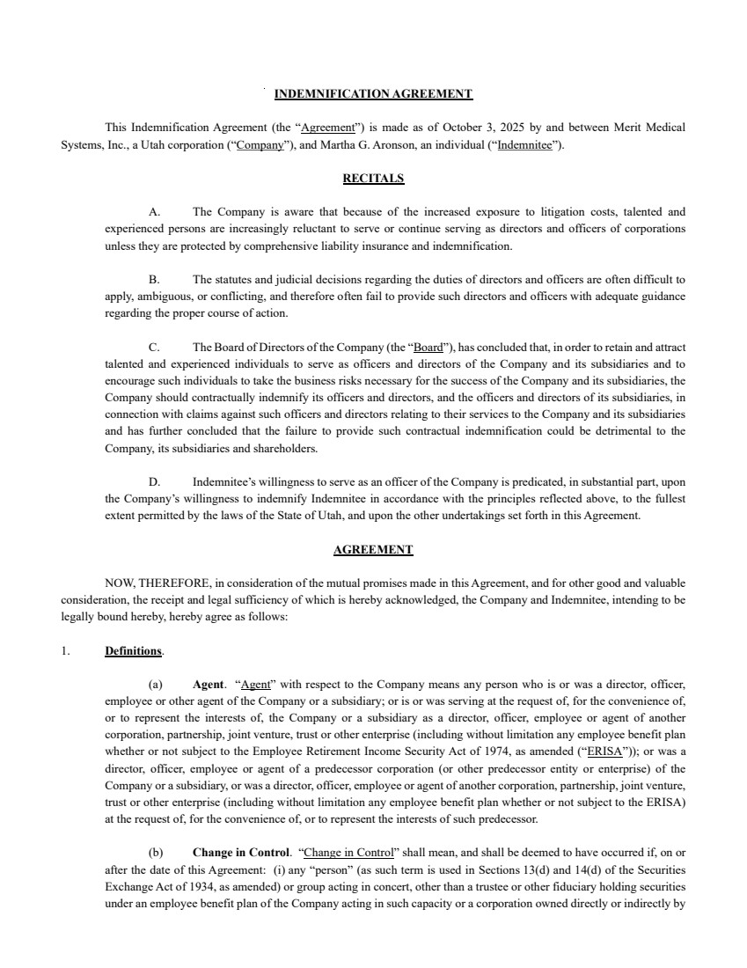 | INDEMNIFICATION AGREEMENT This Indemnification Agreement (the “Agreement”) is made as of October 3, 2025 by and between Merit Medical Systems, Inc., a Utah corporation (“Company”), and Martha G. Aronson, an individual (“Indemnitee”). RECITALS A. The Company is aware that because of the increased exposure to litigation costs, talented and experienced persons are increasingly reluctant to serve or continue serving as directors and officers of corporations unless they are protected by comprehensive liability insurance and indemnification. B. The statutes and judicial decisions regarding the duties of directors and officers are often difficult to apply, ambiguous, or conflicting, and therefore often fail to provide such directors and officers with adequate guidance regarding the proper course of action. C. The Board of Directors of the Company (the “Board”), has concluded that, in order to retain and attract talented and experienced individuals to serve as officers and directors of the Company and its subsidiaries and to encourage such individuals to take the business risks necessary for the success of the Company and its subsidiaries, the Company should contractually indemnify its officers and directors, and the officers and directors of its subsidiaries, in connection with claims against such officers and directors relating to their services to the Company and its subsidiaries and has further concluded that the failure to provide such contractual indemnification could be detrimental to the Company, its subsidiaries and shareholders. D. Indemnitee’s willingness to serve as an officer of the Company is predicated, in substantial part, upon the Company’s willingness to indemnify Indemnitee in accordance with the principles reflected above, to the fullest extent permitted by the laws of the State of Utah, and upon the other undertakings set forth in this Agreement. AGREEMENT NOW, THEREFORE, in consideration of the mutual promises made in this Agreement, and for other good and valuable consideration, the receipt and legal sufficiency of which is hereby acknowledged, the Company and Indemnitee, intending to be legally bound hereby, hereby agree as follows: 1. Definitions. (a) Agent. “Agent” with respect to the Company means any person who is or was a director, officer, employee or other agent of the Company or a subsidiary; or is or was serving at the request of, for the convenience of, or to represent the interests of, the Company or a subsidiary as a director, officer, employee or agent of another corporation, partnership, joint venture, trust or other enterprise (including without limitation any employee benefit plan whether or not subject to the Employee Retirement Income Security Act of 1974, as amended (“ERISA”)); or was a director, officer, employee or agent of a predecessor corporation (or other predecessor entity or enterprise) of the Company or a subsidiary, or was a director, officer, employee or agent of another corporation, partnership, joint venture, trust or other enterprise (including without limitation any employee benefit plan whether or not subject to the ERISA) at the request of, for the convenience of, or to represent the interests of such predecessor. (b) Change in Control. “Change in Control” shall mean, and shall be deemed to have occurred if, on or after the date of this Agreement: (i) any “person” (as such term is used in Sections 13(d) and 14(d) of the Securities Exchange Act of 1934, as amended) or group acting in concert, other than a trustee or other fiduciary holding securities under an employee benefit plan of the Company acting in such capacity or a corporation owned directly or indirectly by
 | 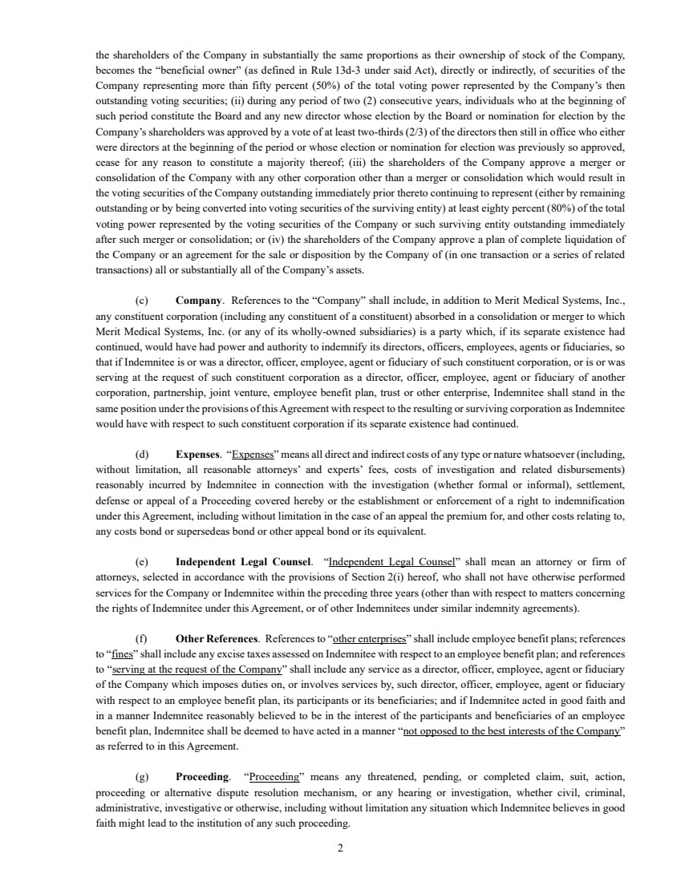 | 2 the shareholders of the Company in substantially the same proportions as their ownership of stock of the Company, becomes the “beneficial owner” (as defined in Rule 13d-3 under said Act), directly or indirectly, of securities of the Company representing more than fifty percent (50%) of the total voting power represented by the Company’s then outstanding voting securities; (ii) during any period of two (2) consecutive years, individuals who at the beginning of such period constitute the Board and any new director whose election by the Board or nomination for election by the Company’s shareholders was approved by a vote of at least two-thirds (2/3) of the directors then still in office who either were directors at the beginning of the period or whose election or nomination for election was previously so approved, cease for any reason to constitute a majority thereof; (iii) the shareholders of the Company approve a merger or consolidation of the Company with any other corporation other than a merger or consolidation which would result in the voting securities of the Company outstanding immediately prior thereto continuing to represent (either by remaining outstanding or by being converted into voting securities of the surviving entity) at least eighty percent (80%) of the total voting power represented by the voting securities of the Company or such surviving entity outstanding immediately after such merger or consolidation; or (iv) the shareholders of the Company approve a plan of complete liquidation of the Company or an agreement for the sale or disposition by the Company of (in one transaction or a series of related transactions) all or substantially all of the Company’s assets. (c) Company. References to the “Company” shall include, in addition to Merit Medical Systems, Inc., any constituent corporation (including any constituent of a constituent) absorbed in a consolidation or merger to which Merit Medical Systems, Inc. (or any of its wholly-owned subsidiaries) is a party which, if its separate existence had continued, would have had power and authority to indemnify its directors, officers, employees, agents or fiduciaries, so that if Indemnitee is or was a director, officer, employee, agent or fiduciary of such constituent corporation, or is or was serving at the request of such constituent corporation as a director, officer, employee, agent or fiduciary of another corporation, partnership, joint venture, employee benefit plan, trust or other enterprise, Indemnitee shall stand in the same position under the provisions of this Agreement with respect to the resulting or surviving corporation as Indemnitee would have with respect to such constituent corporation if its separate existence had continued. (d) Expenses. “Expenses” means all direct and indirect costs of any type or nature whatsoever (including, without limitation, all reasonable attorneys’ and experts’ fees, costs of investigation and related disbursements) reasonably incurred by Indemnitee in connection with the investigation (whether formal or informal), settlement, defense or appeal of a Proceeding covered hereby or the establishment or enforcement of a right to indemnification under this Agreement, including without limitation in the case of an appeal the premium for, and other costs relating to, any costs bond or supersedeas bond or other appeal bond or its equivalent. (e) Independent Legal Counsel. “Independent Legal Counsel” shall mean an attorney or firm of attorneys, selected in accordance with the provisions of Section 2(i) hereof, who shall not have otherwise performed services for the Company or Indemnitee within the preceding three years (other than with respect to matters concerning the rights of Indemnitee under this Agreement, or of other Indemnitees under similar indemnity agreements). (f) Other References. References to “other enterprises” shall include employee benefit plans; references to “fines” shall include any excise taxes assessed on Indemnitee with respect to an employee benefit plan; and references to “serving at the request of the Company” shall include any service as a director, officer, employee, agent or fiduciary of the Company which imposes duties on, or involves services by, such director, officer, employee, agent or fiduciary with respect to an employee benefit plan, its participants or its beneficiaries; and if Indemnitee acted in good faith and in a manner Indemnitee reasonably believed to be in the interest of the participants and beneficiaries of an employee benefit plan, Indemnitee shall be deemed to have acted in a manner “not opposed to the best interests of the Company” as referred to in this Agreement. (g) Proceeding. “Proceeding” means any threatened, pending, or completed claim, suit, action, proceeding or alternative dispute resolution mechanism, or any hearing or investigation, whether civil, criminal, administrative, investigative or otherwise, including without limitation any situation which Indemnitee believes in good faith might lead to the institution of any such proceeding.
 | 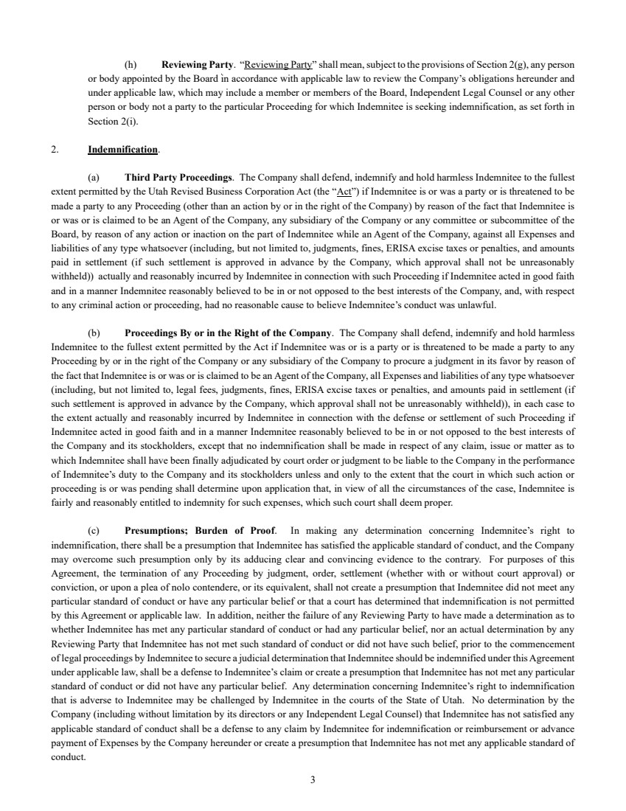 | 3 (h) Reviewing Party. “Reviewing Party” shall mean, subject to the provisions of Section 2(g), any person or body appointed by the Board in accordance with applicable law to review the Company’s obligations hereunder and under applicable law, which may include a member or members of the Board, Independent Legal Counsel or any other person or body not a party to the particular Proceeding for which Indemnitee is seeking indemnification, as set forth in Section 2(i). 2. Indemnification. (a) Third Party Proceedings. The Company shall defend, indemnify and hold harmless Indemnitee to the fullest extent permitted by the Utah Revised Business Corporation Act (the “Act”) if Indemnitee is or was a party or is threatened to be made a party to any Proceeding (other than an action by or in the right of the Company) by reason of the fact that Indemnitee is or was or is claimed to be an Agent of the Company, any subsidiary of the Company or any committee or subcommittee of the Board, by reason of any action or inaction on the part of Indemnitee while an Agent of the Company, against all Expenses and liabilities of any type whatsoever (including, but not limited to, judgments, fines, ERISA excise taxes or penalties, and amounts paid in settlement (if such settlement is approved in advance by the Company, which approval shall not be unreasonably withheld)) actually and reasonably incurred by Indemnitee in connection with such Proceeding if Indemnitee acted in good faith and in a manner Indemnitee reasonably believed to be in or not opposed to the best interests of the Company, and, with respect to any criminal action or proceeding, had no reasonable cause to believe Indemnitee’s conduct was unlawful. (b) Proceedings By or in the Right of the Company. The Company shall defend, indemnify and hold harmless Indemnitee to the fullest extent permitted by the Act if Indemnitee was or is a party or is threatened to be made a party to any Proceeding by or in the right of the Company or any subsidiary of the Company to procure a judgment in its favor by reason of the fact that Indemnitee is or was or is claimed to be an Agent of the Company, all Expenses and liabilities of any type whatsoever (including, but not limited to, legal fees, judgments, fines, ERISA excise taxes or penalties, and amounts paid in settlement (if such settlement is approved in advance by the Company, which approval shall not be unreasonably withheld)), in each case to the extent actually and reasonably incurred by Indemnitee in connection with the defense or settlement of such Proceeding if Indemnitee acted in good faith and in a manner Indemnitee reasonably believed to be in or not opposed to the best interests of the Company and its stockholders, except that no indemnification shall be made in respect of any claim, issue or matter as to which Indemnitee shall have been finally adjudicated by court order or judgment to be liable to the Company in the performance of Indemnitee’s duty to the Company and its stockholders unless and only to the extent that the court in which such action or proceeding is or was pending shall determine upon application that, in view of all the circumstances of the case, Indemnitee is fairly and reasonably entitled to indemnity for such expenses, which such court shall deem proper. (c) Presumptions; Burden of Proof. In making any determination concerning Indemnitee’s right to indemnification, there shall be a presumption that Indemnitee has satisfied the applicable standard of conduct, and the Company may overcome such presumption only by its adducing clear and convincing evidence to the contrary. For purposes of this Agreement, the termination of any Proceeding by judgment, order, settlement (whether with or without court approval) or conviction, or upon a plea of nolo contendere, or its equivalent, shall not create a presumption that Indemnitee did not meet any particular standard of conduct or have any particular belief or that a court has determined that indemnification is not permitted by this Agreement or applicable law. In addition, neither the failure of any Reviewing Party to have made a determination as to whether Indemnitee has met any particular standard of conduct or had any particular belief, nor an actual determination by any Reviewing Party that Indemnitee has not met such standard of conduct or did not have such belief, prior to the commencement of legal proceedings by Indemnitee to secure a judicial determination that Indemnitee should be indemnified under this Agreement under applicable law, shall be a defense to Indemnitee’s claim or create a presumption that Indemnitee has not met any particular standard of conduct or did not have any particular belief. Any determination concerning Indemnitee’s right to indemnification that is adverse to Indemnitee may be challenged by Indemnitee in the courts of the State of Utah. No determination by the Company (including without limitation by its directors or any Independent Legal Counsel) that Indemnitee has not satisfied any applicable standard of conduct shall be a defense to any claim by Indemnitee for indemnification or reimbursement or advance payment of Expenses by the Company hereunder or create a presumption that Indemnitee has not met any applicable standard of conduct.
 | 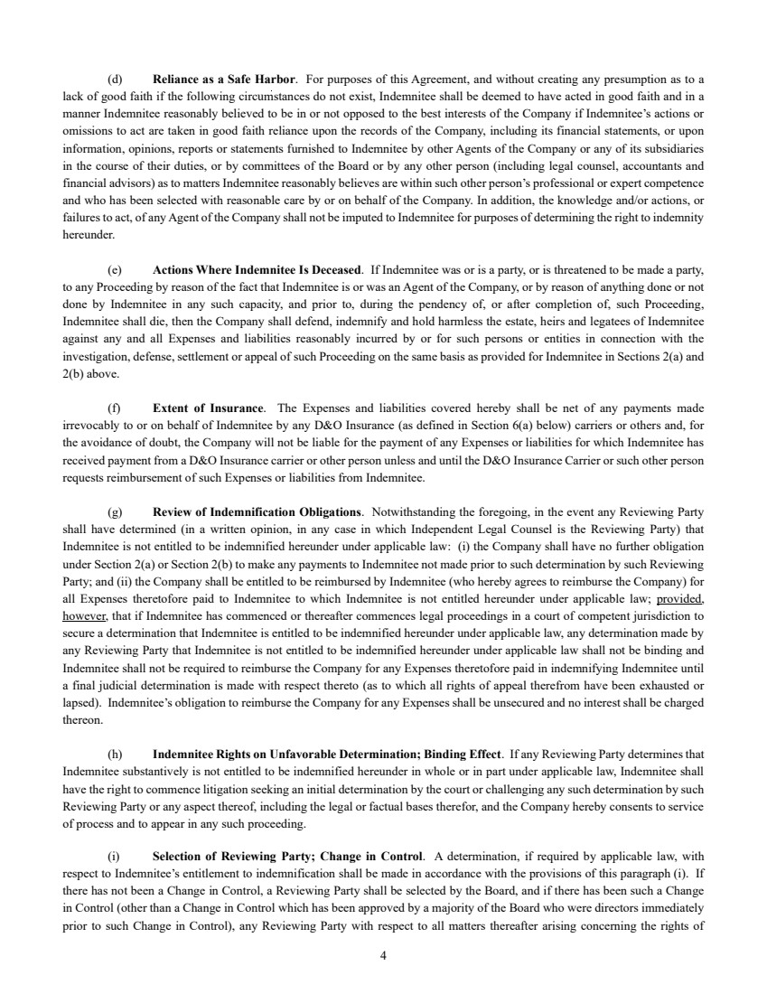 | 4 (d) Reliance as a Safe Harbor. For purposes of this Agreement, and without creating any presumption as to a lack of good faith if the following circumstances do not exist, Indemnitee shall be deemed to have acted in good faith and in a manner Indemnitee reasonably believed to be in or not opposed to the best interests of the Company if Indemnitee’s actions or omissions to act are taken in good faith reliance upon the records of the Company, including its financial statements, or upon information, opinions, reports or statements furnished to Indemnitee by other Agents of the Company or any of its subsidiaries in the course of their duties, or by committees of the Board or by any other person (including legal counsel, accountants and financial advisors) as to matters Indemnitee reasonably believes are within such other person’s professional or expert competence and who has been selected with reasonable care by or on behalf of the Company. In addition, the knowledge and/or actions, or failures to act, of any Agent of the Company shall not be imputed to Indemnitee for purposes of determining the right to indemnity hereunder. (e) Actions Where Indemnitee Is Deceased. If Indemnitee was or is a party, or is threatened to be made a party, to any Proceeding by reason of the fact that Indemnitee is or was an Agent of the Company, or by reason of anything done or not done by Indemnitee in any such capacity, and prior to, during the pendency of, or after completion of, such Proceeding, Indemnitee shall die, then the Company shall defend, indemnify and hold harmless the estate, heirs and legatees of Indemnitee against any and all Expenses and liabilities reasonably incurred by or for such persons or entities in connection with the investigation, defense, settlement or appeal of such Proceeding on the same basis as provided for Indemnitee in Sections 2(a) and 2(b) above. (f) Extent of Insurance. The Expenses and liabilities covered hereby shall be net of any payments made irrevocably to or on behalf of Indemnitee by any D&O Insurance (as defined in Section 6(a) below) carriers or others and, for the avoidance of doubt, the Company will not be liable for the payment of any Expenses or liabilities for which Indemnitee has received payment from a D&O Insurance carrier or other person unless and until the D&O Insurance Carrier or such other person requests reimbursement of such Expenses or liabilities from Indemnitee. (g) Review of Indemnification Obligations. Notwithstanding the foregoing, in the event any Reviewing Party shall have determined (in a written opinion, in any case in which Independent Legal Counsel is the Reviewing Party) that Indemnitee is not entitled to be indemnified hereunder under applicable law: (i) the Company shall have no further obligation under Section 2(a) or Section 2(b) to make any payments to Indemnitee not made prior to such determination by such Reviewing Party; and (ii) the Company shall be entitled to be reimbursed by Indemnitee (who hereby agrees to reimburse the Company) for all Expenses theretofore paid to Indemnitee to which Indemnitee is not entitled hereunder under applicable law; provided, however, that if Indemnitee has commenced or thereafter commences legal proceedings in a court of competent jurisdiction to secure a determination that Indemnitee is entitled to be indemnified hereunder under applicable law, any determination made by any Reviewing Party that Indemnitee is not entitled to be indemnified hereunder under applicable law shall not be binding and Indemnitee shall not be required to reimburse the Company for any Expenses theretofore paid in indemnifying Indemnitee until a final judicial determination is made with respect thereto (as to which all rights of appeal therefrom have been exhausted or lapsed). Indemnitee’s obligation to reimburse the Company for any Expenses shall be unsecured and no interest shall be charged thereon. (h) Indemnitee Rights on Unfavorable Determination; Binding Effect. If any Reviewing Party determines that Indemnitee substantively is not entitled to be indemnified hereunder in whole or in part under applicable law, Indemnitee shall have the right to commence litigation seeking an initial determination by the court or challenging any such determination by such Reviewing Party or any aspect thereof, including the legal or factual bases therefor, and the Company hereby consents to service of process and to appear in any such proceeding. (i) Selection of Reviewing Party; Change in Control. A determination, if required by applicable law, with respect to Indemnitee’s entitlement to indemnification shall be made in accordance with the provisions of this paragraph (i). If there has not been a Change in Control, a Reviewing Party shall be selected by the Board, and if there has been such a Change in Control (other than a Change in Control which has been approved by a majority of the Board who were directors immediately prior to such Change in Control), any Reviewing Party with respect to all matters thereafter arising concerning the rights of
 | 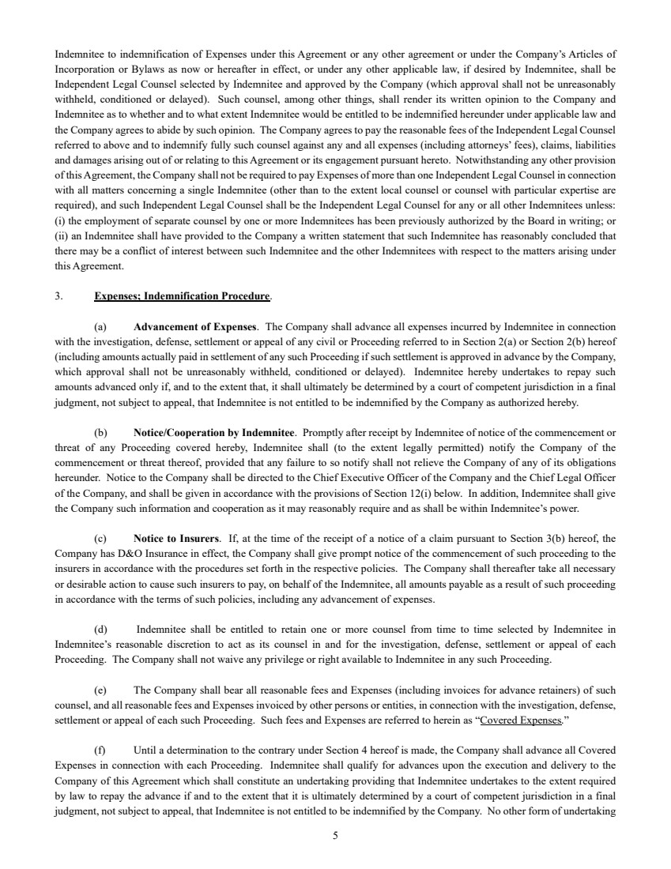 | 5 Indemnitee to indemnification of Expenses under this Agreement or any other agreement or under the Company’s Articles of Incorporation or Bylaws as now or hereafter in effect, or under any other applicable law, if desired by Indemnitee, shall be Independent Legal Counsel selected by Indemnitee and approved by the Company (which approval shall not be unreasonably withheld, conditioned or delayed). Such counsel, among other things, shall render its written opinion to the Company and Indemnitee as to whether and to what extent Indemnitee would be entitled to be indemnified hereunder under applicable law and the Company agrees to abide by such opinion. The Company agrees to pay the reasonable fees of the Independent Legal Counsel referred to above and to indemnify fully such counsel against any and all expenses (including attorneys’ fees), claims, liabilities and damages arising out of or relating to this Agreement or its engagement pursuant hereto. Notwithstanding any other provision of this Agreement, the Company shall not be required to pay Expenses of more than one Independent Legal Counsel in connection with all matters concerning a single Indemnitee (other than to the extent local counsel or counsel with particular expertise are required), and such Independent Legal Counsel shall be the Independent Legal Counsel for any or all other Indemnitees unless: (i) the employment of separate counsel by one or more Indemnitees has been previously authorized by the Board in writing; or (ii) an Indemnitee shall have provided to the Company a written statement that such Indemnitee has reasonably concluded that there may be a conflict of interest between such Indemnitee and the other Indemnitees with respect to the matters arising under this Agreement. 3. Expenses; Indemnification Procedure. (a) Advancement of Expenses. The Company shall advance all expenses incurred by Indemnitee in connection with the investigation, defense, settlement or appeal of any civil or Proceeding referred to in Section 2(a) or Section 2(b) hereof (including amounts actually paid in settlement of any such Proceeding if such settlement is approved in advance by the Company, which approval shall not be unreasonably withheld, conditioned or delayed). Indemnitee hereby undertakes to repay such amounts advanced only if, and to the extent that, it shall ultimately be determined by a court of competent jurisdiction in a final judgment, not subject to appeal, that Indemnitee is not entitled to be indemnified by the Company as authorized hereby. (b) Notice/Cooperation by Indemnitee. Promptly after receipt by Indemnitee of notice of the commencement or threat of any Proceeding covered hereby, Indemnitee shall (to the extent legally permitted) notify the Company of the commencement or threat thereof, provided that any failure to so notify shall not relieve the Company of any of its obligations hereunder. Notice to the Company shall be directed to the Chief Executive Officer of the Company and the Chief Legal Officer of the Company, and shall be given in accordance with the provisions of Section 12(i) below. In addition, Indemnitee shall give the Company such information and cooperation as it may reasonably require and as shall be within Indemnitee’s power. (c) Notice to Insurers. If, at the time of the receipt of a notice of a claim pursuant to Section 3(b) hereof, the Company has D&O Insurance in effect, the Company shall give prompt notice of the commencement of such proceeding to the insurers in accordance with the procedures set forth in the respective policies. The Company shall thereafter take all necessary or desirable action to cause such insurers to pay, on behalf of the Indemnitee, all amounts payable as a result of such proceeding in accordance with the terms of such policies, including any advancement of expenses. (d) Indemnitee shall be entitled to retain one or more counsel from time to time selected by Indemnitee in Indemnitee’s reasonable discretion to act as its counsel in and for the investigation, defense, settlement or appeal of each Proceeding. The Company shall not waive any privilege or right available to Indemnitee in any such Proceeding. (e) The Company shall bear all reasonable fees and Expenses (including invoices for advance retainers) of such counsel, and all reasonable fees and Expenses invoiced by other persons or entities, in connection with the investigation, defense, settlement or appeal of each such Proceeding. Such fees and Expenses are referred to herein as “Covered Expenses.” (f) Until a determination to the contrary under Section 4 hereof is made, the Company shall advance all Covered Expenses in connection with each Proceeding. Indemnitee shall qualify for advances upon the execution and delivery to the Company of this Agreement which shall constitute an undertaking providing that Indemnitee undertakes to the extent required by law to repay the advance if and to the extent that it is ultimately determined by a court of competent jurisdiction in a final judgment, not subject to appeal, that Indemnitee is not entitled to be indemnified by the Company. No other form of undertaking
 | 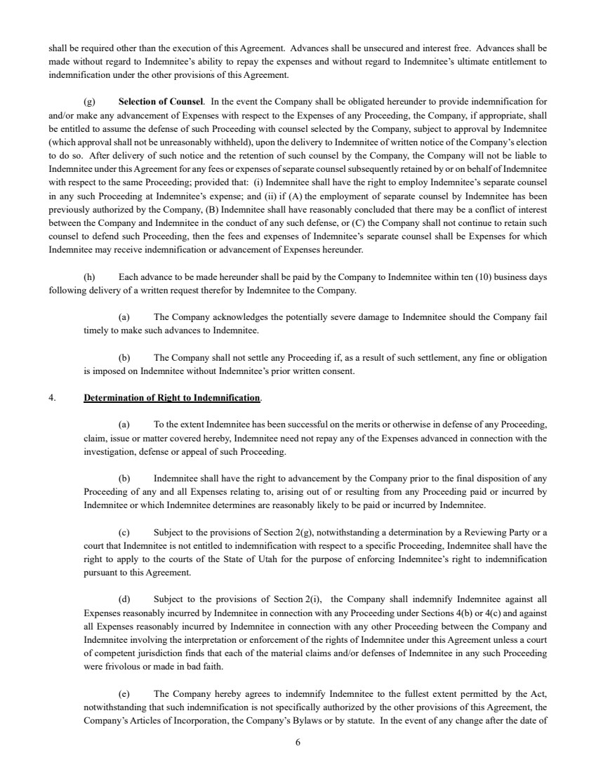 | 6 shall be required other than the execution of this Agreement. Advances shall be unsecured and interest free. Advances shall be made without regard to Indemnitee’s ability to repay the expenses and without regard to Indemnitee’s ultimate entitlement to indemnification under the other provisions of this Agreement. (g) Selection of Counsel. In the event the Company shall be obligated hereunder to provide indemnification for and/or make any advancement of Expenses with respect to the Expenses of any Proceeding, the Company, if appropriate, shall be entitled to assume the defense of such Proceeding with counsel selected by the Company, subject to approval by Indemnitee (which approval shall not be unreasonably withheld), upon the delivery to Indemnitee of written notice of the Company’s election to do so. After delivery of such notice and the retention of such counsel by the Company, the Company will not be liable to Indemnitee under this Agreement for any fees or expenses of separate counsel subsequently retained by or on behalf of Indemnitee with respect to the same Proceeding; provided that: (i) Indemnitee shall have the right to employ Indemnitee’s separate counsel in any such Proceeding at Indemnitee’s expense; and (ii) if (A) the employment of separate counsel by Indemnitee has been previously authorized by the Company, (B) Indemnitee shall have reasonably concluded that there may be a conflict of interest between the Company and Indemnitee in the conduct of any such defense, or (C) the Company shall not continue to retain such counsel to defend such Proceeding, then the fees and expenses of Indemnitee’s separate counsel shall be Expenses for which Indemnitee may receive indemnification or advancement of Expenses hereunder. (h) Each advance to be made hereunder shall be paid by the Company to Indemnitee within ten (10) business days following delivery of a written request therefor by Indemnitee to the Company. (a) The Company acknowledges the potentially severe damage to Indemnitee should the Company fail timely to make such advances to Indemnitee. (b) The Company shall not settle any Proceeding if, as a result of such settlement, any fine or obligation is imposed on Indemnitee without Indemnitee’s prior written consent. 4. Determination of Right to Indemnification. (a) To the extent Indemnitee has been successful on the merits or otherwise in defense of any Proceeding, claim, issue or matter covered hereby, Indemnitee need not repay any of the Expenses advanced in connection with the investigation, defense or appeal of such Proceeding. (b) Indemnitee shall have the right to advancement by the Company prior to the final disposition of any Proceeding of any and all Expenses relating to, arising out of or resulting from any Proceeding paid or incurred by Indemnitee or which Indemnitee determines are reasonably likely to be paid or incurred by Indemnitee. (c) Subject to the provisions of Section 2(g), notwithstanding a determination by a Reviewing Party or a court that Indemnitee is not entitled to indemnification with respect to a specific Proceeding, Indemnitee shall have the right to apply to the courts of the State of Utah for the purpose of enforcing Indemnitee’s right to indemnification pursuant to this Agreement. (d) Subject to the provisions of Section 2(i), the Company shall indemnify Indemnitee against all Expenses reasonably incurred by Indemnitee in connection with any Proceeding under Sections 4(b) or 4(c) and against all Expenses reasonably incurred by Indemnitee in connection with any other Proceeding between the Company and Indemnitee involving the interpretation or enforcement of the rights of Indemnitee under this Agreement unless a court of competent jurisdiction finds that each of the material claims and/or defenses of Indemnitee in any such Proceeding were frivolous or made in bad faith. (e) The Company hereby agrees to indemnify Indemnitee to the fullest extent permitted by the Act, notwithstanding that such indemnification is not specifically authorized by the other provisions of this Agreement, the Company’s Articles of Incorporation, the Company’s Bylaws or by statute. In the event of any change after the date of
 | 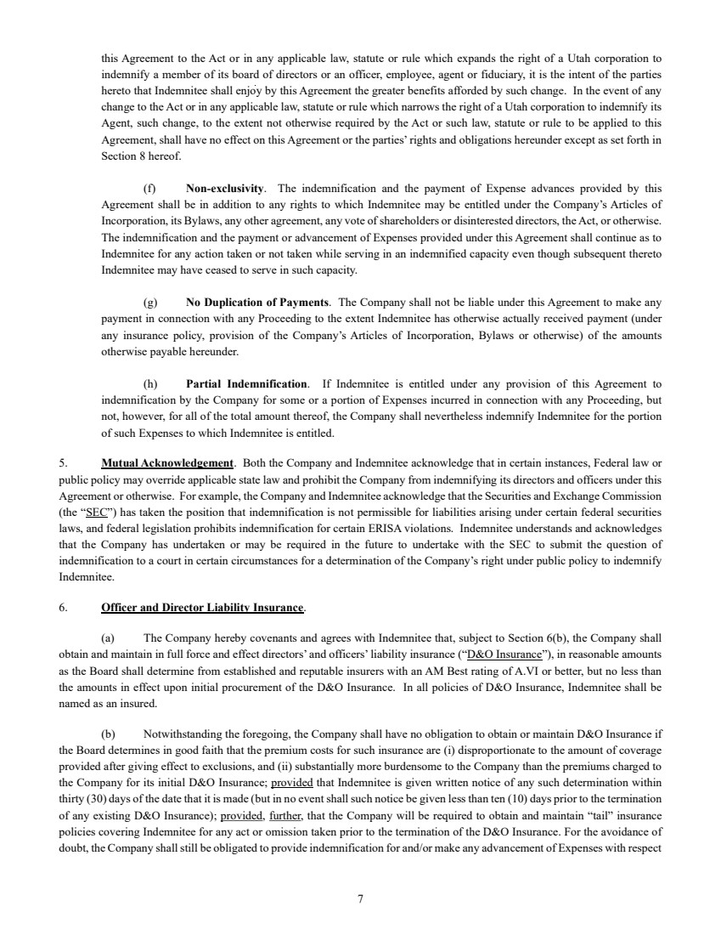 | 7 this Agreement to the Act or in any applicable law, statute or rule which expands the right of a Utah corporation to indemnify a member of its board of directors or an officer, employee, agent or fiduciary, it is the intent of the parties hereto that Indemnitee shall enjoy by this Agreement the greater benefits afforded by such change. In the event of any change to the Act or in any applicable law, statute or rule which narrows the right of a Utah corporation to indemnify its Agent, such change, to the extent not otherwise required by the Act or such law, statute or rule to be applied to this Agreement, shall have no effect on this Agreement or the parties’ rights and obligations hereunder except as set forth in Section 8 hereof. (f) Non-exclusivity. The indemnification and the payment of Expense advances provided by this Agreement shall be in addition to any rights to which Indemnitee may be entitled under the Company’s Articles of Incorporation, its Bylaws, any other agreement, any vote of shareholders or disinterested directors, the Act, or otherwise. The indemnification and the payment or advancement of Expenses provided under this Agreement shall continue as to Indemnitee for any action taken or not taken while serving in an indemnified capacity even though subsequent thereto Indemnitee may have ceased to serve in such capacity. (g) No Duplication of Payments. The Company shall not be liable under this Agreement to make any payment in connection with any Proceeding to the extent Indemnitee has otherwise actually received payment (under any insurance policy, provision of the Company’s Articles of Incorporation, Bylaws or otherwise) of the amounts otherwise payable hereunder. (h) Partial Indemnification. If Indemnitee is entitled under any provision of this Agreement to indemnification by the Company for some or a portion of Expenses incurred in connection with any Proceeding, but not, however, for all of the total amount thereof, the Company shall nevertheless indemnify Indemnitee for the portion of such Expenses to which Indemnitee is entitled. 5. Mutual Acknowledgement. Both the Company and Indemnitee acknowledge that in certain instances, Federal law or public policy may override applicable state law and prohibit the Company from indemnifying its directors and officers under this Agreement or otherwise. For example, the Company and Indemnitee acknowledge that the Securities and Exchange Commission (the “SEC”) has taken the position that indemnification is not permissible for liabilities arising under certain federal securities laws, and federal legislation prohibits indemnification for certain ERISA violations. Indemnitee understands and acknowledges that the Company has undertaken or may be required in the future to undertake with the SEC to submit the question of indemnification to a court in certain circumstances for a determination of the Company’s right under public policy to indemnify Indemnitee. 6. Officer and Director Liability Insurance. (a) The Company hereby covenants and agrees with Indemnitee that, subject to Section 6(b), the Company shall obtain and maintain in full force and effect directors’ and officers’ liability insurance (“D&O Insurance”), in reasonable amounts as the Board shall determine from established and reputable insurers with an AM Best rating of A.VI or better, but no less than the amounts in effect upon initial procurement of the D&O Insurance. In all policies of D&O Insurance, Indemnitee shall be named as an insured. (b) Notwithstanding the foregoing, the Company shall have no obligation to obtain or maintain D&O Insurance if the Board determines in good faith that the premium costs for such insurance are (i) disproportionate to the amount of coverage provided after giving effect to exclusions, and (ii) substantially more burdensome to the Company than the premiums charged to the Company for its initial D&O Insurance; provided that Indemnitee is given written notice of any such determination within thirty (30) days of the date that it is made (but in no event shall such notice be given less than ten (10) days prior to the termination of any existing D&O Insurance); provided, further, that the Company will be required to obtain and maintain “tail” insurance policies covering Indemnitee for any act or omission taken prior to the termination of the D&O Insurance. For the avoidance of doubt, the Company shall still be obligated to provide indemnification for and/or make any advancement of Expenses with respect
 | 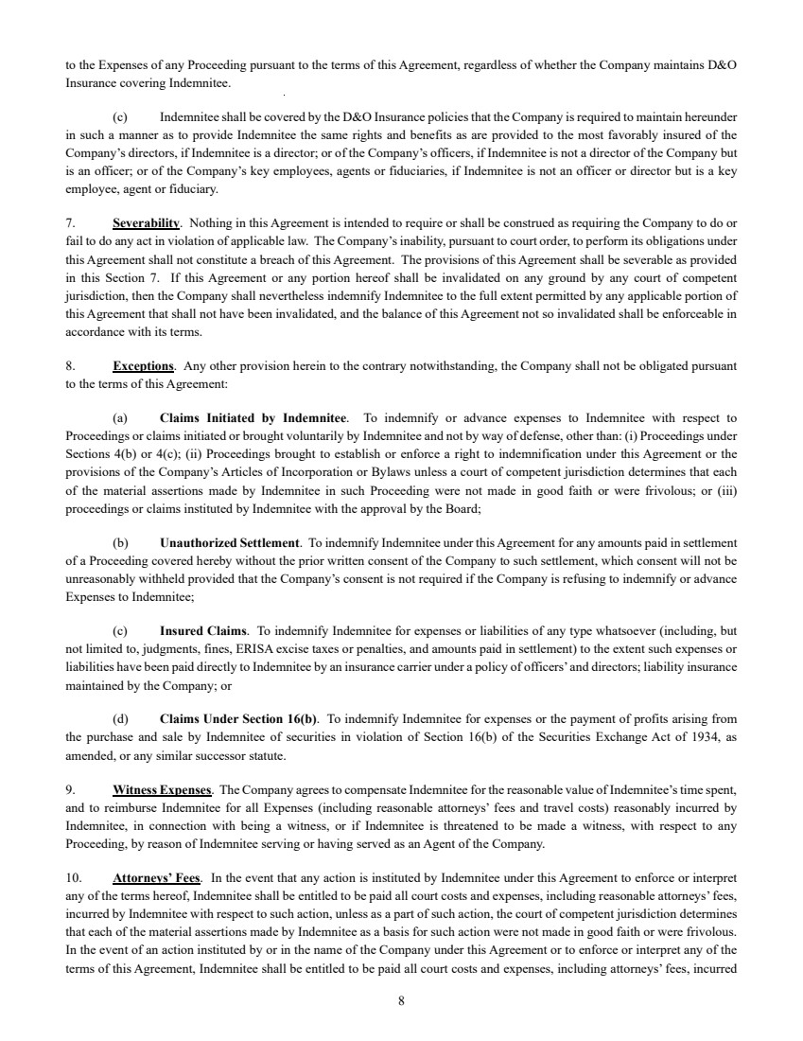 | 8 to the Expenses of any Proceeding pursuant to the terms of this Agreement, regardless of whether the Company maintains D&O Insurance covering Indemnitee. (c) Indemnitee shall be covered by the D&O Insurance policies that the Company is required to maintain hereunder in such a manner as to provide Indemnitee the same rights and benefits as are provided to the most favorably insured of the Company’s directors, if Indemnitee is a director; or of the Company’s officers, if Indemnitee is not a director of the Company but is an officer; or of the Company’s key employees, agents or fiduciaries, if Indemnitee is not an officer or director but is a key employee, agent or fiduciary. 7. Severability. Nothing in this Agreement is intended to require or shall be construed as requiring the Company to do or fail to do any act in violation of applicable law. The Company’s inability, pursuant to court order, to perform its obligations under this Agreement shall not constitute a breach of this Agreement. The provisions of this Agreement shall be severable as provided in this Section 7. If this Agreement or any portion hereof shall be invalidated on any ground by any court of competent jurisdiction, then the Company shall nevertheless indemnify Indemnitee to the full extent permitted by any applicable portion of this Agreement that shall not have been invalidated, and the balance of this Agreement not so invalidated shall be enforceable in accordance with its terms. 8. Exceptions. Any other provision herein to the contrary notwithstanding, the Company shall not be obligated pursuant to the terms of this Agreement: (a) Claims Initiated by Indemnitee. To indemnify or advance expenses to Indemnitee with respect to Proceedings or claims initiated or brought voluntarily by Indemnitee and not by way of defense, other than: (i) Proceedings under Sections 4(b) or 4(c); (ii) Proceedings brought to establish or enforce a right to indemnification under this Agreement or the provisions of the Company’s Articles of Incorporation or Bylaws unless a court of competent jurisdiction determines that each of the material assertions made by Indemnitee in such Proceeding were not made in good faith or were frivolous; or (iii) proceedings or claims instituted by Indemnitee with the approval by the Board; (b) Unauthorized Settlement. To indemnify Indemnitee under this Agreement for any amounts paid in settlement of a Proceeding covered hereby without the prior written consent of the Company to such settlement, which consent will not be unreasonably withheld provided that the Company’s consent is not required if the Company is refusing to indemnify or advance Expenses to Indemnitee; (c) Insured Claims. To indemnify Indemnitee for expenses or liabilities of any type whatsoever (including, but not limited to, judgments, fines, ERISA excise taxes or penalties, and amounts paid in settlement) to the extent such expenses or liabilities have been paid directly to Indemnitee by an insurance carrier under a policy of officers’ and directors; liability insurance maintained by the Company; or (d) Claims Under Section 16(b). To indemnify Indemnitee for expenses or the payment of profits arising from the purchase and sale by Indemnitee of securities in violation of Section 16(b) of the Securities Exchange Act of 1934, as amended, or any similar successor statute. 9. Witness Expenses. The Company agrees to compensate Indemnitee for the reasonable value of Indemnitee’s time spent, and to reimburse Indemnitee for all Expenses (including reasonable attorneys’ fees and travel costs) reasonably incurred by Indemnitee, in connection with being a witness, or if Indemnitee is threatened to be made a witness, with respect to any Proceeding, by reason of Indemnitee serving or having served as an Agent of the Company. 10. Attorneys’ Fees. In the event that any action is instituted by Indemnitee under this Agreement to enforce or interpret any of the terms hereof, Indemnitee shall be entitled to be paid all court costs and expenses, including reasonable attorneys’ fees, incurred by Indemnitee with respect to such action, unless as a part of such action, the court of competent jurisdiction determines that each of the material assertions made by Indemnitee as a basis for such action were not made in good faith or were frivolous. In the event of an action instituted by or in the name of the Company under this Agreement or to enforce or interpret any of the terms of this Agreement, Indemnitee shall be entitled to be paid all court costs and expenses, including attorneys’ fees, incurred
 | 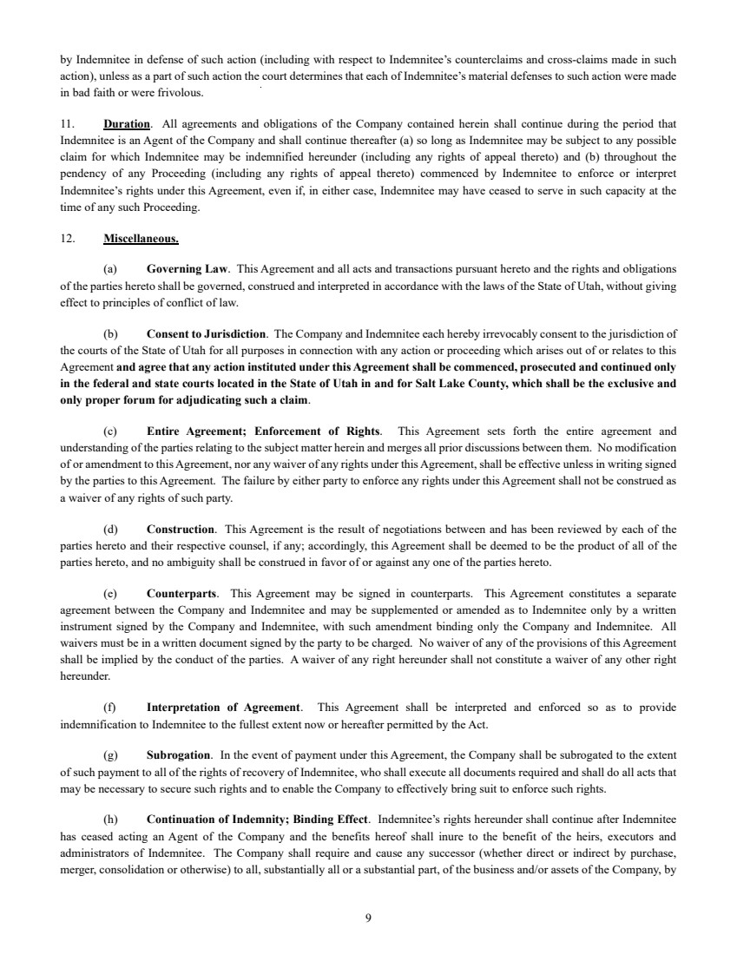 | 9 by Indemnitee in defense of such action (including with respect to Indemnitee’s counterclaims and cross-claims made in such action), unless as a part of such action the court determines that each of Indemnitee’s material defenses to such action were made in bad faith or were frivolous. 11. Duration. All agreements and obligations of the Company contained herein shall continue during the period that Indemnitee is an Agent of the Company and shall continue thereafter (a) so long as Indemnitee may be subject to any possible claim for which Indemnitee may be indemnified hereunder (including any rights of appeal thereto) and (b) throughout the pendency of any Proceeding (including any rights of appeal thereto) commenced by Indemnitee to enforce or interpret Indemnitee’s rights under this Agreement, even if, in either case, Indemnitee may have ceased to serve in such capacity at the time of any such Proceeding. 12. Miscellaneous. (a) Governing Law. This Agreement and all acts and transactions pursuant hereto and the rights and obligations of the parties hereto shall be governed, construed and interpreted in accordance with the laws of the State of Utah, without giving effect to principles of conflict of law. (b) Consent to Jurisdiction. The Company and Indemnitee each hereby irrevocably consent to the jurisdiction of the courts of the State of Utah for all purposes in connection with any action or proceeding which arises out of or relates to this Agreement and agree that any action instituted under this Agreement shall be commenced, prosecuted and continued only in the federal and state courts located in the State of Utah in and for Salt Lake County, which shall be the exclusive and only proper forum for adjudicating such a claim. (c) Entire Agreement; Enforcement of Rights. This Agreement sets forth the entire agreement and understanding of the parties relating to the subject matter herein and merges all prior discussions between them. No modification of or amendment to this Agreement, nor any waiver of any rights under this Agreement, shall be effective unless in writing signed by the parties to this Agreement. The failure by either party to enforce any rights under this Agreement shall not be construed as a waiver of any rights of such party. (d) Construction. This Agreement is the result of negotiations between and has been reviewed by each of the parties hereto and their respective counsel, if any; accordingly, this Agreement shall be deemed to be the product of all of the parties hereto, and no ambiguity shall be construed in favor of or against any one of the parties hereto. (e) Counterparts. This Agreement may be signed in counterparts. This Agreement constitutes a separate agreement between the Company and Indemnitee and may be supplemented or amended as to Indemnitee only by a written instrument signed by the Company and Indemnitee, with such amendment binding only the Company and Indemnitee. All waivers must be in a written document signed by the party to be charged. No waiver of any of the provisions of this Agreement shall be implied by the conduct of the parties. A waiver of any right hereunder shall not constitute a waiver of any other right hereunder. (f) Interpretation of Agreement. This Agreement shall be interpreted and enforced so as to provide indemnification to Indemnitee to the fullest extent now or hereafter permitted by the Act. (g) Subrogation. In the event of payment under this Agreement, the Company shall be subrogated to the extent of such payment to all of the rights of recovery of Indemnitee, who shall execute all documents required and shall do all acts that may be necessary to secure such rights and to enable the Company to effectively bring suit to enforce such rights. (h) Continuation of Indemnity; Binding Effect. Indemnitee’s rights hereunder shall continue after Indemnitee has ceased acting an Agent of the Company and the benefits hereof shall inure to the benefit of the heirs, executors and administrators of Indemnitee. The Company shall require and cause any successor (whether direct or indirect by purchase, merger, consolidation or otherwise) to all, substantially all or a substantial part, of the business and/or assets of the Company, by
 | 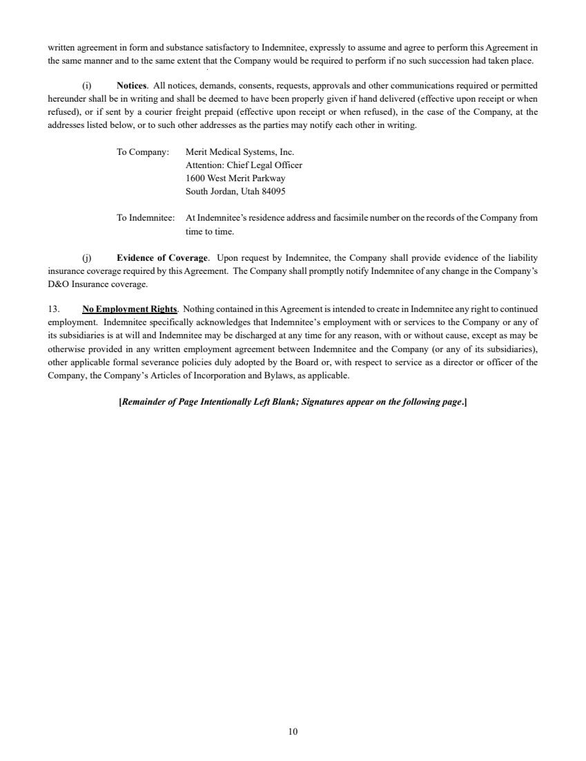 | 10 written agreement in form and substance satisfactory to Indemnitee, expressly to assume and agree to perform this Agreement in the same manner and to the same extent that the Company would be required to perform if no such succession had taken place. (i) Notices. All notices, demands, consents, requests, approvals and other communications required or permitted hereunder shall be in writing and shall be deemed to have been properly given if hand delivered (effective upon receipt or when refused), or if sent by a courier freight prepaid (effective upon receipt or when refused), in the case of the Company, at the addresses listed below, or to such other addresses as the parties may notify each other in writing. To Company: Merit Medical Systems, Inc. Attention: Chief Legal Officer 1600 West Merit Parkway South Jordan, Utah 84095 To Indemnitee: At Indemnitee’s residence address and facsimile number on the records of the Company from time to time. (j) Evidence of Coverage. Upon request by Indemnitee, the Company shall provide evidence of the liability insurance coverage required by this Agreement. The Company shall promptly notify Indemnitee of any change in the Company’s D&O Insurance coverage. 13. No Employment Rights. Nothing contained in this Agreement is intended to create in Indemnitee any right to continued employment. Indemnitee specifically acknowledges that Indemnitee’s employment with or services to the Company or any of its subsidiaries is at will and Indemnitee may be discharged at any time for any reason, with or without cause, except as may be otherwise provided in any written employment agreement between Indemnitee and the Company (or any of its subsidiaries), other applicable formal severance policies duly adopted by the Board or, with respect to service as a director or officer of the Company, the Company’s Articles of Incorporation and Bylaws, as applicable. [Remainder of Page Intentionally Left Blank; Signatures appear on the following page.]
 | 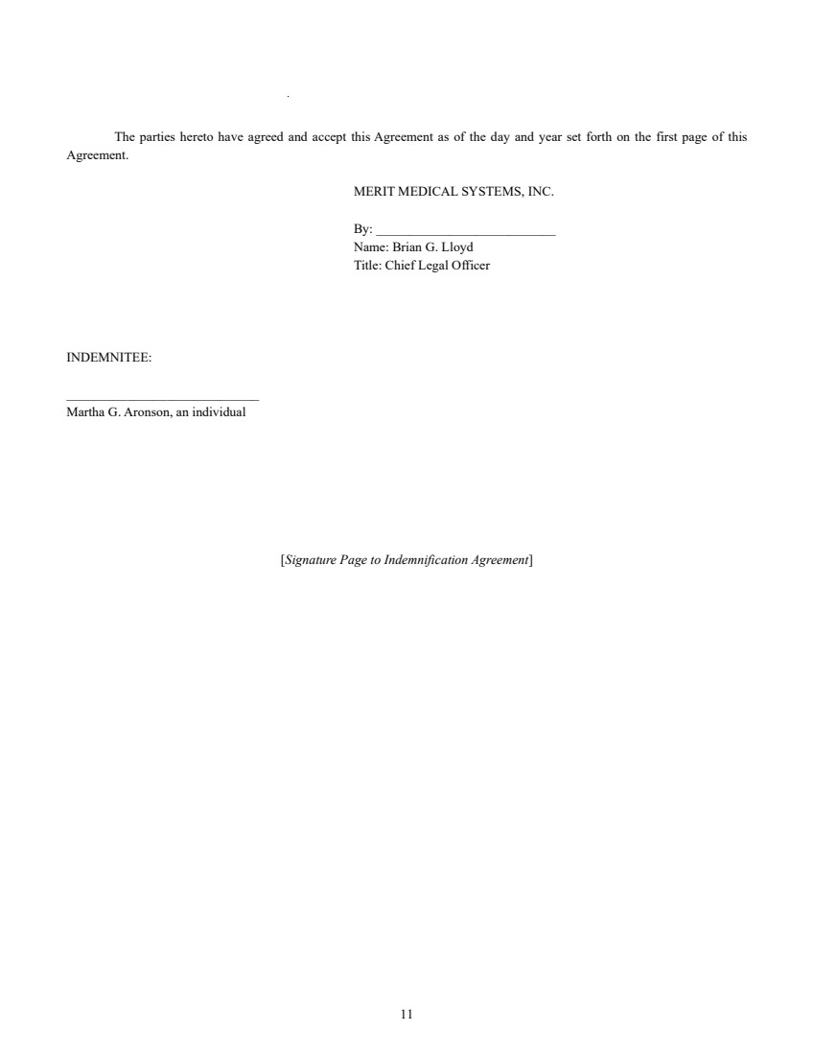 | 11 The parties hereto have agreed and accept this Agreement as of the day and year set forth on the first page of this Agreement. MERIT MEDICAL SYSTEMS, INC. By: ___________________________ Name: Brian G. Lloyd Title: Chief Legal Officer INDEMNITEE: _____________________________ Martha G. Aronson, an individual [Signature Page to Indemnification Agreement]
Exhibit 10.68
 | 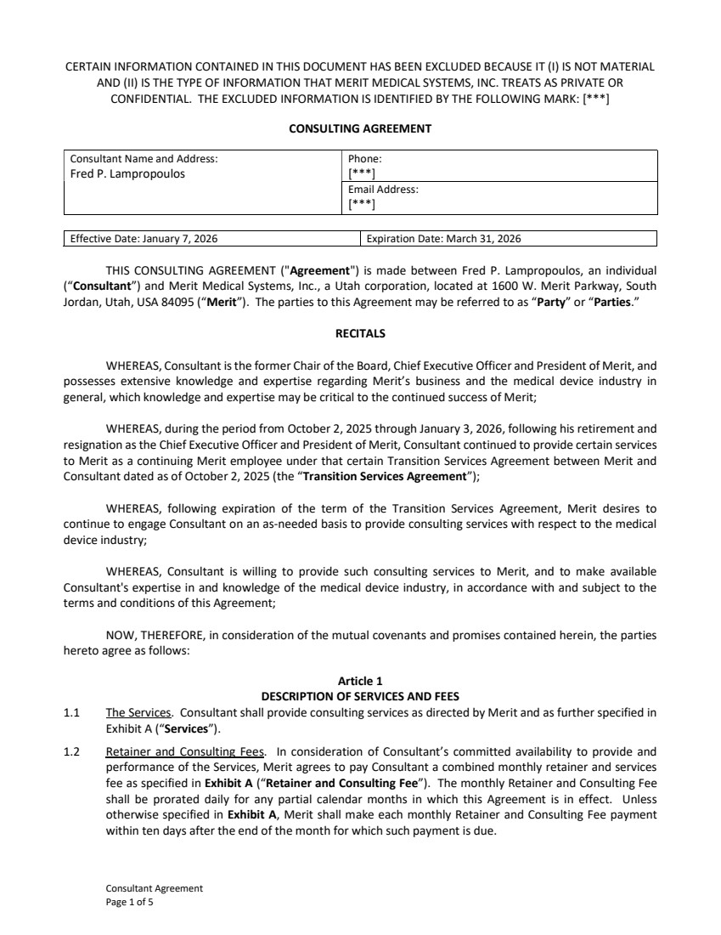 | Consultant Agreement Page 1 of 5 CERTAIN INFORMATION CONTAINED IN THIS DOCUMENT HAS BEEN EXCLUDED BECAUSE IT (I) IS NOT MATERIAL AND (II) IS THE TYPE OF INFORMATION THAT MERIT MEDICAL SYSTEMS, INC. TREATS AS PRIVATE OR CONFIDENTIAL. THE EXCLUDED INFORMATION IS IDENTIFIED BY THE FOLLOWING MARK: [***] CONSULTING AGREEMENT Consultant Name and Address: Fred P. Lampropoulos Phone: [***] Email Address: [***] Effective Date: January 7, 2026 Expiration Date: March 31, 2026 THIS CONSULTING AGREEMENT ("Agreement") is made between Fred P. Lampropoulos, an individual (“Consultant”) and Merit Medical Systems, Inc., a Utah corporation, located at 1600 W. Merit Parkway, South Jordan, Utah, USA 84095 (“Merit”). The parties to this Agreement may be referred to as “Party” or “Parties.” RECITALS WHEREAS, Consultant is the former Chair of the Board, Chief Executive Officer and President of Merit, and possesses extensive knowledge and expertise regarding Merit’s business and the medical device industry in general, which knowledge and expertise may be critical to the continued success of Merit; WHEREAS, during the period from October 2, 2025 through January 3, 2026, following his retirement and resignation as the Chief Executive Officer and President of Merit, Consultant continued to provide certain services to Merit as a continuing Merit employee under that certain Transition Services Agreement between Merit and Consultant dated as of October 2, 2025 (the “Transition Services Agreement”); WHEREAS, following expiration of the term of the Transition Services Agreement, Merit desires to continue to engage Consultant on an as-needed basis to provide consulting services with respect to the medical device industry; WHEREAS, Consultant is willing to provide such consulting services to Merit, and to make available Consultant's expertise in and knowledge of the medical device industry, in accordance with and subject to the terms and conditions of this Agreement; NOW, THEREFORE, in consideration of the mutual covenants and promises contained herein, the parties hereto agree as follows: Article 1 DESCRIPTION OF SERVICES AND FEES 1.1 The Services. Consultant shall provide consulting services as directed by Merit and as further specified in Exhibit A (“Services”). 1.2 Retainer and Consulting Fees. In consideration of Consultant’s committed availability to provide and performance of the Services, Merit agrees to pay Consultant a combined monthly retainer and services fee as specified in Exhibit A (“Retainer and Consulting Fee”). The monthly Retainer and Consulting Fee shall be prorated daily for any partial calendar months in which this Agreement is in effect. Unless otherwise specified in Exhibit A, Merit shall make each monthly Retainer and Consulting Fee payment within ten days after the end of the month for which such payment is due.
 | 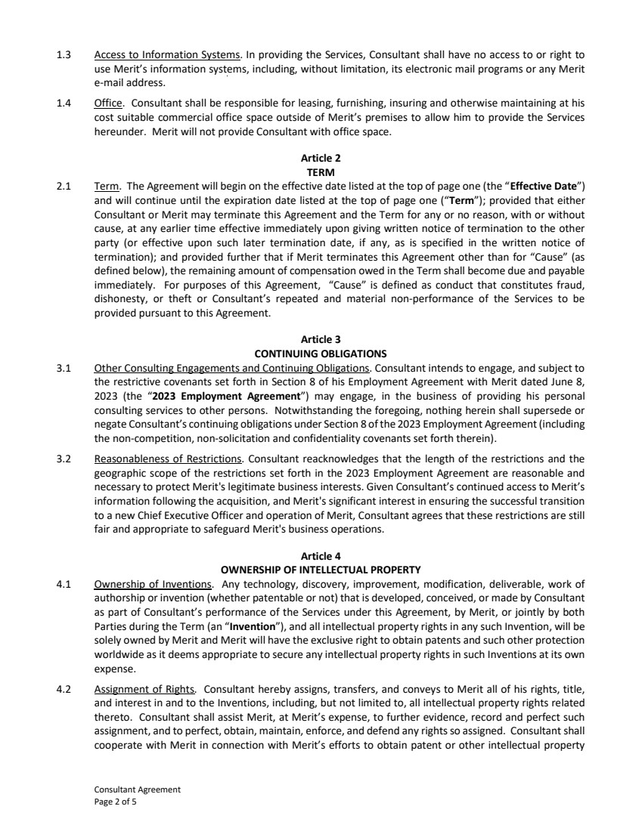 | Consultant Agreement Page 2 of 5 1.3 Access to Information Systems. In providing the Services, Consultant shall have no access to or right to use Merit’s information systems, including, without limitation, its electronic mail programs or any Merit e-mail address. 1.4 Office. Consultant shall be responsible for leasing, furnishing, insuring and otherwise maintaining at his cost suitable commercial office space outside of Merit’s premises to allow him to provide the Services hereunder. Merit will not provide Consultant with office space. Article 2 TERM 2.1 Term. The Agreement will begin on the effective date listed at the top of page one (the “Effective Date”) and will continue until the expiration date listed at the top of page one (“Term”); provided that either Consultant or Merit may terminate this Agreement and the Term for any or no reason, with or without cause, at any earlier time effective immediately upon giving written notice of termination to the other party (or effective upon such later termination date, if any, as is specified in the written notice of termination); and provided further that if Merit terminates this Agreement other than for “Cause” (as defined below), the remaining amount of compensation owed in the Term shall become due and payable immediately. For purposes of this Agreement, “Cause” is defined as conduct that constitutes fraud, dishonesty, or theft or Consultant’s repeated and material non-performance of the Services to be provided pursuant to this Agreement. Article 3 CONTINUING OBLIGATIONS 3.1 Other Consulting Engagements and Continuing Obligations. Consultant intends to engage, and subject to the restrictive covenants set forth in Section 8 of his Employment Agreement with Merit dated June 8, 2023 (the “2023 Employment Agreement”) may engage, in the business of providing his personal consulting services to other persons. Notwithstanding the foregoing, nothing herein shall supersede or negate Consultant’s continuing obligations under Section 8 of the 2023 Employment Agreement (including the non-competition, non-solicitation and confidentiality covenants set forth therein). 3.2 Reasonableness of Restrictions. Consultant reacknowledges that the length of the restrictions and the geographic scope of the restrictions set forth in the 2023 Employment Agreement are reasonable and necessary to protect Merit's legitimate business interests. Given Consultant’s continued access to Merit’s information following the acquisition, and Merit's significant interest in ensuring the successful transition to a new Chief Executive Officer and operation of Merit, Consultant agrees that these restrictions are still fair and appropriate to safeguard Merit's business operations. Article 4 OWNERSHIP OF INTELLECTUAL PROPERTY 4.1 Ownership of Inventions. Any technology, discovery, improvement, modification, deliverable, work of authorship or invention (whether patentable or not) that is developed, conceived, or made by Consultant as part of Consultant’s performance of the Services under this Agreement, by Merit, or jointly by both Parties during the Term (an “Invention”), and all intellectual property rights in any such Invention, will be solely owned by Merit and Merit will have the exclusive right to obtain patents and such other protection worldwide as it deems appropriate to secure any intellectual property rights in such Inventions at its own expense. 4.2 Assignment of Rights. Consultant hereby assigns, transfers, and conveys to Merit all of his rights, title, and interest in and to the Inventions, including, but not limited to, all intellectual property rights related thereto. Consultant shall assist Merit, at Merit’s expense, to further evidence, record and perfect such assignment, and to perfect, obtain, maintain, enforce, and defend any rights so assigned. Consultant shall cooperate with Merit in connection with Merit’s efforts to obtain patent or other intellectual property
 | 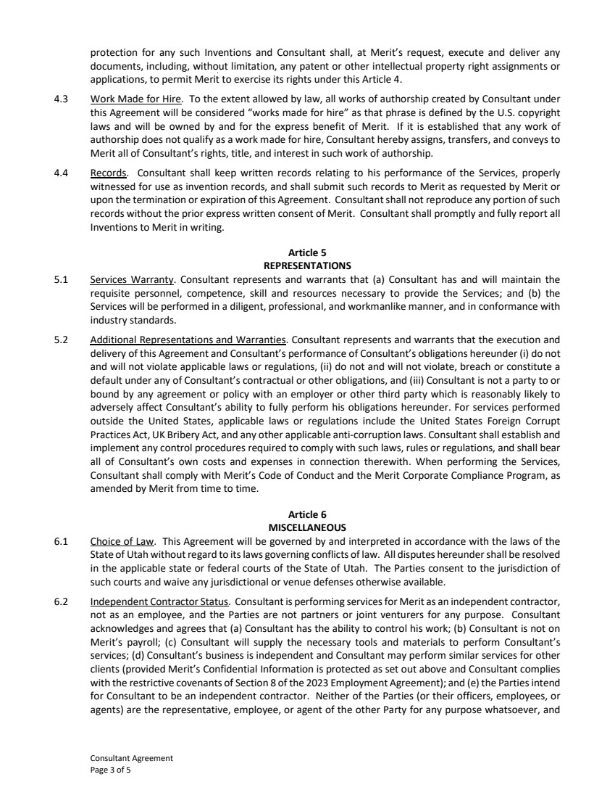 | Consultant Agreement Page 3 of 5 protection for any such Inventions and Consultant shall, at Merit’s request, execute and deliver any documents, including, without limitation, any patent or other intellectual property right assignments or applications, to permit Merit to exercise its rights under this Article 4. 4.3 Work Made for Hire. To the extent allowed by law, all works of authorship created by Consultant under this Agreement will be considered “works made for hire” as that phrase is defined by the U.S. copyright laws and will be owned by and for the express benefit of Merit. If it is established that any work of authorship does not qualify as a work made for hire, Consultant hereby assigns, transfers, and conveys to Merit all of Consultant’s rights, title, and interest in such work of authorship. 4.4 Records. Consultant shall keep written records relating to his performance of the Services, properly witnessed for use as invention records, and shall submit such records to Merit as requested by Merit or upon the termination or expiration of this Agreement. Consultant shall not reproduce any portion of such records without the prior express written consent of Merit. Consultant shall promptly and fully report all Inventions to Merit in writing. Article 5 REPRESENTATIONS 5.1 Services Warranty. Consultant represents and warrants that (a) Consultant has and will maintain the requisite personnel, competence, skill and resources necessary to provide the Services; and (b) the Services will be performed in a diligent, professional, and workmanlike manner, and in conformance with industry standards. 5.2 Additional Representations and Warranties. Consultant represents and warrants that the execution and delivery of this Agreement and Consultant’s performance of Consultant’s obligations hereunder (i) do not and will not violate applicable laws or regulations, (ii) do not and will not violate, breach or constitute a default under any of Consultant’s contractual or other obligations, and (iii) Consultant is not a party to or bound by any agreement or policy with an employer or other third party which is reasonably likely to adversely affect Consultant’s ability to fully perform his obligations hereunder. For services performed outside the United States, applicable laws or regulations include the United States Foreign Corrupt Practices Act, UK Bribery Act, and any other applicable anti-corruption laws. Consultant shall establish and implement any control procedures required to comply with such laws, rules or regulations, and shall bear all of Consultant’s own costs and expenses in connection therewith. When performing the Services, Consultant shall comply with Merit’s Code of Conduct and the Merit Corporate Compliance Program, as amended by Merit from time to time. Article 6 MISCELLANEOUS 6.1 Choice of Law. This Agreement will be governed by and interpreted in accordance with the laws of the State of Utah without regard to its laws governing conflicts of law. All disputes hereunder shall be resolved in the applicable state or federal courts of the State of Utah. The Parties consent to the jurisdiction of such courts and waive any jurisdictional or venue defenses otherwise available. 6.2 Independent Contractor Status. Consultant is performing services for Merit as an independent contractor, not as an employee, and the Parties are not partners or joint venturers for any purpose. Consultant acknowledges and agrees that (a) Consultant has the ability to control his work; (b) Consultant is not on Merit’s payroll; (c) Consultant will supply the necessary tools and materials to perform Consultant’s services; (d) Consultant’s business is independent and Consultant may perform similar services for other clients (provided Merit’s Confidential Information is protected as set out above and Consultant complies with the restrictive covenants of Section 8 of the 2023 Employment Agreement); and (e) the Parties intend for Consultant to be an independent contractor. Neither of the Parties (or their officers, employees, or agents) are the representative, employee, or agent of the other Party for any purpose whatsoever, and
 | 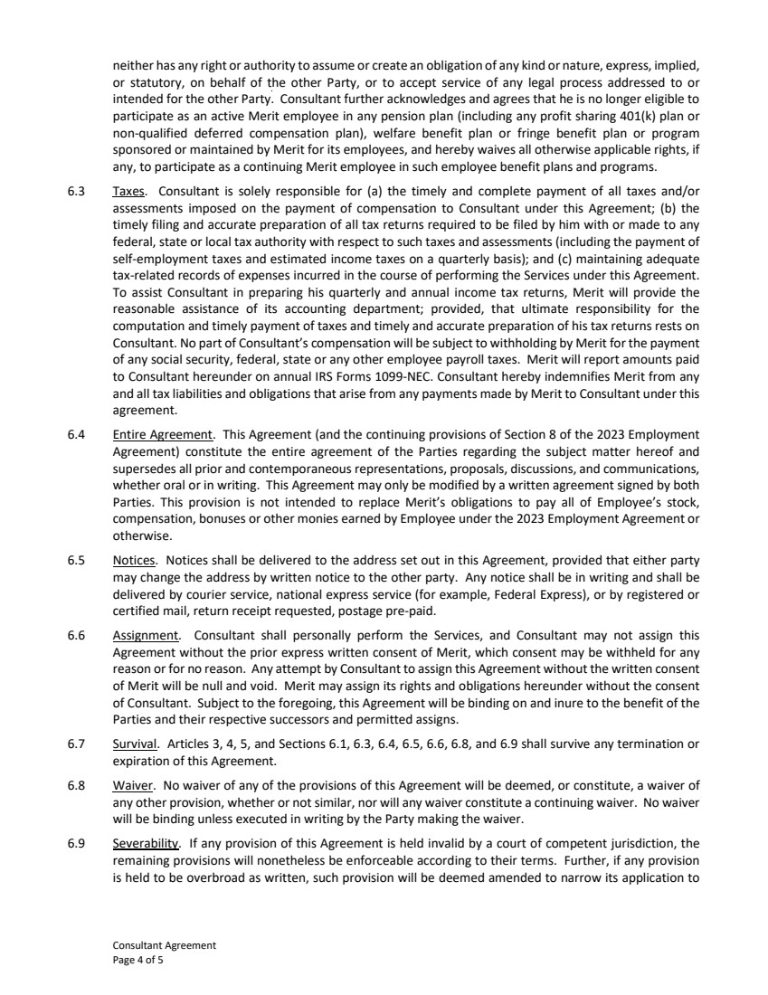 | Consultant Agreement Page 4 of 5 neither has any right or authority to assume or create an obligation of any kind or nature, express, implied, or statutory, on behalf of the other Party, or to accept service of any legal process addressed to or intended for the other Party. Consultant further acknowledges and agrees that he is no longer eligible to participate as an active Merit employee in any pension plan (including any profit sharing 401(k) plan or non-qualified deferred compensation plan), welfare benefit plan or fringe benefit plan or program sponsored or maintained by Merit for its employees, and hereby waives all otherwise applicable rights, if any, to participate as a continuing Merit employee in such employee benefit plans and programs. 6.3 Taxes. Consultant is solely responsible for (a) the timely and complete payment of all taxes and/or assessments imposed on the payment of compensation to Consultant under this Agreement; (b) the timely filing and accurate preparation of all tax returns required to be filed by him with or made to any federal, state or local tax authority with respect to such taxes and assessments (including the payment of self-employment taxes and estimated income taxes on a quarterly basis); and (c) maintaining adequate tax-related records of expenses incurred in the course of performing the Services under this Agreement. To assist Consultant in preparing his quarterly and annual income tax returns, Merit will provide the reasonable assistance of its accounting department; provided, that ultimate responsibility for the computation and timely payment of taxes and timely and accurate preparation of his tax returns rests on Consultant. No part of Consultant’s compensation will be subject to withholding by Merit for the payment of any social security, federal, state or any other employee payroll taxes. Merit will report amounts paid to Consultant hereunder on annual IRS Forms 1099-NEC. Consultant hereby indemnifies Merit from any and all tax liabilities and obligations that arise from any payments made by Merit to Consultant under this agreement. 6.4 Entire Agreement. This Agreement (and the continuing provisions of Section 8 of the 2023 Employment Agreement) constitute the entire agreement of the Parties regarding the subject matter hereof and supersedes all prior and contemporaneous representations, proposals, discussions, and communications, whether oral or in writing. This Agreement may only be modified by a written agreement signed by both Parties. This provision is not intended to replace Merit’s obligations to pay all of Employee’s stock, compensation, bonuses or other monies earned by Employee under the 2023 Employment Agreement or otherwise. 6.5 Notices. Notices shall be delivered to the address set out in this Agreement, provided that either party may change the address by written notice to the other party. Any notice shall be in writing and shall be delivered by courier service, national express service (for example, Federal Express), or by registered or certified mail, return receipt requested, postage pre-paid. 6.6 Assignment. Consultant shall personally perform the Services, and Consultant may not assign this Agreement without the prior express written consent of Merit, which consent may be withheld for any reason or for no reason. Any attempt by Consultant to assign this Agreement without the written consent of Merit will be null and void. Merit may assign its rights and obligations hereunder without the consent of Consultant. Subject to the foregoing, this Agreement will be binding on and inure to the benefit of the Parties and their respective successors and permitted assigns. 6.7 Survival. Articles 3, 4, 5, and Sections 6.1, 6.3, 6.4, 6.5, 6.6, 6.8, and 6.9 shall survive any termination or expiration of this Agreement. 6.8 Waiver. No waiver of any of the provisions of this Agreement will be deemed, or constitute, a waiver of any other provision, whether or not similar, nor will any waiver constitute a continuing waiver. No waiver will be binding unless executed in writing by the Party making the waiver. 6.9 Severability. If any provision of this Agreement is held invalid by a court of competent jurisdiction, the remaining provisions will nonetheless be enforceable according to their terms. Further, if any provision is held to be overbroad as written, such provision will be deemed amended to narrow its application to
 | 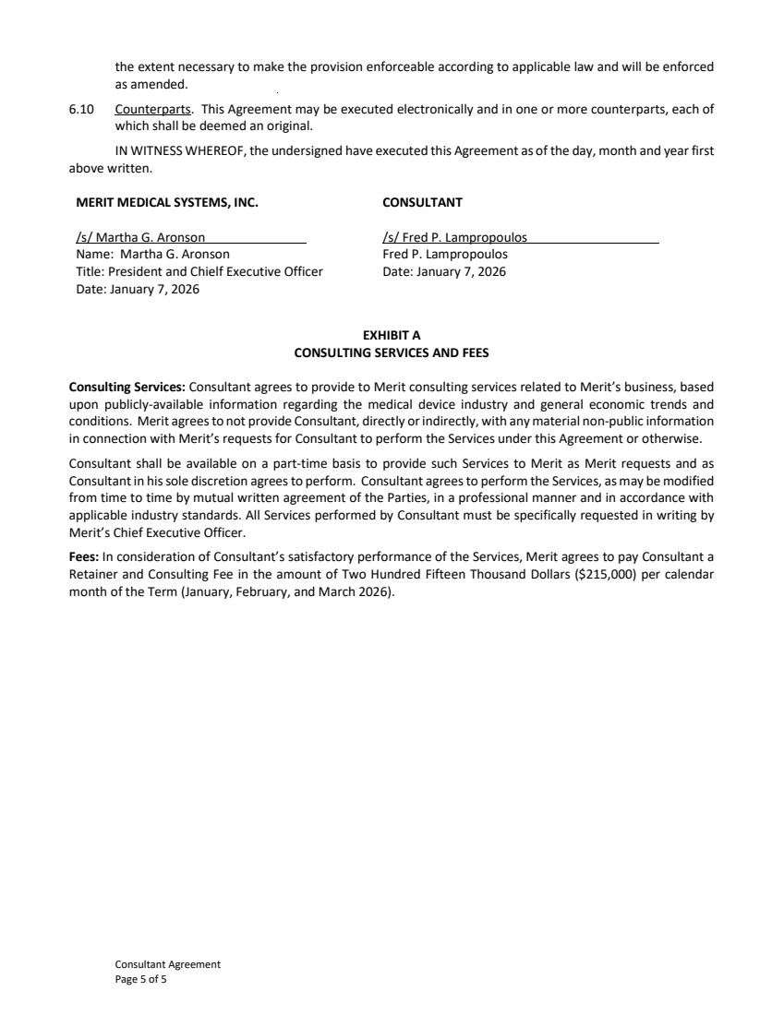 | Consultant Agreement Page 5 of 5 the extent necessary to make the provision enforceable according to applicable law and will be enforced as amended. 6.10 Counterparts. This Agreement may be executed electronically and in one or more counterparts, each of which shall be deemed an original. IN WITNESS WHEREOF, the undersigned have executed this Agreement as of the day, month and year first above written. MERIT MEDICAL SYSTEMS, INC. /s/ Martha G. Aronson Name: Martha G. Aronson Title: President and Chielf Executive Officer Date: January 7, 2026 CONSULTANT /s/ Fred P. Lampropoulos Fred P. Lampropoulos Date: January 7, 2026 EXHIBIT A CONSULTING SERVICES AND FEES Consulting Services: Consultant agrees to provide to Merit consulting services related to Merit’s business, based upon publicly-available information regarding the medical device industry and general economic trends and conditions. Merit agrees to not provide Consultant, directly or indirectly, with any material non-public information in connection with Merit’s requests for Consultant to perform the Services under this Agreement or otherwise. Consultant shall be available on a part-time basis to provide such Services to Merit as Merit requests and as Consultant in his sole discretion agrees to perform. Consultant agrees to perform the Services, as may be modified from time to time by mutual written agreement of the Parties, in a professional manner and in accordance with applicable industry standards. All Services performed by Consultant must be specifically requested in writing by Merit’s Chief Executive Officer. Fees: In consideration of Consultant’s satisfactory performance of the Services, Merit agrees to pay Consultant a Retainer and Consulting Fee in the amount of Two Hundred Fifteen Thousand Dollars ($215,000) per calendar month of the Term (January, February, and March 2026).
Exhibit 10.71
 | 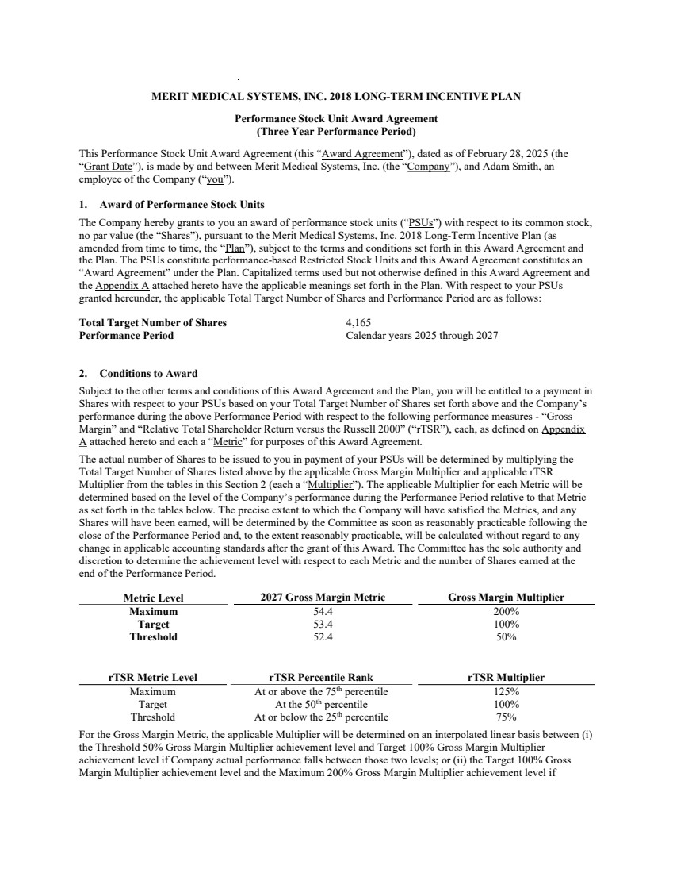 | MERIT MEDICAL SYSTEMS, INC. 2018 LONG-TERM INCENTIVE PLAN Performance Stock Unit Award Agreement (Three Year Performance Period) This Performance Stock Unit Award Agreement (this “Award Agreement”), dated as of February 28, 2025 (the “Grant Date”), is made by and between Merit Medical Systems, Inc. (the “Company”), and Adam Smith, an employee of the Company (“you”). 1. Award of Performance Stock Units The Company hereby grants to you an award of performance stock units (“PSUs”) with respect to its common stock, no par value (the “Shares”), pursuant to the Merit Medical Systems, Inc. 2018 Long-Term Incentive Plan (as amended from time to time, the “Plan”), subject to the terms and conditions set forth in this Award Agreement and the Plan. The PSUs constitute performance-based Restricted Stock Units and this Award Agreement constitutes an “Award Agreement” under the Plan. Capitalized terms used but not otherwise defined in this Award Agreement and the Appendix A attached hereto have the applicable meanings set forth in the Plan. With respect to your PSUs granted hereunder, the applicable Total Target Number of Shares and Performance Period are as follows: Total Target Number of Shares 4,165 Performance Period Calendar years 2025 through 2027 2. Conditions to Award Subject to the other terms and conditions of this Award Agreement and the Plan, you will be entitled to a payment in Shares with respect to your PSUs based on your Total Target Number of Shares set forth above and the Company’s performance during the above Performance Period with respect to the following performance measures - “Gross Margin” and “Relative Total Shareholder Return versus the Russell 2000” (“rTSR”), each, as defined on Appendix A attached hereto and each a “Metric” for purposes of this Award Agreement. The actual number of Shares to be issued to you in payment of your PSUs will be determined by multiplying the Total Target Number of Shares listed above by the applicable Gross Margin Multiplier and applicable rTSR Multiplier from the tables in this Section 2 (each a “Multiplier”). The applicable Multiplier for each Metric will be determined based on the level of the Company’s performance during the Performance Period relative to that Metric as set forth in the tables below. The precise extent to which the Company will have satisfied the Metrics, and any Shares will have been earned, will be determined by the Committee as soon as reasonably practicable following the close of the Performance Period and, to the extent reasonably practicable, will be calculated without regard to any change in applicable accounting standards after the grant of this Award. The Committee has the sole authority and discretion to determine the achievement level with respect to each Metric and the number of Shares earned at the end of the Performance Period. Metric Level 2027 Gross Margin Metric Gross Margin Multiplier Maximum 54.4 200% Target 53.4 100% Threshold 52.4 50% rTSR Metric Level rTSR Percentile Rank rTSR Multiplier Maximum At or above the 75th percentile 125% Target At the 50th percentile 100% Threshold At or below the 25th percentile 75% For the Gross Margin Metric, the applicable Multiplier will be determined on an interpolated linear basis between (i) the Threshold 50% Gross Margin Multiplier achievement level and Target 100% Gross Margin Multiplier achievement level if Company actual performance falls between those two levels; or (ii) the Target 100% Gross Margin Multiplier achievement level and the Maximum 200% Gross Margin Multiplier achievement level if
 | 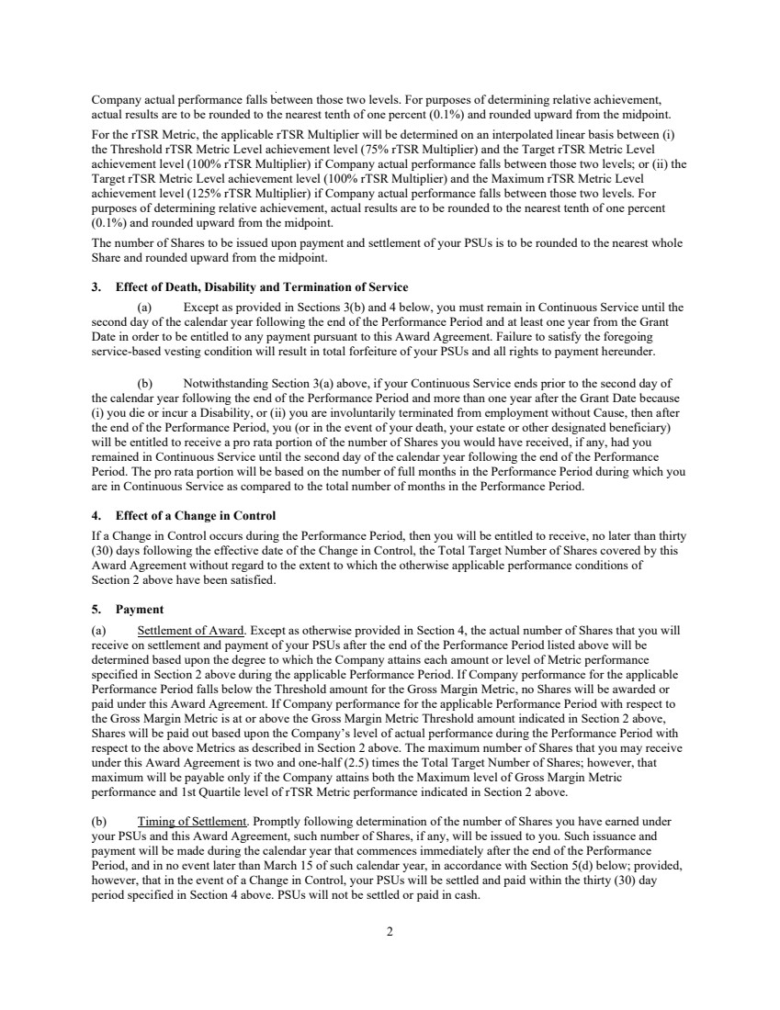 | 2 Company actual performance falls between those two levels. For purposes of determining relative achievement, actual results are to be rounded to the nearest tenth of one percent (0.1%) and rounded upward from the midpoint. For the rTSR Metric, the applicable rTSR Multiplier will be determined on an interpolated linear basis between (i) the Threshold rTSR Metric Level achievement level (75% rTSR Multiplier) and the Target rTSR Metric Level achievement level (100% rTSR Multiplier) if Company actual performance falls between those two levels; or (ii) the Target rTSR Metric Level achievement level (100% rTSR Multiplier) and the Maximum rTSR Metric Level achievement level (125% rTSR Multiplier) if Company actual performance falls between those two levels. For purposes of determining relative achievement, actual results are to be rounded to the nearest tenth of one percent (0.1%) and rounded upward from the midpoint. The number of Shares to be issued upon payment and settlement of your PSUs is to be rounded to the nearest whole Share and rounded upward from the midpoint. 3. Effect of Death, Disability and Termination of Service (a) Except as provided in Sections 3(b) and 4 below, you must remain in Continuous Service until the second day of the calendar year following the end of the Performance Period and at least one year from the Grant Date in order to be entitled to any payment pursuant to this Award Agreement. Failure to satisfy the foregoing service-based vesting condition will result in total forfeiture of your PSUs and all rights to payment hereunder. (b) Notwithstanding Section 3(a) above, if your Continuous Service ends prior to the second day of the calendar year following the end of the Performance Period and more than one year after the Grant Date because (i) you die or incur a Disability, or (ii) you are involuntarily terminated from employment without Cause, then after the end of the Performance Period, you (or in the event of your death, your estate or other designated beneficiary) will be entitled to receive a pro rata portion of the number of Shares you would have received, if any, had you remained in Continuous Service until the second day of the calendar year following the end of the Performance Period. The pro rata portion will be based on the number of full months in the Performance Period during which you are in Continuous Service as compared to the total number of months in the Performance Period. 4. Effect of a Change in Control If a Change in Control occurs during the Performance Period, then you will be entitled to receive, no later than thirty (30) days following the effective date of the Change in Control, the Total Target Number of Shares covered by this Award Agreement without regard to the extent to which the otherwise applicable performance conditions of Section 2 above have been satisfied. 5. Payment (a) Settlement of Award. Except as otherwise provided in Section 4, the actual number of Shares that you will receive on settlement and payment of your PSUs after the end of the Performance Period listed above will be determined based upon the degree to which the Company attains each amount or level of Metric performance specified in Section 2 above during the applicable Performance Period. If Company performance for the applicable Performance Period falls below the Threshold amount for the Gross Margin Metric, no Shares will be awarded or paid under this Award Agreement. If Company performance for the applicable Performance Period with respect to the Gross Margin Metric is at or above the Gross Margin Metric Threshold amount indicated in Section 2 above, Shares will be paid out based upon the Company’s level of actual performance during the Performance Period with respect to the above Metrics as described in Section 2 above. The maximum number of Shares that you may receive under this Award Agreement is two and one-half (2.5) times the Total Target Number of Shares; however, that maximum will be payable only if the Company attains both the Maximum level of Gross Margin Metric performance and 1st Quartile level of rTSR Metric performance indicated in Section 2 above. (b) Timing of Settlement. Promptly following determination of the number of Shares you have earned under your PSUs and this Award Agreement, such number of Shares, if any, will be issued to you. Such issuance and payment will be made during the calendar year that commences immediately after the end of the Performance Period, and in no event later than March 15 of such calendar year, in accordance with Section 5(d) below; provided, however, that in the event of a Change in Control, your PSUs will be settled and paid within the thirty (30) day period specified in Section 4 above. PSUs will not be settled or paid in cash.
 | 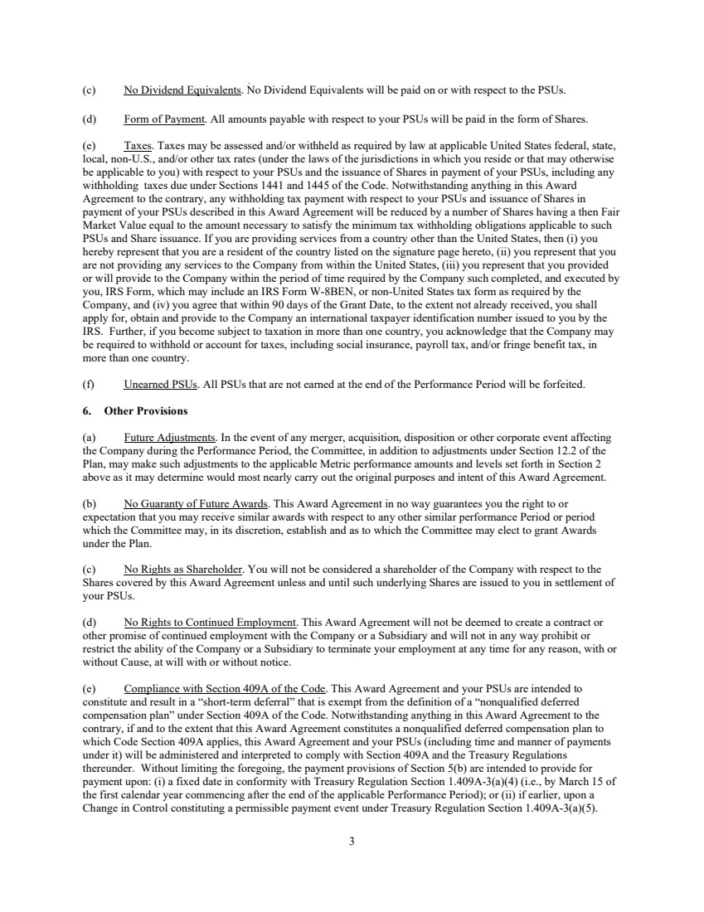 | 3 (c) No Dividend Equivalents. No Dividend Equivalents will be paid on or with respect to the PSUs. (d) Form of Payment. All amounts payable with respect to your PSUs will be paid in the form of Shares. (e) Taxes. Taxes may be assessed and/or withheld as required by law at applicable United States federal, state, local, non-U.S., and/or other tax rates (under the laws of the jurisdictions in which you reside or that may otherwise be applicable to you) with respect to your PSUs and the issuance of Shares in payment of your PSUs, including any withholding taxes due under Sections 1441 and 1445 of the Code. Notwithstanding anything in this Award Agreement to the contrary, any withholding tax payment with respect to your PSUs and issuance of Shares in payment of your PSUs described in this Award Agreement will be reduced by a number of Shares having a then Fair Market Value equal to the amount necessary to satisfy the minimum tax withholding obligations applicable to such PSUs and Share issuance. If you are providing services from a country other than the United States, then (i) you hereby represent that you are a resident of the country listed on the signature page hereto, (ii) you represent that you are not providing any services to the Company from within the United States, (iii) you represent that you provided or will provide to the Company within the period of time required by the Company such completed, and executed by you, IRS Form, which may include an IRS Form W-8BEN, or non-United States tax form as required by the Company, and (iv) you agree that within 90 days of the Grant Date, to the extent not already received, you shall apply for, obtain and provide to the Company an international taxpayer identification number issued to you by the IRS. Further, if you become subject to taxation in more than one country, you acknowledge that the Company may be required to withhold or account for taxes, including social insurance, payroll tax, and/or fringe benefit tax, in more than one country. (f) Unearned PSUs. All PSUs that are not earned at the end of the Performance Period will be forfeited. 6. Other Provisions (a) Future Adjustments. In the event of any merger, acquisition, disposition or other corporate event affecting the Company during the Performance Period, the Committee, in addition to adjustments under Section 12.2 of the Plan, may make such adjustments to the applicable Metric performance amounts and levels set forth in Section 2 above as it may determine would most nearly carry out the original purposes and intent of this Award Agreement. (b) No Guaranty of Future Awards. This Award Agreement in no way guarantees you the right to or expectation that you may receive similar awards with respect to any other similar performance Period or period which the Committee may, in its discretion, establish and as to which the Committee may elect to grant Awards under the Plan. (c) No Rights as Shareholder. You will not be considered a shareholder of the Company with respect to the Shares covered by this Award Agreement unless and until such underlying Shares are issued to you in settlement of your PSUs. (d) No Rights to Continued Employment. This Award Agreement will not be deemed to create a contract or other promise of continued employment with the Company or a Subsidiary and will not in any way prohibit or restrict the ability of the Company or a Subsidiary to terminate your employment at any time for any reason, with or without Cause, at will with or without notice. (e) Compliance with Section 409A of the Code. This Award Agreement and your PSUs are intended to constitute and result in a “short-term deferral” that is exempt from the definition of a “nonqualified deferred compensation plan” under Section 409A of the Code. Notwithstanding anything in this Award Agreement to the contrary, if and to the extent that this Award Agreement constitutes a nonqualified deferred compensation plan to which Code Section 409A applies, this Award Agreement and your PSUs (including time and manner of payments under it) will be administered and interpreted to comply with Section 409A and the Treasury Regulations thereunder. Without limiting the foregoing, the payment provisions of Section 5(b) are intended to provide for payment upon: (i) a fixed date in conformity with Treasury Regulation Section 1.409A-3(a)(4) (i.e., by March 15 of the first calendar year commencing after the end of the applicable Performance Period); or (ii) if earlier, upon a Change in Control constituting a permissible payment event under Treasury Regulation Section 1.409A-3(a)(5).
 | 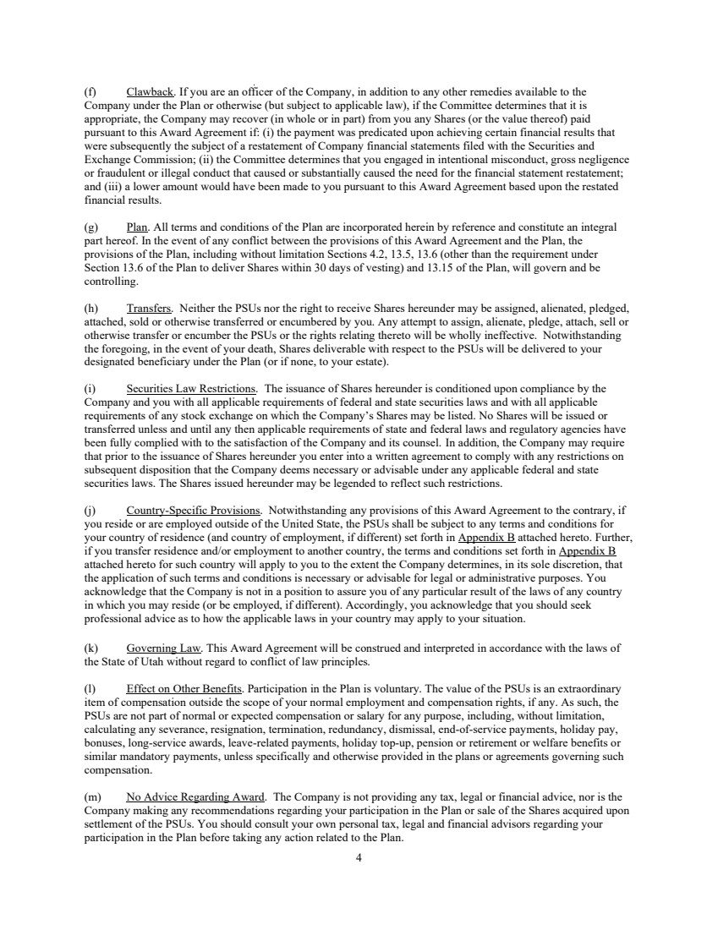 | 4 (f) Clawback. If you are an officer of the Company, in addition to any other remedies available to the Company under the Plan or otherwise (but subject to applicable law), if the Committee determines that it is appropriate, the Company may recover (in whole or in part) from you any Shares (or the value thereof) paid pursuant to this Award Agreement if: (i) the payment was predicated upon achieving certain financial results that were subsequently the subject of a restatement of Company financial statements filed with the Securities and Exchange Commission; (ii) the Committee determines that you engaged in intentional misconduct, gross negligence or fraudulent or illegal conduct that caused or substantially caused the need for the financial statement restatement; and (iii) a lower amount would have been made to you pursuant to this Award Agreement based upon the restated financial results. (g) Plan. All terms and conditions of the Plan are incorporated herein by reference and constitute an integral part hereof. In the event of any conflict between the provisions of this Award Agreement and the Plan, the provisions of the Plan, including without limitation Sections 4.2, 13.5, 13.6 (other than the requirement under Section 13.6 of the Plan to deliver Shares within 30 days of vesting) and 13.15 of the Plan, will govern and be controlling. (h) Transfers. Neither the PSUs nor the right to receive Shares hereunder may be assigned, alienated, pledged, attached, sold or otherwise transferred or encumbered by you. Any attempt to assign, alienate, pledge, attach, sell or otherwise transfer or encumber the PSUs or the rights relating thereto will be wholly ineffective. Notwithstanding the foregoing, in the event of your death, Shares deliverable with respect to the PSUs will be delivered to your designated beneficiary under the Plan (or if none, to your estate). (i) Securities Law Restrictions. The issuance of Shares hereunder is conditioned upon compliance by the Company and you with all applicable requirements of federal and state securities laws and with all applicable requirements of any stock exchange on which the Company’s Shares may be listed. No Shares will be issued or transferred unless and until any then applicable requirements of state and federal laws and regulatory agencies have been fully complied with to the satisfaction of the Company and its counsel. In addition, the Company may require that prior to the issuance of Shares hereunder you enter into a written agreement to comply with any restrictions on subsequent disposition that the Company deems necessary or advisable under any applicable federal and state securities laws. The Shares issued hereunder may be legended to reflect such restrictions. (j) Country-Specific Provisions. Notwithstanding any provisions of this Award Agreement to the contrary, if you reside or are employed outside of the United State, the PSUs shall be subject to any terms and conditions for your country of residence (and country of employment, if different) set forth in Appendix B attached hereto. Further, if you transfer residence and/or employment to another country, the terms and conditions set forth in Appendix B attached hereto for such country will apply to you to the extent the Company determines, in its sole discretion, that the application of such terms and conditions is necessary or advisable for legal or administrative purposes. You acknowledge that the Company is not in a position to assure you of any particular result of the laws of any country in which you may reside (or be employed, if different). Accordingly, you acknowledge that you should seek professional advice as to how the applicable laws in your country may apply to your situation. (k) Governing Law. This Award Agreement will be construed and interpreted in accordance with the laws of the State of Utah without regard to conflict of law principles. (l) Effect on Other Benefits. Participation in the Plan is voluntary. The value of the PSUs is an extraordinary item of compensation outside the scope of your normal employment and compensation rights, if any. As such, the PSUs are not part of normal or expected compensation or salary for any purpose, including, without limitation, calculating any severance, resignation, termination, redundancy, dismissal, end-of-service payments, holiday pay, bonuses, long-service awards, leave-related payments, holiday top-up, pension or retirement or welfare benefits or similar mandatory payments, unless specifically and otherwise provided in the plans or agreements governing such compensation. (m) No Advice Regarding Award. The Company is not providing any tax, legal or financial advice, nor is the Company making any recommendations regarding your participation in the Plan or sale of the Shares acquired upon settlement of the PSUs. You should consult your own personal tax, legal and financial advisors regarding your participation in the Plan before taking any action related to the Plan.
 | 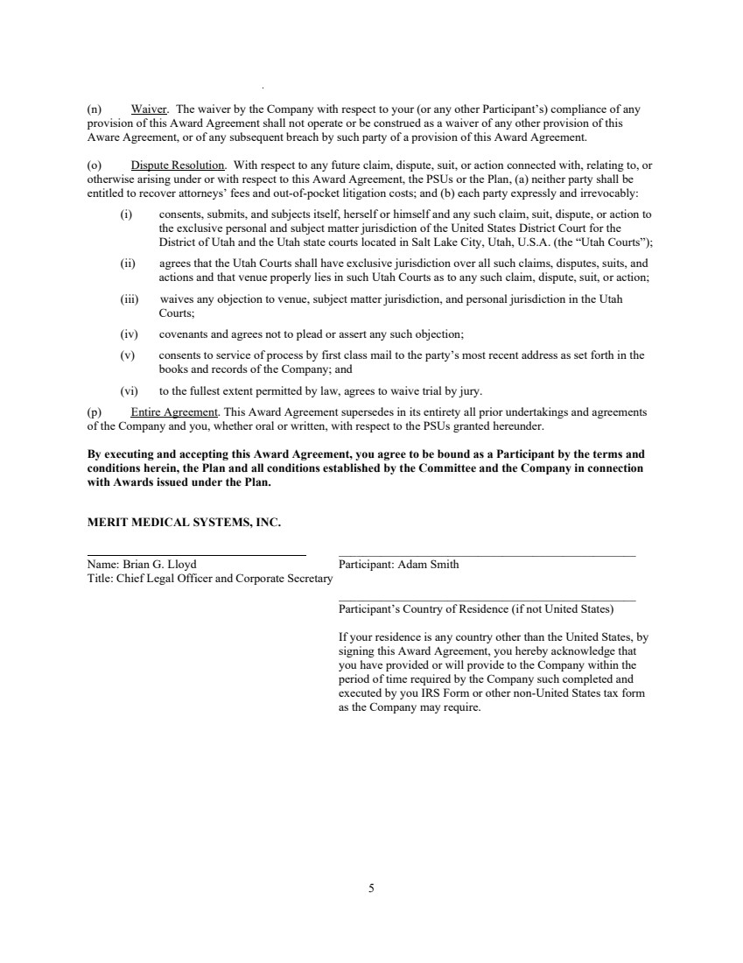 | 5 (n) Waiver. The waiver by the Company with respect to your (or any other Participant’s) compliance of any provision of this Award Agreement shall not operate or be construed as a waiver of any other provision of this Aware Agreement, or of any subsequent breach by such party of a provision of this Award Agreement. (o) Dispute Resolution. With respect to any future claim, dispute, suit, or action connected with, relating to, or otherwise arising under or with respect to this Award Agreement, the PSUs or the Plan, (a) neither party shall be entitled to recover attorneys’ fees and out-of-pocket litigation costs; and (b) each party expressly and irrevocably: (i) consents, submits, and subjects itself, herself or himself and any such claim, suit, dispute, or action to the exclusive personal and subject matter jurisdiction of the United States District Court for the District of Utah and the Utah state courts located in Salt Lake City, Utah, U.S.A. (the “Utah Courts”); (ii) agrees that the Utah Courts shall have exclusive jurisdiction over all such claims, disputes, suits, and actions and that venue properly lies in such Utah Courts as to any such claim, dispute, suit, or action; (iii) waives any objection to venue, subject matter jurisdiction, and personal jurisdiction in the Utah Courts; (iv) covenants and agrees not to plead or assert any such objection; (v) consents to service of process by first class mail to the party’s most recent address as set forth in the books and records of the Company; and (vi) to the fullest extent permitted by law, agrees to waive trial by jury. (p) Entire Agreement. This Award Agreement supersedes in its entirety all prior undertakings and agreements of the Company and you, whether oral or written, with respect to the PSUs granted hereunder. By executing and accepting this Award Agreement, you agree to be bound as a Participant by the terms and conditions herein, the Plan and all conditions established by the Committee and the Company in connection with Awards issued under the Plan. MERIT MEDICAL SYSTEMS, INC. Name: Brian G. Lloyd _________________________________________________ Participant: Adam Smith Title: Chief Legal Officer and Corporate Secretary _________________________________________________ Participant’s Country of Residence (if not United States) If your residence is any country other than the United States, by signing this Award Agreement, you hereby acknowledge that you have provided or will provide to the Company within the period of time required by the Company such completed and executed by you IRS Form or other non-United States tax form as the Company may require.
 | 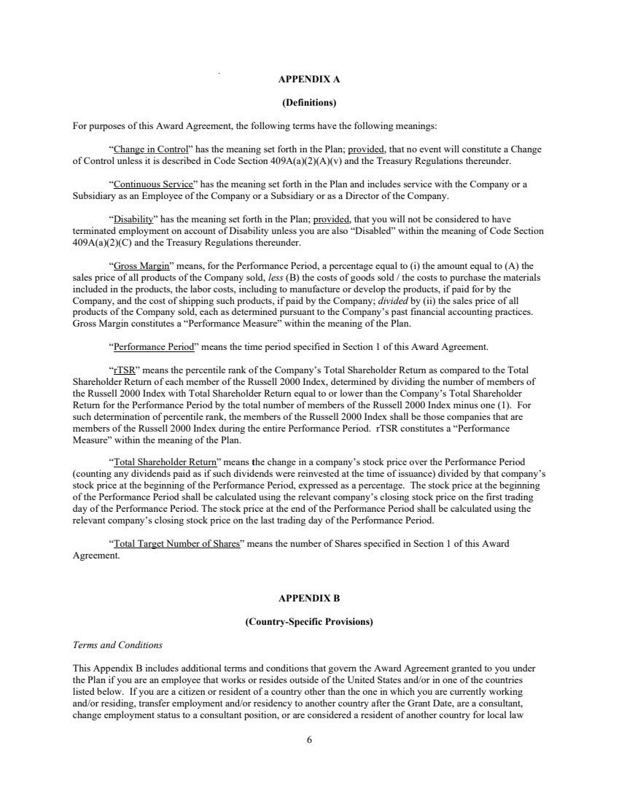 | 6 APPENDIX A (Definitions) For purposes of this Award Agreement, the following terms have the following meanings: “Change in Control” has the meaning set forth in the Plan; provided, that no event will constitute a Change of Control unless it is described in Code Section 409A(a)(2)(A)(v) and the Treasury Regulations thereunder. “Continuous Service” has the meaning set forth in the Plan and includes service with the Company or a Subsidiary as an Employee of the Company or a Subsidiary or as a Director of the Company. “Disability” has the meaning set forth in the Plan; provided, that you will not be considered to have terminated employment on account of Disability unless you are also “Disabled” within the meaning of Code Section 409A(a)(2)(C) and the Treasury Regulations thereunder. “Gross Margin” means, for the Performance Period, a percentage equal to (i) the amount equal to (A) the sales price of all products of the Company sold, less (B) the costs of goods sold / the costs to purchase the materials included in the products, the labor costs, including to manufacture or develop the products, if paid for by the Company, and the cost of shipping such products, if paid by the Company; divided by (ii) the sales price of all products of the Company sold, each as determined pursuant to the Company’s past financial accounting practices. Gross Margin constitutes a “Performance Measure” within the meaning of the Plan. “Performance Period” means the time period specified in Section 1 of this Award Agreement. “rTSR” means the percentile rank of the Company’s Total Shareholder Return as compared to the Total Shareholder Return of each member of the Russell 2000 Index, determined by dividing the number of members of the Russell 2000 Index with Total Shareholder Return equal to or lower than the Company’s Total Shareholder Return for the Performance Period by the total number of members of the Russell 2000 Index minus one (1). For such determination of percentile rank, the members of the Russell 2000 Index shall be those companies that are members of the Russell 2000 Index during the entire Performance Period. rTSR constitutes a “Performance Measure” within the meaning of the Plan. “Total Shareholder Return” means the change in a company’s stock price over the Performance Period (counting any dividends paid as if such dividends were reinvested at the time of issuance) divided by that company’s stock price at the beginning of the Performance Period, expressed as a percentage. The stock price at the beginning of the Performance Period shall be calculated using the relevant company’s closing stock price on the first trading day of the Performance Period. The stock price at the end of the Performance Period shall be calculated using the relevant company’s closing stock price on the last trading day of the Performance Period. “Total Target Number of Shares” means the number of Shares specified in Section 1 of this Award Agreement. APPENDIX B (Country-Specific Provisions) Terms and Conditions This Appendix B includes additional terms and conditions that govern the Award Agreement granted to you under the Plan if you are an employee that works or resides outside of the United States and/or in one of the countries listed below. If you are a citizen or resident of a country other than the one in which you are currently working and/or residing, transfer employment and/or residency to another country after the Grant Date, are a consultant, change employment status to a consultant position, or are considered a resident of another country for local law
 | 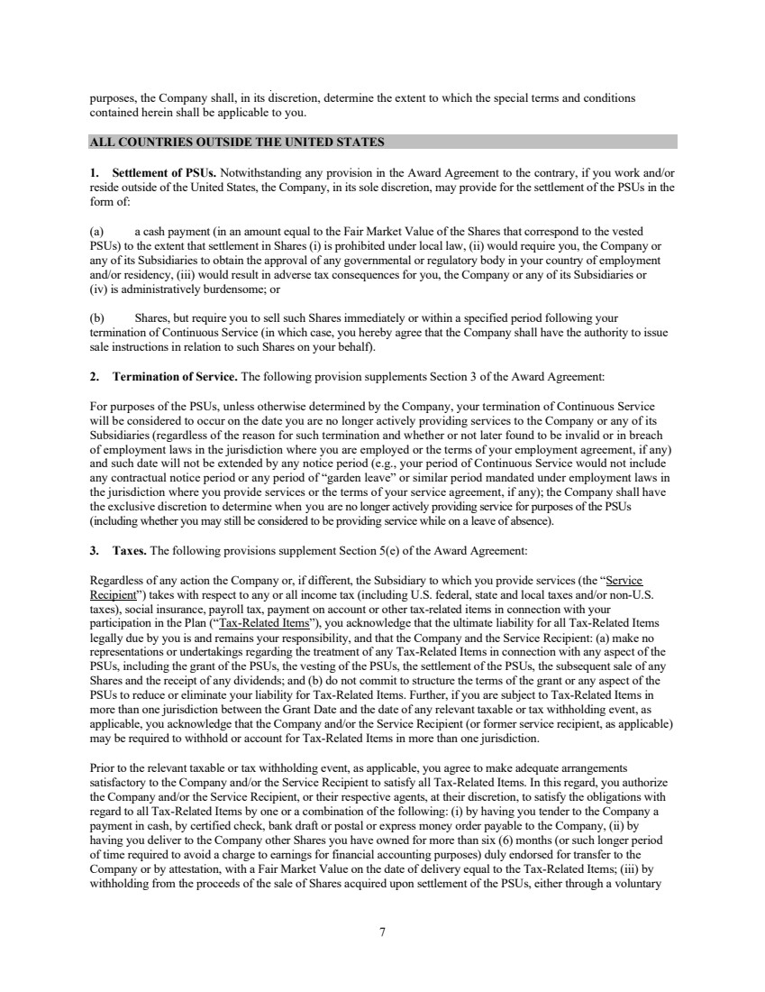 | 7 purposes, the Company shall, in its discretion, determine the extent to which the special terms and conditions contained herein shall be applicable to you. ALL COUNTRIES OUTSIDE THE UNITED STATES 1. Settlement of PSUs. Notwithstanding any provision in the Award Agreement to the contrary, if you work and/or reside outside of the United States, the Company, in its sole discretion, may provide for the settlement of the PSUs in the form of: (a) a cash payment (in an amount equal to the Fair Market Value of the Shares that correspond to the vested PSUs) to the extent that settlement in Shares (i) is prohibited under local law, (ii) would require you, the Company or any of its Subsidiaries to obtain the approval of any governmental or regulatory body in your country of employment and/or residency, (iii) would result in adverse tax consequences for you, the Company or any of its Subsidiaries or (iv) is administratively burdensome; or (b) Shares, but require you to sell such Shares immediately or within a specified period following your termination of Continuous Service (in which case, you hereby agree that the Company shall have the authority to issue sale instructions in relation to such Shares on your behalf). 2. Termination of Service. The following provision supplements Section 3 of the Award Agreement: For purposes of the PSUs, unless otherwise determined by the Company, your termination of Continuous Service will be considered to occur on the date you are no longer actively providing services to the Company or any of its Subsidiaries (regardless of the reason for such termination and whether or not later found to be invalid or in breach of employment laws in the jurisdiction where you are employed or the terms of your employment agreement, if any) and such date will not be extended by any notice period (e.g., your period of Continuous Service would not include any contractual notice period or any period of “garden leave” or similar period mandated under employment laws in the jurisdiction where you provide services or the terms of your service agreement, if any); the Company shall have the exclusive discretion to determine when you are no longer actively providing service for purposes of the PSUs (including whether you may still be considered to be providing service while on a leave of absence). 3. Taxes. The following provisions supplement Section 5(e) of the Award Agreement: Regardless of any action the Company or, if different, the Subsidiary to which you provide services (the “Service Recipient”) takes with respect to any or all income tax (including U.S. federal, state and local taxes and/or non-U.S. taxes), social insurance, payroll tax, payment on account or other tax-related items in connection with your participation in the Plan (“Tax-Related Items”), you acknowledge that the ultimate liability for all Tax-Related Items legally due by you is and remains your responsibility, and that the Company and the Service Recipient: (a) make no representations or undertakings regarding the treatment of any Tax-Related Items in connection with any aspect of the PSUs, including the grant of the PSUs, the vesting of the PSUs, the settlement of the PSUs, the subsequent sale of any Shares and the receipt of any dividends; and (b) do not commit to structure the terms of the grant or any aspect of the PSUs to reduce or eliminate your liability for Tax-Related Items. Further, if you are subject to Tax-Related Items in more than one jurisdiction between the Grant Date and the date of any relevant taxable or tax withholding event, as applicable, you acknowledge that the Company and/or the Service Recipient (or former service recipient, as applicable) may be required to withhold or account for Tax-Related Items in more than one jurisdiction. Prior to the relevant taxable or tax withholding event, as applicable, you agree to make adequate arrangements satisfactory to the Company and/or the Service Recipient to satisfy all Tax-Related Items. In this regard, you authorize the Company and/or the Service Recipient, or their respective agents, at their discretion, to satisfy the obligations with regard to all Tax-Related Items by one or a combination of the following: (i) by having you tender to the Company a payment in cash, by certified check, bank draft or postal or express money order payable to the Company, (ii) by having you deliver to the Company other Shares you have owned for more than six (6) months (or such longer period of time required to avoid a charge to earnings for financial accounting purposes) duly endorsed for transfer to the Company or by attestation, with a Fair Market Value on the date of delivery equal to the Tax-Related Items; (iii) by withholding from the proceeds of the sale of Shares acquired upon settlement of the PSUs, either through a voluntary
 | 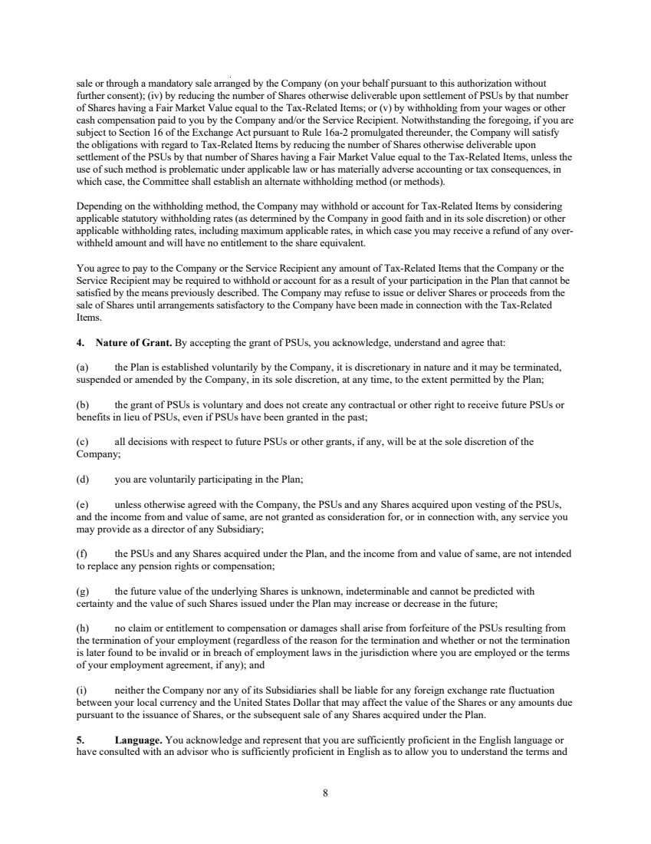 | 8 sale or through a mandatory sale arranged by the Company (on your behalf pursuant to this authorization without further consent); (iv) by reducing the number of Shares otherwise deliverable upon settlement of PSUs by that number of Shares having a Fair Market Value equal to the Tax-Related Items; or (v) by withholding from your wages or other cash compensation paid to you by the Company and/or the Service Recipient. Notwithstanding the foregoing, if you are subject to Section 16 of the Exchange Act pursuant to Rule 16a-2 promulgated thereunder, the Company will satisfy the obligations with regard to Tax-Related Items by reducing the number of Shares otherwise deliverable upon settlement of the PSUs by that number of Shares having a Fair Market Value equal to the Tax-Related Items, unless the use of such method is problematic under applicable law or has materially adverse accounting or tax consequences, in which case, the Committee shall establish an alternate withholding method (or methods). Depending on the withholding method, the Company may withhold or account for Tax-Related Items by considering applicable statutory withholding rates (as determined by the Company in good faith and in its sole discretion) or other applicable withholding rates, including maximum applicable rates, in which case you may receive a refund of any over-withheld amount and will have no entitlement to the share equivalent. You agree to pay to the Company or the Service Recipient any amount of Tax-Related Items that the Company or the Service Recipient may be required to withhold or account for as a result of your participation in the Plan that cannot be satisfied by the means previously described. The Company may refuse to issue or deliver Shares or proceeds from the sale of Shares until arrangements satisfactory to the Company have been made in connection with the Tax-Related Items. 4. Nature of Grant. By accepting the grant of PSUs, you acknowledge, understand and agree that: (a) the Plan is established voluntarily by the Company, it is discretionary in nature and it may be terminated, suspended or amended by the Company, in its sole discretion, at any time, to the extent permitted by the Plan; (b) the grant of PSUs is voluntary and does not create any contractual or other right to receive future PSUs or benefits in lieu of PSUs, even if PSUs have been granted in the past; (c) all decisions with respect to future PSUs or other grants, if any, will be at the sole discretion of the Company; (d) you are voluntarily participating in the Plan; (e) unless otherwise agreed with the Company, the PSUs and any Shares acquired upon vesting of the PSUs, and the income from and value of same, are not granted as consideration for, or in connection with, any service you may provide as a director of any Subsidiary; (f) the PSUs and any Shares acquired under the Plan, and the income from and value of same, are not intended to replace any pension rights or compensation; (g) the future value of the underlying Shares is unknown, indeterminable and cannot be predicted with certainty and the value of such Shares issued under the Plan may increase or decrease in the future; (h) no claim or entitlement to compensation or damages shall arise from forfeiture of the PSUs resulting from the termination of your employment (regardless of the reason for the termination and whether or not the termination is later found to be invalid or in breach of employment laws in the jurisdiction where you are employed or the terms of your employment agreement, if any); and (i) neither the Company nor any of its Subsidiaries shall be liable for any foreign exchange rate fluctuation between your local currency and the United States Dollar that may affect the value of the Shares or any amounts due pursuant to the issuance of Shares, or the subsequent sale of any Shares acquired under the Plan. 5. Language. You acknowledge and represent that you are sufficiently proficient in the English language or have consulted with an advisor who is sufficiently proficient in English as to allow you to understand the terms and
 | 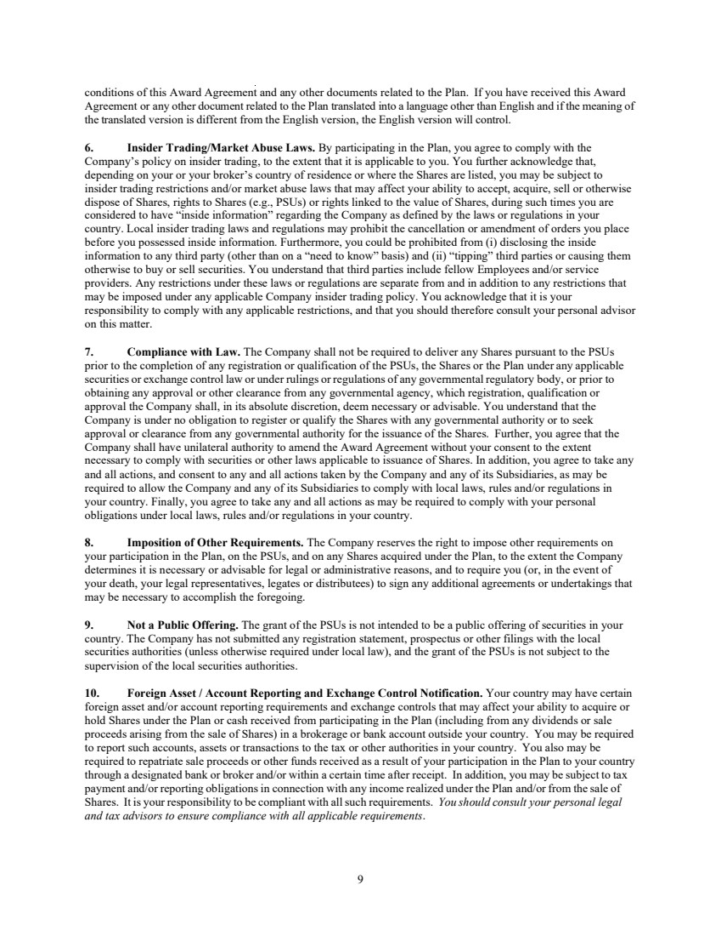 | 9 conditions of this Award Agreement and any other documents related to the Plan. If you have received this Award Agreement or any other document related to the Plan translated into a language other than English and if the meaning of the translated version is different from the English version, the English version will control. 6. Insider Trading/Market Abuse Laws. By participating in the Plan, you agree to comply with the Company’s policy on insider trading, to the extent that it is applicable to you. You further acknowledge that, depending on your or your broker’s country of residence or where the Shares are listed, you may be subject to insider trading restrictions and/or market abuse laws that may affect your ability to accept, acquire, sell or otherwise dispose of Shares, rights to Shares (e.g., PSUs) or rights linked to the value of Shares, during such times you are considered to have “inside information” regarding the Company as defined by the laws or regulations in your country. Local insider trading laws and regulations may prohibit the cancellation or amendment of orders you place before you possessed inside information. Furthermore, you could be prohibited from (i) disclosing the inside information to any third party (other than on a “need to know” basis) and (ii) “tipping” third parties or causing them otherwise to buy or sell securities. You understand that third parties include fellow Employees and/or service providers. Any restrictions under these laws or regulations are separate from and in addition to any restrictions that may be imposed under any applicable Company insider trading policy. You acknowledge that it is your responsibility to comply with any applicable restrictions, and that you should therefore consult your personal advisor on this matter. 7. Compliance with Law. The Company shall not be required to deliver any Shares pursuant to the PSUs prior to the completion of any registration or qualification of the PSUs, the Shares or the Plan under any applicable securities or exchange control law or under rulings or regulations of any governmental regulatory body, or prior to obtaining any approval or other clearance from any governmental agency, which registration, qualification or approval the Company shall, in its absolute discretion, deem necessary or advisable. You understand that the Company is under no obligation to register or qualify the Shares with any governmental authority or to seek approval or clearance from any governmental authority for the issuance of the Shares. Further, you agree that the Company shall have unilateral authority to amend the Award Agreement without your consent to the extent necessary to comply with securities or other laws applicable to issuance of Shares. In addition, you agree to take any and all actions, and consent to any and all actions taken by the Company and any of its Subsidiaries, as may be required to allow the Company and any of its Subsidiaries to comply with local laws, rules and/or regulations in your country. Finally, you agree to take any and all actions as may be required to comply with your personal obligations under local laws, rules and/or regulations in your country. 8. Imposition of Other Requirements. The Company reserves the right to impose other requirements on your participation in the Plan, on the PSUs, and on any Shares acquired under the Plan, to the extent the Company determines it is necessary or advisable for legal or administrative reasons, and to require you (or, in the event of your death, your legal representatives, legates or distributees) to sign any additional agreements or undertakings that may be necessary to accomplish the foregoing. 9. Not a Public Offering. The grant of the PSUs is not intended to be a public offering of securities in your country. The Company has not submitted any registration statement, prospectus or other filings with the local securities authorities (unless otherwise required under local law), and the grant of the PSUs is not subject to the supervision of the local securities authorities. 10. Foreign Asset / Account Reporting and Exchange Control Notification. Your country may have certain foreign asset and/or account reporting requirements and exchange controls that may affect your ability to acquire or hold Shares under the Plan or cash received from participating in the Plan (including from any dividends or sale proceeds arising from the sale of Shares) in a brokerage or bank account outside your country. You may be required to report such accounts, assets or transactions to the tax or other authorities in your country. You also may be required to repatriate sale proceeds or other funds received as a result of your participation in the Plan to your country through a designated bank or broker and/or within a certain time after receipt. In addition, you may be subject to tax payment and/or reporting obligations in connection with any income realized under the Plan and/or from the sale of Shares. It is your responsibility to be compliant with all such requirements. You should consult your personal legal and tax advisors to ensure compliance with all applicable requirements.
 | 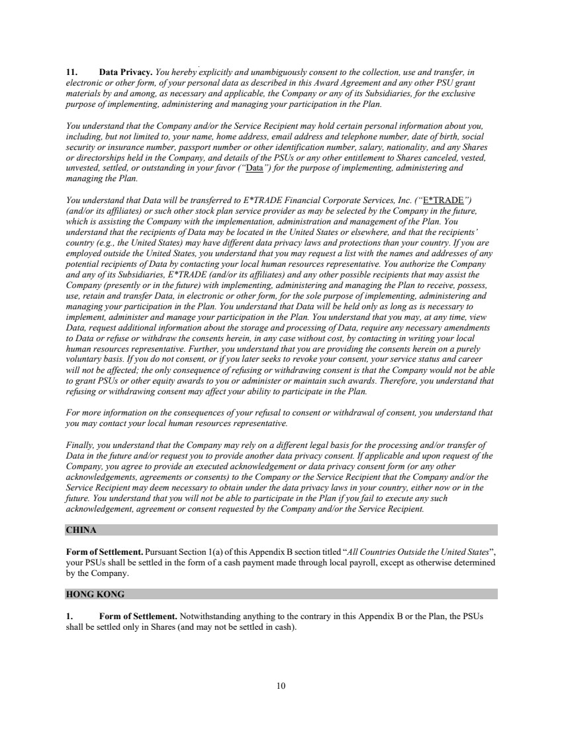 | 10 11. Data Privacy. You hereby explicitly and unambiguously consent to the collection, use and transfer, in electronic or other form, of your personal data as described in this Award Agreement and any other PSU grant materials by and among, as necessary and applicable, the Company or any of its Subsidiaries, for the exclusive purpose of implementing, administering and managing your participation in the Plan. You understand that the Company and/or the Service Recipient may hold certain personal information about you, including, but not limited to, your name, home address, email address and telephone number, date of birth, social security or insurance number, passport number or other identification number, salary, nationality, and any Shares or directorships held in the Company, and details of the PSUs or any other entitlement to Shares canceled, vested, unvested, settled, or outstanding in your favor (“Data”) for the purpose of implementing, administering and managing the Plan. You understand that Data will be transferred to E*TRADE Financial Corporate Services, Inc. (“E*TRADE”) (and/or its affiliates) or such other stock plan service provider as may be selected by the Company in the future, which is assisting the Company with the implementation, administration and management of the Plan. You understand that the recipients of Data may be located in the United States or elsewhere, and that the recipients’ country (e.g., the United States) may have different data privacy laws and protections than your country. If you are employed outside the United States, you understand that you may request a list with the names and addresses of any potential recipients of Data by contacting your local human resources representative. You authorize the Company and any of its Subsidiaries, E*TRADE (and/or its affiliates) and any other possible recipients that may assist the Company (presently or in the future) with implementing, administering and managing the Plan to receive, possess, use, retain and transfer Data, in electronic or other form, for the sole purpose of implementing, administering and managing your participation in the Plan. You understand that Data will be held only as long as is necessary to implement, administer and manage your participation in the Plan. You understand that you may, at any time, view Data, request additional information about the storage and processing of Data, require any necessary amendments to Data or refuse or withdraw the consents herein, in any case without cost, by contacting in writing your local human resources representative. Further, you understand that you are providing the consents herein on a purely voluntary basis. If you do not consent, or if you later seeks to revoke your consent, your service status and career will not be affected; the only consequence of refusing or withdrawing consent is that the Company would not be able to grant PSUs or other equity awards to you or administer or maintain such awards. Therefore, you understand that refusing or withdrawing consent may affect your ability to participate in the Plan. For more information on the consequences of your refusal to consent or withdrawal of consent, you understand that you may contact your local human resources representative. Finally, you understand that the Company may rely on a different legal basis for the processing and/or transfer of Data in the future and/or request you to provide another data privacy consent. If applicable and upon request of the Company, you agree to provide an executed acknowledgement or data privacy consent form (or any other acknowledgements, agreements or consents) to the Company or the Service Recipient that the Company and/or the Service Recipient may deem necessary to obtain under the data privacy laws in your country, either now or in the future. You understand that you will not be able to participate in the Plan if you fail to execute any such acknowledgement, agreement or consent requested by the Company and/or the Service Recipient. CHINA Form of Settlement. Pursuant Section 1(a) of this Appendix B section titled “All Countries Outside the United States”, your PSUs shall be settled in the form of a cash payment made through local payroll, except as otherwise determined by the Company. HONG KONG 1. Form of Settlement. Notwithstanding anything to the contrary in this Appendix B or the Plan, the PSUs shall be settled only in Shares (and may not be settled in cash).
 | 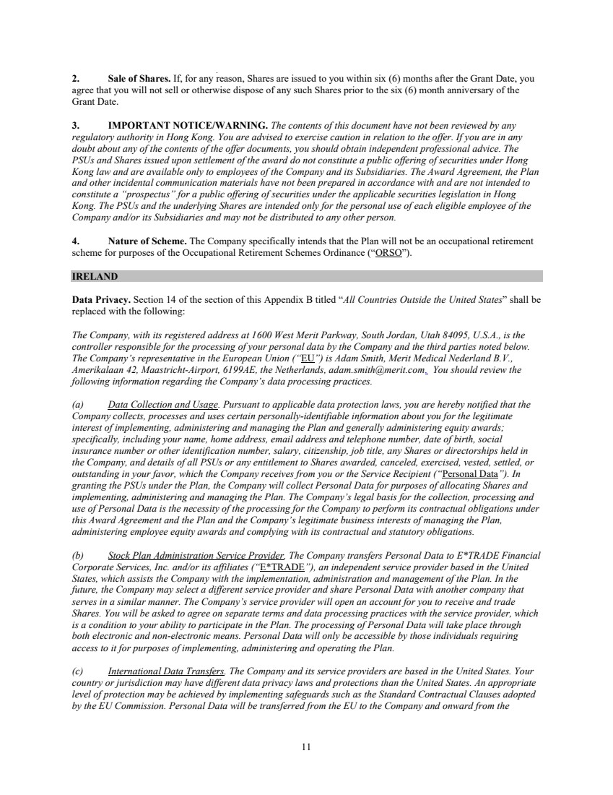 | 11 2. Sale of Shares. If, for any reason, Shares are issued to you within six (6) months after the Grant Date, you agree that you will not sell or otherwise dispose of any such Shares prior to the six (6) month anniversary of the Grant Date. 3. IMPORTANT NOTICE/WARNING. The contents of this document have not been reviewed by any regulatory authority in Hong Kong. You are advised to exercise caution in relation to the offer. If you are in any doubt about any of the contents of the offer documents, you should obtain independent professional advice. The PSUs and Shares issued upon settlement of the award do not constitute a public offering of securities under Hong Kong law and are available only to employees of the Company and its Subsidiaries. The Award Agreement, the Plan and other incidental communication materials have not been prepared in accordance with and are not intended to constitute a “prospectus” for a public offering of securities under the applicable securities legislation in Hong Kong. The PSUs and the underlying Shares are intended only for the personal use of each eligible employee of the Company and/or its Subsidiaries and may not be distributed to any other person. 4. Nature of Scheme. The Company specifically intends that the Plan will not be an occupational retirement scheme for purposes of the Occupational Retirement Schemes Ordinance (“ORSO”). IRELAND Data Privacy. Section 14 of the section of this Appendix B titled “All Countries Outside the United States” shall be replaced with the following: The Company, with its registered address at 1600 West Merit Parkway, South Jordan, Utah 84095, U.S.A., is the controller responsible for the processing of your personal data by the Company and the third parties noted below. The Company’s representative in the European Union (“EU”) is Adam Smith, Merit Medical Nederland B.V., Amerikalaan 42, Maastricht-Airport, 6199AE, the Netherlands, adam.smith@merit.com. You should review the following information regarding the Company’s data processing practices. (a) Data Collection and Usage. Pursuant to applicable data protection laws, you are hereby notified that the Company collects, processes and uses certain personally-identifiable information about you for the legitimate interest of implementing, administering and managing the Plan and generally administering equity awards; specifically, including your name, home address, email address and telephone number, date of birth, social insurance number or other identification number, salary, citizenship, job title, any Shares or directorships held in the Company, and details of all PSUs or any entitlement to Shares awarded, canceled, exercised, vested, settled, or outstanding in your favor, which the Company receives from you or the Service Recipient (“Personal Data”). In granting the PSUs under the Plan, the Company will collect Personal Data for purposes of allocating Shares and implementing, administering and managing the Plan. The Company’s legal basis for the collection, processing and use of Personal Data is the necessity of the processing for the Company to perform its contractual obligations under this Award Agreement and the Plan and the Company’s legitimate business interests of managing the Plan, administering employee equity awards and complying with its contractual and statutory obligations. (b) Stock Plan Administration Service Provider. The Company transfers Personal Data to E*TRADE Financial Corporate Services, Inc. and/or its affiliates (“E*TRADE”), an independent service provider based in the United States, which assists the Company with the implementation, administration and management of the Plan. In the future, the Company may select a different service provider and share Personal Data with another company that serves in a similar manner. The Company’s service provider will open an account for you to receive and trade Shares. You will be asked to agree on separate terms and data processing practices with the service provider, which is a condition to your ability to participate in the Plan. The processing of Personal Data will take place through both electronic and non-electronic means. Personal Data will only be accessible by those individuals requiring access to it for purposes of implementing, administering and operating the Plan. (c) International Data Transfers. The Company and its service providers are based in the United States. Your country or jurisdiction may have different data privacy laws and protections than the United States. An appropriate level of protection may be achieved by implementing safeguards such as the Standard Contractual Clauses adopted by the EU Commission. Personal Data will be transferred from the EU to the Company and onward from the
 | 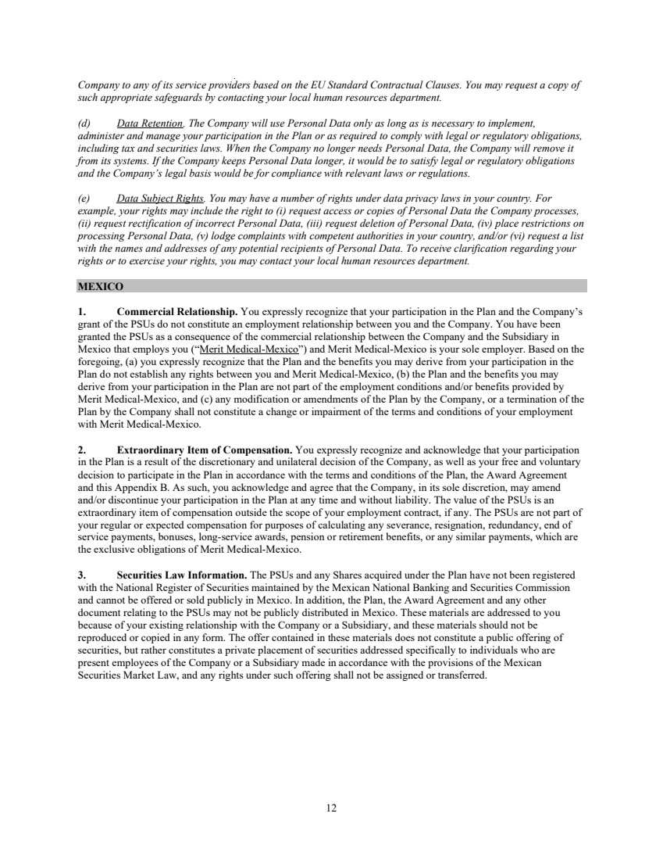 | 12 Company to any of its service providers based on the EU Standard Contractual Clauses. You may request a copy of such appropriate safeguards by contacting your local human resources department. (d) Data Retention. The Company will use Personal Data only as long as is necessary to implement, administer and manage your participation in the Plan or as required to comply with legal or regulatory obligations, including tax and securities laws. When the Company no longer needs Personal Data, the Company will remove it from its systems. If the Company keeps Personal Data longer, it would be to satisfy legal or regulatory obligations and the Company’s legal basis would be for compliance with relevant laws or regulations. (e) Data Subject Rights. You may have a number of rights under data privacy laws in your country. For example, your rights may include the right to (i) request access or copies of Personal Data the Company processes, (ii) request rectification of incorrect Personal Data, (iii) request deletion of Personal Data, (iv) place restrictions on processing Personal Data, (v) lodge complaints with competent authorities in your country, and/or (vi) request a list with the names and addresses of any potential recipients of Personal Data. To receive clarification regarding your rights or to exercise your rights, you may contact your local human resources department. MEXICO 1. Commercial Relationship. You expressly recognize that your participation in the Plan and the Company’s grant of the PSUs do not constitute an employment relationship between you and the Company. You have been granted the PSUs as a consequence of the commercial relationship between the Company and the Subsidiary in Mexico that employs you (“Merit Medical-Mexico”) and Merit Medical-Mexico is your sole employer. Based on the foregoing, (a) you expressly recognize that the Plan and the benefits you may derive from your participation in the Plan do not establish any rights between you and Merit Medical-Mexico, (b) the Plan and the benefits you may derive from your participation in the Plan are not part of the employment conditions and/or benefits provided by Merit Medical-Mexico, and (c) any modification or amendments of the Plan by the Company, or a termination of the Plan by the Company shall not constitute a change or impairment of the terms and conditions of your employment with Merit Medical-Mexico. 2. Extraordinary Item of Compensation. You expressly recognize and acknowledge that your participation in the Plan is a result of the discretionary and unilateral decision of the Company, as well as your free and voluntary decision to participate in the Plan in accordance with the terms and conditions of the Plan, the Award Agreement and this Appendix B. As such, you acknowledge and agree that the Company, in its sole discretion, may amend and/or discontinue your participation in the Plan at any time and without liability. The value of the PSUs is an extraordinary item of compensation outside the scope of your employment contract, if any. The PSUs are not part of your regular or expected compensation for purposes of calculating any severance, resignation, redundancy, end of service payments, bonuses, long-service awards, pension or retirement benefits, or any similar payments, which are the exclusive obligations of Merit Medical-Mexico. 3. Securities Law Information. The PSUs and any Shares acquired under the Plan have not been registered with the National Register of Securities maintained by the Mexican National Banking and Securities Commission and cannot be offered or sold publicly in Mexico. In addition, the Plan, the Award Agreement and any other document relating to the PSUs may not be publicly distributed in Mexico. These materials are addressed to you because of your existing relationship with the Company or a Subsidiary, and these materials should not be reproduced or copied in any form. The offer contained in these materials does not constitute a public offering of securities, but rather constitutes a private placement of securities addressed specifically to individuals who are present employees of the Company or a Subsidiary made in accordance with the provisions of the Mexican Securities Market Law, and any rights under such offering shall not be assigned or transferred.
Exhibit 10.72
 | 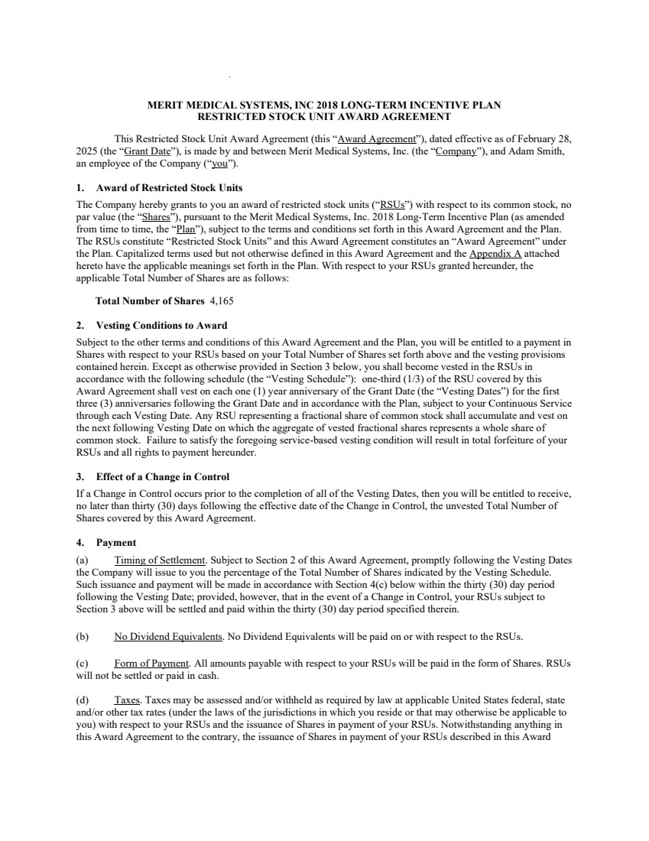 | MERIT MEDICAL SYSTEMS, INC 2018 LONG-TERM INCENTIVE PLAN RESTRICTED STOCK UNIT AWARD AGREEMENT This Restricted Stock Unit Award Agreement (this “Award Agreement”), dated effective as of February 28, 2025 (the “Grant Date”), is made by and between Merit Medical Systems, Inc. (the “Company”), and Adam Smith, an employee of the Company (“you”). 1. Award of Restricted Stock Units The Company hereby grants to you an award of restricted stock units (“RSUs”) with respect to its common stock, no par value (the “Shares”), pursuant to the Merit Medical Systems, Inc. 2018 Long-Term Incentive Plan (as amended from time to time, the “Plan”), subject to the terms and conditions set forth in this Award Agreement and the Plan. The RSUs constitute “Restricted Stock Units” and this Award Agreement constitutes an “Award Agreement” under the Plan. Capitalized terms used but not otherwise defined in this Award Agreement and the Appendix A attached hereto have the applicable meanings set forth in the Plan. With respect to your RSUs granted hereunder, the applicable Total Number of Shares are as follows: Total Number of Shares 4,165 2. Vesting Conditions to Award Subject to the other terms and conditions of this Award Agreement and the Plan, you will be entitled to a payment in Shares with respect to your RSUs based on your Total Number of Shares set forth above and the vesting provisions contained herein. Except as otherwise provided in Section 3 below, you shall become vested in the RSUs in accordance with the following schedule (the “Vesting Schedule”): one-third (1/3) of the RSU covered by this Award Agreement shall vest on each one (1) year anniversary of the Grant Date (the “Vesting Dates”) for the first three (3) anniversaries following the Grant Date and in accordance with the Plan, subject to your Continuous Service through each Vesting Date. Any RSU representing a fractional share of common stock shall accumulate and vest on the next following Vesting Date on which the aggregate of vested fractional shares represents a whole share of common stock. Failure to satisfy the foregoing service-based vesting condition will result in total forfeiture of your RSUs and all rights to payment hereunder. 3. Effect of a Change in Control If a Change in Control occurs prior to the completion of all of the Vesting Dates, then you will be entitled to receive, no later than thirty (30) days following the effective date of the Change in Control, the unvested Total Number of Shares covered by this Award Agreement. 4. Payment (a) Timing of Settlement. Subject to Section 2 of this Award Agreement, promptly following the Vesting Dates the Company will issue to you the percentage of the Total Number of Shares indicated by the Vesting Schedule. Such issuance and payment will be made in accordance with Section 4(c) below within the thirty (30) day period following the Vesting Date; provided, however, that in the event of a Change in Control, your RSUs subject to Section 3 above will be settled and paid within the thirty (30) day period specified therein. (b) No Dividend Equivalents. No Dividend Equivalents will be paid on or with respect to the RSUs. (c) Form of Payment. All amounts payable with respect to your RSUs will be paid in the form of Shares. RSUs will not be settled or paid in cash. (d) Taxes. Taxes may be assessed and/or withheld as required by law at applicable United States federal, state and/or other tax rates (under the laws of the jurisdictions in which you reside or that may otherwise be applicable to you) with respect to your RSUs and the issuance of Shares in payment of your RSUs. Notwithstanding anything in this Award Agreement to the contrary, the issuance of Shares in payment of your RSUs described in this Award
 | 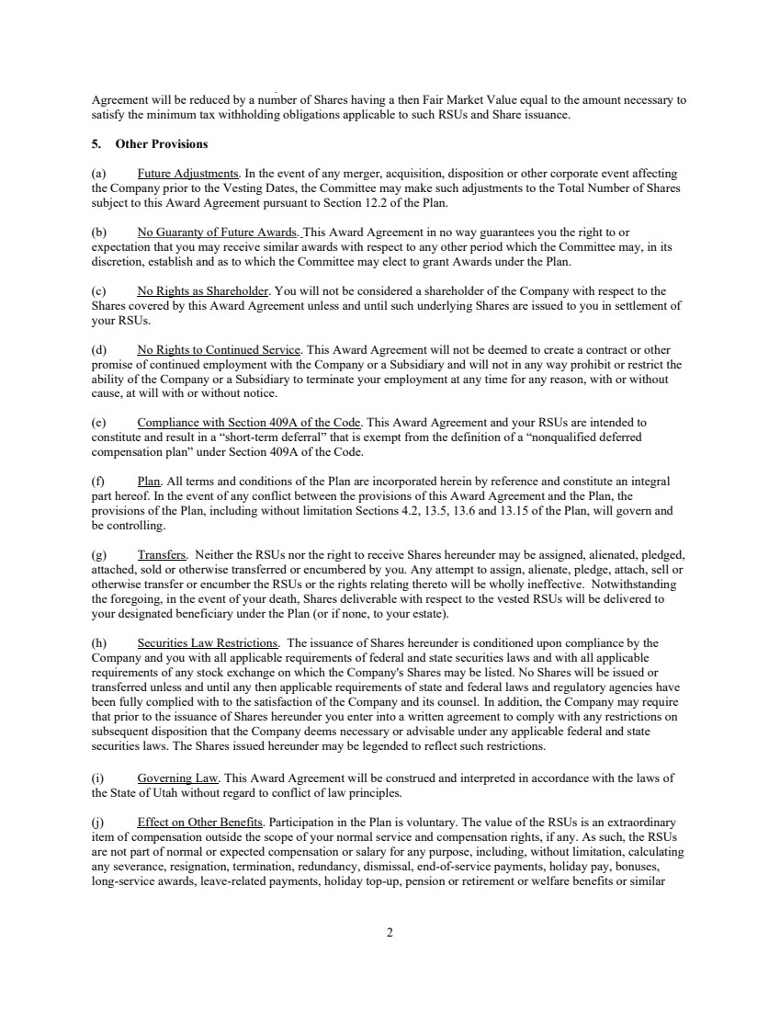 | 2 Agreement will be reduced by a number of Shares having a then Fair Market Value equal to the amount necessary to satisfy the minimum tax withholding obligations applicable to such RSUs and Share issuance. 5. Other Provisions (a) Future Adjustments. In the event of any merger, acquisition, disposition or other corporate event affecting the Company prior to the Vesting Dates, the Committee may make such adjustments to the Total Number of Shares subject to this Award Agreement pursuant to Section 12.2 of the Plan. (b) No Guaranty of Future Awards. This Award Agreement in no way guarantees you the right to or expectation that you may receive similar awards with respect to any other period which the Committee may, in its discretion, establish and as to which the Committee may elect to grant Awards under the Plan. (c) No Rights as Shareholder. You will not be considered a shareholder of the Company with respect to the Shares covered by this Award Agreement unless and until such underlying Shares are issued to you in settlement of your RSUs. (d) No Rights to Continued Service. This Award Agreement will not be deemed to create a contract or other promise of continued employment with the Company or a Subsidiary and will not in any way prohibit or restrict the ability of the Company or a Subsidiary to terminate your employment at any time for any reason, with or without cause, at will with or without notice. (e) Compliance with Section 409A of the Code. This Award Agreement and your RSUs are intended to constitute and result in a “short-term deferral” that is exempt from the definition of a “nonqualified deferred compensation plan” under Section 409A of the Code. (f) Plan. All terms and conditions of the Plan are incorporated herein by reference and constitute an integral part hereof. In the event of any conflict between the provisions of this Award Agreement and the Plan, the provisions of the Plan, including without limitation Sections 4.2, 13.5, 13.6 and 13.15 of the Plan, will govern and be controlling. (g) Transfers. Neither the RSUs nor the right to receive Shares hereunder may be assigned, alienated, pledged, attached, sold or otherwise transferred or encumbered by you. Any attempt to assign, alienate, pledge, attach, sell or otherwise transfer or encumber the RSUs or the rights relating thereto will be wholly ineffective. Notwithstanding the foregoing, in the event of your death, Shares deliverable with respect to the vested RSUs will be delivered to your designated beneficiary under the Plan (or if none, to your estate). (h) Securities Law Restrictions. The issuance of Shares hereunder is conditioned upon compliance by the Company and you with all applicable requirements of federal and state securities laws and with all applicable requirements of any stock exchange on which the Company's Shares may be listed. No Shares will be issued or transferred unless and until any then applicable requirements of state and federal laws and regulatory agencies have been fully complied with to the satisfaction of the Company and its counsel. In addition, the Company may require that prior to the issuance of Shares hereunder you enter into a written agreement to comply with any restrictions on subsequent disposition that the Company deems necessary or advisable under any applicable federal and state securities laws. The Shares issued hereunder may be legended to reflect such restrictions. (i) Governing Law. This Award Agreement will be construed and interpreted in accordance with the laws of the State of Utah without regard to conflict of law principles. (j) Effect on Other Benefits. Participation in the Plan is voluntary. The value of the RSUs is an extraordinary item of compensation outside the scope of your normal service and compensation rights, if any. As such, the RSUs are not part of normal or expected compensation or salary for any purpose, including, without limitation, calculating any severance, resignation, termination, redundancy, dismissal, end-of-service payments, holiday pay, bonuses, long-service awards, leave-related payments, holiday top-up, pension or retirement or welfare benefits or similar
 | 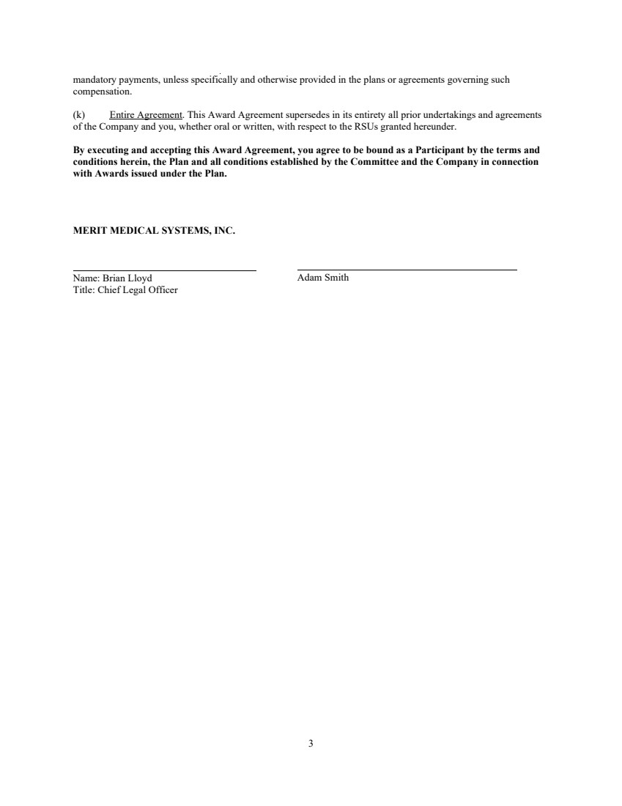 | 3 mandatory payments, unless specifically and otherwise provided in the plans or agreements governing such compensation. (k) Entire Agreement. This Award Agreement supersedes in its entirety all prior undertakings and agreements of the Company and you, whether oral or written, with respect to the RSUs granted hereunder. By executing and accepting this Award Agreement, you agree to be bound as a Participant by the terms and conditions herein, the Plan and all conditions established by the Committee and the Company in connection with Awards issued under the Plan. MERIT MEDICAL SYSTEMS, INC. Name: Brian Lloyd Title: Chief Legal Officer Adam Smith
 | 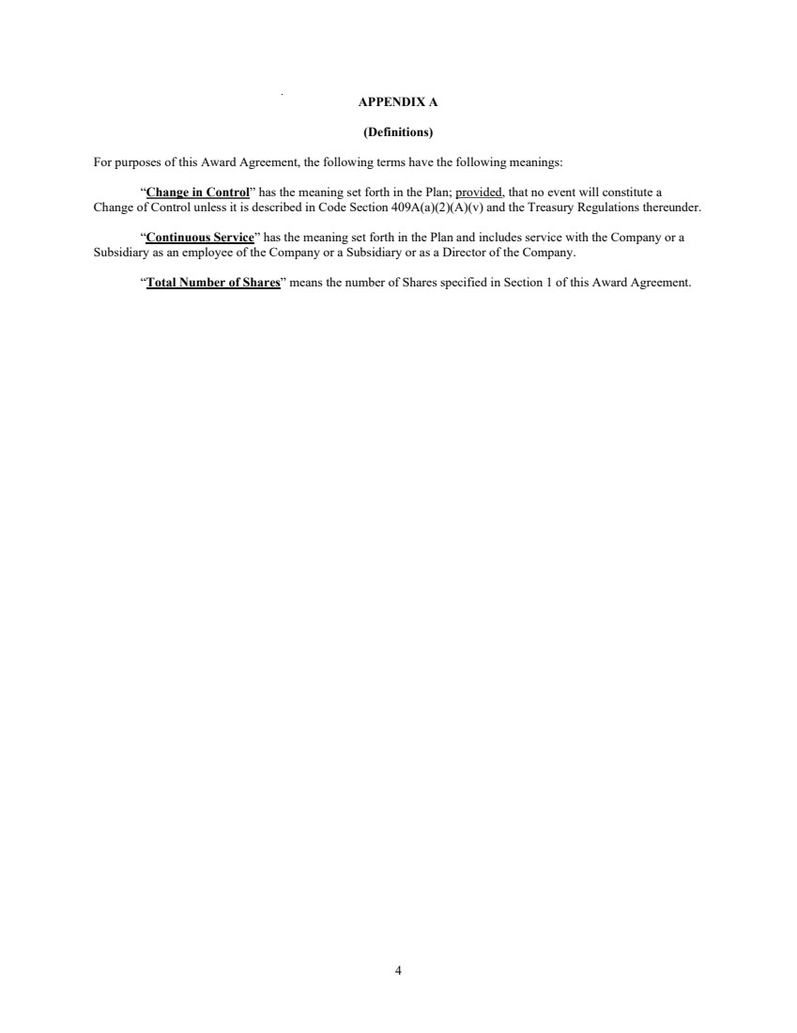 | 4 APPENDIX A (Definitions) For purposes of this Award Agreement, the following terms have the following meanings: “Change in Control” has the meaning set forth in the Plan; provided, that no event will constitute a Change of Control unless it is described in Code Section 409A(a)(2)(A)(v) and the Treasury Regulations thereunder. “Continuous Service” has the meaning set forth in the Plan and includes service with the Company or a Subsidiary as an employee of the Company or a Subsidiary or as a Director of the Company. “Total Number of Shares” means the number of Shares specified in Section 1 of this Award Agreement.
 | 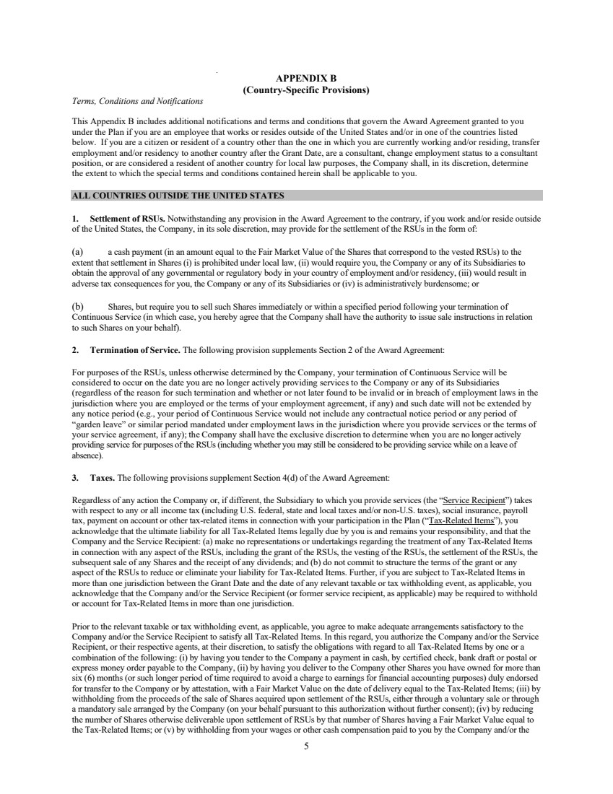 | 5 APPENDIX B (Country-Specific Provisions) Terms, Conditions and Notifications This Appendix B includes additional notifications and terms and conditions that govern the Award Agreement granted to you under the Plan if you are an employee that works or resides outside of the United States and/or in one of the countries listed below. If you are a citizen or resident of a country other than the one in which you are currently working and/or residing, transfer employment and/or residency to another country after the Grant Date, are a consultant, change employment status to a consultant position, or are considered a resident of another country for local law purposes, the Company shall, in its discretion, determine the extent to which the special terms and conditions contained herein shall be applicable to you. ALL COUNTRIES OUTSIDE THE UNITED STATES 1. Settlement of RSUs. Notwithstanding any provision in the Award Agreement to the contrary, if you work and/or reside outside of the United States, the Company, in its sole discretion, may provide for the settlement of the RSUs in the form of: (a) a cash payment (in an amount equal to the Fair Market Value of the Shares that correspond to the vested RSUs) to the extent that settlement in Shares (i) is prohibited under local law, (ii) would require you, the Company or any of its Subsidiaries to obtain the approval of any governmental or regulatory body in your country of employment and/or residency, (iii) would result in adverse tax consequences for you, the Company or any of its Subsidiaries or (iv) is administratively burdensome; or (b) Shares, but require you to sell such Shares immediately or within a specified period following your termination of Continuous Service (in which case, you hereby agree that the Company shall have the authority to issue sale instructions in relation to such Shares on your behalf). 2. Termination of Service. The following provision supplements Section 2 of the Award Agreement: For purposes of the RSUs, unless otherwise determined by the Company, your termination of Continuous Service will be considered to occur on the date you are no longer actively providing services to the Company or any of its Subsidiaries (regardless of the reason for such termination and whether or not later found to be invalid or in breach of employment laws in the jurisdiction where you are employed or the terms of your employment agreement, if any) and such date will not be extended by any notice period (e.g., your period of Continuous Service would not include any contractual notice period or any period of “garden leave” or similar period mandated under employment laws in the jurisdiction where you provide services or the terms of your service agreement, if any); the Company shall have the exclusive discretion to determine when you are no longer actively providing service for purposes of the RSUs (including whether you may still be considered to be providing service while on a leave of absence). 3. Taxes. The following provisions supplement Section 4(d) of the Award Agreement: Regardless of any action the Company or, if different, the Subsidiary to which you provide services (the “Service Recipient”) takes with respect to any or all income tax (including U.S. federal, state and local taxes and/or non-U.S. taxes), social insurance, payroll tax, payment on account or other tax-related items in connection with your participation in the Plan (“Tax-Related Items”), you acknowledge that the ultimate liability for all Tax-Related Items legally due by you is and remains your responsibility, and that the Company and the Service Recipient: (a) make no representations or undertakings regarding the treatment of any Tax-Related Items in connection with any aspect of the RSUs, including the grant of the RSUs, the vesting of the RSUs, the settlement of the RSUs, the subsequent sale of any Shares and the receipt of any dividends; and (b) do not commit to structure the terms of the grant or any aspect of the RSUs to reduce or eliminate your liability for Tax-Related Items. Further, if you are subject to Tax-Related Items in more than one jurisdiction between the Grant Date and the date of any relevant taxable or tax withholding event, as applicable, you acknowledge that the Company and/or the Service Recipient (or former service recipient, as applicable) may be required to withhold or account for Tax-Related Items in more than one jurisdiction. Prior to the relevant taxable or tax withholding event, as applicable, you agree to make adequate arrangements satisfactory to the Company and/or the Service Recipient to satisfy all Tax-Related Items. In this regard, you authorize the Company and/or the Service Recipient, or their respective agents, at their discretion, to satisfy the obligations with regard to all Tax-Related Items by one or a combination of the following: (i) by having you tender to the Company a payment in cash, by certified check, bank draft or postal or express money order payable to the Company, (ii) by having you deliver to the Company other Shares you have owned for more than six (6) months (or such longer period of time required to avoid a charge to earnings for financial accounting purposes) duly endorsed for transfer to the Company or by attestation, with a Fair Market Value on the date of delivery equal to the Tax-Related Items; (iii) by withholding from the proceeds of the sale of Shares acquired upon settlement of the RSUs, either through a voluntary sale or through a mandatory sale arranged by the Company (on your behalf pursuant to this authorization without further consent); (iv) by reducing the number of Shares otherwise deliverable upon settlement of RSUs by that number of Shares having a Fair Market Value equal to the Tax-Related Items; or (v) by withholding from your wages or other cash compensation paid to you by the Company and/or the
 | 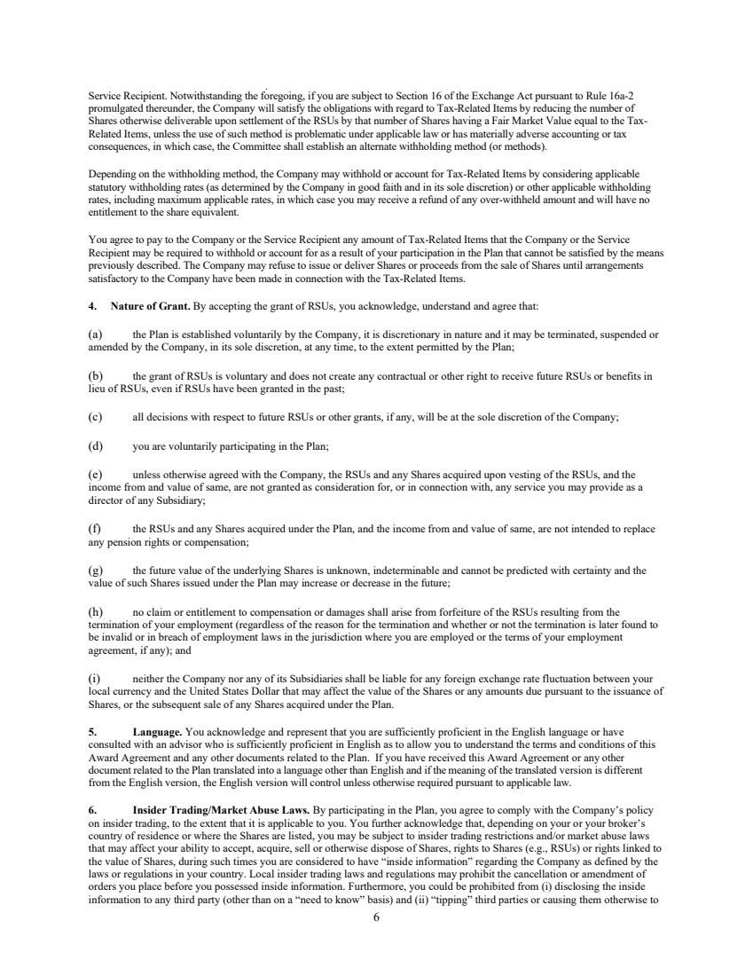 | 6 Service Recipient. Notwithstanding the foregoing, if you are subject to Section 16 of the Exchange Act pursuant to Rule 16a-2 promulgated thereunder, the Company will satisfy the obligations with regard to Tax-Related Items by reducing the number of Shares otherwise deliverable upon settlement of the RSUs by that number of Shares having a Fair Market Value equal to the Tax-Related Items, unless the use of such method is problematic under applicable law or has materially adverse accounting or tax consequences, in which case, the Committee shall establish an alternate withholding method (or methods). Depending on the withholding method, the Company may withhold or account for Tax-Related Items by considering applicable statutory withholding rates (as determined by the Company in good faith and in its sole discretion) or other applicable withholding rates, including maximum applicable rates, in which case you may receive a refund of any over-withheld amount and will have no entitlement to the share equivalent. You agree to pay to the Company or the Service Recipient any amount of Tax-Related Items that the Company or the Service Recipient may be required to withhold or account for as a result of your participation in the Plan that cannot be satisfied by the means previously described. The Company may refuse to issue or deliver Shares or proceeds from the sale of Shares until arrangements satisfactory to the Company have been made in connection with the Tax-Related Items. 4. Nature of Grant. By accepting the grant of RSUs, you acknowledge, understand and agree that: (a) the Plan is established voluntarily by the Company, it is discretionary in nature and it may be terminated, suspended or amended by the Company, in its sole discretion, at any time, to the extent permitted by the Plan; (b) the grant of RSUs is voluntary and does not create any contractual or other right to receive future RSUs or benefits in lieu of RSUs, even if RSUs have been granted in the past; (c) all decisions with respect to future RSUs or other grants, if any, will be at the sole discretion of the Company; (d) you are voluntarily participating in the Plan; (e) unless otherwise agreed with the Company, the RSUs and any Shares acquired upon vesting of the RSUs, and the income from and value of same, are not granted as consideration for, or in connection with, any service you may provide as a director of any Subsidiary; (f) the RSUs and any Shares acquired under the Plan, and the income from and value of same, are not intended to replace any pension rights or compensation; (g) the future value of the underlying Shares is unknown, indeterminable and cannot be predicted with certainty and the value of such Shares issued under the Plan may increase or decrease in the future; (h) no claim or entitlement to compensation or damages shall arise from forfeiture of the RSUs resulting from the termination of your employment (regardless of the reason for the termination and whether or not the termination is later found to be invalid or in breach of employment laws in the jurisdiction where you are employed or the terms of your employment agreement, if any); and (i) neither the Company nor any of its Subsidiaries shall be liable for any foreign exchange rate fluctuation between your local currency and the United States Dollar that may affect the value of the Shares or any amounts due pursuant to the issuance of Shares, or the subsequent sale of any Shares acquired under the Plan. 5. Language. You acknowledge and represent that you are sufficiently proficient in the English language or have consulted with an advisor who is sufficiently proficient in English as to allow you to understand the terms and conditions of this Award Agreement and any other documents related to the Plan. If you have received this Award Agreement or any other document related to the Plan translated into a language other than English and if the meaning of the translated version is different from the English version, the English version will control unless otherwise required pursuant to applicable law. 6. Insider Trading/Market Abuse Laws. By participating in the Plan, you agree to comply with the Company’s policy on insider trading, to the extent that it is applicable to you. You further acknowledge that, depending on your or your broker’s country of residence or where the Shares are listed, you may be subject to insider trading restrictions and/or market abuse laws that may affect your ability to accept, acquire, sell or otherwise dispose of Shares, rights to Shares (e.g., RSUs) or rights linked to the value of Shares, during such times you are considered to have “inside information” regarding the Company as defined by the laws or regulations in your country. Local insider trading laws and regulations may prohibit the cancellation or amendment of orders you place before you possessed inside information. Furthermore, you could be prohibited from (i) disclosing the inside information to any third party (other than on a “need to know” basis) and (ii) “tipping” third parties or causing them otherwise to
 | 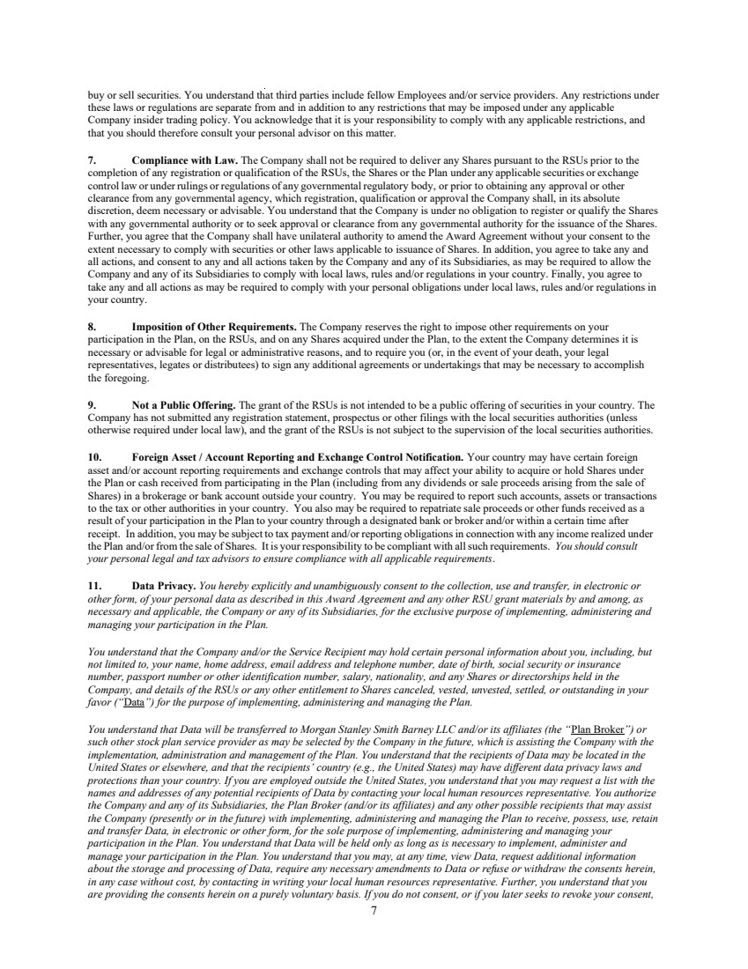 | 7 buy or sell securities. You understand that third parties include fellow Employees and/or service providers. Any restrictions under these laws or regulations are separate from and in addition to any restrictions that may be imposed under any applicable Company insider trading policy. You acknowledge that it is your responsibility to comply with any applicable restrictions, and that you should therefore consult your personal advisor on this matter. 7. Compliance with Law. The Company shall not be required to deliver any Shares pursuant to the RSUs prior to the completion of any registration or qualification of the RSUs, the Shares or the Plan under any applicable securities or exchange control law or under rulings or regulations of any governmental regulatory body, or prior to obtaining any approval or other clearance from any governmental agency, which registration, qualification or approval the Company shall, in its absolute discretion, deem necessary or advisable. You understand that the Company is under no obligation to register or qualify the Shares with any governmental authority or to seek approval or clearance from any governmental authority for the issuance of the Shares. Further, you agree that the Company shall have unilateral authority to amend the Award Agreement without your consent to the extent necessary to comply with securities or other laws applicable to issuance of Shares. In addition, you agree to take any and all actions, and consent to any and all actions taken by the Company and any of its Subsidiaries, as may be required to allow the Company and any of its Subsidiaries to comply with local laws, rules and/or regulations in your country. Finally, you agree to take any and all actions as may be required to comply with your personal obligations under local laws, rules and/or regulations in your country. 8. Imposition of Other Requirements. The Company reserves the right to impose other requirements on your participation in the Plan, on the RSUs, and on any Shares acquired under the Plan, to the extent the Company determines it is necessary or advisable for legal or administrative reasons, and to require you (or, in the event of your death, your legal representatives, legates or distributees) to sign any additional agreements or undertakings that may be necessary to accomplish the foregoing. 9. Not a Public Offering. The grant of the RSUs is not intended to be a public offering of securities in your country. The Company has not submitted any registration statement, prospectus or other filings with the local securities authorities (unless otherwise required under local law), and the grant of the RSUs is not subject to the supervision of the local securities authorities. 10. Foreign Asset / Account Reporting and Exchange Control Notification. Your country may have certain foreign asset and/or account reporting requirements and exchange controls that may affect your ability to acquire or hold Shares under the Plan or cash received from participating in the Plan (including from any dividends or sale proceeds arising from the sale of Shares) in a brokerage or bank account outside your country. You may be required to report such accounts, assets or transactions to the tax or other authorities in your country. You also may be required to repatriate sale proceeds or other funds received as a result of your participation in the Plan to your country through a designated bank or broker and/or within a certain time after receipt. In addition, you may be subject to tax payment and/or reporting obligations in connection with any income realized under the Plan and/or from the sale of Shares. It is your responsibility to be compliant with all such requirements. You should consult your personal legal and tax advisors to ensure compliance with all applicable requirements. 11. Data Privacy. You hereby explicitly and unambiguously consent to the collection, use and transfer, in electronic or other form, of your personal data as described in this Award Agreement and any other RSU grant materials by and among, as necessary and applicable, the Company or any of its Subsidiaries, for the exclusive purpose of implementing, administering and managing your participation in the Plan. You understand that the Company and/or the Service Recipient may hold certain personal information about you, including, but not limited to, your name, home address, email address and telephone number, date of birth, social security or insurance number, passport number or other identification number, salary, nationality, and any Shares or directorships held in the Company, and details of the RSUs or any other entitlement to Shares canceled, vested, unvested, settled, or outstanding in your favor (“Data”) for the purpose of implementing, administering and managing the Plan. You understand that Data will be transferred to Morgan Stanley Smith Barney LLC and/or its affiliates (the “Plan Broker”) or such other stock plan service provider as may be selected by the Company in the future, which is assisting the Company with the implementation, administration and management of the Plan. You understand that the recipients of Data may be located in the United States or elsewhere, and that the recipients’ country (e.g., the United States) may have different data privacy laws and protections than your country. If you are employed outside the United States, you understand that you may request a list with the names and addresses of any potential recipients of Data by contacting your local human resources representative. You authorize the Company and any of its Subsidiaries, the Plan Broker (and/or its affiliates) and any other possible recipients that may assist the Company (presently or in the future) with implementing, administering and managing the Plan to receive, possess, use, retain and transfer Data, in electronic or other form, for the sole purpose of implementing, administering and managing your participation in the Plan. You understand that Data will be held only as long as is necessary to implement, administer and manage your participation in the Plan. You understand that you may, at any time, view Data, request additional information about the storage and processing of Data, require any necessary amendments to Data or refuse or withdraw the consents herein, in any case without cost, by contacting in writing your local human resources representative. Further, you understand that you are providing the consents herein on a purely voluntary basis. If you do not consent, or if you later seeks to revoke your consent,
 | 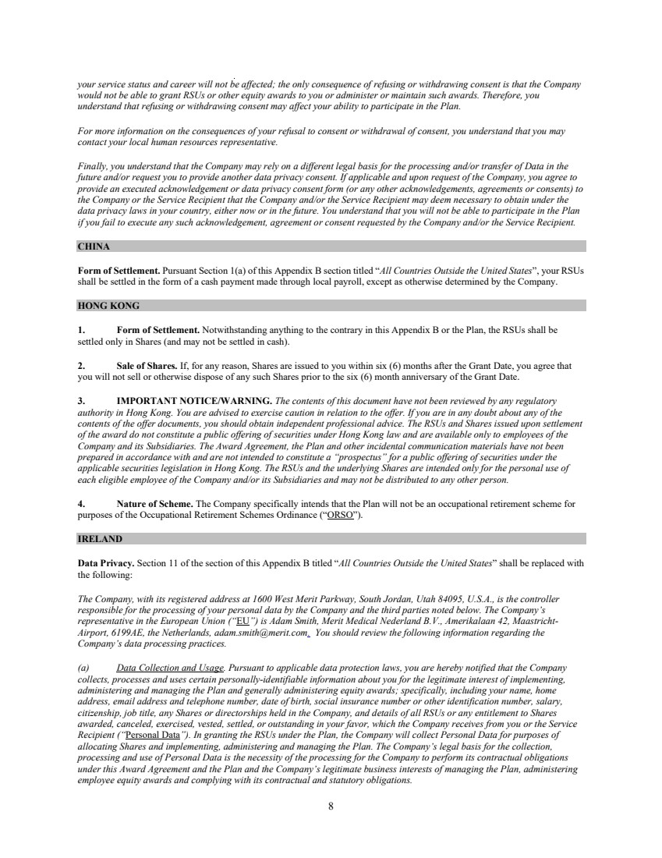 | 8 your service status and career will not be affected; the only consequence of refusing or withdrawing consent is that the Company would not be able to grant RSUs or other equity awards to you or administer or maintain such awards. Therefore, you understand that refusing or withdrawing consent may affect your ability to participate in the Plan. For more information on the consequences of your refusal to consent or withdrawal of consent, you understand that you may contact your local human resources representative. Finally, you understand that the Company may rely on a different legal basis for the processing and/or transfer of Data in the future and/or request you to provide another data privacy consent. If applicable and upon request of the Company, you agree to provide an executed acknowledgement or data privacy consent form (or any other acknowledgements, agreements or consents) to the Company or the Service Recipient that the Company and/or the Service Recipient may deem necessary to obtain under the data privacy laws in your country, either now or in the future. You understand that you will not be able to participate in the Plan if you fail to execute any such acknowledgement, agreement or consent requested by the Company and/or the Service Recipient. CHINA Form of Settlement. Pursuant Section 1(a) of this Appendix B section titled “All Countries Outside the United States”, your RSUs shall be settled in the form of a cash payment made through local payroll, except as otherwise determined by the Company. HONG KONG 1. Form of Settlement. Notwithstanding anything to the contrary in this Appendix B or the Plan, the RSUs shall be settled only in Shares (and may not be settled in cash). 2. Sale of Shares. If, for any reason, Shares are issued to you within six (6) months after the Grant Date, you agree that you will not sell or otherwise dispose of any such Shares prior to the six (6) month anniversary of the Grant Date. 3. IMPORTANT NOTICE/WARNING. The contents of this document have not been reviewed by any regulatory authority in Hong Kong. You are advised to exercise caution in relation to the offer. If you are in any doubt about any of the contents of the offer documents, you should obtain independent professional advice. The RSUs and Shares issued upon settlement of the award do not constitute a public offering of securities under Hong Kong law and are available only to employees of the Company and its Subsidiaries. The Award Agreement, the Plan and other incidental communication materials have not been prepared in accordance with and are not intended to constitute a “prospectus” for a public offering of securities under the applicable securities legislation in Hong Kong. The RSUs and the underlying Shares are intended only for the personal use of each eligible employee of the Company and/or its Subsidiaries and may not be distributed to any other person. 4. Nature of Scheme. The Company specifically intends that the Plan will not be an occupational retirement scheme for purposes of the Occupational Retirement Schemes Ordinance (“ORSO”). IRELAND Data Privacy. Section 11 of the section of this Appendix B titled “All Countries Outside the United States” shall be replaced with the following: The Company, with its registered address at 1600 West Merit Parkway, South Jordan, Utah 84095, U.S.A., is the controller responsible for the processing of your personal data by the Company and the third parties noted below. The Company’s representative in the European Union (“EU”) is Adam Smith, Merit Medical Nederland B.V., Amerikalaan 42, Maastricht-Airport, 6199AE, the Netherlands, adam.smith@merit.com. You should review the following information regarding the Company’s data processing practices. (a) Data Collection and Usage. Pursuant to applicable data protection laws, you are hereby notified that the Company collects, processes and uses certain personally-identifiable information about you for the legitimate interest of implementing, administering and managing the Plan and generally administering equity awards; specifically, including your name, home address, email address and telephone number, date of birth, social insurance number or other identification number, salary, citizenship, job title, any Shares or directorships held in the Company, and details of all RSUs or any entitlement to Shares awarded, canceled, exercised, vested, settled, or outstanding in your favor, which the Company receives from you or the Service Recipient (“Personal Data”). In granting the RSUs under the Plan, the Company will collect Personal Data for purposes of allocating Shares and implementing, administering and managing the Plan. The Company’s legal basis for the collection, processing and use of Personal Data is the necessity of the processing for the Company to perform its contractual obligations under this Award Agreement and the Plan and the Company’s legitimate business interests of managing the Plan, administering employee equity awards and complying with its contractual and statutory obligations.
 | 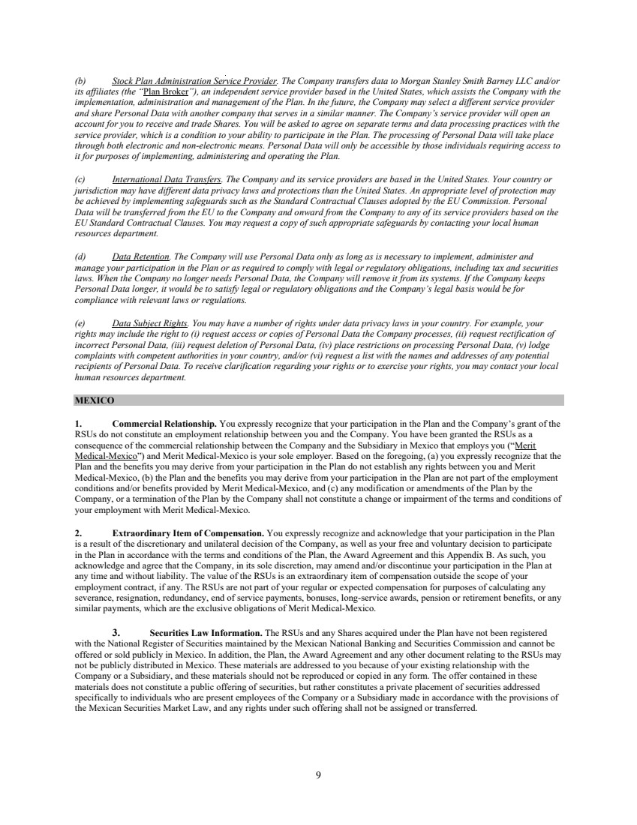 | 9 (b) Stock Plan Administration Service Provider. The Company transfers data to Morgan Stanley Smith Barney LLC and/or its affiliates (the “Plan Broker”), an independent service provider based in the United States, which assists the Company with the implementation, administration and management of the Plan. In the future, the Company may select a different service provider and share Personal Data with another company that serves in a similar manner. The Company’s service provider will open an account for you to receive and trade Shares. You will be asked to agree on separate terms and data processing practices with the service provider, which is a condition to your ability to participate in the Plan. The processing of Personal Data will take place through both electronic and non-electronic means. Personal Data will only be accessible by those individuals requiring access to it for purposes of implementing, administering and operating the Plan. (c) International Data Transfers. The Company and its service providers are based in the United States. Your country or jurisdiction may have different data privacy laws and protections than the United States. An appropriate level of protection may be achieved by implementing safeguards such as the Standard Contractual Clauses adopted by the EU Commission. Personal Data will be transferred from the EU to the Company and onward from the Company to any of its service providers based on the EU Standard Contractual Clauses. You may request a copy of such appropriate safeguards by contacting your local human resources department. (d) Data Retention. The Company will use Personal Data only as long as is necessary to implement, administer and manage your participation in the Plan or as required to comply with legal or regulatory obligations, including tax and securities laws. When the Company no longer needs Personal Data, the Company will remove it from its systems. If the Company keeps Personal Data longer, it would be to satisfy legal or regulatory obligations and the Company’s legal basis would be for compliance with relevant laws or regulations. (e) Data Subject Rights. You may have a number of rights under data privacy laws in your country. For example, your rights may include the right to (i) request access or copies of Personal Data the Company processes, (ii) request rectification of incorrect Personal Data, (iii) request deletion of Personal Data, (iv) place restrictions on processing Personal Data, (v) lodge complaints with competent authorities in your country, and/or (vi) request a list with the names and addresses of any potential recipients of Personal Data. To receive clarification regarding your rights or to exercise your rights, you may contact your local human resources department. MEXICO 1. Commercial Relationship. You expressly recognize that your participation in the Plan and the Company’s grant of the RSUs do not constitute an employment relationship between you and the Company. You have been granted the RSUs as a consequence of the commercial relationship between the Company and the Subsidiary in Mexico that employs you (“Merit Medical-Mexico”) and Merit Medical-Mexico is your sole employer. Based on the foregoing, (a) you expressly recognize that the Plan and the benefits you may derive from your participation in the Plan do not establish any rights between you and Merit Medical-Mexico, (b) the Plan and the benefits you may derive from your participation in the Plan are not part of the employment conditions and/or benefits provided by Merit Medical-Mexico, and (c) any modification or amendments of the Plan by the Company, or a termination of the Plan by the Company shall not constitute a change or impairment of the terms and conditions of your employment with Merit Medical-Mexico. 2. Extraordinary Item of Compensation. You expressly recognize and acknowledge that your participation in the Plan is a result of the discretionary and unilateral decision of the Company, as well as your free and voluntary decision to participate in the Plan in accordance with the terms and conditions of the Plan, the Award Agreement and this Appendix B. As such, you acknowledge and agree that the Company, in its sole discretion, may amend and/or discontinue your participation in the Plan at any time and without liability. The value of the RSUs is an extraordinary item of compensation outside the scope of your employment contract, if any. The RSUs are not part of your regular or expected compensation for purposes of calculating any severance, resignation, redundancy, end of service payments, bonuses, long-service awards, pension or retirement benefits, or any similar payments, which are the exclusive obligations of Merit Medical-Mexico. 3. Securities Law Information. The RSUs and any Shares acquired under the Plan have not been registered with the National Register of Securities maintained by the Mexican National Banking and Securities Commission and cannot be offered or sold publicly in Mexico. In addition, the Plan, the Award Agreement and any other document relating to the RSUs may not be publicly distributed in Mexico. These materials are addressed to you because of your existing relationship with the Company or a Subsidiary, and these materials should not be reproduced or copied in any form. The offer contained in these materials does not constitute a public offering of securities, but rather constitutes a private placement of securities addressed specifically to individuals who are present employees of the Company or a Subsidiary made in accordance with the provisions of the Mexican Securities Market Law, and any rights under such offering shall not be assigned or transferred.
Exhibit 10.73
 | 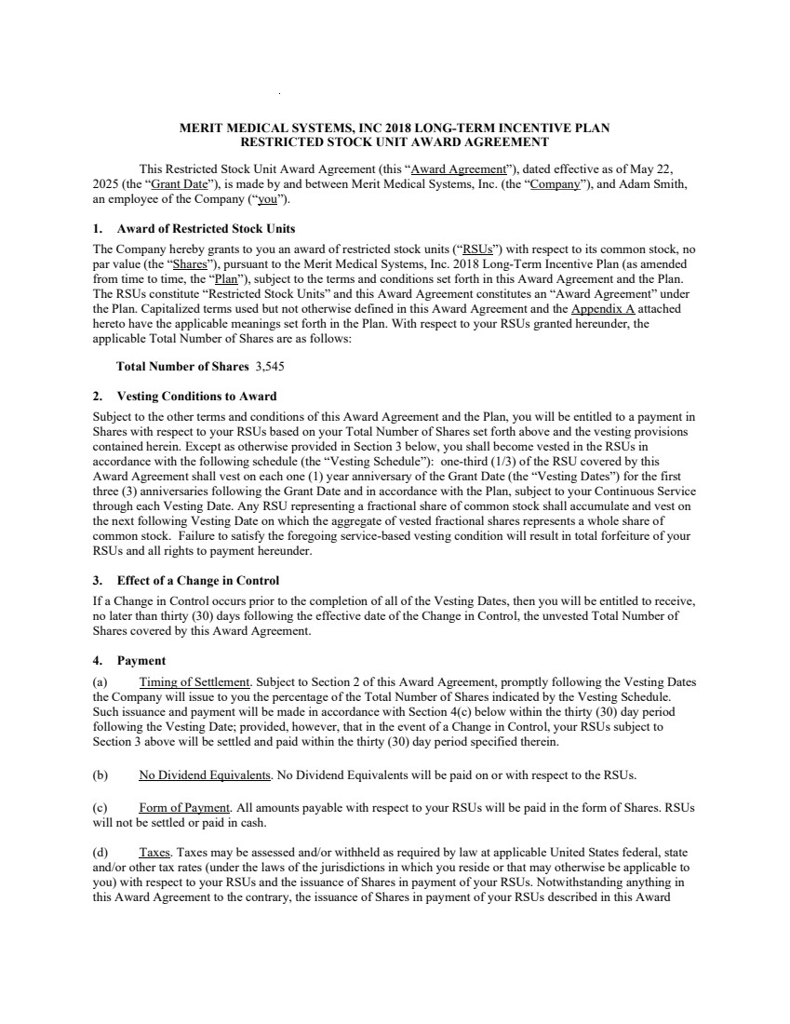 | MERIT MEDICAL SYSTEMS, INC 2018 LONG-TERM INCENTIVE PLAN RESTRICTED STOCK UNIT AWARD AGREEMENT This Restricted Stock Unit Award Agreement (this “Award Agreement”), dated effective as of May 22, 2025 (the “Grant Date”), is made by and between Merit Medical Systems, Inc. (the “Company”), and Adam Smith, an employee of the Company (“you”). 1. Award of Restricted Stock Units The Company hereby grants to you an award of restricted stock units (“RSUs”) with respect to its common stock, no par value (the “Shares”), pursuant to the Merit Medical Systems, Inc. 2018 Long-Term Incentive Plan (as amended from time to time, the “Plan”), subject to the terms and conditions set forth in this Award Agreement and the Plan. The RSUs constitute “Restricted Stock Units” and this Award Agreement constitutes an “Award Agreement” under the Plan. Capitalized terms used but not otherwise defined in this Award Agreement and the Appendix A attached hereto have the applicable meanings set forth in the Plan. With respect to your RSUs granted hereunder, the applicable Total Number of Shares are as follows: Total Number of Shares 3,545 2. Vesting Conditions to Award Subject to the other terms and conditions of this Award Agreement and the Plan, you will be entitled to a payment in Shares with respect to your RSUs based on your Total Number of Shares set forth above and the vesting provisions contained herein. Except as otherwise provided in Section 3 below, you shall become vested in the RSUs in accordance with the following schedule (the “Vesting Schedule”): one-third (1/3) of the RSU covered by this Award Agreement shall vest on each one (1) year anniversary of the Grant Date (the “Vesting Dates”) for the first three (3) anniversaries following the Grant Date and in accordance with the Plan, subject to your Continuous Service through each Vesting Date. Any RSU representing a fractional share of common stock shall accumulate and vest on the next following Vesting Date on which the aggregate of vested fractional shares represents a whole share of common stock. Failure to satisfy the foregoing service-based vesting condition will result in total forfeiture of your RSUs and all rights to payment hereunder. 3. Effect of a Change in Control If a Change in Control occurs prior to the completion of all of the Vesting Dates, then you will be entitled to receive, no later than thirty (30) days following the effective date of the Change in Control, the unvested Total Number of Shares covered by this Award Agreement. 4. Payment (a) Timing of Settlement. Subject to Section 2 of this Award Agreement, promptly following the Vesting Dates the Company will issue to you the percentage of the Total Number of Shares indicated by the Vesting Schedule. Such issuance and payment will be made in accordance with Section 4(c) below within the thirty (30) day period following the Vesting Date; provided, however, that in the event of a Change in Control, your RSUs subject to Section 3 above will be settled and paid within the thirty (30) day period specified therein. (b) No Dividend Equivalents. No Dividend Equivalents will be paid on or with respect to the RSUs. (c) Form of Payment. All amounts payable with respect to your RSUs will be paid in the form of Shares. RSUs will not be settled or paid in cash. (d) Taxes. Taxes may be assessed and/or withheld as required by law at applicable United States federal, state and/or other tax rates (under the laws of the jurisdictions in which you reside or that may otherwise be applicable to you) with respect to your RSUs and the issuance of Shares in payment of your RSUs. Notwithstanding anything in this Award Agreement to the contrary, the issuance of Shares in payment of your RSUs described in this Award
 | 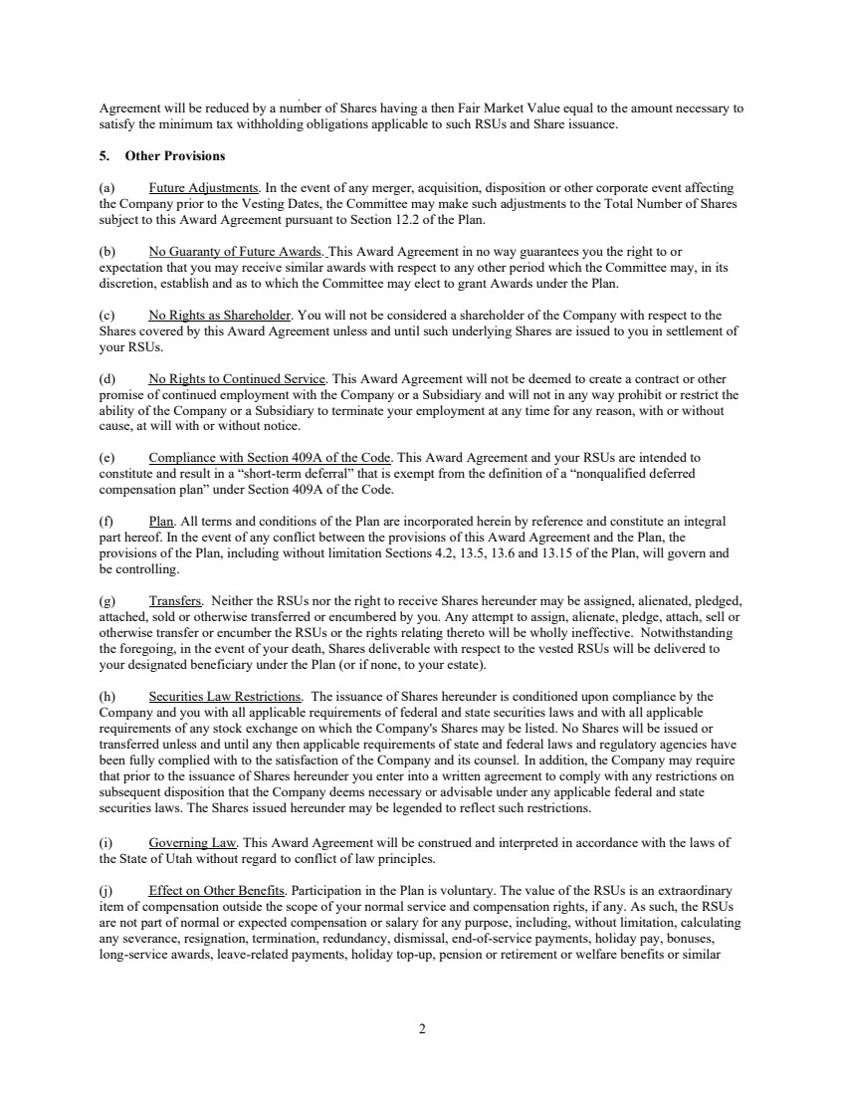 | 2 Agreement will be reduced by a number of Shares having a then Fair Market Value equal to the amount necessary to satisfy the minimum tax withholding obligations applicable to such RSUs and Share issuance. 5. Other Provisions (a) Future Adjustments. In the event of any merger, acquisition, disposition or other corporate event affecting the Company prior to the Vesting Dates, the Committee may make such adjustments to the Total Number of Shares subject to this Award Agreement pursuant to Section 12.2 of the Plan. (b) No Guaranty of Future Awards. This Award Agreement in no way guarantees you the right to or expectation that you may receive similar awards with respect to any other period which the Committee may, in its discretion, establish and as to which the Committee may elect to grant Awards under the Plan. (c) No Rights as Shareholder. You will not be considered a shareholder of the Company with respect to the Shares covered by this Award Agreement unless and until such underlying Shares are issued to you in settlement of your RSUs. (d) No Rights to Continued Service. This Award Agreement will not be deemed to create a contract or other promise of continued employment with the Company or a Subsidiary and will not in any way prohibit or restrict the ability of the Company or a Subsidiary to terminate your employment at any time for any reason, with or without cause, at will with or without notice. (e) Compliance with Section 409A of the Code. This Award Agreement and your RSUs are intended to constitute and result in a “short-term deferral” that is exempt from the definition of a “nonqualified deferred compensation plan” under Section 409A of the Code. (f) Plan. All terms and conditions of the Plan are incorporated herein by reference and constitute an integral part hereof. In the event of any conflict between the provisions of this Award Agreement and the Plan, the provisions of the Plan, including without limitation Sections 4.2, 13.5, 13.6 and 13.15 of the Plan, will govern and be controlling. (g) Transfers. Neither the RSUs nor the right to receive Shares hereunder may be assigned, alienated, pledged, attached, sold or otherwise transferred or encumbered by you. Any attempt to assign, alienate, pledge, attach, sell or otherwise transfer or encumber the RSUs or the rights relating thereto will be wholly ineffective. Notwithstanding the foregoing, in the event of your death, Shares deliverable with respect to the vested RSUs will be delivered to your designated beneficiary under the Plan (or if none, to your estate). (h) Securities Law Restrictions. The issuance of Shares hereunder is conditioned upon compliance by the Company and you with all applicable requirements of federal and state securities laws and with all applicable requirements of any stock exchange on which the Company's Shares may be listed. No Shares will be issued or transferred unless and until any then applicable requirements of state and federal laws and regulatory agencies have been fully complied with to the satisfaction of the Company and its counsel. In addition, the Company may require that prior to the issuance of Shares hereunder you enter into a written agreement to comply with any restrictions on subsequent disposition that the Company deems necessary or advisable under any applicable federal and state securities laws. The Shares issued hereunder may be legended to reflect such restrictions. (i) Governing Law. This Award Agreement will be construed and interpreted in accordance with the laws of the State of Utah without regard to conflict of law principles. (j) Effect on Other Benefits. Participation in the Plan is voluntary. The value of the RSUs is an extraordinary item of compensation outside the scope of your normal service and compensation rights, if any. As such, the RSUs are not part of normal or expected compensation or salary for any purpose, including, without limitation, calculating any severance, resignation, termination, redundancy, dismissal, end-of-service payments, holiday pay, bonuses, long-service awards, leave-related payments, holiday top-up, pension or retirement or welfare benefits or similar
 | 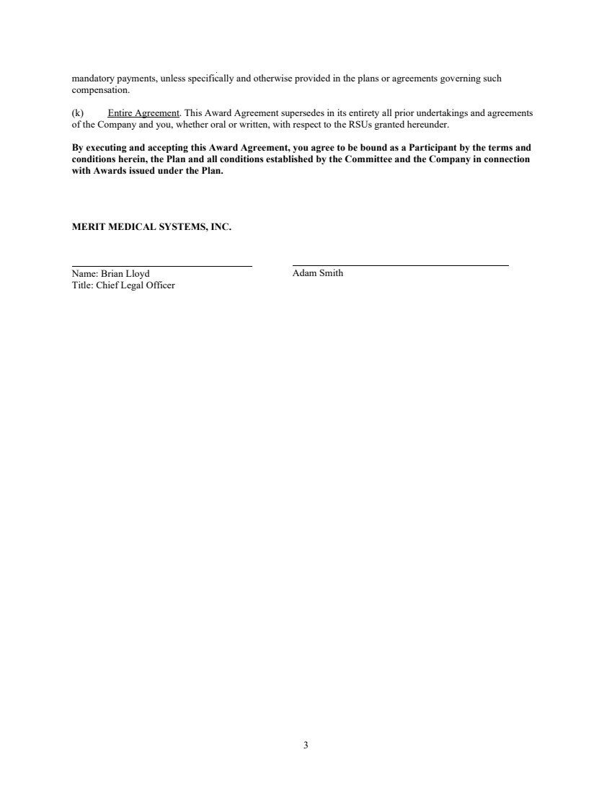 | 3 mandatory payments, unless specifically and otherwise provided in the plans or agreements governing such compensation. (k) Entire Agreement. This Award Agreement supersedes in its entirety all prior undertakings and agreements of the Company and you, whether oral or written, with respect to the RSUs granted hereunder. By executing and accepting this Award Agreement, you agree to be bound as a Participant by the terms and conditions herein, the Plan and all conditions established by the Committee and the Company in connection with Awards issued under the Plan. MERIT MEDICAL SYSTEMS, INC. Name: Brian Lloyd Title: Chief Legal Officer Adam Smith
 |  | APPENDIX A (Definitions) For purposes of this Award Agreement, the following terms have the following meanings: “Change in Control” has the meaning set forth in the Plan; provided, that no event will constitute a Change of Control unless it is described in Code Section 409A(a)(2)(A)(v) and the Treasury Regulations thereunder. “Continuous Service” has the meaning set forth in the Plan and includes service with the Company or a Subsidiary as an employee of the Company or a Subsidiary or as a Director of the Company. “Total Number of Shares” means the number of Shares specified in Section 1 of this Award Agreement.
5 APPENDIX B (Country-Specific Provisions) Terms, Conditions and Notifications This Appendix B includes additional notifications and terms and conditions that govern the Award Agreement granted to you under the Plan if you are an employee that works or resides outside of the United States and/or in one of the countries listed below. If you are a citizen or resident of a country other than the one in which you are currently working and/or residing, transfer employment and/or residency to another country after the Grant Date, are a consultant, change employment status to a consultant position, or are considered a resident of another country for local law purposes, the Company shall, in its discretion, determine the extent to which the special terms and conditions contained herein shall be applicable to you. ALL COUNTRIES OUTSIDE THE UNITED STATES 1. Settlement of RSUs. Notwithstanding any provision in the Award Agreement to the contrary, if you work and/or reside outside of the United States, the Company, in its sole discretion, may provide for the settlement of the RSUs in the form of: (a) a cash payment (in an amount equal to the Fair Market Value of the Shares that correspond to the vested RSUs) to the extent that settlement in Shares (i) is prohibited under local law, (ii) would require you, the Company or any of its Subsidiaries to obtain the approval of any governmental or regulatory body in your country of employment and/or residency, (iii) would result in adverse tax consequences for you, the Company or any of its Subsidiaries or (iv) is administratively burdensome; or (b) Shares, but require you to sell such Shares immediately or within a specified period following your termination of Continuous Service (in which case, you hereby agree that the Company shall have the authority to issue sale instructions in relation to such Shares on your behalf). 2. Termination of Service. The following provision supplements Section 2 of the Award Agreement: For purposes of the RSUs, unless otherwise determined by the Company, your termination of Continuous Service will be considered to occur on the date you are no longer actively providing services to the Company or any of its Subsidiaries (regardless of the reason for such termination and whether or not later found to be invalid or in breach of employment laws in the jurisdiction where you are employed or the terms of your employment agreement, if any) and such date will not be extended by any notice period (e.g., your period of Continuous Service would not include any contractual notice period or any period of “garden leave” or similar period mandated under employment laws in the jurisdiction where you provide services or the terms of your service agreement, if any); the Company shall have the exclusive discretion to determine when you are no longer actively providing service for purposes of the RSUs (including whether you may still be considered to be providing service while on a leave of absence). 3. Taxes. The following provisions supplement Section 4(d) of the Award Agreement: Regardless of any action the Company or, if different, the Subsidiary to which you provide services (the “Service Recipient”) takes with respect to any or all income tax (including U.S. federal, state and local taxes and/or non-U.S. taxes), social insurance, payroll tax, payment on account or other tax-related items in connection with your participation in the Plan (“Tax-Related Items”), you acknowledge that the ultimate liability for all Tax-Related Items legally due by you is and remains your responsibility, and that the Company and the Service Recipient: (a) make no representations or undertakings regarding the treatment of any Tax-Related Items in connection with any aspect of the RSUs, including the grant of the RSUs, the vesting of the RSUs, the settlement of the RSUs, the subsequent sale of any Shares and the receipt of any dividends; and (b) do not commit to structure the terms of the grant or any aspect of the RSUs to reduce or eliminate your liability for Tax-Related Items. Further, if you are subject to Tax-Related Items in more than one jurisdiction between the Grant Date and the date of any relevant taxable or tax withholding event, as applicable, you acknowledge that the Company and/or the Service Recipient (or former service recipient, as applicable) may be required to withhold or account for Tax-Related Items in more than one jurisdiction. Prior to the relevant taxable or tax withholding event, as applicable, you agree to make adequate arrangements satisfactory to the Company and/or the Service Recipient to satisfy all Tax-Related Items. In this regard, you authorize the Company and/or the Service Recipient, or their respective agents, at their discretion, to satisfy the obligations with regard to all Tax-Related Items by one or a combination of the following: (i) by having you tender to the Company a payment in cash, by certified check, bank draft or postal or express money order payable to the Company, (ii) by having you deliver to the Company other Shares you have owned for more than six (6) months (or such longer period of time required to avoid a charge to earnings for financial accounting purposes) duly endorsed for transfer to the Company or by attestation, with a Fair Market Value on the date of delivery equal to the Tax-Related Items; (iii) by withholding from the proceeds of the sale of Shares acquired upon settlement of the RSUs, either through a voluntary sale or through a mandatory sale arranged by the Company (on your behalf pursuant to this authorization without further consent); (iv) by reducing the number of Shares otherwise deliverable upon settlement of RSUs by that number of Shares having a Fair Market Value equal to the Tax-Related Items; or (v) by withholding from your wages or other cash compensation paid to you by the Company and/or the
6 Service Recipient. Notwithstanding the foregoing, if you are subject to Section 16 of the Exchange Act pursuant to Rule 16a-2 promulgated thereunder, the Company will satisfy the obligations with regard to Tax-Related Items by reducing the number of Shares otherwise deliverable upon settlement of the RSUs by that number of Shares having a Fair Market Value equal to the Tax-Related Items, unless the use of such method is problematic under applicable law or has materially adverse accounting or tax consequences, in which case, the Committee shall establish an alternate withholding method (or methods). Depending on the withholding method, the Company may withhold or account for Tax-Related Items by considering applicable statutory withholding rates (as determined by the Company in good faith and in its sole discretion) or other applicable withholding rates, including maximum applicable rates, in which case you may receive a refund of any over-withheld amount and will have no entitlement to the share equivalent. You agree to pay to the Company or the Service Recipient any amount of Tax-Related Items that the Company or the Service Recipient may be required to withhold or account for as a result of your participation in the Plan that cannot be satisfied by the means previously described. The Company may refuse to issue or deliver Shares or proceeds from the sale of Shares until arrangements satisfactory to the Company have been made in connection with the Tax-Related Items. 4. Nature of Grant. By accepting the grant of RSUs, you acknowledge, understand and agree that: (a) the Plan is established voluntarily by the Company, it is discretionary in nature and it may be terminated, suspended or amended by the Company, in its sole discretion, at any time, to the extent permitted by the Plan; (b) the grant of RSUs is voluntary and does not create any contractual or other right to receive future RSUs or benefits in lieu of RSUs, even if RSUs have been granted in the past; (c) all decisions with respect to future RSUs or other grants, if any, will be at the sole discretion of the Company; (d) you are voluntarily participating in the Plan; (e) unless otherwise agreed with the Company, the RSUs and any Shares acquired upon vesting of the RSUs, and the income from and value of same, are not granted as consideration for, or in connection with, any service you may provide as a director of any Subsidiary; (f) the RSUs and any Shares acquired under the Plan, and the income from and value of same, are not intended to replace any pension rights or compensation; (g) the future value of the underlying Shares is unknown, indeterminable and cannot be predicted with certainty and the value of such Shares issued under the Plan may increase or decrease in the future; (h) no claim or entitlement to compensation or damages shall arise from forfeiture of the RSUs resulting from the termination of your employment (regardless of the reason for the termination and whether or not the termination is later found to be invalid or in breach of employment laws in the jurisdiction where you are employed or the terms of your employment agreement, if any); and (i) neither the Company nor any of its Subsidiaries shall be liable for any foreign exchange rate fluctuation between your local currency and the United States Dollar that may affect the value of the Shares or any amounts due pursuant to the issuance of Shares, or the subsequent sale of any Shares acquired under the Plan. 5. Language. You acknowledge and represent that you are sufficiently proficient in the English language or have consulted with an advisor who is sufficiently proficient in English as to allow you to understand the terms and conditions of this Award Agreement and any other documents related to the Plan. If you have received this Award Agreement or any other document related to the Plan translated into a language other than English and if the meaning of the translated version is different from the English version, the English version will control unless otherwise required pursuant to applicable law. 6. Insider Trading/Market Abuse Laws. By participating in the Plan, you agree to comply with the Company’s policy on insider trading, to the extent that it is applicable to you. You further acknowledge that, depending on your or your broker’s country of residence or where the Shares are listed, you may be subject to insider trading restrictions and/or market abuse laws that may affect your ability to accept, acquire, sell or otherwise dispose of Shares, rights to Shares (e.g., RSUs) or rights linked to the value of Shares, during such times you are considered to have “inside information” regarding the Company as defined by the laws or regulations in your country. Local insider trading laws and regulations may prohibit the cancellation or amendment of orders you place before you possessed inside information. Furthermore, you could be prohibited from (i) disclosing the inside information to any third party (other than on a “need to know” basis) and (ii) “tipping” third parties or causing them otherwise to
7 buy or sell securities. You understand that third parties include fellow Employees and/or service providers. Any restrictions under these laws or regulations are separate from and in addition to any restrictions that may be imposed under any applicable Company insider trading policy. You acknowledge that it is your responsibility to comply with any applicable restrictions, and that you should therefore consult your personal advisor on this matter. 7. Compliance with Law. The Company shall not be required to deliver any Shares pursuant to the RSUs prior to the completion of any registration or qualification of the RSUs, the Shares or the Plan under any applicable securities or exchange control law or under rulings or regulations of any governmental regulatory body, or prior to obtaining any approval or other clearance from any governmental agency, which registration, qualification or approval the Company shall, in its absolute discretion, deem necessary or advisable. You understand that the Company is under no obligation to register or qualify the Shares with any governmental authority or to seek approval or clearance from any governmental authority for the issuance of the Shares. Further, you agree that the Company shall have unilateral authority to amend the Award Agreement without your consent to the extent necessary to comply with securities or other laws applicable to issuance of Shares. In addition, you agree to take any and all actions, and consent to any and all actions taken by the Company and any of its Subsidiaries, as may be required to allow the Company and any of its Subsidiaries to comply with local laws, rules and/or regulations in your country. Finally, you agree to take any and all actions as may be required to comply with your personal obligations under local laws, rules and/or regulations in your country. 8. Imposition of Other Requirements. The Company reserves the right to impose other requirements on your participation in the Plan, on the RSUs, and on any Shares acquired under the Plan, to the extent the Company determines it is necessary or advisable for legal or administrative reasons, and to require you (or, in the event of your death, your legal representatives, legates or distributees) to sign any additional agreements or undertakings that may be necessary to accomplish the foregoing. 9. Not a Public Offering. The grant of the RSUs is not intended to be a public offering of securities in your country. The Company has not submitted any registration statement, prospectus or other filings with the local securities authorities (unless otherwise required under local law), and the grant of the RSUs is not subject to the supervision of the local securities authorities. 10. Foreign Asset / Account Reporting and Exchange Control Notification. Your country may have certain foreign asset and/or account reporting requirements and exchange controls that may affect your ability to acquire or hold Shares under the Plan or cash received from participating in the Plan (including from any dividends or sale proceeds arising from the sale of Shares) in a brokerage or bank account outside your country. You may be required to report such accounts, assets or transactions to the tax or other authorities in your country. You also may be required to repatriate sale proceeds or other funds received as a result of your participation in the Plan to your country through a designated bank or broker and/or within a certain time after receipt. In addition, you may be subject to tax payment and/or reporting obligations in connection with any income realized under the Plan and/or from the sale of Shares. It is your responsibility to be compliant with all such requirements. You should consult your personal legal and tax advisors to ensure compliance with all applicable requirements. 11. Data Privacy. You hereby explicitly and unambiguously consent to the collection, use and transfer, in electronic or other form, of your personal data as described in this Award Agreement and any other RSU grant materials by and among, as necessary and applicable, the Company or any of its Subsidiaries, for the exclusive purpose of implementing, administering and managing your participation in the Plan. You understand that the Company and/or the Service Recipient may hold certain personal information about you, including, but not limited to, your name, home address, email address and telephone number, date of birth, social security or insurance number, passport number or other identification number, salary, nationality, and any Shares or directorships held in the Company, and details of the RSUs or any other entitlement to Shares canceled, vested, unvested, settled, or outstanding in your favor (“Data”) for the purpose of implementing, administering and managing the Plan. You understand that Data will be transferred to Morgan Stanley Smith Barney LLC and/or its affiliates (the “Plan Broker”) or such other stock plan service provider as may be selected by the Company in the future, which is assisting the Company with the implementation, administration and management of the Plan. You understand that the recipients of Data may be located in the United States or elsewhere, and that the recipients’ country (e.g., the United States) may have different data privacy laws and protections than your country. If you are employed outside the United States, you understand that you may request a list with the names and addresses of any potential recipients of Data by contacting your local human resources representative. You authorize the Company and any of its Subsidiaries, the Plan Broker (and/or its affiliates) and any other possible recipients that may assist the Company (presently or in the future) with implementing, administering and managing the Plan to receive, possess, use, retain and transfer Data, in electronic or other form, for the sole purpose of implementing, administering and managing your participation in the Plan. You understand that Data will be held only as long as is necessary to implement, administer and manage your participation in the Plan. You understand that you may, at any time, view Data, request additional information about the storage and processing of Data, require any necessary amendments to Data or refuse or withdraw the consents herein, in any case without cost, by contacting in writing your local human resources representative. Further, you understand that you are providing the consents herein on a purely voluntary basis. If you do not consent, or if you later seeks to revoke your consent,
8 your service status and career will not be affected; the only consequence of refusing or withdrawing consent is that the Company would not be able to grant RSUs or other equity awards to you or administer or maintain such awards. Therefore, you understand that refusing or withdrawing consent may affect your ability to participate in the Plan. For more information on the consequences of your refusal to consent or withdrawal of consent, you understand that you may contact your local human resources representative. Finally, you understand that the Company may rely on a different legal basis for the processing and/or transfer of Data in the future and/or request you to provide another data privacy consent. If applicable and upon request of the Company, you agree to provide an executed acknowledgement or data privacy consent form (or any other acknowledgements, agreements or consents) to the Company or the Service Recipient that the Company and/or the Service Recipient may deem necessary to obtain under the data privacy laws in your country, either now or in the future. You understand that you will not be able to participate in the Plan if you fail to execute any such acknowledgement, agreement or consent requested by the Company and/or the Service Recipient. CHINA Form of Settlement. Pursuant Section 1(a) of this Appendix B section titled “All Countries Outside the United States”, your RSUs shall be settled in the form of a cash payment made through local payroll, except as otherwise determined by the Company. HONG KONG 1. Form of Settlement. Notwithstanding anything to the contrary in this Appendix B or the Plan, the RSUs shall be settled only in Shares (and may not be settled in cash). 2. Sale of Shares. If, for any reason, Shares are issued to you within six (6) months after the Grant Date, you agree that you will not sell or otherwise dispose of any such Shares prior to the six (6) month anniversary of the Grant Date. 3. IMPORTANT NOTICE/WARNING. The contents of this document have not been reviewed by any regulatory authority in Hong Kong. You are advised to exercise caution in relation to the offer. If you are in any doubt about any of the contents of the offer documents, you should obtain independent professional advice. The RSUs and Shares issued upon settlement of the award do not constitute a public offering of securities under Hong Kong law and are available only to employees of the Company and its Subsidiaries. The Award Agreement, the Plan and other incidental communication materials have not been prepared in accordance with and are not intended to constitute a “prospectus” for a public offering of securities under the applicable securities legislation in Hong Kong. The RSUs and the underlying Shares are intended only for the personal use of each eligible employee of the Company and/or its Subsidiaries and may not be distributed to any other person. 4. Nature of Scheme. The Company specifically intends that the Plan will not be an occupational retirement scheme for purposes of the Occupational Retirement Schemes Ordinance (“ORSO”). IRELAND Data Privacy. Section 11 of the section of this Appendix B titled “All Countries Outside the United States” shall be replaced with the following: The Company, with its registered address at 1600 West Merit Parkway, South Jordan, Utah 84095, U.S.A., is the controller responsible for the processing of your personal data by the Company and the third parties noted below. The Company’s representative in the European Union (“EU”) is Adam Smith, Merit Medical Nederland B.V., Amerikalaan 42, Maastricht-Airport, 6199AE, the Netherlands, adam.smith@merit.com. You should review the following information regarding the Company’s data processing practices. (a) Data Collection and Usage. Pursuant to applicable data protection laws, you are hereby notified that the Company collects, processes and uses certain personally-identifiable information about you for the legitimate interest of implementing, administering and managing the Plan and generally administering equity awards; specifically, including your name, home address, email address and telephone number, date of birth, social insurance number or other identification number, salary, citizenship, job title, any Shares or directorships held in the Company, and details of all RSUs or any entitlement to Shares awarded, canceled, exercised, vested, settled, or outstanding in your favor, which the Company receives from you or the Service Recipient (“Personal Data”). In granting the RSUs under the Plan, the Company will collect Personal Data for purposes of allocating Shares and implementing, administering and managing the Plan. The Company’s legal basis for the collection, processing and use of Personal Data is the necessity of the processing for the Company to perform its contractual obligations under this Award Agreement and the Plan and the Company’s legitimate business interests of managing the Plan, administering employee equity awards and complying with its contractual and statutory obligations.
9 (b) Stock Plan Administration Service Provider. The Company transfers data to Morgan Stanley Smith Barney LLC and/or its affiliates (the “Plan Broker”), an independent service provider based in the United States, which assists the Company with the implementation, administration and management of the Plan. In the future, the Company may select a different service provider and share Personal Data with another company that serves in a similar manner. The Company’s service provider will open an account for you to receive and trade Shares. You will be asked to agree on separate terms and data processing practices with the service provider, which is a condition to your ability to participate in the Plan. The processing of Personal Data will take place through both electronic and non-electronic means. Personal Data will only be accessible by those individuals requiring access to it for purposes of implementing, administering and operating the Plan. (c) International Data Transfers. The Company and its service providers are based in the United States. Your country or jurisdiction may have different data privacy laws and protections than the United States. An appropriate level of protection may be achieved by implementing safeguards such as the Standard Contractual Clauses adopted by the EU Commission. Personal Data will be transferred from the EU to the Company and onward from the Company to any of its service providers based on the EU Standard Contractual Clauses. You may request a copy of such appropriate safeguards by contacting your local human resources department. (d) Data Retention. The Company will use Personal Data only as long as is necessary to implement, administer and manage your participation in the Plan or as required to comply with legal or regulatory obligations, including tax and securities laws. When the Company no longer needs Personal Data, the Company will remove it from its systems. If the Company keeps Personal Data longer, it would be to satisfy legal or regulatory obligations and the Company’s legal basis would be for compliance with relevant laws or regulations. (e) Data Subject Rights. You may have a number of rights under data privacy laws in your country. For example, your rights may include the right to (i) request access or copies of Personal Data the Company processes, (ii) request rectification of incorrect Personal Data, (iii) request deletion of Personal Data, (iv) place restrictions on processing Personal Data, (v) lodge complaints with competent authorities in your country, and/or (vi) request a list with the names and addresses of any potential recipients of Personal Data. To receive clarification regarding your rights or to exercise your rights, you may contact your local human resources department. MEXICO 1. Commercial Relationship. You expressly recognize that your participation in the Plan and the Company’s grant of the RSUs do not constitute an employment relationship between you and the Company. You have been granted the RSUs as a consequence of the commercial relationship between the Company and the Subsidiary in Mexico that employs you (“Merit Medical-Mexico”) and Merit Medical-Mexico is your sole employer. Based on the foregoing, (a) you expressly recognize that the Plan and the benefits you may derive from your participation in the Plan do not establish any rights between you and Merit Medical-Mexico, (b) the Plan and the benefits you may derive from your participation in the Plan are not part of the employment conditions and/or benefits provided by Merit Medical-Mexico, and (c) any modification or amendments of the Plan by the Company, or a termination of the Plan by the Company shall not constitute a change or impairment of the terms and conditions of your employment with Merit Medical-Mexico. 2. Extraordinary Item of Compensation. You expressly recognize and acknowledge that your participation in the Plan is a result of the discretionary and unilateral decision of the Company, as well as your free and voluntary decision to participate in the Plan in accordance with the terms and conditions of the Plan, the Award Agreement and this Appendix B. As such, you acknowledge and agree that the Company, in its sole discretion, may amend and/or discontinue your participation in the Plan at any time and without liability. The value of the RSUs is an extraordinary item of compensation outside the scope of your employment contract, if any. The RSUs are not part of your regular or expected compensation for purposes of calculating any severance, resignation, redundancy, end of service payments, bonuses, long-service awards, pension or retirement benefits, or any similar payments, which are the exclusive obligations of Merit Medical-Mexico. 3. Securities Law Information. The RSUs and any Shares acquired under the Plan have not been registered with the National Register of Securities maintained by the Mexican National Banking and Securities Commission and cannot be offered or sold publicly in Mexico. In addition, the Plan, the Award Agreement and any other document relating to the RSUs may not be publicly distributed in Mexico. These materials are addressed to you because of your existing relationship with the Company or a Subsidiary, and these materials should not be reproduced or copied in any form. The offer contained in these materials does not constitute a public offering of securities, but rather constitutes a private placement of securities addressed specifically to individuals who are present employees of the Company or a Subsidiary made in accordance with the provisions of the Mexican Securities Market Law, and any rights under such offering shall not be assigned or transferred.
​
Exhibit 21
​
​
SUBSIDIARIES OF MERIT MEDICAL SYSTEMS, INC.
​
​
Subsidiary Name | ​ ​ ​ | Jurisdiction of  Incorporation/Organization
Merit Medical Australia Pty Ltd. |  | Australia
Merit Medical Austria GmbH |  | Austria
Merit Medical Belgium Sprl (BVBA) |  | Belgium
Merit Medical Comercialização, Distribuição, Importação e Exportação de Produtos Hospitalares LTDA. |  | Brazil
Merit Medical Canada Ltd. |  | Canada
Merit Medical Beijing Co. Ltd. | ​ | China
Merit Medical Colombia S.A.S. | ​ | Colombia
Biolife Delaware, LLC | ​ | Delaware
BioSphere Medical, Inc. |  | Delaware
BioSphere Medical Japan, Inc. |  | Delaware
Brightwater Medical, Inc. | ​ | Delaware
Cianna Medical, Inc. | ​ | Delaware
DFINE, Inc. |  | Delaware
Restore Endosystems, LLC | ​ | Delaware
Vascular Access Technologies, Inc. |  | Delaware
Merit Medical Denmark A/S |  | Denmark
Merit Medical Egypt LLC | ​ | Egypt
Merit Medical Finland Ltd. |  | Finland
Biolife Management Services, LLC | ​ | Florida
BioSphere Medical SA |  | France
Merit Medical France SAS |  | France
Dfine Europe GmbH |  | Germany
Merit Medical GmbH |  | Germany
Merit Medical Asia Company Limited |  | Hong Kong
Merit Medical Systems India Private Limited |  | India
PT Merit Medical Systems Indonesia | ​ | Indonesia
Merit Medical Ireland, Ltd. |  | Ireland
Merit Medical Italy S.R.L. |  | Italy
Merit Medical Japan KK |  | Japan
Merit Medical Malaysia Sdn. Bhd |  | Malaysia
Merit Maquiladora México, S. de R.L. de C.V. |  | Mexico
Merit Mexico Sales, S. de R.L. de C.V. |  | Mexico
KA Medical, LLC | ​ | Minnesota
Merit Medical Coatings B.V. |  | Netherlands
Merit Medical Nederland B.V. |  | Netherlands
Merit Medical New Zealand Limited |  | New Zealand
Merit Medical Norway AS |  | Norway
Thomas Medical Products, Inc. |  | Pennsylvania
Merit Medical Poland sp.z.o.o. | ​ | Poland
Merit Medical Portugal, S.A. | ​ ​ ​ | Portugal
LLC Merit Technologies |  | Russia
Merit Medical Singapore Pte. Ltd. |  | Singapore
​

Merit Medical Africa (Pty) LTD | ​ | South Africa
Merit Medical South Africa (Pty) LTD | ​ | South Africa
Merit Medical Korea Co., Ltd. | ​ | South Korea
Merit Medical Spain S.L. |  | Spain
Merit Medical Systems AB |  | Sweden
Merit Medical Switzerland AG |  | Switzerland
Merit Medical (Thailand) Limited | ​ | Thailand
Merit Medical Turkey Tıbbi Ürünler Ticaret Anonim Şirketi |  | Turkey
Merit Medical ME FZ-LLC |  | United Arab Emirates
Merit Medical UK Limited |  | United Kingdom
Merit Holdings, Inc. |  | Utah
Merit Sensor Systems, Inc. |  | Utah
​

EXHIBIT 23.1
​
CONSENT OF INDEPENDENT REGISTERED PUBLIC ACCOUNTING FIRM
​
We consent to the incorporation by reference in Registration Statement No. 333-226320 on Form S-3ASR and Registration Statement Nos. 333-281838, 333-262158, 333-262157, 333-225426, 333-206297, 333-206296, 333-163104, 333-135614, 333-129267, 333-58112 and 333-58162 on Form S-8 of our reports dated February 24, 2026, relating to the financial statements of Merit Medical Systems, Inc. and the effectiveness of Merit Medical Systems, Inc.’s internal control over financial reporting appearing in this Annual Report on Form 10-K for the year ended December 31, 2025.
​
/s/ DELOITTE & TOUCHE LLP
Salt Lake City, Utah
February 24, 2026
​ | ​
​

EXHIBIT 31.1
​
CERTIFICATION
​
I, Martha G. Aronson, certify that:
​
1. I have reviewed this Annual Report on Form 10-K (the “Report”) of Merit Medical Systems, Inc. (the “Registrant”);
​
2. Based on my knowledge, this Report does not contain any untrue statement of a material fact or omit to state a material fact necessary to make the statements made, in light of the circumstances under which such statements were made, not misleading with respect to the period covered by this Report;
​
3. Based on my knowledge, the financial statements, and other financial information included in this Report, fairly present in all material respects the financial condition, results of operations and cash flows of the Registrant as of, and for, the periods presented in this Report;
​
4. The Registrant’s other certifying officer and I are responsible for establishing and maintaining disclosure controls and procedures (as defined in Exchange Act Rules 13a-15(e) and 15d-15(e)) and internal control over financial reporting (as defined in Exchange Act Rules 13a-15(f) and 15d-15(f)) for the Registrant and have:
​
a) designed such disclosure controls and procedures, or caused such disclosure controls and procedures to be designed under our supervision, to ensure that material information relating to the Registrant, including its consolidated subsidiaries, is made known to us by others within those entities, particularly during the period in which this Report is being prepared;
​
b) designed such internal control over financial reporting, or caused such internal control over financial reporting to be designed under our supervision, to provide reasonable assurance regarding the reliability of financial reporting and the preparation of financial statements for external purposes in accordance with general accepted accounting principles;
​
c) evaluated the effectiveness of the Registrant’s disclosure controls and procedures and presented in this Report our conclusions about the effectiveness of the disclosure controls and procedures, as of the end of the period covered by this Report based on such evaluation; and
​
d) disclosed in this Report any change in the Registrant’s internal control over financial reporting that occurred during the Registrant’s most recent fiscal quarter (the registrant’s fourth fiscal quarter in case of an annual report) that has materially affected, or is reasonably likely to materially affect, the Registrant’s internal control over financial reporting; and
​
5. The Registrant’s other certifying officer and I have disclosed, based on our most recent evaluation of internal control over financial reporting, to the Registrant’s auditors and the audit committee of the Registrant’s board of directors (or persons performing the equivalent functions):
​
a) all significant deficiencies and material weaknesses in the design or operation of internal control over financial reporting which are reasonably likely to adversely affect the Registrant’s ability to record, process, summarize and report financial information; and
​
b) any fraud, whether or not material, that involves management or other employees who have a significant role in the Registrant’s internal control over financial reporting.
​
Date: February 24, 2026 | /s/ Martha G. Aronson
 | Martha G. Aronson
 | President and Chief Executive Officer
 | (principal executive officer)
​

EXHIBIT 31.2
​
CERTIFICATION
​
I, Raul Parra, certify that:
​
1. I have reviewed this Annual Report on Form 10-K (the “Report”) of Merit Medical Systems, Inc. (the “Registrant”);
​
2. Based on my knowledge, this Report does not contain any untrue statement of a material fact or omit to state a material fact necessary to make the statements made, in light of the circumstances under which such statements were made, not misleading with respect to the period covered by this Report;
​
3. Based on my knowledge, the financial statements, and other financial information included in this Report, fairly present in all material respects the financial condition, results of operations and cash flows of the Registrant as of, and for, the periods presented in this Report;
​
4. The Registrant’s other certifying officer and I are responsible for establishing and maintaining disclosure controls and procedures (as defined in Exchange Act Rules 13a-15(e) and 15d-15(e)) and internal controls over financial reporting (as defined in Exchange Act Rules 13a-15(f) and 15d-15(f)) for the Registrant and have:
​
a) designed such disclosure controls and procedures, or caused such disclosure controls and procedures to be designed under our supervision, to ensure that material information relating to the Registrant, including its consolidated subsidiaries, is made known to us by others within those entities, particularly during the period in which this Report is being prepared;
​
b) designed such internal control over financial reporting, or caused such internal control over financial reporting to be designed under our supervision, to provide reasonable assurance regarding the reliability of financial reporting and the preparation of financial statements for external purposes in accordance with general accepted accounting principles;
​
c) evaluated the effectiveness of the Registrant’s disclosure controls and procedures and presented in this Report our conclusions about the effectiveness of the disclosure controls and procedures, as of the end of the period covered by this Report based on such evaluation; and
​
d) disclosed in this Report any change in the Registrant’s internal control over financial reporting that occurred during the Registrant’s most recent fiscal quarter (the registrant’s fourth fiscal quarter in case of an annual report) that has materially affected, or is reasonably likely to materially affect, the Registrant’s internal control over financial reporting; and
​
5. The Registrant’s other certifying officer and I have disclosed, based on our most recent evaluation of internal control over financial reporting, to the Registrant’s auditors and the audit committee of the Registrant’s board of directors (or persons performing the equivalent functions):
​
a) all significant deficiencies and material weaknesses in the design or operation of internal control over financial reporting which are reasonably likely to adversely affect the Registrant’s ability to record, process, summarize and report financial information; and
​
b) any fraud, whether or not material, that involves management or other employees who have a significant role in the Registrant’s internal control over financial reporting.
​
Date: February 24, 2026 | /s/ Raul Parra
 | Raul Parra
 | Chief Financial Officer
 | (principal financial officer)
​

EXHIBIT 32.1
​
Certification of Principal Executive Officer
Pursuant to 18 U.S.C. Section 1350, as Adopted
Pursuant to Section 906 of the Sarbanes-Oxley Act of 2002
​
In connection with the Annual Report on Form 10-K of Merit Medical Systems, Inc. (the “Company”) for the year ended December 31, 2025, as filed with the Securities and Exchange Commission (the “Report”), I, Martha G. Aronson, Chief Executive Officer of the Company, certify, pursuant to 18 U.S.C. Section 1350, as adopted pursuant to Section 906 of the Sarbanes-Oxley Act of 2002, that, to the best of my knowledge:
​
(1) The Report fully complies with the requirements of Section 13(a) or 15 (d) of the Securities Exchange Act of 1934; and
​
(2) The information contained in the Report fairly presents, in all material respects, the financial condition and results of operations of the Company.
​
Date: February 24, 2026 | /s/ Martha G. Aronson
 | Martha G. Aronson
 | President and Chief Executive Officer
 | (principal executive officer)
​
This certification accompanies the foregoing Report pursuant to 18 U.S.C. Section 1350, as adopted pursuant to Section 906 of the Sarbanes-Oxley Act of 2002 and shall not, except to the extent required by the Sarbanes-Oxley Act of 2002, be deemed filed by the Registrant for purposes of Section 18 of the Securities Exchange Act of 1934, as amended. A signed original of this certification has been provided to the Company and will be retained by the Company and furnished to the Securities and Exchange Commission or its staff upon request.

EXHIBIT 32.2
​
Certification of Chief Financial Officer
Pursuant to 18 U.S.C. Section 1350, as Adopted
Pursuant to Section 906 of the Sarbanes-Oxley Act of 2002
​
In connection with the Annual Report on Form 10-K of Merit Medical Systems, Inc. (the “Company”) for the year ended December 31, 2025, as filed with the Securities and Exchange Commission (the “Report”), I, Raul Parra, Chief Financial Officer of the Company, certify, pursuant to 18 U.S.C. Section 1350, as adopted pursuant to Section 906 of the Sarbanes-Oxley Act of 2002, that, to the best of my knowledge:
​
(1) The Report fully complies with the requirements of Section 13(a) or 15(d) of the Securities Exchange Act of 1934; and
​
(2) The information contained in the Report fairly presents, in all material respects, the financial condition and results of operations of the Company.
​
Date: February 24, 2026 | /s/ Raul Parra
 | Raul Parra
 | Chief Financial Officer
 | (principal financial officer)
​
This certification accompanies the foregoing Report pursuant to 18 U.S.C. Section 1350, as adopted pursuant to Section 906 of the Sarbanes-Oxley Act of 2002 and shall not, except to the extent required by the Sarbanes-Oxley Act of 2002, be deemed filed by the Registrant for purposes of Section 18 of the Securities Exchange Act of 1934, as amended. A signed original of this certification has been provided to the Company and will be retained by the Company and furnished to the Securities and Exchange Commission or its staff upon request.

