​
​
​
UNITED STATES
SECURITIES AND EXCHANGE COMMISSION
Washington, D.C. 20549
​
FORM 8-K
​
CURRENT REPORT
​
Pursuant to Section 13 or 15(d) of the Securities Exchange Act of 1934
Date of Report (date of earliest event reported): August 14, 2026
​

​
Merit Medical Systems, Inc.
(Exact name of registrant as specified in its charter)
​

​ | ​ | ​ | ​ | ​
Utah | ​ ​ ​ | 0-18592 | ​ ​ ​ | 87-0447695
(State or other jurisdiction of | ​ | (Commission | ​ | (I.R.S. Employer
incorporation or organization) | ​ | File Number) | ​ | Identification No.)
​
​

​ | ​ | ​
1600 West Merit Parkway | ​ ​ ​ | ​
South Jordan, Utah | ​ | 84095
(Address of principal executive offices) | ​ | (Zip Code)
​
(801) 253-1600
(Registrant's telephone number, including area code)
​
N/A
(Former name or former address, if changed since last report)
​
Check the appropriate box below if the Form 8-K filing is intended to simultaneously satisfy the filing obligation of the registrant under any of the following provisions:
​
☐ Written communications pursuant to Rule 425 under the Securities Act (17 CFR 230.425)
​
☐ Soliciting material pursuant to Rule 14a-12 under the Exchange Act (17 CFR 240.14a-12)
​
☐ Pre-commencement communications pursuant to Rule 14d-2(b) under the Exchange Act (17 CFR 240.14d-2(b))
​
☐ Pre-commencement communications pursuant to Rule 13e-4(c) under the Exchange Act (17 CFR 240.13e-4(c))
​
Securities registered pursuant to Section 12(b) of the Act:
​

​ | ​ | ​ | ​ | ​
Title of each class | ​ ​ ​ | Trading Symbol(s) | ​ ​ ​ | Name of each exchange on which registered
Common Stock, no par value | ​ | MMSI | ​ | NASDAQ Global Select Market
​
Indicate by check mark whether the registrant is an emerging growth company as defined in Rule 405 of the Securities Act of 1933 (§230.405 of this chapter) or Rule 12b-2 of the Securities Exchange Act of 1934 (§240.12b-2 of this chapter).
​
Emerging growth company ☐
​
If an emerging growth company, indicate by check mark if the registrant has elected not to use the extended transition period for complying with any new or revised financial accounting standards provided pursuant to Section 13(a) of the Exchange Act. ☐
​
​
​
​
​
​
​
Item 5.02 Departure of Directors or Certain Officers; Election of Directors; Appointment of Certain Officers; Compensatory Arrangements of Certain Officers.
(b) On August 14, 2026, Merit Medical Systems, Inc. (“Merit”) reorganized portions of its global operations function. As a result of such reorganization, the position of Chief Operating Officer was eliminated, and Neil W. Peterson’s title was changed to Senior Advisor. On August 18, 2026, Mr. Peterson provided Merit with written notice of his resignation for good reason as an employee of the Company effective March 5, 2027.
(c) Effective August 31, 2026, Merit appointed Sheri Lewis as Merit’s Executive Vice President of Global Operations. Prior to her appointment with Merit, Ms. Lewis was employed from April 2024 as Chief Supply Chain and Operations Officer of Skin Health Systems. Ms. Lewis was employed as Executive Vice President, Global Supply Chain Operations, of Avantor Sciences from January 2021 until March 2024 and previously served in multiple operations, supply chain and distribution positions with Medtronic and Honeywell Inc. Ms. Lewis holds a Bachelor of Arts degree in Organizational Management from Concordia University, currently serves as a member of the Supply Chain Advisory Board at the University of Wisconsin and previously served as a member of the Supply Chain Advisory Board at the University of Minnesota. Ms. Lewis is 60 years old.
There is no arrangement or understanding between Ms. Lewis and any other person pursuant to which she was appointed as an officer of Merit, and she is not a party to any transaction required to be disclosed pursuant to Item 404(a) of Regulation S-K.
In connection with the commencement of her employment, Ms. Lewis entered into an employment agreement with Merit effective as of August 31, 2026 (the “Employment Agreement”). The Employment Agreement provides for a base salary of $600,000 per year, a signing bonus of $400,000, and for Ms. Lewis to participate in Merit’s annual bonus program commencing in the 2026 fiscal year, with a target bonus of 60% of her base salary (pro-rated for the portion of 2026 during which she is employed by Merit) and a maximum of 200% of her base salary. Additionally, Ms. Lewis will participate in Merit’s 2026 Equity Incentive Plan, with eligibility for equity awards to be determined by the Compensation and Talent Committee of Merit’s Board of Directors.
Under the Employment Agreement, if Ms. Lewis’ employment is terminated for any reason, Merit would be obligated to pay her a lump sum cash payment equal to her accrued and unpaid base salary and any accrued vacation pay earned but not yet paid through the date of termination, plus a lump sum cash payment equal to her annual bonus earned for Merit’s last fiscal year ending immediately prior to her date of termination, to the extent not already paid (the “Accrued Obligations”). In addition to such Accrued Obligations, if her employment is terminated by Merit without cause or by Ms. Lewis for good reason, other than in connection with a change of control, Merit is obligated to pay to such her a lump sum equal to the greater of the following: (i) her annual base salary; or (ii) the product of (a) her applicable three-week salary rate multiplied by (b) the number of completed years of service (not to exceed 26 years) with the Company. In addition, Ms. Lewis would be entitled to receive a pro-rata portion of the number of shares of Common Stock that would have been received under performance stock unit award agreements had she remained in continuous service through the end of the applicable performance period.
If her employment is terminated by the Company without cause or by Ms. Lewis for good reason in connection with a change of control, Merit is obligated to pay her, in addition to the Accrued Obligations, a lump sum equal to two times the sum of (i) her annual base salary then in effect, and (ii) the average of her annual bonus for the last three full fiscal years ending prior to the change in control. In addition, Merit would be obligated to provide the total target performance stock unit shares under outstanding performance stock unit agreements, without regard to Merit’s performance or vesting requirements.
The foregoing summary of the Employment Agreement is qualified in its entirety by reference to the full text of the Employment Agreement, a copy of which is filed as Exhibit 10.1 hereto and incorporated herein by reference.
2
​
Item 7.01. Regulation FD Disclosure.
On August 19, 2026, Merit issued a press release entitled “Merit Medical Announces Global Operations Leadership Transition,” a copy of which is furnished as Exhibit 99.1 to this report and incorporated herein by reference.
The information contained in Item 7.01 of this report (including the exhibits attached hereto) is furnished pursuant to General Instruction B.2. of Form 8-K and shall not be deemed to be “filed” for purposes of Section 18 of the Securities Exchange Act of 1934, as amended (the “Exchange Act”), or otherwise subject to the liabilities of that section, nor shall it be deemed incorporated by reference in any filing made by Merit under the Securities Act of 1933, as amended, or the Exchange Act.
​
​
Item 9.01. Financial Statements and Exhibits.
​
(d) Exhibits
​ | ​ | ​
EXHIBIT NUMBER |  | DESCRIPTION
​ | ​ | ​
10.1 | ​ | Employment Agreement, effective as of August 31, 2026, between Merit Medical Systems, Inc. and Sheri L. Lewis
99.1 | ​ | Press release dated August 19, 2026 and entitled “Merit Medical Announces Global Operations Leadership Transition”
104 | ​ | The cover page from this Current Report on Form 8-K, formatted in Inline XBRL
† Indicates management contract or compensatory plan or arrangement.
​
3
​
​
​
​
SIGNATURES
​
Pursuant to the requirements of the Securities Exchange Act of 1934, as amended, the registrant has duly caused this report to be signed on its behalf by the undersigned hereunto duly authorized.
​
​ | ​ | ​
​ | MERIT MEDICAL SYSTEMS, INC.
​ | ​ | ​
​ | ​ | ​
Date: August 20, 2026 | By: | /s/ Brian G. Lloyd
​ | ​ | Brian G. Lloyd
​ | ​ | Chief Legal Officer and Corporate Secretary
​
​
​
4
Exhibit 10.1
 | 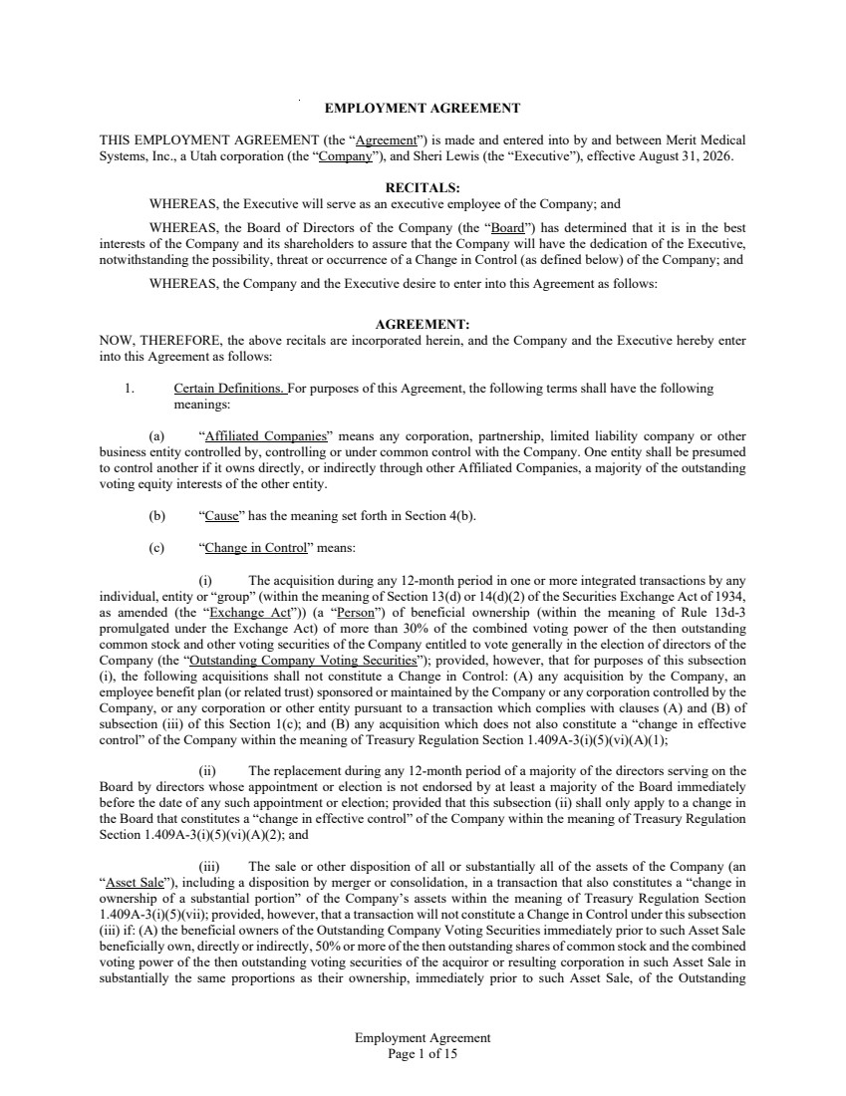 | Employment Agreement Page 1 of 15 EMPLOYMENT AGREEMENT THIS EMPLOYMENT AGREEMENT (the “Agreement”) is made and entered into by and between Merit Medical Systems, Inc., a Utah corporation (the “Company”), and Sheri Lewis (the “Executive”), effective August 31, 2026. RECITALS: WHEREAS, the Executive will serve as an executive employee of the Company; and WHEREAS, the Board of Directors of the Company (the “Board”) has determined that it is in the best interests of the Company and its shareholders to assure that the Company will have the dedication of the Executive, notwithstanding the possibility, threat or occurrence of a Change in Control (as defined below) of the Company; and WHEREAS, the Company and the Executive desire to enter into this Agreement as follows: AGREEMENT: NOW, THEREFORE, the above recitals are incorporated herein, and the Company and the Executive hereby enter into this Agreement as follows: 1. Certain Definitions. For purposes of this Agreement, the following terms shall have the following meanings: (a) “Affiliated Companies” means any corporation, partnership, limited liability company or other business entity controlled by, controlling or under common control with the Company. One entity shall be presumed to control another if it owns directly, or indirectly through other Affiliated Companies, a majority of the outstanding voting equity interests of the other entity. (b) “Cause” has the meaning set forth in Section 4(b). (c) “Change in Control” means: (i) The acquisition during any 12-month period in one or more integrated transactions by any individual, entity or “group” (within the meaning of Section 13(d) or 14(d)(2) of the Securities Exchange Act of 1934, as amended (the “Exchange Act”)) (a “Person”) of beneficial ownership (within the meaning of Rule 13d-3 promulgated under the Exchange Act) of more than 30% of the combined voting power of the then outstanding common stock and other voting securities of the Company entitled to vote generally in the election of directors of the Company (the “Outstanding Company Voting Securities”); provided, however, that for purposes of this subsection (i), the following acquisitions shall not constitute a Change in Control: (A) any acquisition by the Company, an employee benefit plan (or related trust) sponsored or maintained by the Company or any corporation controlled by the Company, or any corporation or other entity pursuant to a transaction which complies with clauses (A) and (B) of subsection (iii) of this Section 1(c); and (B) any acquisition which does not also constitute a “change in effective control” of the Company within the meaning of Treasury Regulation Section 1.409A-3(i)(5)(vi)(A)(1); (ii) The replacement during any 12-month period of a majority of the directors serving on the Board by directors whose appointment or election is not endorsed by at least a majority of the Board immediately before the date of any such appointment or election; provided that this subsection (ii) shall only apply to a change in the Board that constitutes a “change in effective control” of the Company within the meaning of Treasury Regulation Section 1.409A-3(i)(5)(vi)(A)(2); and (iii) The sale or other disposition of all or substantially all of the assets of the Company (an “Asset Sale”), including a disposition by merger or consolidation, in a transaction that also constitutes a “change in ownership of a substantial portion” of the Company’s assets within the meaning of Treasury Regulation Section 1.409A-3(i)(5)(vii); provided, however, that a transaction will not constitute a Change in Control under this subsection (iii) if: (A) the beneficial owners of the Outstanding Company Voting Securities immediately prior to such Asset Sale beneficially own, directly or indirectly, 50% or more of the then outstanding shares of common stock and the combined voting power of the then outstanding voting securities of the acquiror or resulting corporation in such Asset Sale in substantially the same proportions as their ownership, immediately prior to such Asset Sale, of the Outstanding
 | 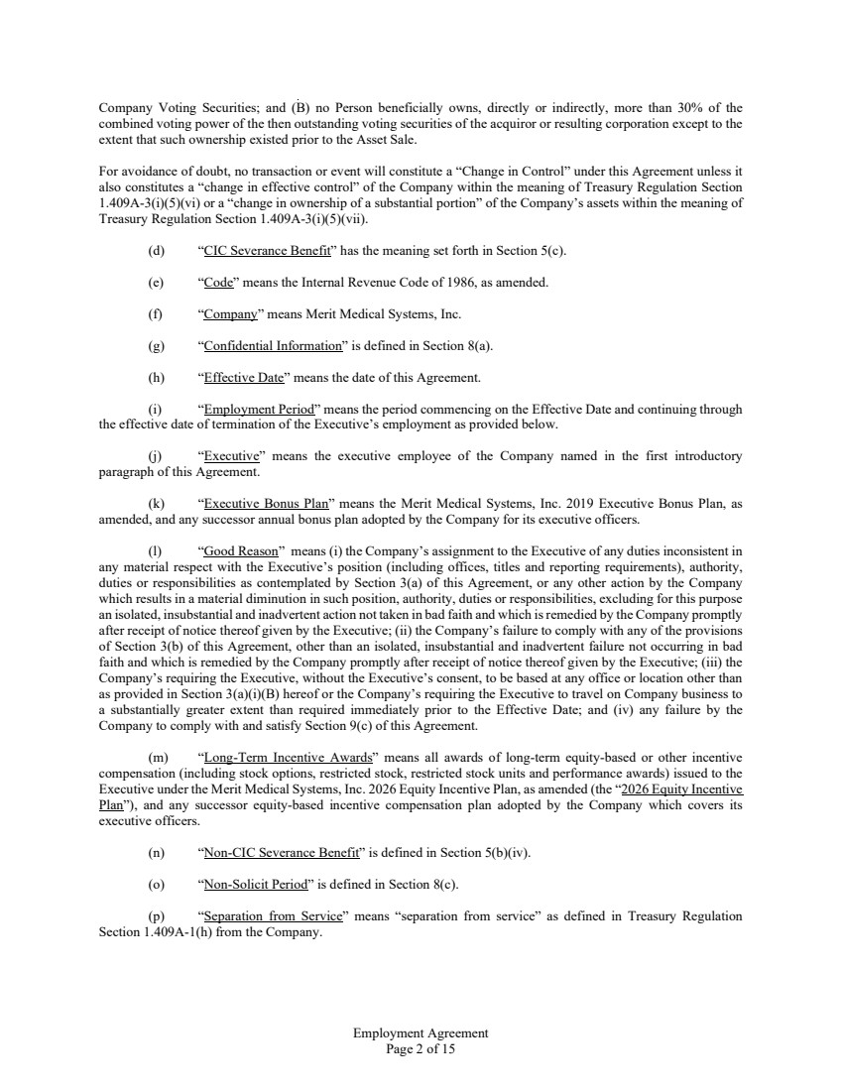 | Employment Agreement Page 2 of 15 Company Voting Securities; and (B) no Person beneficially owns, directly or indirectly, more than 30% of the combined voting power of the then outstanding voting securities of the acquiror or resulting corporation except to the extent that such ownership existed prior to the Asset Sale. For avoidance of doubt, no transaction or event will constitute a “Change in Control” under this Agreement unless it also constitutes a “change in effective control” of the Company within the meaning of Treasury Regulation Section 1.409A-3(i)(5)(vi) or a “change in ownership of a substantial portion” of the Company’s assets within the meaning of Treasury Regulation Section 1.409A-3(i)(5)(vii). (d) “CIC Severance Benefit” has the meaning set forth in Section 5(c). (e) “Code” means the Internal Revenue Code of 1986, as amended. (f) “Company” means Merit Medical Systems, Inc. (g) “Confidential Information” is defined in Section 8(a). (h) “Effective Date” means the date of this Agreement. (i) “Employment Period” means the period commencing on the Effective Date and continuing through the effective date of termination of the Executive’s employment as provided below. (j) “Executive” means the executive employee of the Company named in the first introductory paragraph of this Agreement. (k) “Executive Bonus Plan” means the Merit Medical Systems, Inc. 2019 Executive Bonus Plan, as amended, and any successor annual bonus plan adopted by the Company for its executive officers. (l) “Good Reason” means (i) the Company’s assignment to the Executive of any duties inconsistent in any material respect with the Executive’s position (including offices, titles and reporting requirements), authority, duties or responsibilities as contemplated by Section 3(a) of this Agreement, or any other action by the Company which results in a material diminution in such position, authority, duties or responsibilities, excluding for this purpose an isolated, insubstantial and inadvertent action not taken in bad faith and which is remedied by the Company promptly after receipt of notice thereof given by the Executive; (ii) the Company’s failure to comply with any of the provisions of Section 3(b) of this Agreement, other than an isolated, insubstantial and inadvertent failure not occurring in bad faith and which is remedied by the Company promptly after receipt of notice thereof given by the Executive; (iii) the Company’s requiring the Executive, without the Executive’s consent, to be based at any office or location other than as provided in Section 3(a)(i)(B) hereof or the Company’s requiring the Executive to travel on Company business to a substantially greater extent than required immediately prior to the Effective Date; and (iv) any failure by the Company to comply with and satisfy Section 9(c) of this Agreement. (m) “Long-Term Incentive Awards” means all awards of long-term equity-based or other incentive compensation (including stock options, restricted stock, restricted stock units and performance awards) issued to the Executive under the Merit Medical Systems, Inc. 2026 Equity Incentive Plan, as amended (the “2026 Equity Incentive Plan”), and any successor equity-based incentive compensation plan adopted by the Company which covers its executive officers. (n) “Non-CIC Severance Benefit” is defined in Section 5(b)(iv). (o) “Non-Solicit Period” is defined in Section 8(c). (p) “Separation from Service” means “separation from service” as defined in Treasury Regulation Section 1.409A-1(h) from the Company.
 | 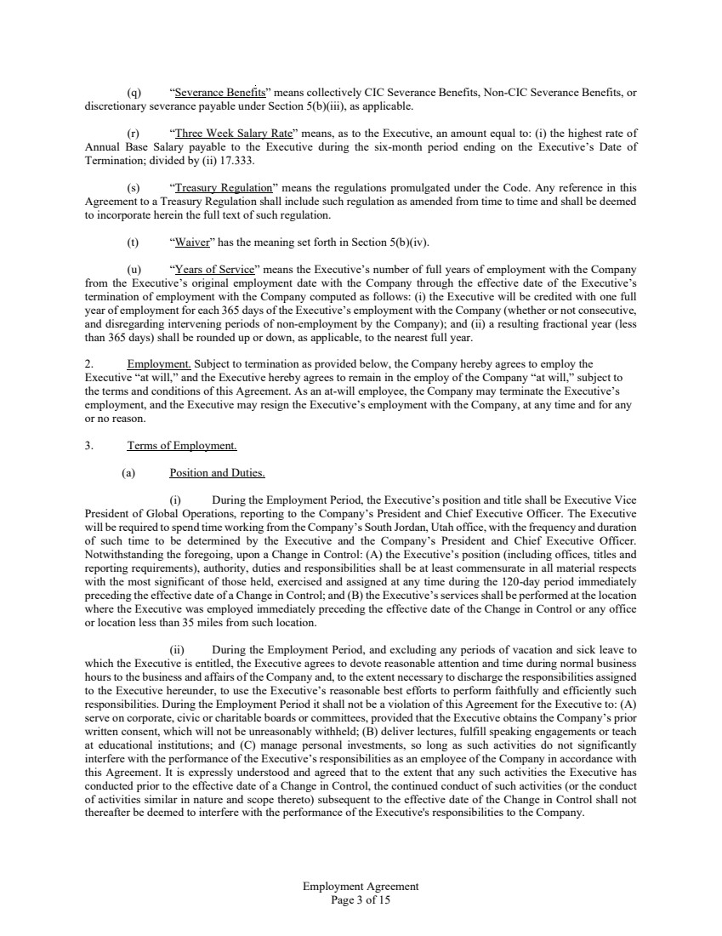 | Employment Agreement Page 3 of 15 (q) “Severance Benefits” means collectively CIC Severance Benefits, Non-CIC Severance Benefits, or discretionary severance payable under Section 5(b)(iii), as applicable. (r) “Three Week Salary Rate” means, as to the Executive, an amount equal to: (i) the highest rate of Annual Base Salary payable to the Executive during the six-month period ending on the Executive’s Date of Termination; divided by (ii) 17.333. (s) “Treasury Regulation” means the regulations promulgated under the Code. Any reference in this Agreement to a Treasury Regulation shall include such regulation as amended from time to time and shall be deemed to incorporate herein the full text of such regulation. (t) “Waiver” has the meaning set forth in Section 5(b)(iv). (u) “Years of Service” means the Executive’s number of full years of employment with the Company from the Executive’s original employment date with the Company through the effective date of the Executive’s termination of employment with the Company computed as follows: (i) the Executive will be credited with one full year of employment for each 365 days of the Executive’s employment with the Company (whether or not consecutive, and disregarding intervening periods of non-employment by the Company); and (ii) a resulting fractional year (less than 365 days) shall be rounded up or down, as applicable, to the nearest full year. 2. Employment. Subject to termination as provided below, the Company hereby agrees to employ the Executive “at will,” and the Executive hereby agrees to remain in the employ of the Company “at will,” subject to the terms and conditions of this Agreement. As an at-will employee, the Company may terminate the Executive’s employment, and the Executive may resign the Executive’s employment with the Company, at any time and for any or no reason. 3. Terms of Employment. (a) Position and Duties. (i) During the Employment Period, the Executive’s position and title shall be Executive Vice President of Global Operations, reporting to the Company’s President and Chief Executive Officer. The Executive will be required to spend time working from the Company’s South Jordan, Utah office, with the frequency and duration of such time to be determined by the Executive and the Company’s President and Chief Executive Officer. Notwithstanding the foregoing, upon a Change in Control: (A) the Executive’s position (including offices, titles and reporting requirements), authority, duties and responsibilities shall be at least commensurate in all material respects with the most significant of those held, exercised and assigned at any time during the 120-day period immediately preceding the effective date of a Change in Control; and (B) the Executive’s services shall be performed at the location where the Executive was employed immediately preceding the effective date of the Change in Control or any office or location less than 35 miles from such location. (ii) During the Employment Period, and excluding any periods of vacation and sick leave to which the Executive is entitled, the Executive agrees to devote reasonable attention and time during normal business hours to the business and affairs of the Company and, to the extent necessary to discharge the responsibilities assigned to the Executive hereunder, to use the Executive’s reasonable best efforts to perform faithfully and efficiently such responsibilities. During the Employment Period it shall not be a violation of this Agreement for the Executive to: (A) serve on corporate, civic or charitable boards or committees, provided that the Executive obtains the Company’s prior written consent, which will not be unreasonably withheld; (B) deliver lectures, fulfill speaking engagements or teach at educational institutions; and (C) manage personal investments, so long as such activities do not significantly interfere with the performance of the Executive’s responsibilities as an employee of the Company in accordance with this Agreement. It is expressly understood and agreed that to the extent that any such activities the Executive has conducted prior to the effective date of a Change in Control, the continued conduct of such activities (or the conduct of activities similar in nature and scope thereto) subsequent to the effective date of the Change in Control shall not thereafter be deemed to interfere with the performance of the Executive's responsibilities to the Company.
 | 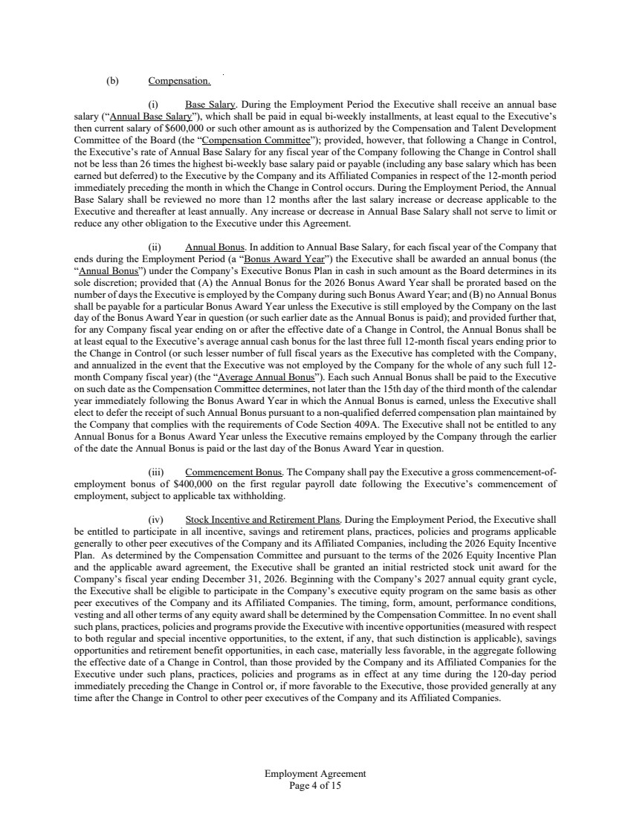 | Employment Agreement Page 4 of 15 (b) Compensation. (i) Base Salary. During the Employment Period the Executive shall receive an annual base salary (“Annual Base Salary”), which shall be paid in equal bi-weekly installments, at least equal to the Executive’s then current salary of $600,000 or such other amount as is authorized by the Compensation and Talent Development Committee of the Board (the “Compensation Committee”); provided, however, that following a Change in Control, the Executive’s rate of Annual Base Salary for any fiscal year of the Company following the Change in Control shall not be less than 26 times the highest bi-weekly base salary paid or payable (including any base salary which has been earned but deferred) to the Executive by the Company and its Affiliated Companies in respect of the 12-month period immediately preceding the month in which the Change in Control occurs. During the Employment Period, the Annual Base Salary shall be reviewed no more than 12 months after the last salary increase or decrease applicable to the Executive and thereafter at least annually. Any increase or decrease in Annual Base Salary shall not serve to limit or reduce any other obligation to the Executive under this Agreement. (ii) Annual Bonus. In addition to Annual Base Salary, for each fiscal year of the Company that ends during the Employment Period (a “Bonus Award Year”) the Executive shall be awarded an annual bonus (the “Annual Bonus”) under the Company’s Executive Bonus Plan in cash in such amount as the Board determines in its sole discretion; provided that (A) the Annual Bonus for the 2026 Bonus Award Year shall be prorated based on the number of days the Executive is employed by the Company during such Bonus Award Year; and (B) no Annual Bonus shall be payable for a particular Bonus Award Year unless the Executive is still employed by the Company on the last day of the Bonus Award Year in question (or such earlier date as the Annual Bonus is paid); and provided further that, for any Company fiscal year ending on or after the effective date of a Change in Control, the Annual Bonus shall be at least equal to the Executive’s average annual cash bonus for the last three full 12-month fiscal years ending prior to the Change in Control (or such lesser number of full fiscal years as the Executive has completed with the Company, and annualized in the event that the Executive was not employed by the Company for the whole of any such full 12- month Company fiscal year) (the “Average Annual Bonus”). Each such Annual Bonus shall be paid to the Executive on such date as the Compensation Committee determines, not later than the 15th day of the third month of the calendar year immediately following the Bonus Award Year in which the Annual Bonus is earned, unless the Executive shall elect to defer the receipt of such Annual Bonus pursuant to a non-qualified deferred compensation plan maintained by the Company that complies with the requirements of Code Section 409A. The Executive shall not be entitled to any Annual Bonus for a Bonus Award Year unless the Executive remains employed by the Company through the earlier of the date the Annual Bonus is paid or the last day of the Bonus Award Year in question. (iii) Commencement Bonus. The Company shall pay the Executive a gross commencement-of-employment bonus of $400,000 on the first regular payroll date following the Executive’s commencement of employment, subject to applicable tax withholding. (iv) Stock Incentive and Retirement Plans. During the Employment Period, the Executive shall be entitled to participate in all incentive, savings and retirement plans, practices, policies and programs applicable generally to other peer executives of the Company and its Affiliated Companies, including the 2026 Equity Incentive Plan. As determined by the Compensation Committee and pursuant to the terms of the 2026 Equity Incentive Plan and the applicable award agreement, the Executive shall be granted an initial restricted stock unit award for the Company’s fiscal year ending December 31, 2026. Beginning with the Company’s 2027 annual equity grant cycle, the Executive shall be eligible to participate in the Company’s executive equity program on the same basis as other peer executives of the Company and its Affiliated Companies. The timing, form, amount, performance conditions, vesting and all other terms of any equity award shall be determined by the Compensation Committee. In no event shall such plans, practices, policies and programs provide the Executive with incentive opportunities (measured with respect to both regular and special incentive opportunities, to the extent, if any, that such distinction is applicable), savings opportunities and retirement benefit opportunities, in each case, materially less favorable, in the aggregate following the effective date of a Change in Control, than those provided by the Company and its Affiliated Companies for the Executive under such plans, practices, policies and programs as in effect at any time during the 120-day period immediately preceding the Change in Control or, if more favorable to the Executive, those provided generally at any time after the Change in Control to other peer executives of the Company and its Affiliated Companies.
 | 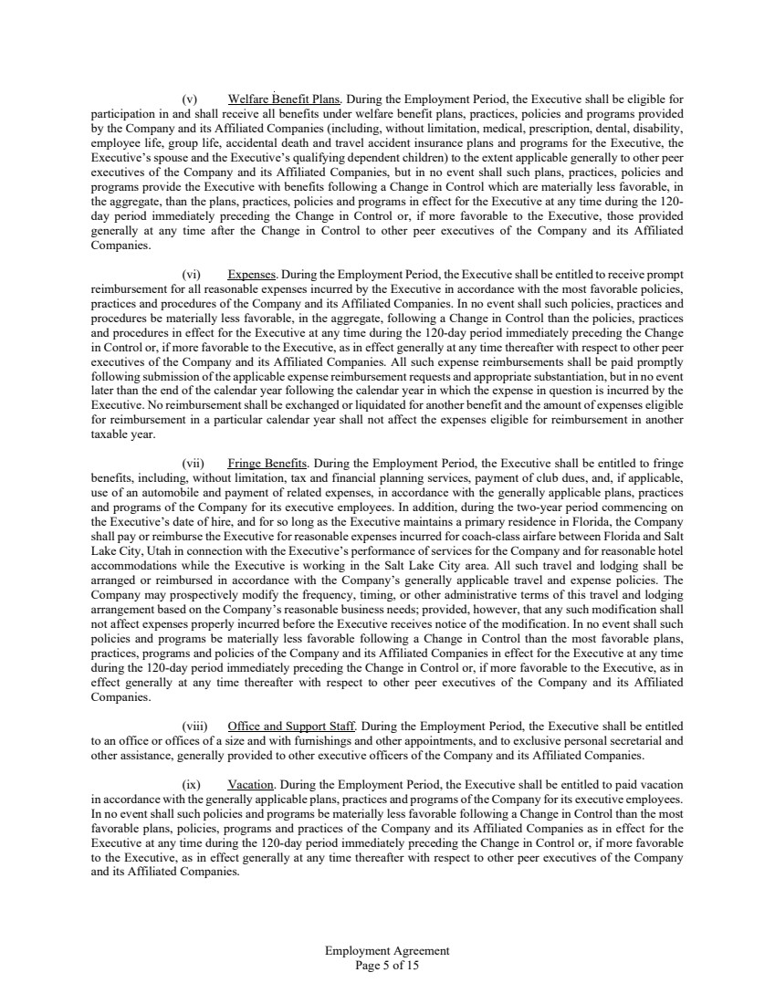 | Employment Agreement Page 5 of 15 (v) Welfare Benefit Plans. During the Employment Period, the Executive shall be eligible for participation in and shall receive all benefits under welfare benefit plans, practices, policies and programs provided by the Company and its Affiliated Companies (including, without limitation, medical, prescription, dental, disability, employee life, group life, accidental death and travel accident insurance plans and programs for the Executive, the Executive’s spouse and the Executive’s qualifying dependent children) to the extent applicable generally to other peer executives of the Company and its Affiliated Companies, but in no event shall such plans, practices, policies and programs provide the Executive with benefits following a Change in Control which are materially less favorable, in the aggregate, than the plans, practices, policies and programs in effect for the Executive at any time during the 120- day period immediately preceding the Change in Control or, if more favorable to the Executive, those provided generally at any time after the Change in Control to other peer executives of the Company and its Affiliated Companies. (vi) Expenses. During the Employment Period, the Executive shall be entitled to receive prompt reimbursement for all reasonable expenses incurred by the Executive in accordance with the most favorable policies, practices and procedures of the Company and its Affiliated Companies. In no event shall such policies, practices and procedures be materially less favorable, in the aggregate, following a Change in Control than the policies, practices and procedures in effect for the Executive at any time during the 120-day period immediately preceding the Change in Control or, if more favorable to the Executive, as in effect generally at any time thereafter with respect to other peer executives of the Company and its Affiliated Companies. All such expense reimbursements shall be paid promptly following submission of the applicable expense reimbursement requests and appropriate substantiation, but in no event later than the end of the calendar year following the calendar year in which the expense in question is incurred by the Executive. No reimbursement shall be exchanged or liquidated for another benefit and the amount of expenses eligible for reimbursement in a particular calendar year shall not affect the expenses eligible for reimbursement in another taxable year. (vii) Fringe Benefits. During the Employment Period, the Executive shall be entitled to fringe benefits, including, without limitation, tax and financial planning services, payment of club dues, and, if applicable, use of an automobile and payment of related expenses, in accordance with the generally applicable plans, practices and programs of the Company for its executive employees. In addition, during the two-year period commencing on the Executive’s date of hire, and for so long as the Executive maintains a primary residence in Florida, the Company shall pay or reimburse the Executive for reasonable expenses incurred for coach-class airfare between Florida and Salt Lake City, Utah in connection with the Executive’s performance of services for the Company and for reasonable hotel accommodations while the Executive is working in the Salt Lake City area. All such travel and lodging shall be arranged or reimbursed in accordance with the Company’s generally applicable travel and expense policies. The Company may prospectively modify the frequency, timing, or other administrative terms of this travel and lodging arrangement based on the Company’s reasonable business needs; provided, however, that any such modification shall not affect expenses properly incurred before the Executive receives notice of the modification. In no event shall such policies and programs be materially less favorable following a Change in Control than the most favorable plans, practices, programs and policies of the Company and its Affiliated Companies in effect for the Executive at any time during the 120-day period immediately preceding the Change in Control or, if more favorable to the Executive, as in effect generally at any time thereafter with respect to other peer executives of the Company and its Affiliated Companies. (viii) Office and Support Staff. During the Employment Period, the Executive shall be entitled to an office or offices of a size and with furnishings and other appointments, and to exclusive personal secretarial and other assistance, generally provided to other executive officers of the Company and its Affiliated Companies. (ix) Vacation. During the Employment Period, the Executive shall be entitled to paid vacation in accordance with the generally applicable plans, practices and programs of the Company for its executive employees. In no event shall such policies and programs be materially less favorable following a Change in Control than the most favorable plans, policies, programs and practices of the Company and its Affiliated Companies as in effect for the Executive at any time during the 120-day period immediately preceding the Change in Control or, if more favorable to the Executive, as in effect generally at any time thereafter with respect to other peer executives of the Company and its Affiliated Companies.
 | 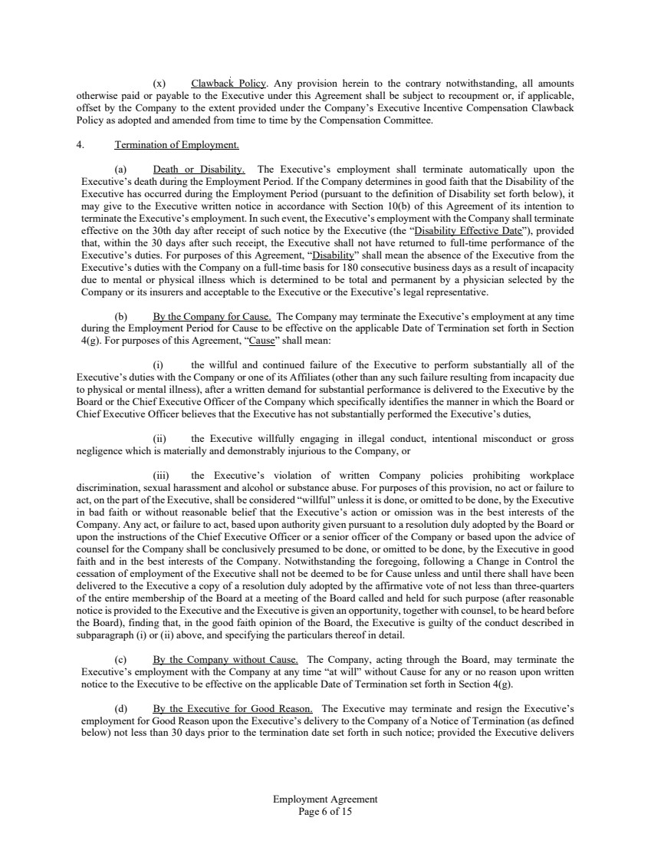 | Employment Agreement Page 6 of 15 (x) Clawback Policy. Any provision herein to the contrary notwithstanding, all amounts otherwise paid or payable to the Executive under this Agreement shall be subject to recoupment or, if applicable, offset by the Company to the extent provided under the Company’s Executive Incentive Compensation Clawback Policy as adopted and amended from time to time by the Compensation Committee. 4. Termination of Employment. (a) Death or Disability. The Executive’s employment shall terminate automatically upon the Executive’s death during the Employment Period. If the Company determines in good faith that the Disability of the Executive has occurred during the Employment Period (pursuant to the definition of Disability set forth below), it may give to the Executive written notice in accordance with Section 10(b) of this Agreement of its intention to terminate the Executive’s employment. In such event, the Executive’s employment with the Company shall terminate effective on the 30th day after receipt of such notice by the Executive (the “Disability Effective Date”), provided that, within the 30 days after such receipt, the Executive shall not have returned to full-time performance of the Executive’s duties. For purposes of this Agreement, “Disability” shall mean the absence of the Executive from the Executive’s duties with the Company on a full-time basis for 180 consecutive business days as a result of incapacity due to mental or physical illness which is determined to be total and permanent by a physician selected by the Company or its insurers and acceptable to the Executive or the Executive’s legal representative. (b) By the Company for Cause. The Company may terminate the Executive’s employment at any time during the Employment Period for Cause to be effective on the applicable Date of Termination set forth in Section 4(g). For purposes of this Agreement, “Cause” shall mean: (i) the willful and continued failure of the Executive to perform substantially all of the Executive’s duties with the Company or one of its Affiliates (other than any such failure resulting from incapacity due to physical or mental illness), after a written demand for substantial performance is delivered to the Executive by the Board or the Chief Executive Officer of the Company which specifically identifies the manner in which the Board or Chief Executive Officer believes that the Executive has not substantially performed the Executive’s duties, (ii) the Executive willfully engaging in illegal conduct, intentional misconduct or gross negligence which is materially and demonstrably injurious to the Company, or (iii) the Executive’s violation of written Company policies prohibiting workplace discrimination, sexual harassment and alcohol or substance abuse. For purposes of this provision, no act or failure to act, on the part of the Executive, shall be considered “willful” unless it is done, or omitted to be done, by the Executive in bad faith or without reasonable belief that the Executive’s action or omission was in the best interests of the Company. Any act, or failure to act, based upon authority given pursuant to a resolution duly adopted by the Board or upon the instructions of the Chief Executive Officer or a senior officer of the Company or based upon the advice of counsel for the Company shall be conclusively presumed to be done, or omitted to be done, by the Executive in good faith and in the best interests of the Company. Notwithstanding the foregoing, following a Change in Control the cessation of employment of the Executive shall not be deemed to be for Cause unless and until there shall have been delivered to the Executive a copy of a resolution duly adopted by the affirmative vote of not less than three-quarters of the entire membership of the Board at a meeting of the Board called and held for such purpose (after reasonable notice is provided to the Executive and the Executive is given an opportunity, together with counsel, to be heard before the Board), finding that, in the good faith opinion of the Board, the Executive is guilty of the conduct described in subparagraph (i) or (ii) above, and specifying the particulars thereof in detail. (c) By the Company without Cause. The Company, acting through the Board, may terminate the Executive’s employment with the Company at any time “at will” without Cause for any or no reason upon written notice to the Executive to be effective on the applicable Date of Termination set forth in Section 4(g). (d) By the Executive for Good Reason. The Executive may terminate and resign the Executive’s employment for Good Reason upon the Executive’s delivery to the Company of a Notice of Termination (as defined below) not less than 30 days prior to the termination date set forth in such notice; provided the Executive delivers
 | 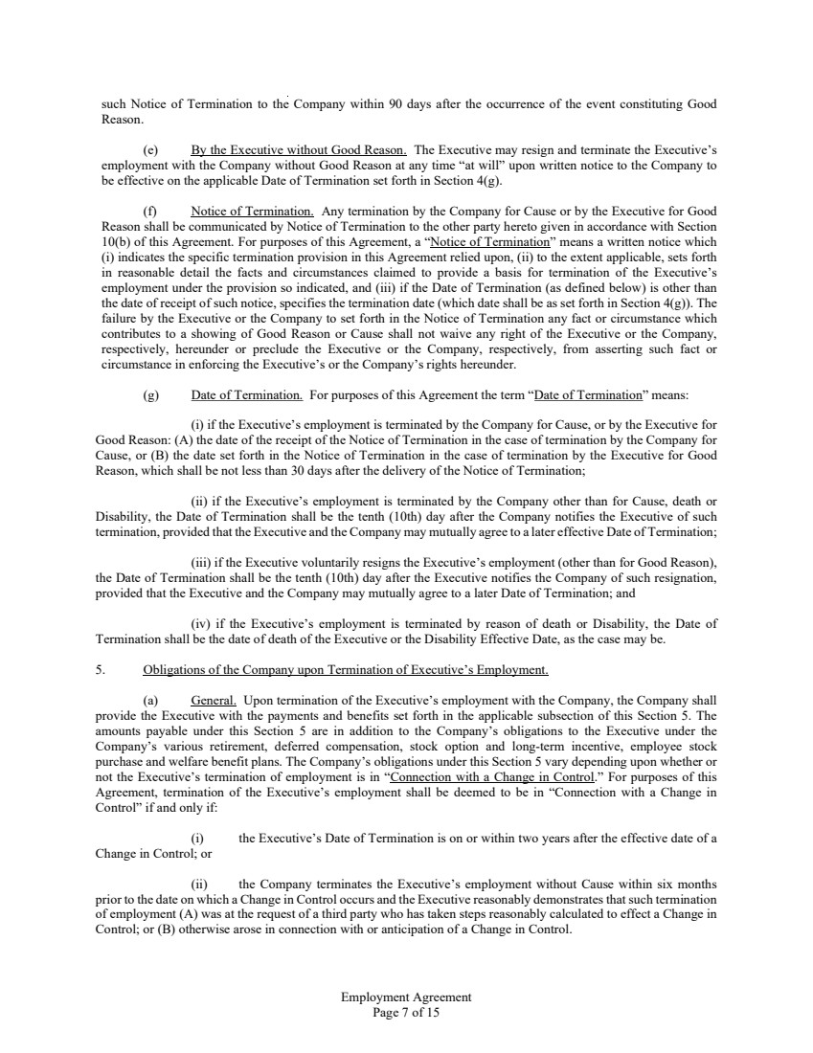 | Employment Agreement Page 7 of 15 such Notice of Termination to the Company within 90 days after the occurrence of the event constituting Good Reason. (e) By the Executive without Good Reason. The Executive may resign and terminate the Executive’s employment with the Company without Good Reason at any time “at will” upon written notice to the Company to be effective on the applicable Date of Termination set forth in Section 4(g). (f) Notice of Termination. Any termination by the Company for Cause or by the Executive for Good Reason shall be communicated by Notice of Termination to the other party hereto given in accordance with Section 10(b) of this Agreement. For purposes of this Agreement, a “Notice of Termination” means a written notice which (i) indicates the specific termination provision in this Agreement relied upon, (ii) to the extent applicable, sets forth in reasonable detail the facts and circumstances claimed to provide a basis for termination of the Executive’s employment under the provision so indicated, and (iii) if the Date of Termination (as defined below) is other than the date of receipt of such notice, specifies the termination date (which date shall be as set forth in Section 4(g)). The failure by the Executive or the Company to set forth in the Notice of Termination any fact or circumstance which contributes to a showing of Good Reason or Cause shall not waive any right of the Executive or the Company, respectively, hereunder or preclude the Executive or the Company, respectively, from asserting such fact or circumstance in enforcing the Executive’s or the Company’s rights hereunder. (g) Date of Termination. For purposes of this Agreement the term “Date of Termination” means: (i) if the Executive’s employment is terminated by the Company for Cause, or by the Executive for Good Reason: (A) the date of the receipt of the Notice of Termination in the case of termination by the Company for Cause, or (B) the date set forth in the Notice of Termination in the case of termination by the Executive for Good Reason, which shall be not less than 30 days after the delivery of the Notice of Termination; (ii) if the Executive’s employment is terminated by the Company other than for Cause, death or Disability, the Date of Termination shall be the tenth (10th) day after the Company notifies the Executive of such termination, provided that the Executive and the Company may mutually agree to a later effective Date of Termination; (iii) if the Executive voluntarily resigns the Executive’s employment (other than for Good Reason), the Date of Termination shall be the tenth (10th) day after the Executive notifies the Company of such resignation, provided that the Executive and the Company may mutually agree to a later Date of Termination; and (iv) if the Executive’s employment is terminated by reason of death or Disability, the Date of Termination shall be the date of death of the Executive or the Disability Effective Date, as the case may be. 5. Obligations of the Company upon Termination of Executive’s Employment. (a) General. Upon termination of the Executive’s employment with the Company, the Company shall provide the Executive with the payments and benefits set forth in the applicable subsection of this Section 5. The amounts payable under this Section 5 are in addition to the Company’s obligations to the Executive under the Company’s various retirement, deferred compensation, stock option and long-term incentive, employee stock purchase and welfare benefit plans. The Company’s obligations under this Section 5 vary depending upon whether or not the Executive’s termination of employment is in “Connection with a Change in Control.” For purposes of this Agreement, termination of the Executive’s employment shall be deemed to be in “Connection with a Change in Control” if and only if: (i) the Executive’s Date of Termination is on or within two years after the effective date of a Change in Control; or (ii) the Company terminates the Executive’s employment without Cause within six months prior to the date on which a Change in Control occurs and the Executive reasonably demonstrates that such termination of employment (A) was at the request of a third party who has taken steps reasonably calculated to effect a Change in Control; or (B) otherwise arose in connection with or anticipation of a Change in Control.
 | 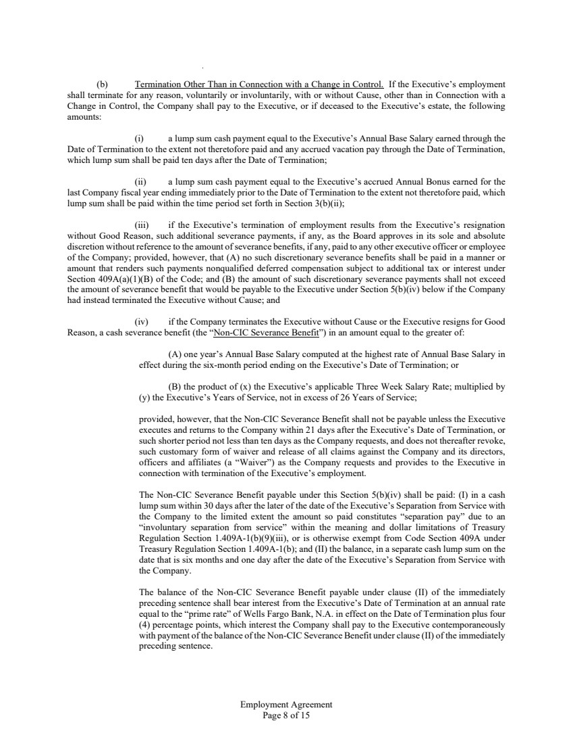 | Employment Agreement Page 8 of 15 (b) Termination Other Than in Connection with a Change in Control. If the Executive’s employment shall terminate for any reason, voluntarily or involuntarily, with or without Cause, other than in Connection with a Change in Control, the Company shall pay to the Executive, or if deceased to the Executive’s estate, the following amounts: (i) a lump sum cash payment equal to the Executive’s Annual Base Salary earned through the Date of Termination to the extent not theretofore paid and any accrued vacation pay through the Date of Termination, which lump sum shall be paid ten days after the Date of Termination; (ii) a lump sum cash payment equal to the Executive’s accrued Annual Bonus earned for the last Company fiscal year ending immediately prior to the Date of Termination to the extent not theretofore paid, which lump sum shall be paid within the time period set forth in Section 3(b)(ii); (iii) if the Executive’s termination of employment results from the Executive’s resignation without Good Reason, such additional severance payments, if any, as the Board approves in its sole and absolute discretion without reference to the amount of severance benefits, if any, paid to any other executive officer or employee of the Company; provided, however, that (A) no such discretionary severance benefits shall be paid in a manner or amount that renders such payments nonqualified deferred compensation subject to additional tax or interest under Section 409A(a)(1)(B) of the Code; and (B) the amount of such discretionary severance payments shall not exceed the amount of severance benefit that would be payable to the Executive under Section 5(b)(iv) below if the Company had instead terminated the Executive without Cause; and (iv) if the Company terminates the Executive without Cause or the Executive resigns for Good Reason, a cash severance benefit (the “Non-CIC Severance Benefit”) in an amount equal to the greater of: (A) one year’s Annual Base Salary computed at the highest rate of Annual Base Salary in effect during the six-month period ending on the Executive’s Date of Termination; or (B) the product of (x) the Executive’s applicable Three Week Salary Rate; multiplied by (y) the Executive’s Years of Service, not in excess of 26 Years of Service; provided, however, that the Non-CIC Severance Benefit shall not be payable unless the Executive executes and returns to the Company within 21 days after the Executive’s Date of Termination, or such shorter period not less than ten days as the Company requests, and does not thereafter revoke, such customary form of waiver and release of all claims against the Company and its directors, officers and affiliates (a “Waiver”) as the Company requests and provides to the Executive in connection with termination of the Executive’s employment. The Non-CIC Severance Benefit payable under this Section 5(b)(iv) shall be paid: (I) in a cash lump sum within 30 days after the later of the date of the Executive’s Separation from Service with the Company to the limited extent the amount so paid constitutes “separation pay” due to an “involuntary separation from service” within the meaning and dollar limitations of Treasury Regulation Section 1.409A-1(b)(9)(iii), or is otherwise exempt from Code Section 409A under Treasury Regulation Section 1.409A-1(b); and (II) the balance, in a separate cash lump sum on the date that is six months and one day after the date of the Executive’s Separation from Service with the Company. The balance of the Non-CIC Severance Benefit payable under clause (II) of the immediately preceding sentence shall bear interest from the Executive’s Date of Termination at an annual rate equal to the “prime rate” of Wells Fargo Bank, N.A. in effect on the Date of Termination plus four (4) percentage points, which interest the Company shall pay to the Executive contemporaneously with payment of the balance of the Non-CIC Severance Benefit under clause (II) of the immediately preceding sentence.
 | 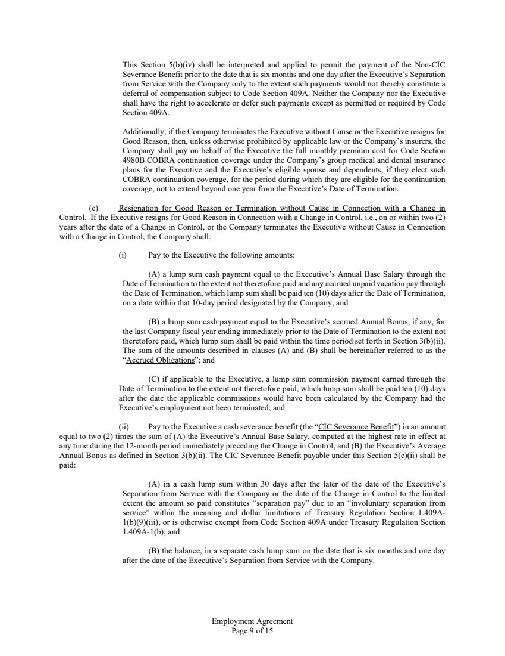 | Employment Agreement Page 9 of 15 This Section 5(b)(iv) shall be interpreted and applied to permit the payment of the Non-CIC Severance Benefit prior to the date that is six months and one day after the Executive’s Separation from Service with the Company only to the extent such payments would not thereby constitute a deferral of compensation subject to Code Section 409A. Neither the Company nor the Executive shall have the right to accelerate or defer such payments except as permitted or required by Code Section 409A. Additionally, if the Company terminates the Executive without Cause or the Executive resigns for Good Reason, then, unless otherwise prohibited by applicable law or the Company’s insurers, the Company shall pay on behalf of the Executive the full monthly premium cost for Code Section 4980B COBRA continuation coverage under the Company’s group medical and dental insurance plans for the Executive and the Executive’s eligible spouse and dependents, if they elect such COBRA continuation coverage, for the period during which they are eligible for the continuation coverage, not to extend beyond one year from the Executive’s Date of Termination. (c) Resignation for Good Reason or Termination without Cause in Connection with a Change in Control. If the Executive resigns for Good Reason in Connection with a Change in Control, i.e., on or within two (2) years after the date of a Change in Control, or the Company terminates the Executive without Cause in Connection with a Change in Control, the Company shall: (i) Pay to the Executive the following amounts: (A) a lump sum cash payment equal to the Executive’s Annual Base Salary through the Date of Termination to the extent not theretofore paid and any accrued unpaid vacation pay through the Date of Termination, which lump sum shall be paid ten (10) days after the Date of Termination, on a date within that 10-day period designated by the Company; and (B) a lump sum cash payment equal to the Executive’s accrued Annual Bonus, if any, for the last Company fiscal year ending immediately prior to the Date of Termination to the extent not theretofore paid, which lump sum shall be paid within the time period set forth in Section 3(b)(ii). The sum of the amounts described in clauses (A) and (B) shall be hereinafter referred to as the “Accrued Obligations”; and (C) if applicable to the Executive, a lump sum commission payment earned through the Date of Termination to the extent not theretofore paid, which lump sum shall be paid ten (10) days after the date the applicable commissions would have been calculated by the Company had the Executive’s employment not been terminated; and (ii) Pay to the Executive a cash severance benefit (the “CIC Severance Benefit”) in an amount equal to two (2) times the sum of (A) the Executive’s Annual Base Salary, computed at the highest rate in effect at any time during the 12-month period immediately preceding the Change in Control; and (B) the Executive’s Average Annual Bonus as defined in Section 3(b)(ii). The CIC Severance Benefit payable under this Section 5(c)(ii) shall be paid: (A) in a cash lump sum within 30 days after the later of the date of the Executive’s Separation from Service with the Company or the date of the Change in Control to the limited extent the amount so paid constitutes “separation pay” due to an “involuntary separation from service” within the meaning and dollar limitations of Treasury Regulation Section 1.409A-1(b)(9)(iii), or is otherwise exempt from Code Section 409A under Treasury Regulation Section 1.409A-1(b); and (B) the balance, in a separate cash lump sum on the date that is six months and one day after the date of the Executive’s Separation from Service with the Company.
 | 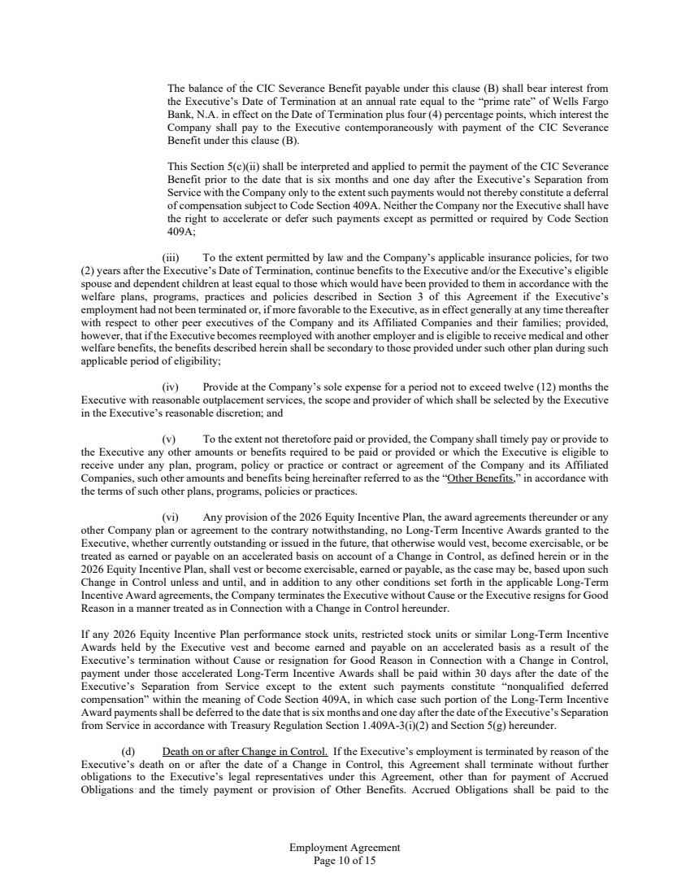 | Employment Agreement Page 10 of 15 The balance of the CIC Severance Benefit payable under this clause (B) shall bear interest from the Executive’s Date of Termination at an annual rate equal to the “prime rate” of Wells Fargo Bank, N.A. in effect on the Date of Termination plus four (4) percentage points, which interest the Company shall pay to the Executive contemporaneously with payment of the CIC Severance Benefit under this clause (B). This Section 5(c)(ii) shall be interpreted and applied to permit the payment of the CIC Severance Benefit prior to the date that is six months and one day after the Executive’s Separation from Service with the Company only to the extent such payments would not thereby constitute a deferral of compensation subject to Code Section 409A. Neither the Company nor the Executive shall have the right to accelerate or defer such payments except as permitted or required by Code Section 409A; (iii) To the extent permitted by law and the Company’s applicable insurance policies, for two (2) years after the Executive’s Date of Termination, continue benefits to the Executive and/or the Executive’s eligible spouse and dependent children at least equal to those which would have been provided to them in accordance with the welfare plans, programs, practices and policies described in Section 3 of this Agreement if the Executive’s employment had not been terminated or, if more favorable to the Executive, as in effect generally at any time thereafter with respect to other peer executives of the Company and its Affiliated Companies and their families; provided, however, that if the Executive becomes reemployed with another employer and is eligible to receive medical and other welfare benefits, the benefits described herein shall be secondary to those provided under such other plan during such applicable period of eligibility; (iv) Provide at the Company’s sole expense for a period not to exceed twelve (12) months the Executive with reasonable outplacement services, the scope and provider of which shall be selected by the Executive in the Executive’s reasonable discretion; and (v) To the extent not theretofore paid or provided, the Company shall timely pay or provide to the Executive any other amounts or benefits required to be paid or provided or which the Executive is eligible to receive under any plan, program, policy or practice or contract or agreement of the Company and its Affiliated Companies, such other amounts and benefits being hereinafter referred to as the “Other Benefits,” in accordance with the terms of such other plans, programs, policies or practices. (vi) Any provision of the 2026 Equity Incentive Plan, the award agreements thereunder or any other Company plan or agreement to the contrary notwithstanding, no Long-Term Incentive Awards granted to the Executive, whether currently outstanding or issued in the future, that otherwise would vest, become exercisable, or be treated as earned or payable on an accelerated basis on account of a Change in Control, as defined herein or in the 2026 Equity Incentive Plan, shall vest or become exercisable, earned or payable, as the case may be, based upon such Change in Control unless and until, and in addition to any other conditions set forth in the applicable Long-Term Incentive Award agreements, the Company terminates the Executive without Cause or the Executive resigns for Good Reason in a manner treated as in Connection with a Change in Control hereunder. If any 2026 Equity Incentive Plan performance stock units, restricted stock units or similar Long-Term Incentive Awards held by the Executive vest and become earned and payable on an accelerated basis as a result of the Executive’s termination without Cause or resignation for Good Reason in Connection with a Change in Control, payment under those accelerated Long-Term Incentive Awards shall be paid within 30 days after the date of the Executive’s Separation from Service except to the extent such payments constitute “nonqualified deferred compensation” within the meaning of Code Section 409A, in which case such portion of the Long-Term Incentive Award payments shall be deferred to the date that is six months and one day after the date of the Executive’s Separation from Service in accordance with Treasury Regulation Section 1.409A-3(i)(2) and Section 5(g) hereunder. (d) Death on or after Change in Control. If the Executive’s employment is terminated by reason of the Executive’s death on or after the date of a Change in Control, this Agreement shall terminate without further obligations to the Executive’s legal representatives under this Agreement, other than for payment of Accrued Obligations and the timely payment or provision of Other Benefits. Accrued Obligations shall be paid to the
 | 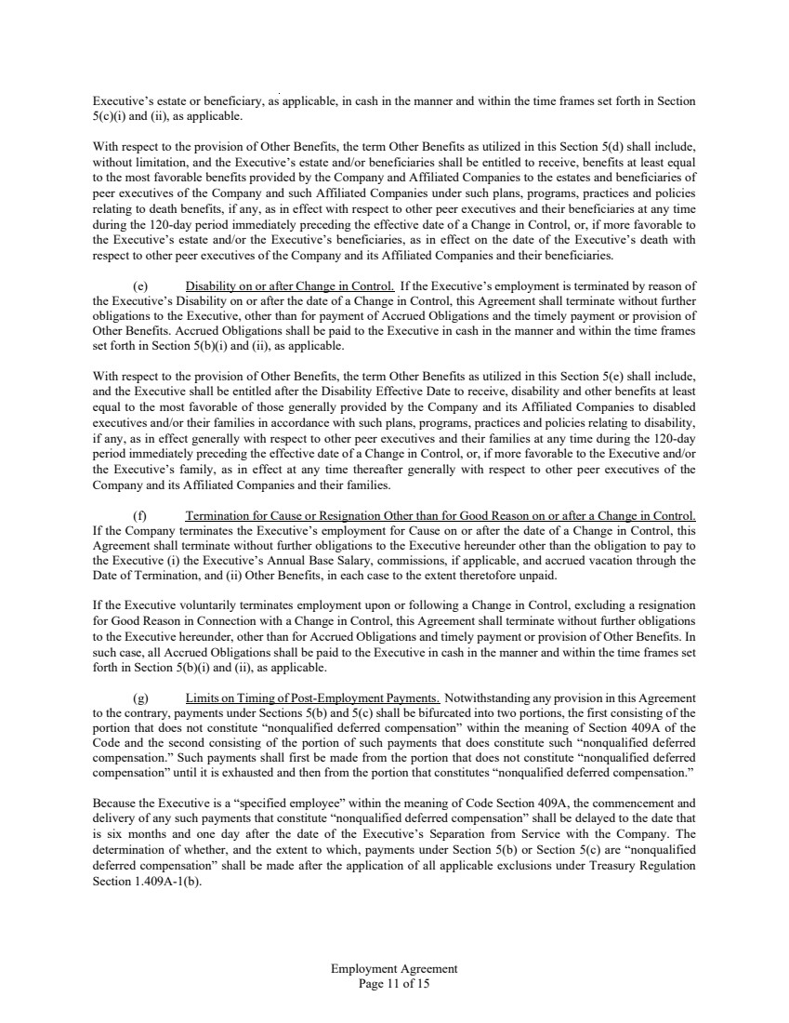 | Employment Agreement Page 11 of 15 Executive’s estate or beneficiary, as applicable, in cash in the manner and within the time frames set forth in Section 5(c)(i) and (ii), as applicable. With respect to the provision of Other Benefits, the term Other Benefits as utilized in this Section 5(d) shall include, without limitation, and the Executive’s estate and/or beneficiaries shall be entitled to receive, benefits at least equal to the most favorable benefits provided by the Company and Affiliated Companies to the estates and beneficiaries of peer executives of the Company and such Affiliated Companies under such plans, programs, practices and policies relating to death benefits, if any, as in effect with respect to other peer executives and their beneficiaries at any time during the 120-day period immediately preceding the effective date of a Change in Control, or, if more favorable to the Executive’s estate and/or the Executive’s beneficiaries, as in effect on the date of the Executive’s death with respect to other peer executives of the Company and its Affiliated Companies and their beneficiaries. (e) Disability on or after Change in Control. If the Executive’s employment is terminated by reason of the Executive’s Disability on or after the date of a Change in Control, this Agreement shall terminate without further obligations to the Executive, other than for payment of Accrued Obligations and the timely payment or provision of Other Benefits. Accrued Obligations shall be paid to the Executive in cash in the manner and within the time frames set forth in Section 5(b)(i) and (ii), as applicable. With respect to the provision of Other Benefits, the term Other Benefits as utilized in this Section 5(e) shall include, and the Executive shall be entitled after the Disability Effective Date to receive, disability and other benefits at least equal to the most favorable of those generally provided by the Company and its Affiliated Companies to disabled executives and/or their families in accordance with such plans, programs, practices and policies relating to disability, if any, as in effect generally with respect to other peer executives and their families at any time during the 120-day period immediately preceding the effective date of a Change in Control, or, if more favorable to the Executive and/or the Executive’s family, as in effect at any time thereafter generally with respect to other peer executives of the Company and its Affiliated Companies and their families. (f) Termination for Cause or Resignation Other than for Good Reason on or after a Change in Control. If the Company terminates the Executive’s employment for Cause on or after the date of a Change in Control, this Agreement shall terminate without further obligations to the Executive hereunder other than the obligation to pay to the Executive (i) the Executive’s Annual Base Salary, commissions, if applicable, and accrued vacation through the Date of Termination, and (ii) Other Benefits, in each case to the extent theretofore unpaid. If the Executive voluntarily terminates employment upon or following a Change in Control, excluding a resignation for Good Reason in Connection with a Change in Control, this Agreement shall terminate without further obligations to the Executive hereunder, other than for Accrued Obligations and timely payment or provision of Other Benefits. In such case, all Accrued Obligations shall be paid to the Executive in cash in the manner and within the time frames set forth in Section 5(b)(i) and (ii), as applicable. (g) Limits on Timing of Post-Employment Payments. Notwithstanding any provision in this Agreement to the contrary, payments under Sections 5(b) and 5(c) shall be bifurcated into two portions, the first consisting of the portion that does not constitute “nonqualified deferred compensation” within the meaning of Section 409A of the Code and the second consisting of the portion of such payments that does constitute such “nonqualified deferred compensation.” Such payments shall first be made from the portion that does not constitute “nonqualified deferred compensation” until it is exhausted and then from the portion that constitutes “nonqualified deferred compensation.” Because the Executive is a “specified employee” within the meaning of Code Section 409A, the commencement and delivery of any such payments that constitute “nonqualified deferred compensation” shall be delayed to the date that is six months and one day after the date of the Executive’s Separation from Service with the Company. The determination of whether, and the extent to which, payments under Section 5(b) or Section 5(c) are “nonqualified deferred compensation” shall be made after the application of all applicable exclusions under Treasury Regulation Section 1.409A-1(b).
 | 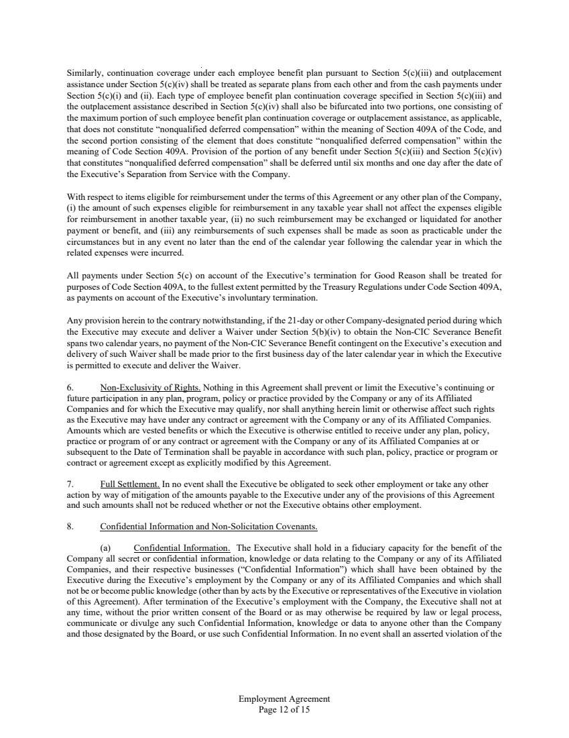 | Employment Agreement Page 12 of 15 Similarly, continuation coverage under each employee benefit plan pursuant to Section 5(c)(iii) and outplacement assistance under Section 5(c)(iv) shall be treated as separate plans from each other and from the cash payments under Section 5(c)(i) and (ii). Each type of employee benefit plan continuation coverage specified in Section 5(c)(iii) and the outplacement assistance described in Section 5(c)(iv) shall also be bifurcated into two portions, one consisting of the maximum portion of such employee benefit plan continuation coverage or outplacement assistance, as applicable, that does not constitute “nonqualified deferred compensation” within the meaning of Section 409A of the Code, and the second portion consisting of the element that does constitute “nonqualified deferred compensation” within the meaning of Code Section 409A. Provision of the portion of any benefit under Section 5(c)(iii) and Section 5(c)(iv) that constitutes “nonqualified deferred compensation” shall be deferred until six months and one day after the date of the Executive’s Separation from Service with the Company. With respect to items eligible for reimbursement under the terms of this Agreement or any other plan of the Company, (i) the amount of such expenses eligible for reimbursement in any taxable year shall not affect the expenses eligible for reimbursement in another taxable year, (ii) no such reimbursement may be exchanged or liquidated for another payment or benefit, and (iii) any reimbursements of such expenses shall be made as soon as practicable under the circumstances but in any event no later than the end of the calendar year following the calendar year in which the related expenses were incurred. All payments under Section 5(c) on account of the Executive’s termination for Good Reason shall be treated for purposes of Code Section 409A, to the fullest extent permitted by the Treasury Regulations under Code Section 409A, as payments on account of the Executive’s involuntary termination. Any provision herein to the contrary notwithstanding, if the 21-day or other Company-designated period during which the Executive may execute and deliver a Waiver under Section 5(b)(iv) to obtain the Non-CIC Severance Benefit spans two calendar years, no payment of the Non-CIC Severance Benefit contingent on the Executive’s execution and delivery of such Waiver shall be made prior to the first business day of the later calendar year in which the Executive is permitted to execute and deliver the Waiver. 6. Non-Exclusivity of Rights. Nothing in this Agreement shall prevent or limit the Executive’s continuing or future participation in any plan, program, policy or practice provided by the Company or any of its Affiliated Companies and for which the Executive may qualify, nor shall anything herein limit or otherwise affect such rights as the Executive may have under any contract or agreement with the Company or any of its Affiliated Companies. Amounts which are vested benefits or which the Executive is otherwise entitled to receive under any plan, policy, practice or program of or any contract or agreement with the Company or any of its Affiliated Companies at or subsequent to the Date of Termination shall be payable in accordance with such plan, policy, practice or program or contract or agreement except as explicitly modified by this Agreement. 7. Full Settlement. In no event shall the Executive be obligated to seek other employment or take any other action by way of mitigation of the amounts payable to the Executive under any of the provisions of this Agreement and such amounts shall not be reduced whether or not the Executive obtains other employment. 8. Confidential Information and Non-Solicitation Covenants. (a) Confidential Information. The Executive shall hold in a fiduciary capacity for the benefit of the Company all secret or confidential information, knowledge or data relating to the Company or any of its Affiliated Companies, and their respective businesses (“Confidential Information”) which shall have been obtained by the Executive during the Executive’s employment by the Company or any of its Affiliated Companies and which shall not be or become public knowledge (other than by acts by the Executive or representatives of the Executive in violation of this Agreement). After termination of the Executive’s employment with the Company, the Executive shall not at any time, without the prior written consent of the Board or as may otherwise be required by law or legal process, communicate or divulge any such Confidential Information, knowledge or data to anyone other than the Company and those designated by the Board, or use such Confidential Information. In no event shall an asserted violation of the
 | 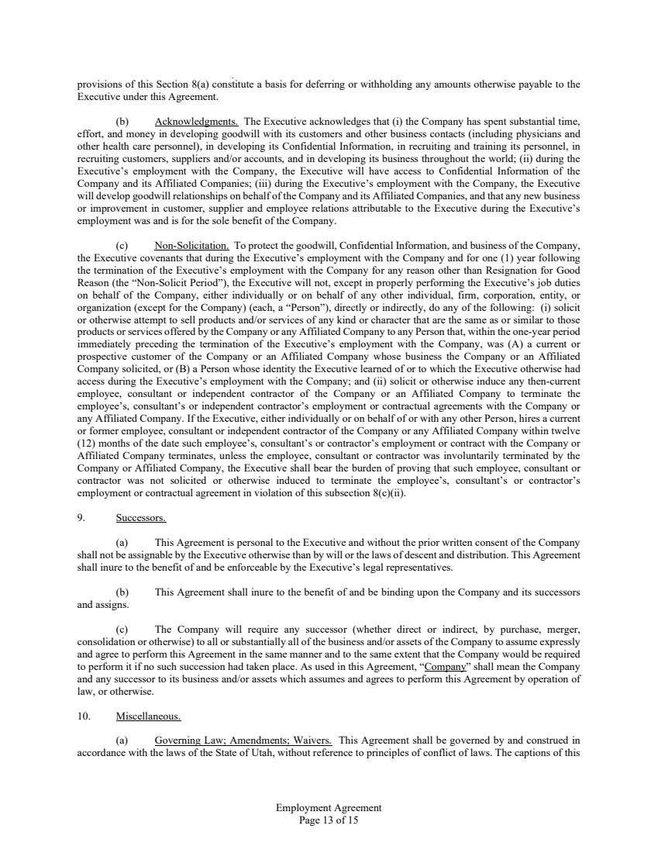 | Employment Agreement Page 13 of 15 provisions of this Section 8(a) constitute a basis for deferring or withholding any amounts otherwise payable to the Executive under this Agreement. (b) Acknowledgments. The Executive acknowledges that (i) the Company has spent substantial time, effort, and money in developing goodwill with its customers and other business contacts (including physicians and other health care personnel), in developing its Confidential Information, in recruiting and training its personnel, in recruiting customers, suppliers and/or accounts, and in developing its business throughout the world; (ii) during the Executive’s employment with the Company, the Executive will have access to Confidential Information of the Company and its Affiliated Companies; (iii) during the Executive’s employment with the Company, the Executive will develop goodwill relationships on behalf of the Company and its Affiliated Companies, and that any new business or improvement in customer, supplier and employee relations attributable to the Executive during the Executive’s employment was and is for the sole benefit of the Company. (c) Non-Solicitation. To protect the goodwill, Confidential Information, and business of the Company, the Executive covenants that during the Executive’s employment with the Company and for one (1) year following the termination of the Executive’s employment with the Company for any reason other than Resignation for Good Reason (the “Non-Solicit Period”), the Executive will not, except in properly performing the Executive’s job duties on behalf of the Company, either individually or on behalf of any other individual, firm, corporation, entity, or organization (except for the Company) (each, a “Person”), directly or indirectly, do any of the following: (i) solicit or otherwise attempt to sell products and/or services of any kind or character that are the same as or similar to those products or services offered by the Company or any Affiliated Company to any Person that, within the one-year period immediately preceding the termination of the Executive’s employment with the Company, was (A) a current or prospective customer of the Company or an Affiliated Company whose business the Company or an Affiliated Company solicited, or (B) a Person whose identity the Executive learned of or to which the Executive otherwise had access during the Executive’s employment with the Company; and (ii) solicit or otherwise induce any then-current employee, consultant or independent contractor of the Company or an Affiliated Company to terminate the employee’s, consultant’s or independent contractor’s employment or contractual agreements with the Company or any Affiliated Company. If the Executive, either individually or on behalf of or with any other Person, hires a current or former employee, consultant or independent contractor of the Company or any Affiliated Company within twelve (12) months of the date such employee’s, consultant’s or contractor’s employment or contract with the Company or Affiliated Company terminates, unless the employee, consultant or contractor was involuntarily terminated by the Company or Affiliated Company, the Executive shall bear the burden of proving that such employee, consultant or contractor was not solicited or otherwise induced to terminate the employee’s, consultant’s or contractor’s employment or contractual agreement in violation of this subsection 8(c)(ii). 9. Successors. (a) This Agreement is personal to the Executive and without the prior written consent of the Company shall not be assignable by the Executive otherwise than by will or the laws of descent and distribution. This Agreement shall inure to the benefit of and be enforceable by the Executive’s legal representatives. (b) This Agreement shall inure to the benefit of and be binding upon the Company and its successors and assigns. (c) The Company will require any successor (whether direct or indirect, by purchase, merger, consolidation or otherwise) to all or substantially all of the business and/or assets of the Company to assume expressly and agree to perform this Agreement in the same manner and to the same extent that the Company would be required to perform it if no such succession had taken place. As used in this Agreement, “Company” shall mean the Company and any successor to its business and/or assets which assumes and agrees to perform this Agreement by operation of law, or otherwise. 10. Miscellaneous. (a) Governing Law; Amendments; Waivers. This Agreement shall be governed by and construed in accordance with the laws of the State of Utah, without reference to principles of conflict of laws. The captions of this
 | 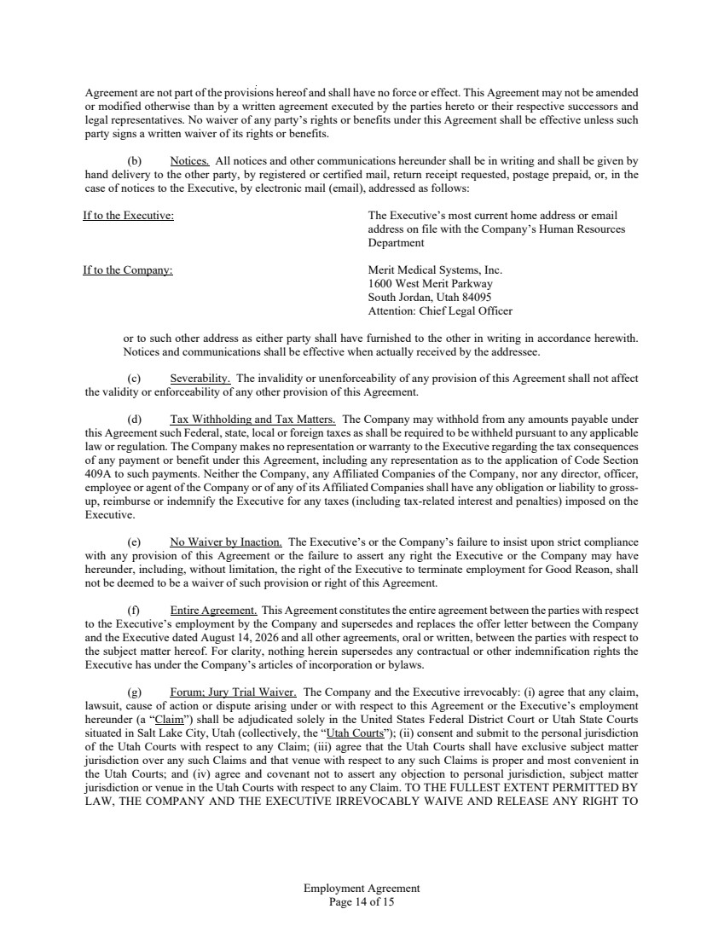 | Employment Agreement Page 14 of 15 Agreement are not part of the provisions hereof and shall have no force or effect. This Agreement may not be amended or modified otherwise than by a written agreement executed by the parties hereto or their respective successors and legal representatives. No waiver of any party’s rights or benefits under this Agreement shall be effective unless such party signs a written waiver of its rights or benefits. (b) Notices. All notices and other communications hereunder shall be in writing and shall be given by hand delivery to the other party, by registered or certified mail, return receipt requested, postage prepaid, or, in the case of notices to the Executive, by electronic mail (email), addressed as follows: If to the Executive: The Executive’s most current home address or email address on file with the Company’s Human Resources Department If to the Company: Merit Medical Systems, Inc. 1600 West Merit Parkway South Jordan, Utah 84095 Attention: Chief Legal Officer or to such other address as either party shall have furnished to the other in writing in accordance herewith. Notices and communications shall be effective when actually received by the addressee. (c) Severability. The invalidity or unenforceability of any provision of this Agreement shall not affect the validity or enforceability of any other provision of this Agreement. (d) Tax Withholding and Tax Matters. The Company may withhold from any amounts payable under this Agreement such Federal, state, local or foreign taxes as shall be required to be withheld pursuant to any applicable law or regulation. The Company makes no representation or warranty to the Executive regarding the tax consequences of any payment or benefit under this Agreement, including any representation as to the application of Code Section 409A to such payments. Neither the Company, any Affiliated Companies of the Company, nor any director, officer, employee or agent of the Company or of any of its Affiliated Companies shall have any obligation or liability to gross-up, reimburse or indemnify the Executive for any taxes (including tax-related interest and penalties) imposed on the Executive. (e) No Waiver by Inaction. The Executive’s or the Company’s failure to insist upon strict compliance with any provision of this Agreement or the failure to assert any right the Executive or the Company may have hereunder, including, without limitation, the right of the Executive to terminate employment for Good Reason, shall not be deemed to be a waiver of such provision or right of this Agreement. (f) Entire Agreement. This Agreement constitutes the entire agreement between the parties with respect to the Executive’s employment by the Company and supersedes and replaces the offer letter between the Company and the Executive dated August 14, 2026 and all other agreements, oral or written, between the parties with respect to the subject matter hereof. For clarity, nothing herein supersedes any contractual or other indemnification rights the Executive has under the Company’s articles of incorporation or bylaws. (g) Forum; Jury Trial Waiver. The Company and the Executive irrevocably: (i) agree that any claim, lawsuit, cause of action or dispute arising under or with respect to this Agreement or the Executive’s employment hereunder (a “Claim”) shall be adjudicated solely in the United States Federal District Court or Utah State Courts situated in Salt Lake City, Utah (collectively, the “Utah Courts”); (ii) consent and submit to the personal jurisdiction of the Utah Courts with respect to any Claim; (iii) agree that the Utah Courts shall have exclusive subject matter jurisdiction over any such Claims and that venue with respect to any such Claims is proper and most convenient in the Utah Courts; and (iv) agree and covenant not to assert any objection to personal jurisdiction, subject matter jurisdiction or venue in the Utah Courts with respect to any Claim. TO THE FULLEST EXTENT PERMITTED BY LAW, THE COMPANY AND THE EXECUTIVE IRREVOCABLY WAIVE AND RELEASE ANY RIGHT TO
 | 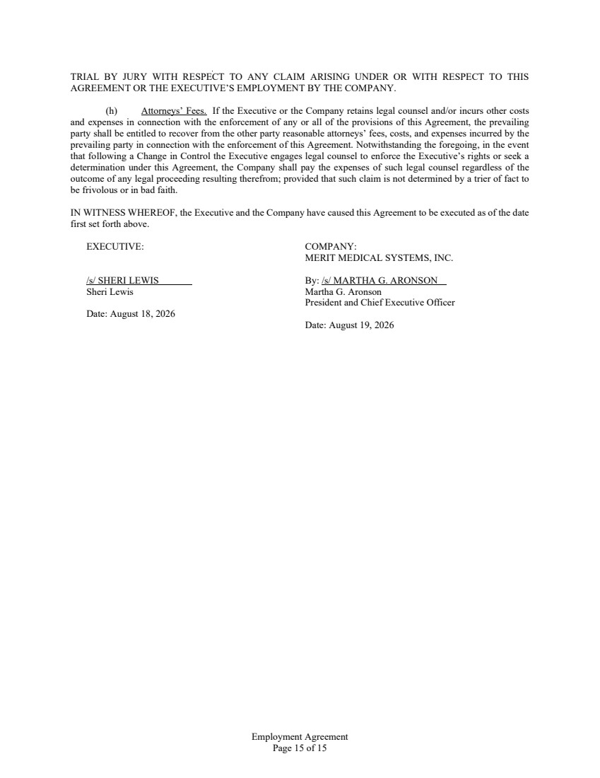 | Employment Agreement Page 15 of 15 TRIAL BY JURY WITH RESPECT TO ANY CLAIM ARISING UNDER OR WITH RESPECT TO THIS AGREEMENT OR THE EXECUTIVE’S EMPLOYMENT BY THE COMPANY. (h) Attorneys’ Fees. If the Executive or the Company retains legal counsel and/or incurs other costs and expenses in connection with the enforcement of any or all of the provisions of this Agreement, the prevailing party shall be entitled to recover from the other party reasonable attorneys’ fees, costs, and expenses incurred by the prevailing party in connection with the enforcement of this Agreement. Notwithstanding the foregoing, in the event that following a Change in Control the Executive engages legal counsel to enforce the Executive’s rights or seek a determination under this Agreement, the Company shall pay the expenses of such legal counsel regardless of the outcome of any legal proceeding resulting therefrom; provided that such claim is not determined by a trier of fact to be frivolous or in bad faith. IN WITNESS WHEREOF, the Executive and the Company have caused this Agreement to be executed as of the date first set forth above. EXECUTIVE: /s/ SHERI LEWIS Sheri Lewis Date: August 18, 2026 COMPANY: MERIT MEDICAL SYSTEMS, INC. By: /s/ MARTHA G. ARONSON Martha G. Aronson President and Chief Executive Officer Date: August 19, 2026

Exhibit 99.1
​
​
​
​
​
​
Merit Medical Announces Global Operations Leadership Transition
SOUTH JORDAN, Utah, August 19, 2026 (GLOBE NEWSWIRE) – Merit Medical Systems, Inc. (NASDAQ: MMSI), a leading global manufacturer of healthcare technology, today announced that Sheri Lewis has agreed to join Merit as Executive Vice President of Global Operations, effective August 31, 2026.
Ms. Lewis brings three decades of experience across global operations, manufacturing, and supply chain management. She previously held senior roles at SkinHealth Systems, Inc., Avantor, Medtronic, and Honeywell, leading global manufacturing, distribution, logistics, supply chain, quality, regulatory, environmental health and safety, and operational excellence functions across large, complex organizations.
"Sheri is an accomplished operations executive with a strong record of leading complex organizations and building high-performing teams," said Martha G. Aronson, Merit’s President and Chief Executive Officer. "Her experience strengthening integrated business processes, ensuring product availability, and driving global operational excellence will be important as Merit continues to scale globally and execute its long-term growth strategy."
To support continuity, Mr. Peterson will move into the role of Senior Advisor, where he will help ensure a smooth transition through March 5, 2027. At that time, Mr. Peterson will complete his service to Merit after more than 32 years with the company.
Mr. Peterson has held leadership roles across Merit’s operations and engineering functions, most recently serving as Chief Operating Officer for the past four years. Throughout his career, he has strengthened product quality, improved on-time delivery, advanced operational efficiencies, and driven cost reductions. He also helped navigate supply chain constraints, raw material shortages, and the operational challenges of the COVID-19 pandemic. Mr. Peterson has consistently shown a deep commitment to supporting employees and their well-being.
"Neil has been a dedicated and respected leader at Merit. His operational discipline, commitment to execution, and deep knowledge of our manufacturing and supply chain network have contributed meaningfully to the company’s growth and performance," added Aronson. "We are grateful for his many contributions and for the important role he has played in strengthening our global operations."
​

ABOUT MERIT MEDICAL
Founded in 1987, Merit is engaged in the development, manufacture, and distribution of proprietary medical devices used in interventional, diagnostic, and therapeutic procedures, particularly in cardiology, radiology, oncology, critical care, and endoscopy. Merit serves customers worldwide with a domestic and international sales force and clinical support team totaling more than 800 individuals. Merit employs approximately 7,500 people worldwide.
CONTACTS
PR/Media Inquiries
Sarah Comstock
Merit Medical
+1-801-432-2864 | sarah.comstock@merit.com
Investor Inquiries
Mike Piccinino, CFA, IRC
ICR Healthcare
+1-443-213-0509 | mike.piccinino@icrhealthcare.com

